CO3 AT1

Q1. Functional Dependencies & Candidate Key

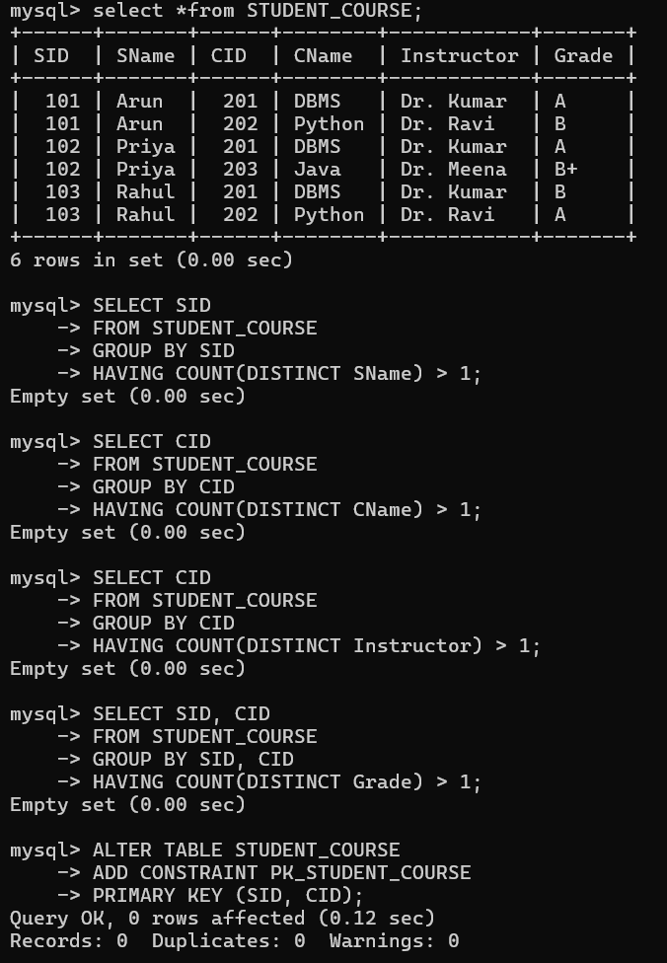
Q2 .Unnormalized Relation → 1NF

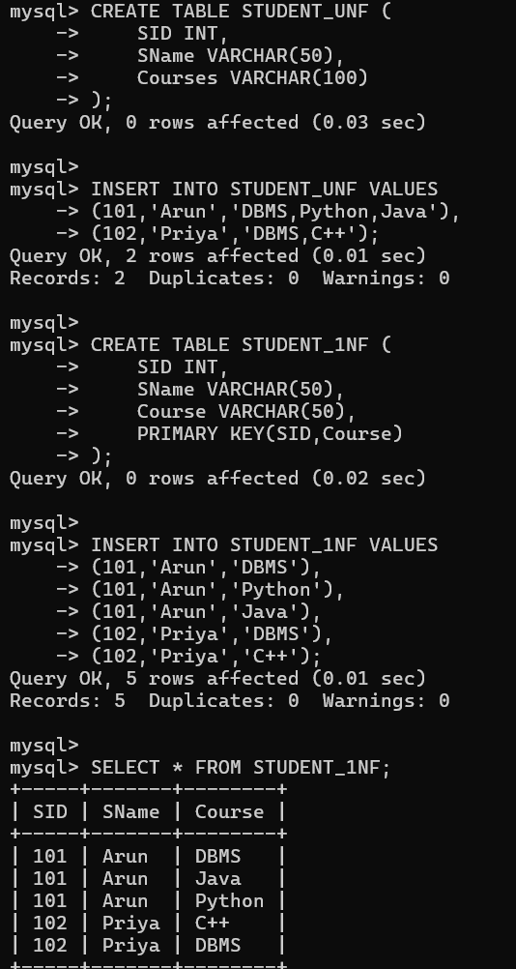
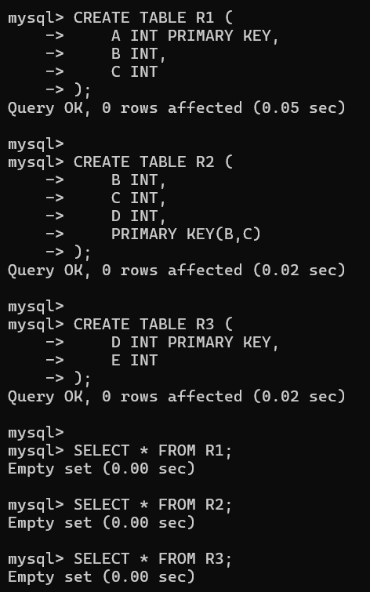
Q3 . Decomposition into 2NF
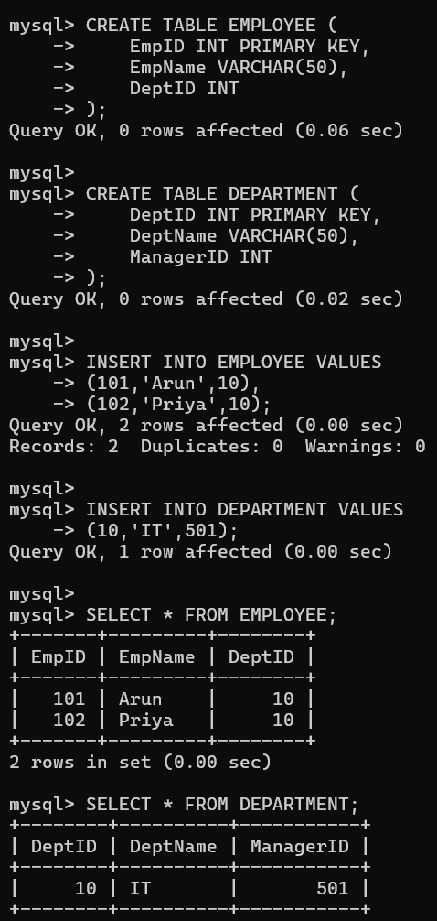
Q4 . 3NF Decomposition

Q5 . BCNF Decomposition

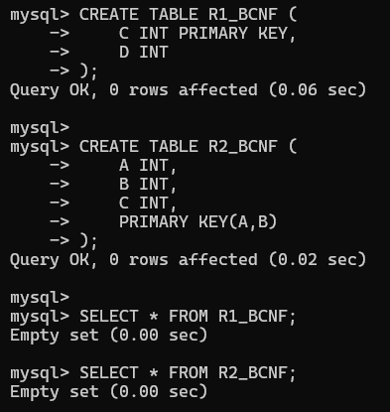

Q6 . Lossless Join – Chase Algorithm
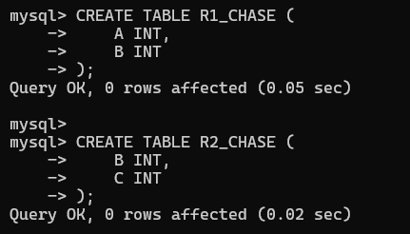

Q8. 4NF Decomposition

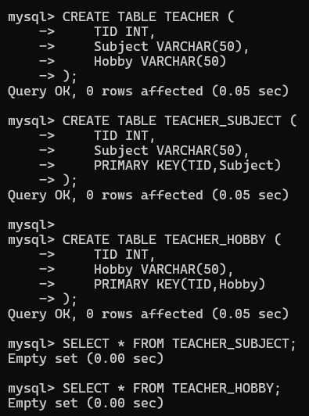

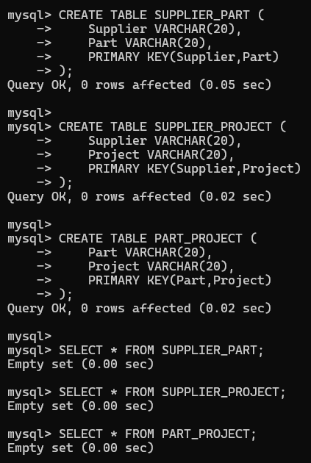
Q9 . 5NF / Join Dependency

Q10 . College Anomalies → 3NF

