Exp – 4a):

AIM: To find out the average pay of all employees whose salary is more than 6000 and no. of days worked is more than 4.

PROGRAM:

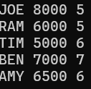

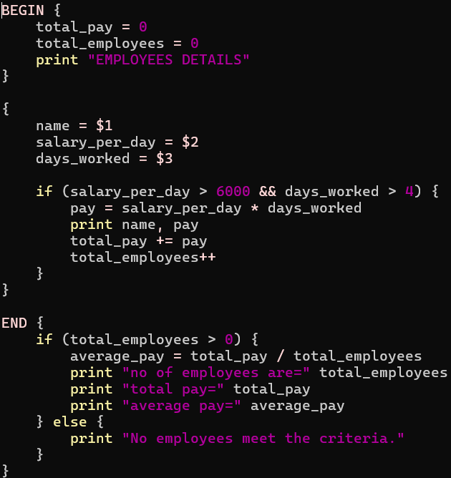

OUTPUT:

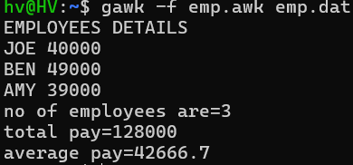

Exp – 4b):

AIM: To print the pass/fail status of a student in a class.

PROGRAM:

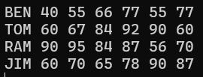

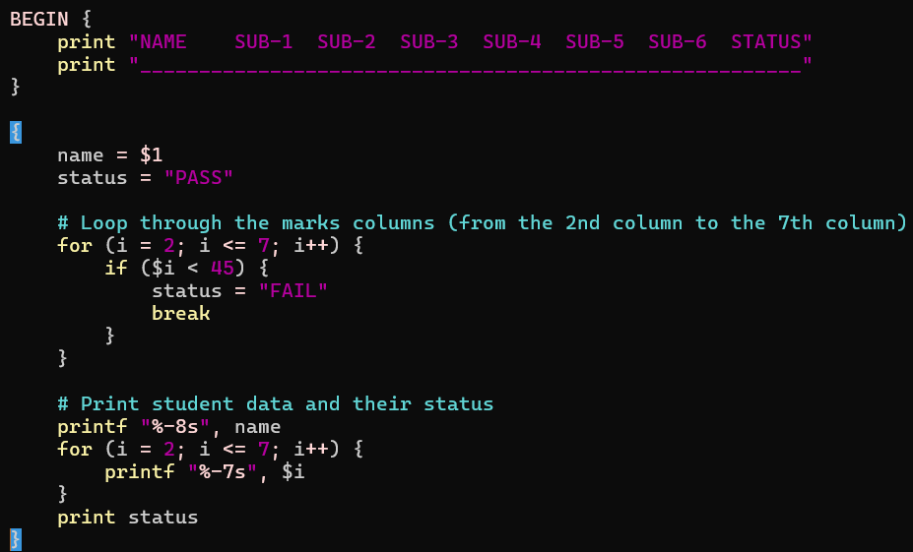

OUTPUT:

