Exp – 5:

AIM: To experiment system calls using fork(), execlp() and pid() functions.

PROGRAM:

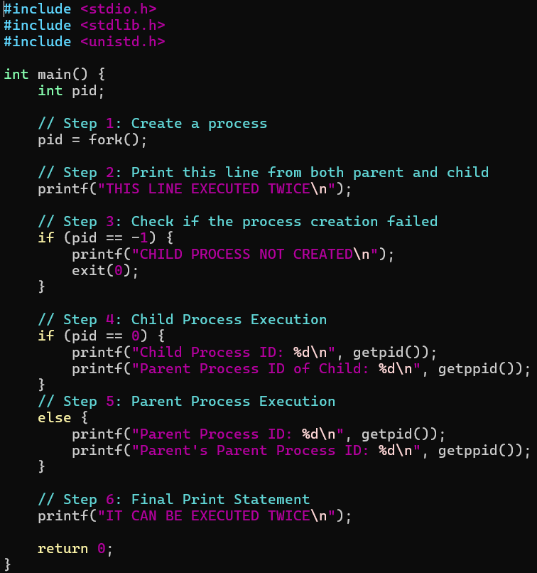

OUTPUT:

