Exp – 6a):

AIM: To implement First-come First- serve (FCFS) scheduling technique

PROGRAM:

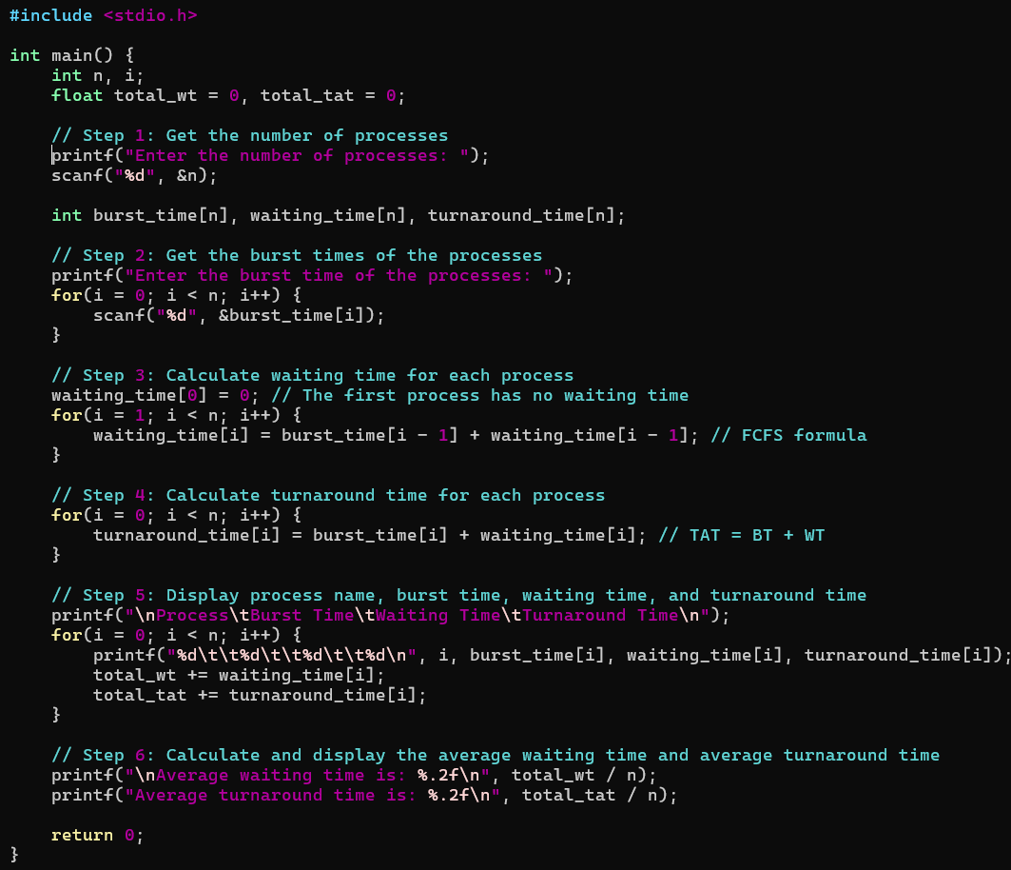

OUTPUT:

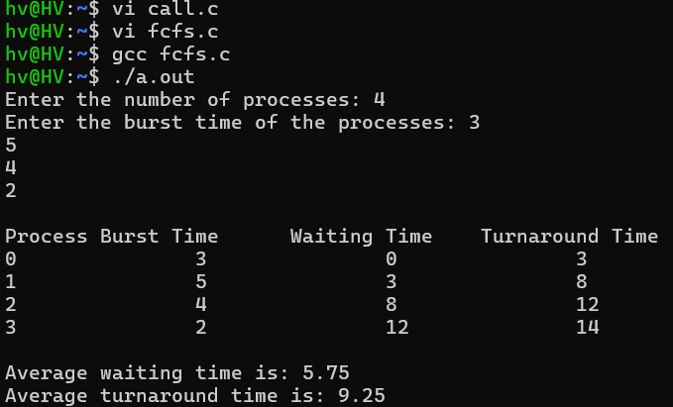

Exp – 6b):

AIM: To implement the Shortest Job First (SJF) scheduling technique

PROGRAM:

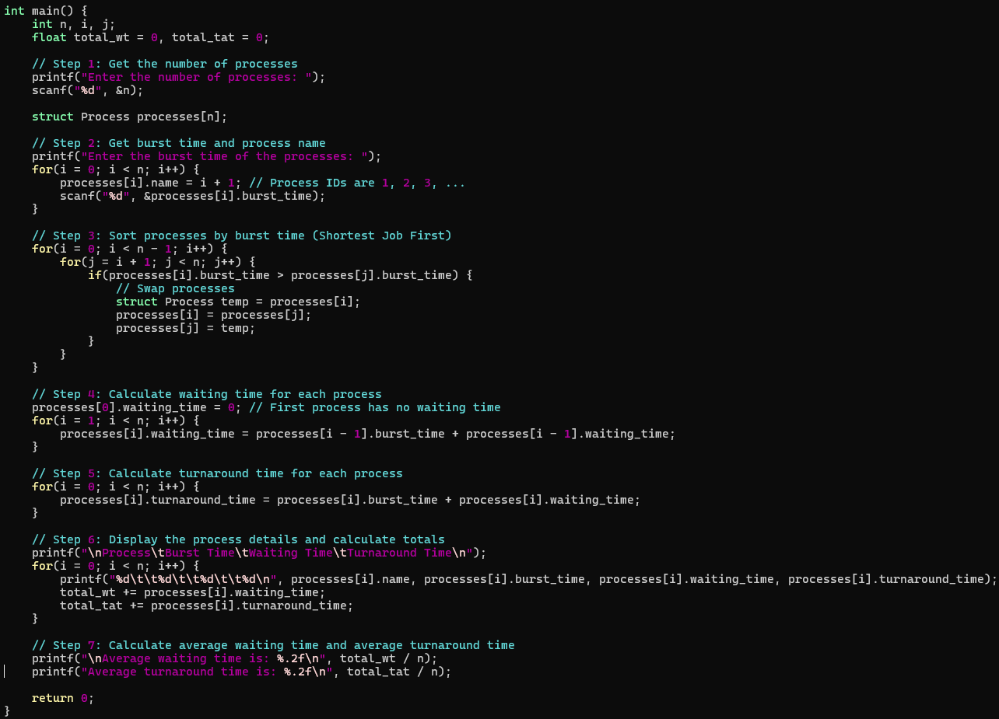

OUTPUT:

