ABSTRACT : Diabetes is an illness caused because of high glucose level in a human body. Diabetes should not be ignored if it isuntreated then Diabetes may cause some major issues in a person like: heart related problems, kidney problem, blood pressure,eye damage and it can also affects other organs of human body.Diabetes can be controlled if it is predicted earlier. To achieve this goal this project work we will do early prediction of Diabetesin a human body or a patient for a higher accuracy through applying, Various Machine Learning Techniques. Machine learning techniques Provide better result for prediction by constructing models from datasets collected from patients. In this work we will use Machine Learning Classification and ensemble techniques on a dataset to predict diabetes. Which are K Nearest Neighbor (KNN), Logistic Regression (LR), Decision Tree (DT),Support Vector Machine (SVM), Gradient Boosting (GB) and Random Forest (RF). The accuracy is different for every model when compared to other models. The Project work gives the accurate or higher accuracy model shows that the model is capable of predicting diabetes effectively. Our Result shows that Random Forest
achieved higher accuracy compared to other machine learning techniques.

Keywords : Diabetes, Machine, Learning, Prediction, Dataset, Ensemble

PROJECT TITLE : AI Based Diabetes Prediction System

PROBLEM STATEMENT : Develop an AI-powered diabetes prediction system that leverages machine learning algorithms to analyze medical data and predict the likelihood of an individual developing diabetes, providing early risk assessment and personalized preventive measures.

PROBLEM DEFINITION :
The problem is to build an AI-powered diabetes prediction system that uses machine learning algorithms to analyze medical data and predict the likelihood of an individual developing diabetes. The system aims to provide early risk assessment and personalized preventive measures,
allowing individuals to take proactive actions to manage their health.

DESING THINKING :

- Data Preprocessing: The medical data needs to be cleaned, normalized, and prepared for training machine learning models.
- Feature Selection: We will select relevant features that can impact diabetes risk prediction.
- Model Selection: We can experiment with various machine learning algorithms like Logistic Regression, Random Forest, and Gradient Boosting.
- Evaluation: We will evaluate the model's performance using metrics like accuracy, precision, recall, F1-score, and ROC-AUC.
- Iterative Improvement: We will fine-tune the model parameters and explore techniques like feature engineering to enhance prediction accuracy.
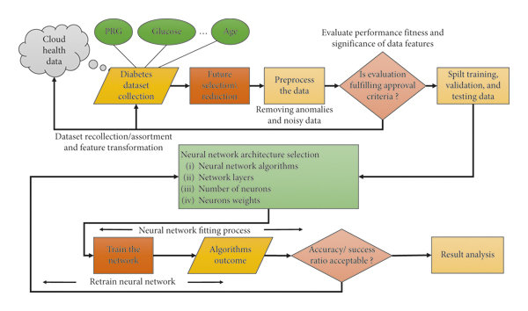

Goal of the paper is to investigate for model to predict diabetes with better accuracy. We experimented with differentclassification and ensemble algorithms to predict diabetes.In the following, we briefly discuss the phase.

A. Dataset Description - The data is gathered from UCI repository which is named as Mathchi Diabetes Dataset. The dataset have many attributes .
Dataset Link:
https://www.kaggle.com/datasets/mathchi/diabetes-data-set

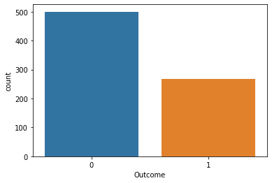

Distribution of Diabetic patient - We made a model to predict diabetes however the dataset was slightly imbalanced having around 500 classes labeled as 0 means negative means no diabetes and 268 labeled as 1 means positive means diabetic

B. Data Preprocessing- Data preprocessing is most important process. Mostly healthcare related data contains missing vale and other impurities that can cause effectiveness of data. To improve quality and effectiveness obtained after mining process, Data preprocessing is done. To use Machine Learning
Techniques on the dataset effectively this process is essential for accurate result and successful prediction. For Pima Indian diabetes dataset we need to perform pre processing in two steps .
1). Missing Values removal- Remove all the instances that have zero (0) as worth. Having zero as worth is not possible. Therefore this instance is eliminated. Through eliminating irrelevant features/instances we make feature subset and this process is called features subset selection, which reduces diamentonality of data and help to work faster.
2). Splitting of data- After cleaning the data, data is normalized in training and testing the model. When data is spitted then we train algorithm on the training data set and keep test data set aside. This training process will produce the training model based on logic and algorithms and values of the feature in training data. Basically aim of normalization is to bring all the attributes under same scale.
C. Apply Machine Learning- When data has been ready we apply Machine Learning Technique. We use different classification and ensemble techniques, to predict diabetes.The methods applied on Pima Indians diabetes dataset. Main objective to apply Machine Learning Techniques to analyze the performance of these methods and find accuracy of them, and also been able to figure out the responsible/important feature which play a major role in prediction.
The Techniques are follows-
1) Support Vector Machine- Support Vector Machine also known as svm is a supervised machine learning algorithm. Svm is most popular classification technique. Svm creates a hyperplane that separate two classes. It can create a hyperplane or set of hyperplane in high dimensional space. This hyper plane can be used for classification or regression also. Svm differentiates instances in specific classes and can also classify the entities which are not supported by data. Separation is done by through hyperplane performs the separation to the closest training point of any class.
Algorithm-
• Select the hyper plane which divides the class better.
• To find the better hyper plane you have to calculate the distance between the planes and the data which is called Margin.
• If the distance between the classes is low then the chance of miss conception is high and vice versa.So we need to
• Select the class which has the high margin. Margin = distance to positive point + Distance to negative point.
2) K-Nearest Neighbor - KNN is also a supervised machine learning algorithm. KNN helps to solve both the classification and regression problems. KNN is lazy prediction technique.KNN assumes that similar things are near to each other. Many times data points which are similar are very near to each other.KNN helps to group new work based on similarity measure.KNN algorithm record all the records and classify them according to their similarity measure. For finding the distance between the points uses tree like structure. To make a prediction for a new datapoint, the algorithm finds the closest data points in the training data set — it’s nearest neighbors. Here K= Number of nearby neighbors, it’s always a positive integer. Neighbor’s value is chosen from set of class. Closeness is mainly defined in terms of Euclidean distance. The Euclidean distance between two points P and Q i.e. P (p1,p2, …. Pn) and Q (q1, q2,..qn) is defined by the following equation:-
Algorithm-
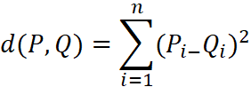
• Take a sample dataset of columns and rows named as mathchi Diabetes data set.Take a test dataset of attributes and rows.
• Find the Euclidean distance by the help of formula
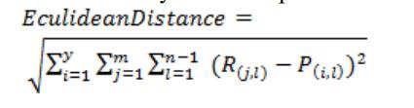
Then, Decide a random value of K. is the no. Of nearest neighbors Then with the help of these minimum distance and Euclidean distance find out the nth column of each. Find out the same output values. If the values are same, then the patient is diabetic, other wise not.
3) Decision Tree- Decision tree is a basic classification method. It is supervised learning method. Decision tree used when response variable is categorical. Decision tree has tree like structure based model which describes classification process based on input feature. Input variables are any types like graph, text, discrete, continuous etc. Steps for Decision Tree Algorithm-
• Construct tree with nodes as input feature.
• Select feature to predict the output from input feature whose information gain is highest.
• The highest information gain is calculated for each attribute in each node of tree.
• Repeat step 2 to form a subtree using the feature which is not used in above node.

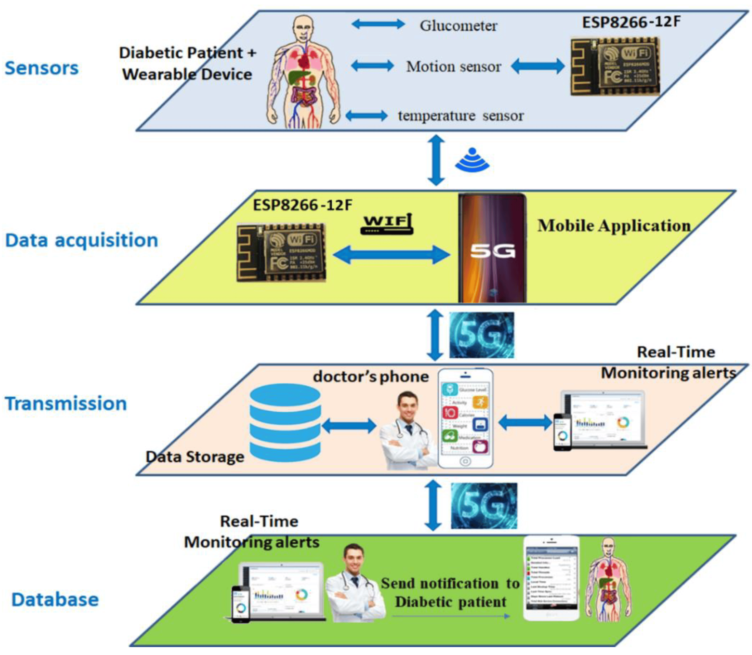

4) Logistic Regression- Logistic regression is also a supervised learning classification algorithm. It is used to estimate the probability of a binary response based on one or more predictors. They can be continuous or discrete. Logistic regression used when we want to classify or distinguish some data items into categories. It classify the data in binary form means only in 0 and 1 which refer case to classify patient that is positive or negative for diabetes. Main aim of logistic regression is to best fit which is responsible for describing the relationship between target and predictor variable. Logistic regression is a based on Linear regression model. Logistic regression model uses sigmoid function to predict probability of positive and negative class.
Sigmoid function P = 1/1+e - (a+bx) Here P = probability,
a and b = parameter of Model.
Ensembling- Ensembling is a machine learning technique Ensemble means using multiple learning algorithms together for some task. It provides better prediction than any other individual model that’s why it is used. The main cause of error is noise bias and variance, ensemble methods help to reduce or minimize these errors. There are two popular ensemble methods such as – Bagging, Boosting, ada-boosting, Gradient boosting, voting, averaging etc.Here In these work we have used Bagging (Random forest)and Gradient boosting ensemble methods for predicting diabetes.

5) Random Forest – It is type of ensemble learning method and also used for classification and regression tasks.The accuracy it gives is grater then compared to other models. This method can easily handle large datasets. Random Forest is developed by Leo Bremen. It is popular ensemble Learning Method. Random Forest Improve Performance of Decision Tree by reducing variance. It operates by constructing a multitude of decision trees at training time and outputs the class that is the mode of the classes or classification or mean prediction (regression) of the individual trees.
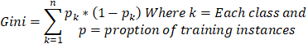

• The first step is to select the “R” features from the total features “m” where R<<M.
• Among the “R” features, the node using the best split point.
• Split the node into sub nodes using the best split.
• Repeat a to c steps until ”l” number of nodes has been reached.
• Built forest by repeating steps a to d for “a” number of times to create “n” number of trees.The random forest finds the best split using the Gin-Index Cost Function
The first step is to need the take a glance at choices and use the foundations of each indiscriminately created decision tree to predict the result and stores the anticipated outcome at intervals the target place. Secondly, calculate the votes for each predicted target and ultimately, admit the high voted predicted target as a result of the ultimate prediction from the random forest formula. Some of the options of Random Forest does correct predictions result for a spread of applications are offered.

6) Gradient Boosting - Gradient Boosting is most powerful ensemble technique used for prediction and it is a classification technique. It combine week learner together to make strong learner models for prediction. It uses Decision Tree model. it classify complex data sets and it is very effective and popular method. In gradient boosting model performance improve over iterations.
Algorithm-
• Consider a sample of target values as P
• Estimate the error in target values.
• Update and adjust the weights to reduce error M.
- P[x] =p[x] +alpha M[x]
- Model Learners are analyzed and calculated by loss function F
- Repeat steps till desired & target result P.
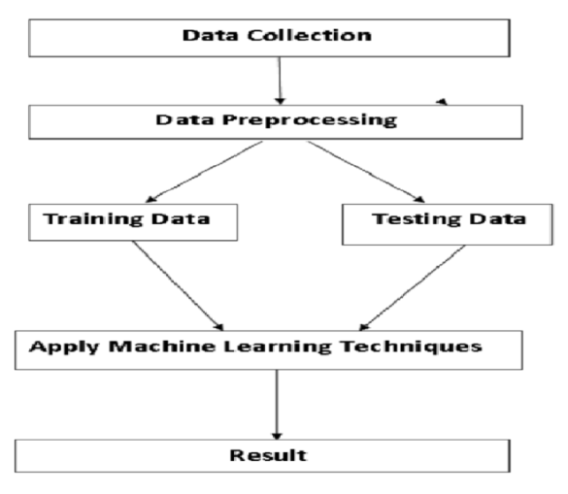

MODEL BUILDING :
This is most important phase which includes model building for prediction of diabetes. In this we have implemented various machine learning algorithms which are discussed above for diabetes prediction.
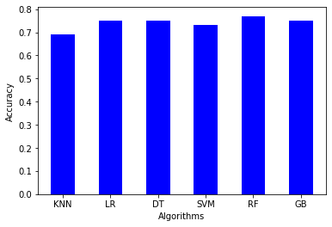
Procedure of Proposed Methodology-
Step1: Import required libraries, Import diabetes dataset.

Step2: Pre-process data to remove missing data.

Step3: Perform percentage split of 80% to divide dataset as
Training set and 20% to Test set.

Step4: Select the machine learning algorithm i.e. K-
Nearest Neighbor, Support Vector Machine, Decision Tree,Logistic regression, Random Forest and Gradient boosting algorithm.

Step5: Build the classifier model for the mentioned machine learning algorithm based on training set.

Step6: Test the Classifier model for the mentioned machine learning algorithm based on test set.
Step7: Perform Comparison Evaluation of the experimental performance results obtained for each classifier.

Step8: After analyzing based on various measures conclude the best performing algorithm.

CONCLUSION :The main aim of this project was to design and implement Diabetes Prediction Using Machine Learning Methods and Performance Analysis of that methods and it has been achieved successfully. The proposed approach uses various classification and ensemble learning method in which SVM, Knn, Random Forest, Decision Tree, Logistic Regression and Gradient Boosting classifiers are used. And 77% classification accuracy has been achieved. The Experimental results can be asst health care to take early prediction and make early decision to cure diabetes and save humans life.

REFRENCES :
IJERTV9IS090496
Debadri Dutta, Debpriyo Paul, Parthajeet Ghosh, "Analyzing Feature Importance’s for Diabetes Prediction using Machine Learning". IEEE, pp 942-928, 2018.

K.VijiyaKumar, B.Lavanya, I.Nirmala, S.Sofia Caroline,"Random Forest Algorithm for the Prediction of Diabetes".Proceeding of International Conference on Systems Compu-
tation Automation and Networking, 2019.

Md. Faisal Faruque, Asaduzzaman, Iqbal H. Sarker, "Performance Analysis of Machine Learning Techniques to Predict Diabetes Mellitus". International Conference on Electrical,Computer and Communication (ECCE), 7-9 February, 2019.

