**(**SYAIMLA77 : HARSHAL SADANAND MALI**)**

**ASSIGNMENT NO 1**

Q.1

create table branch(branch_name varchar(40) primary key,

branch_city varchar(40),

balance number(5));

insert into branch(branch_name,branch_city,balance) values(&branch_name,&branch_city,&balance);

select * from branch;

BRANCH_NAME BRANCH_CITY ASSET

---------------------------------------- ----------

Bhosari pune 100

Akurdi pune 200

Shivajinagar pune 300

Nigdi pune 400

Chinchwad pune 500

SQL> create table account(acc_no number(12) primary key,

branch_name varchar(40),

balance number(4),

FOREIGN KEY (branch_name) REFERENCES branch(branch_name));

insert into account(acc_no,branch_name,balance)

values(&acc_no,&branch_name,&balance);

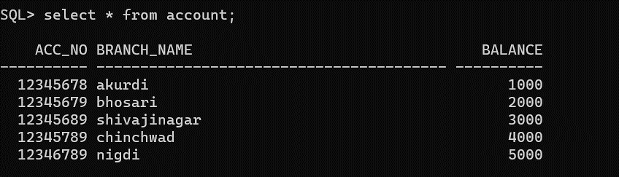

SQL> create table loan(

2 loan_no number(12),

3 branch_name varchar(40),

4 amount number(6),

5 primary key(loan_no),

6 foreign key(branch_name) references branch(branch_name));

insert into loan(loan_no,branch_name,amount) values(&loan_no,&branch_name,&amount);

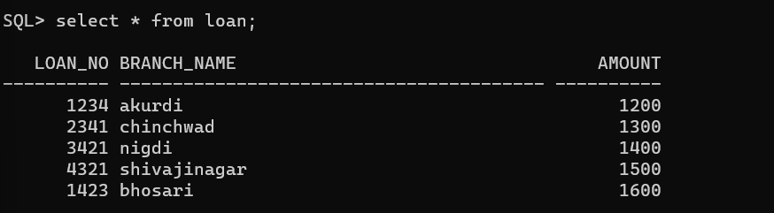

SQL> create table customer(

2 cust_name varchar(40),

3 cust_street varchar(40),

4 cust_city varchar(40),

5 primary key(cust_name));

insert into customer(cust_name,cust_street,cust_city) values(&cust_name,&cust_street,&cust_city);

CUST_NAME CUST_STREET CUST_CITY

---------------------------------------- ---------------------------------------- ----------------------------------------

Harshal dighiroad pune

Ankush akurdiroad pune

Ptm akurdiroad pune

Onkar akurdiroad pune

Anjali moshiroad pune

create table borrower(

2 cust_name varchar(40),

3 loan_no number(12),

4 foreign key(cust_name) references customer(cust_name),

5 foreign key(loan_no) references loan(loan_no));

insert into borrower(cust_name,loan_no) values(&cust_name,&loan_no);

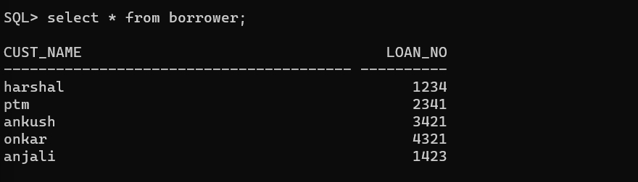

create table depositor(

2 cust_name varchar(40),

3 acc_no number(10),

4 foreign key(cust_name) references customer(cust_name),

5 foreign key(acc_no) references account(acc_no));

insert into depositor(cust_name,acc_no) values (&cust_name,&acc_no);

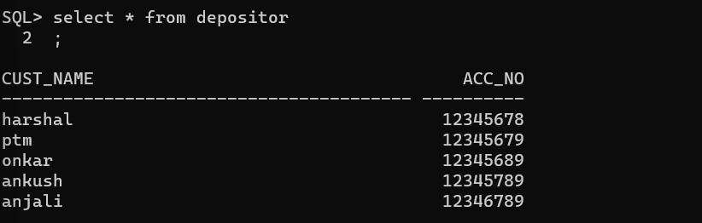

1.

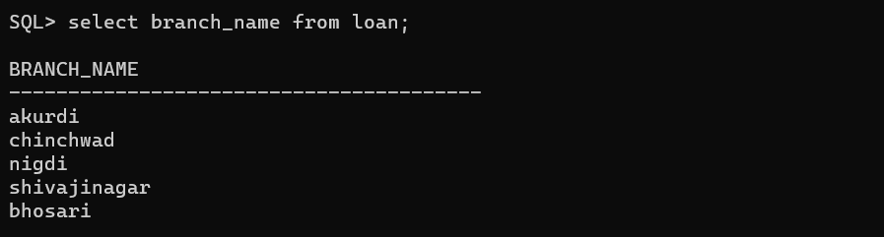

2.

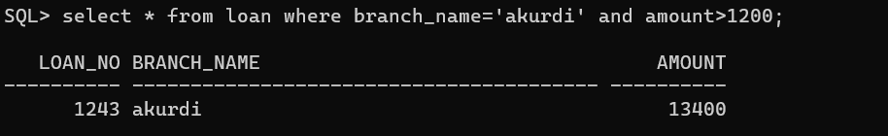

3.

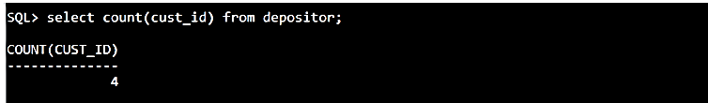

4.

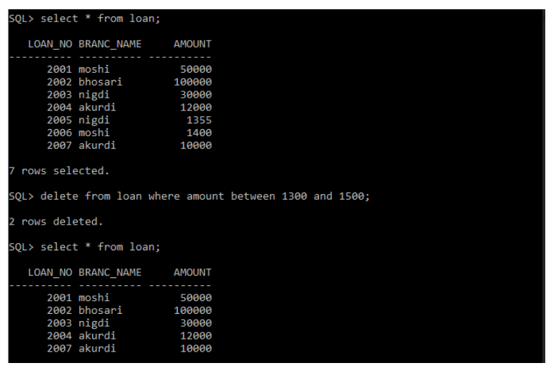

5.

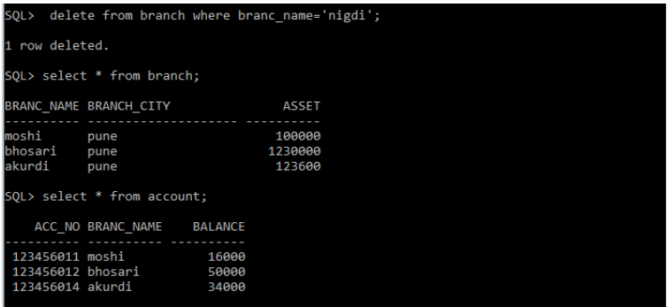

6.

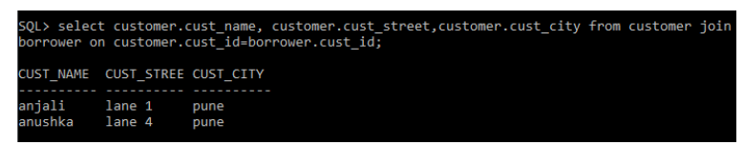

7.

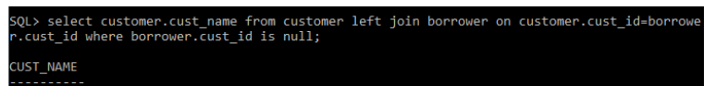

8.

CUST_NAME CUST_STREET CUST_CITY

---------------------------------------- ---------------------------------------- ----------------------------------------

Harshal dighiroad pune

Ankush akurdiroad pune

Ptm akurdiroad pune

Onkar akurdiroad pune

Anjali moshiroad pune

9.

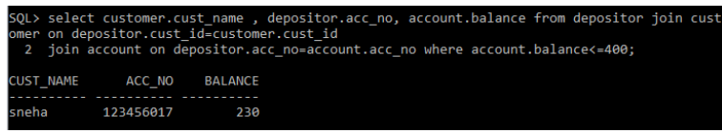

10.

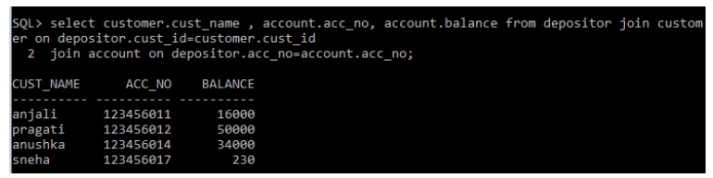

11.

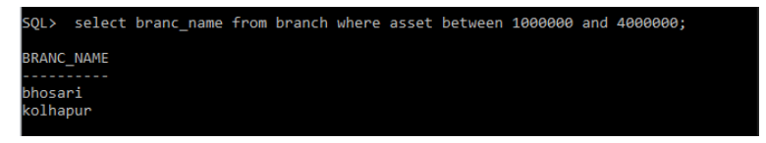

12.



13.

\

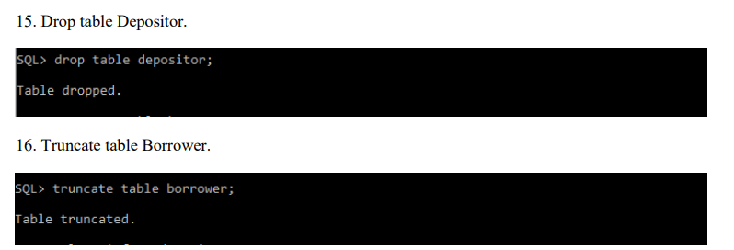

Q.2 Create table Student



2.1 Create Index College_Index using using any column



2.2 Create unique index for unique values.

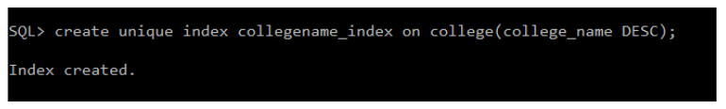

2.3 Remove index from tables.



