1.

create table cust_mstr(

cust_no number(5) primary key,

fname varchar(40),

lname varchar(40))

insert into cust_mstr(cust_no,fname,lname) values(&cust_no,'&fname','&lname');

select * from cust_mstr;

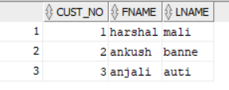

create table add_dets(

code_no number(5) primary key,

add1 varchar(40),

add2 varchar(40),

statee varchar(40),

city varchar(40),

pincode number(8));

insert into add_dets(code_no,add1,add2,statee,city,pincode) values(&code_no,'&add1','&add2','&statee','&city',&pincode);

select * from add_dets;

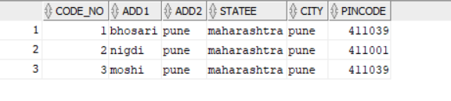

select cust_mstr.fname,cust_mstr.lname, add_dets.add1,add_dets.add2,add_dets.city

from cust_mstr

inner join add_dets on cust_mstr.cust_no=add_dets.code_no

where cust_mstr.fname='harshal' and cust_mstr.lname='mali';



2.

create table acc_fd_dets(

codeno number(5) primary key,

acc_fd_no number(5));

insert into acc_fd_dets(codeno,acc_fd_no) values(&codeno,&acc_fd_no);

select * from acc_fd_dets;

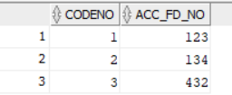

create table fd_dets(

fd_sr_no number(5) primary key,

amt number(5));

insert into fd_dets(fd_sr_no,amt) values(&fd_sr_no,&amt);

select * from fd_dets;

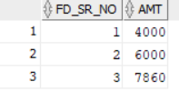

select cust_mstr.fname,cust_mstr.lname,acc_fd_dets.acc_fd_no,fd_dets.amt from cust_mstr

inner join fd_dets on cust_mstr.cust_no=fd_dets.fd_sr_no

inner join acc_fd_dets on cust_mstr.cust_no=acc_fd_dets.codeno

where fd_dets.amt>5000;

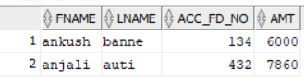

3.

create table emp_mstr(

emp_no number(5) ,

f_name varchar(45),

m_name varchar(45),

l_name varchar(45),

dept varchar(40),

desg varchar(40),

branch_no number(5) primary key);

insert into emp_mstr(emp_no,f_name,m_name,l_name,dept,desg,branch_no) values(&emp_no,'&f_name','&m_name','&l_name','&dept','&desg',&branch_no)

select * from emp_mstr;

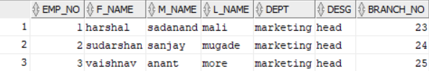

create table branch_mstr(

name varchar(40),

b_no number(5) primary key);

insert into branch_mstr(name,b_no) values('&name',&b_no);

select * from branch_mstr;

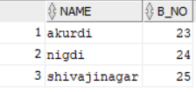

select emp_mstr.f_name,emp_mstr.l_name,emp_mstr.dept,branch_mstr.name

from emp_mstr inner join branch_mstr on emp_mstr.branch_no=branch_mstr.b_no;

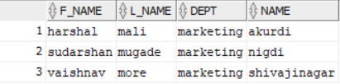

4.

create table cntc_dets(

code_no number(5) primary key,

cntc_type varchar(40),

cntc_data varchar(40));

insert into cntc_dets(code_no,cntc_type,cntc_data) values(&code_no,'&cntc_type','&cntc_data');

select * from cntc_dets;

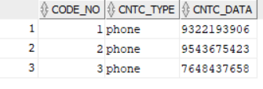

a)

select emp_mstr.f_name,emp_mstr.l_name,emp_mstr.dept,cntc_dets.cntc_type,cntc_dets.cntc_data

from emp_mstr left join cntc_dets on emp_mstr.emp_no=cntc_dets.code_no;

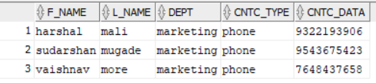

b)

select emp_mstr.f_name,emp_mstr.l_name,emp_mstr.dept,cntc_dets.cntc_type,cntc_dets.cntc_data

from emp_mstr right join cntc_dets on emp_mstr.emp_no=cntc_dets.code_no;

