***Team Name***

***Meet Your Makers***

***Team***

***Department: I.T.***

***Kanaparthi Harshini***

***Email:harshinigc@gmail.com***

***Mobile: 9491648780***

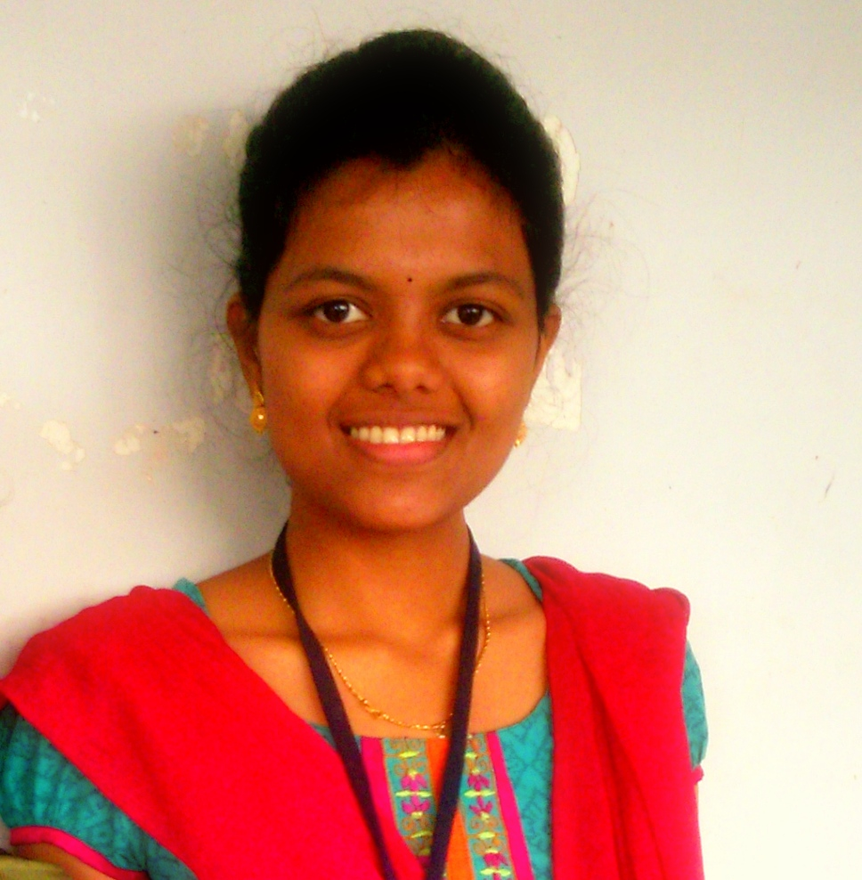

***Maddali Susmitha***

***Email:maddalisusmitha@gmail.com***

***Mobile: 8106107233***

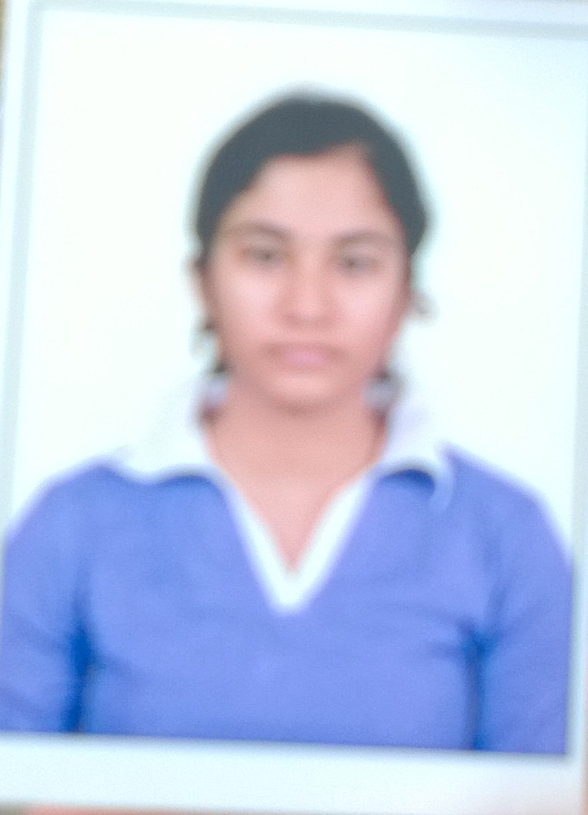

***Koppusetti Hareesh***

***Email:hareestorm@gmail.com***

***Mobile: 9533510213***

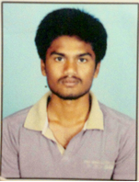

***Kakarlamudi Prudhvi Prasanth***

***Email: kprudhviraj007@gmail.com***

***Mobile***: ***9959986007***

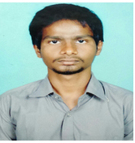

***Project Guide***

***Mr S.Kanthi Kiran***

***Associate Professor (change***

***Email:s.kanthi.kiran@gvpce.ac.in***

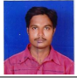

***Abstract***

This Online Examination website consists of features like registration of user, login sessions for user, Selection of subject, Objective Questions, display of marks, retake the exam.

***Select domain (s) where your solution can be implemented***

□ Students

□Lecturers and Professors

□ Academic Institutions

***Describe how your solution helping the selected domains***

It helps us to conduct Exams for various users across the globe, run online courses, Conduct various competitive exams, asses the ability of user, and publish results

***Describe the engineering solution***

It helps in assessment of performance of user by analysis of marks, conduct exams globally helping E-Learning, improve the performance by retaking the exam

***Industry or Institutions/Researchers working in this domain or technology***

Zakir Laliwala,Dhirubhai Ambhani Institute of Information and Communication Technology,India**.**

**l**