**Speech Recognition**

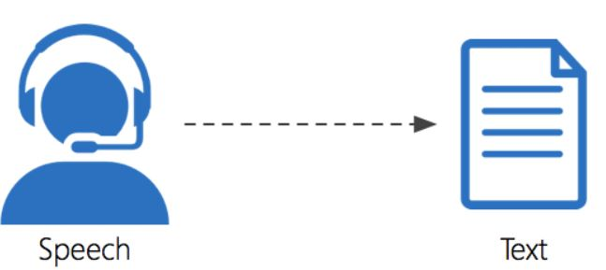

* **Speech Recognition:** Converting speech into text
* **EXPLANATION OF PYTHON CODE**
* **First, we have to install three modules for this project**
* **1---pip install pipwin**
* Pipwin is a complementary tool for pip on Windows
* Pipwin installs unofficial python package binaries for windows
* **2---pip install speech Recognition**
* Speech recognition is a machine's ability to listen to spoken words and identify them
* **3---pipwin install pyaudio**
* provides Python bindings for Port Audio v19, the cross-platform audio I/O library.

**Code:**

* **import speech recognition as kt**

* importing the speech recognition library as kt instead of speech recognition we are using kt in further use of code
* **def main ():**
* This is the function
* **h = kt. Recognizer ()**
* h is a variable
* Recognizer is function it recognize the voice
* assign the function to the variable h with kt. Microphone () as source
* we are giving voice source through Microphone
* **h. adjusts_for_ambient_noise(source)**
* It is used for clearing the unwanted voice
* **print ("please say something")**

* This is the print statement
* **audio = h. listen(source)**
* It taking the voice
* **print ("Recognizing now....")**
* while listing it shows this print statement
* **try:**
* **print ("you have said\n"+r. recognize_google(audio))**
* If we are giving any source through Microphone, it will recognize the speech by using google and it display speech in text
* **print ("Audio recorder successfully\n")**

* **except Exception as e:**
* **print("Error:"+str(e))**
* If we are not giving any voice, it will entered in to the Exception block
* **open ("recorded. wave","wb”) as f:**
* **f. write (audio.get_wav_data ())**
* wav = it is a wave extension
* wb = write binary as f
* it will save in file
* **if _name== "main_":**

main ()

* if it is in a main function it will execute

**ABOUT FLASK CODE:**

* **flask is a framework written in Python**

from flask import Flask, render_template

app = Flask(_name_)

@app. route ("/")

@app. route("/home")

def home ():

return render_template ("PYTHON IIIT.py")

#Giving the python file name here

if _name_ == '_main_':

app.run (debug= True, port=5000)

* **speech recognition code in python**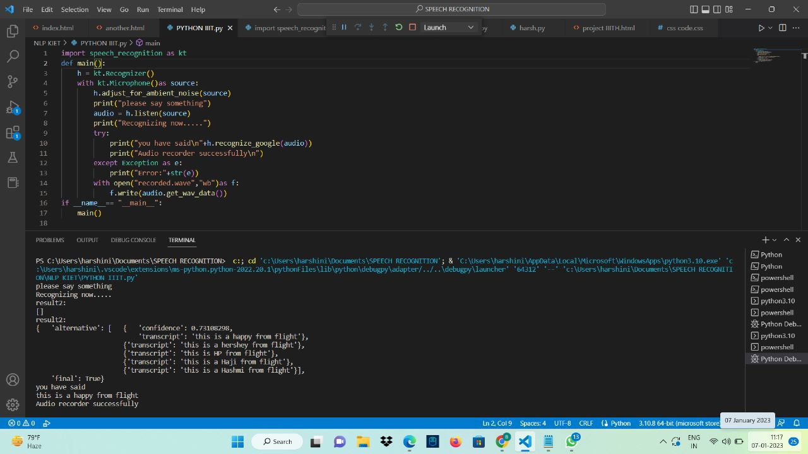
* **flask code**

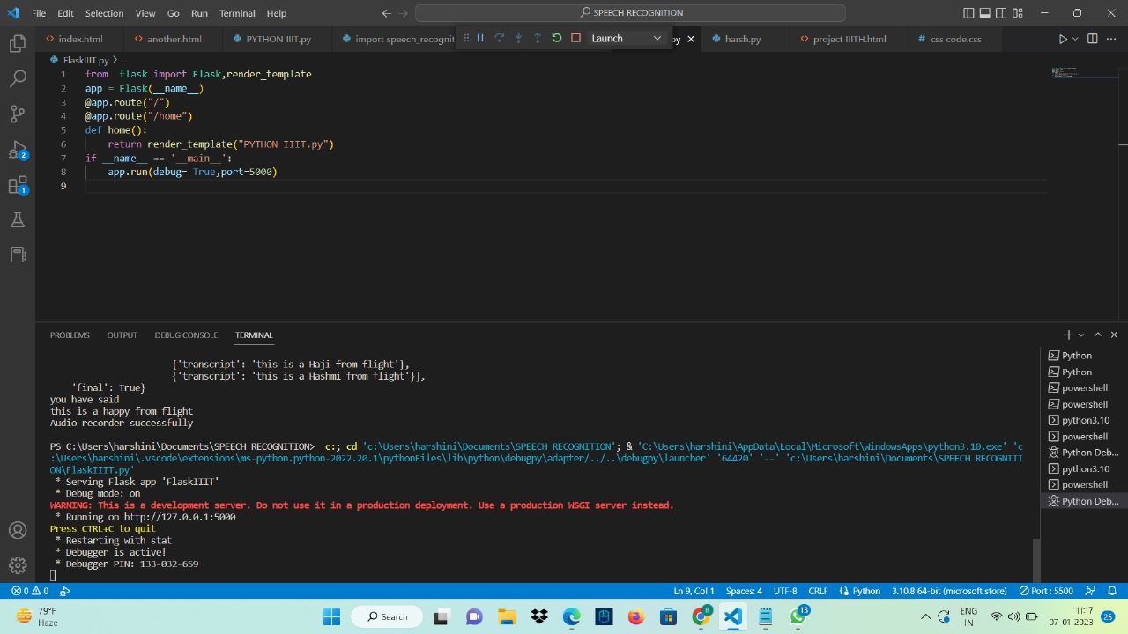

**Output:**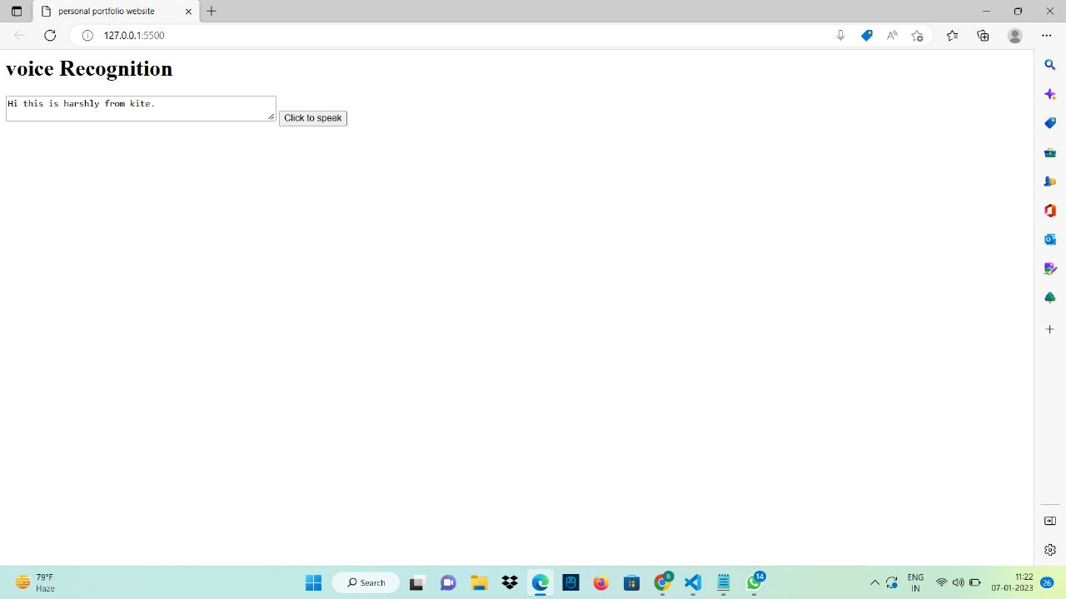

* **Speech recognition code using html:**

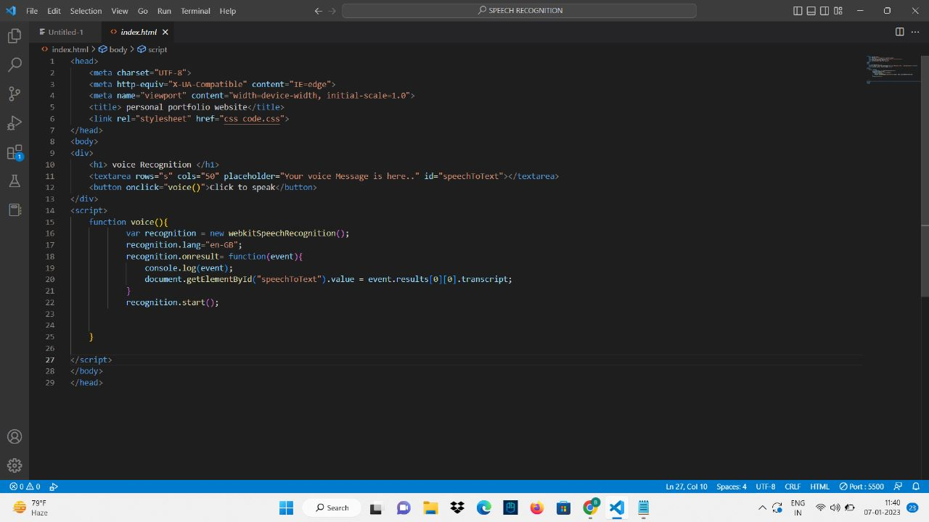

* **CSS CODE:**

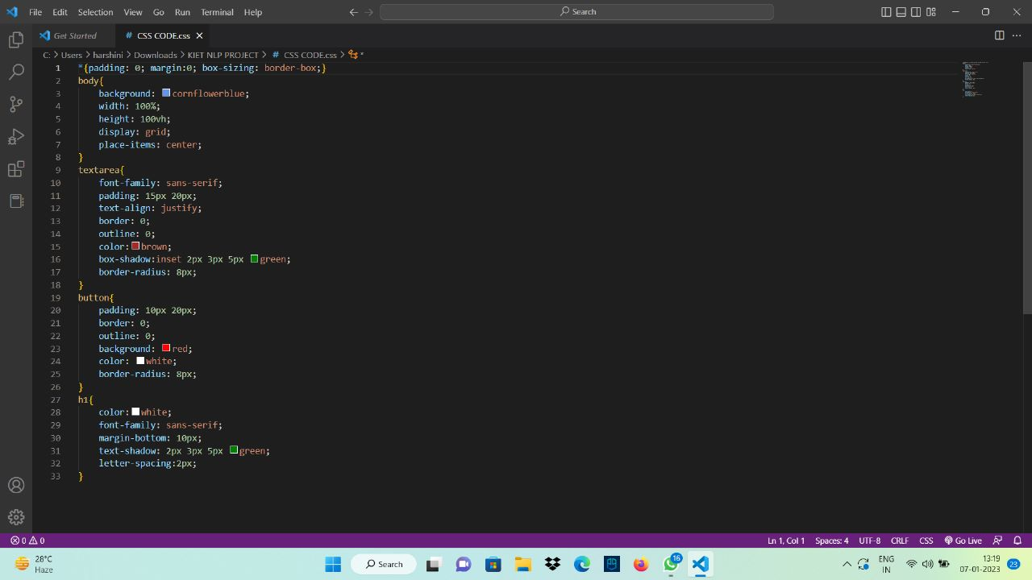**Output:**

