

# Reference: Notice ID IN448-139972 Date: {Date}

To

**{Name }**

**{Resi Address}**

**SUB:** Loan Recall Notice in respect of total amount of Rs. **{POS}**/-against the **AUTO LOAN**

loan facility no. **{Loan No }**

Dear Sir / Madam,

Under instructions of my client **Axis Bank Limited**, this legal notice is being issued as under:

1. As you are aware that you have availed AUTO LOAN loan facility from my client. As per the terms and
2. conditions of the Loan cum facility Agreement and Most Important Terms and Conditions (MITC), you are

liable to make payments of the total amount including other charges, as are applicable for the utilization of the said facility.

1. It is pertinent to mention here that you have been regularly reminded by the representatives of my client

regarding the outstanding amount, but you have however, deliberately failed/avoided to adhere to the terms of

the payment and your loan account is overdue.

1. This is a loan recall notice highlighting the defaults in payment committed by you and requiring you to pay the

total amount due to my client.

1. Please note that by not adhering to the re-payment schedule, you along with the **Co-borrower and**

**Guarantor** may be liable to have **Civil/Criminal proceedings initiated against you under the provisions**

**of relevant laws,** as applicable.

# Thus, on behalf of my client, I constrained to state as under:

That if you continue to remain in default and do not comply with this notice, my client has the liberty to share your default details with various **Credit Information Bureau including CIBIL (Credit Information Bureau India Limited)**. Please note that all the banks and Non- Banking Financial Companies provide credit facilities after verification of the credit history of the customer from CIBIL. **A default history against your name could jeopardize your Credit Rating across the Industry.**

On behalf of my client, I call upon you to pay the total amount of Rs. **{POS}**, together with applicable charges, tax and interest and other dues till actual realization within 7 days, failing which, Axis Bank shall be constrained to initiate appropriate Civil / Criminal proceedings including repossession of hypothecated vehicle as per terms of the said agreement, initiation of Arbitration proceedings as per clause envisage in the loan agreement and interim action pending under various provisions of Arbitration & Conciliation Act , 1996 (including rules and amendments made thereof till date), against you to settle the dispute, for which you shall be entirely responsible as to the cost and the consequences thereof.

# Please note that legal proceedings might be initiated for attachment of your assets/properties/income/salary and consequent sale of the property etc., as applicable

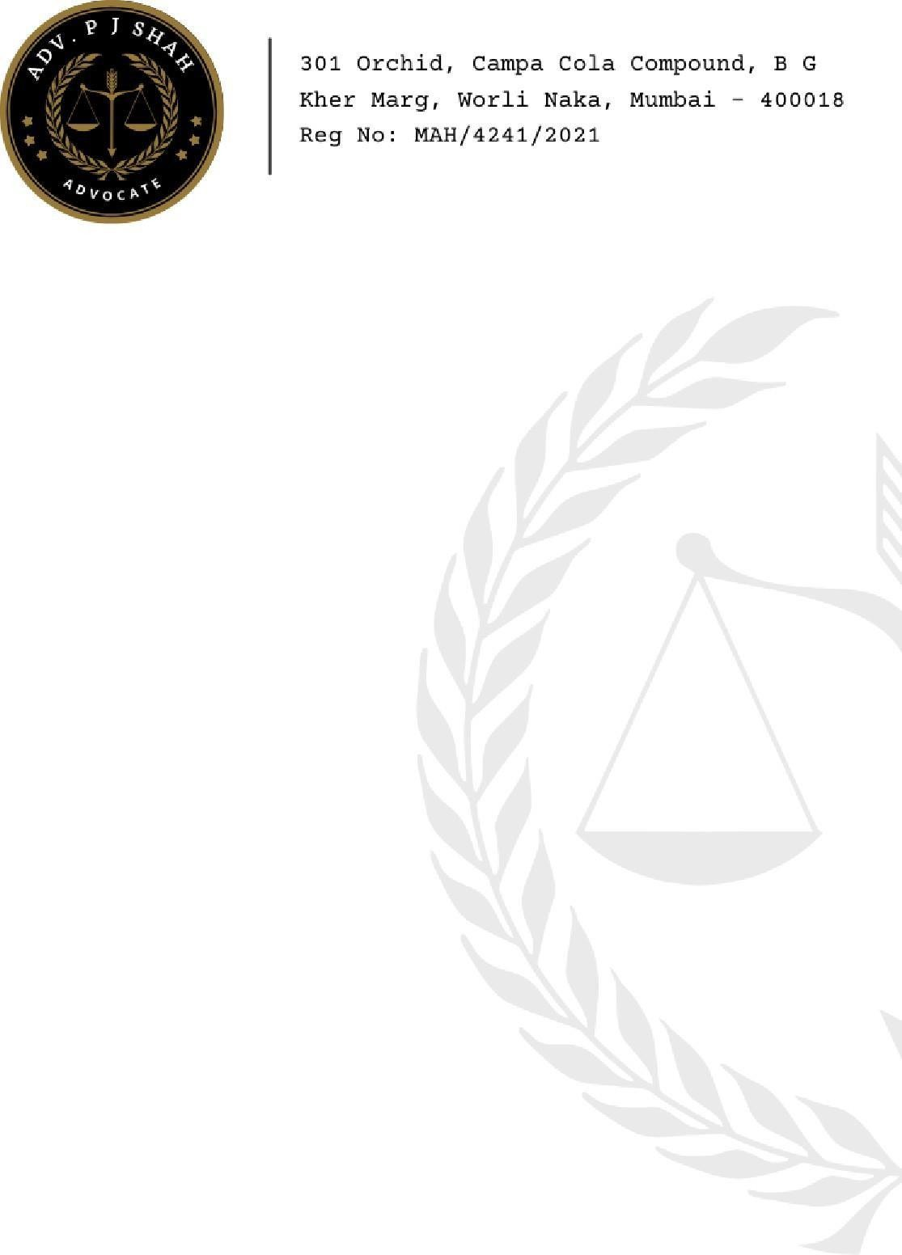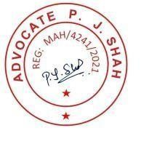

Kindly note that this letter is issued without prejudice to any of the terms and conditions as per the agreement/MITC agreed between you and my client.

For making the payment, please contact Axis Bank loan center immediately or visit the Axis Bank

Portal [www.axisbank.com.](https://www.axisbank.com/) Please treat this notice as Final Notice; you may ignore it at your own risk and cost.

Kindly note, confirmation via SMS for payment may take 48 business hours. If there is no message confirmation received against the payment, please visit [www.axisbank.com](http://www.axisbank.com/) or the nearest loan center.

For any assistance you may contact my client Collection Manager **Nithin Chauhan at 8960020121.**

# If the total payment including charges are already made by/before receipt of this notice, please ignore the same.

Yours Faithfully,

P. J. Shah

Advocate, High Court

** This is a digitally generated letter. The content of this letter is legally privileged and confidential for the use of intended recipient only.