**PBLJ_2.3**

**NAME: HARSHIT UID: 23BCS13622**

**SECTION:902-A DATE: 6-OCT-2025**

**PART A: Sorting Employee Objects Using Lambda Expressions**

**Output:**

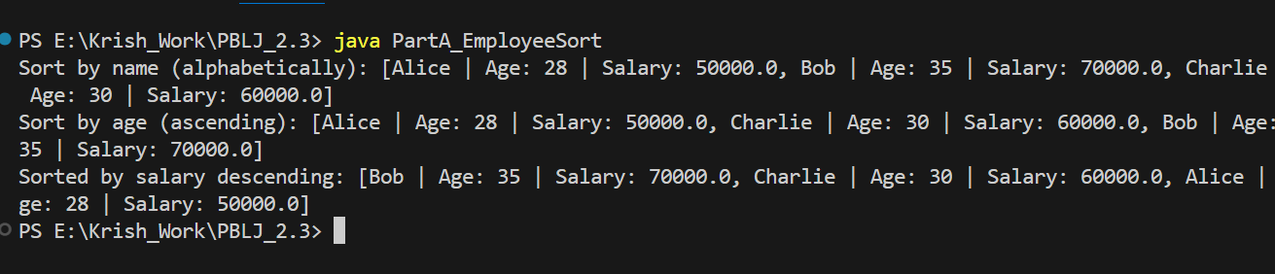

**PART B:  Filtering and Sorting Students Using Streams**

**Output:**

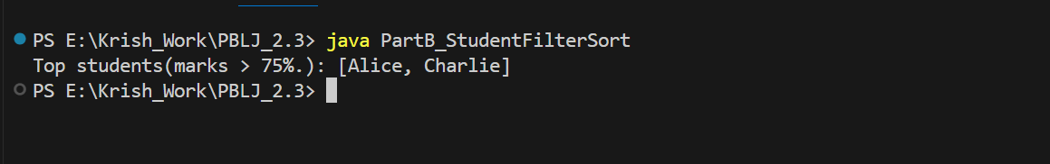

**PART C: Stream Operations on Product Dataset**

**Output:**

