**Industrial Internship Report on**

**”Quiz Game”**

**Prepared by**

**HARSHITH.H.D.**

|  |
| --- |
| *Executive Summary* |
| This report provides details of the Industrial Internship provided by upskill Campus and The IoT Academy in collaboration with Industrial Partner UniConverge Technologies Pvt Ltd (UCT).  This internship was focused on a project/problem statement provided by UCT. We had to finish the project including the report in 4 weeks’ time.  My project was Quiz Game Application made using Python Programming language.  This internship gave me a very good opportunity to get exposure to Industrial problems and design/implement solution for that. It was an overall great experience to have this internship. |

**TABLE OF CONTENTS**

1 Preface 4

2 Introduction 5

2.1 About UniConverge Technologies Pvt Ltd 5

2.2 About upskill Campus 10

## 2.3 The IoT Academy..........................................................................................................................12

2.4 Objective 12

2.5 Reference 12

2.6 Glossary 13

3 Problem Statement 14

4 Existing and Proposed solution 15

5 Proposed Design/ Model 16

5.1 High Level Diagram (if applicable) 18

5.2 Interfaces (if applicable) 19

6 Performance Test 20

6.1 Test Plan/ Test Cases 21

6.2 Test Procedure 22

6.3 Performance Outcome 22

7 My learnings 24

8 Future work scope 25

# Preface

The internship of 4 weeks was helpful because it allowed me to explore more about the Python programming language.The recorded classes were very helpful which were about numpy and pandas.I learnt many unknown details about these libraries in these videos.The notes were improving our vision about the subjects.The Quiz after every week were helpful , which was used to check ourselves about the topics which we have learnt in the session/week.

I needed this kind of internship because it helps many students and graduates to improve,analyse and enhance their skills on their respective selected domain.

I choosed the project “Quiz Game”.Quiz game is the game which tests the knowledge and improve their knowledge on the certain topic.I like to play quiz game.So, I choosed “Quiz Game”.I have used many libraries to create a User Interface and used files which stores the questions and answers of the respective questions.

**Opportunity given by USC/UCT.**

The program was planned as shown below:

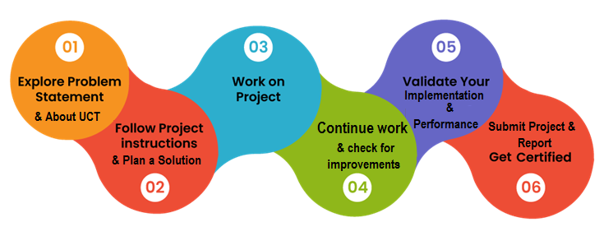

I have learnt many things in this internship and this is agood experience which I will take this in my future as a learning.

I Thank to all friends,teachers and family, who have helped me directly or indirectly.

I will say one thing to my juniors and peers that join this internship to upgrade the skill and knowledge on your favourite domains and programming language which gives you a good experience.

# Introduction

## About UniConverge Technologies Pvt Ltd

A company established in 2013 and working in Digital Transformation domain and providing Industrial solutions with prime focus on sustainability and RoI.

For developing its products and solutions it is leveraging various**Cutting Edge Technologies e.g. Internet of Things (IoT), Cyber Security, Cloud computing (AWS, Azure), Machine Learning, Communication Technologies (4G/5G/LoRaWAN), Java Full Stack, Python, Front end**etc.



1. UCT IoT Platform **(****)**

**UCT Insight** is an IOT platform designed for quick deployment of IOT applications on the same time providing valuable “insight” for your process/business. It has been built in Java for backend and ReactJS for Front end. It has support for MySQL and various NoSql Databases.

* It enables device connectivity via industry standard IoT protocols - MQTT, CoAP, HTTP, Modbus TCP, OPC UA
* It supports both cloud and on-premises deployments.

It has features to  
• Build Your own dashboard  
• Analytics and Reporting  
• Alert and Notification  
• Integration with third party application(Power BI, SAP, ERP)  
• Rule Engine

 

1. **Smart Factory Platform (****)**

Factory watch is a platform for smart factory needs.

It provides Users/ Factory

* with a scalable solution for their Production and asset monitoring
* OEE and predictive maintenance solution scaling up to digital twin for your assets.
* to unleased the true potential of the data that their machines are generating and helps to identify the KPIs and also improve them.
* A modular architecture that allows users to choose the service that they what to start and then can scale to more complex solutions as per their demands.

Its unique SaaS model helps users to save time, cost and money.

 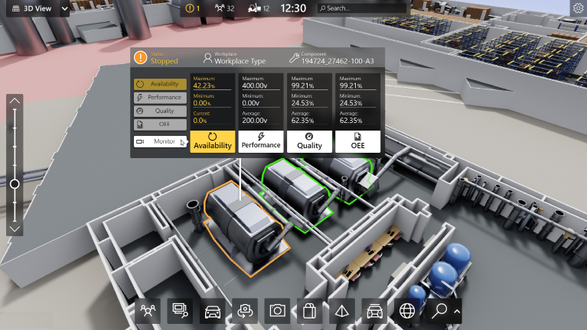

1.  based Solution

UCT is one of the early adopters of LoRAWAN teschnology and providing solution in Agritech, Smart cities, Industrial Monitoring, Smart Street Light, Smart Water/ Gas/ Electricity metering solutions etc.

1. Predictive Maintenance

UCT is providing Industrial Machine health monitoring and Predictive maintenance solution leveraging Embedded system, Industrial IoT and Machine Learning Technologies by finding Remaining useful life time of various Machines used in production process.



## About upskill Campus (USC)

upskill Campus along with The IoT Academy and in association with Uniconverge technologies has facilitated the smooth execution of the complete internship process.

USC is a career development platform that delivers **personalized executive coaching** in a more affordable, scalable and measurable way.



Seeing need of upskilling in self paced manner along-with additional support services e.g. Internship, projects, interaction with Industry experts, Career growth Services



upSkill Campus aiming to upskill 1 million learners in next 5 year

<https://www.upskillcampus.com/>

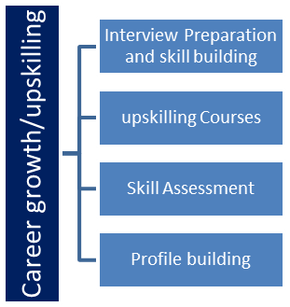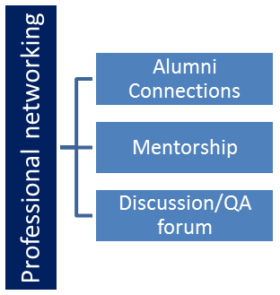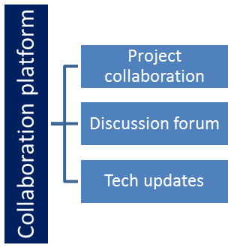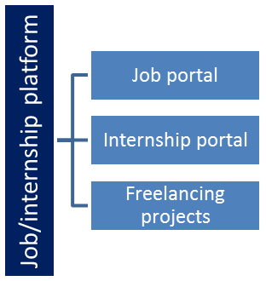

## The IoT Academy

The IoT academy is EdTech Division of UCT that is running long executive certification programs in collaboration with EICT Academy, IITK, IITR and IITG in multiple domains.

## Objectives of this Internship program

The objective for this internship program was to

 ☛ get practical experience of working in the industry.

 ☛ to solve real world problems.

 ☛ to have improved job prospects.

 ☛ to have Improved understanding of our field and its applications.

 ☛ to have Personal growth like better communication and problem solving.

## Reference

[1] https://learn.upskillcampus.com/

[2] https://geeksforgeeks.com/

[3] https://www.scribbr.com/dissertation/list-of-abbreviations/

## Glossary

|  |  |
| --- | --- |
| Terms | Acronyms |
| API | Application Programming Interface. |
| Python | It is a programming language. |
| MVC | Model-View-Controller, a design pattern for organizing code in web applications |
| tkinter | It is a python module which is used to create a  GUI program. |
| CSV | Comma Seperated Values. |
| CProfile | It is a python module which is used to check the program’s performance. |

# Problem Statement

In the assigned problem statement

The problem statement involves creating a Python project for a Quiz Game. Here's a breakdown:

Description:

* The Quiz Game is a program designed to quiz users on various topics.
* It will read questions and corresponding answers from a file or a database.
* It will present these questions to the user and collect their answers.
* The program will also keep track of the user's score throughout the quiz.

Scope:

* Designing a user interface: Create an interface that displays questions to the user and allows them to input their answers.
* Implementing a database or file system: Choose a method to store the quiz data, either in a structured file format or a database system.
* Developing a scoring algorithm: Create a system that tracks the user's progress, evaluates their answers, and calculates their final score at the end of the quiz.

Overall, the project aims to provide a functional and engaging quiz experience for users while demonstrating proficiency in Python programming, potentially utilizing libraries like NumPy and Pandas for certain functionalities.

窗体顶端

窗体底端

# Existing and Proposed solution

By existing idea,I say that the analysis based on the score of the player in this game is given by none.

In my project , I proposed a solution by calculating the score and showing the final results in visualized manner.

Iam showing the final results of the Quiz game in the form of bar graph and the score is calculated simultaneously while solving the “questions”.

## Code submission (Github link):

## Report submission (Github link) : first make placeholder, copy the link.

# Proposed Design/ Model

The proposed MVC architectural pattern for the quiz application separates data (Model), user interface (View), and application logic (Controller) for better organization and scalability.

Components:

* ****Model****: Manages quiz data and logic (e.g., reading questions, processing responses).
* ****View****: Creates GUI components using tkinter to display questions, options, and scores.
* ****Controller****: Handles user input events, updates Model and View, and acts as a bridge between them.

****Start Stage:****

1. ****Model Initialization****:

* QuizModel reads questions and answers from files.
* Data structures are set up to store quiz data.

1. ****View Initialization****:

* QuizView creates GUI components using tkinter.
* Basic layout and structure of the quiz interface are established.

1. ****Controller Initialization****:

* QuizController sets up event handlers for user interactions.
* Initial connections between Model and View are established.

****Intermediate Stage:****

1. ****User Interaction****:

* Users interact with the GUI by selecting answers and navigating through questions.
* Controller captures user input events and updates the Model accordingly.

1. ****Data Update****:

* Model processes user responses to calculate scores and track correct/incorrect answers.
* Data structures are updated based on user interactions.

1. ****View Update****:

* View dynamically displays updated information such as scores, progress, and question changes.
* GUI components are refreshed to reflect changes in the Model.

****Final Stage:****

1. ****Refinement****:

* Fine-tuning of the Model's logic for accurate score calculation and answer tracking.
* Enhancements to the View for improved user experience and visual appeal.

1. ****Testing****:

* Comprehensive testing of all components for functionality and interaction.
* Debugging and error handling to ensure smooth operation.

1. ****Optimization****:

* Performance optimization for efficient data processing and GUI rendering.
* Code review and refactoring for better maintainability and scalability.

1. ****Deployment****:

* Final deployment of the quiz application for users to access.
* Monitoring and feedback collection for further improvements.

Throughout these stages, collaboration and communication between the Model, View, and Controller are essential to ensure a cohesive and functional quiz application. Regular testing, feedback integration, and iterative development will lead to a successful implementation of the MVC pattern in your project.

## 5.1 High Level Diagram :

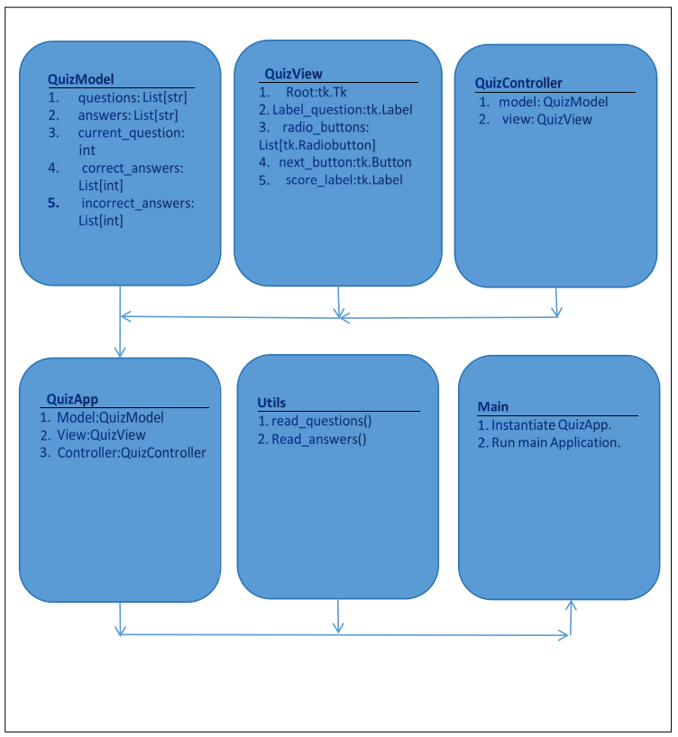

Figure 1: HIGH LEVEL DIAGRAM OF THE SYSTEM

**5.2** Interfaces :

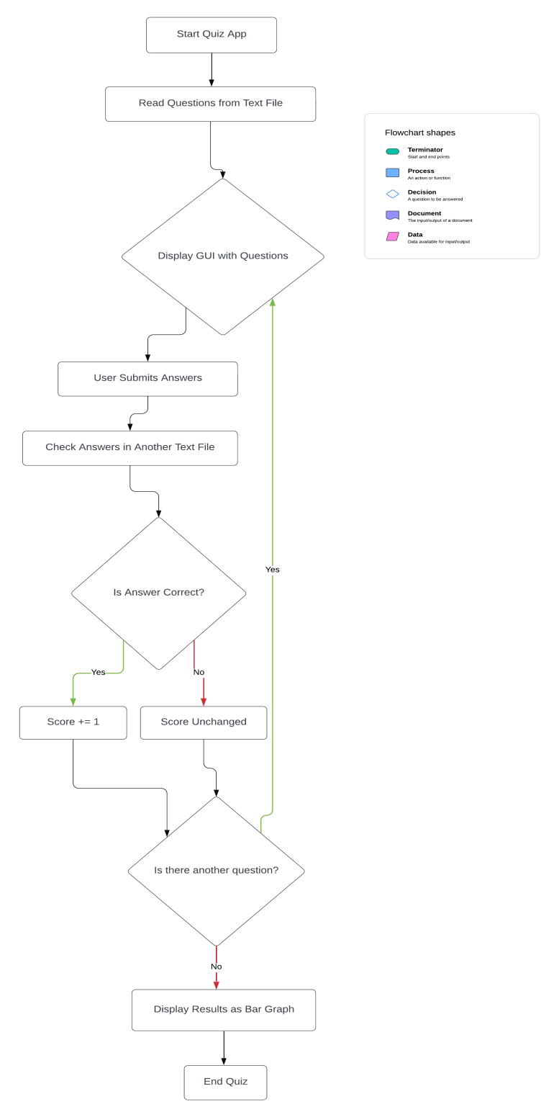

This flowchart explains about the working of the program of my Quiz App.

# 6 Performance Test

**File Reading Performance:**

* The program reads questions and answers from files (example.txt and answers.txt).
* File reading performance depends on the size of the files and the efficiency of the file reading implementation.
* To improve file reading performance, consider optimizing file reading operations (e.g., using buffered reading, reading chunks of data instead of line by line if applicable).

**GUI Responsiveness:**

* The GUI responsiveness depends on the efficiency of the GUI toolkit (tkinter) and the complexity of the GUI elements being displayed.
* In this program, tkinter is used to create the GUI elements.
* GUI responsiveness could be impacted by heavy computations or long-running operations in the main thread.
* Ensure that GUI updates are performed efficiently and that long-running operations are executed asynchronously or in background threads to prevent freezing or lagging.

**Overall Execution Time:**

* The overall execution time of the program includes file reading, GUI initialization, user interaction, and any computations performed.
* Profiling with cProfile provides insights into which parts of the code consume the most time and resources.
* Optimization opportunities may include improving algorithm efficiency, minimizing unnecessary computations, and optimizing resource-intensive operations.

**Profiling Results:**

* Profiling results obtained with cProfile can help identify performance bottlenecks and areas for optimization.
* Analyze the profiling results to identify functions or operations that contribute significantly to the overall execution time.
* Focus on optimizing these critical areas to improve the overall performance of the program.

**Optimization Strategies:**

* Depending on the profiling results, optimization strategies may include algorithmic optimizations, caching, parallelization, or optimizing GUI updates.
* Prioritize optimizations based on the impact they have on the overall performance and user experience.

## 6.1 Test Plan/ Test Cases:

****Basic Functionality Test:****

* Ensure that the program loads questions and answers correctly, displays them in the GUI, allows users to select answers, and calculates the score accurately.

****Robustness Test:****

* Validate how the program handles invalid user inputs or unexpected behavior during execution, ensuring it displays appropriate error messages and continues functioning without crashing.

****Performance Test:****

* Evaluate how the program handles large sets of questions and answers, checking for efficient processing without significant performance degradation or freezing of the GUI.

****Compatibility Test:****

* Test the program on different platforms (Windows, macOS, Linux) to ensure it runs correctly and displays consistent behavior across various operating systems.

****GUI Appearance Test:****

* Verify the appearance of GUI elements (labels, buttons, radio buttons) to ensure they are properly aligned, readable, and visually appealing, enhancing the user experience.

## 6.2 Test Procedure:

* ****Basic Functionality Test****: This test ensures that the core functionality of the program, such as displaying questions, selecting answers, and calculating scores, works as expected. It is crucial to validate these fundamental features to ensure the program functions correctly.
* ****Performance Test****: Evaluating the program's performance with a large dataset is essential to assess its efficiency in handling substantial amounts of data. This test helps identify any performance issues, such as slow response times or freezing, that may impact the user experience.
* ****Robustness Test****: Testing the program with invalid inputs or unexpected behavior is vital to ensure that it can handle unforeseen scenarios gracefully. Robust error handling and appropriate error messages are essential for enhancing the program's reliability and user experience.
* ****Compatibility Test****: Verifying the program's behavior across different platforms helps ensure that it functions consistently regardless of the operating system. This test is critical for confirming that the program is platform-independent and provides a seamless user experience on various systems.
* ****GUI Appearance Test****: Assessing the visual design and layout of GUI elements is important for user engagement and usability. Well-designed and visually appealing GUI elements contribute to a positive user experience and can enhance the program's overall usability and attractiveness.

These points highlight key aspects of the test plan that focus on functionality, performance, reliability, compatibility, and user interface design, all of which are crucial for the success of the program.

## 6.3 Performance Outcome:

* **File Reading Performance:** The program should read questions and answers from files efficiently, without significant delays.
* **GUI Responsiveness:** The GUI should respond smoothly to user interactions, without freezing or lagging.
* **Overall Execution Time:** The program's execution time should be reasonable, even with large datasets.
* **Profiling Results:** Profiling results should indicate efficient use of resources and identify any performance bottlenecks.
* **Optimization Strategies:** Based on profiling results, optimization strategies may be applied to improve performance in critical areas.

# 7 My learnings

I started this internship program during by college exam holidays.I began this internship during the phase where in known only the surface or basic level of python.This internship made me to learn many things about the python programming language.

The internship started with basics of python like conditional and branching statements.This was very helpful and the recorded class were very informative.The notes which was attached in the programme gave me many unknown details about the “Python” programming language.The quiz which was conducted after every week was very helpful to know how we understood the topics which was covered in that week.I learnt the data science libraries like numpy and pandas which is very useful to represent data and analyse data in the real time world.

So,this internship was very good experience for me.I will continue to do many internship by using this internship’s experience.

# 

# 8 Future work scope

* I want to improve the GUI experience of the users by using advanced libraries.
* I want to make the code more compact.
* I want to integrate DBMS in this application in the future which will increase the spped of the program.
* The program should include user authentication and should store the user’s detail.
* The game’s level should be set.So, the game would bw intresting.
* I will store the end result of every user and the highest score will be displayed in the result.