Name:Harshitha_Saripilli

UCID:Hs759

Final Project

Output 1:

Output2

Post a job:

Output 4

Job Description:

Output 7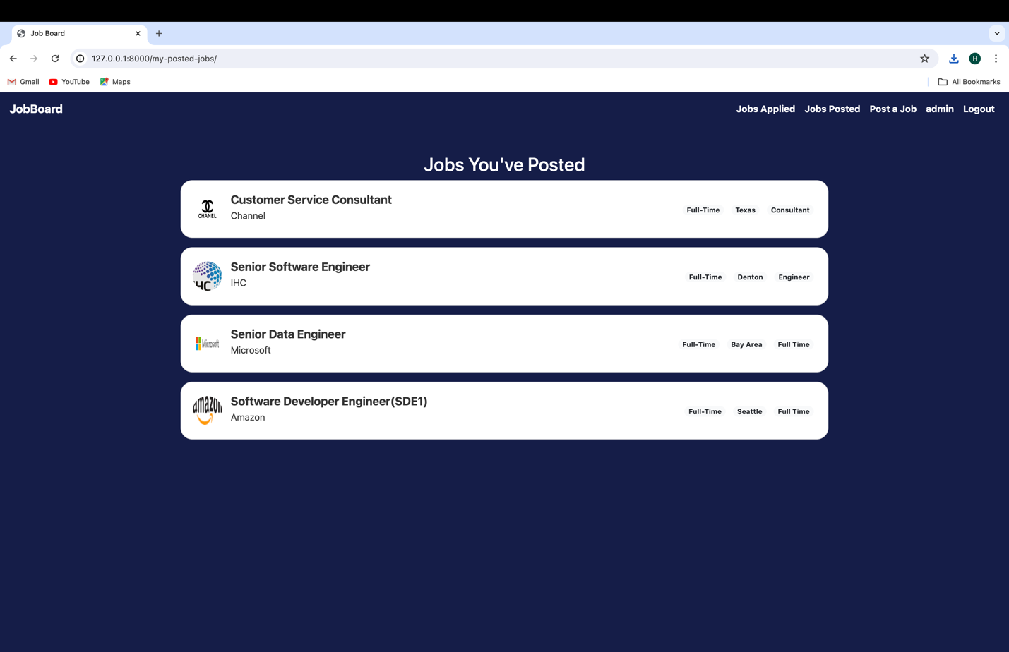

Output 9

