

A project report on
“AUTO PARTS ECOMMERCE SELLING WEBSITE”

Submitted in partial fulfilment of
VI SEMESTER BCA

As Prescribed by
INDIAN ACADEMY DEGREE COLLEGE-AUTONOMOUS

Developed by

Sree Harish. P K [22IABCA071]
Varun K S [22IABCA080]
Venkat Bhanu Prasad [22IABCA083]

Under the guidance of
Mrs. PARVATHY. J

A project report on
“AUTO PARTS ECOMMERCE SELLING WEBSITE”

Submitted in partial fulfilment of
VI SEMESTER BCA

As Prescribed by
INDIAN ACADEMY DEGREE COLLEGE-AUTONOMOUS

Developed by
Sree Harish. P K [22IABCA071]
Varun K S [22IABCA080]
Venkat Bhanu Prasad [22IABCA083]

Under the guidance of
Mrs. PARVATHY. J

CERTIFICATE

This is to certify that the project entitled “AUTO PARTS ECOMMERCE SELLING WEBSITE” is a Bonafide work done by SREE HARISH. P K [22IABCA071], VARUN K S [22IABCA071], VENKAT BHANU PRASAD [22IABCA083] submitted in partial fulfilment of VI semester BCA A Section during the academic year 2024-25.

INTERNAL GUIDE HEAD OF THE DEPARTMENT
Mrs. PARVATHY J Mrs. ANURADHA P

EXAMINER

1.

2.

ACKNOWLEDGEMENT

We would like to express my sincere gratitude to our respected principal DR. BHARATHI.S, who gave opportunity to do the project and complete it successfully. We are very much thankful to mam.

We would like to express my special thanks to our HOD (computer science) Mrs. ANURADHA P, for providing constant support and cooperation during the project development.

We take this opportunity to express my thanks to our project guide Mrs. PARVATHY. J, for the valuable help and guidance to develop this project. We would also like to thank my parents and friends who helped me a lot.

Sree Harish. P K [22IABCA071]
Varun K S [22IABCA080]
Venkat Bhanu Prasa [22IABCA083]

DECLARATION

We hereby declare that this project work entitled to “AUTO PARTS ECOMMERCE SELLING WEBSITE” is submitted to Department of Computer Science, Indian Academy Degree College-Autonomous, Bangalore for partial fulfilment of the requirement for the award of Bachelor of Computer Applications is a result of original work carried out by us.

We further declare that we have not submitted this project either in part or full to any other college/university for the award of any degree.

DATE:

Sree Harish. P K [22IABCA071]
Varun K S [22IABCA080]
Venkat Bhanu Prasad [22IABCA083]

TABLE OF CONTENTS
SL.NO | CONTENTS | PAGE NO.
01 | Introduction  1.1 Scope of the Project  1.2 Objective of the Project | 01
02 | System Analysis  2.1 Existing System  2.2 Proposed System  2.3 Hardware Requirements  2.4 Software Requirements | 02-03
03 | System Design  3.1 Use case diagram for User & Admin  3.2 ER-Diagram  3.3 DFD  3.4 Admin  3.5 User  3.6 Table structure | 04-14
04 | Coding | 15-81
05 | Screenshots | 82-91
06 | Testing | 92-93
07 | Limitations | 94
08 | Conclusion | 95
09 | Bibliography | 96

ABSTRACT

This project focuses on the development of an online auto parts selling website designed to simplify the buying process for customers and streamline inventory and order management for administrators. The platform allows users to browse a comprehensive catalog of auto parts, view detailed product descriptions, compare prices, and place orders securely. Simultaneously, administrators can manage products, monitor orders, and oversee user accounts efficiently through a dedicated backend interface.
The system includes core e-commerce functionalities such as user registration and login, product search and filtering, shopping cart, order placement, and order tracking. Customers benefit from a user-friendly interface where they can easily navigate through product categories, add desired items to their cart, and complete transactions. Admin users can add, update, or delete products, manage inventory levels, view sales reports, and respond to customer inquiries, ensuring smooth website operation and customer satisfaction.
The technology stack employed for this project includes PHP for front-end development and MySQL for managing the relational database. PHP is used to create interactive web pages and process user requests, while MySQL efficiently stores and retrieves data such as user information, product listings, orders, and transaction records. This combination ensures dynamic content delivery and secure data management.
Overall, this online auto parts selling website enhances user convenience, supports business growth, and provides a scalable digital platform for auto part retailers to expand their reach in the competitive automotive market. It serves as a practical and modern solution for managing e-commerce operations in the automotive sector.

01. INTRODUCTION

The online auto parts selling website is a web-based platform developed to facilitate the purchase and management of automotive components for consumers and business administrators. By offering an accessible, user-friendly interface, it allows customers to browse, search, and purchase auto parts from any location. For administrators, it provides tools to manage inventory, update product listings, and monitor transactions efficiently. This system aims to replace traditional methods with a more streamlined and scalable digital solution.

1.1 Scope of the Project:
The project covers the creation of a fully functional e-commerce website focused on automotive spare parts. It includes features for user account creation, product browsing, real-time inventory display, secure checkout, and order tracking. For administrators, the system allows inventory control, user management, and report generation. The platform is designed to handle multiple users simultaneously and can be extended to include mobile compatibility and additional third-party integrations in the future.

1.2 Objective:
The primary objective of this project is to design and implement a convenient, secure, and efficient online marketplace for auto parts. It aims to improve customer accessibility and satisfaction by simplifying the search and purchase process. Additionally, the project focuses on optimizing backend operations for administrators, allowing them to manage orders and inventory seamlessly. The goal is to digitize the sales process and enhance business growth through a scalable web platform.

02.SYSTEM ANALYSIS

2.1 Existing System
Currently, most auto parts are sold through physical retail shops or basic classified websites. Customers must visit stores or rely on calls and limited information. Stock availability, price comparison, and product details are often inaccessible, this existing system is not providing secure registration and profile management of all users properly. This system doesn't have live tracking of packages, and no payment gateways is added to the users to pay online, the user can pay in hand to the delivery person. The system is giving manual information through the admin’s data.

2.1.1 Drawbacks of Existing System:
The drawbacks are:
- No security
- Requires Payment
- No live tracking
- Manual processes lead to human error
- Difficult to compare prices or check part compatibility.

2.2 Proposed System
The proposed system is a web-based platform designed to streamline the sale and purchase of auto parts. It allows users to browse a wide range of automotive components, view detailed product descriptions, check real-time availability. Customers can search for parts by category, brand, model, or vehicle compatibility, making the process efficient and user-friendly. The system also features a responsive design, ensuring seamless access across desktops, tablets. For administrators, the backend provides tools to manage product listings, inventory levels, customer orders, and sales reports. Automated notifications and order tracking enhance customer engagement. The system reduces the need for manual intervention, minimizes errors, and speeds up the entire sales process. Overall, it offers a modern, scalable, and reliable solution for auto parts distribution, improving customer satisfaction and enabling businesses to expand their market reach.

2.2.1 Advantages of proposed system:
- User friendly
- Security
- Simple and well-structured
- Easily accessible by anyone
- Accurate information
- Free to Use

2.3 Hardware requirements:
- Processor: Intel Core i5/i7
- Processor Speed: 2.0. GHz
- RAM: 1 GB
- Hard Disk: 40GB to 80GB

2.4 Software requirements:
- Database: MySQL
- Server: Apache Frontend: HTML
- Scripting language: Java Script
- IDE: Visual Studio Code
- Technology: PHP

03.System Design

- Admin Panel

Responsibilities:
- Manage product listings (add, edit, delete)
- Monitor and process customer orders
- Manage users and access permissions
- Update inventory levels

Key Features:
- Login/Authentication
- Dashboard with order and sales overview
- Product management interface
- Inventory and stock tracking

02. User Panel (Customer)

Responsibilities:
- Browse and search for auto parts
- View product details and specifications
- Add products to cart and place orders
- Register and manage personal profile
- Track order status and history

Key Features:
- User registration/login
- Product search with filters (category, make, model, price, etc.)
- Shopping cart and checkout
- Payment integration
- Order history and tracking

03. Database Table Structure

Table Name | Description
Users | Stores customer information
Admins | Stores admin login data
Products | Contains details of all auto parts
Categories | Organizes products into categories (e.g., Engine, Brakes)
Orders | Records customer order
Order Items | Stores individual items in each order
Inventory | Manages stock levels of each product

3.4 UML Diagrams:
A UML diagram is a way to visualize systems and software using Unified Modelling Language (UML). UML diagrams serve as blueprints for software systems, showing how they behave and how components interact. Common types of UML diagrams include class diagrams, which describe the structure of a system, and activity diagrams, which model workflows and processes.
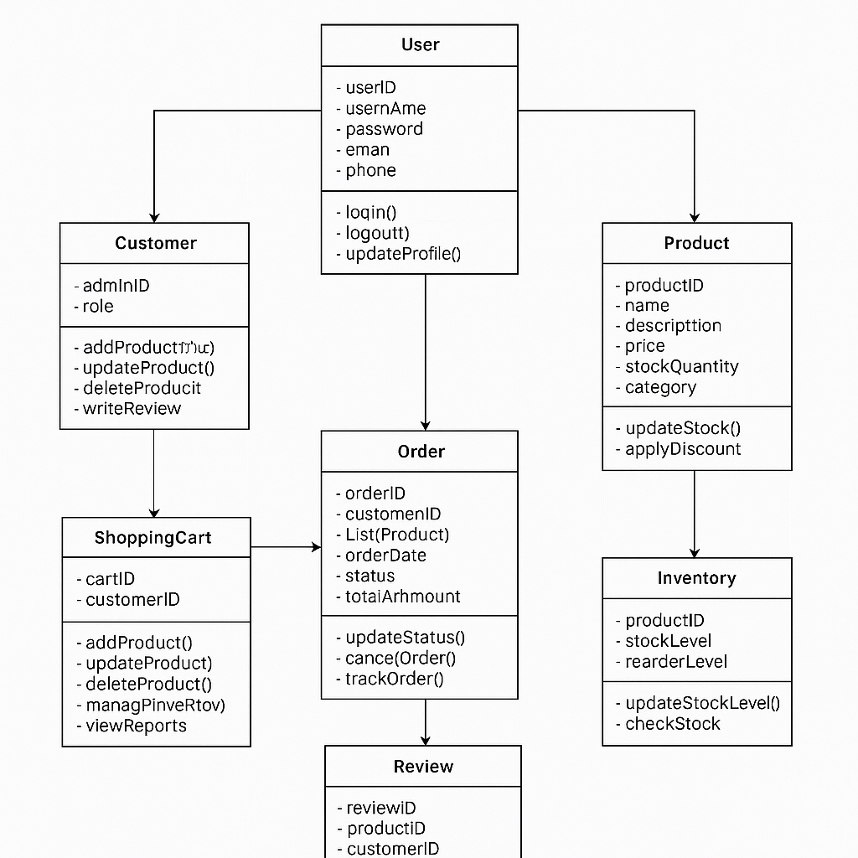

3.4.1 Use case diagrams:
A Use Case Diagram is a type of Unified Modelling Language (UML) diagram that visually represents the interactions between actors (users or external systems) and a system to achieve specific goals. It provides a high-level view of the system's functionality by illustrating the various ways users can interact with it

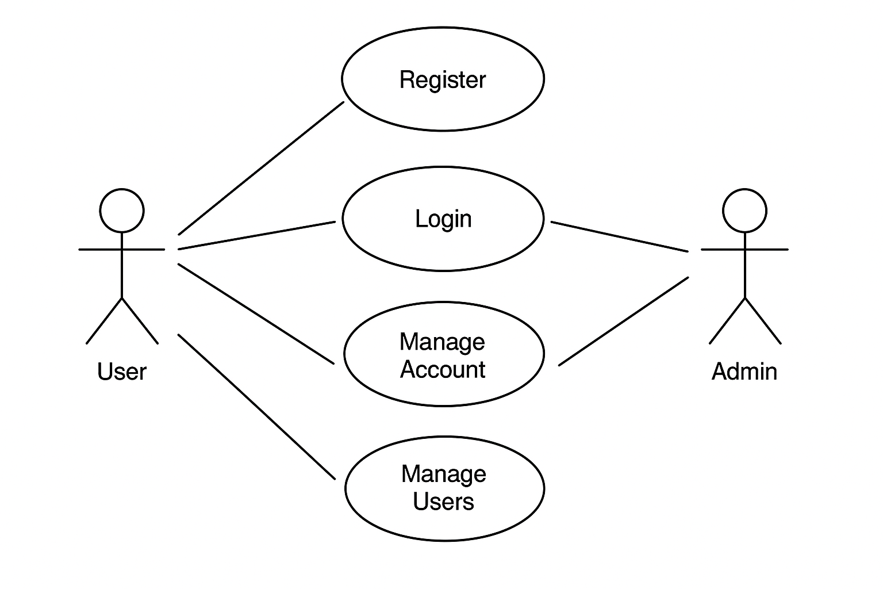

3.5 ER-DIAGRAM:
An Entity-Relationship (ER) Diagram is a visual representation of the structure of a database. It illustrates how different entities (objects or concepts) are connected and interact with each other through relationships.
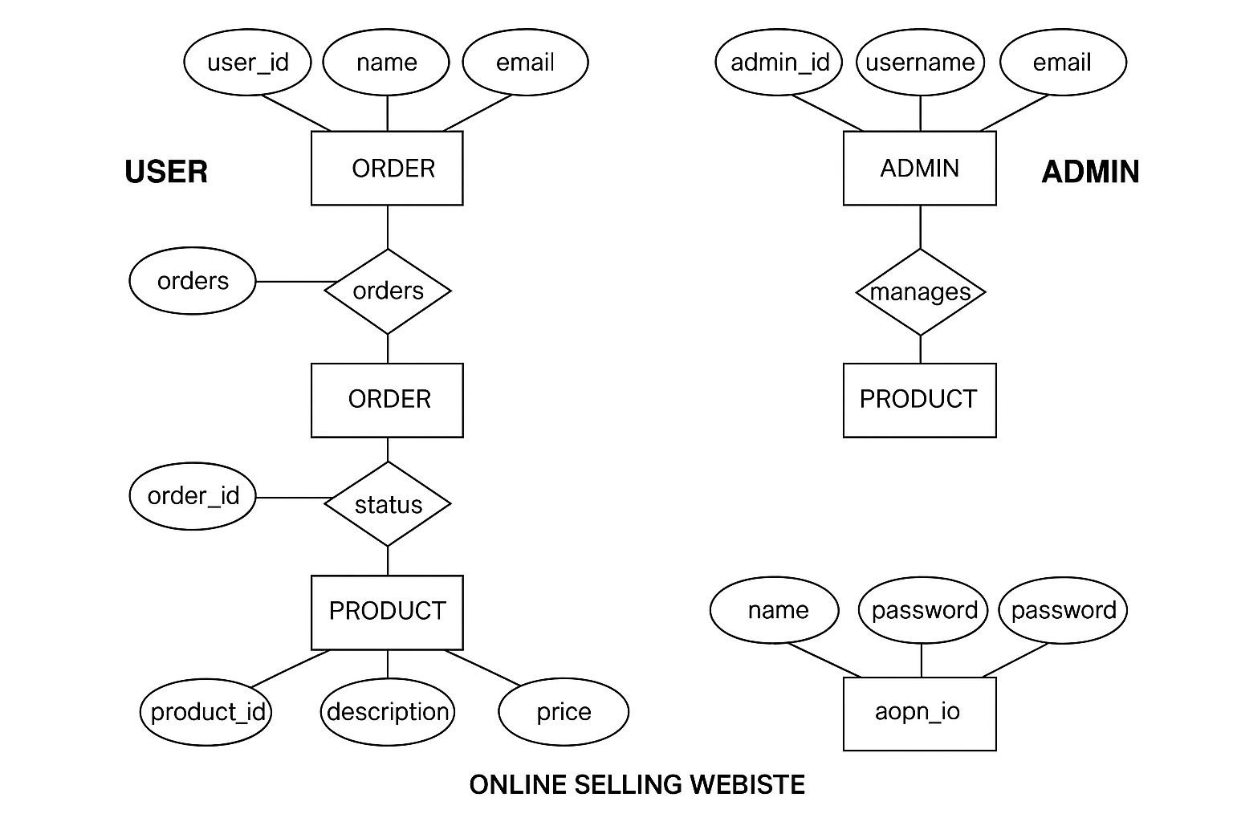

3.6 DFD (DATA FLOW DIAGRAM):
DFD is the abbreviation for Data Flow Diagram. The flow of data of a system or a process is represented by DFD. It also gives insight into the inputs and outputs of each entity and the process itself. DFD does not have control flow, and no loops or decision rules are present. Specific operations depending on the type of data can be explained by a flowchart. It is a graphical tool, useful for communicating with users, managers and other personnel. it is useful for analysing existing as well as proposed system.

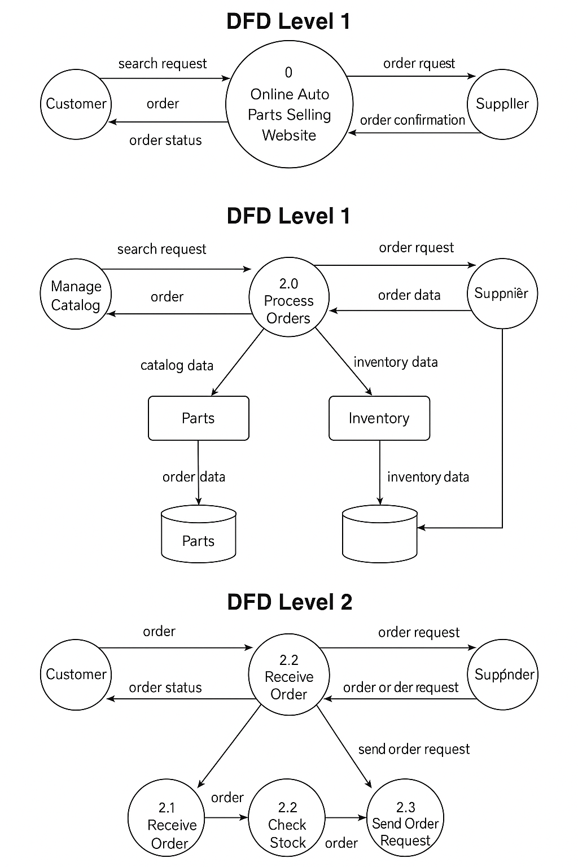

Auto Parts Ecommerce Selling Website (APESW) contains 14 MYSQL tables:

Tab 3.3.1: tblbrand_list: This table stores the brands signed with our website for selling their product.

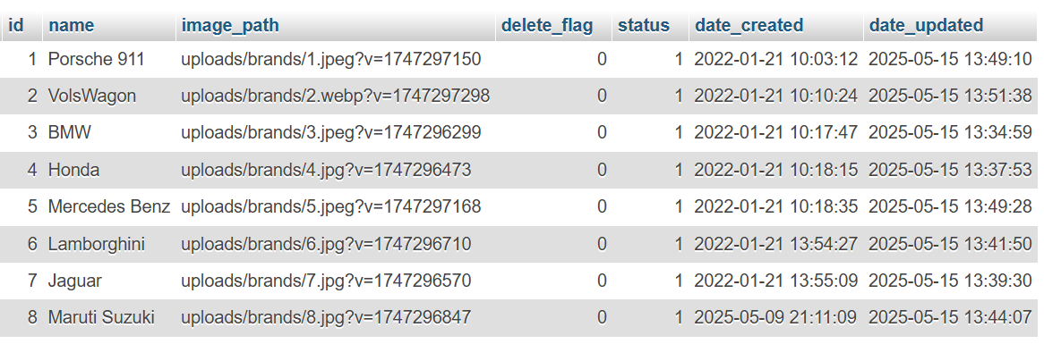
Tab 3.3.2: tblcart_list: This table stores the carts information once product is selected.

Tab 3.3.3: tblcategories : this tables stores the type of product available on the website.

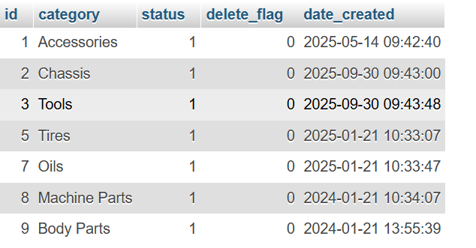

Tab 3.3.4: tblclient_list : This table stores the information of the client.

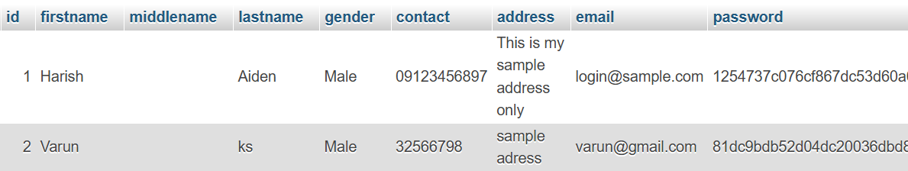
Tab 3.3.5: tblmechanic_list : This table stores the information of the mechanic joined with us.

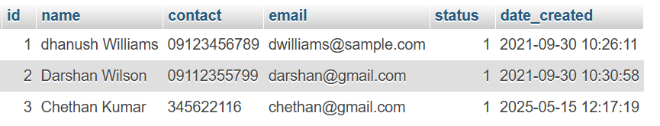
Tab 3.3.6: tblorder_items : This table stores the order information.

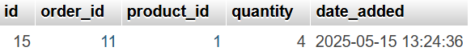

Tab 3.3.7: tblorder_list : this table stores the order list to be purchased and the details of what is been purchased.

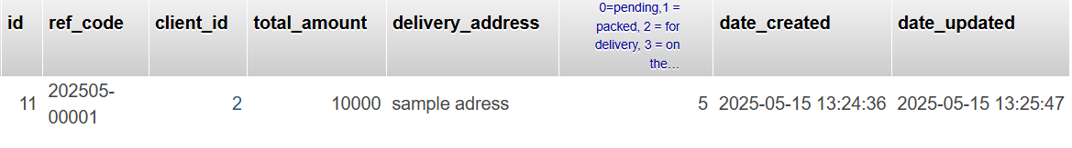

Tab 3.3.8: tblproduct_list : This table stores the information of the products available on the website.

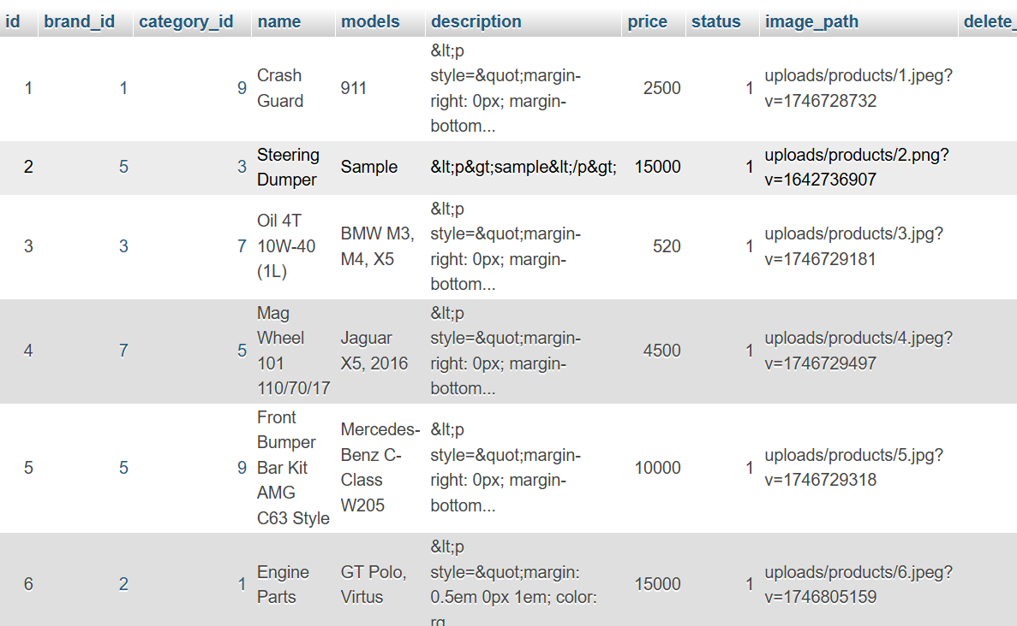
Tab 3.3.9: tblrequest_meta : This table stores the request from the user.

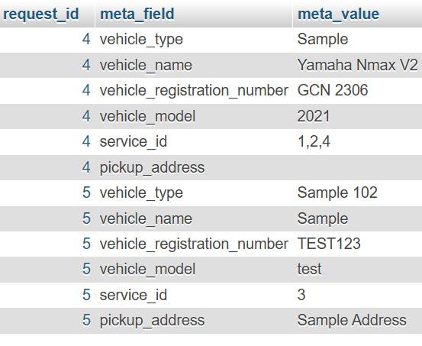

Tab 3.3.10: tblservice_list : This table stores the services available on the website.

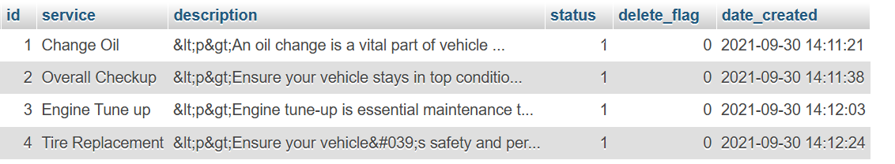
Tab 3.3.11: tblservice_request : This table displays service type and the mechanic assigned to the service.

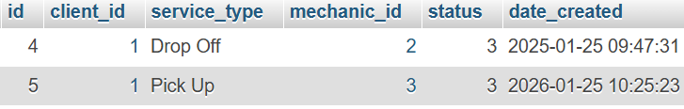
Tab 3.3.12: tblstock_list : This table stores the quantity of the products.

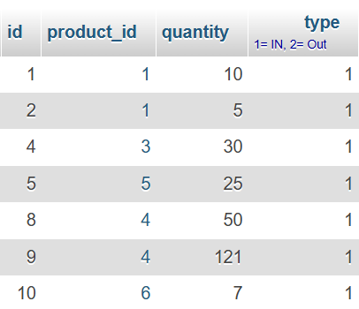

Tab 3.3.13: tblsystem_info : This table stores the information of the whole website like name of the website, background image used, etc...,

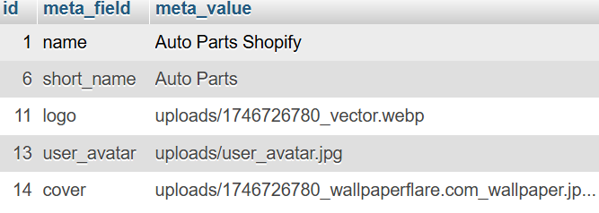
Tab 3.3.14: tbluser_info: This table stores the information of admin/user details.

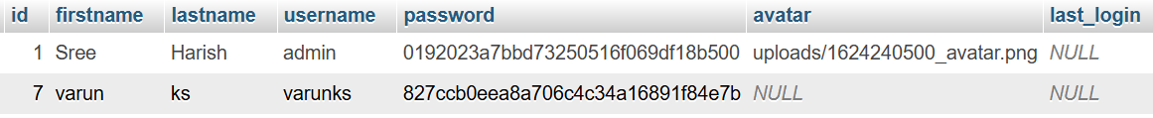

04. CODING

INDEX.PHP
<!DOCTYPE html>
<html lang="en" class="" style="height: auto;">
<?php require_once('inc/header.php') ?>
<body class="sidebar-mini layout-fixed control-sidebar-slide-open layout-navbar-fixed sidebar-mini-md sidebar-mini-xs" data-new-gr-c-s-check-loaded="14.991.0" data-gr-ext-installed="" style="height: auto;">
<div class="wrapper">
<?php require_once('inc/topBarNav.php') ?>
<?php require_once('inc/navigation.php') ?>

<?php $page = isset($_GET['page']) ? $_GET['page'] : 'home'; ?>
<?php if($_settings->chk_flashdata('success')): ?>
<script>
alert_toast("<?php echo $_settings->flashdata('success') ?>",'success')
</script>
<?php endif;?>
<!-- Content Wrapper. Contains page content -->
<div class="content-wrapper pt-3" style="min-height: 567.854px;">

<!-- Main content -->
<section class="content">
<div class="container-fluid">
<?php
if(!file_exists($page.".php") && !is_dir($page)){
include '404.html';
}else{
if(is_dir($page))

include $page.'/index.php';
else
include $page.'.php';

}
?>
</div>
</section>
<!-- /.content -->
<div class="modal fade" id="confirm_modal" role='dialog'>
<div class="modal-dialog modal-md modal-dialog-centered" role="document">
<div class="modal-content">
<div class="modal-header">
<h5 class="modal-title">Confirmation</h5>
</div>
<div class="modal-body">
<div id="delete_content"></div>
</div>
<div class="modal-footer">
<button type="button" class="btn btn-primary" id='confirm' onclick="">Continue</button>
<button type="button" class="btn btn-secondary" data-dismiss="modal">Close</button>
</div>
</div>
</div>
</div>
<div class="modal fade" id="uni_modal" role='dialog'> <div class="modal-dialog modal-md modal-dialog-centered" role="document"> <div class="modal-content">

<div class="modal-header">
<h5 class="modal-title"></h5>
</div>
<div class="modal-body">
</div>
<div class="modal-footer">
<button type="button" class="btn btn-primary" id='submit' onclick="$('#uni_modal form').submit()">Save</button>
<button type="button" class="btn btn-secondary" data-dismiss="modal">Cancel</button>
</div>
</div>
</div>
</div>
<div class="modal fade" id="uni_modal_right" role='dialog'>
<div class="modal-dialog modal-full-height modal-md" role="document">
<div class="modal-content">
<div class="modal-header">
<h5 class="modal-title"></h5>
<button type="button" class="close" data-dismiss="modal" aria-label="Close">
<span class="fa fa-arrow-right"></span>
</button>
</div>
<div class="modal-body">
</div>
</div>
</div>
</div> <div class="modal fade" id="viewer_modal" role='dialog'>
<div class="modal-dialog modal-md" role="document">
<div class="modal-content">
<button type="button" class="btn-close" data-dismiss="modal"><span class="fa fa-times"></span></button>
<img src="" alt="">
</div>
</div>
</div>
</div>
<!-- /.content-wrapper -->
<?php require_once('inc/footer.php') ?>
</body>
</html>

ABOUT.PHP
<!-- Header-->
<header class="bg-dark py-5" id="main-header">
<div class="container h-100 d-flex align-items-end justify-content-center w-100">
<div class="text-center text-white w-100">
<h1 class="display-4 fw-bolder mx-5">About Us</h1>
</div>
</div>
</header>
<section class="py-5">
<div class="container">
<div class="card rounded-0">
<div class="card-body">
<?php include "about.html" ?>
</div>
</div>
</div>
</section>

<script>
$(document).scroll(function() {
$('#topNavBar').removeClass('bg-transparent navbar-dark bg-primary')
if($(window).scrollTop() === 0) {
$('#topNavBar').addClass('navbar-dark bg-transparent')
}else{
$('#topNavBar').addClass('navbar-dark bg-primary')
}
});
$(function(){
$(document).trigger('scroll')
})
</script>

BRANDS.PHP
<div class="content py-5 mt-3">
<div class="container px-4 px-lg-5 mt-5">
<div class="row">
<div class="col-md-12">
<h3 class="text-center">Brands in Our Shop</h3>
<hr class="bg-primary opacity-100">
<div class="form-group">
<div class="input-group mb-3">
<input type="search" id="search" class="form-control" placeholder="Search brand Here" aria-label="Search brand Here" aria-describedby="basic-addon2">
<div class="input-group-append">
<span class="input-group-text bg-primary" id="basic-addon2"><i class="fa fa-search"></i></span>
</div>
</div>
</div>
<div class="row gx-4 gx-lg-5 row-cols-1 row-cols-sm-1 row-cols-md-2 row-cols-xl-3 justify-content-center" id="brand_list">
<?php
$brands = $conn->query("SELECT * FROM `brand_list` where status = 1 and delete_flag = 0 order by `name`");
while($row= $brands->fetch_assoc()):
?>
<div class="col brand-item">
<div class="card rounded-0 shadow">
<div class="brand-img-holder overflow-hidden position-relative bg-gradient-dark">
<img src="<?= validate_image($row['image_path']) ?>" alt="Brand Image" class="img-top"/>
</div>
<div class="card-body">
<h3 class="card-title text-center w-100"><?= $row['name'] ?></h3>
</div>
</div>
</div>
<?php endwhile; ?>
</div>
<div id="noResult" style="display:none" class="text-center"><b>No Result</b></div>
</div>
</div>
</div>
</div>
<script>
$(function(){
$('#search').on('input',function(){
var _search = $(this).val().toLowerCase().trim()
$('#brand_list .brand-item').each(function(){
var _text = $(this).text().toLowerCase().trim()
_text = _text.replace(/\s+/g,' ')
console.log(_text)
if((_text).includes(_search) == true){
$(this).toggle(true)
}else{
$(this).toggle(false)
}
})
if( $('#brand_list .brand-item:visible').length > 0){
$('#noResult').hide('slow')
}else{
$('#noResult').show('slow')
}
})
$('#brand_list .brand-item').hover(function(){
$(this).find('.callout').addClass('shadow')
})
$('#brand_list .view_brand').click(function(){
uni_modal("brand Details","view_brand.php?id="+$(this).attr('data-id'),'mid-large')
})
$('#send_request').click(function(){
if("<?= $_settings->userdata('id') > 0 && $_settings->userdata('login_type') == 2 ?>" == 1)
uni_modal("Fill the brand Request Form","send_request.php",'mid-large');
else
alert_toast(" Please Login First.","warning");
})

})
$(function(){
$(document).trigger('scroll')
})
</script>

CART.PHP
<style>
.prod-cart-img{
width:10em;
height:10em;
object-fit:scale-down;
object-position: center center;
}
</style>
<div class="content py-5 mt-3">
<div class="container">
<h3><b>My Shopping Cart</b></h3>
<hr>
<div class="card card-outline card-primary shadow rounded-0">
<div class="w-100" id="cart-list">
<?php
$total = 0;
$cart = $conn->query("SELECT c.*,p.name, p.price, p.image_path,b.name as brand, cc.category FROM `cart_list` c inner join product_list p on c.product_id = p.id inner join brand_list b on p.brand_id = b.id inner join categories cc on p.category_id = cc.id where c.client_id = '{$_settings->userdata('id')}' order by p.name asc");
while($row = $cart->fetch_assoc()):
$total += ($row['quantity'] * $row['price']);
?>
<div class="d-flex align-items-center w-100 border cart-item" data-id="<?= $row['id'] ?>">
<div class="col-auto flex-grow-1 flex-shrink-1 px-1 py-1">
<div class="d-flex align-items-center w-100 ">
<div class="col-auto">
<img src="<?= validate_image($row['image_path']) ?>" alt="Product Image" class="img-thumbnail prod-cart-img">
</div>
<div class="col-auto flex-grow-1 flex-shrink-1">
<a href="./?p=products/view_product&id=<?= $row['product_id'] ?>" class="h4 text-muted">
<p class="text-truncate-1 m-0"><?= $row['name'] ?></p>
</a>
<small><?= $row['brand'] ?></small><br>
<small><?= $row['category'] ?></small><br>
<div class="d-flex align-items-center w-100 mb-1">
<div class="input-group " style="width:8em">
<div class="input-group-prepend">
<button class="btn btn-sm btn-outline-secondary btn-minus" data-id='<?= $row['id'] ?>'><i class="fa fa-minus"></i></button>
</div>
<input type="text" value="<?= $row['quantity'] ?>" readonly class="form-control form-control-sm text-center">
<div class="input-group-append">
<button class="btn btn-sm btn-outline-secondary btn-plus" data-id='<?= $row['id'] ?>'><i class="fa fa-plus"></i></button>
</div>
</div>
<span class="ml-2">X <?= number_format($row['price'],2) ?></span>
</div>
<button class="btn btn-sm btn-flat btn-outline-danger btn-remove" data-id="<?= $row['id'] ?>"><i class="fa fa-times"></i> Remove</button>
</div>
</div>
</div>
<div class="col-auto text-right">
<h3><b><?= number_format($row['quantity'] * $row['price'],2) ?></b></h3>
</div>
</div>
<?php endwhile; ?>
<?php if($cart->num_rows <= 0): ?>
<div class="d-flex align-items-center w-100 border justify-content-center">
<div class="col-12 flex-grow-1 flex-shrink-1 px-1 py-1">
<small class="text-muted">No Data</small>
</div>
</div>
<?php endif; ?>
<div class="d-flex align-items-center w-100 border">
<div class="col-auto flex-grow-1 flex-shrink-1 px-1 py-1">
<h3 class="text-center">TOTAL</h3>
</div>
<div class="col-auto text-right">
<h3><b><?= number_format($total,2) ?></b></h3>
</div>
</div>
</div>
</div>
<div class="clear-fix my-2"></div>
<div class="text-right">
<button class="btn btn-flat btn-sm btn-dark" type="button" id="checkout">Checkout</button>
</div>
</div>
</div>
<script>
window.update_quantity = function($cart_id = 0, $quantity = ""){
start_loader();
$.ajax({
url:_base_url_+'classes/master.php?f=update_cart_quantity',
data:{cart_id : $cart_id, quantity : $quantity},
method:'POST',
dataType:'json',
error:err=>{
console.error(err)
alert_toast('An error occurred.','error')
end_loader()
},
success:function(resp){
if(resp.status == 'success'){
location.reload()
}else if(!!resp.msg){
alert_toast(resp.msg,'error')
}else{
alert_toast('An error occurred.','error')
}
end_loader();
}
})
}
$(function(){
$('.btn-minus').click(function(){
update_quantity($(this).attr('data-id'),"- 1")
})
$('.btn-plus').click(function(){
update_quantity($(this).attr('data-id'),"+ 1")
})
$('.btn-remove').click(function(){
_conf("Are you sure to remove this product from cart list?","remove_from_cart",[$(this).attr('data-id')])
})
$('#checkout').click(function(){
if($('#cart-list .cart-item').length > 0){
location.href="./?p=place_order"
}else{
alert_toast('Shopping cart is empty.','error')
}
})
})
function remove_from_cart($id){
start_loader();
$.ajax({
url:_base_url_+'classes/master.php?f=remove_from_cart',
data:{cart_id : $id},
method:'POST',
dataType:'json',
error:err=>{
console.error(err)
alert_toast('An error occurred.','error')
end_loader()
},
success:function(resp){
if(resp.status == 'success'){
location.reload()
}else if(!!resp.msg){
alert_toast(resp.msg,'error')
}else{
alert_toast('An error occurred.','error')
}
end_loader();
}
})
}
</script>

LOGIN.PHP
<!DOCTYPE html>
<html lang="en" class="" style="height: auto;">
<?php require_once('inc/header.php') ?>
<body class="hold-transition login-page">
<script>
start_loader()
</script>
<style>
body{
width:calc(100%);
height:calc(100%);
background-image:url('<?= validate_image($_settings->info('cover')) ?>');
background-repeat: no-repeat;
background-size:cover;
}
#logo-img{
width:15em;
height:15em;
object-fit:scale-down;
object-position:center center;
}
</style>
<div class="login-box">
<?php $page = isset($_GET['page']) ? $_GET['page'] : 'home'; ?>
<?php if($_settings->chk_flashdata('success')): ?>
<script>
alert_toast("<?php echo $_settings->flashdata('success') ?>",'success')
</script>
<?php endif;?>
<!-- /.login-logo -->
<center><img src="<?= validate_image($_settings->info('logo')) ?>" alt="System Logo" class="img-thumbnail rounded-circle" id="logo-img"></center>
<div class="clear-fix my-2"></div>
<div class="card card-outline card-primary">
<div class="card-header text-center">
<a href="./" class="h1 text-decoration-none"><b>Login</b></a>
</div>
<div class="card-body">
<p class="login-box-msg">Sign in to start your session</p>

<form id="clogin-frm" action="" method="post">
<div class="input-group mb-3">
<input type="email" class="form-control" name="email" autofocus placeholder="Email">
<div class="input-group-append">
<div class="input-group-text">
<span class="fas fa-user"></span>
</div>
</div>
</div>
<div class="input-group mb-3">
<input type="password" class="form-control" name="password" placeholder="Password">
<div class="input-group-append">
<div class="input-group-text">
<span class="fas fa-lock"></span>
</div>
</div>
</div>
<div class="row align-items-center">
<div class="col-8">
<a href="<?php echo base_url ?>">Back to Shop</a>
</div>
<!-- /.col -->
<div class="col-4">
<button type="submit" class="btn btn-primary btn-sm btn-flat btn-block">Sign In</button>
</div>
<!-- /.col -->
</div>
<div class="row">
<div class="col-12 text-center">
<a href="<?php echo base_url.'register.php' ?>">Create an Account</a>
</div>
</div>
</form>
<!-- /.social-auth-links -->

<!-- <p class="mb-1">
<a href="forgot-password.html">I forgot my password</a>
</p> -->

</div>
<!-- /.card-body -->
</div>
<!-- /.card -->
</div>
<!-- /.login-box -->

<!-- jQuery -->
<script src="plugins/jquery/jquery.min.js"></script>
<!-- Bootstrap 4 -->
<script src="plugins/bootstrap/js/bootstrap.bundle.min.js"></script>
<!-- AdminLTE App -->
<script src="dist/js/adminlte.min.js"></script>

<script>
$(document).ready(function(){
end_loader();
})
</script>
</body>
</html>

MANAGE ACCOUNT.PHP
<?php
if($_settings->userdata('id') > 0 && $_settings->userdata('login_type') == 2){
$qry = $conn->query("SELECT * FROM `client_list` where id = '{$_settings->userdata('id')}'");
if($qry->num_rows >0){
$res = $qry->fetch_array();
foreach($res as $k => $v){
if(!is_numeric($k)){
$$k = $v;
}
}
}else{
echo "<script> alert('You are not allowed to access this page. Unknown User ID.'); location.replace('./') </script>";
}
}else{
echo "<script> alert('You are not allowed to access this page.'); location.replace('./') </script>";
}
?>
<div class="content py-5 mt-3">
<div class="container">
<div class="card card-outline card-dark shadow rounded-0">
<div class="card-header">
<h4 class="card-title"><b>Manage Account Details/Credentials</b></h4>
</div>
<div class="card-body">
<div class="container-fluid">
<form id="register-frm" action="" method="post">
<input type="hidden" name="id" value="<?= isset($id) ? $id : "" ?>">
<div class="row">
<div class="form-group col-md-6">
<input type="text" name="firstname" id="firstname" placeholder="Enter First Name" autofocus class="form-control form-control-sm form-control-border" value="<?= isset($firstname) ? $firstname : "" ?>" required>
<small class="ml-3">First Name</small>
</div>
<div class="form-group col-md-6">
<input type="text" name="middlename" id="middlename" placeholder="Enter Middle Name (optional)" class="form-control form-control-sm form-control-border" value="<?= isset($middlename) ? $middlename : "" ?>">
<small class="ml-3">Middle Name</small>
</div>
<div class="form-group col-md-6">
<input type="text" name="lastname" id="lastname" placeholder="Enter Last Name" class="form-control form-control-sm form-control-border" required value="<?= isset($lastname) ? $lastname : "" ?>">
<small class="ml-3">Last Name</small>
</div>
</div>
<div class="row">
<div class="form-group col-md-6">
<select name="gender" id="gender" class="custom-select custom-select-sm form-control-border" required>
<option <?= isset($gender) && $gender == 'Male' ? "selected" : "" ?>>Male</option>
<option <?= isset($gender) && $gender == 'Female' ? "selected" : "" ?>>Female</option>
</select>
<small class="ml-3">Gender</small>
</div>
<div class="form-group col-md-6">
<input type="text" name="contact" id="contact" placeholder="Enter Contact #" class="form-control form-control-sm form-control-border" required value="<?= isset($contact) ? $contact : "" ?>">
<small class="ml-3">Contact #</small>
</div>
</div>
<div class="row">
<div class="form-group col-md-12">
<small class="ml-3">Address</small>
<textarea name="address" id="address" rows="3" class="form-control form-control-sm rounded-0" placeholder="Block 6 Lot 23, Here Subd., There City, Anywhere, 2306"><?= isset($address) ? $address : "" ?></textarea>
</div>
</div>
<hr>
<div class="row">
<div class="form-group col-md-6">
<input type="email" name="email" id="email" placeholder="jsmith@sample.com" class="form-control form-control-sm form-control-border" required value="<?= isset($email) ? $email : "" ?>">
<small class="ml-3">Email</small>
</div>
</div>
<div class="row">
<div class="form-group col-md-6">
<div class="input-group">
<input type="password" name="password" id="password" placeholder="" class="form-control form-control-sm form-control-border">
<div class="input-group-append border-bottom border-top-0 border-left-0 border-right-0">
<span class="input-append-text text-sm"><i class="fa fa-eye-slash text-muted pass_type" data-type="password"></i></span>
</div>
</div>
<small class="ml-3">New Password</small>
</div>
<div class="form-group col-md-6">
<div class="input-group">
<input type="password" id="cpassword" placeholder="" class="form-control form-control-sm form-control-border">
<div class="input-group-append border-bottom border-top-0 border-left-0 border-right-0">
<span class="input-append-text text-sm"><i class="fa fa-eye-slash text-muted pass_type" data-type="password"></i></span>
</div>
</div>
<small class="ml-3">Confirm New Password</small>
</div>
<div class="col-12"><small class="text-muted"><em>Fill the password fields above only if you want to update your password.</em></small></div>
</div>
<div class="row">
<div class="form-group col-md-6">
<div class="input-group">
<input type="password" name="oldpassword" id="oldpassword" placeholder="" class="form-control form-control-sm form-control-border" required>
<div class="input-group-append border-bottom border-top-0 border-left-0 border-right-0">
<span class="input-append-text text-sm"><i class="fa fa-eye-slash text-muted pass_type" data-type="password"></i></span>
</div>
</div>
<small class="ml-3">Current Password</small>
</div>
</div>
<div class="row align-items-center">
<div class="col-8">
</div>
<!-- /.col -->
<div class="col-4">
<button type="submit" class="btn btn-primary btn-sm btn-flat btn-block">Update Details</button>
</div>
<!-- /.col -->
</div>
</form>
</div>
</div>
</div>
</div>
</div>
<script>
$(function(){
$('.pass_type').click(function(){
var type = $(this).attr('data-type')
if(type == 'password'){
$(this).attr('data-type','text')
$(this).closest('.input-group').find('input').attr('type',"text")
$(this).removeClass("fa-eye-slash")
$(this).addClass("fa-eye")
}else{
$(this).attr('data-type','password')
$(this).closest('.input-group').find('input').attr('type',"password")
$(this).removeClass("fa-eye")
$(this).addClass("fa-eye-slash")
}
})
$('#register-frm').submit(function(e){
e.preventDefault()
var _this = $(this)
$('.err-msg').remove();
var el = $('<div>')
el.hide()
if($('#password').val() != $('#cpassword').val()){
el.addClass('alert alert-danger err-msg').text('Password does not match.');
_this.prepend(el)
el.show('slow')
return false;
}
start_loader();
$.ajax({
url:_base_url_+"classes/Users.php?f=save_client",
data: new FormData($(this)[0]),
cache: false,
contentType: false,
processData: false,
method: 'POST',
type: 'POST',
dataType: 'json',
error:err=>{
console.log(err)
alert_toast("An error occured",'error');
end_loader();
},
success:function(resp){
if(typeof resp =='object' && resp.status == 'success'){
location.reload();
}else if(resp.status == 'failed' && !!resp.msg){
el.addClass("alert alert-danger err-msg").text(resp.msg)
_this.prepend(el)
el.show('slow')
}else{
alert_toast("An error occured",'error');
end_loader();
console.log(resp)
}
end_loader();
$('html, body').scrollTop(0)
}
})

REGISTER.PHP
<!DOCTYPE html>
<html lang="en">
<?php require_once('inc/header.php') ?>
<body class="">
<script>
start_loader()
</script>
<style>
html, body{
width:calc(100%);
height:calc(100%);
}
body{

background-image:url('<?= validate_image($_settings->info('cover')) ?>');
background-repeat: no-repeat;
background-size:cover;
}
#logo-img{
width:15em;
height:15em;
object-fit:scale-down;
object-position:center center;
}
.pass_type{
cursor: pointer;
}
</style>
<div class="d-flex align-items-center justify-content-center h-100">
<!-- /.login-logo -->
<div class="d-flex h-100 justify-content-center align-items-center col-lg-5">
<center><img src="<?= validate_image($_settings->info('logo')) ?>" alt="System Logo" class="img-thumbnail rounded-circle" id="logo-img"></center>
<div class="clear-fix my-2"></div>
</div>
<div class="d-flex h-100 justify-content-center align-items-center col-lg-7 bg-gradient-navy text-dark">
<div class="card card-outline card-primary w-75">
<div class="card-header text-center">
<a href="./" class="text-decoration-none text-dark"><b>Create an Account</b></a>
</div>
<div class="card-body">
<form id="register-frm" action="" method="post">
<input type="hidden" name="id">
<div class="row">
<div class="form-group col-md-6">
<input type="text" name="firstname" id="firstname" placeholder="Enter First Name" autofocus class="form-control form-control-sm form-control-border" required>
<small class="ml-3">First Name</small>
</div>
<div class="form-group col-md-6">
<input type="text" name="middlename" id="middlename" placeholder="Enter Middle Name (optional)" class="form-control form-control-sm form-control-border">
<small class="ml-3">Middle Name</small>
</div>
<div class="form-group col-md-6">
<input type="text" name="lastname" id="lastname" placeholder="Enter Last Name" class="form-control form-control-sm form-control-border" required>
<small class="ml-3">Last Name</small>
</div>
</div>
<div class="row">
<div class="form-group col-md-6">
<select name="lastname" id="lastname" class="custom-select custom-select-sm form-control-border" required>
<option>Male</option>
<option>Female</option>
</select>
<small class="ml-3">Gender</small>
</div>
<div class="form-group col-md-6">
<input type="text" name="contact" id="contact" placeholder="Enter Contact #" class="form-control form-control-sm form-control-border" required>
<small class="ml-3">Contact #</small>
</div>
</div>
<div class="row">
<div class="form-group col-md-12">
<small class="ml-3">Address</small>
<textarea name="address" id="address" rows="3" class="form-control form-control-sm rounded-0" placeholder="Block 6 Lot 23, Here Subd., There City, Anywhere, 2306"></textarea>
</div>
</div>
<hr>
<div class="row">
<div class="form-group col-md-6">
<input type="email" name="email" id="email" placeholder="jsmith@sample.com" class="form-control form-control-sm form-control-border" required>
<small class="ml-3">Email</small>
</div>
</div>
<div class="row">
<div class="form-group col-md-6">
<div class="input-group">
<input type="password" name="password" id="password" placeholder="" class="form-control form-control-sm form-control-border" required>
<div class="input-group-append border-bottom border-top-0 border-left-0 border-right-0">
<span class="input-append-text text-sm"><i class="fa fa-eye-slash text-muted pass_type" data-type="password"></i></span>
</div>
</div>
<small class="ml-3">Password</small>
</div>
<div class="form-group col-md-6">
<div class="input-group">
<input type="password" id="cpassword" placeholder="" class="form-control form-control-sm form-control-border" required>
<div class="input-group-append border-bottom border-top-0 border-left-0 border-right-0">
<span class="input-append-text text-sm"><i class="fa fa-eye-slash text-muted pass_type" data-type="password"></i></span>
</div>
</div>
<small class="ml-3">Confirm Password</small>
</div>
</div>
<div class="row align-items-center">
<div class="col-8">
<a href="<?php echo base_url ?>">Back to Shop</a>
</div>
<!-- /.col -->
<div class="col-4">
<button type="submit" class="btn btn-primary btn-sm btn-flat btn-block">Register</button>
</div>
<!-- /.col -->
</div>
<div class="row">
<div class="col-12 text-center">
<a href="<?php echo base_url.'login.php' ?>">Already have an Account</a>
</div>
</div>
</form>
<!-- /.social-auth-links -->

<!-- <p class="mb-1">
<a href="forgot-password.html">I forgot my password</a>
</p> -->

</div>
<!-- /.card-body -->
</div>
<!-- /.card -->
</div>

</div>

<script src="<?= base_url ?>plugins/jquery/jquery.min.js"></script>
<!-- Bootstrap 4 -->
<script src="<?= base_url ?>plugins/bootstrap/js/bootstrap.bundle.min.js"></script>
<!-- AdminLTE App -->
<!-- <script src="<?= base_url ?>dist/js/adminlte.min.js"></script> -->

<script>
$(document).ready(function(){
end_loader();
$('.pass_type').click(function(){
var type = $(this).attr('data-type')
if(type == 'password'){
$(this).attr('data-type','text')
$(this).closest('.input-group').find('input').attr('type',"text")
$(this).removeClass("fa-eye-slash")
$(this).addClass("fa-eye")
}else{
$(this).attr('data-type','password')
$(this).closest('.input-group').find('input').attr('type',"password")
$(this).removeClass("fa-eye")
$(this).addClass("fa-eye-slash")
}
})
$('#register-frm').submit(function(e){
e.preventDefault()
var _this = $(this)
$('.err-msg').remove();
var el = $('<div>')
el.hide()
if($('#password').val() != $('#cpassword').val()){
el.addClass('alert alert-danger err-msg').text('Password does not match.');
_this.prepend(el)
el.show('slow')
return false;
}
start_loader();
$.ajax({
url:_base_url_+"classes/Users.php?f=save_client",
data: new FormData($(this)[0]),
cache: false,
contentType: false,
processData: false,
method: 'POST',
type: 'POST',
dataType: 'json',
error:err=>{
console.log(err)
alert_toast("An error occured",'error');
end_loader();
},
success:function(resp){
if(typeof resp =='object' && resp.status == 'success'){
location.href = "./login.php";
}else if(resp.status == 'failed' && !!resp.msg){
el.addClass("alert alert-danger err-msg").text(resp.msg)
_this.prepend(el)
el.show('slow')
}else{
alert_toast("An error occured",'error');
end_loader();
console.log(resp)
}
$('html, body').scrollTop(0)
}
})
})
})
</script>
</body>
</html>

MANAGE USER.PHP
<?php
if(isset($_GET['id']) && $_GET['id'] > 0){
$user = $conn->query("SELECT * FROM users where id ='{$_GET['id']}'");
foreach($user->fetch_array() as $k =>$v){
$meta[$k] = $v;
}
}
?>
<?php if($_settings->chk_flashdata('success')): ?>
<script>
alert_toast("<?php echo $_settings->flashdata('success') ?>",'success')
</script>
<?php endif;?>
<div class="card card-outline card-primary">
<div class="card-body">
<div class="container-fluid">
<div id="msg"></div>
<form action="" id="manage-user">
<input type="hidden" name="id" value="<?php echo isset($meta['id']) ? $meta['id']: '' ?>">
<div class="form-group col-6">
<label for="name">First Name</label>
<input type="text" name="firstname" id="firstname" class="form-control" value="<?php echo isset($meta['firstname']) ? $meta['firstname']: '' ?>" required>
</div>
<div class="form-group col-6">
<label for="name">Last Name</label>
<input type="text" name="lastname" id="lastname" class="form-control" value="<?php echo isset($meta['lastname']) ? $meta['lastname']: '' ?>" required>
</div>
<div class="form-group col-6">
<label for="username">Username</label>
<input type="text" name="username" id="username" class="form-control" value="<?php echo isset($meta['username']) ? $meta['username']: '' ?>" required autocomplete="off">
</div>
<div class="form-group col-6">
<label for="password">Password</label>
<input type="password" name="password" id="password" class="form-control" value="" autocomplete="off" <?php echo isset($meta['id']) ? "": 'required' ?>>
<?php if(isset($_GET['id'])): ?>
<small><i>Leave this blank if you dont want to change the password.</i></small>
<?php endif; ?>
</div>
<div class="form-group col-6">
<label for="type">Login Type</label>
<select name="type" id="type" class="custom-select">
<option value="1" <?php echo isset($meta['type']) && $meta['type'] == 1 ? 'selected' : '' ?>>Administrator</option>
<option value="2" <?php echo isset($meta['type']) && $meta['type'] == 2 ? 'selected' : '' ?>>Staff</option>
</select>
</div>
<div class="form-group col-6">
<label for="" class="control-label">Avatar</label>
<div class="custom-file">
<input type="file" class="custom-file-input rounded-circle" id="customFile" name="img" onchange="displayImg(this,$(this))">
<label class="custom-file-label" for="customFile">Choose file</label>
</div>
</div>
<div class="form-group col-6 d-flex justify-content-center">
<img src="<?php echo validate_image(isset($meta['avatar']) ? $meta['avatar'] :'') ?>" alt="" id="cimg" class="img-fluid img-thumbnail">
</div>
</form>
</div>
</div>
<div class="card-footer">
<div class="col-md-12">
<div class="row">
<button class="btn btn-sm btn-primary mr-2" form="manage-user">Save</button>
<a class="btn btn-sm btn-secondary" href="./?page=user/list">Cancel</a>
</div>
</div>
</div>
</div>
<style>
img#cimg{
height: 15vh;
width: 15vh;
object-fit: cover;
border-radius: 100% 100%;
}
</style>
<script>
function displayImg(input,_this) {
if (input.files && input.files[0]) {
var reader = new FileReader();
reader.onload = function (e) {
$('#cimg').attr('src', e.target.result);
}

reader.readAsDataURL(input.files[0]);
}
}
$('#manage-user').submit(function(e){
e.preventDefault();
var _this = $(this)
start_loader()
$.ajax({
url:_base_url_+'classes/Users.php?f=save',
data: new FormData($(this)[0]),
cache: false,
contentType: false,
processData: false,
method: 'POST',
type: 'POST',
success:function(resp){
if(resp ==1){
location.href = './?page=user/list';
}else{
$('#msg').html('<div class="alert alert-danger">Username already exist</div>')
$("html, body").animate({ scrollTop: 0 }, "fast");
}
end_loader()
}
})
})

</script>

SERVICES.PHP
<!-- Header-->
<header class="bg-dark py-5" id="main-header">
<div class="container h-100 d-flex align-items-end justify-content-center w-100">
<div class="text-center text-white w-100">
<h1 class="display-4 fw-bolder"><?php echo $_settings->info('name') ?></h1>
<p class="lead fw-normal text-white-50 mb-0">We will take care of your vehicle</p>
<div class="col-auto mt-2">
<button class="btn btn-primary btn-lg rounded-0" id="send_request" type="button">Send Service Request</button>
</div>
</div>
</div>
</header>
<!-- Section-->
<section class="py-5">
<div class="container px-4 px-lg-5 mt-5">
<div class="row">
<div class="col-md-12">
<h3 class="text-center">Our Services</h3>
<hr class="bg-primary opacity-100">
<div class="form-group">
<div class="input-group mb-3">
<input type="search" id="search" class="form-control" placeholder="Search Service Here" aria-label="Search Service Here" aria-describedby="basic-addon2">
<div class="input-group-append">
<span class="input-group-text bg-primary" id="basic-addon2"><i class="fa fa-search"></i></span>
</div>
</div>
</div>
<div class="row gx-4 gx-lg-5 row-cols-1 row-cols-sm-1 row-cols-md-2 row-cols-xl-2" id="service_list">
<?php
$services = $conn->query("SELECT * FROM `service_list` where status = 1 and delete_flag = 0 order by `service`");
while($row= $services->fetch_assoc()):
$row['description'] = strip_tags(html_entity_decode(stripslashes($row['description'])));
?>
<a class="col item text-decoration-none text-dark view_service" href="javascript:void(0)" data-id="<?php echo $row['id'] ?>">
<div class="callout callout-primary border-primary rounded-0">
<dl>
<dt><?php echo $row['service'] ?></dt>
<dd class="truncate-3 text-muted lh-1"><small><?php echo $row['description'] ?></small></dd>
</dl>
</div>
</a>
<?php endwhile; ?>
</div>
<div id="noResult" style="display:none" class="text-center"><b>No Result</b></div>
</div>
</div>
</div>
</section>
<script>
$(function(){
$('#search').on('input',function(){
var _search = $(this).val().toLowerCase().trim()
$('#service_list .item').each(function(){
var _text = $(this).text().toLowerCase().trim()
_text = _text.replace(/\s+/g,' ')
console.log(_text)
if((_text).includes(_search) == true){
$(this).toggle(true)
}else{
$(this).toggle(false)
}
})
if( $('#service_list .item:visible').length > 0){
$('#noResult').hide('slow')
}else{
$('#noResult').show('slow')
}
})
$('#service_list .item').hover(function(){
$(this).find('.callout').addClass('shadow')
})
$('#service_list .view_service').click(function(){
uni_modal("Service Details","view_service.php?id="+$(this).attr('data-id'),'mid-large')
})
$('#send_request').click(function(){
if("<?= $_settings->userdata('id') > 0 && $_settings->userdata('login_type') == 2 ?>" == 1)
uni_modal("Fill the Service Request Form","send_request.php",'mid-large');
else
alert_toast(" Please Login First.","warning");
})

})
$(document).scroll(function() {
$('#topNavBar').removeClass('bg-transparent navbar-dark bg-primary')
if($(window).scrollTop() === 0) {
$('#topNavBar').addClass('navbar-dark bg-transparent')
}else{
$('#topNavBar').addClass('navbar-dark bg-primary')
}
});
$(function(){
$(document).trigger('scroll')
})
</script>

MANAGE_MECHANIC.PHP
<?php
if(isset($_GET['id']) && $_GET['id'] > 0){
$qry = $conn->query("SELECT * from `mechanics_list` where id = '{$_GET['id']}' ");
if($qry->num_rows > 0){
foreach($qry->fetch_assoc() as $k => $v){
$$k=stripslashes($v);
}
}
}
?>
<div class="card card-outline card-info">
<div class="card-header">
<h3 class="card-title"><?php echo isset($id) ? "Update ": "Create New " ?> Mechanic</h3>
</div>
<div class="card-body">
<form action="" id="mechanic-form">
<input type="hidden" name ="id" value="<?php echo isset($id) ? $id : '' ?>">
<div class="form-group">
<label for="name" class="control-label">Full Name</label>
<input name="name" id="name" type="text" class="form-control rounded-0" value="<?php echo isset($name) ? $name : ''; ?>" required>
</div>
<div class="form-group">
<label for="contact" class="control-label">Contact</label>
<input name="contact" id="contact" type="text" class="form-control rounded-0" value="<?php echo isset($contact) ? $contact : ''; ?>" required>
</div>
<div class="form-group">
<label for="email" class="control-label">Email</label>
<input name="email" id="email" type="email" class="form-control rounded-0" value="<?php echo isset($email) ? $email : ''; ?>" required>
</div>
<div class="form-group">
<label for="status" class="control-label">Status</label>
<select name="status" id="status" class="custom-select selevt">
<option value="1" <?php echo isset($status) && $status == 1 ? 'selected' : '' ?>>Active</option>
<option value="0" <?php echo isset($status) && $status == 0 ? 'selected' : '' ?>>Inactive</option>
</select>
</div>
</form>
</div>
<div class="card-footer">
<button class="btn btn-flat btn-primary" form="mechanic-form">Save</button>
<a class="btn btn-flat btn-default" href="?page=mechanic">Cancel</a>
</div>
</div>
<script>
$(document).ready(function(){

$('#mechanic-form').submit(function(e){
e.preventDefault();
var _this = $(this)
$('.err-msg').remove();
start_loader();
$.ajax({
url:_base_url_+"classes/Master.php?f=save_mechanic",
data: new FormData($(this)[0]),
cache: false,
contentType: false,
processData: false,
method: 'POST',
type: 'POST',
dataType: 'json',
error:err=>{
console.log(err)
alert_toast("An error occured",'error');
end_loader();
},
success:function(resp){
if(typeof resp =='object' && resp.status == 'success'){
location.href = "./?page=mechanics";
}else if(resp.status == 'failed' && !!resp.msg){
var el = $('<div>')
el.addClass("alert alert-danger err-msg").text(resp.msg)
_this.prepend(el)
el.show('slow')
$("html, body").animate({ scrollTop: _this.closest('.card').offset().top }, "fast");
end_loader()
}else{
alert_toast("An error occured",'error');
end_loader();
console.log(resp)
}
}
})
})

$('.summernote').summernote({
height: 200,
toolbar: [
[ 'style', [ 'style' ] ],
[ 'font', [ 'bold', 'italic', 'underline', 'strikethrough', 'superscript', 'subscript', 'clear'] ],
[ 'fontname', [ 'fontname' ] ],
[ 'fontsize', [ 'fontsize' ] ],
[ 'color', [ 'color' ] ],
[ 'para', [ 'ol', 'ul', 'paragraph', 'height' ] ],
[ 'table', [ 'table' ] ],
[ 'view', [ 'undo', 'redo', 'fullscreen', 'codeview', 'help' ] ]
]
})
})
</script>

MANAGE_CLIENT.PHP
<?php
if(isset($_GET['id']) && $_GET['id'] > 0){
$qry = $conn->query("SELECT * from `client_list` where id = '{$_GET['id']}' ");
if($qry->num_rows > 0){
foreach($qry->fetch_assoc() as $k => $v){
$$k=stripslashes($v);
}
}
}
?>
<div class="card card-outline card-info">
<div class="card-header">
<h3 class="card-title"><?php echo isset($id) ? "Update ": "Create New " ?> Client Details</h3>
</div>
<div class="card-body">
<form action="" id="client-form">
<input type="hidden" name ="id" value="<?php echo isset($id) ? $id : '' ?>">
<div class="form-group">
<label for="firstname" class="control-label">First Name</label>
<input name="firstname" id="firstname" type="text" class="form-control rounded-0" value="<?php echo isset($firstname) ? $firstname : ''; ?>" required>
</div>
<div class="form-group">
<label for="middlename" class="control-label">Middle Name</label>
<input name="middlename" id="middlename" type="text" class="form-control rounded-0" value="<?php echo isset($middlename) ? $middlename : ''; ?>" placeholder="optional">
</div>
<div class="form-group">
<label for="lastname" class="control-label">Last Name</label>
<input name="lastname" id="lastname" type="text" class="form-control rounded-0" value="<?php echo isset($lastname) ? $lastname : ''; ?>" required>
</div>
<div class="form-group">
<label for="gender" class="control-label">Gender</label>
<select name="gender" id="gender" class="custom-select selevt">
<option <?php echo isset($gender) && $gender == 'Male' ? 'selected' : '' ?>>Male</option>
<option <?php echo isset($gender) && $gender == 'Female' ? 'selected' : '' ?>>Female</option>
</select>
</div>
<div class="form-group">
<label for="contact" class="control-label">Contact</label>
<input name="contact" id="contact" type="text" class="form-control rounded-0" value="<?php echo isset($contact) ? $contact : ''; ?>" required>
</div>
<div class="form-group">
<label for="address" class="control-label">Address</label>
<textarea name="address" id="address"class="form-control rounded-0" required><?php echo isset($address) ? $address : ''; ?></textarea>
</div>
<div class="form-group">
<label for="email" class="control-label">Email</label>
<input name="email" id="email" type="email" class="form-control rounded-0" value="<?php echo isset($email) ? $email : ''; ?>" required>
</div>
<div class="form-group">
<label for="password" class="control-label">New Password</label>
<div class="input-group">
<input type="password" name="password" id="password" placeholder="" class="form-control">
<div class="input-group-append border">
<span class="input-group-text text-sm"><i class="fa fa-eye-slash text-muted pass_type" data-type="password"></i></span>
</div>
</div>
<small><em class="text-muted">Fill only to update Client's Password</em></small>
</div>
<div class="form-group">
<label for="status" class="control-label">Status</label>
<select name="status" id="status" class="custom-select selevt">
<option value="1" <?php echo isset($status) && $status == 1 ? 'selected' : '' ?>>Active</option>
<option value="0" <?php echo isset($status) && $status == 0 ? 'selected' : '' ?>>Inactive</option>
</select>
</div>
</form>
</div>
<div class="card-footer">
<button class="btn btn-flat btn-primary" form="client-form">Save</button>
<a class="btn btn-flat btn-default" href="?page=client">Cancel</a>
</div>
</div>
<script>
$(document).ready(function(){
$('.pass_type').click(function(){
var type = $(this).attr('data-type')
if(type == 'password'){
$(this).attr('data-type','text')
$(this).closest('.input-group').find('input').attr('type',"text")
$(this).removeClass("fa-eye-slash")
$(this).addClass("fa-eye")
}else{
$(this).attr('data-type','password')
$(this).closest('.input-group').find('input').attr('type',"password")
$(this).removeClass("fa-eye")
$(this).addClass("fa-eye-slash")
}
})
$('#client-form').submit(function(e){
e.preventDefault();
var _this = $(this)
$('.err-msg').remove();
start_loader();
$.ajax({
url:_base_url_+"classes/Users.php?f=save_client",
data: new FormData($(this)[0]),
cache: false,
contentType: false,
processData: false,
method: 'POST',
type: 'POST',
dataType: 'json',
error:err=>{
console.log(err)
alert_toast("An error occured",'error');
end_loader();
},
success:function(resp){
if(typeof resp =='object' && resp.status == 'success'){
location.href = "./?page=clients";
}else if(resp.status == 'failed' && !!resp.msg){
var el = $('<div>')
el.addClass("alert alert-danger err-msg").text(resp.msg)
_this.prepend(el)
el.show('slow')
$("html, body").animate({ scrollTop: _this.closest('.card').offset().top }, "fast");
end_loader()
}else{
alert_toast("An error occured",'error');
end_loader();
console.log(resp)
}
}
})
})

$('.summernote').summernote({
height: 200,
toolbar: [
[ 'style', [ 'style' ] ],
[ 'font', [ 'bold', 'italic', 'underline', 'strikethrough', 'superscript', 'subscript', 'clear'] ],
[ 'fontname', [ 'fontname' ] ],
[ 'fontsize', [ 'fontsize' ] ],
[ 'color', [ 'color' ] ],
[ 'para', [ 'ol', 'ul', 'paragraph', 'height' ] ],
[ 'table', [ 'table' ] ],
[ 'view', [ 'undo', 'redo', 'fullscreen', 'codeview', 'help' ] ]
]
})
})
</script>

PLACE_ORDER.PHP
<div class="content py-5 mt-3">
<div class="container">
<div class="card card-outline card-dark shadow rounded-0">
<div class="card-header">
<h4 class="card-title">Place Order</h4>
</div>
<div class="card-body">
<form action="" id="place_order">
<div class="form-group">
<label for="delivery_address" class="control-label">Delivery Address</label>
<textarea name="delivery_address" id="delivery_address" class="form-control form-control-sm rounded-0" rows="4"><?= $_settings->userdata('address') ?></textarea>
</div>
<div class="form-group text-right">
<button class="btn btn-flat btn-primary">Place Order</button>
</div>
</form>
</div>
</div>
</div>
</div>
<script>
$(function(){
$('#place_order').submit(function(e){
e.preventDefault();
var _this = $(this)
$('.err-msg').remove();
start_loader();
$.ajax({
url:_base_url_+"classes/Master.php?f=place_order",
data: new FormData($(this)[0]),
cache: false,
contentType: false,
processData: false,
method: 'POST',
type: 'POST',
dataType: 'json',
error:err=>{
console.log(err)
alert_toast("An error occured",'error');
end_loader();
},
success:function(resp){
if(typeof resp =='object' && resp.status == 'success'){
location.replace('./?p=my_orders');
}else if(resp.status == 'failed' && !!resp.msg){
var el = $('<div>')
el.addClass("alert alert-danger err-msg").text(resp.msg)
_this.prepend(el)
el.show('slow')
$("html, body").animate({ scrollTop: _this.closest('.card').offset().top }, "fast");
end_loader()
}else{
alert_toast("An error occured",'error');
end_loader();
console.log(resp)
}
}
})
})
})
</script>

VIEW_ORDER.PHP
<?php
require_once('./config.php');
if(isset($_GET['id'])){
$qry = $conn->query("SELECT * FROM `order_list` where id = '{$_GET['id']}'");
if($qry->num_rows > 0){
foreach($qry->fetch_array() as $k => $v){
if(!is_numeric($k))
$$k = $v;
}
}
}
?>
<style>
#uni_modal .modal-footer{
display:none;
}
.prod-cart-img{
width:7em;
height:7em;
object-fit:scale-down;
object-position: center center;
}
</style>
<div class="container-fluid">
<div class="row">
<div class="col-md-6">
<label for="" class="text-muted">Reference Code</label>
<div class="ml-3"><b><?= isset($ref_code) ? $ref_code : "N/A" ?></b></div>
</div>
<div class="col-md-6">
<label for="" class="text-muted">Date Ordered</label>
<div class="ml-3"><b><?= isset($date_created) ? date("M d, Y h:i A", strtotime($date_created)) : "N/A" ?></b></div>
</div>
</div>
<div class="row">
<div class="col-md-6">
<label for="" class="text-muted">Status</label>
<div class="ml-3">
<?php if(isset($status)): ?>
<?php if($status == 0): ?>
<span class="badge badge-secondary px-3 rounded-pill">Pending</span>
<?php elseif($status == 1): ?>
<span class="badge badge-primary px-3 rounded-pill">Packed</span>
<?php elseif($status == 2): ?>
<span class="badge badge-success px-3 rounded-pill">For Delivery</span>
<?php elseif($status == 3): ?>
<span class="badge badge-warning px-3 rounded-pill">On the Way</span>
<?php elseif($status == 4): ?>
<span class="badge badge-default bg-gradient-teal px-3 rounded-pill">Delivered</span>
<?php else: ?>
<span class="badge badge-danger px-3 rounded-pill">Cancelled</span>
<?php endif; ?>
<?php else: ?>
N/A
<?php endif; ?>
</div>
</div>
</div>
<div class="clear-fix my-2"></div>
<div class="row">
<div class="col-12">
<div class="w-100" id="order-list">
<?php
$total = 0;
if(isset($id)):
$order_item = $conn->query("SELECT o.*,p.name, p.price, p.image_path,b.name as brand, cc.category FROM `order_items` o inner join product_list p on o.product_id = p.id inner join brand_list b on p.brand_id = b.id inner join categories cc on p.category_id = cc.id where o.order_id = '{$id}' order by p.name asc");
while($row = $order_item->fetch_assoc()):
$total += ($row['quantity'] * $row['price']);
?>
<div class="d-flex align-items-center w-100 border cart-item" data-id="<?= $row['id'] ?>">
<div class="col-auto flex-grow-1 flex-shrink-1 px-1 py-1">
<div class="d-flex align-items-center w-100 ">
<div class="col-auto">
<img src="<?= validate_image($row['image_path']) ?>" alt="Product Image" class="img-thumbnail prod-cart-img">
</div>
<div class="col-auto flex-grow-1 flex-shrink-1">
<a href="./?p=products/view_product&id=<?= $row['product_id'] ?>" class="h4 text-muted" target="_blank">
<p class="text-truncate-1 m-0"><?= $row['name'] ?></p>
</a>
<small><?= $row['brand'] ?></small><br>
<small><?= $row['category'] ?></small><br>
<div class="d-flex align-items-center w-100 mb-1">
<span><?= number_format($row['quantity']) ?></span>
<span class="ml-2">X <?= number_format($row['price'],2) ?></span>
</div>
</div>
</div>
</div>
<div class="col-auto text-right">
<h3><b><?= number_format($row['quantity'] * $row['price'],2) ?></b></h3>
</div>
</div>
<?php
endwhile;
endif;
?>
<?php if(isset($order_item) && $order_item->num_rows <= 0): ?>
<div class="d-flex align-items-center w-100 border justify-content-center">
<div class="col-12 flex-grow-1 flex-shrink-1 px-1 py-1">
<small class="text-muted">No Data</small>
</div>
</div>
<?php endif; ?>
<div class="d-flex align-items-center w-100 border">
<div class="col-auto flex-grow-1 flex-shrink-1 px-1 py-1">
<h3 class="text-center">TOTAL</h3>
</div>
<div class="col-auto text-right">
<h3><b><?= number_format($total,2) ?></b></h3>
</div>
</div>
</div>
</div>
</div>
<div class="clear-fix my-2"></div>
<div class="row">
<div class="col-12 text-right">
<?php if(isset($status) && $status == 0): ?>
<button class="btn btn-danger btn-flat btn-sm" id="btn-cancel" type="button">Cancel Order</button>
<?php endif; ?>
<button class="btn btn-dark btn-flat btn-sm" type="button" data-dismiss="modal"><i class="fa fa-times"></i> Close</button>
</div>
</div>
</div>
<script>
$('#btn-cancel').click(function(){
_conf("Are you sure to cancel this order?","cancel_order",[])
})
function cancel_order(){
start_loader();
$.ajax({
url:_base_url_+'classes/master.php?f=cancel_order',
data:{id : "<?= isset($id) ? $id : '' ?>"},
method:'POST',
dataType:'json',
error:err=>{
console.error(err)
alert_toast('An error occurred.','error')
end_loader()
},
success:function(resp){
if(resp.status == 'success'){
location.reload()
}else if(!!resp.msg){
alert_toast(resp.msg,'error')
}else{
alert_toast('An error occurred.','error')
}
end_loader();
}
})
}
</script>

VIEW_PRODUCT.PHP

<?php
if(isset($_GET['id']) && $_GET['id'] > 0){
$qry = $conn->query("SELECT p.*, b.name as brand,c.category from `product_list` p inner join brand_list b on p.brand_id = b.id inner join categories c on p.category_id = c.id where p.id = '{$_GET['id']}' ");
if($qry->num_rows > 0){
foreach($qry->fetch_assoc() as $k => $v){
$$k=stripslashes($v);
}
$stocks = $conn->query("SELECT SUM(quantity) FROM stock_list where product_id = '$id'")->fetch_array()[0];
$out = $conn->query("SELECT SUM(quantity) FROM order_items where product_id = '{$id}' and order_id in (SELECT id FROM order_list where `status` != 5) ")->fetch_array()[0];
$stocks = $stocks > 0 ? $stocks : 0;
$out = $out > 0 ? $out : 0;
$available = $stocks - $out;
}else{
echo "<script> alert('Unkown Product ID!'); location.replace('./?page=products');</script>";

}
}else{
echo "<script> alert('Product ID is required!'); location.replace('./?page=products');</script>";
}
?>
<style>
.product-img{
width:20em;
height:17em;
object-fit:scale-down;
object-position:center center;
}
</style>
<div class="content py-5 mt-3">
<div class="container">
<div class="card card-outline rounded-0 card-primary shadow">
<div class="card-header">
<h4 class="card-title">Product Details</h4>
<div class="card-tools">
<a class="btn btn-default border btn-sm btn-flat" href="javascript:void(0)" id="add_to_cart"><i class="fa fa-cart-plus"></i> Add to Cart</a>
</div>
</div>
<div class="card-body">
<div class="container">
<div class="row">
<div class="col-md-12 text-center">
<img src="<?= validate_image(isset($image_path) ? $image_path : "") ?>" alt="Product Image <?= isset($name) ? $name : "" ?>" class="img-thumbnail product-img">
</div>
</div>
<div class="row">
<div class="col-md-6">
<small class="mx-2 text-muted">Brand Name</small>
<div class="pl-4"><?= isset($brand) ? $brand : '' ?></div>
</div>
<div class="col-md-6">
<small class="mx-2 text-muted">Category</small>
<div class="pl-4"><?= isset($category) ? $category : '' ?></div>
</div>
</div>
<div class="row">
<div class="col-md-12">
<small class="mx-2 text-muted">Compatible Models</small>
<div class="pl-4"><?= isset($models) ? $models : '' ?></div>
</div>
</div>
<div class="row">
<div class="col-md-6">
<small class="mx-2 text-muted">Name</small>
<div class="pl-4"><?= isset($name) ? $name : '' ?></div>
</div>
<div class="col-md-6">
<small class="mx-2 text-muted">Price</small>
<div class="pl-4"><?= isset($price) ? number_format($price,2) : '' ?></div>
</div>
</div>
<div class="row">
<div class="col-md-12">
<small class="mx-2 text-muted">Available Stocks</small>
<div class="pl-4"><?= isset($available) ? number_format($available) : '' ?></div>
</div>
</div>
<div class="row">
<div class="col-md-12">
<small class="mx-2 text-muted">Description</small>
<div class="pl-4"><?= isset($description) ? html_entity_decode($description) : '' ?></div>
</div>
</div>
<div class="row">
<div class="col-md-12">
<small class="mx-2 text-muted">Status</small>
<div class="pl-4">
<?php if(isset($status)): ?>
<?php if($status == 1): ?>
<span class="badge badge-success px-3 rounded-pill">Active</span>
<?php else: ?>
<span class="badge badge-danger px-3 rounded-pill">Inactive</span>
<?php endif; ?>
<?php endif; ?>
</div>
</div>
</div>
</div>
</div>
</div>
</div>
</div>
<script>
$(function(){
$('#add_to_cart').click(function(){
if("<?= $_settings->userdata('id') > 0 && $_settings->userdata('login_type') == 2 ?>" == 1){
if('<?= $available > 0 ?>' == 1){
start_loader()
$.ajax({
url:_base_url_+"classes/Master.php?f=save_to_cart",
method:'POST',
data:{product_id: '<?= isset($id) ? $id : "" ?>',quantity:1},
dataType:'json',
error:err=>{
console.error(err)
alert_toast("An error occured","error")
end_loader();
},
success:function(resp){
if(resp.status =='success'){
update_cart_count(resp.cart_count);
alert_toast(" Product has been added to cart.",'success')
}else if(!!resp.msg){
alert_toast(resp.msg,'error')
}else{
alert_toast("An error occured","error")
}
end_loader();
}
})
}
}else{
alert_toast(" Please Login First!",'warning')
}
})
})
</script>

MANAGE_STOCK.PHP
<?php
require_once('./../../config.php');
if(isset($_GET['pid']) && !empty($_GET['pid']))
$product_id = $_GET['pid'];
if(isset($_GET['id']) && $_GET['id'] > 0){
$qry = $conn->query("SELECT * from `stock_list` where id = '{$_GET['id']}' ");
if($qry->num_rows > 0){
foreach($qry->fetch_assoc() as $k => $v){
$$k=stripslashes($v);
}
}
}
?>
<div class="container-fluid">
<form action="" id="stock-form">
<input type="hidden" name ="id" value="<?php echo isset($id) ? $id : '' ?>">
<?php if(isset($product_id)): ?>
<input type="hidden" name ="product_id" value="<?php echo $product_id ?>">
<?php else: ?>
<div class="form-group">
<label for="product_id" class="control-label">Product</label>
<select name="product_id" id="product_id" class="custom-select select2">
<option value="" <?= !isset($product_id) ? "selected" : "" ?> disabled></option>
<?php
$product = $conn->query("SELECT p.*,b.name as brand from `product_list` p inner join brand_list b on p.brand_id = b.id where p.delete_flag = 0 ".(isset($product_id) ? " or p.id = '{$product_id}'" : "")." order by (p.`name`) asc ");
while($row= $product->fetch_assoc()):
?>
<option value="<?= $row['id'] ?>" <?= isset($product_id) && $product_id == 1 ? "selected" : "" ?>><?= $row['brand'].' - '.$row['name'] ?> <?= $row['status'] == 0 ? "<small>(Inactive)</small>" : "" ?> <?= $row['delete_flag'] == 1 ? "<small>(Deleted)</small>" : "" ?></option>
<?php endwhile; ?>
</select>
</div>
<?php endif; ?>
<div class="form-group">
<label for="quantity" class="control-label">Quantity</label>
<input name="quantity" id="quantity" type="number" min="1" class="form-control rounded-0 text-right" value="<?php echo isset($quantity) ? $quantity : 1; ?>" required>
</div>

</form>
</div>
<script>
$(document).ready(function(){
$('#uni_modal').on('shown.bs.modal',function(){
$('.select2').select2({
width:'100%',
placeholder:"Please Select Here",
dropdownParent:$('#uni_modal')
})
$('.summernote').summernote({
height: 200,
toolbar: [
[ 'style', [ 'style' ] ],
[ 'font', [ 'bold', 'italic', 'underline', 'strikethrough', 'superscript', 'subscript', 'clear'] ],
[ 'fontname', [ 'fontname' ] ],
[ 'fontsize', [ 'fontsize' ] ],
[ 'color', [ 'color' ] ],
[ 'para', [ 'ol', 'ul', 'paragraph', 'height' ] ],
[ 'table', [ 'table' ] ],
[ 'view', [ 'undo', 'redo', 'fullscreen', 'codeview', 'help' ] ]
]
})
})

$('#stock-form').submit(function(e){
e.preventDefault();
var _this = $(this)
$('.err-msg').remove();
start_loader();
$.ajax({
url:_base_url_+"classes/Master.php?f=save_stock",
data: new FormData($(this)[0]),
cache: false,
contentType: false,
processData: false,
method: 'POST',
type: 'POST',
dataType: 'json',
error:err=>{
console.log(err)
alert_toast("An error occured",'error');
end_loader();
},
success:function(resp){
if(typeof resp =='object' && resp.status == 'success'){
location.reload();
}else if(resp.status == 'failed' && !!resp.msg){
var el = $('<div>')
el.addClass("alert alert-danger err-msg").text(resp.msg)
_this.prepend(el)
el.show('slow')
$("html, body").animate({ scrollTop: _this.closest('.card').offset().top }, "fast");
end_loader()
}else{
alert_toast("An error occured",'error');
end_loader();
console.log(resp)
}
}
})
})

})
</script>

CATEDORY.PHP
<?php
if($_settings->chk_flashdata('success')): ?>
<script>
alert_toast("<?php echo $_settings->flashdata('success') ?>",'success')
</script>
<?php endif;?>
<div class="card card-outline card-primary">
<div class="card-header">
<h3 class="card-title">List of Categories</h3>
<div class="card-tools">
<a href="?page=maintenance/manage_category" class="btn btn-flat btn-primary"><span class="fas fa-plus"></span> Create New</a>
</div>
</div>
<div class="card-body">
<div class="container-fluid">
<div class="container-fluid">
<table class="table table-bordered table-stripped">
<colgroup>
<col width="15%">
<col width="20%">
<col width="30%">
<col width="20%">
<col width="15%">

</colgroup>
<thead>
<tr>
<th>#</th>
<th>Date Created</th>
<th>Category</th>
<th>Status</th>
<th>Action</th>
</tr>
</thead>
<tbody>
<?php
$i = 1;
$qry = $conn->query("SELECT * from `categories` where delete_flag = 0 order by category asc ");
while($row = $qry->fetch_assoc()):
?>
<tr>
<td class="text-center"><?php echo $i++; ?></td>
<td><?php echo date("Y-m-d H:i",strtotime($row['date_created'])) ?></td>
<td><?php echo $row['category'] ?></td>
<td class="text-center">
<?php if($row['status'] == 1): ?>
<span class="badge badge-success">Active</span>
<?php else: ?>
<span class="badge badge-danger">Inactive</span>
<?php endif; ?>
</td>
<td align="center">
<button type="button" class="btn btn-flat btn-default btn-sm dropdown-toggle dropdown-icon" data-toggle="dropdown">
Action
<span class="sr-only">Toggle Dropdown</span>
</button>
<div class="dropdown-menu" role="menu">
<a class="dropdown-item" href="?page=maintenance/manage_category&id=<?php echo $row['id'] ?>"><span class="fa fa-edit text-primary"></span> Edit</a>
<div class="dropdown-divider"></div>
<a class="dropdown-item delete_data" href="javascript:void(0)" data-id="<?php echo $row['id'] ?>"><span class="fa fa-trash text-danger"></span> Delete</a>
</div>
</td>
</tr>
<?php endwhile; ?>
</tbody>
</table>
</div>
</div>
</div>
</div>
<script>
$(document).ready(function(){
$('.delete_data').click(function(){
_conf("Are you sure to delete this category permanently?","delete_category",[$(this).attr('data-id')])
})
$('.table').dataTable();
})
function delete_category($id){
start_loader();
$.ajax({
url:_base_url_+"classes/Master.php?f=delete_category",
method:"POST",
data:{id: $id},
dataType:"json",
error:err=>{
console.log(err)
alert_toast("An error occured.",'error');
end_loader();
},
success:function(resp){
if(typeof resp== 'object' && resp.status == 'success'){
location.reload();
}else{
alert_toast("An error occured.",'error');
end_loader();
}
}
})
}
</script>

05.SCREENSHOT
USER MODULE

HOME PAGE
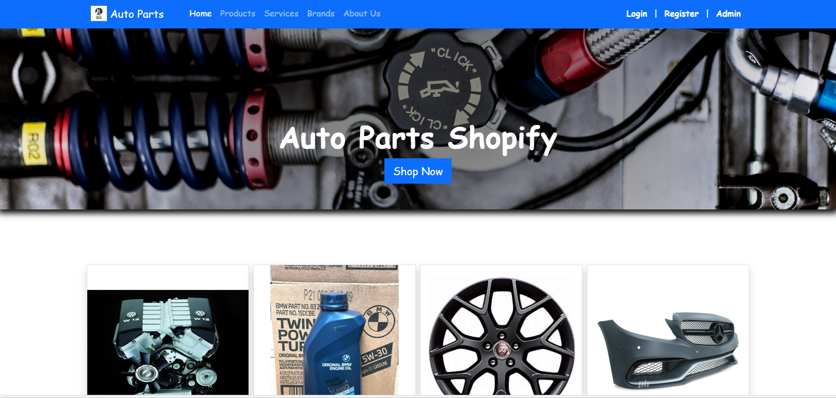

ABOUT US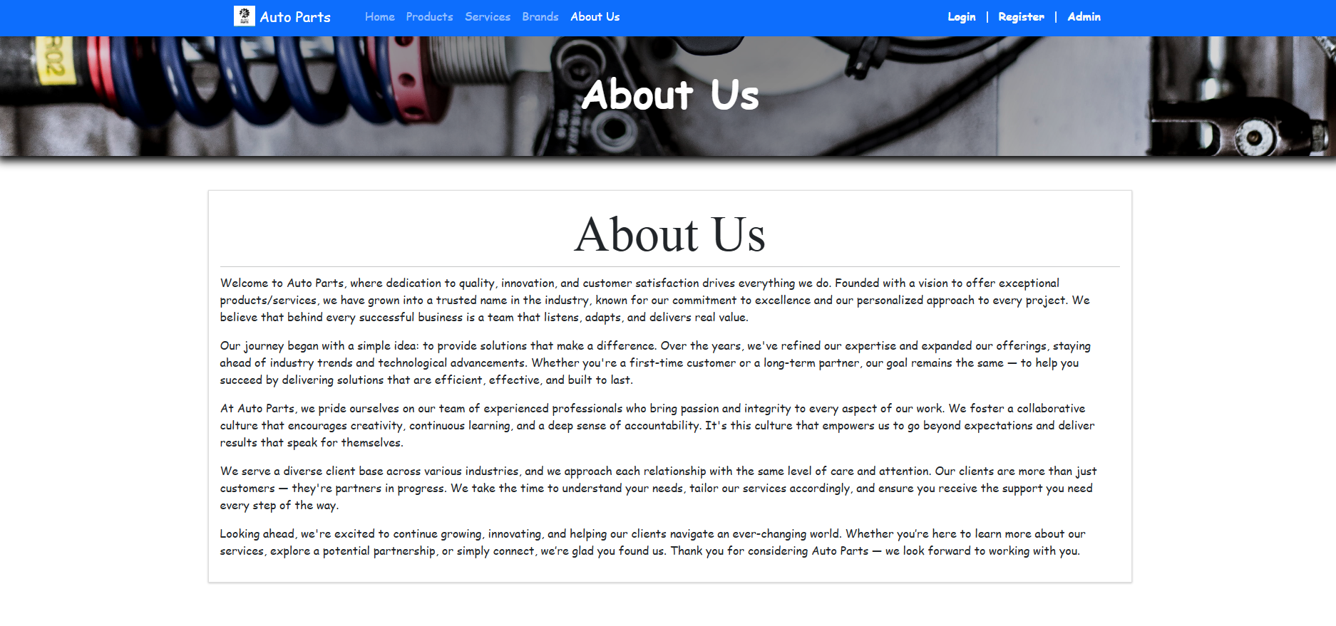

SERVICES
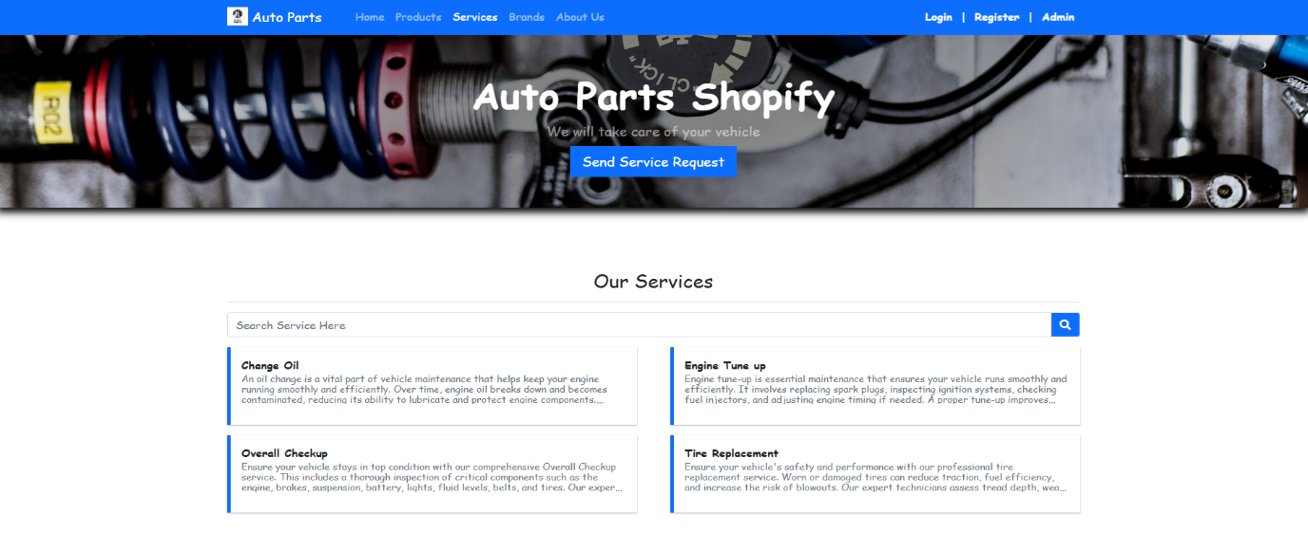

SERVICES REQUEST
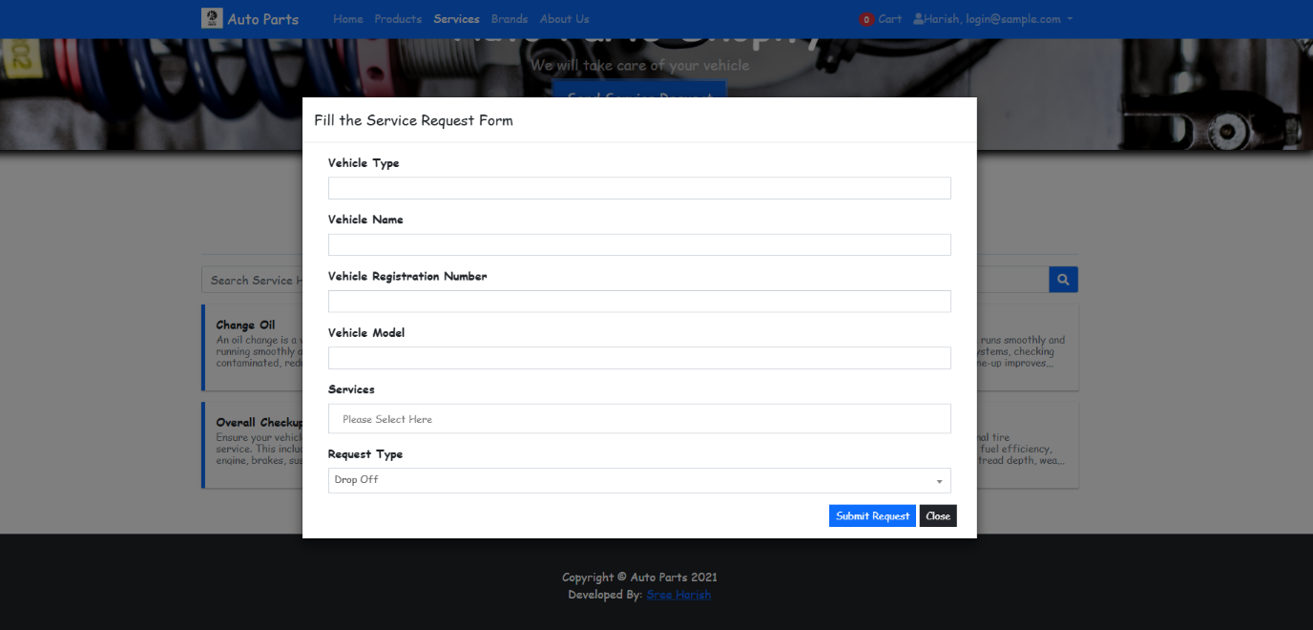

BRANDS SIGNED
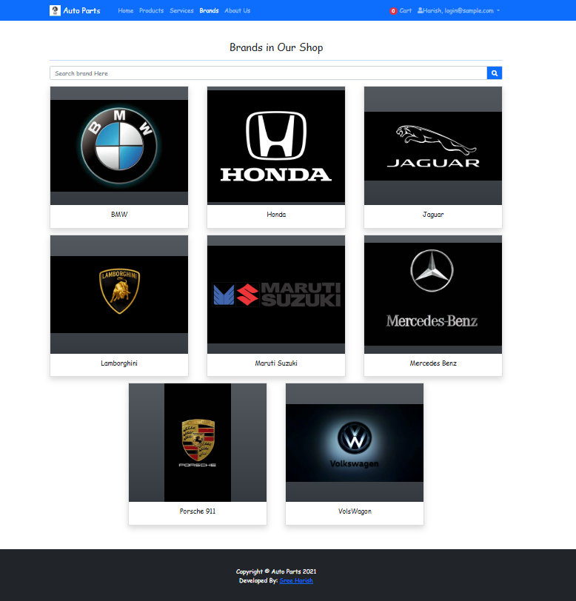

USER LOGIN PAGE
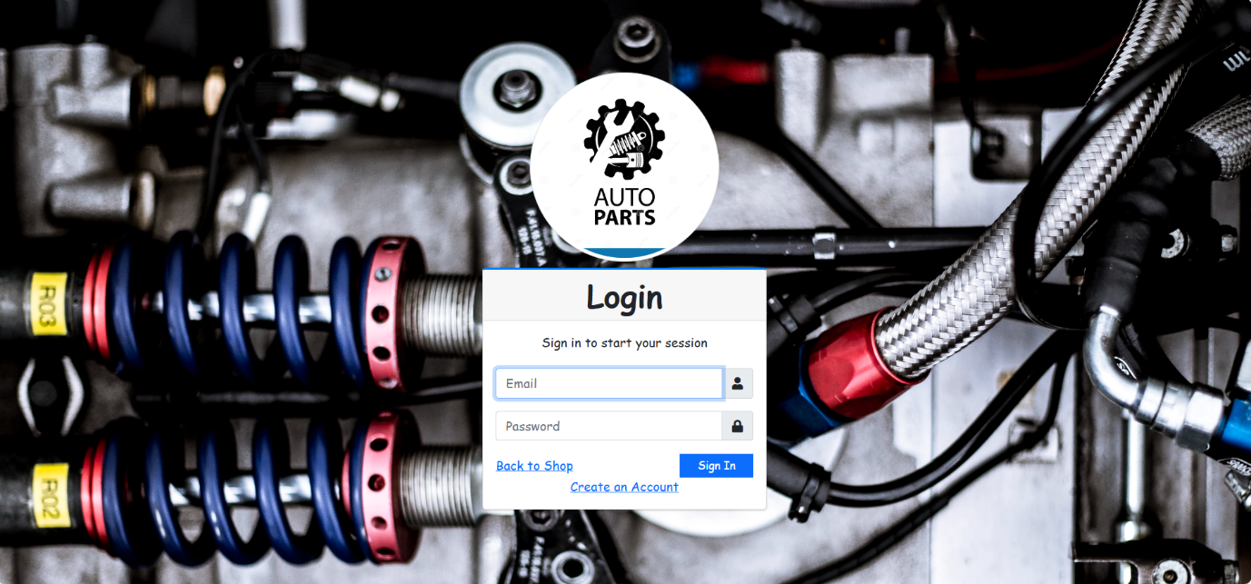

REGISTER PAGE
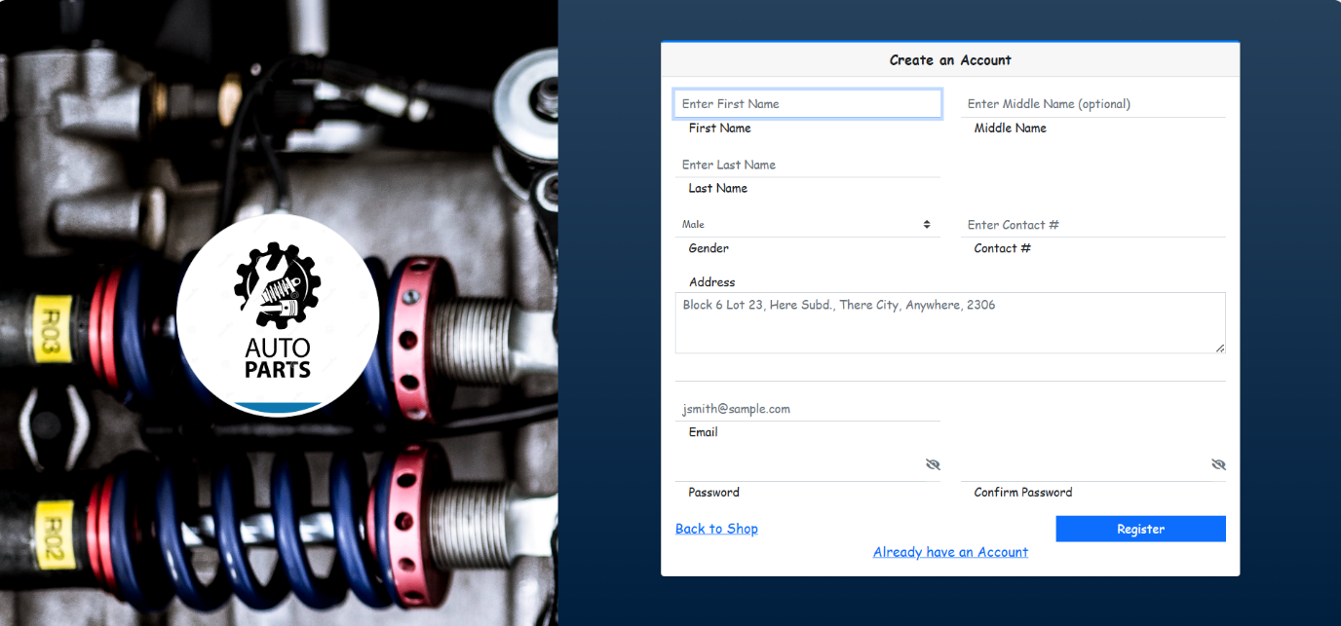

ADMIN LOGIN PAGE
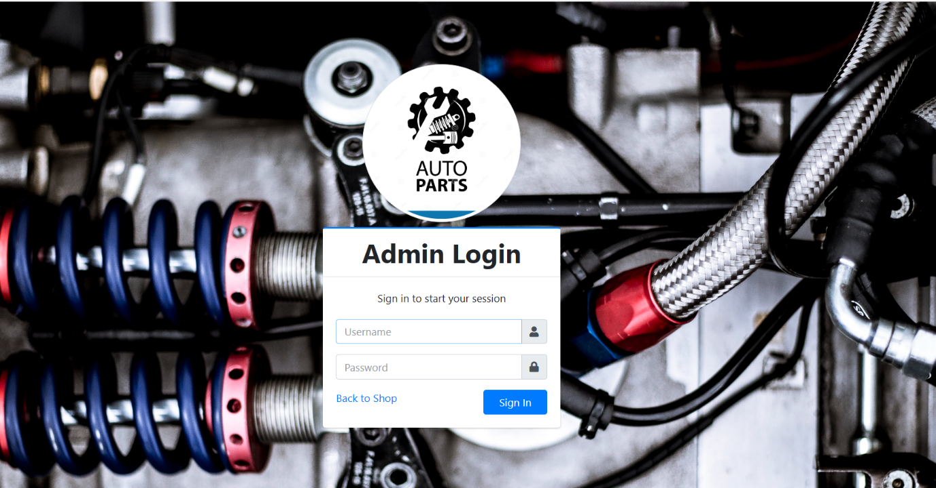

PRODUCTS
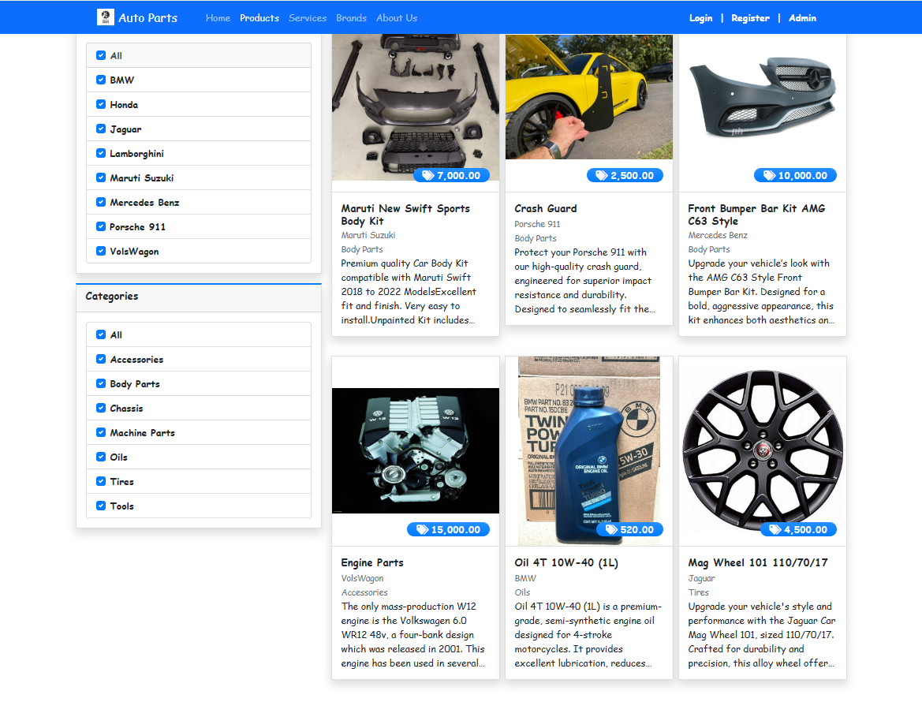

ADMIN DASHBOARD
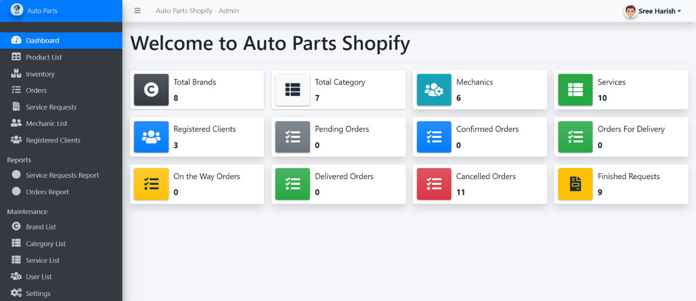

ADMIN PROFILE
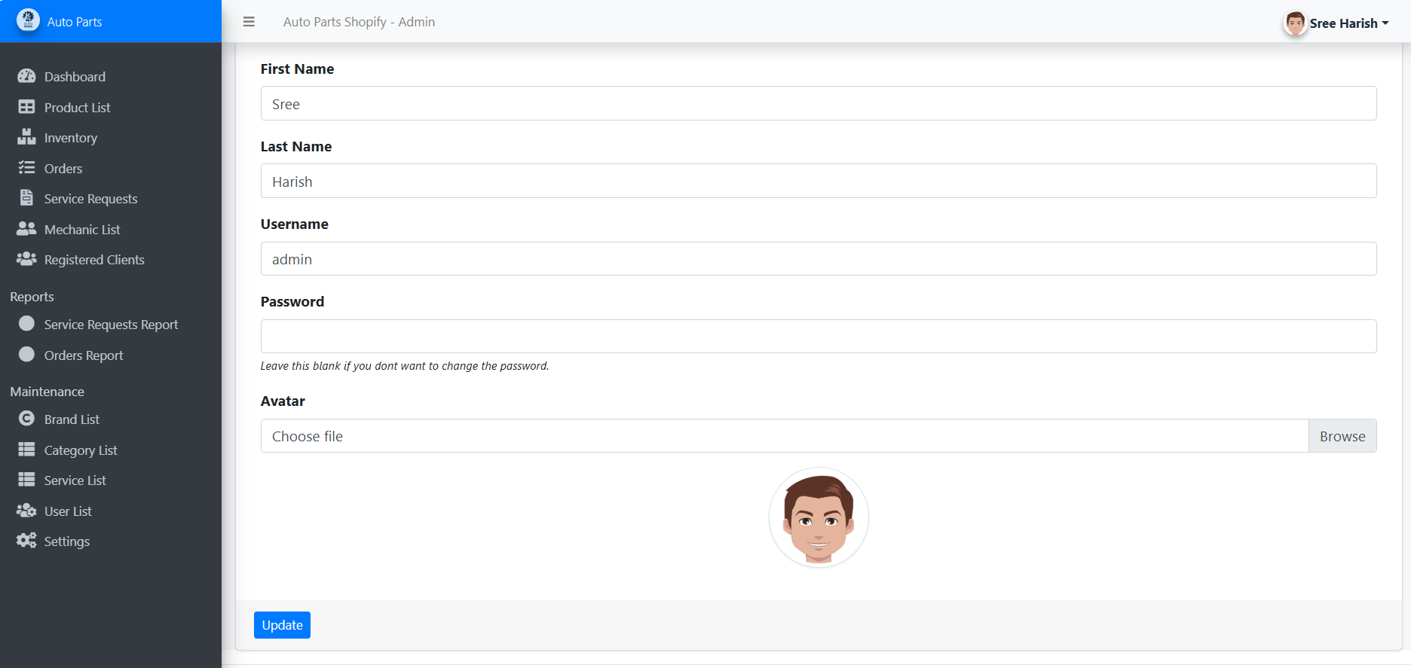

SYSTEM INFORMATION
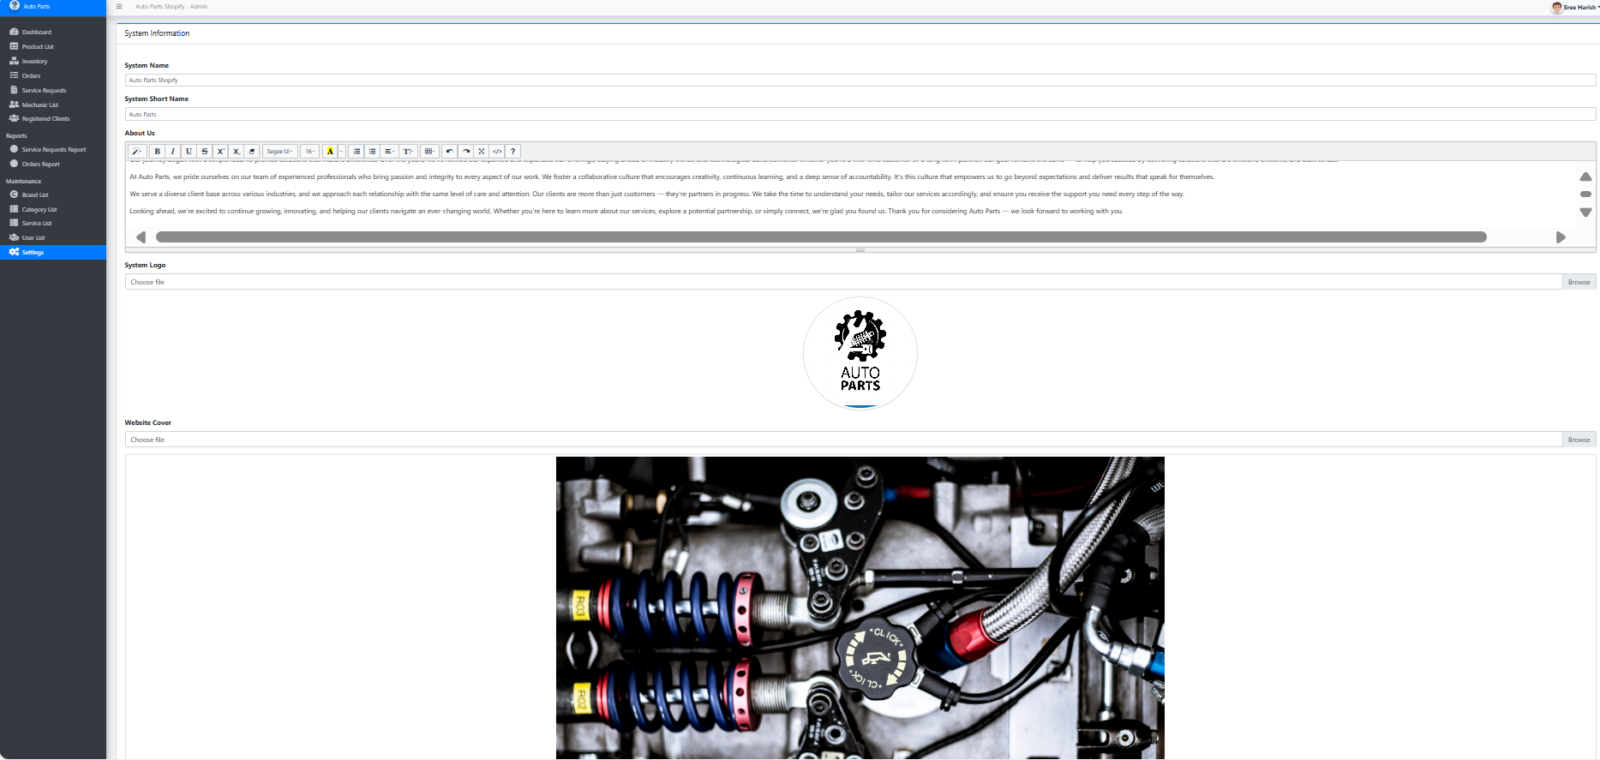

SERVICE REQUEST DETAILS
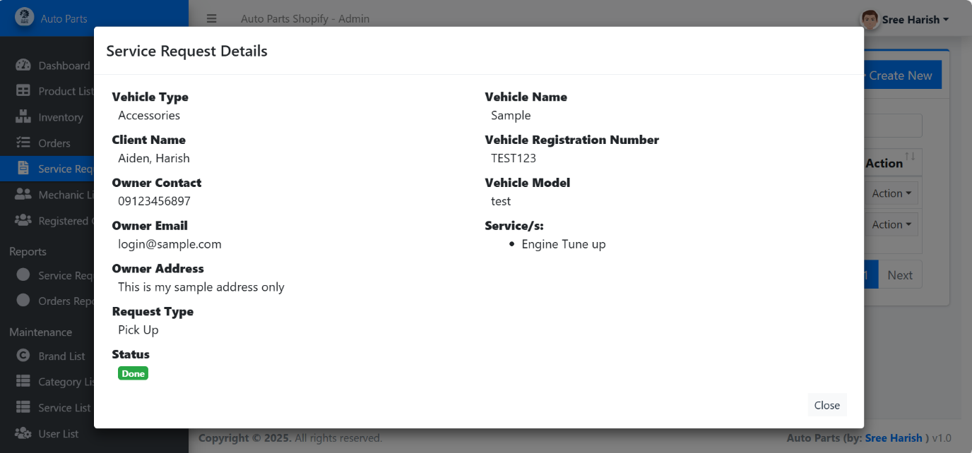

ORDER DETAILS
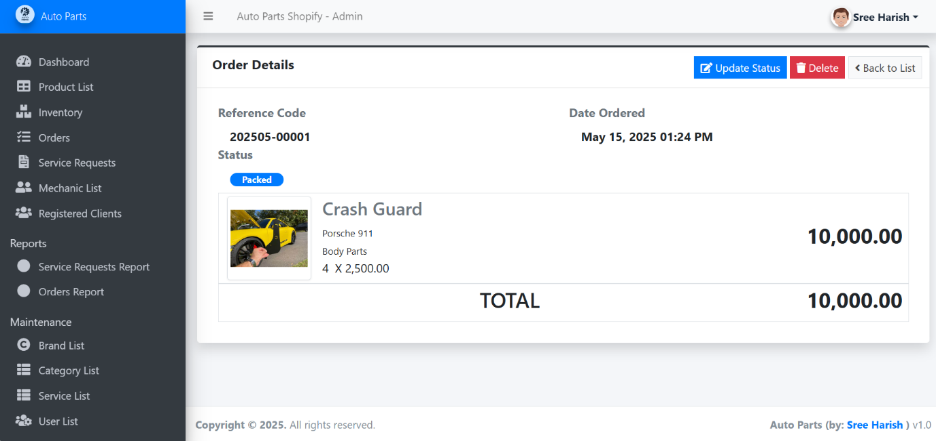

ADD PRODUCTS
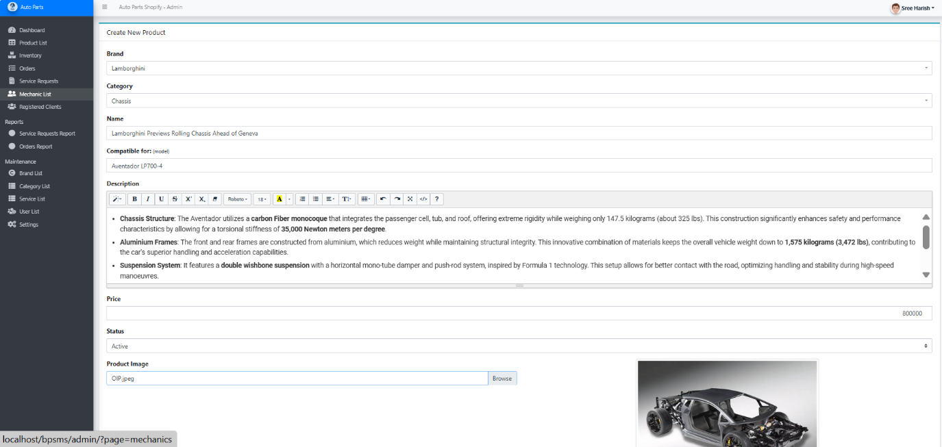

USER CREDENTIALS
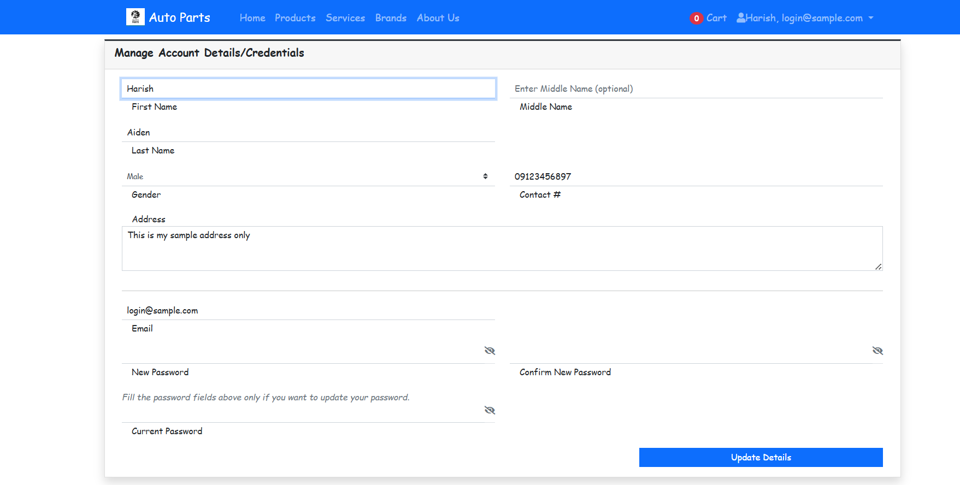

USER CART DETAILS
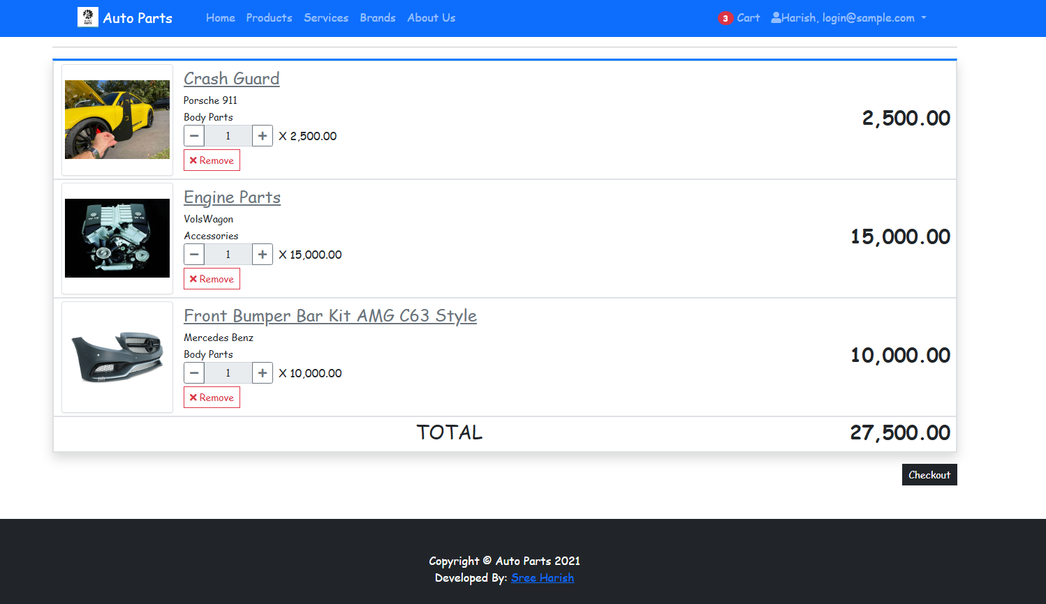

ORDER REPORT
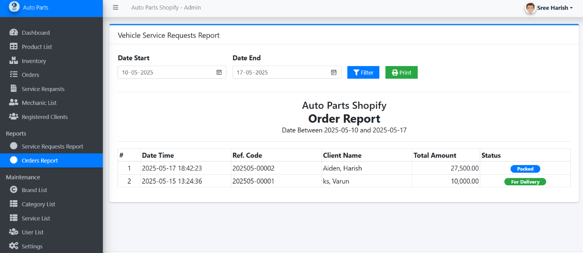

User Wrong Crendentials
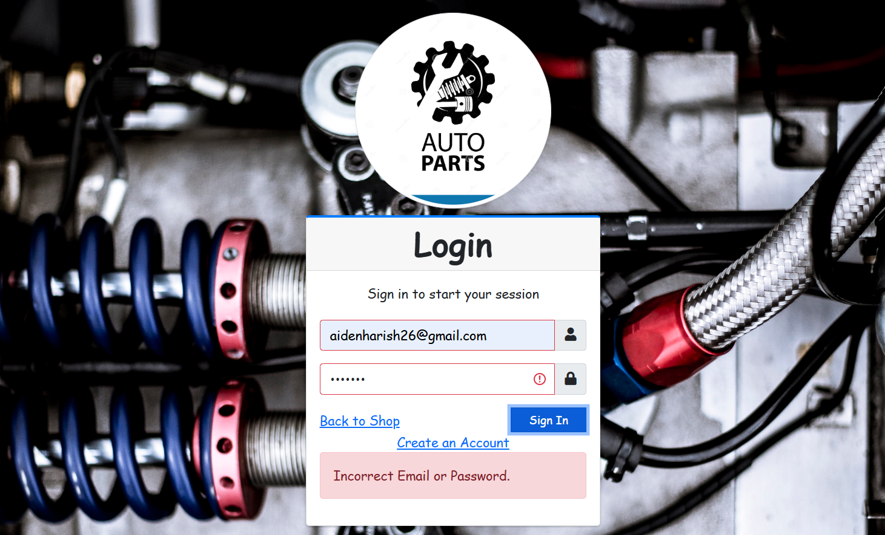

Admin Wrong Credentials
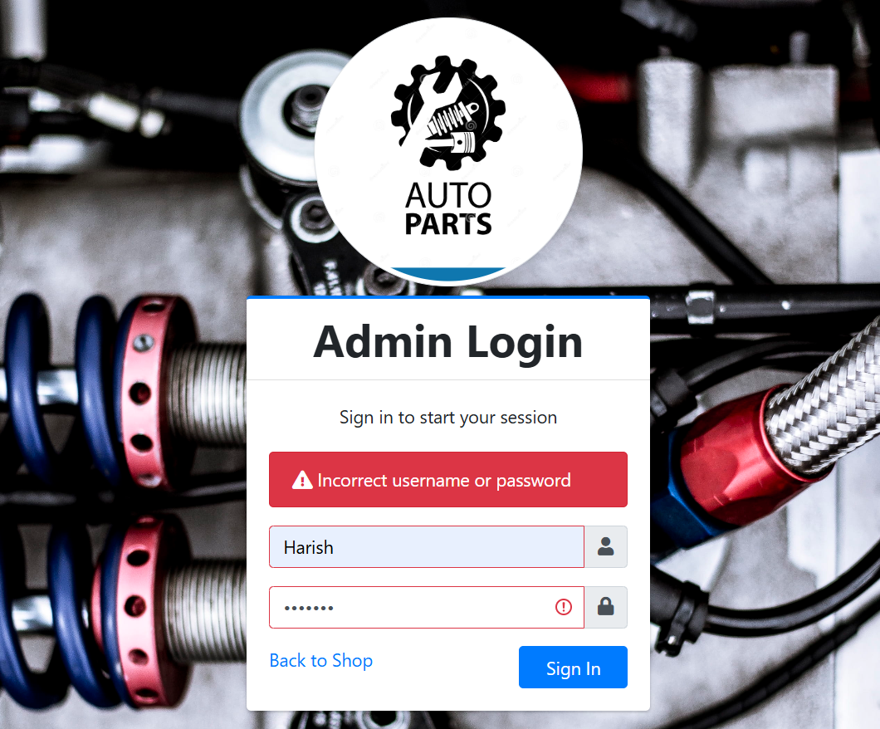
07.TESTING

Testing is an essential phase in the development process of the online auto parts selling website to ensure that all functionalities perform as expected and provide a smooth user experience. Both Black Box and White Box testing methods are used to validate different aspects of the system.

5.1 Black Box Testing
Black Box testing focuses on verifying the system's functionality without knowledge of its internal code structure. It ensures that the input-output behavior of the application matches the requirements. The following features were tested:
- User Registration and Login: Ensured that valid credentials log users in and incorrect inputs show proper error messages.
- Product Browsing and Search: Tested the search functionality for accuracy and relevance.
- Shopping Cart: Verified that items can be added/removed, and quantities updated correctly.
- Order Placement: Checked the end-to-end process from cart to successful order confirmation.

5.2 White Box Testing
White Box testing focuses on the internal logic and structure of the code. It includes testing loops, conditions, and functions:
- Login Authentication Logic: Verified secure handling of user credentials using PHP sessions and hashed passwords.
- Inventory Update Functions: Checked for correct stock level updates after order placement.
- SQL Query Execution: Validated correct data retrieval and insertion using MySQL queries.
- Form Validations: Tested client-side and server-side form validations for input sanitization.
- Error Handling: Verified that exception handling is in place for failed queries or broken processes.

Functional Testing
Functional testing verifies that the software’s features work according to the specified requirements. It focuses on what the system does. For the auto parts selling website, functional testing includes:
- User Registration and Login: Testing if users can successfully create accounts, log in, and recover passwords.
- Product Search and Filtering: Ensuring that users can search for parts by name, category, or price range.
- Shopping Cart Operations: Verifying adding, updating, and removing products in the cart.
- Order Placement: Checking if orders are processed correctly, including payment and confirmation.
- Admin Functions: Testing inventory management, product addition, order monitoring, and report generation.

Non-Functional Testing
Non-functional testing evaluates how the system performs under various conditions, focusing on aspects beyond specific behaviors. For this project, it includes:
- Performance Testing: Ensuring the website loads quickly and handles multiple simultaneous users without slowdowns.
- Security Testing: Verifying secure data transmission, user authentication, and protection against threats like SQL injection.
- Usability Testing: Checking if the interface is user-friendly, intuitive, and accessible to different user types.
- Reliability Testing: Ensuring the system is stable and operates without crashes during prolonged use.
- Scalability Testing: Assessing the website’s ability to handle increased loads as the number of users or products grows.

LIMITATIONS

Despite the comprehensive features of the online auto parts selling website, there are several limitations that affect its overall performance and scope. Firstly, the current system is limited to web-based access and does not include a dedicated mobile application, which may restrict user convenience for customers who prefer shopping via smartphones or tablets. Secondly, the payment gateway integration is not available we will working on it in future.Another limitation is the absence of advanced search filters and recommendation algorithms, which could otherwise enhance the user experience by providing personalized suggestions based on browsing and purchase history. The inventory management system currently assumes manual updates by administrators, lacking automated stock alerts or integration with suppliers’ databases to streamline restocking.
Additionally, the platform’s scalability is limited using PHP and MySQL without incorporating modern frameworks or cloud-based services, which might affect performance during high traffic periods. Security features are adequate but could be strengthened with multi-factor authentication and encryption protocols to better protect sensitive user data.
Finally, customer support functionality is minimal, relying on manual responses, which may delay issue resolution and impact overall customer satisfaction. Addressing these limitations in future versions will greatly enhance the system’s robustness and user appeal.

08.Conclusion

In conclusion, the online auto parts selling website successfully streamlines the process of purchasing vehicle components by offering a user-friendly platform that ensures convenience, efficiency, and accessibility. Through advanced search features, and detailed product listings, the website addresses the growing demand for digital automotive solutions. It reduces dependency on physical stores and enables users to compare prices, check compatibility, and make informed decisions. This project demonstrates the potential of e-commerce in the auto parts industry, enhancing customer experience while supporting business growth. The platform lays a strong foundation for future scalability and technological integration.

GOALS ACHIEVED
- Reduced entry work
- Easy retrieval of information
- User-Friendly Interface
- Comprehensive Product CatLog
- Advanced Search and Filtering
- Order Management System
- Admin Dashboard
- Inventory Tracking

09.Bibliography

- www.w3schools.com

- Php.net

- En.wikipedia.org/wiki/php

- www.apache.org

- Chatgpt

- www.mysql.com/click.php?e=35050

