# Overview

# Methods

## Study area

## Data

### Phenology information

#### Leaf color change

1. Early color change
2. 50% Color change
3. All leaves changed color

#### Leaf dropping

1. Early dropping
2. 50% leaf drop
3. All leaves dropped

### Tree size

### Climate data

### PRISM

To characterize the climate conditions for each tree, we also obtained monthly precipitation totals, minimum temperatures, and maximum temperature 30-year normals from PRISM (PRISM Climate Group 2021) using the *prism* package (Hart and Bell 2015).

##   
 |   
 | | 0%

##   
 |   
 |======================================================================| 100%

##   
 |   
 | | 0%

##   
 |   
 |======================================================================| 100%

##   
 |   
 | | 0%

##   
 |   
 |======================================================================| 100%

##   
 |   
 | | 0%

##   
 |   
 |======================================================================| 100%

## Data preparation

## Analyses

### Were small trees more likely to drop their leaves earlier?

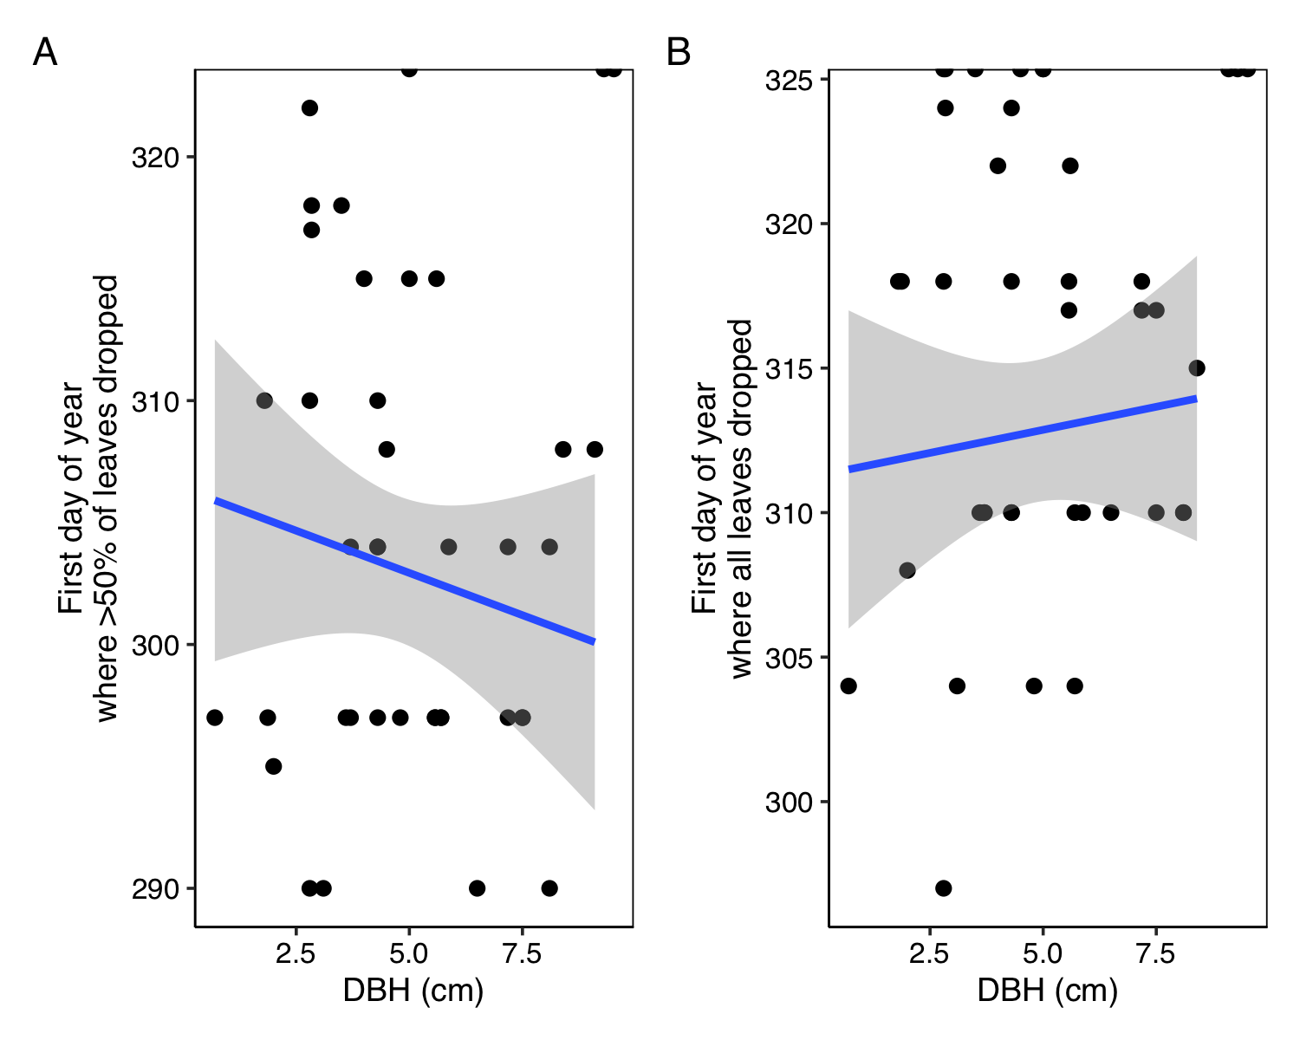

### Did trees in Fort Collins drop their leaves earlier?

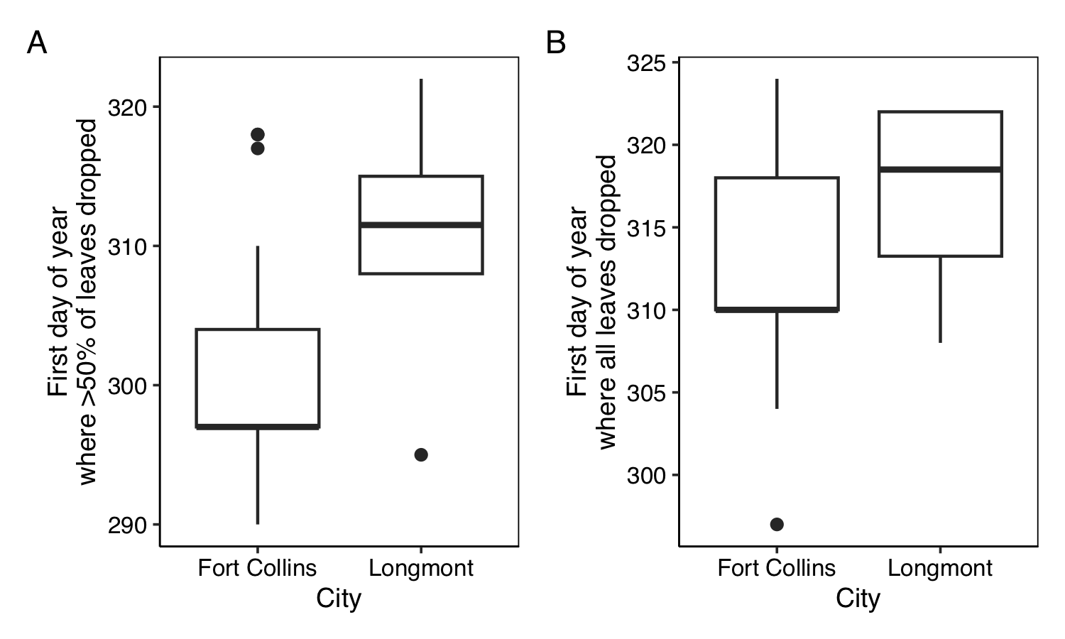

### Did trees from cooler climates drop their leaves earlier?

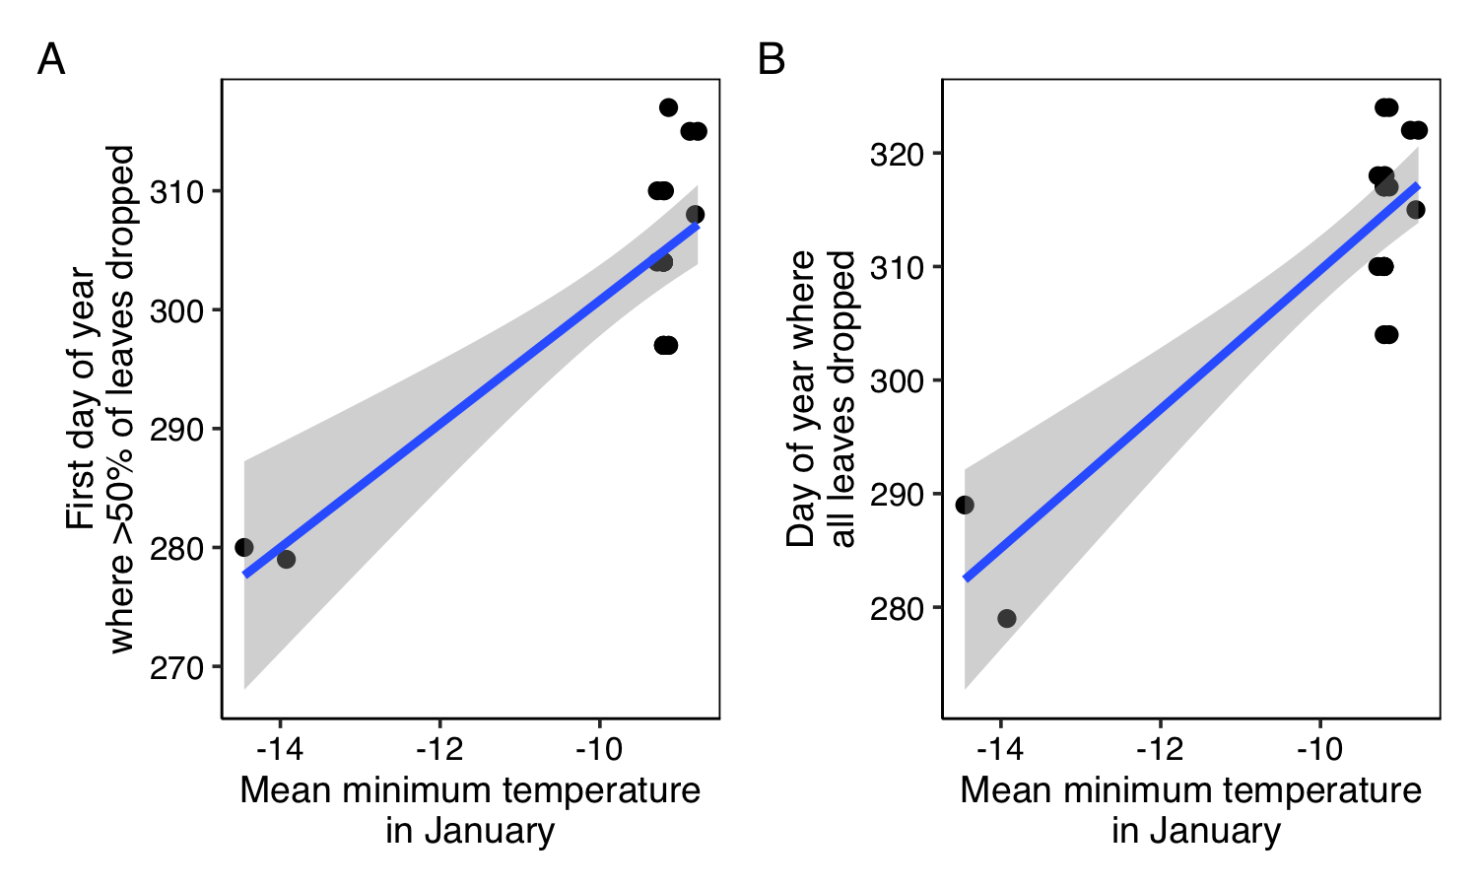

# References

Hart, E. M., and K. Bell. 2015. [Prism: Download data from the oregon prism project](https://doi.org/10.5281/zenodo.33663).

PRISM Climate Group. 2021. [Monthly 30-year climate normals (1981-2010)](https://prism.oregonstate.edu/normals/).