# Overview

# Data

## Budburst

## PRISM

To characterize the study area’s climate, we obtained monthly precipitation totals, minimum temperatures, and maximum temperature 30-year normals from PRISM (PRISM Climate Group 2021) using the *prism* package (Hart and Bell 2015).

dir.create(here("Data", "Spatial", "PRISM"), showWarnings = FALSE) # Create directory to hold data  
prism_set_dl_dir(here("Data", "Spatial", "PRISM")) # tell program to download PRISM data to the directory we just created  
   
# download climate normals  
get_prism_normals("ppt", "800m", annual = TRUE, keepZip = FALSE) # annual precipitation

##   
 |   
 | | 0%

##   
## PRISM_ppt_30yr_normal_800mM4_annual_bil.zip already exists. Skipping downloading.

##   
 |   
 |======================================================================| 100%

get_prism_normals("tmin", "800m", mon=1, keepZip = FALSE) # minimum temperature in January

##   
 |   
 | | 0%

##   
## PRISM_tmin_30yr_normal_800mM5_01_bil.zip already exists. Skipping downloading.

##   
 |   
 |======================================================================| 100%

get_prism_normals("tmax", "800m", mon=7, keepZip = FALSE) # maximum temperature in July

##   
 |   
 | | 0%

##   
## PRISM_tmax_30yr_normal_800mM5_07_bil.zip already exists. Skipping downloading.

##   
 |   
 |======================================================================| 100%

# Data preparation

# read in budburst observation csv file  
budburst <- read.csv(here("Data", "budburst_observations_1733415315.csv")) %>%  
 filter(genus=="Populus" & species=="tremuloides") %>%   
 filter(administrative_area_level_1 %in% c("CO", "Colorado")) %>% # limit to sites in Colorado  
 filter(phenophase_plant_structure %in% c("Autumn Leaf Color Change", "Autumn Leaves Dropping")) # limit dataset to just fall phenophase data  
  
budburst.sf <- st_as_sf(x = budburst, coords = c("longitude", "latitude"), crs = "+proj=longlat +ellps=WGS84 +datum=WGS84 +no_defs")  
  
# read in prism data  
prism_set_dl_dir(here("Data", "Spatial", "PRISM")) # tell computer where PRISM data is stored  
ppt.normal <- prism_archive_subset("ppt", "annual normals", resolution="800m") %>% # set what PRISM data we want to look at  
 pd_to_file() %>% # get path  
 rast() # read in data   
  
# overlay budburst observations and extract precipitation normals  
budburst.sf <- extract(ppt.normal,budburst.sf, bind=T)

## Warning: [extract] transforming vector data to the CRS of the raster

# Analyses

budburst <- budburst.sf %>% as.data.frame() %>% filter(phenophase_title=="50% Color change") %>%   
 # convert observation_date to date object   
 mutate(date=as.Date(observation_date, format="%m/%d/%Y")) %>%   
 mutate(year =lubridate::year(date), doy=lubridate::yday(date))  
  
ggplot(budburst, aes(y=doy, x=PRISM_ppt_30yr_normal_800mM4_annual_bil))+geom_point()+geom_smooth(method="lm")

## `geom_smooth()` using formula = 'y ~ x'

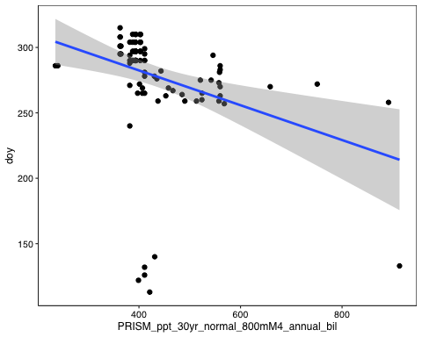

# References

Hart, E. M., and K. Bell. 2015. [Prism: Download data from the oregon prism project](https://doi.org/10.5281/zenodo.33663).

PRISM Climate Group. 2021. [Monthly 30-year climate normals (1981-2010)](https://prism.oregonstate.edu/normals/).