Preprocessing of Douglas-fir chronologies for: Drought may initiate western spruce budworm outbreaks, but multi-year periods of increased moisture availability promote widespread defoliation

Sarah J. Hart, Olivia Santiago, Joshua D. Carrell, and Thomas T. Veblen

March 19, 2025

# Overview

Here we re-evaluated the crossdating of the host chronologies to ensure that the series were correctly dated. We used the dplR package (Bunn et al., 2024; Bunn, 2008) to calculate the correlation between each series and a main chronology built from all other series at each site. Using the *corr.rwl.seg()* function, we calculated correlation coefficients in 50-year segments that overlapped by 25 years and then removed series that were poorly correlated with the main chronology.

### Boulder County 18

We retained most series from the Boulder County 18 site, but removed two series because they were poorly correlated with the other series (Fig. ; Table ).

rwlj <-read.rwl(here("Data", "TreeRing", "Raw", "Host", "Veblen", "B18.rwl"))

rwljcor <- corr.rwl.seg(rwlj, seg.length=50, pcrit=0.1)

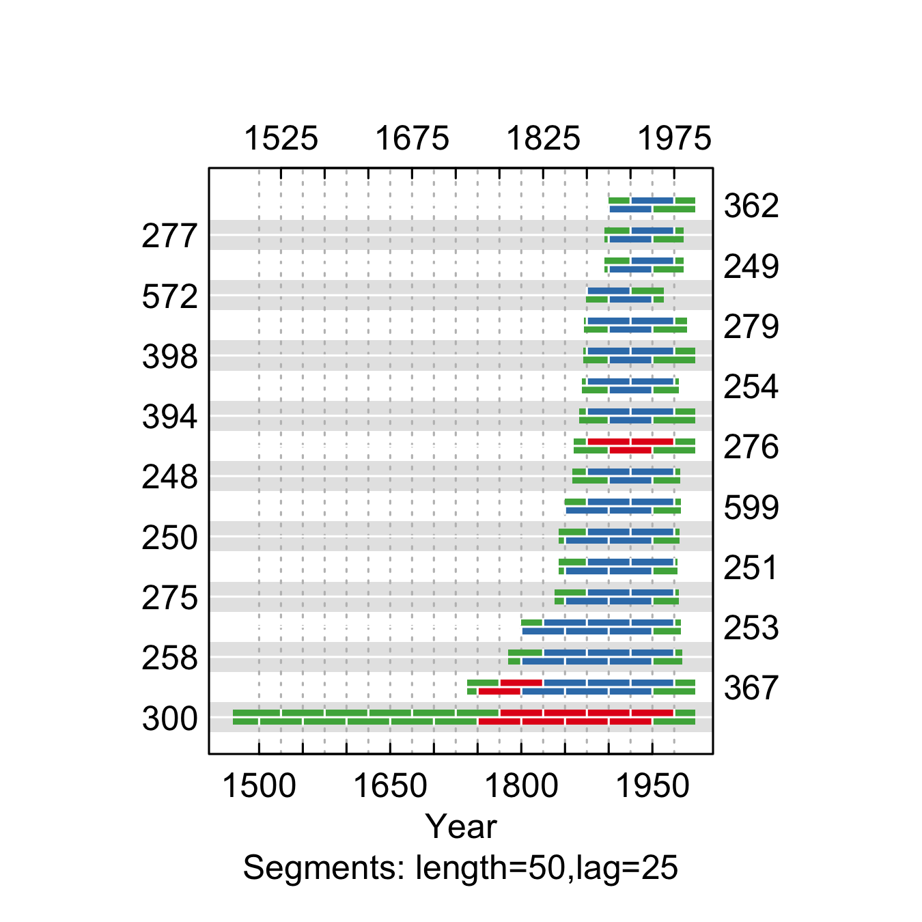

**Figure** **:** The correlations between each tree-ring series and a main chronology built from all other series from the Boulder County 18 site. Correlations were calculated in 50-year segments that overlap by 25 years. Blue segments show period that correlate well with the main chronology (p<0.1). Red segments show poor correlation with the main chronology (p>0.1). Green segments show periods do not overlap with the main chronology.

summary.tab <- summary.rwl(rwlj)  
summary.tab$rho <- round(corr.rwl.seg(rwlj, seg.length=50, pcrit=0.1, make.plot=F)$overall[,1],2)  
summary.tab$notes <- "Retained"  
  
summary.tab <- summary.tab %>% select(series, first, last, rho, notes) %>% mutate(first=as.character(first), last=as.character(last))  
  
colnames(summary.tab) <- c("Series", "First\nyear", "Last\nyear", "Spearman's correlation", "Notes")  
summary.tab[summary.tab$Series %in% c("300", "276"), "Notes"] <- "Removed - poorly correlated with the other series"  
  
summary.tab[order(summary.tab$Series),] %>% flextable() %>% flextable::align(j=-1, align = "center", part = "all") %>% set_table_properties(layout = "autofit", width=1)

**Table** **:** Series statistics and cross-dating notes for the Boulder County 18 site. Spearman's correlations were calculated over the common period of overlap between the series and a main chronology built from all other series.

| Series | First year | Last year | Spearman's correlation | Notes |
| --- | --- | --- | --- | --- |
| 248 | 1853 | 1981 | 0.62 | Retained |
| 249 | 1894 | 1985 | 0.75 | Retained |
| 250 | 1838 | 1980 | 0.70 | Retained |
| 251 | 1841 | 1978 | 0.59 | Retained |
| 253 | 1797 | 1982 | 0.66 | Retained |
| 254 | 1867 | 1979 | 0.66 | Retained |
| 258 | 1782 | 1983 | 0.53 | Retained |
| 275 | 1835 | 1979 | 0.75 | Retained |
| 276 | 1857 | 1998 | -0.03 | Removed - poorly correlated with the other series |
| 277 | 1892 | 1985 | 0.78 | Retained |
| 279 | 1869 | 1989 | 0.75 | Retained |
| 300 | 1464 | 1998 | 0.00 | Removed - poorly correlated with the other series |
| 362 | 1899 | 1998 | 0.58 | Retained |
| 367 | 1734 | 1998 | 0.43 | Retained |
| 394 | 1864 | 1998 | 0.60 | Retained |
| 398 | 1858 | 1998 | 0.58 | Retained |
| 572 | 1871 | 1962 | 0.75 | Retained |
| 599 | 1845 | 1982 | 0.50 | Retained |

rwlj <- rwlj[,!(colnames(rwlj) %in% c("300", "276"))]  
write.rwl(rwlj, fname=here("Data", "TreeRing", "Processed", "Host", "B18.rwl"), format="tucson")

### Boulder County 19

We retained most series from the Boulder County 19 site, but removed three series because they were poorly correlated with the other series (Fig. ; Table ).

rwljcor <- corr.rwl.seg(rwlj, seg.length=50, pcrit=0.1)

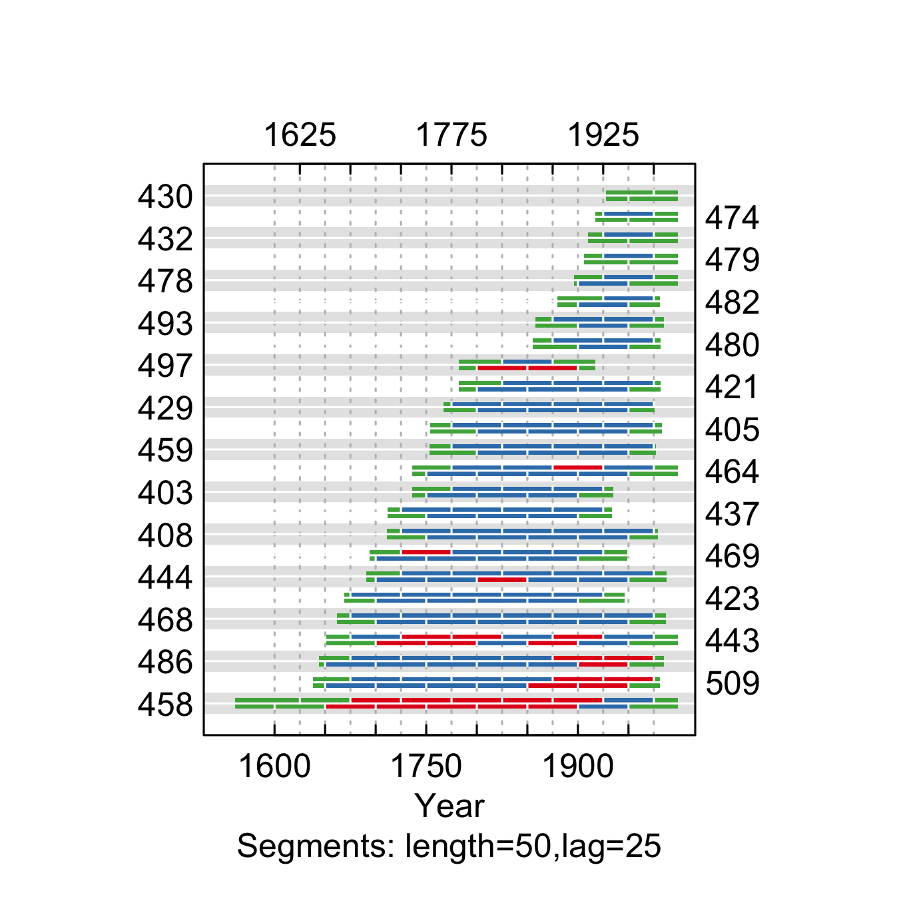

**Figure** **:** The correlations between each tree-ring series and a main chronology built from all other series from the Boulder County 19 site. Correlations were calculated in 50-year segments that overlap by 25 years. Blue segments show period that correlate well with the main chronology (p<0.1). Red segments show poor correlation with the main chronology (p>0.1). Green segments show periods do not overlap with the main chronology.

summary.tab <- summary.rwl(rwlj)  
summary.tab$rho <- round(corr.rwl.seg(rwlj, seg.length=50, pcrit=0.1, make.plot=F)$overall[,1],2)  
summary.tab$notes <- "Retained"  
  
summary.tab <- summary.tab %>% select(series, first, last, rho, notes) %>% mutate(first=as.character(first), last=as.character(last))  
  
colnames(summary.tab) <- c("Series", "First\nyear", "Last\nyear", "Spearman's correlation", "Notes")  
summary.tab[summary.tab$Series %in% c("458", "497", "443"), "Notes"] <- "Removed - poorly correlated with the other series"  
  
summary.tab[order(summary.tab$Series),] %>% flextable() %>% flextable::align(j=-1, align = "center", part = "all") %>% flextable::align(j=-1, align = "center", part = "all") %>% set_table_properties(layout = "autofit", width=1) %>% paginate()

**Table** **:** Series statistics and cross-dating notes for the Boulder County 19 site. Spearman's correlations were calculated over the common period of overlap between the series and a main chronology built from all other series.

| Series | First year | Last year | Spearman's correlation | Notes |
| --- | --- | --- | --- | --- |
| 403 | 1733 | 1934 | 0.50 | Retained |
| 405 | 1750 | 1982 | 0.62 | Retained |
| 408 | 1703 | 1978 | 0.60 | Retained |
| 421 | 1768 | 1981 | 0.59 | Retained |
| 423 | 1664 | 1945 | 0.56 | Retained |
| 429 | 1751 | 1975 | 0.60 | Retained |
| 430 | 1926 | 1998 | 0.70 | Retained |
| 432 | 1909 | 1998 | 0.46 | Retained |
| 437 | 1707 | 1933 | 0.46 | Retained |
| 443 | 1647 | 1998 | 0.14 | Removed - poorly correlated with the other series |
| 444 | 1675 | 1987 | 0.50 | Retained |
| 458 | 1548 | 1998 | -0.01 | Removed - poorly correlated with the other series |
| 459 | 1749 | 1976 | 0.53 | Retained |
| 464 | 1733 | 1998 | 0.52 | Retained |
| 468 | 1659 | 1986 | 0.55 | Retained |
| 469 | 1689 | 1948 | 0.48 | Retained |
| 474 | 1914 | 1998 | 0.62 | Retained |
| 478 | 1894 | 1998 | 0.58 | Retained |
| 479 | 1904 | 1998 | 0.71 | Retained |
| 480 | 1853 | 1981 | 0.74 | Retained |
| 482 | 1879 | 1980 | 0.45 | Retained |
| 486 | 1628 | 1984 | 0.33 | Retained |
| 493 | 1856 | 1984 | 0.71 | Retained |
| 497 | 1779 | 1916 | 0.10 | Removed - poorly correlated with the other series |
| 509 | 1615 | 1980 | 0.35 | Retained |

rwlj <- rwlj[,!(colnames(rwlj) %in% c("458", "497", "443"))]  
write.rwl(rwlj, fname=here("Data", "TreeRing", "Processed", "Host", "B19.rwl"), format="tucson")

### Lost Junction

We retained all series from the Lost Junction site (Fig. ; Table ).

rwljcor <- corr.rwl.seg(rwlj, seg.length=50, pcrit=0.1)

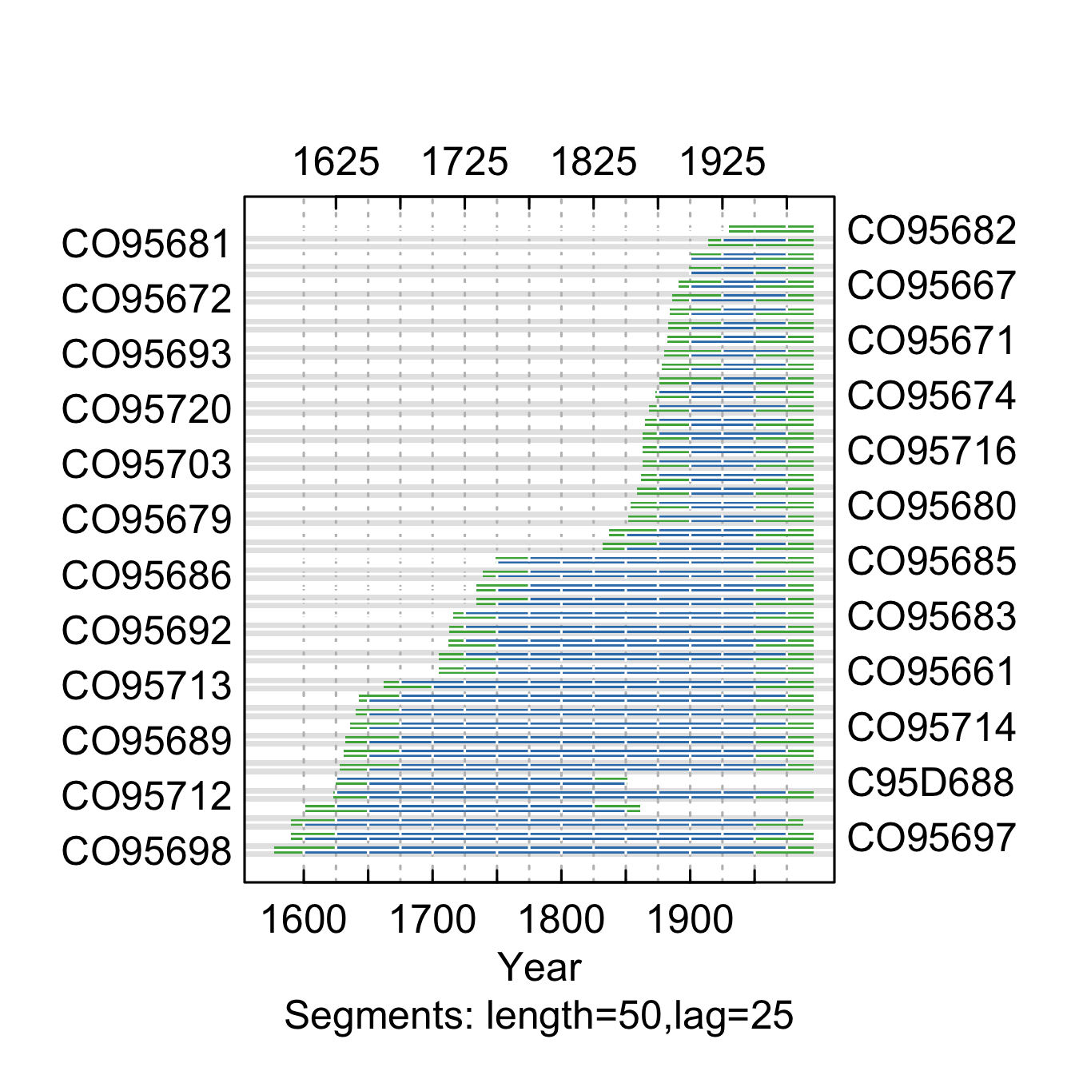

**Figure** **:** The correlations between each tree-ring series and a main chronology built from all other series from the Lost Junction site. Correlations were calculated in 50-year segments that overlap by 25 years. Blue segments show period that correlate well with the main chronology (p<0.1). Red segments show poor correlation with the main chronology (p>0.1). Green segments show periods do not overlap with the main chronology.

summary.tab <- summary.rwl(rwlj)  
summary.tab$rho <- round(corr.rwl.seg(rwlj, seg.length=50, pcrit=0.1, make.plot=F)$overall[,1],2)  
summary.tab$notes <- "Retained"  
  
summary.tab <- summary.tab %>% select(series, first, last, rho, notes) %>% mutate(first=as.character(first), last=as.character(last))  
colnames(summary.tab) <- c("Series", "First\nyear", "Last\nyear", "Spearman's correlation", "Notes")  
  
summary.tab[order(summary.tab$Series),] %>% flextable() %>% flextable::align(j=-1, align = "center", part = "all") %>% set_table_properties(layout = "autofit", width=1)

**Table** **:** Series statistics and cross-dating notes for the Lost Junction site. Spearman's correlations were calculated over the common period of overlap between the series and a main chronology built from all other series.

| Series | First year | Last year | Spearman's correlation | Notes |
| --- | --- | --- | --- | --- |
| C95D687 | 1598 | 1860 | 0.54 | Retained |
| C95D688 | 1622 | 1850 | 0.58 | Retained |
| CO95661 | 1693 | 1995 | 0.65 | Retained |
| CO95662 | 1732 | 1995 | 0.79 | Retained |
| CO95663 | 1729 | 1995 | 0.64 | Retained |
| CO95665 | 1895 | 1995 | 0.55 | Retained |
| CO95666 | 1897 | 1995 | 0.63 | Retained |
| CO95667 | 1888 | 1995 | 0.56 | Retained |
| CO95668 | 1882 | 1995 | 0.73 | Retained |
| CO95671 | 1879 | 1995 | 0.61 | Retained |
| CO95672 | 1883 | 1995 | 0.65 | Retained |
| CO95673 | 1875 | 1995 | 0.79 | Retained |
| CO95674 | 1871 | 1995 | 0.68 | Retained |
| CO95677 | 1860 | 1995 | 0.73 | Retained |
| CO95678 | 1879 | 1995 | 0.75 | Retained |
| CO95679 | 1844 | 1995 | 0.71 | Retained |
| CO95680 | 1851 | 1995 | 0.73 | Retained |
| CO95681 | 1907 | 1995 | 0.62 | Retained |
| CO95682 | 1927 | 1995 | 0.66 | Retained |
| CO95683 | 1703 | 1995 | 0.50 | Retained |
| CO95684 | 1690 | 1995 | 0.64 | Retained |
| CO95685 | 1738 | 1995 | 0.60 | Retained |
| CO95686 | 1729 | 1995 | 0.69 | Retained |
| CO95689 | 1628 | 1995 | 0.53 | Retained |
| CO95690 | 1624 | 1995 | 0.64 | Retained |
| CO95691 | 1709 | 1995 | 0.66 | Retained |
| CO95692 | 1711 | 1995 | 0.63 | Retained |
| CO95693 | 1877 | 1995 | 0.60 | Retained |
| CO95697 | 1584 | 1995 | 0.52 | Retained |
| CO95698 | 1571 | 1995 | 0.59 | Retained |
| CO95701 | 1623 | 1995 | 0.55 | Retained |
| CO95702 | 1638 | 1995 | 0.61 | Retained |
| CO95703 | 1860 | 1995 | 0.69 | Retained |
| CO95704 | 1873 | 1995 | 0.70 | Retained |
| CO95707 | 1826 | 1995 | 0.36 | Retained |
| CO95708 | 1583 | 1987 | 0.57 | Retained |
| CO95711 | 1628 | 1995 | 0.61 | Retained |
| CO95712 | 1617 | 1995 | 0.66 | Retained |
| CO95713 | 1660 | 1995 | 0.57 | Retained |
| CO95714 | 1634 | 1995 | 0.63 | Retained |
| CO95715 | 1834 | 1995 | 0.54 | Retained |
| CO95716 | 1860 | 1995 | 0.62 | Retained |
| CO95717 | 1854 | 1995 | 0.73 | Retained |
| CO95718 | 1857 | 1995 | 0.83 | Retained |
| CO95719 | 1860 | 1995 | 0.69 | Retained |
| CO95720 | 1866 | 1995 | 0.68 | Retained |

write.rwl(rwlj, fname=here("Data", "TreeRing", "Processed", "Host", "LJ.rwl"), format="tucson")

### Sugarloaf Saddle

We retained all series from the Sugarloaf Saddle site (Fig. ; Table ).

rwljcor <- corr.rwl.seg(rwlj, seg.length=50, pcrit=0.1)

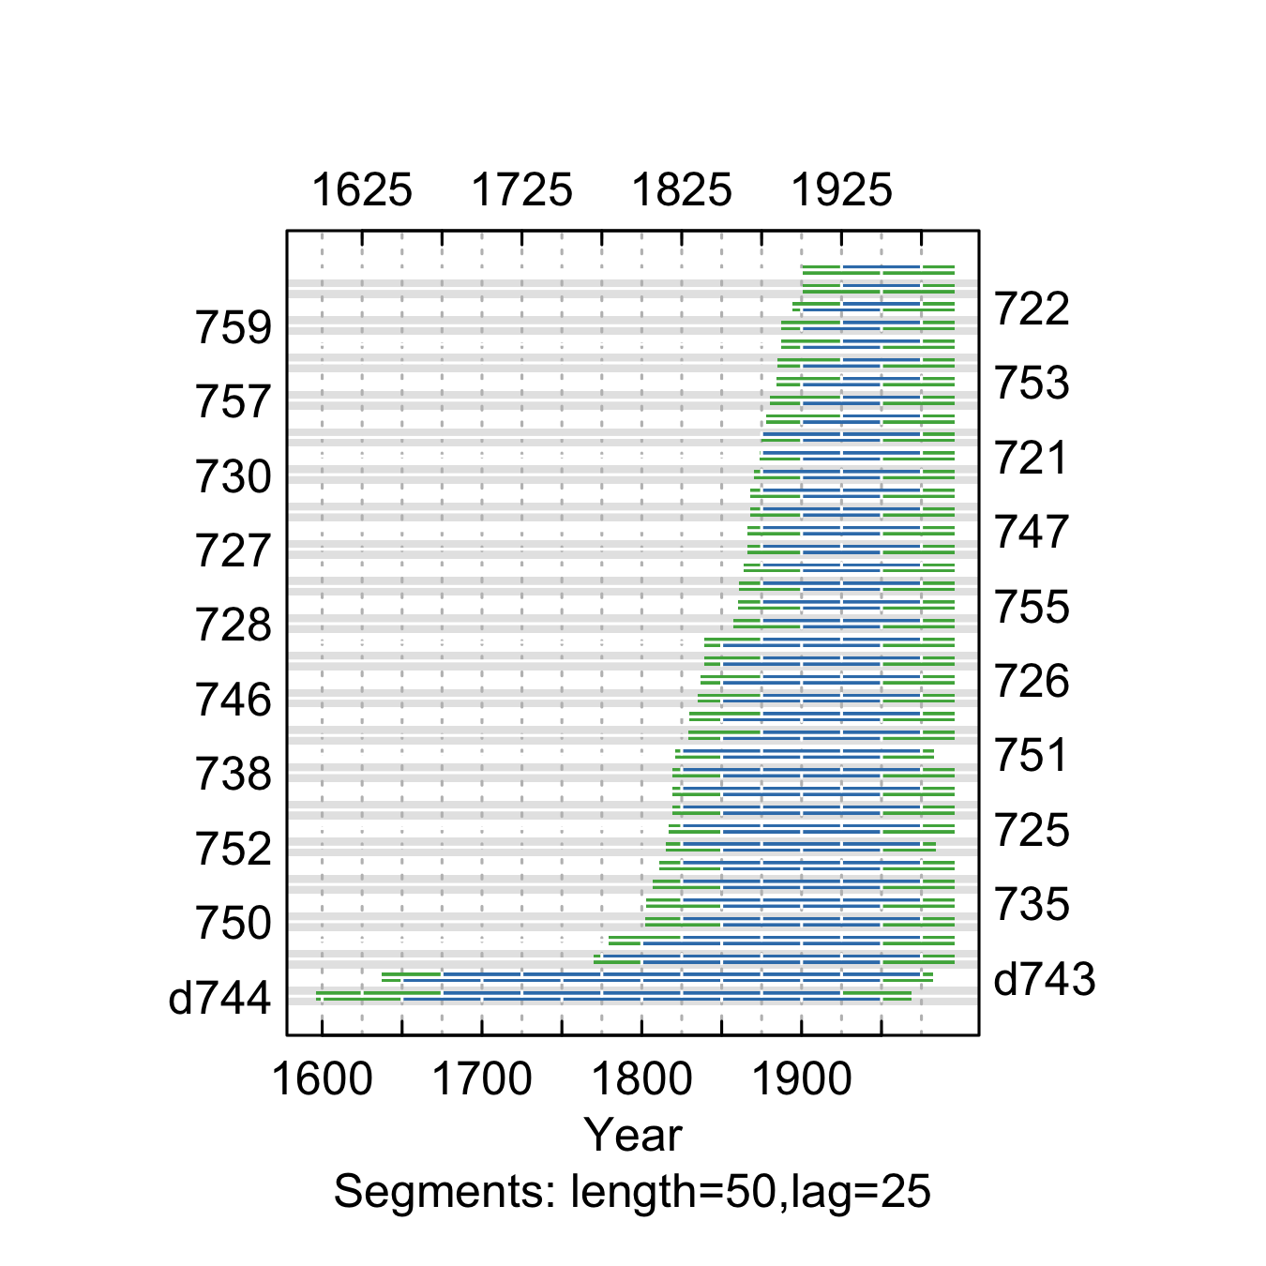

**Figure** **:** The correlations between each tree-ring series and a main chronology built from all other series from the Sugarloaf Saddle site. Correlations were calculated in 50-year segments that overlap by 25 years. Blue segments show period that correlate well with the main chronology (p<0.1). Red segments show poor correlation with the main chronology (p>0.1). Green segments show periods do not overlap with the main chronology.

summary.tab <- summary.rwl(rwlj)  
summary.tab$rho <- round(corr.rwl.seg(rwlj, seg.length=50, pcrit=0.1, make.plot=F)$overall[,1],2)  
summary.tab$notes <- "Retained"  
  
summary.tab <- summary.tab %>% select(series, first, last, rho, notes) %>% mutate(first=as.character(first), last=as.character(last))  
colnames(summary.tab) <- c("Series", "First\nyear", "Last\nyear", "Spearman's correlation", "Notes")  
  
summary.tab[order(summary.tab$Series),] %>% flextable() %>% flextable::align(j=-1, align = "center", part = "all") %>% set_table_properties(layout = "autofit", width=1)

**Table** **:** Series statistics and cross-dating notes for the Sugarloaf Saddle site. Spearman's correlations were calculated over the common period of overlap between the series and a main chronology built from all other series.

| Series | First year | Last year | Spearman's correlation | Notes |
| --- | --- | --- | --- | --- |
| 721 | 1871 | 1995 | 0.67 | Retained |
| 722 | 1892 | 1995 | 0.65 | Retained |
| 723 | 1886 | 1995 | 0.43 | Retained |
| 724 | 1900 | 1995 | 0.43 | Retained |
| 725 | 1814 | 1995 | 0.71 | Retained |
| 726 | 1827 | 1995 | 0.61 | Retained |
| 727 | 1858 | 1995 | 0.56 | Retained |
| 728 | 1854 | 1995 | 0.77 | Retained |
| 729 | 1860 | 1995 | 0.63 | Retained |
| 730 | 1866 | 1995 | 0.62 | Retained |
| 731 | 1775 | 1995 | 0.62 | Retained |
| 732 | 1767 | 1995 | 0.68 | Retained |
| 733 | 1800 | 1995 | 0.67 | Retained |
| 734 | 1816 | 1995 | 0.61 | Retained |
| 735 | 1789 | 1995 | 0.53 | Retained |
| 736 | 1808 | 1995 | 0.53 | Retained |
| 737 | 1823 | 1995 | 0.71 | Retained |
| 738 | 1813 | 1995 | 0.72 | Retained |
| 739 | 1861 | 1995 | 0.77 | Retained |
| 740 | 1865 | 1995 | 0.82 | Retained |
| 741 | 1837 | 1995 | 0.72 | Retained |
| 742 | 1828 | 1995 | 0.68 | Retained |
| 745 | 1836 | 1995 | 0.74 | Retained |
| 746 | 1833 | 1995 | 0.66 | Retained |
| 747 | 1865 | 1995 | 0.55 | Retained |
| 748 | 1870 | 1995 | 0.73 | Retained |
| 749 | 1804 | 1995 | 0.81 | Retained |
| 750 | 1797 | 1995 | 0.62 | Retained |
| 751 | 1819 | 1982 | 0.75 | Retained |
| 752 | 1812 | 1983 | 0.72 | Retained |
| 753 | 1881 | 1995 | 0.73 | Retained |
| 754 | 1879 | 1995 | 0.70 | Retained |
| 755 | 1856 | 1995 | 0.71 | Retained |
| 756 | 1857 | 1995 | 0.77 | Retained |
| 757 | 1877 | 1995 | 0.75 | Retained |
| 758 | 1874 | 1995 | 0.76 | Retained |
| 759 | 1886 | 1995 | 0.71 | Retained |
| 760 | 1884 | 1995 | 0.57 | Retained |
| d743 | 1627 | 1981 | 0.50 | Retained |
| d744 | 1594 | 1968 | 0.49 | Retained |

write.rwl(rwlj, fname=here("Data", "TreeRing", "Processed", "Host", "SS.rwl"), format="tucson")

### Estes Park

We retained all series from the Estes Park site, but trimmed one series because it was poorly correlated at the beginning of the record (Fig. ; Table ).

rwlcor <- corr.rwl.seg(rwlj, seg.length=50, pcrit=0.1)

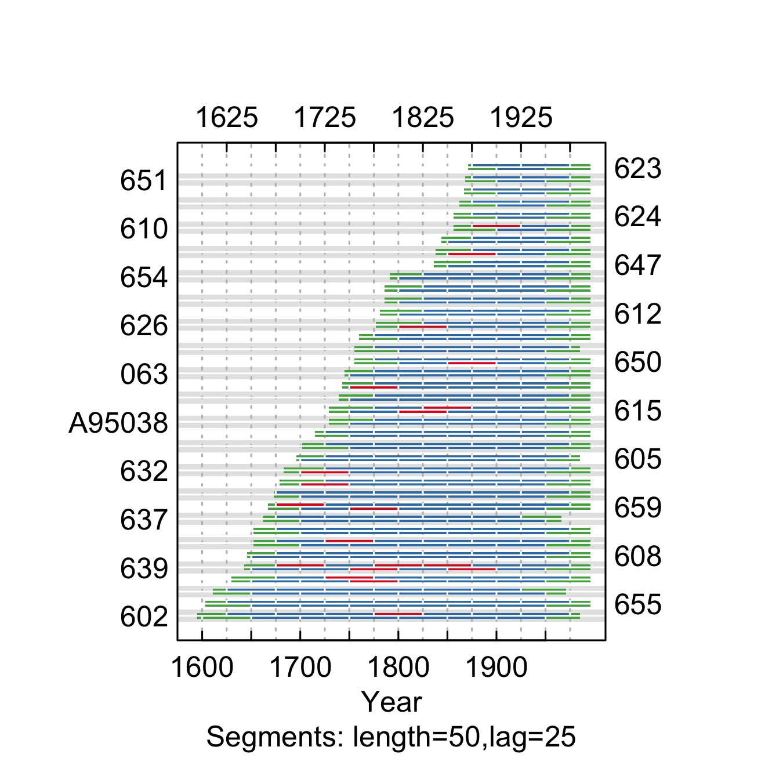

**Figure** **:** The correlations between each tree-ring series and a main chronology built from all other series the Estes Park site. Correlations were calculated in 50-year segments that overlap by 25 years. Blue segments show period that correlate well with the main chronology (p<0.1). Red segments show poor correlation with the main chronology (p>0.1). Green segments show periods do not overlap with the main chronology.

summary.tab <- summary.rwl(rwlj)  
summary.tab$rho <- round(corr.rwl.seg(rwlj, seg.length=50, pcrit=0.1, make.plot=F)$overall[,1],2)  
summary.tab$notes <- "Retained"  
  
summary.tab <- summary.tab %>% select(series, first, last, rho, notes) %>% mutate(first=as.character(first), last=as.character(last))  
colnames(summary.tab) <- c("Series", "First\nyear", "Last\nyear", "Spearman's correlation", "Notes")  
  
summary.tab[summary.tab$Series=="632", "Notes"] <- "Years prior to 1750 were removed due to poor correlation"  
  
summary.tab[order(summary.tab$Series),] %>% flextable() %>% flextable::align(j=-1, align = "center", part = "all") %>% set_table_properties(layout = "autofit", width=1)

**Table** **:** Series statistics and cross-dating notes for the Estes Park site. Spearman's correlations were calculated over the common period of overlap between the series and a main chronology built from all other series.

| Series | First year | Last year | Spearman's correlation | Notes |
| --- | --- | --- | --- | --- |
| 063 | 1743 | 1995 | 0.55 | Retained |
| 602 | 1591 | 1984 | 0.44 | Retained |
| 605 | 1690 | 1984 | 0.52 | Retained |
| 606 | 1676 | 1995 | 0.42 | Retained |
| 607 | 1646 | 1995 | 0.50 | Retained |
| 608 | 1643 | 1995 | 0.55 | Retained |
| 609 | 1864 | 1995 | 0.62 | Retained |
| 610 | 1855 | 1995 | 0.47 | Retained |
| 611 | 1781 | 1995 | 0.65 | Retained |
| 612 | 1777 | 1995 | 0.71 | Retained |
| 615 | 1725 | 1995 | 0.36 | Retained |
| 616 | 1736 | 1995 | 0.36 | Retained |
| 618 | 1827 | 1995 | 0.32 | Retained |
| 621 | 1746 | 1984 | 0.70 | Retained |
| 622 | 1757 | 1995 | 0.66 | Retained |
| 623 | 1868 | 1995 | 0.71 | Retained |
| 624 | 1848 | 1995 | 0.50 | Retained |
| 626 | 1770 | 1995 | 0.42 | Retained |
| 631 | 1708 | 1995 | 0.62 | Retained |
| 632 | 1679 | 1995 | 0.63 | Years prior to 1750 were removed due to poor correlation |
| 633 | 1694 | 1995 | 0.61 | Retained |
| 635 | 1626 | 1995 | 0.43 | Retained |
| 636 | 1646 | 1995 | 0.57 | Retained |
| 637 | 1659 | 1965 | 0.63 | Retained |
| 639 | 1635 | 1995 | 0.31 | Retained |
| 647 | 1834 | 1995 | 0.74 | Retained |
| 648 | 1833 | 1995 | 0.63 | Retained |
| 649 | 1741 | 1995 | 0.43 | Retained |
| 650 | 1752 | 1995 | 0.42 | Retained |
| 651 | 1862 | 1995 | 0.52 | Retained |
| 652 | 1859 | 1995 | 0.37 | Retained |
| 653 | 1781 | 1995 | 0.67 | Retained |
| 654 | 1788 | 1995 | 0.68 | Retained |
| 655 | 1592 | 1995 | 0.60 | Retained |
| 656 | 1594 | 1970 | 0.58 | Retained |
| 659 | 1646 | 1995 | 0.44 | Retained |
| 660 | 1664 | 1995 | 0.48 | Retained |
| A95038 | 1726 | 1995 | 0.59 | Retained |

rwlj <- clipfun(rwlz=rwlj, series.name="632", clip.year=1750)  
write.rwl(rwlj, fname=here("Data", "TreeRing", "Processed", "Host", "EP.rwl"), format="tucson")

### Frankenberger Point

We retained all series from the Frankenberger Point site, but trimmed two series because they were poorly correlated at the beginning of the record (Fig. ; Table ).

rwlj <-read.rwl(here("Data", "TreeRing", "Raw", "Host", "Veblen", "FP.rwl"))

rwljcor <- corr.rwl.seg(rwlj, seg.length=50, pcrit=0.1)

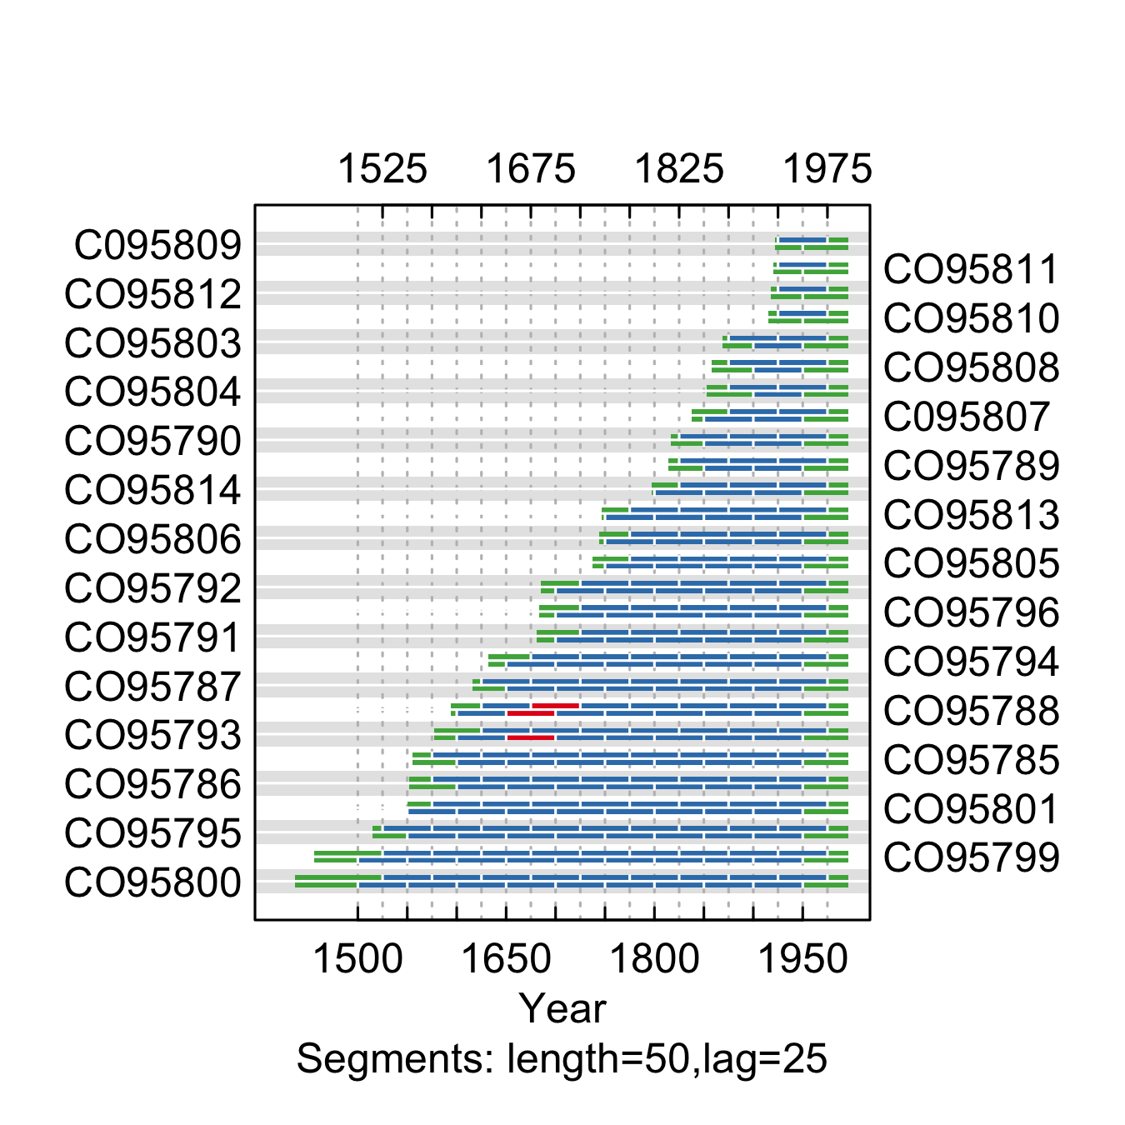

**Figure** **:** The Spearman’s correlations between each tree-ring series and a main chronology built from all other series from the Frankenberger Point site. Correlations were calculated in 50-year segments that overlap by 25 years. Blue segments show period that correlate well with the main chronology (p<0.1). Red segments show poor correlation with the main chronology (p>0.1). Green segments show periods do not overlap with the main chronology.

summary.tab <- summary.rwl(rwlj)  
summary.tab$rho <- round(corr.rwl.seg(rwlj, seg.length=50, pcrit=0.1, make.plot=F)$overall[,1],2)  
summary.tab$notes <- "Retained"  
  
summary.tab <- summary.tab %>% select(series, first, last, rho, notes) %>% mutate(first=as.character(first), last=as.character(last))  
colnames(summary.tab) <- c("Series", "First\nyear", "Last\nyear", "Spearman's correlation", "Notes")  
  
summary.tab[summary.tab$Series %in% c("CO95788", "CO95793"), "Notes"] <- "Removed years prior to 1700 due to poor correlation"  
  
summary.tab[order(summary.tab$Series),] %>% flextable() %>% flextable::align(j=-1, align = "center", part = "all") %>% set_table_properties(layout = "autofit", width=1)

**Table** **:** Series statistics and cross-dating notes for the Frankenberger Point site. Spearman's correlations were calculated over the common period of overlap between the series and a main chronology built from all other series.

| Series | First year | Last year | Spearman's correlation | Notes |
| --- | --- | --- | --- | --- |
| C095807 | 1833 | 1995 | 0.53 | Retained |
| C095809 | 1918 | 1995 | 0.69 | Retained |
| CO95785 | 1545 | 1995 | 0.64 | Retained |
| CO95786 | 1538 | 1995 | 0.59 | Retained |
| CO95787 | 1595 | 1995 | 0.67 | Retained |
| CO95788 | 1585 | 1995 | 0.59 | Removed years prior to 1700 due to poor correlation |
| CO95789 | 1799 | 1995 | 0.51 | Retained |
| CO95790 | 1807 | 1995 | 0.51 | Retained |
| CO95791 | 1674 | 1995 | 0.59 | Retained |
| CO95792 | 1682 | 1995 | 0.56 | Retained |
| CO95793 | 1572 | 1995 | 0.66 | Removed years prior to 1700 due to poor correlation |
| CO95794 | 1627 | 1995 | 0.64 | Retained |
| CO95795 | 1505 | 1995 | 0.52 | Retained |
| CO95796 | 1679 | 1995 | 0.63 | Retained |
| CO95799 | 1442 | 1995 | 0.60 | Retained |
| CO95800 | 1419 | 1995 | 0.52 | Retained |
| CO95801 | 1533 | 1995 | 0.45 | Retained |
| CO95803 | 1867 | 1995 | 0.70 | Retained |
| CO95804 | 1850 | 1995 | 0.60 | Retained |
| CO95805 | 1724 | 1995 | 0.62 | Retained |
| CO95806 | 1735 | 1995 | 0.65 | Retained |
| CO95808 | 1853 | 1995 | 0.69 | Retained |
| CO95810 | 1913 | 1995 | 0.65 | Retained |
| CO95811 | 1917 | 1995 | 0.54 | Retained |
| CO95812 | 1916 | 1995 | 0.58 | Retained |
| CO95813 | 1731 | 1995 | 0.49 | Retained |
| CO95814 | 1786 | 1995 | 0.53 | Retained |

rwlj <- clipfun(rwlz=rwlj, series.name="CO95788", clip.year=1700)  
rwlj <- clipfun(rwlz=rwlj, series.name="CO95793", clip.year=1700)  
write.rwl(rwlj, fname=here("Data", "TreeRing", "Processed", "Host", "FP.rwl"), format="tucson")

### South Hollowell

We retained all series from the South Hollowell site (Fig. ; Table ).

rwlj <-read.rwl(here("Data", "TreeRing", "Raw", "Host", "Veblen", "SH.rwl"))

rwljcor <- corr.rwl.seg(rwlj, seg.length=50, pcrit=0.1)

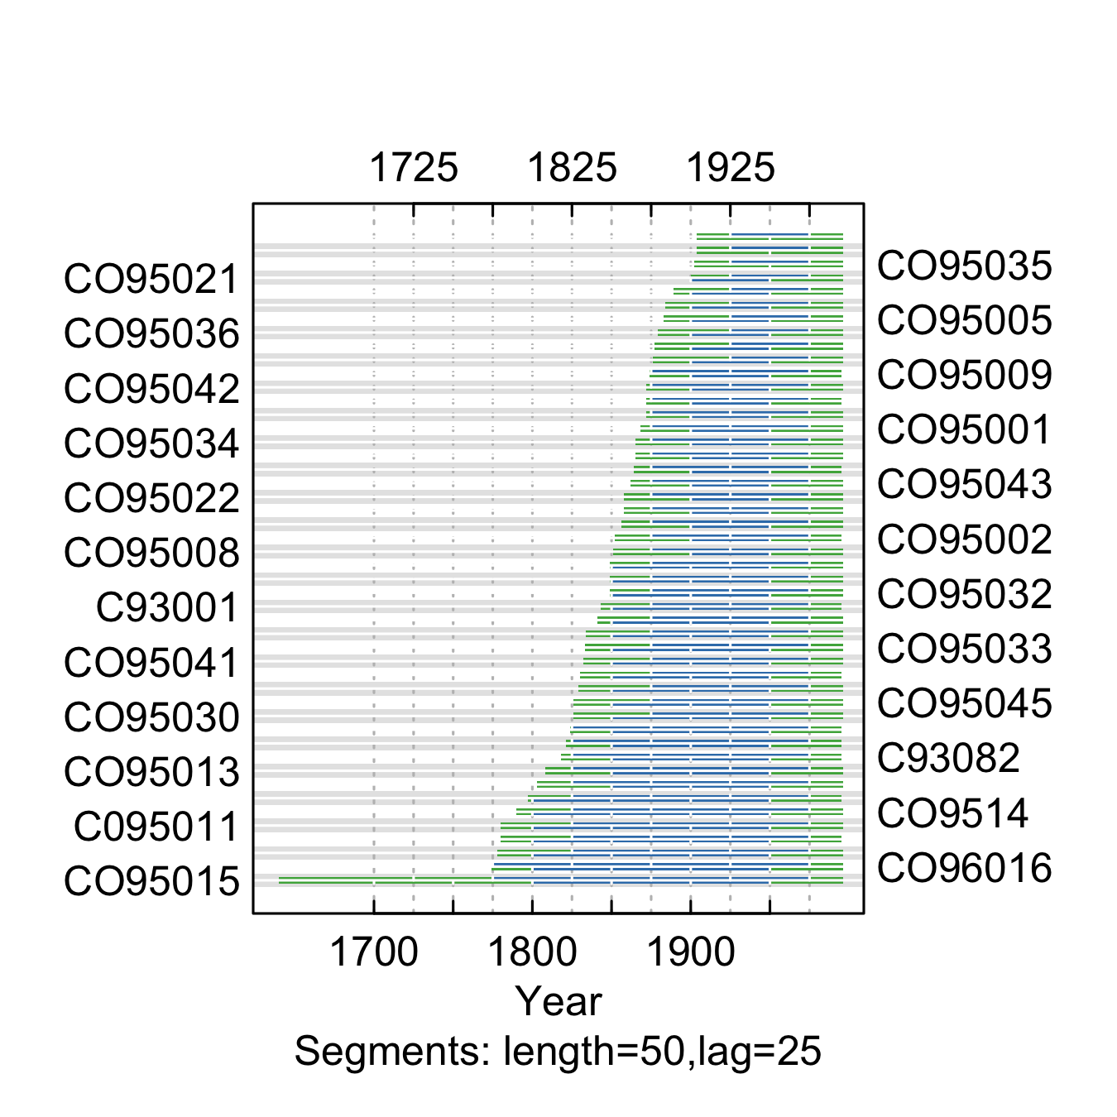

**Figure** **:** The correlations between each tree-ring series and a main chronology built from all other series from the South Hollowell site. Correlations were calculated in 50-year segments that overlap by 25 years. Blue segments show period that correlate well with the main chronology (p<0.1). Red segments show poor correlation with the main chronology (p>0.1). Green segments show periods do not overlap with the main chronology.

summary.tab <- summary.rwl(rwlj)  
summary.tab$rho <- round(corr.rwl.seg(rwlj, seg.length=50, pcrit=0.1, make.plot=F)$overall[,1],2)  
summary.tab$notes <- "Retained"  
  
summary.tab <- summary.tab %>% select(series, first, last, rho, notes) %>% mutate(first=as.character(first), last=as.character(last))  
  
colnames(summary.tab) <- c("Series", "First\nyear", "Last\nyear", "Spearman's correlation", "Notes")  
  
summary.tab[order(summary.tab$Series),] %>% flextable() %>% flextable::align(j=-1, align = "center", part = "all") %>% set_table_properties(layout = "autofit", width=1)

**Table** **:** Series statistics and cross-dating notes for the South Hollowell site. Spearman's correlations were calculated over the common period of overlap between the series and a main chronology built from all other series.

| Series | First year | Last year | Spearman's correlation | Notes |
| --- | --- | --- | --- | --- |
| C095011 | 1770 | 1995 | 0.58 | Retained |
| C93001 | 1841 | 1994 | 0.81 | Retained |
| C93003 | 1819 | 1994 | 0.75 | Retained |
| C93004 | 1777 | 1994 | 0.83 | Retained |
| C93009 | 1861 | 1994 | 0.77 | Retained |
| C93013 | 1819 | 1994 | 0.73 | Retained |
| C93017 | 1796 | 1994 | 0.77 | Retained |
| C93018 | 1825 | 1994 | 0.66 | Retained |
| C93082 | 1817 | 1994 | 0.82 | Retained |
| CO95001 | 1866 | 1995 | 0.74 | Retained |
| CO95002 | 1850 | 1994 | 0.70 | Retained |
| CO95003 | 1871 | 1995 | 0.77 | Retained |
| CO95004 | 1883 | 1995 | 0.71 | Retained |
| CO95005 | 1882 | 1995 | 0.61 | Retained |
| CO95006 | 1857 | 1995 | 0.66 | Retained |
| CO95007 | 1863 | 1995 | 0.59 | Retained |
| CO95008 | 1849 | 1995 | 0.77 | Retained |
| CO95009 | 1873 | 1994 | 0.63 | Retained |
| CO95010 | 1888 | 1995 | 0.78 | Retained |
| CO95012 | 1829 | 1995 | 0.66 | Retained |
| CO95013 | 1807 | 1995 | 0.80 | Retained |
| CO95015 | 1638 | 1995 | 0.42 | Retained |
| CO95017 | 1869 | 1994 | 0.71 | Retained |
| CO95018 | 1770 | 1995 | 0.74 | Retained |
| CO95020 | 1900 | 1995 | 0.63 | Retained |
| CO95021 | 1896 | 1995 | 0.64 | Retained |
| CO95022 | 1857 | 1995 | 0.66 | Retained |
| CO95023 | 1798 | 1995 | 0.42 | Retained |
| CO95025 | 1901 | 1995 | 0.63 | Retained |
| CO95027 | 1853 | 1995 | 0.48 | Retained |
| CO95028 | 1840 | 1995 | 0.76 | Retained |
| CO95029 | 1875 | 1995 | 0.78 | Retained |
| CO95030 | 1821 | 1995 | 0.74 | Retained |
| CO95031 | 1876 | 1995 | 0.72 | Retained |
| CO95032 | 1848 | 1995 | 0.76 | Retained |
| CO95033 | 1831 | 1995 | 0.64 | Retained |
| CO95034 | 1864 | 1995 | 0.67 | Retained |
| CO95035 | 1901 | 1995 | 0.74 | Retained |
| CO95036 | 1877 | 1995 | 0.77 | Retained |
| CO95038 | 1845 | 1995 | 0.70 | Retained |
| CO95041 | 1831 | 1995 | 0.72 | Retained |
| CO95042 | 1871 | 1995 | 0.64 | Retained |
| CO95043 | 1861 | 1995 | 0.70 | Retained |
| CO95044 | 1845 | 1995 | 0.68 | Retained |
| CO95045 | 1823 | 1995 | 0.51 | Retained |
| CO95046 | 1827 | 1995 | 0.60 | Retained |
| CO9514 | 1785 | 1995 | 0.65 | Retained |
| CO96016 | 1765 | 1995 | 0.77 | Retained |

write.rwl(rwlj, fname=here("Data", "TreeRing", "Processed", "Host", "SH.rwl"), format="tucson")

### West Rd. 211

We retained all series from the West Rd. 211 site (Fig. ; Table ).

rwlj <-read.rwl(here("Data", "TreeRing", "Raw", "Host", "Veblen", "WR.rwl"))

rwljcor <- corr.rwl.seg(rwlj, seg.length=50, pcrit=0.1)

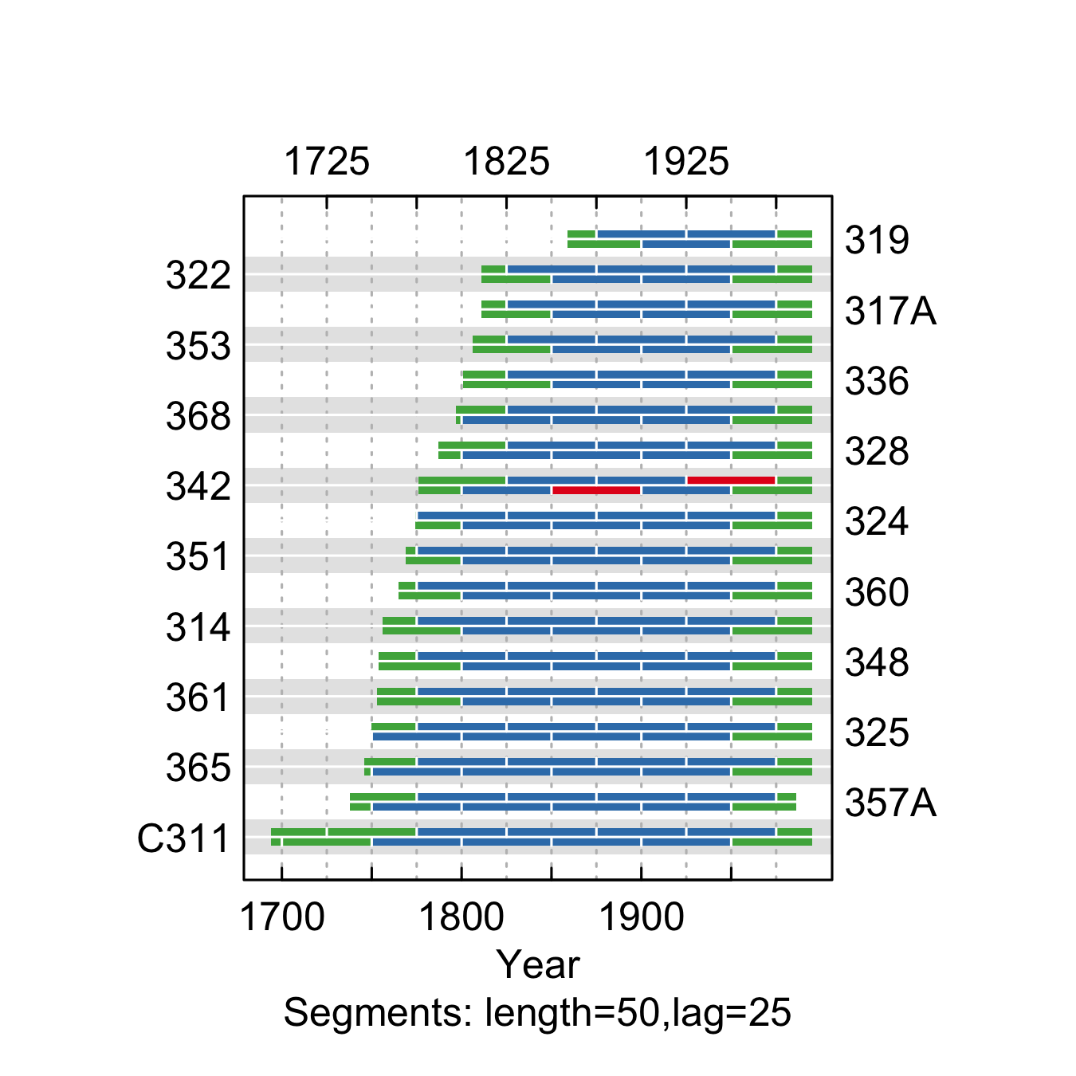

**Figure** **:** The correlations between each tree-ring series and a main chronology built from all other series from the West Rd. 211 site. Correlations were calculated in 50-year segments that overlap by 25 years. Blue segments show period that correlate well with the main chronology (p<0.1). Red segments show poor correlation with the main chronology (p>0.1). Green segments show periods do not overlap with the main chronology.

summary.tab <- summary.rwl(rwlj)  
summary.tab$rho <- round(corr.rwl.seg(rwlj, seg.length=50, pcrit=0.1, make.plot=F)$overall[,1],2)  
summary.tab$notes <- "Retained"  
  
summary.tab <- summary.tab %>% select(series, first, last, rho, notes) %>% mutate(first=as.character(first), last=as.character(last))  
  
colnames(summary.tab) <- c("Series", "First\nyear", "Last\nyear", "Spearman's correlation", "Notes")  
  
summary.tab[order(summary.tab$Series),] %>% flextable() %>% flextable::align(j=-1, align = "center", part = "all") %>% set_table_properties(layout = "autofit", width=1)

**Table** **:** Series statistics and cross-dating notes for the West Rd. 211 site. Spearman's correlations were calculated over the common period of overlap between the series and a main chronology built from all other series.

| Series | First year | Last year | Spearman's correlation | Notes |
| --- | --- | --- | --- | --- |
| 314 | 1753 | 1994 | 0.72 | Retained |
| 317A | 1808 | 1994 | 0.61 | Retained |
| 319 | 1858 | 1994 | 0.69 | Retained |
| 322 | 1808 | 1994 | 0.67 | Retained |
| 324 | 1771 | 1994 | 0.82 | Retained |
| 325 | 1739 | 1994 | 0.71 | Retained |
| 328 | 1783 | 1994 | 0.78 | Retained |
| 336 | 1798 | 1994 | 0.46 | Retained |
| 342 | 1767 | 1994 | 0.42 | Retained |
| 348 | 1742 | 1994 | 0.48 | Retained |
| 351 | 1762 | 1994 | 0.76 | Retained |
| 353 | 1803 | 1994 | 0.67 | Retained |
| 357A | 1731 | 1985 | 0.66 | Retained |
| 360 | 1762 | 1994 | 0.78 | Retained |
| 361 | 1747 | 1994 | 0.60 | Retained |
| 365 | 1743 | 1994 | 0.76 | Retained |
| 368 | 1795 | 1994 | 0.70 | Retained |
| C311 | 1691 | 1994 | 0.75 | Retained |

### Write to file  
write.rwl(rwlj,fname=here("Data", "TreeRing", "Processed", "Host", "WR.rwl"), format="tucson")

### Lost Jeep

We retained all series from the Lost Jeep site (Fig. ; Table ).

rwlj <-read.rwl(here("Data", "TreeRing", "Raw", "Host", "Veblen", "JP.rwl"))

rwljcor <- corr.rwl.seg(rwlj, seg.length=50, pcrit=0.1)

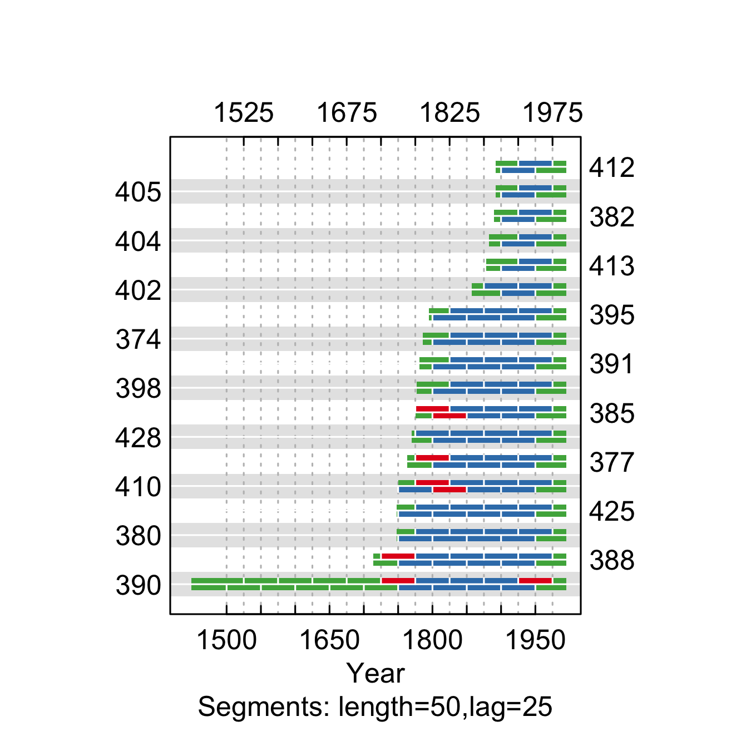

**Figure** **:** The correlations between each tree-ring series and a main chronology built from all other series from the Lost Jeep site. Correlations were calculated in 50-year segments that overlap by 25 years. Blue segments show period that correlate well with the main chronology (p<0.1). Red segments show poor correlation with the main chronology (p>0.1). Green segments show periods do not overlap with the main chronology.

summary.tab <- summary.rwl(rwlj)  
summary.tab$rho <- round(corr.rwl.seg(rwlj, seg.length=50, pcrit=0.1, make.plot=F)$overall[,1],2)  
summary.tab$notes <- "Retained"  
  
summary.tab <- summary.tab %>% select(series, first, last, rho, notes) %>% mutate(first=as.character(first), last=as.character(last))  
colnames(summary.tab) <- c("Series", "First\nyear", "Last\nyear", "Spearman's correlation", "Notes")  
  
summary.tab[summary.tab$Series %in% c("390"), "Notes"] <- "Removed - poorly correlated with the other series"  
  
summary.tab[order(summary.tab$Series),] %>% flextable() %>% flextable::align(j=-1, align = "center", part = "all") %>% set_table_properties(layout = "autofit", width=1)

**Table** **:** Series statistics and cross-dating notes for the Lost Jeep site. Spearman's correlations were calculated over the common period of overlap between the series and a main chronology built from all other series.

| Series | First year | Last year | Spearman's correlation | Notes |
| --- | --- | --- | --- | --- |
| 374 | 1775 | 1994 | 0.77 | Retained |
| 377 | 1759 | 1994 | 0.57 | Retained |
| 380 | 1745 | 1994 | 0.59 | Retained |
| 382 | 1887 | 1994 | 0.85 | Retained |
| 385 | 1765 | 1994 | 0.36 | Retained |
| 388 | 1706 | 1994 | 0.51 | Retained |
| 390 | 1440 | 1994 | 0.39 | Removed - poorly correlated with the other series |
| 391 | 1778 | 1994 | 0.73 | Retained |
| 395 | 1792 | 1994 | 0.69 | Retained |
| 398 | 1774 | 1994 | 0.68 | Retained |
| 402 | 1849 | 1994 | 0.63 | Retained |
| 404 | 1877 | 1994 | 0.57 | Retained |
| 405 | 1889 | 1994 | 0.76 | Retained |
| 410 | 1745 | 1994 | 0.49 | Retained |
| 412 | 1889 | 1994 | 0.71 | Retained |
| 413 | 1875 | 1994 | 0.67 | Retained |
| 425 | 1741 | 1994 | 0.60 | Retained |
| 428 | 1767 | 1994 | 0.73 | Retained |

write.rwl(rwlj, fname=here("Data", "TreeRing", "Processed", "Host", "JP.rwl"), format="tucson")

### Wigwam 1

We retained all series from the Wigwam 1 site (Fig. ; Table ).

rwlj <-read.rwl(here("Data", "TreeRing", "Raw", "Host", "Veblen", "WW.rwl"))

rwljcor <- corr.rwl.seg(rwlj, seg.length=50, pcrit=0.1)

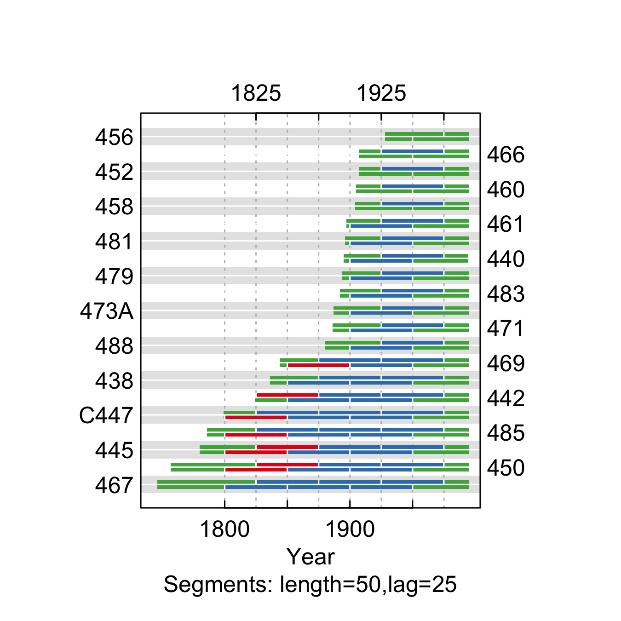

**Figure** **:** The correlations between each tree-ring series and a main chronology built from all other series from the Wigwam 1 site. Correlations were calculated in 50-year segments that overlap by 25 years. Blue segments show period that correlate well with the main chronology (p<0.1). Red segments show poor correlation with the main chronology (p>0.1). Green segments show periods do not overlap with the main chronology.

summary.tab <- summary.rwl(rwlj)  
summary.tab$rho <- round(corr.rwl.seg(rwlj, seg.length=50, pcrit=0.1, make.plot=F)$overall[,1],2)  
summary.tab$notes <- "Retained"  
  
summary.tab <- summary.tab %>% select(series, first, last, rho, notes) %>% mutate(first=as.character(first), last=as.character(last))  
colnames(summary.tab) <- c("Series", "First\nyear", "Last\nyear", "Spearman's correlation", "Notes")  
  
summary.tab[order(summary.tab$Series),] %>% flextable() %>% flextable::align(j=-1, align = "center", part = "all") %>% set_table_properties(layout = "autofit", width=1)

**Table** **:** Series statistics and cross-dating notes for the Wigwam 1 site. Spearman's correlations were calculated over the common period of overlap between the series and a main chronology built from all other series.

| Series | First year | Last year | Spearman's correlation | Notes |
| --- | --- | --- | --- | --- |
| 438 | 1824 | 1994 | 0.65 | Retained |
| 440 | 1891 | 1993 | 0.40 | Retained |
| 442 | 1821 | 1994 | 0.59 | Retained |
| 445 | 1770 | 1994 | 0.39 | Retained |
| 450 | 1754 | 1994 | 0.39 | Retained |
| 452 | 1905 | 1994 | 0.65 | Retained |
| 456 | 1923 | 1994 | 0.62 | Retained |
| 458 | 1901 | 1994 | 0.70 | Retained |
| 460 | 1902 | 1994 | 0.44 | Retained |
| 461 | 1890 | 1994 | 0.54 | Retained |
| 466 | 1904 | 1994 | 0.56 | Retained |
| 467 | 1743 | 1994 | 0.48 | Retained |
| 469 | 1841 | 1994 | 0.54 | Retained |
| 471 | 1884 | 1994 | 0.38 | Retained |
| 473A | 1874 | 1994 | 0.46 | Retained |
| 479 | 1889 | 1994 | 0.71 | Retained |
| 481 | 1888 | 1994 | 0.60 | Retained |
| 483 | 1889 | 1994 | 0.55 | Retained |
| 485 | 1783 | 1994 | 0.38 | Retained |
| 488 | 1872 | 1994 | 0.57 | Retained |
| C447 | 1792 | 1994 | 0.55 | Retained |

write.rwl(rwlj, fname=here("Data", "TreeRing", "Processed", "Host", "WW.rwl"), format="tucson")

### South Rd. 30

We retained all series from the South Rd. 30 site (Fig. ; Table ).

rwlj <-read.rwl(here("Data", "TreeRing", "Raw", "Host", "Veblen", "SR.rwl"))

rwljcor <- corr.rwl.seg(rwlj, seg.length=50, pcrit=0.1)

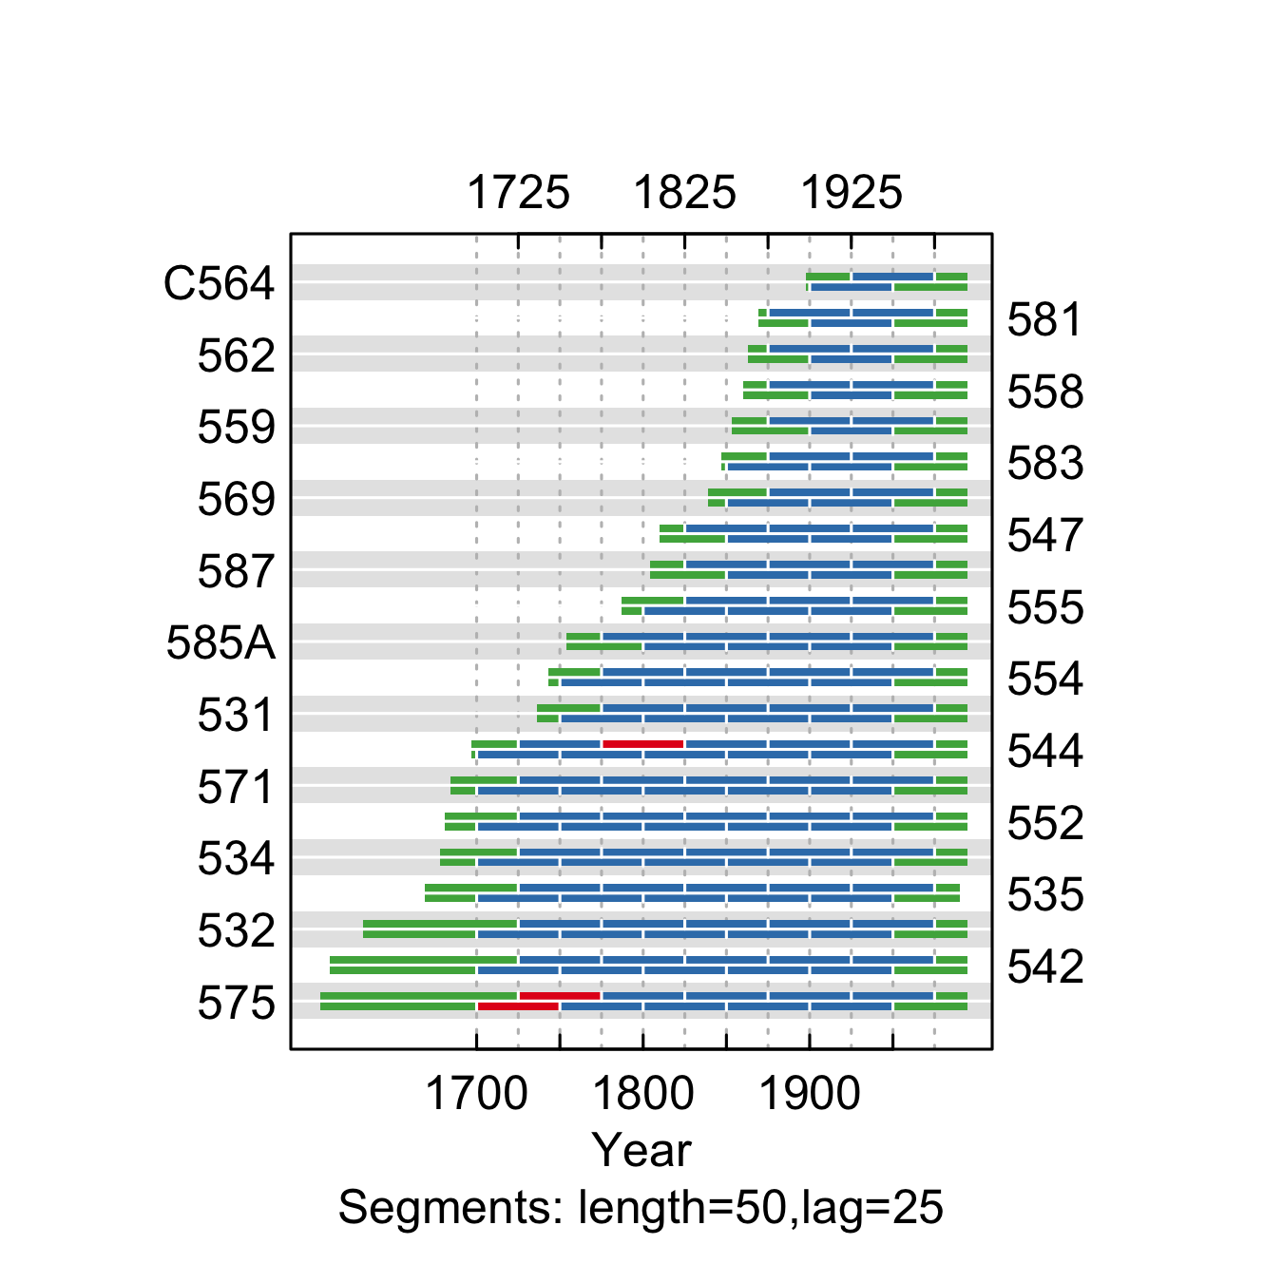

**Figure** **:** The correlations between each tree-ring series and a main chronology built from all other series from the the South Rd. 30 site. Correlations were calculated in 50-year segments that overlap by 25 years. Blue segments show period that correlate well with the main chronology (p<0.1). Red segments show poor correlation with the main chronology (p>0.1). Green segments show periods do not overlap with the main chronology.

summary.tab <- summary.rwl(rwlj)  
summary.tab$rho <- round(corr.rwl.seg(rwlj, seg.length=50, pcrit=0.1, make.plot=F)$overall[,1],2)  
summary.tab$notes <- "Retained"  
  
summary.tab <- summary.tab %>% select(series, first, last, rho, notes) %>% mutate(first=as.character(first), last=as.character(last))  
colnames(summary.tab) <- c("Series", "First\nyear", "Last\nyear", "Spearman's correlation", "Notes")  
  
summary.tab[summary.tab$Series %in% c("300", "276"), "Notes"] <- "Removed - poorly correlated with the other series"  
  
summary.tab[order(summary.tab$Series),] %>% flextable() %>% flextable::align(j=-1, align = "center", part = "all") %>% set_table_properties(layout = "autofit", width=1)

**Table** **:** Series statistics and cross-dating notes for the South Rd. 30 site. Spearman's correlations were calculated over the common period of overlap between the series and a main chronology built from all other series.

| Series | First year | Last year | Spearman's correlation | Notes |
| --- | --- | --- | --- | --- |
| 531 | 1732 | 1994 | 0.75 | Retained |
| 532 | 1630 | 1994 | 0.56 | Retained |
| 534 | 1676 | 1994 | 0.69 | Retained |
| 535 | 1666 | 1989 | 0.49 | Retained |
| 542 | 1609 | 1994 | 0.48 | Retained |
| 544 | 1695 | 1994 | 0.54 | Retained |
| 547 | 1808 | 1994 | 0.54 | Retained |
| 552 | 1679 | 1994 | 0.55 | Retained |
| 554 | 1741 | 1994 | 0.62 | Retained |
| 555 | 1782 | 1994 | 0.41 | Retained |
| 558 | 1858 | 1994 | 0.62 | Retained |
| 559 | 1851 | 1994 | 0.64 | Retained |
| 562 | 1862 | 1994 | 0.61 | Retained |
| 569 | 1835 | 1994 | 0.60 | Retained |
| 571 | 1676 | 1994 | 0.48 | Retained |
| 575 | 1604 | 1994 | 0.35 | Retained |
| 581 | 1867 | 1994 | 0.44 | Retained |
| 583 | 1845 | 1994 | 0.72 | Retained |
| 585A | 1751 | 1994 | 0.53 | Retained |
| 587 | 1800 | 1994 | 0.55 | Retained |
| C564 | 1897 | 1994 | 0.47 | Retained |

write.rwl(rwlj, fname=here("Data", "TreeRing", "Processed", "Host", "SR.rwl"), format="tucson")

### Summerland Park

We retained most series from the Summerland Park site, but removed two series because they were poorly correlated with the other series (Fig. ; Table ).

rwlj <-read.rwl(here("Data", "TreeRing", "Raw", "Host", "Veblen", "SP.rwl"))

rwljcor <- corr.rwl.seg(rwlj, seg.length=50, pcrit=0.1)

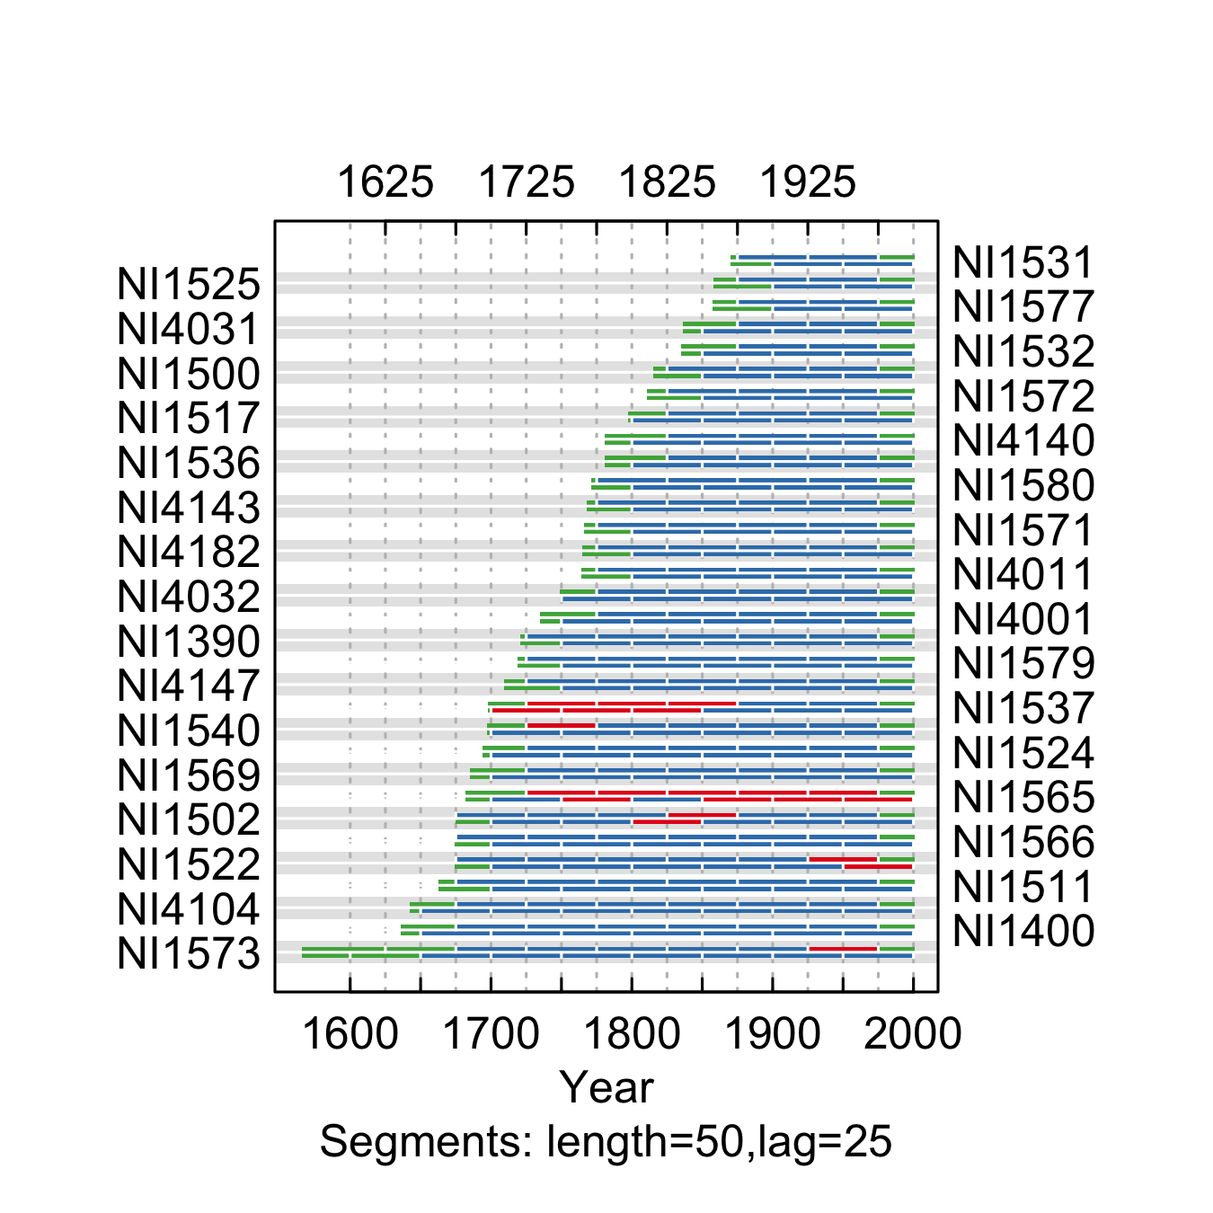

**Figure** **:** The correlations between each tree-ring series and a main chronology built from all other series from the Summerland Park site. Correlations were calculated in 50-year segments that overlap by 25 years. Blue segments show period that correlate well with the main chronology (p<0.1). Red segments show poor correlation with the main chronology (p>0.1). Green segments show periods do not overlap with the main chronology.

summary.tab <- summary.rwl(rwlj)  
summary.tab$rho <- round(corr.rwl.seg(rwlj, seg.length=50, pcrit=0.1, make.plot=F)$overall[,1],2)  
summary.tab$notes <- "Retained"  
  
summary.tab <- summary.tab %>% select(series, first, last, rho, notes) %>% mutate(first=as.character(first), last=as.character(last))  
  
colnames(summary.tab) <- c("Series", "First\nyear", "Last\nyear", "Spearman's correlation", "Notes")  
summary.tab[summary.tab$Series %in% c("NI1565", "NI1537"), "Notes"] <- "Removed - poorly correlated with the other series"  
  
summary.tab[order(summary.tab$Series),] %>% flextable() %>% flextable::align(j=-1, align = "center", part = "all") %>% set_table_properties(layout = "autofit", width=1)

**Table** **:** Series statistics and cross-dating notes for the Summerland Park site. Spearman's correlations were calculated over the common period of overlap between the series and a main chronology built from all other series.

| Series | First year | Last year | Spearman's correlation | Notes |
| --- | --- | --- | --- | --- |
| NI1390 | 1719 | 2000 | 0.65 | Retained |
| NI1400 | 1626 | 2000 | 0.53 | Retained |
| NI1500 | 1806 | 2000 | 0.65 | Retained |
| NI1502 | 1671 | 2000 | 0.61 | Retained |
| NI1511 | 1659 | 2000 | 0.57 | Retained |
| NI1517 | 1794 | 2000 | 0.56 | Retained |
| NI1522 | 1660 | 2000 | 0.61 | Retained |
| NI1524 | 1689 | 2000 | 0.74 | Retained |
| NI1525 | 1852 | 2000 | 0.63 | Retained |
| NI1531 | 1868 | 2000 | 0.66 | Retained |
| NI1532 | 1829 | 2000 | 0.63 | Retained |
| NI1536 | 1779 | 2000 | 0.53 | Retained |
| NI1537 | 1697 | 2000 | 0.23 | Removed - poorly correlated with the other series |
| NI1540 | 1696 | 2000 | 0.44 | Retained |
| NI1565 | 1679 | 2000 | 0.03 | Removed - poorly correlated with the other series |
| NI1566 | 1669 | 2000 | 0.59 | Retained |
| NI1569 | 1678 | 2000 | 0.66 | Retained |
| NI1571 | 1757 | 2000 | 0.65 | Retained |
| NI1572 | 1808 | 2000 | 0.60 | Retained |
| NI1573 | 1564 | 2000 | 0.48 | Retained |
| NI1577 | 1853 | 2000 | 0.63 | Retained |
| NI1579 | 1717 | 2000 | 0.72 | Retained |
| NI1580 | 1767 | 2000 | 0.66 | Retained |
| NI4001 | 1733 | 2000 | 0.63 | Retained |
| NI4011 | 1760 | 2000 | 0.65 | Retained |
| NI4031 | 1832 | 2000 | 0.61 | Retained |
| NI4032 | 1740 | 2000 | 0.51 | Retained |
| NI4104 | 1630 | 2000 | 0.48 | Retained |
| NI4140 | 1779 | 2000 | 0.64 | Retained |
| NI4143 | 1765 | 2000 | 0.67 | Retained |
| NI4147 | 1699 | 2000 | 0.63 | Retained |
| NI4182 | 1756 | 2000 | 0.58 | Retained |

rwlj <- rwlj[,!(colnames(rwlj) %in% c("NI1565", "NI1537"))]  
write.rwl(rwlj, fname=here("Data", "TreeRing", "Processed", "Host", "SP.rwl"), format="tucson")

### North Inlet

We retained most series from the North Inlet site, but removed ones series because it was poorly correlated with the other series (Fig. ; Table ).

rwlj <-read.rwl(here("Data", "TreeRing", "Raw", "Host", "Veblen", "NI.rwl"))

rwljcor <- corr.rwl.seg(rwlj, seg.length=50, pcrit=0.1)

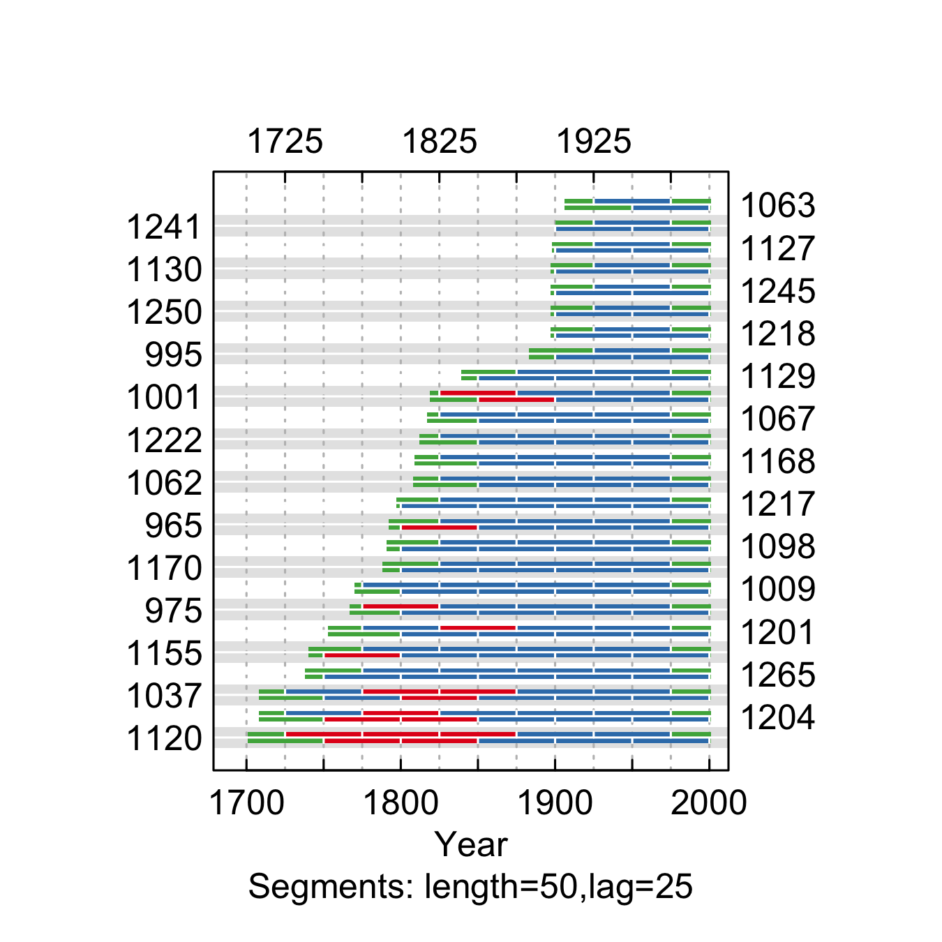

**Figure** **:** The correlations between each tree-ring series and a main chronology built from all other series from the North Inlet site. Correlations were calculated in 50-year segments that overlap by 25 years. Blue segments show period that correlate well with the main chronology (p<0.1). Red segments show poor correlation with the main chronology (p>0.1). Green segments show periods do not overlap with the main chronology.

summary.tab <- summary.rwl(rwlj)  
summary.tab$rho <- round(corr.rwl.seg(rwlj, seg.length=50, pcrit=0.1, make.plot=F)$overall[,1],2)  
summary.tab$notes <- "Retained"  
  
summary.tab <- summary.tab %>% select(series, first, last, rho, notes) %>% mutate(first=as.character(first), last=as.character(last))  
colnames(summary.tab) <- c("Series", "First\nyear", "Last\nyear", "Spearman's correlation", "Notes")  
  
summary.tab[summary.tab$Series %in% c("1120"), "Notes"] <- "Removed - poorly correlated with the other series"  
  
summary.tab[order(summary.tab$Series),] %>% flextable() %>% flextable::align(j=-1, align = "center", part = "all") %>% set_table_properties(layout = "autofit", width=1)

**Table** **:** Series statistics and cross-dating notes for the North Inlet site. Spearman's correlations were calculated over the common period of overlap between the series and a main chronology built from all other series.

| Series | First year | Last year | Spearman's correlation | Notes |
| --- | --- | --- | --- | --- |
| 1001 | 1800 | 2000 | 0.32 | Retained |
| 1009 | 1766 | 2000 | 0.53 | Retained |
| 1037 | 1704 | 2000 | 0.29 | Retained |
| 1062 | 1805 | 2000 | 0.56 | Retained |
| 1063 | 1901 | 2000 | 0.75 | Retained |
| 1067 | 1809 | 2000 | 0.47 | Retained |
| 1098 | 1789 | 2000 | 0.51 | Retained |
| 1120 | 1691 | 2000 | 0.28 | Removed - poorly correlated with the other series |
| 1127 | 1894 | 2000 | 0.64 | Retained |
| 1129 | 1827 | 2000 | 0.42 | Retained |
| 1130 | 1889 | 2000 | 0.46 | Retained |
| 1155 | 1739 | 2000 | 0.36 | Retained |
| 1168 | 1800 | 2000 | 0.57 | Retained |
| 1170 | 1781 | 2000 | 0.47 | Retained |
| 1201 | 1750 | 2000 | 0.38 | Retained |
| 1204 | 1700 | 2000 | 0.30 | Retained |
| 1217 | 1787 | 2000 | 0.51 | Retained |
| 1218 | 1890 | 2000 | 0.42 | Retained |
| 1222 | 1806 | 2000 | 0.38 | Retained |
| 1241 | 1897 | 2000 | 0.72 | Retained |
| 1245 | 1894 | 2000 | 0.44 | Retained |
| 1250 | 1894 | 2000 | 0.61 | Retained |
| 1265 | 1730 | 2000 | 0.40 | Retained |
| 965 | 1787 | 2000 | 0.34 | Retained |
| 975 | 1763 | 2000 | 0.46 | Retained |
| 995 | 1879 | 2000 | 0.51 | Retained |

rwlj <- rwlj[,!(colnames(rwlj) %in% c("1120"))]  
### Write to file  
write.rwl(rwlj, fname=here("Data", "TreeRing", "Processed", "Host", "NI.rwl"), format="tucson")

### Three Island Lake Trail

We retained all series from the Three Island Lake Trail (Fig. ; Table ).

rwlj <-read.rwl(here("Data", "TreeRing", "Raw", "Host", "Veblen", "TI.rwl"))

rwljcor <- corr.rwl.seg(rwlj, seg.length=50, pcrit=0.1)

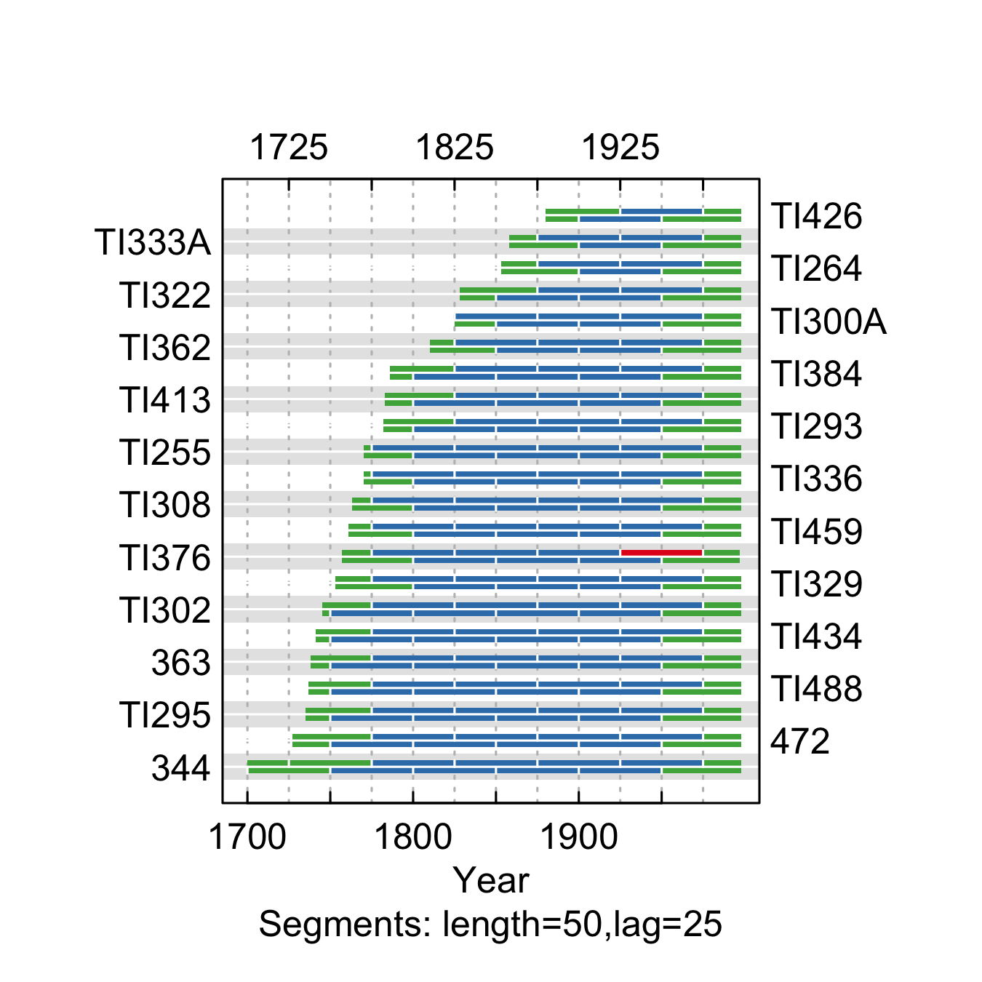

**Figure** **:** The correlations between each tree-ring series and a main chronology built from all other series from the Three Island Lake Trail site. Correlations were calculated in 50-year segments that overlap by 25 years. Blue segments show period that correlate well with the main chronology (p<0.1). Red segments show poor correlation with the main chronology (p>0.1). Green segments show periods do not overlap with the main chronology.

summary.tab <- summary.rwl(rwlj)  
summary.tab$rho <- round(corr.rwl.seg(rwlj, seg.length=50, pcrit=0.1, make.plot=F)$overall[,1],2)  
summary.tab$notes <- "Retained"  
  
summary.tab <- summary.tab %>% select(series, first, last, rho, notes) %>% mutate(first=as.character(first), last=as.character(last))  
  
colnames(summary.tab) <- c("Series", "First\nyear", "Last\nyear", "Spearman's correlation", "Notes")  
  
summary.tab[order(summary.tab$Series),] %>% flextable() %>% flextable::align(j=-1, align = "center", part = "all") %>% set_table_properties(layout = "autofit", width=1)

**Table** **:** Series statistics and cross-dating notes for the Three Island Lake Trail site. Spearman's correlations were calculated over the common period of overlap between the series and a main chronology built from all other series.

| Series | First year | Last year | Spearman's correlation | Notes |
| --- | --- | --- | --- | --- |
| 344 | 1697 | 1997 | 0.62 | Retained |
| 363 | 1735 | 1997 | 0.51 | Retained |
| 472 | 1721 | 1997 | 0.52 | Retained |
| TI255 | 1768 | 1997 | 0.64 | Retained |
| TI264 | 1850 | 1997 | 0.67 | Retained |
| TI293 | 1778 | 1997 | 0.71 | Retained |
| TI295 | 1733 | 1997 | 0.48 | Retained |
| TI300A | 1824 | 1997 | 0.61 | Retained |
| TI302 | 1741 | 1997 | 0.66 | Retained |
| TI308 | 1759 | 1997 | 0.58 | Retained |
| TI322 | 1827 | 1997 | 0.64 | Retained |
| TI329 | 1751 | 1997 | 0.54 | Retained |
| TI333A | 1857 | 1997 | 0.63 | Retained |
| TI336 | 1767 | 1997 | 0.53 | Retained |
| TI362 | 1809 | 1997 | 0.62 | Retained |
| TI376 | 1754 | 1996 | 0.47 | Retained |
| TI384 | 1784 | 1997 | 0.69 | Retained |
| TI413 | 1782 | 1997 | 0.69 | Retained |
| TI426 | 1872 | 1997 | 0.62 | Retained |
| TI434 | 1732 | 1997 | 0.65 | Retained |
| TI459 | 1757 | 1997 | 0.64 | Retained |
| TI488 | 1733 | 1997 | 0.53 | Retained |

write.rwl(rwlj, fname=here("Data", "TreeRing", "Processed", "Host", "TI.rwl"), format="tucson")

### Wild Basin

We retained all series from the Wild Basin site, but trimmed one series to the period following 1800 because of poor correlation in the early part of the record (Fig. ; Table ).

rwlj <-read.rwl(here("Data", "TreeRing", "Raw", "Host", "Veblen", "WB.rwl"))

rwljcor <- corr.rwl.seg(rwlj, seg.length=50, pcrit=0.1)

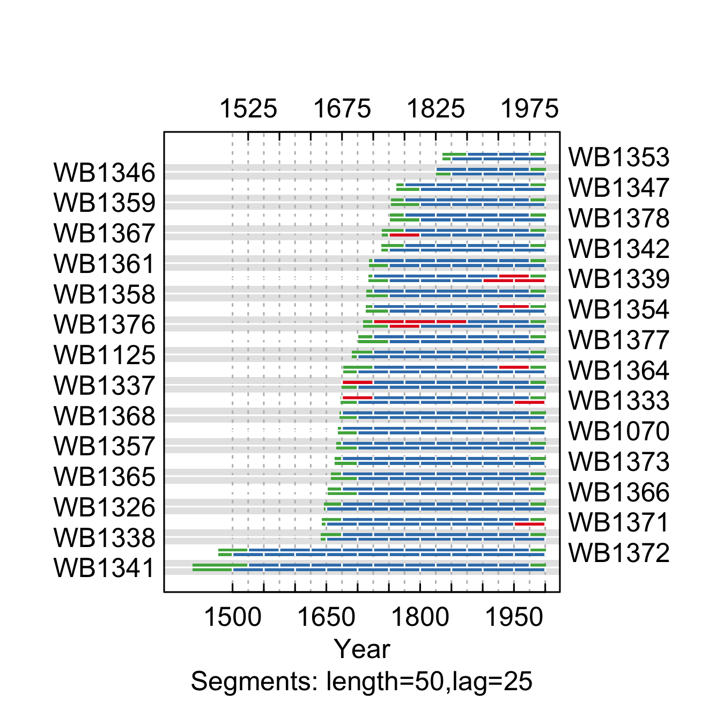

**Figure** **:** The correlations between each tree-ring series and a main chronology built from all other series for the Wild Basin site. Correlations were calculated in 50-year segments that overlap by 25 years. Blue segments show period that correlate well with the main chronology (p<0.1). Red segments show poor correlation with the main chronology (p>0.1). Green segments show periods do not overlap with the main chronology.

summary.tab <- summary.rwl(rwlj)  
summary.tab$rho <- round(corr.rwl.seg(rwlj, seg.length=50, pcrit=0.1, make.plot=F)$overall[,1],2)  
summary.tab$notes <- "Retained"  
  
summary.tab <- summary.tab %>% select(series, first, last, rho, notes) %>% mutate(first=as.character(first), last=as.character(last))  
colnames(summary.tab) <- c("Series", "First\nyear", "Last\nyear", "Spearman's correlation", "Notes")  
  
summary.tab[summary.tab$Series %in% c("WB1367"), "Notes"] <- "Trimmed series to remove all years prior to 1800 due to poor correlation"  
  
summary.tab[order(summary.tab$Series),] %>% flextable() %>% flextable::align(j=-1, align = "center", part = "all") %>% set_table_properties(layout = "autofit", width=1) %>% paginate

**Table** **:** Series statistics and cross-dating notes for the Wild Basin site. Spearman's correlations were calculated over the common period of overlap between the series and a main chronology built from all other series.

| Series | First year | Last year | Spearman's correlation | Notes |
| --- | --- | --- | --- | --- |
| WB1070 | 1661 | 2000 | 0.53 | Retained |
| WB1125 | 1677 | 2000 | 0.60 | Retained |
| WB1326 | 1639 | 2000 | 0.53 | Retained |
| WB1333 | 1657 | 2000 | 0.36 | Retained |
| WB1337 | 1670 | 2000 | 0.39 | Retained |
| WB1338 | 1637 | 2000 | 0.47 | Retained |
| WB1339 | 1712 | 2000 | 0.31 | Retained |
| WB1341 | 1414 | 2000 | 0.49 | Retained |
| WB1342 | 1729 | 2000 | 0.52 | Retained |
| WB1346 | 1824 | 2000 | 0.49 | Retained |
| WB1347 | 1750 | 2000 | 0.59 | Retained |
| WB1353 | 1835 | 2000 | 0.60 | Retained |
| WB1354 | 1707 | 2000 | 0.43 | Retained |
| WB1357 | 1659 | 2000 | 0.47 | Retained |
| WB1358 | 1703 | 2000 | 0.57 | Retained |
| WB1359 | 1751 | 2000 | 0.49 | Retained |
| WB1361 | 1713 | 2000 | 0.67 | Retained |
| WB1364 | 1673 | 2000 | 0.63 | Retained |
| WB1365 | 1650 | 2000 | 0.54 | Retained |
| WB1366 | 1646 | 2000 | 0.48 | Retained |
| WB1367 | 1735 | 2000 | 0.35 | Trimmed series to remove all years prior to 1800 due to poor correlation |
| WB1368 | 1657 | 2000 | 0.56 | Retained |
| WB1371 | 1634 | 2000 | 0.52 | Retained |
| WB1372 | 1467 | 2000 | 0.46 | Retained |
| WB1373 | 1652 | 2000 | 0.62 | Retained |
| WB1376 | 1695 | 2000 | 0.16 | Retained |
| WB1377 | 1676 | 2000 | 0.63 | Retained |
| WB1378 | 1750 | 2000 | 0.58 | Retained |

rwlj <- clipfun(rwlz=rwlj, series.name="WB1367", clip.year=1800)  
  
write.rwl(rwlj, fname=here("Data", "TreeRing", "Processed", "Host", "WB.rwl"), format="tucson")

keymet.host <- read.csv(here("Data", "TreeRing", "Raw", "Host", "Veblen", "SiteInfo-WSB.csv"))  
keymet.host$nseries=NA  
keymet.host$FirstYear=NA  
keymet.host$LastYear=NA  
keymet.host$interrbar=NA  
keymet.host$interrbar.sd=NA  
keymet.host$ar1bar=NA  
keymet.host$ar1bar.sd=NA  
  
  
### Calculate basic chronology statistics  
for(j in 1:nrow(keymet.host)){  
 series <- as.character(keymet.host[j, "SeriesCode"])  
 site <- keymet.host[j, "SiteName"]  
 series.site <- gsub( " ", "-",paste(series, site))  
 rwlj <- read.rwl(here("Data", "TreeRing", "Processed", "Host", paste0(series, ".rwl")))  
 rwl.reportj <- rwl.report(rwlj)  
 keymet.host[keymet.host$`SeriesCode`==series, "nseries"] <- rwl.reportj$nSeries # calculate the number of series  
 keymet.host[keymet.host$`SeriesCode`==series, "FirstYear"] <- rwl.reportj$firstYear# calculate the number of series  
 keymet.host[keymet.host$`SeriesCode`==series, "LastYear"] <- rwl.reportj$lastYear# calculate the number of series  
 keymet.host[keymet.host$`SeriesCode`==series, "interrbar"] <- rwl.reportj$meanInterSeriesCor # calculate mean interseries correlation  
 keymet.host[keymet.host$`SeriesCode`==series, "interrbar.sd"] <- rwl.reportj$sdInterSeriesCor# calculate sd interseries correlation  
 keymet.host[keymet.host$`SeriesCode`==series, "ar1bar"] <- rwl.reportj$meanAR1 # calculate mean first order autocorrelation  
 keymet.host[keymet.host$`SeriesCode`==series, "ar1bar.sd"] <- rwl.reportj$sdAR1 # calculate sd first order autocorrelation  
}  
  
write.csv(keymet.host, here("Data", "TreeRing", "Processed", "Host", "Host-Metadata.csv"), row.names=F)

# References

Bunn, A.G., 2008. A dendrochronology program library in R (dplR). Dendrochronologia 26, 115–124. <https://doi.org/10.1016/j.dendro.2008.01.002>

Bunn, A.G., Korpela, M., Campelo, F., Mérian, P., Qeadan, F., Zang, C., 2024. [dplR: Dendrochronology program library in R](https://CRAN.R-project.org/package=dplR).