Preprocessing of ponderosa pine chronologies for: Drought may initiate western spruce budworm outbreaks, but multi-year periods of increased moisture availability promote widespread defoliation

Sarah J. Hart, Olivia Santiago, Josh Carrell, and Thomas T. Veblen

January 15, 2025

# Overview

Here we compile metadata for ponderosa pine chronologies used as a non-host control series in our analyses. We also combine data from the same site that were collected in several collection efforts.

# Compile metadata

Additionally, we used the *dplR* package (Bunn et al., 2024; Bunn, 2008) to calculate the number of series, chronology length, mean and standard deviation of the interseries correlation, and the mean and standard deviation of the first order autocorrelation coefficient.

## International Tree Ring Database

We downloaded all available ponderosa pine chronologies collected in the state of Colorado from the International Tree Ring Databank (ITRDB).

## Veblen

We also acquired ponderosa pine chronologies initially collected by Veblen et al. (2000) and recollection data collected by Veblen, but unpublished.

# Combine recollections with original data

We computed the correlation between each tree-ring series using the *corr.rwl.seg()* function in the *dplR* package (Bunn et al., 2024; Bunn, 2008).

## Deer Mountain

We combined ponderosa pine data collected by Graybill (2002a) and Woodhouse et al. (2006c).

rwlcombocor <- corr.rwl.seg(rwlcombo, seg.length=50, pcrit=0.1)

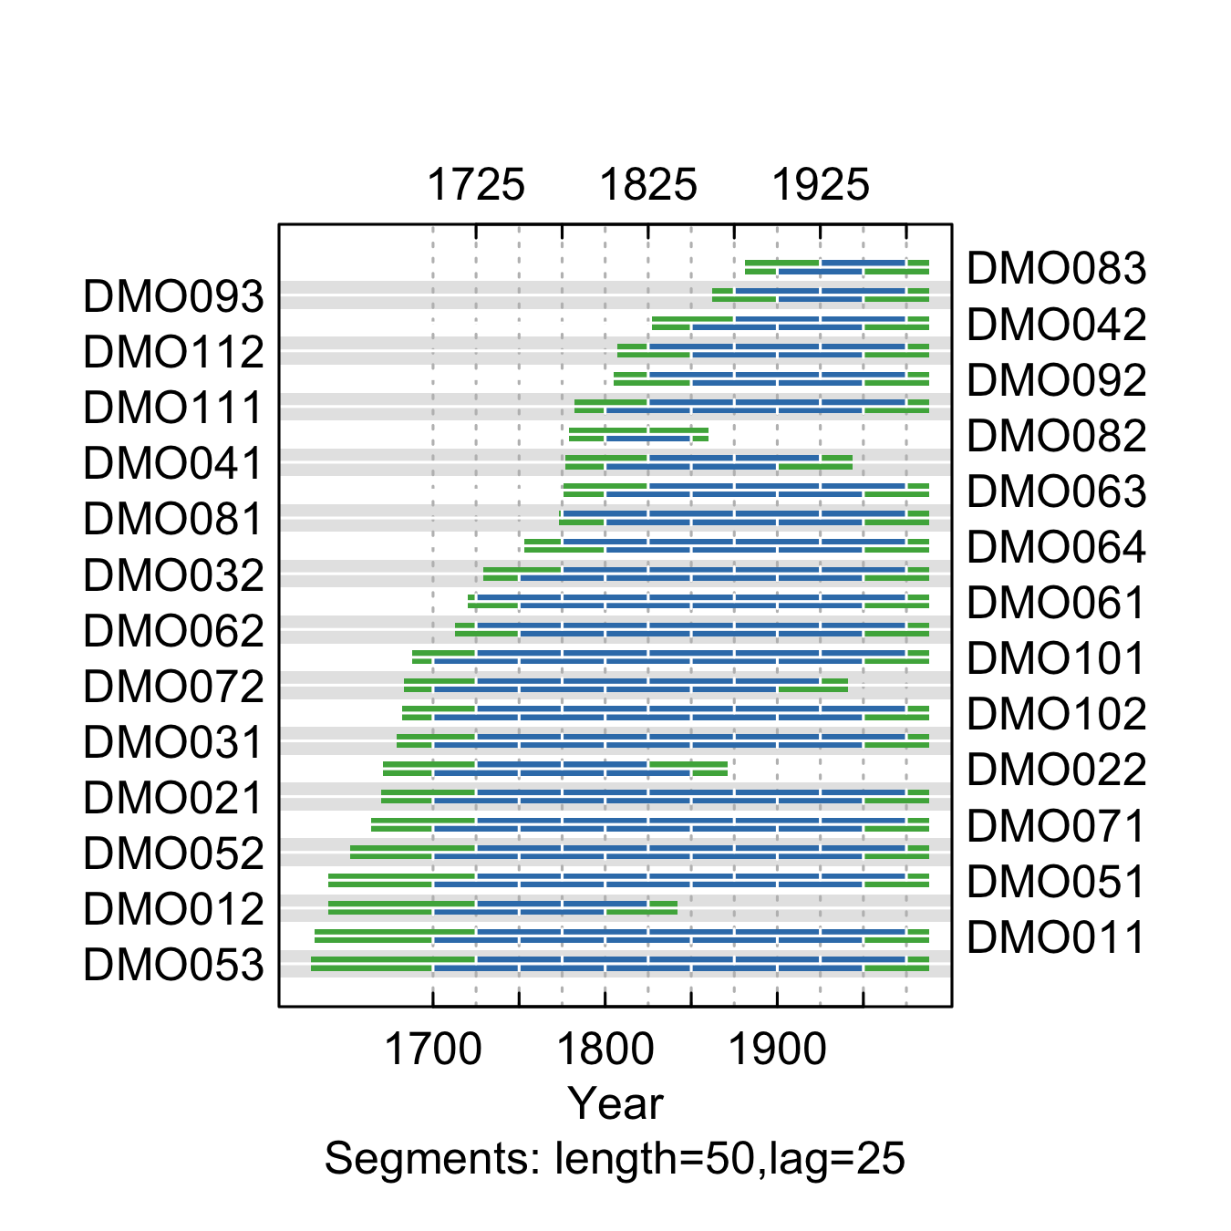

**Figure** **:** The correlations between each tree-ring series and a main chronology built from all other series from the Deer Mountain. Correlations were calculated in 50-year segments that overlap by 25 years. Blue segments show period that correlate well with the main chronology (p<0.1). Red segments show poor correlation with the main chronology (p>0.1). Green segments show periods do not overlap with the main chronology.

summary.tab <- summary.rwl(rwlcombo)  
summary.tab$rho <- round(corr.rwl.seg(rwlcombo, seg.length=50, pcrit=0.1, make.plot=F)$overall[,1],2)  
summary.tab <- summary.tab %>% dplyr::select(series, first, last, rho) %>% mutate(first=as.character(first), last=as.character(last))  
colnames(summary.tab) <- c("Series", "First\nyear", "Last\nyear", "Spearman's correlation")  
summary.tab$Update <- ifelse(summary.tab$Series %in% colnames(rwlj1), "Yes", "No")  
  
summary.tab[order(summary.tab$Series),] %>% flextable() %>% flextable::align(j=-1, align = "center", part = "all") %>% set_table_properties(layout = "autofit", width=1)

**Table** **:** Series statistics and cross-dating notes for the Deer Mountain site. Spearman's correlations were calculated over the common period of overlap between the series and a main chronology built from all other series.

| Series | First year | Last year | Spearman's correlation | Update |
| --- | --- | --- | --- | --- |
| DMO011 | 1629 | 1987 | 0.80 | No |
| DMO012 | 1633 | 1841 | 0.73 | No |
| DMO021 | 1657 | 1987 | 0.75 | No |
| DMO022 | 1667 | 1870 | 0.81 | No |
| DMO031 | 1676 | 1987 | 0.63 | No |
| DMO032 | 1721 | 1987 | 0.70 | No |
| DMO041 | 1775 | 1943 | 0.55 | No |
| DMO042 | 1825 | 1987 | 0.62 | No |
| DMO051 | 1635 | 1987 | 0.76 | No |
| DMO052 | 1644 | 1987 | 0.77 | No |
| DMO053 | 1625 | 1987 | 0.77 | No |
| DMO061 | 1714 | 1987 | 0.76 | No |
| DMO062 | 1704 | 1987 | 0.78 | No |
| DMO063 | 1770 | 1987 | 0.80 | No |
| DMO064 | 1747 | 1987 | 0.76 | No |
| DMO071 | 1653 | 1987 | 0.71 | No |
| DMO072 | 1677 | 1940 | 0.74 | No |
| DMO081 | 1771 | 1987 | 0.73 | No |
| DMO082 | 1778 | 1859 | 0.71 | No |
| DMO083 | 1880 | 1987 | 0.77 | No |
| DMO092 | 1800 | 1987 | 0.61 | No |
| DMO093 | 1860 | 1987 | 0.54 | No |
| DMO101 | 1686 | 1987 | 0.79 | No |
| DMO102 | 1679 | 1987 | 0.76 | No |
| DMO111 | 1780 | 1987 | 0.66 | No |
| DMO112 | 1796 | 1987 | 0.66 | No |

## Deer Ridge

We combined ponderosa pine data collected by Veblen et al. (2000) and subsequently recollected, but unpublished, by Veblen.

rwlcombocor <- corr.rwl.seg(rwlcombo, seg.length=50, pcrit=0.1)

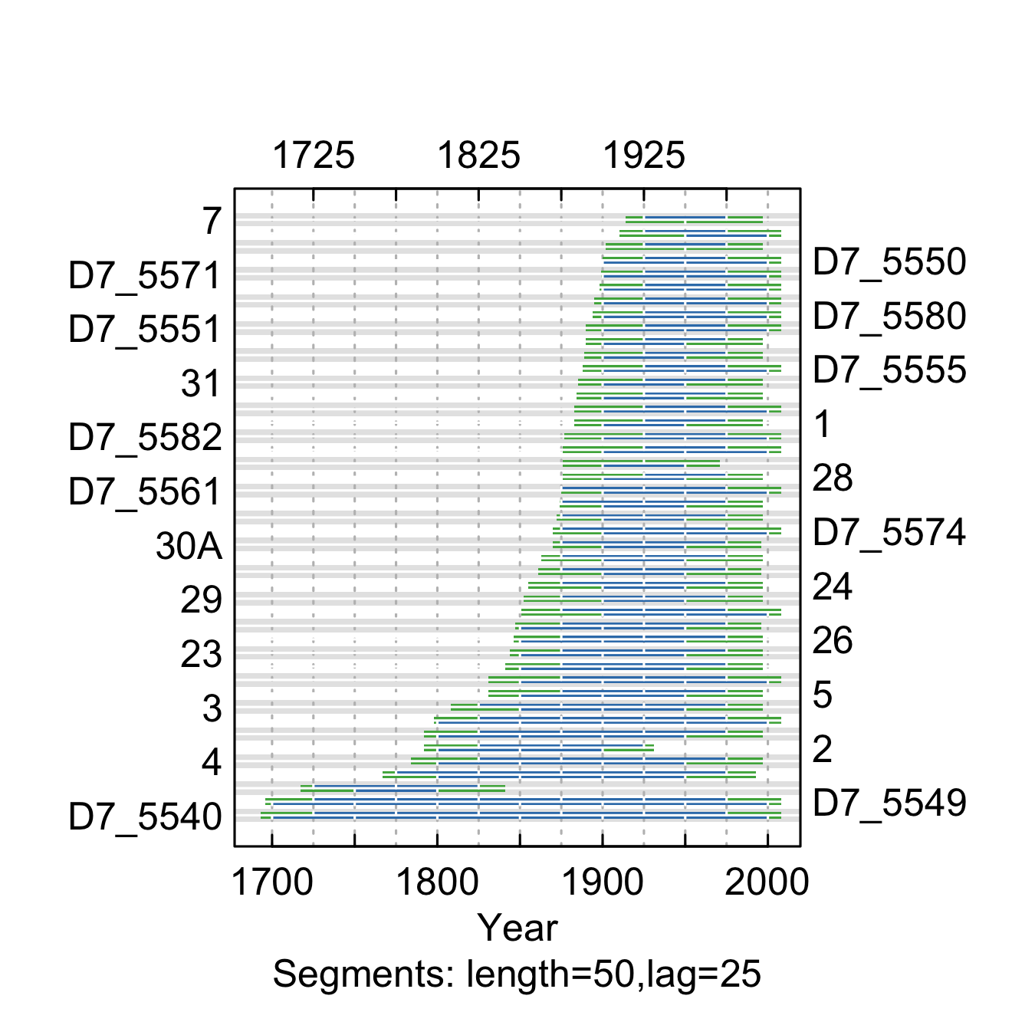

**Figure** **:** The correlations between each tree-ring series and a main chronology built from all other series from the Deer Ridge. Correlations were calculated in 50-year segments that overlap by 25 years. Blue segments show period that correlate well with the main chronology (p<0.1). Red segments show poor correlation with the main chronology (p>0.1). Green segments show periods do not overlap with the main chronology.

summary.tab <- summary.rwl(rwlcombo)  
summary.tab$rho <- round(corr.rwl.seg(rwlcombo, seg.length=50, pcrit=0.1, make.plot=F)$overall[,1],2)  
summary.tab <- summary.tab %>% dplyr::select(series, first, last, rho) %>% mutate(first=as.character(first), last=as.character(last))  
colnames(summary.tab) <- c("Series", "First\nyear", "Last\nyear", "Spearman's correlation")  
summary.tab$Update <- ifelse(summary.tab$Series %in% colnames(rwlj1), "Yes", "No")  
  
summary.tab[order(summary.tab$Series),] %>% flextable() %>% flextable::align(j=-1, align = "center", part = "all") %>% set_table_properties(layout = "autofit", width=1)

**Table** **:** Series statistics and cross-dating notes for the Deer Mountain site. Spearman's correlations were calculated over the common period of overlap between the series and a main chronology built from all other series.

| Series | First year | Last year | Spearman's correlation | Update |
| --- | --- | --- | --- | --- |
| 1 | 1880 | 1996 | 0.63 | No |
| 11 | 1863 | 1996 | 0.56 | No |
| 12 | 1868 | 1996 | 0.61 | No |
| 13 | 1836 | 1996 | 0.75 | No |
| 15 | 1866 | 1996 | 0.76 | No |
| 16 | 1855 | 1995 | 0.76 | No |
| 18 | 1881 | 1996 | 0.75 | No |
| 19 | 1715 | 1840 | 0.56 | No |
| 2 | 1780 | 1930 | 0.64 | No |
| 21 | 1841 | 1995 | 0.74 | No |
| 23 | 1838 | 1996 | 0.80 | No |
| 24 | 1849 | 1996 | 0.85 | No |
| 25 | 1870 | 1970 | 0.82 | No |
| 26 | 1837 | 1996 | 0.83 | No |
| 28 | 1870 | 1996 | 0.68 | No |
| 29 | 1846 | 1996 | 0.71 | No |
| 3 | 1800 | 1996 | 0.69 | No |
| 30A | 1864 | 1995 | 0.67 | No |
| 31 | 1879 | 1996 | 0.71 | No |
| 32 | 1896 | 1996 | 0.80 | No |
| 36 | 1860 | 1996 | 0.65 | No |
| 4 | 1780 | 1996 | 0.80 | No |
| 5 | 1828 | 1996 | 0.75 | No |
| 6 | 1890 | 1996 | 0.69 | No |
| 7 | 1910 | 1996 | 0.51 | No |
| 8 | 1780 | 1996 | 0.62 | No |
| 9 | 1766 | 1992 | 0.58 | No |
| D7_5540 | 1690 | 2007 | 0.59 | Yes |
| D7_5548 | 1908 | 2007 | 0.60 | Yes |
| D7_5549 | 1693 | 2007 | 0.63 | Yes |
| D7_5550 | 1892 | 2007 | 0.83 | Yes |
| D7_5551 | 1888 | 2007 | 0.82 | Yes |
| D7_5554 | 1896 | 2007 | 0.83 | Yes |
| D7_5555 | 1880 | 2007 | 0.84 | Yes |
| D7_5561 | 1873 | 2007 | 0.71 | Yes |
| D7_5562 | 1849 | 2007 | 0.53 | Yes |
| D7_5568 | 1874 | 2007 | 0.78 | Yes |
| D7_5571 | 1891 | 2007 | 0.79 | Yes |
| D7_5574 | 1867 | 2007 | 0.77 | Yes |
| D7_5580 | 1886 | 2007 | 0.58 | Yes |
| D7_5582 | 1871 | 2007 | 0.77 | Yes |
| D7_5592 | 1796 | 2007 | 0.78 | Yes |
| D7_5594 | 1816 | 2007 | 0.74 | Yes |
| D7_5595 | 1868 | 2007 | 0.75 | Yes |
| D7_5597 | 1892 | 2007 | 0.72 | Yes |

## Eldorado Canyon

We combined ponderosa pine chronologies collected by Graybill (2002b) and recollected by Veblen, but unpublished.

x <- corr.rwl.seg(rwlcombo, seg.length=50, pcrit=0.1)

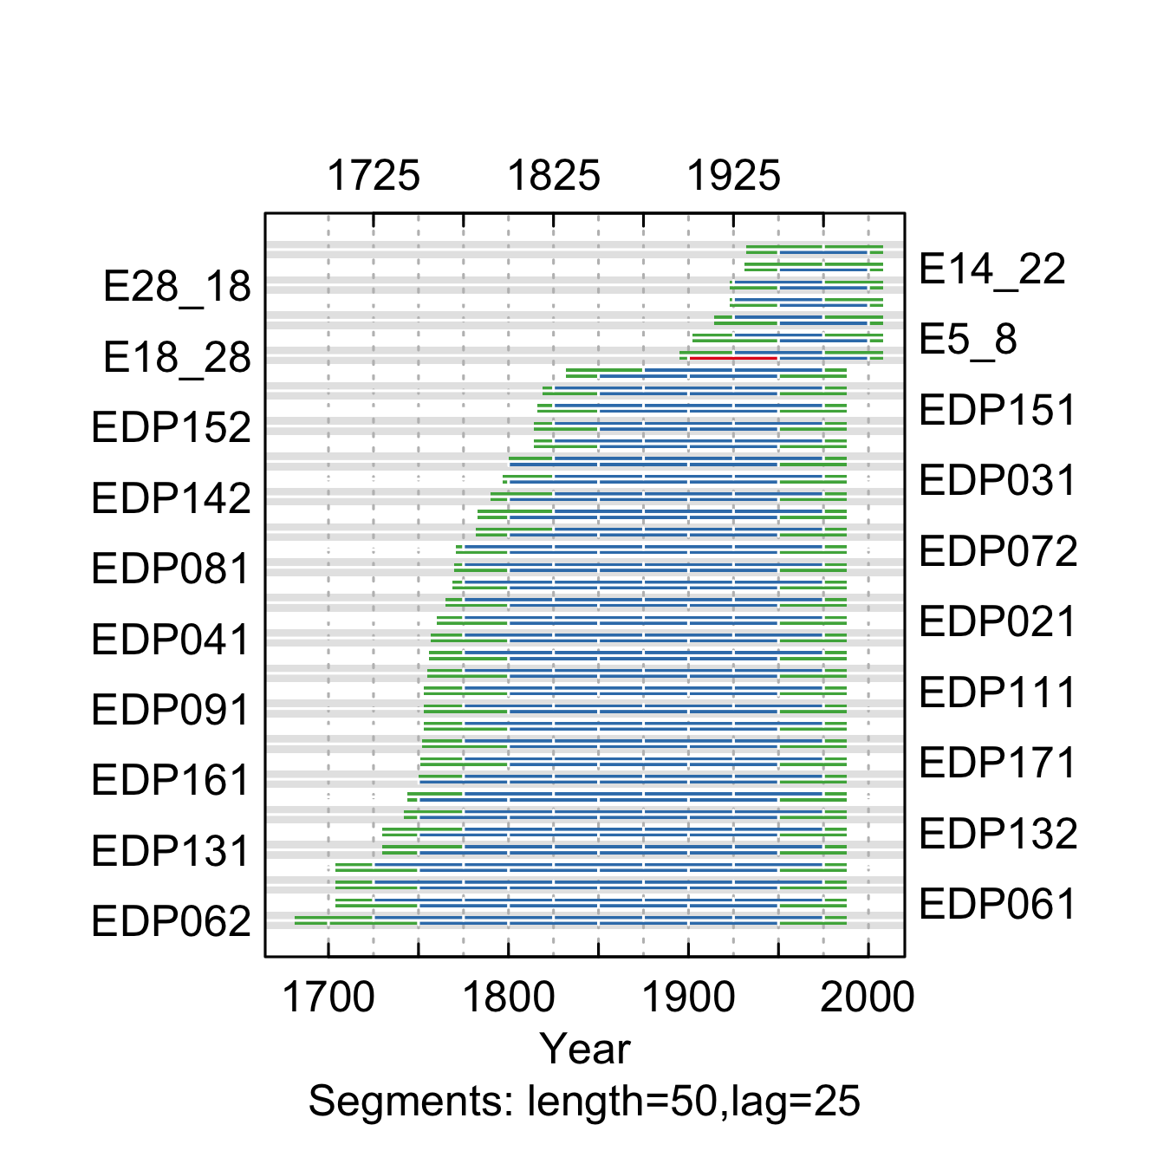

**Figure** **:** The correlations between each tree-ring series and a main chronology built from all other series from the Eldorado Canyon site. Correlations were calculated in 50-year segments that overlap by 25 years. Blue segments show period that correlate well with the main chronology (p<0.1). Red segments show poor correlation with the main chronology (p>0.1). Green segments show periods do not overlap with the main chronology.

summary.tab <- summary.rwl(rwlcombo)  
summary.tab$rho <- round(corr.rwl.seg(rwlcombo, seg.length=50, pcrit=0.1, make.plot=F)$overall[,1],2)  
summary.tab <- summary.tab %>% dplyr::select(series, first, last, rho) %>% mutate(first=as.character(first), last=as.character(last))  
colnames(summary.tab) <- c("Series", "First\nyear", "Last\nyear", "Spearman's correlation")  
summary.tab$Update <- ifelse(summary.tab$Series %in% colnames(rwlj1), "Yes", "No")  
summary.tab[order(summary.tab$Series),] %>% flextable() %>% flextable::align(j=-1, align = "center", part = "all") %>% set_table_properties(layout = "autofit", width=1)

**Table** **:** Series statistics and cross-dating notes for the Eldorado Canyon site. Spearman's correlations were calculated over the common period of overlap between the series and a main chronology built from all other series.

| Series | First year | Last year | Spearman's correlation | Update |
| --- | --- | --- | --- | --- |
| E1_10 | 1930 | 2007 | 0.49 | Yes |
| E14_22 | 1930 | 2007 | 0.62 | Yes |
| E17_23 | 1913 | 2007 | 0.41 | Yes |
| E18_28 | 1892 | 2007 | 0.41 | Yes |
| E28_18 | 1920 | 2007 | 0.64 | Yes |
| E5_8 | 1899 | 2007 | 0.58 | Yes |
| E7_2 | 1921 | 2007 | 0.44 | Yes |
| EDP011 | 1730 | 1987 | 0.47 | No |
| EDP012 | 1745 | 1987 | 0.65 | No |
| EDP021 | 1752 | 1987 | 0.66 | No |
| EDP022 | 1765 | 1987 | 0.70 | No |
| EDP031 | 1791 | 1987 | 0.70 | No |
| EDP032 | 1829 | 1987 | 0.68 | No |
| EDP041 | 1737 | 1987 | 0.63 | No |
| EDP042 | 1749 | 1987 | 0.73 | No |
| EDP051 | 1795 | 1987 | 0.77 | No |
| EDP052 | 1807 | 1987 | 0.72 | No |
| EDP061 | 1699 | 1987 | 0.62 | No |
| EDP062 | 1678 | 1987 | 0.56 | No |
| EDP071 | 1766 | 1987 | 0.50 | No |
| EDP072 | 1766 | 1987 | 0.58 | No |
| EDP081 | 1759 | 1987 | 0.67 | No |
| EDP082 | 1759 | 1987 | 0.64 | No |
| EDP091 | 1750 | 1987 | 0.54 | No |
| EDP092 | 1816 | 1987 | 0.57 | No |
| EDP101 | 1741 | 1987 | 0.63 | No |
| EDP102 | 1739 | 1987 | 0.71 | No |
| EDP111 | 1750 | 1987 | 0.73 | No |
| EDP112 | 1750 | 1987 | 0.74 | No |
| EDP121 | 1701 | 1987 | 0.71 | No |
| EDP122 | 1701 | 1987 | 0.68 | No |
| EDP131 | 1723 | 1987 | 0.66 | No |
| EDP132 | 1723 | 1987 | 0.68 | No |
| EDP141 | 1777 | 1987 | 0.77 | No |
| EDP142 | 1784 | 1987 | 0.70 | No |
| EDP151 | 1811 | 1987 | 0.67 | No |
| EDP152 | 1811 | 1987 | 0.62 | No |
| EDP161 | 1729 | 1987 | 0.59 | No |
| EDP171 | 1739 | 1987 | 0.54 | No |

## Jefferson County Colorado

We combined ponderosa pine chronologies collected by Graybill (2002e) and Woodhouse (2006b).

x <- corr.rwl.seg(rwlcombo, seg.length=50, pcrit=0.1)

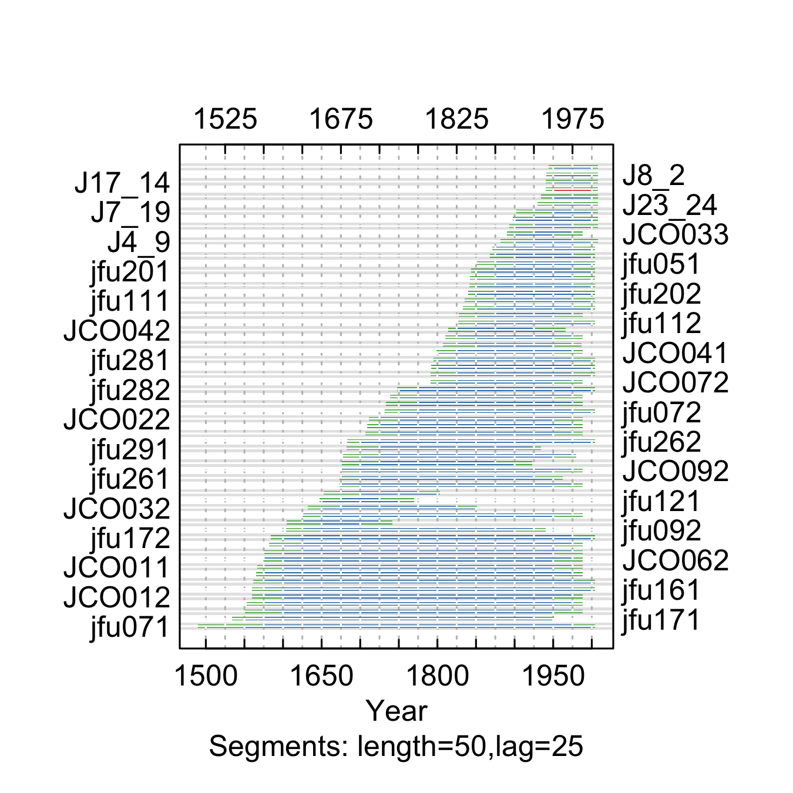

**Figure** **:** The correlations between each tree-ring series and a main chronology built from all other series from the Jefferson County Open Space site. Correlations were calculated in 50-year segments that overlap by 25 years. Blue segments show period that correlate well with the main chronology (p<0.1). Red segments show poor correlation with the main chronology (p>0.1). Green segments show periods do not overlap with the main chronology.

summary.tab <- summary.rwl(rwlcombo)  
summary.tab$rho <- round(corr.rwl.seg(rwlcombo, seg.length=50, pcrit=0.1, make.plot=F)$overall[,1],2)  
summary.tab <- summary.tab %>% dplyr::select(series, first, last, rho) %>% mutate(first=as.character(first), last=as.character(last))  
colnames(summary.tab) <- c("Series", "First\nyear", "Last\nyear", "Spearman's correlation")  
summary.tab$Update <- ifelse(summary.tab$Series %in% c(colnames(rwlj1),colnames(rwlj2)), "Yes", "No")  
  
summary.tab[order(summary.tab$Series),] %>% flextable() %>% flextable::align(j=-1, align = "center", part = "all") %>% set_table_properties(layout = "autofit", width=1)

**Table** **:** Series statistics and cross-dating notes for the Jefferson County Open Space site. Spearman's correlations were calculated over the common period of overlap between the series and a main chronology built from all other series.

| Series | First year | Last year | Spearman's correlation | Update |
| --- | --- | --- | --- | --- |
| J11_22 | 1933 | 2007 | 0.67 | Yes |
| J17_14 | 1940 | 2007 | 0.63 | Yes |
| J19_7 | 1891 | 2007 | 0.67 | Yes |
| J2_8 | 1932 | 2007 | 0.13 | Yes |
| J20_6 | 1892 | 2007 | 0.71 | Yes |
| J23_24 | 1929 | 2007 | 0.63 | Yes |
| J24_23 | 1943 | 2007 | 0.60 | Yes |
| J4_9 | 1881 | 2007 | 0.64 | Yes |
| J7_19 | 1899 | 2007 | 0.78 | Yes |
| J8_2 | 1940 | 2007 | 0.69 | Yes |
| JCO011 | 1564 | 1987 | 0.76 | No |
| JCO012 | 1557 | 1987 | 0.74 | No |
| JCO021 | 1698 | 1987 | 0.68 | No |
| JCO022 | 1705 | 1987 | 0.74 | No |
| JCO031 | 1622 | 1987 | 0.65 | No |
| JCO032 | 1628 | 1850 | 0.69 | No |
| JCO033 | 1890 | 1987 | 0.62 | No |
| JCO041 | 1793 | 1987 | 0.67 | No |
| JCO042 | 1807 | 1965 | 0.61 | No |
| JCO051 | 1808 | 1987 | 0.79 | No |
| JCO052 | 1806 | 1986 | 0.79 | No |
| JCO061 | 1579 | 1987 | 0.72 | No |
| JCO062 | 1556 | 1987 | 0.71 | No |
| JCO071 | 1825 | 1987 | 0.63 | No |
| JCO072 | 1785 | 1987 | 0.60 | No |
| JCO081 | 1548 | 1987 | 0.67 | No |
| JCO082 | 1549 | 1987 | 0.68 | No |
| JCO091 | 1670 | 1987 | 0.65 | No |
| JCO092 | 1671 | 1987 | 0.74 | No |
| JCO101 | 1562 | 1987 | 0.68 | No |
| JCO102 | 1561 | 1987 | 0.69 | No |
| JCO111 | 1731 | 1987 | 0.66 | No |
| JCO112 | 1736 | 1987 | 0.71 | No |
| JCO121 | 1664 | 1979 | 0.75 | No |
| JCO122 | 1705 | 1987 | 0.76 | No |
| jfu032 | 1830 | 2003 | 0.66 | Yes |
| jfu041 | 1867 | 2003 | 0.74 | Yes |
| jfu042 | 1867 | 2003 | 0.74 | Yes |
| jfu051 | 1850 | 2003 | 0.74 | Yes |
| jfu071 | 1487 | 2003 | 0.55 | Yes |
| jfu072 | 1729 | 2003 | 0.62 | Yes |
| jfu091 | 1783 | 2003 | 0.61 | Yes |
| jfu092 | 1583 | 1939 | 0.67 | Yes |
| jfu111 | 1828 | 2003 | 0.70 | Yes |
| jfu112 | 1820 | 2003 | 0.71 | Yes |
| jfu121 | 1646 | 1769 | 0.54 | Yes |
| jfu123 | 1652 | 1802 | 0.67 | Yes |
| jfu151 | 1602 | 1741 | 0.68 | Yes |
| jfu161 | 1557 | 2003 | 0.73 | Yes |
| jfu162 | 1558 | 2003 | 0.76 | Yes |
| jfu171 | 1531 | 1950 | 0.71 | Yes |
| jfu172 | 1566 | 2003 | 0.72 | Yes |
| jfu192 | 1785 | 2003 | 0.66 | Yes |
| jfu201 | 1839 | 2003 | 0.72 | Yes |
| jfu202 | 1835 | 2003 | 0.69 | Yes |
| jfu251 | 1839 | 2003 | 0.66 | Yes |
| jfu252 | 1840 | 2003 | 0.65 | Yes |
| jfu261 | 1670 | 1961 | 0.61 | Yes |
| jfu262 | 1678 | 2003 | 0.63 | Yes |
| jfu281 | 1792 | 2003 | 0.74 | Yes |
| jfu282 | 1745 | 2003 | 0.74 | Yes |
| jfu291 | 1679 | 1933 | 0.75 | Yes |
| jfu292 | 1673 | 1922 | 0.75 | Yes |

## Kassler

We combined ponderosa pine chronologies collected by Fritts (2002) and Graybill (2002c).

x <- corr.rwl.seg(rwlcombo, seg.length=50, pcrit=0.1)

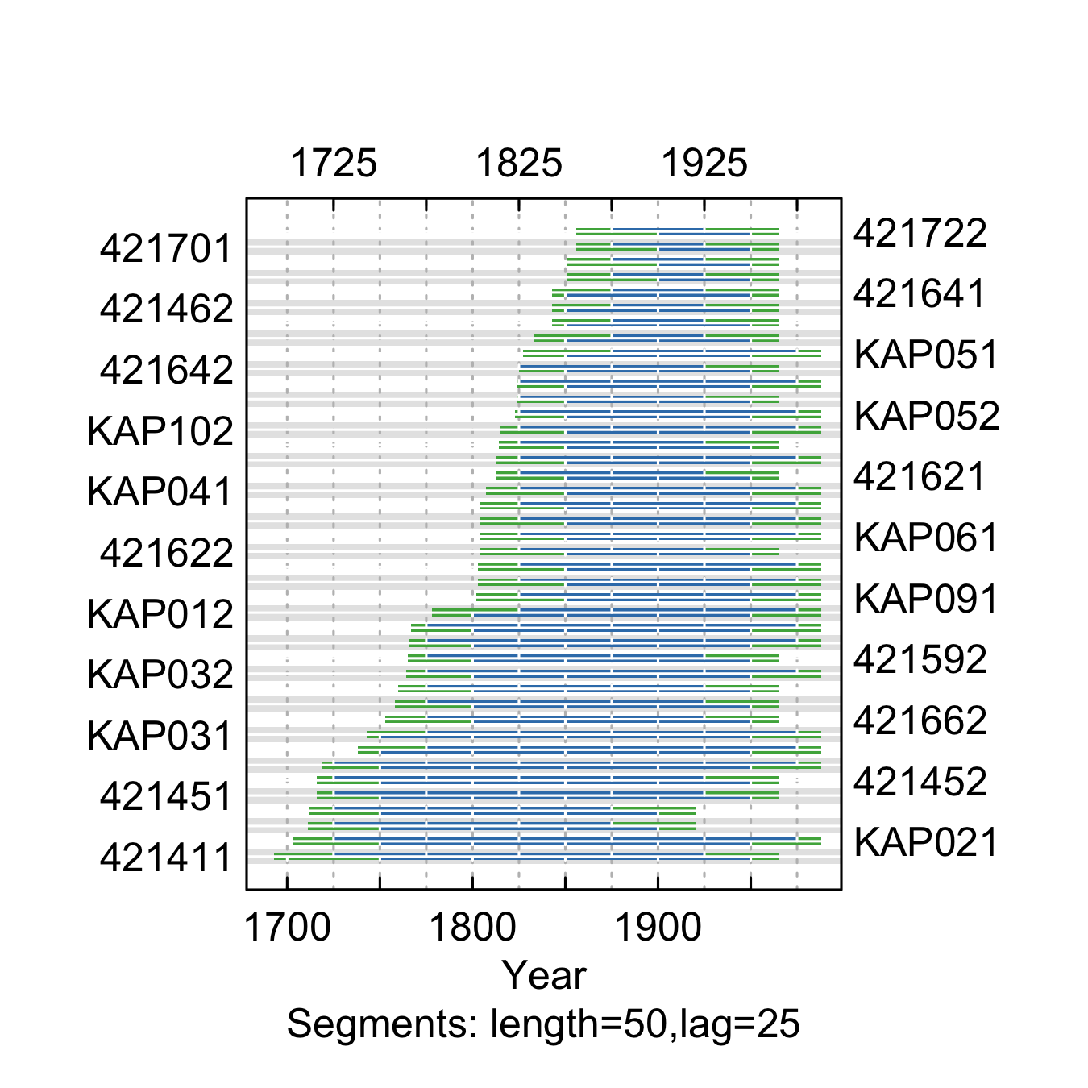

**Figure** **:** The correlations between each tree-ring series and a main chronology built from all other series from the Kassler site. Correlations were calculated in 50-year segments that overlap by 25 years. Blue segments show period that correlate well with the main chronology (p<0.1). Red segments show poor correlation with the main chronology (p>0.1). Green segments show periods do not overlap with the main chronology.

summary.tab <- summary.rwl(rwlcombo)  
summary.tab$rho <- round(corr.rwl.seg(rwlcombo, seg.length=50, pcrit=0.1, make.plot=F)$overall[,1],2)  
summary.tab <- summary.tab %>% dplyr::select(series, first, last, rho) %>% mutate(first=as.character(first), last=as.character(last))  
colnames(summary.tab) <- c("Series", "First\nyear", "Last\nyear", "Spearman's correlation")  
summary.tab$Update <- ifelse(summary.tab$Series %in% c(colnames(rwlj1),colnames(rwlj2)), "Yes", "No")  
  
summary.tab[order(summary.tab$Series),] %>% flextable() %>% flextable::align(j=-1, align = "center", part = "all") %>% set_table_properties(layout = "autofit", width=1)

**Table** **:** Series statistics and cross-dating notes for the Kassler site. Spearman's correlations were calculated over the common period of overlap between the series and a main chronology built from all other series.

| Series | First year | Last year | Spearman's correlation | Update |
| --- | --- | --- | --- | --- |
| 421411 | 1690 | 1964 | 0.66 | No |
| 421412 | 1810 | 1964 | 0.63 | No |
| 421431 | 1700 | 1919 | 0.71 | No |
| 421432 | 1700 | 1919 | 0.70 | No |
| 421451 | 1710 | 1964 | 0.78 | No |
| 421452 | 1710 | 1964 | 0.82 | No |
| 421461 | 1840 | 1964 | 0.73 | No |
| 421462 | 1840 | 1964 | 0.72 | No |
| 421591 | 1750 | 1964 | 0.66 | No |
| 421592 | 1760 | 1964 | 0.77 | No |
| 421621 | 1810 | 1964 | 0.75 | No |
| 421622 | 1800 | 1964 | 0.69 | No |
| 421641 | 1840 | 1964 | 0.70 | No |
| 421642 | 1820 | 1964 | 0.68 | No |
| 421661 | 1750 | 1964 | 0.77 | No |
| 421662 | 1750 | 1964 | 0.71 | No |
| 421681 | 1820 | 1964 | 0.74 | No |
| 421682 | 1830 | 1964 | 0.82 | No |
| 421701 | 1850 | 1964 | 0.74 | No |
| 421702 | 1850 | 1964 | 0.74 | No |
| 421721 | 1850 | 1964 | 0.73 | No |
| 421722 | 1850 | 1964 | 0.71 | No |
| KAP011 | 1728 | 1987 | 0.64 | Yes |
| KAP012 | 1763 | 1987 | 0.71 | Yes |
| KAP021 | 1700 | 1987 | 0.83 | Yes |
| KAP022 | 1700 | 1987 | 0.72 | Yes |
| KAP031 | 1735 | 1987 | 0.72 | Yes |
| KAP032 | 1748 | 1987 | 0.70 | Yes |
| KAP041 | 1804 | 1987 | 0.69 | Yes |
| KAP042 | 1821 | 1987 | 0.75 | Yes |
| KAP051 | 1821 | 1987 | 0.70 | Yes |
| KAP052 | 1820 | 1987 | 0.74 | Yes |
| KAP061 | 1798 | 1987 | 0.80 | Yes |
| KAP062 | 1798 | 1987 | 0.79 | Yes |
| KAP071 | 1801 | 1987 | 0.71 | Yes |
| KAP072 | 1801 | 1987 | 0.70 | Yes |
| KAP081 | 1761 | 1987 | 0.63 | Yes |
| KAP082 | 1761 | 1987 | 0.63 | Yes |
| KAP091 | 1799 | 1987 | 0.72 | Yes |
| KAP092 | 1799 | 1987 | 0.69 | Yes |
| KAP101 | 1810 | 1987 | 0.76 | Yes |
| KAP102 | 1810 | 1987 | 0.68 | Yes |

## South Fork

We combined ponderosa pine chronologies collected by Woodhouse et al. (2006a) and Woodhouse and Losleben (2016).

x <- corr.rwl.seg(rwlcombo, seg.length=50, pcrit=0.1)

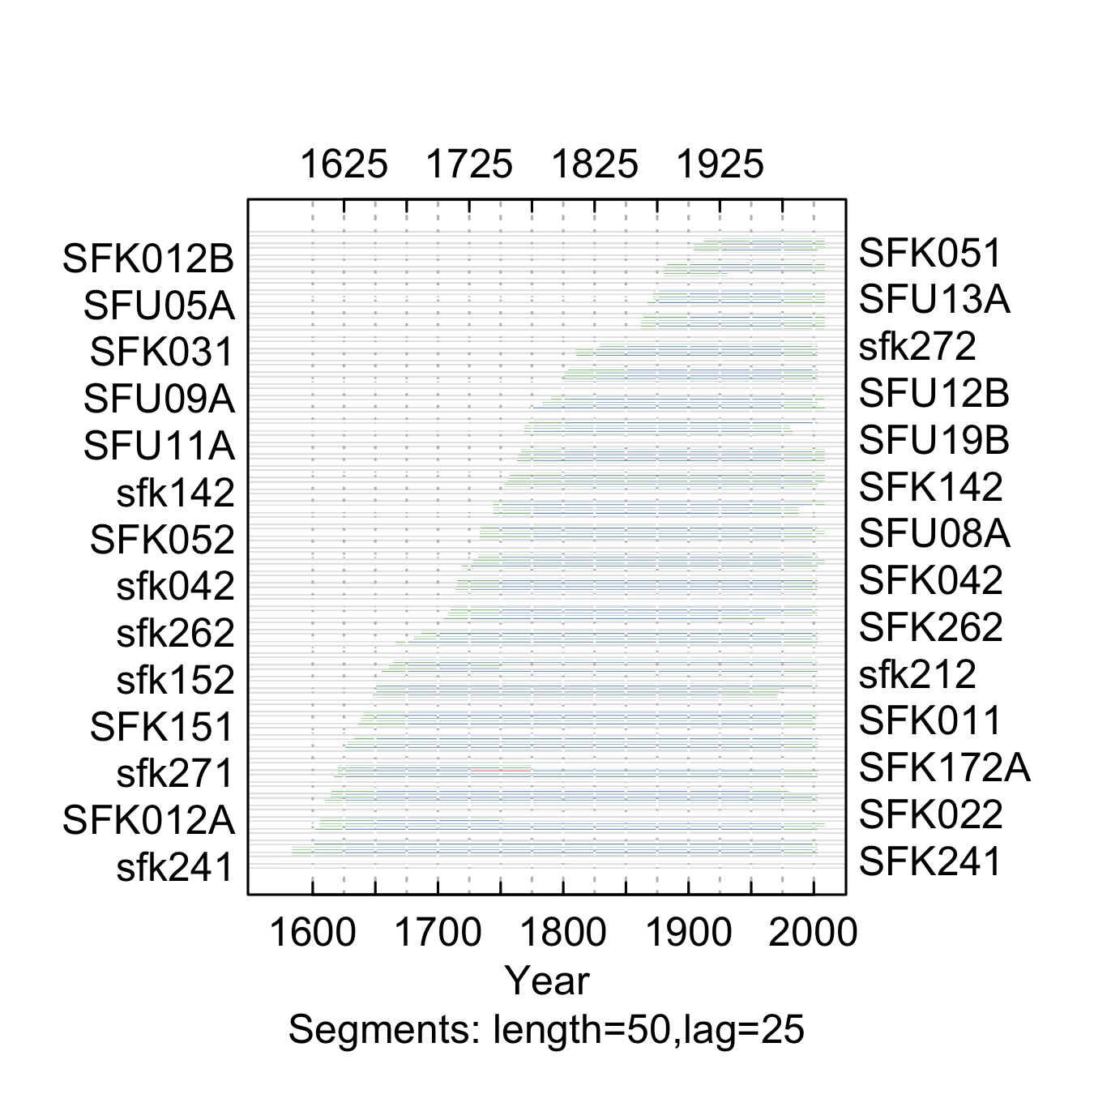

**Figure** **:** The correlations between each tree-ring series and a main chronology built from all other series from the South Fork site. Correlations were calculated in 50-year segments that overlap by 25 years. Blue segments show period that correlate well with the main chronology (p<0.1). Red segments show poor correlation with the main chronology (p>0.1). Green segments show periods do not overlap with the main chronology.

summary.tab <- summary.rwl(rwlcombo)  
summary.tab$rho <- round(corr.rwl.seg(rwlcombo, seg.length=50, pcrit=0.1, make.plot=F)$overall[,1],2)  
summary.tab <- summary.tab %>% dplyr::select(series, first, last, rho) %>% mutate(first=as.character(first), last=as.character(last))  
colnames(summary.tab) <- c("Series", "First\nyear", "Last\nyear", "Spearman's correlation")  
summary.tab$Update <- ifelse(summary.tab$Series %in% c(colnames(rwlj1),colnames(rwlj2)), "Yes", "No")  
  
summary.tab[order(summary.tab$Series),] %>% flextable() %>% flextable::align(j=-1, align = "center", part = "all") %>% set_table_properties(layout = "autofit", width=1)

**Table** **:** Series statistics and cross-dating notes for the South Fork site. Spearman's correlations were calculated over the common period of overlap between the series and a main chronology built from all other series.

| Series | First year | Last year | Spearman's correlation | Update |
| --- | --- | --- | --- | --- |
| sfk011 | 1635 | 2002 | 0.64 | No |
| SFK011 | 1635 | 2001 | 0.64 | Yes |
| SFK012A | 1604 | 1751 | 0.66 | Yes |
| SFK012B | 1900 | 2001 | 0.62 | Yes |
| sfk021 | 1580 | 2002 | 0.74 | No |
| SFK021 | 1580 | 2002 | 0.74 | Yes |
| sfk022 | 1606 | 2002 | 0.71 | No |
| SFK022 | 1601 | 2002 | 0.69 | Yes |
| sfk031 | 1803 | 2002 | 0.82 | No |
| SFK031 | 1803 | 2002 | 0.83 | Yes |
| sfk032 | 1788 | 2002 | 0.81 | No |
| SFK032 | 1787 | 2002 | 0.82 | Yes |
| sfk041 | 1706 | 2002 | 0.81 | No |
| SFK041 | 1703 | 2002 | 0.79 | Yes |
| sfk042 | 1710 | 2002 | 0.84 | No |
| SFK042 | 1710 | 2002 | 0.83 | Yes |
| SFK051 | 1900 | 2002 | 0.83 | Yes |
| sfk052 | 1729 | 2002 | 0.84 | No |
| SFK052 | 1729 | 2001 | 0.83 | Yes |
| sfk081 | 1606 | 2002 | 0.73 | No |
| SFK081 | 1606 | 2002 | 0.70 | Yes |
| sfk082 | 1600 | 1979 | 0.74 | No |
| SFK082 | 1600 | 1960 | 0.71 | Yes |
| sfk111 | 1621 | 2002 | 0.70 | No |
| SFK111 | 1620 | 2002 | 0.69 | Yes |
| SFK112 | 1705 | 2002 | 0.62 | Yes |
| sfk121 | 1595 | 2002 | 0.75 | No |
| SFK121 | 1595 | 2000 | 0.73 | Yes |
| sfk122 | 1598 | 2002 | 0.72 | No |
| SFK132 | 1730 | 2002 | 0.64 | Yes |
| sfk141 | 1614 | 2002 | 0.73 | No |
| SFK141 | 1611 | 2002 | 0.71 | Yes |
| sfk142 | 1747 | 2002 | 0.75 | No |
| SFK142 | 1750 | 2002 | 0.73 | Yes |
| sfk151 | 1644 | 2002 | 0.68 | No |
| SFK151 | 1630 | 2000 | 0.67 | Yes |
| sfk152 | 1644 | 2002 | 0.67 | No |
| SFK152 | 1637 | 2002 | 0.66 | Yes |
| sfk161 | 1715 | 2002 | 0.68 | No |
| SFK161 | 1715 | 2002 | 0.67 | Yes |
| sfk162 | 1766 | 1982 | 0.76 | No |
| SFK162 | 1766 | 1980 | 0.78 | Yes |
| sfk171 | 1660 | 2002 | 0.75 | No |
| SFK171A | 1660 | 1750 | 0.80 | Yes |
| SFK171B | 1800 | 2002 | 0.82 | Yes |
| sfk172 | 1612 | 2002 | 0.76 | No |
| SFK172A | 1611 | 1773 | 0.81 | Yes |
| SFK172B | 1830 | 2002 | 0.78 | Yes |
| sfk211 | 1630 | 2002 | 0.79 | No |
| SFK211 | 1630 | 2002 | 0.79 | Yes |
| sfk212 | 1652 | 2002 | 0.78 | No |
| SFK212 | 1643 | 2002 | 0.75 | Yes |
| sfk221 | 1660 | 2002 | 0.76 | No |
| SFK221 | 1660 | 2002 | 0.76 | Yes |
| sfk222 | 1792 | 2002 | 0.79 | No |
| SFK222 | 1800 | 2002 | 0.82 | Yes |
| sfk231 | 1728 | 2002 | 0.84 | No |
| SFK231 | 1728 | 2002 | 0.84 | Yes |
| sfk232 | 1740 | 1987 | 0.82 | No |
| SFK232 | 1740 | 1987 | 0.81 | Yes |
| sfk241 | 1566 | 2002 | 0.78 | No |
| SFK241 | 1566 | 2000 | 0.77 | Yes |
| sfk242 | 1641 | 1972 | 0.80 | No |
| SFK242 | 1640 | 1970 | 0.79 | Yes |
| sfk251 | 1770 | 2002 | 0.82 | No |
| SFK251 | 1770 | 2002 | 0.80 | Yes |
| sfk252 | 1660 | 2002 | 0.75 | No |
| SFK252 | 1780 | 2002 | 0.82 | Yes |
| sfk261 | 1706 | 2002 | 0.82 | No |
| SFK261 | 1705 | 2002 | 0.81 | Yes |
| sfk262 | 1680 | 2002 | 0.78 | No |
| SFK262 | 1680 | 2002 | 0.77 | Yes |
| sfk271 | 1616 | 2002 | 0.74 | No |
| SFK271 | 1760 | 2002 | 0.80 | Yes |
| sfk272 | 1826 | 2002 | 0.76 | No |
| SFK272 | 1830 | 2002 | 0.76 | Yes |
| SFK282 | 1677 | 2002 | 0.81 | Yes |
| SFU01A | 1750 | 2008 | 0.75 | Yes |
| SFU01B | 1741 | 2008 | 0.76 | Yes |
| SFU02A | 1760 | 2008 | 0.62 | Yes |
| SFU02B | 1701 | 1960 | 0.76 | Yes |
| SFU03A | 1859 | 2008 | 0.60 | Yes |
| SFU03B | 1859 | 2008 | 0.63 | Yes |
| SFU04A | 1880 | 1930 | 0.50 | Yes |
| SFU04B | 1880 | 2008 | 0.72 | Yes |
| SFU05A | 1864 | 2008 | 0.62 | Yes |
| SFU05B | 1870 | 2008 | 0.69 | Yes |
| SFU06A | 1910 | 2008 | 0.72 | Yes |
| SFU06B | 1960 | 2008 | 0.70 | Yes |
| SFU07A | 1863 | 2008 | 0.60 | Yes |
| SFU07B | 1875 | 2008 | 0.69 | Yes |
| SFU08A | 1730 | 2008 | 0.65 | Yes |
| SFU08B | 1730 | 2008 | 0.58 | Yes |
| SFU09A | 1787 | 2007 | 0.66 | Yes |
| SFU10A | 1750 | 2008 | 0.59 | Yes |
| SFU10B | 1719 | 2008 | 0.72 | Yes |
| SFU11A | 1763 | 2008 | 0.68 | Yes |
| SFU11B | 1751 | 2008 | 0.67 | Yes |
| SFU12A | 1900 | 2008 | 0.63 | Yes |
| SFU12B | 1788 | 2008 | 0.63 | Yes |
| SFU13A | 1870 | 2008 | 0.62 | Yes |
| SFU13B | 1870 | 2008 | 0.73 | Yes |
| SFU14B | 1740 | 2008 | 0.72 | Yes |
| SFU15A | 1880 | 2008 | 0.71 | Yes |
| SFU15B | 1860 | 2008 | 0.74 | Yes |
| SFU16A | 1910 | 2008 | 0.78 | Yes |
| SFU16B | 1597 | 2008 | 0.69 | Yes |
| SFU18B | 1761 | 2008 | 0.74 | Yes |
| SFU19A | 1770 | 2008 | 0.70 | Yes |
| SFU19B | 1764 | 2008 | 0.69 | Yes |

## Turkey Creek Bluff

We combined ponderosa pine chronologies collected by Graybill (2002d) and Woodhouse et. al (2019).

x <- corr.rwl.seg(rwlcombo, seg.length=50, pcrit=0.1)

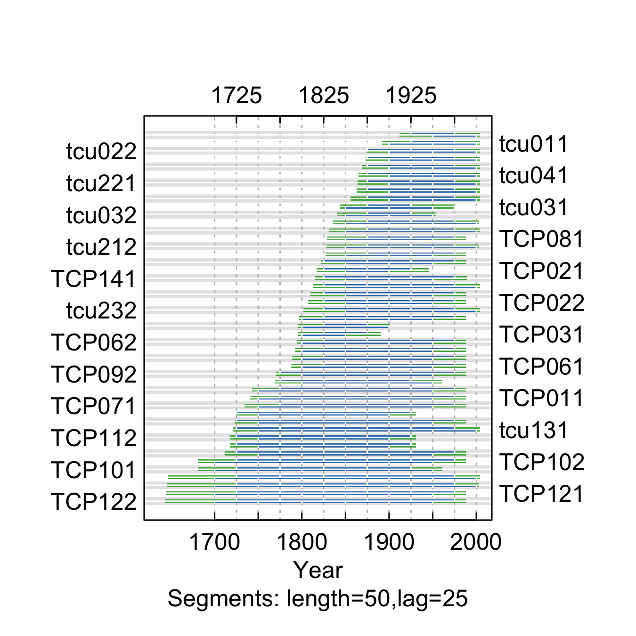

**Figure** **:** The correlations between each tree-ring series and a main chronology built from all other series from the Turkey Creek Bluff site. Correlations were calculated in 50-year segments that overlap by 25 years. Blue segments show period that correlate well with the main chronology (p<0.1). Red segments show poor correlation with the main chronology (p>0.1). Green segments show periods do not overlap with the main chronology.

summary.tab <- summary.rwl(rwlcombo)  
summary.tab$rho <- round(corr.rwl.seg(rwlcombo, seg.length=50, pcrit=0.1, make.plot=F)$overall[,1],2)  
summary.tab <- summary.tab %>% dplyr::select(series, first, last, rho) %>% mutate(first=as.character(first), last=as.character(last))  
colnames(summary.tab) <- c("Series", "First\nyear", "Last\nyear", "Spearman's correlation")  
summary.tab$Update <- ifelse(summary.tab$Series %in% c(colnames(rwlj1),colnames(rwlj2)), "Yes", "No")  
  
summary.tab[order(summary.tab$Series),] %>% flextable() %>% flextable::align(j=-1, align = "center", part = "all") %>% set_table_properties(layout = "autofit", width=1)

**Table** **:** Series statistics and cross-dating notes for the Turkey Creek Bluff site. Spearman's correlations were calculated over the common period of overlap between the series and a main chronology built from all other series.

| Series | First year | Last year | Spearman's correlation | Update |
| --- | --- | --- | --- | --- |
| TCP011 | 1736 | 1987 | 0.77 | No |
| TCP012 | 1715 | 1930 | 0.73 | No |
| TCP021 | 1809 | 1945 | 0.67 | No |
| TCP022 | 1804 | 1987 | 0.85 | No |
| TCP031 | 1793 | 1890 | 0.84 | No |
| TCP032 | 1793 | 1900 | 0.85 | No |
| TCP041 | 1787 | 1987 | 0.82 | No |
| TCP042 | 1787 | 1987 | 0.82 | No |
| TCP051 | 1801 | 1987 | 0.83 | No |
| TCP052 | 1801 | 1987 | 0.76 | No |
| TCP061 | 1784 | 1987 | 0.75 | No |
| TCP062 | 1783 | 1987 | 0.79 | No |
| TCP071 | 1720 | 1987 | 0.74 | No |
| TCP072 | 1720 | 1987 | 0.81 | No |
| TCP081 | 1816 | 1987 | 0.73 | No |
| TCP082 | 1816 | 1987 | 0.68 | No |
| TCP091 | 1764 | 1960 | 0.72 | No |
| TCP092 | 1765 | 1987 | 0.82 | No |
| TCP101 | 1678 | 1960 | 0.79 | No |
| TCP102 | 1678 | 1987 | 0.84 | No |
| TCP111 | 1713 | 1930 | 0.80 | No |
| TCP112 | 1713 | 1930 | 0.76 | No |
| TCP121 | 1641 | 1987 | 0.81 | No |
| TCP122 | 1640 | 1987 | 0.84 | No |
| TCP131 | 1708 | 1987 | 0.83 | No |
| TCP132 | 1740 | 1987 | 0.78 | No |
| TCP141 | 1794 | 1988 | 0.70 | No |
| TCP142 | 1794 | 1987 | 0.88 | No |
| tcu011 | 1890 | 2003 | 0.84 | Yes |
| tcu012 | 1900 | 2003 | 0.76 | Yes |
| tcu021 | 1860 | 2003 | 0.80 | Yes |
| tcu022 | 1862 | 2003 | 0.75 | Yes |
| tcu031 | 1841 | 1973 | 0.80 | Yes |
| tcu032 | 1839 | 1953 | 0.78 | Yes |
| tcu041 | 1856 | 2003 | 0.77 | Yes |
| tcu042 | 1860 | 2003 | 0.67 | Yes |
| tcu111 | 1832 | 2002 | 0.86 | Yes |
| tcu112 | 1830 | 2003 | 0.84 | Yes |
| tcu121 | 1634 | 2003 | 0.81 | Yes |
| tcu122 | 1640 | 2002 | 0.79 | Yes |
| tcu131 | 1718 | 2003 | 0.72 | Yes |
| tcu211 | 1810 | 2003 | 0.78 | Yes |
| tcu212 | 1827 | 2002 | 0.76 | Yes |
| tcu221 | 1855 | 2003 | 0.80 | Yes |
| tcu222 | 1855 | 2003 | 0.82 | Yes |
| tcu231 | 1850 | 2003 | 0.77 | Yes |
| tcu232 | 1797 | 2003 | 0.83 | Yes |

## Van Bibber Creek

We combined ponderosa pine chronologies collected by Graybill (1997), Woodhouse et al. (**woodhouse2010NOAAWDSPaleoclimatologya?**), and recollected by Veblen, but unpublished.

x <- corr.rwl.seg(rwlcombo, seg.length=50, pcrit=0.1)

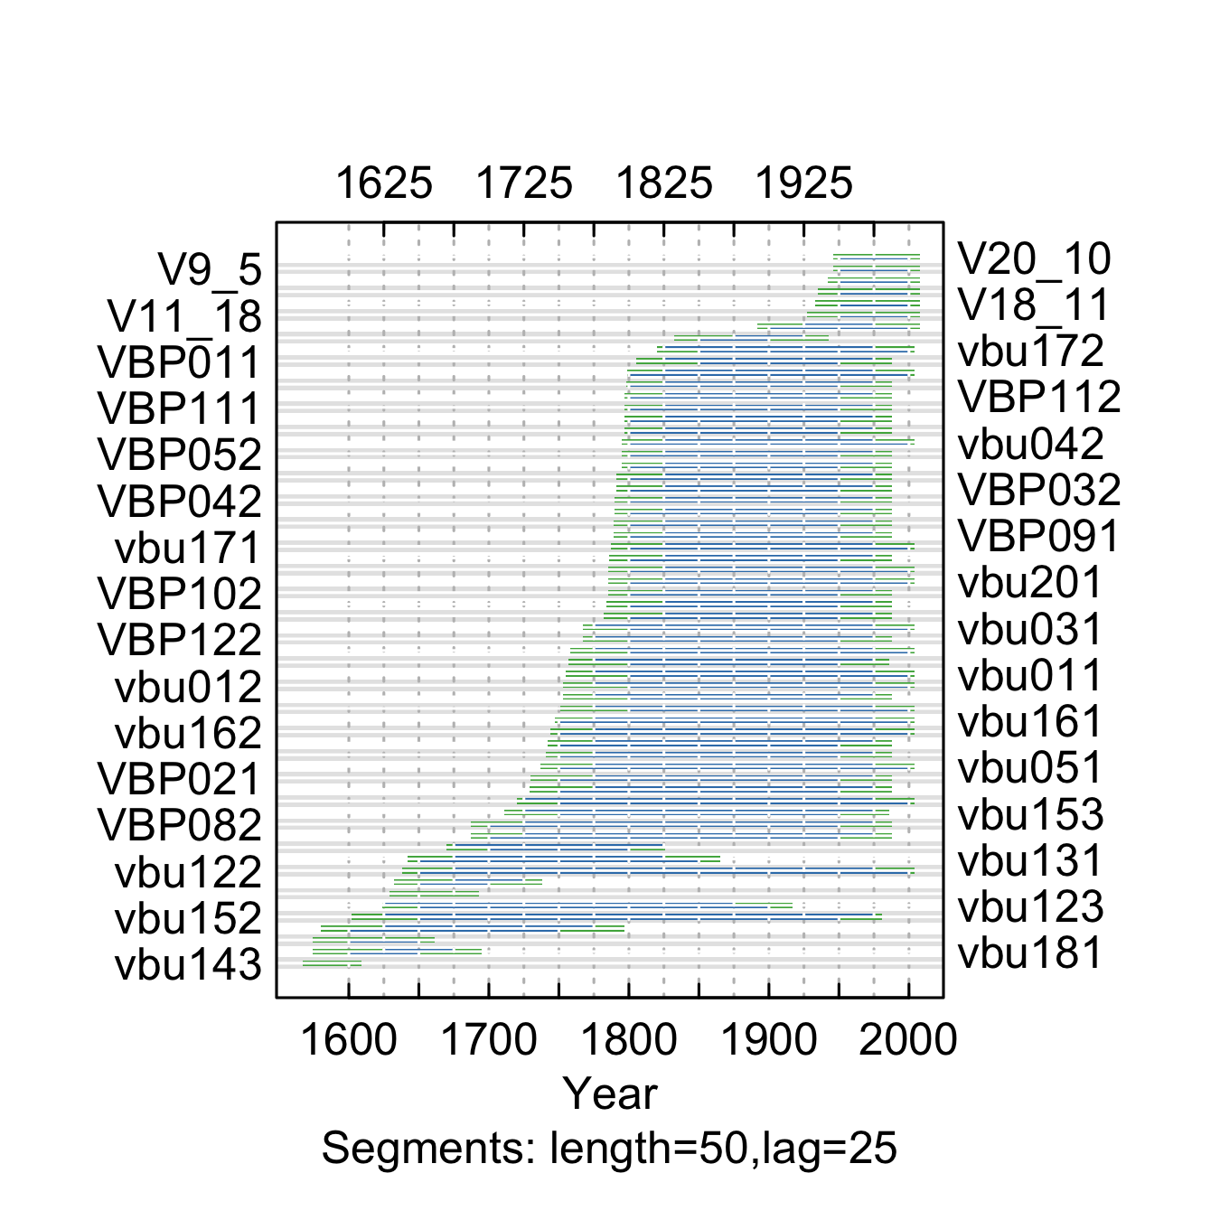

**Figure** **:** The correlations between each tree-ring series and a main chronology built from all other series from the Van Bibber Creek site. Correlations were calculated in 50-year segments that overlap by 25 years. Blue segments show period that correlate well with the main chronology (p<0.1). Red segments show poor correlation with the main chronology (p>0.1). Green segments show periods do not overlap with the main chronology.

summary.tab <- summary.rwl(rwlcombo)  
summary.tab$rho <- round(corr.rwl.seg(rwlcombo, seg.length=50, pcrit=0.1, make.plot=F)$overall[,1],2)  
summary.tab <- summary.tab %>% dplyr::select(series, first, last, rho) %>% mutate(first=as.character(first), last=as.character(last))  
colnames(summary.tab) <- c("Series", "First\nyear", "Last\nyear", "Spearman's correlation")  
summary.tab$Update <- ifelse(summary.tab$Series %in% c(colnames(rwlj1),colnames(rwlj2)), "Yes", "No")  
  
summary.tab[order(summary.tab$Series),] %>% flextable() %>% flextable::align(j=-1, align = "center", part = "all") %>% set_table_properties(layout = "autofit", width=1)

**Table** **:** Series statistics and cross-dating notes for the Van Bibber Creek site. Spearman's correlations were calculated over the common period of overlap between the series and a main chronology built from all other series.

| Series | First year | Last year | Spearman's correlation | Update |
| --- | --- | --- | --- | --- |
| V10_20 | 1890 | 2007 | 0.58 | Yes |
| V11_18 | 1926 | 2007 | 0.61 | Yes |
| V14_8 | 1934 | 2007 | 0.75 | Yes |
| V18_11 | 1928 | 2007 | 0.53 | Yes |
| V20_10 | 1945 | 2007 | 0.51 | Yes |
| V22_4 | 1940 | 2007 | 0.49 | Yes |
| V9_5 | 1945 | 2007 | 0.49 | Yes |
| VBP011 | 1793 | 1987 | 0.66 | No |
| VBP012 | 1793 | 1987 | 0.74 | No |
| VBP021 | 1727 | 1987 | 0.64 | No |
| VBP022 | 1722 | 1987 | 0.64 | No |
| VBP031 | 1788 | 1987 | 0.80 | No |
| VBP032 | 1788 | 1987 | 0.81 | No |
| VBP041 | 1789 | 1987 | 0.76 | No |
| VBP042 | 1789 | 1987 | 0.70 | No |
| VBP051 | 1792 | 1987 | 0.78 | No |
| VBP052 | 1792 | 1987 | 0.75 | No |
| VBP061 | 1794 | 1987 | 0.75 | No |
| VBP062 | 1794 | 1987 | 0.74 | No |
| VBP071 | 1729 | 1987 | 0.67 | No |
| VBP072 | 1733 | 1987 | 0.72 | No |
| VBP081 | 1682 | 1987 | 0.68 | No |
| VBP082 | 1682 | 1987 | 0.62 | No |
| VBP091 | 1782 | 1987 | 0.55 | No |
| VBP092 | 1783 | 1987 | 0.70 | No |
| VBP101 | 1782 | 1987 | 0.64 | No |
| VBP102 | 1782 | 1987 | 0.59 | No |
| VBP111 | 1791 | 1987 | 0.68 | No |
| VBP112 | 1792 | 1987 | 0.68 | No |
| VBP121 | 1750 | 1987 | 0.74 | No |
| VBP122 | 1764 | 1987 | 0.71 | No |
| VBP131 | 1777 | 1987 | 0.64 | No |
| VBP132 | 1778 | 1987 | 0.61 | No |
| vbu011 | 1748 | 2003 | 0.76 | Yes |
| vbu012 | 1748 | 2003 | 0.79 | Yes |
| vbu021 | 1750 | 2003 | 0.70 | Yes |
| vbu031 | 1763 | 2003 | 0.71 | Yes |
| vbu032 | 1750 | 1985 | 0.73 | Yes |
| vbu041 | 1748 | 2003 | 0.70 | Yes |
| vbu042 | 1794 | 2003 | 0.77 | Yes |
| vbu051 | 1730 | 2003 | 0.73 | Yes |
| vbu052 | 1713 | 2003 | 0.68 | Yes |
| vbu111 | 1628 | 1692 | 0.71 | Yes |
| vbu121 | 1796 | 2003 | 0.78 | Yes |
| vbu122 | 1621 | 2003 | 0.71 | Yes |
| vbu123 | 1621 | 1916 | 0.72 | Yes |
| vbu131 | 1640 | 1864 | 0.69 | Yes |
| vbu132 | 1631 | 1737 | 0.68 | Yes |
| vbu141 | 1666 | 1825 | 0.73 | Yes |
| vbu142 | 1566 | 1796 | 0.69 | Yes |
| vbu143 | 1566 | 1608 | 0.61 | Yes |
| vbu151 | 1829 | 1942 | 0.77 | Yes |
| vbu152 | 1599 | 1980 | 0.73 | Yes |
| vbu153 | 1704 | 1985 | 0.72 | Yes |
| vbu161 | 1740 | 2003 | 0.66 | Yes |
| vbu162 | 1739 | 2003 | 0.70 | Yes |
| vbu171 | 1783 | 2003 | 0.68 | Yes |
| vbu172 | 1815 | 2003 | 0.69 | Yes |
| vbu181 | 1573 | 1694 | 0.70 | Yes |
| vbu183 | 1573 | 1660 | 0.61 | Yes |
| vbu201 | 1780 | 2003 | 0.80 | Yes |
| vbu202 | 1780 | 2003 | 0.80 | Yes |

# References

Bunn, A.G., 2008. A dendrochronology program library in R (dplR). Dendrochronologia 26, 115–124. <https://doi.org/10.1016/j.dendro.2008.01.002>

Bunn, A.G., Korpela, M., Campelo, F., Mérian, P., Qeadan, F., Zang, C., 2024. [dplR: Dendrochronology program library in R](https://CRAN.R-project.org/package=dplR).

Fritts, H.C., Holmes, R.L., 2002. NOAA/WDS Paleoclimatology - Fritts - Kassler - PIPO - ITRDB CO030. <https://doi.org/10.25921/0V54-4C75>

Graybill, D.A., 2002a. NOAA/WDS Paleoclimatology - Graybill - Deer Mountain - PIPO - ITRDB CO532. <https://doi.org/10.25921/0PY3-2062>

Graybill, D.A., 2002b. NOAA/WDS Paleoclimatology - Graybill - Eldorado Canyon - PIPO - ITRDB CO534. <https://doi.org/10.25921/TGR2-V868>

Graybill, D.A., 2002d. NOAA/WDS Paleoclimatology - Graybill - Turkey Creek Bluff - PIPO - ITRDB CO548. <https://doi.org/10.25921/79K5-WM65>

Graybill, D.A., 2002c. NOAA/WDS Paleoclimatology - Graybill - Kassler Recollect - PIPO - ITRDB CO541. <https://doi.org/10.25921/RJWZ-5D60>

Graybill, D.A., 2002e. NOAA/WDS Paleoclimatology - Graybill - Jefferson County Colorado - PIPO - ITRDB CO539. <https://doi.org/10.25921/KJPN-G115>

Graybill, D.A., 1997. NOAA/WDS Paleoclimatology - Graybill - Van Bibber Creek - PIPO - ITRDB CO550. <https://doi.org/10.25921/R99W-8C76>

Veblen, T.T., Kitzberger, T., Donnegan, J., 2000. Climatic and human influences on fire regimes in ponderosa pine forests in the Colorado Front Range. Ecological Applications 10, 1178–1195. https://doi.org/<https://doi.org/10.1890/1051-0761(2000)010[1178:CAHIOF]2.0.CO;2>

Woodhouse, C.A., Losleben, M.V., 2016. NOAA/WDS Paleoclimatology - Woodhouse - South Fork Update - PIPO - ITRDB CO653. <https://doi.org/10.25921/RY65-J398>

Woodhouse, C.A., Losleben, M.V., Chowanski, K., 2006a. NOAA/WDS Paleoclimatology - Woodhouse - South Fork - PIPO - ITRDB CO625. <https://doi.org/10.25921/K7KY-Y162>

Woodhouse, C.A., Losleben, M.V., Chowanski, K., Lukas, J.J., 2019. NOAA/WDS Paleoclimatology - Woodhouse - Turkey Creek Update - PIPO - ITRDB CO675. <https://doi.org/10.25921/H9PQ-XX61>

Woodhouse, C.A., Lukas, J.J., Nepstad-Thornberry, C., 2006b. NOAA/WDS Paleoclimatology - Woodhouse - Jefferson County Colorado Recollection - PIPO - ITRDB CO608. <https://doi.org/10.25921/QXRW-6457>

Woodhouse, C.A., Lukas, J.J., Wilkinson Kaye, M., 2006c. NOAA/WDS Paleoclimatology - Woodhouse - Deer Mountain Recollection - PIPO - ITRDB CO598. <https://doi.org/10.25921/APMK-YT44>