Drought may initiate western spruce budworm outbreaks, but multi-year periods of increased moisture availability promote widespread defoliation

Sarah J. Hart, Olivia Santiago, Josh Carrell, and Thomas T. Veblen

September 19, 2024

# Abstract

# Keywords

# Introduction

Changes in climate, population density, and land-use are altering ecosystems around the world (Weiskopf et al., 2020). In forested ecosystems of western North America, these changes are altering plant-insect interactions, leading to changes in in ecosystem structure, composition, and function (Bale et al., 2002). Such changes may be particularly dramatic when insect herbivores increase consumption in response to elevated temperatures, CO2 concentrations, drought stress, and/or nutrient conditions (Hamann et al., 2021). Predicting the effects of global change on the structure, composition, and function of forest ecosystems requires a better understanding of the effects of global change on interactions between plants and insects.

The western spruce budworm (WSB; *Choristoneura occidentalis*) is one of the most widely distributed native defoliators of coniferous forests in North America, where it plays an important role in shaping ecosystem function (Brookes et al., 1987; Johnson, 1975). The WSB is a specialist herbivore that preferentially feed supon young buds and new foliage of their host trees, which include Douglas-fir (*Pseudotsuga menziesii*), true firs (*Abies* spp.) and spruce (*Picea spp.*). Typically, WSBs exist at low population levels and defoliation is minimal (Brookes et al., 1987). However, periodically WSB populations may erupt, leading to severe defoliation. These outbreaks occur when several thresholds in the host-WSB system are crossed and negative feedbacks among the WSB populations, host trees, and natural enemies no longer constrain WSB population dynamics (Meigs et al., 2015; Nealis and Régnière, 2021; Senf et al., 2017a). During outbreaks, affected trees may experience severe reductions in growth and seed production or even death (Alfaro et al., 1982), leading to changes in carbon cycling (Dymond et al., 2010), reductions in timber volume (Alfaro and Maclauchlan, 1992), and changes to subsequent disturbance dynamics (Cole et al., 2022). Importantly, outbreaks often occur synchronously across broad spatial extents [i.e, 1000s of kilometers; Flower (2016)], leading to considerable fluctuation in the provisioning of ecosystem services at a subcontinental scale (Patrick et al., 2021; Wilcox et al., 2017).

Disjunct populations may fluctuate synchronously due to density-dependent processes, including dispersal, parasitoidism, disease, and predation (Liebhold, 2012). For example, analyses of the spatial patterning of recent (ca. 1996-2011) WSB outbreaks in interior southern British Columbia revealed that 90% of patches newly infested by WSB were within 5 km of an existing patch, consistent with the expectation that adult moth dispersal drives spatiotemporal patterns of outbreak (Senf et al., 2017b). While dispersal may explain spatiotemporal synchrony at fine scales, WSB populations may also fluctuate synchronously at subcontinental scales (Flower, 2016). At least part of this pattern has been attributed to Moran effects, where spatial autocorrelation in exogenous drivers leads to synchronicity (Moran, 1953). For the WSB, Moran effects may occur if climate affects WSB population rates by altering insect survival or fecundity (Brookes et al., 1987; Swetnam and Lynch, 1993) and/or if regionally-synchronized stand development affects forage quantity and quality (Brookes et al., 1987; Hadley and Veblen, 1993; Swetnam and Lynch, 1993).

Outbreaks of WSB are most likely to occur in multistoried stands with abundant hosts, particularly when the surrounding landscape is also characterized by abundant hosts (Brookes et al., 1987; Senf et al., 2017b). At the stand and landscape scale, patterns of host abundance and size reflect past disturbances and land-use history (Hadley and Veblen, 1993; Maclauchlan and Brooks, 2009). Notably, the forcible displacement of native peoples by Euro-American settlers and the ensuing changes in land management practices altered forest composition, structure, and disturbance regimes across much of the Western US (Covington et al., 2018). Early Euro-American settlers often heavily logged forests near settlements and ignited fires, which often burned extensive areas (Veblen and Lorenz, 1991). Both logging practices that emphasize the selective harvesting of large trees and severe wildfires can result reduce host abundance and quality, thereby limiting the susceptibility of stands to outbreaks in the near-term (Hadley and Veblen, 1993; Swetnam and Lynch, 1993). While initially logged and burned stands may be less susceptible to WSB outbreaks, after several decades stands may again become susceptible to WSB outbreaks as trees regenerate and grow (Hadley and Veblen, 1993; Swetnam and Lynch, 1993). Additionally in many forests characterized by a low-severity, frequent fire regime prior to Euro-American settlement, Euro-American fire suppression policies initiated in the early 1900s and livestock grazing resulted in denser stands composed of more shade-tolerant species, including Douglas-fir (Covington and Moore, 1994; Hessburg and Agee, 2003; Veblen et al., 2000). Collectively these changes have been hypothesized to make stands more susceptible to WSB outbreaks and lead to increases in the severity and synchronicity of WSB outbreaks (Swetnam and Lynch, 1989). However evidence for this effect appears to vary regionally, (Alfaro et al., 2014; Ellis and Flower, 2017a; Flower et al., 2014; Hadley and Veblen, 1993; Ryerson et al., 2003a; Swetnam and Lynch, 1993).

Given susceptible stand conditions, interannual variability in drought severity may synchronize the dynamics of disjunct populations of folivorous insects (Gely et al., 2020). This may occur if droughts decrease forage digestibility and availability, thereby decreasing population growth rates [i.e., *plant vigor hypothesis*; Price (1991)]. Alternatively, droughts may promote population growth rates if they increase available foliar nitrogen content [i.e., *plant stress hypothesis*; White (1984)]. For the WSB-Douglas fir system, outbreak occurrence has been linked with both periods of drought and above average moisture availability (Flower et al., 2014; Swetnam and Lynch, 1993). This apparent contradiction may arise for several reasons. First, tree resource partitioning may respond non-linearly to drought. For instance, carbon allocation to defenses is expected to be greatest at moderate drought severity when fewer carbohydrates are used for growth and thus more resources available for the production of defense compounds [i.e., *growth-differentiation balance hypothesis; Herms and Mattson (**1992**)*]. Further, multiyear drought events may have particularly important effects on trees (Gao et al., 2018; Kannenberg et al., 2019; Lv et al., 2022), yet most analyses of the effects of drought on WSB outbreak histories has focused on seasonal to annual drought measures. Finally, drought events that are followed by increased moisture availabilty may be most favorable to outbreak if drought increases forage quality thereby triggering outbreak initiation, but above average moisture availability sustains forage production necessary for sustaining high population levels [i.e., *pulsed stress hypothesis*; Huberty and Denno (2004); Flower et al. (2014)].

This study relies upon a multiproxy approach to reconstruct periods of past WSB outbreak across central to northern Colorado. We combine tree-ring records and observational evidence to produce a multi-centennial record, necessary for understanding the dynamics of WSB outbreaks (Swetnam and Lynch, 1989). We use this record data to quantify: (1) temporal synchrony in outbreak history, (2) the effects of Euro-American settlement on the dynamics of WSB outbreaks, and (3) the association between climate and outbreak initiation and cessation.

# Materials and Methods

## Study area

The study area is the montane zone (ca. 1500-3300 m) of central to northern Colorado (ca. 38.3° N to 40.8° latitude), where Douglas fir is commonly found (Fig. 1). The study area typically experiences warm summers (1991-2020 mean July daily maximum temperature: 25.2 °C), cold winters (1991-2020 mean January daily minimum temperature: -10.3 °C), and moderate amounts of precipitation (1991-2020 mean total annual precipitation: 527 mm) (PRISM Climate Group, 2021). At local scales, the climate is driven by elevation gradients, the prevailing westerly winds, and the north-south orientation of the mountains. Temperatures are warmer at lower elevations, while more precipitation falls at higher elevations, particularly on the windward side of the Rockies (Lukas et al., 2014). Summer precipitation patterns exhibit a distinct latitudinal gradient, where more southern locations often receive more precipitation due to the North American Monsoon system (Lukas et al., 2014).

Montane forests across the region are dominated by ponderosa pine (*Pinus ponderosa*) and Douglas fir (*Pseudotsuga menziesii)*, with lesser components of aspen (*Populus tremuloides*), lodgepole pine (*Pinus contorta*), and limber pine (*Pinus flexilis*) (Veblen and Donnegan, 2005). Prior to Euro-American colonization, lower montane forests across the study area were characterized by frequent, low-severity fire, while higher elevation montane forests were characterized by a more variable fire regime (Sherriff and Veblen, 2007).

## Reading layer `us_eco_l3' from data source   
## `/Users/sarahhart/Library/CloudStorage/GoogleDrive-sarahjanehart13@gmail.com/My Drive/JOB/RESEARCH/Analyses/WSBxClimate/Data/Spatial/EcoRegions/us_eco_l3/us_eco_l3.shp'   
## using driver `ESRI Shapefile'  
## Simple feature collection with 1250 features and 13 fields  
## Geometry type: POLYGON  
## Dimension: XY  
## Bounding box: xmin: -2356069 ymin: 272048.5 xmax: 2258225 ymax: 3172577  
## Projected CRS: USA_Contiguous_Albers_Equal_Area_Conic_USGS_version

## Reading layer `cb_2018_us_state_20m' from data source   
## `/Users/sarahhart/Library/CloudStorage/GoogleDrive-sarahjanehart13@gmail.com/My Drive/JOB/RESEARCH/Analyses/WSBxClimate/Data/Spatial/States/cb_2018_us_state_20m.shp'   
## using driver `ESRI Shapefile'  
## Simple feature collection with 52 features and 9 fields  
## Geometry type: MULTIPOLYGON  
## Dimension: XY  
## Bounding box: xmin: -179.1743 ymin: 17.91377 xmax: 179.7739 ymax: 71.35256  
## Geodetic CRS: NAD83

## Reading layer `Colorado_City_Point_Locations' from data source   
## `/Users/sarahhart/Library/CloudStorage/GoogleDrive-sarahjanehart13@gmail.com/My Drive/JOB/RESEARCH/Analyses/WSBxClimate/Data/Spatial/Cities/Colorado_City_Point_Locations.shp'   
## using driver `ESRI Shapefile'  
## Simple feature collection with 587 features and 8 fields  
## Geometry type: POINT  
## Dimension: XY  
## Bounding box: xmin: -109.0146 ymin: 37.00304 xmax: -102.0804 ymax: 40.98833  
## Geodetic CRS: NAD83

## Reading layer `pseumenz' from data source   
## `/Users/sarahhart/Library/CloudStorage/GoogleDrive-sarahjanehart13@gmail.com/My Drive/JOB/RESEARCH/Analyses/WSBxClimate/Data/Spatial/DouglasFirDistribution/pseumenz.shp'   
## using driver `ESRI Shapefile'  
## Simple feature collection with 245 features and 5 fields  
## Geometry type: POLYGON  
## Dimension: XY  
## Bounding box: xmin: -128.9182 ymin: 18.88323 xmax: -97.22346 ymax: 55.41714  
## CRS: NA

## Deleting layer `nonhost-keymeta' using driver `ESRI Shapefile'  
## Writing layer `nonhost-keymeta' to data source   
## `/Users/sarahhart/Library/CloudStorage/GoogleDrive-sarahjanehart13@gmail.com/My Drive/JOB/RESEARCH/Analyses/WSBxClimate/Data/TreeRing/Processed/nonhost-keymeta.shp' using driver `ESRI Shapefile'  
## Writing 12 features with 17 fields and geometry type Point.

## Deleting layer `host-sub-keymeta' using driver `ESRI Shapefile'  
## Writing layer `host-sub-keymeta' to data source   
## `/Users/sarahhart/Library/CloudStorage/GoogleDrive-sarahjanehart13@gmail.com/My Drive/JOB/RESEARCH/Analyses/WSBxClimate/Data/TreeRing/Processed/host-sub-keymeta.shp' using driver `ESRI Shapefile'  
## Writing 12 features with 17 fields and geometry type Point.

## Deleting layer `host-keymeta' using driver `ESRI Shapefile'  
## Writing layer `host-keymeta' to data source   
## `/Users/sarahhart/Library/CloudStorage/GoogleDrive-sarahjanehart13@gmail.com/My Drive/JOB/RESEARCH/Analyses/WSBxClimate/Data/TreeRing/Processed/host-keymeta.shp' using driver `ESRI Shapefile'  
## Writing 15 features with 17 fields and geometry type Point.

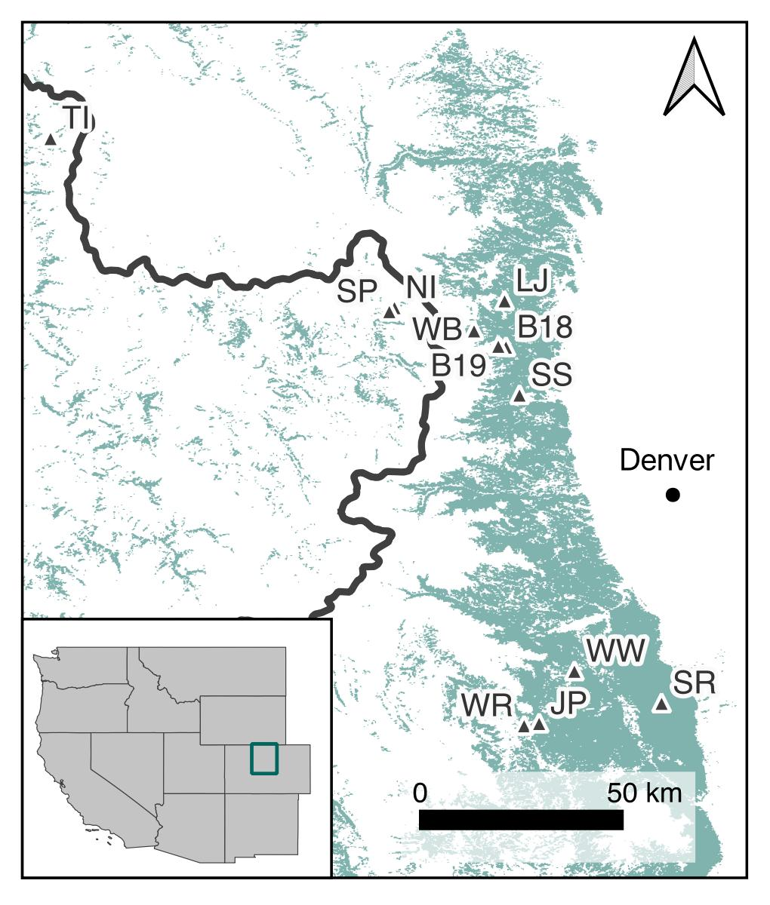

Figure 1: The study area and WSB reconstruction sample sites. The green polygon illustrates the distribution of Douglas fir and the thick black line shows the position of the Continental Divide. The study area’s location relative to the contiguous western United States is shown in the inset map.

## Data

### Dendroecological data

Ring-width data for reconstructing periods of WSB outbreak were collected from Douglas fir in the 1990s, but unpublished (Table 2). Sample sites were selected based on the availability large, old Douglas fir and the absence of evidence of recent fire or logging to minimize the potential effects of other disturbances on radial growth. At each site, tree-ring data were collected by preferentially sampling at least 20 large Douglas fir using an increment borer. Cores were transferred back to the lab, where they were dried, mounted, and sanded to a fine polish, following standard dendrochronological methods (Stokes and Smiley, 1996). Ring-widths were then measured to a 0.01 mm precision using a Velmex unSlide digital encoded traversing table paired with a standard light microscope. To ensure accurate dating, ring-width series were visually cross-dated using the maker year approach (Yamaguchi, 1991). Cross-dating was then verified statistically using the *dplR* package (Bunn et al., 2019) in R (R Core Team, 2022).

## There does not appear to be a header in the rwl file  
## There are 16 series  
## 1 279 1869 1989 0.01  
## 2 251 1841 1978 0.01  
## 3 248 1853 1981 0.01  
## 4 258 1782 1983 0.01  
## 5 275 1835 1979 0.01  
## 6 249 1894 1985 0.01  
## 7 250 1838 1980 0.01  
## 8 253 1797 1982 0.01  
## 9 599 1845 1982 0.01  
## 10 572 1871 1962 0.01  
## 11 277 1892 1985 0.01  
## 12 254 1867 1979 0.01  
## 13 367 1734 1998 0.01  
## 14 398 1858 1998 0.01  
## 15 394 1864 1998 0.01  
## 16 362 1899 1998 0.01  
## There does not appear to be a header in the rwl file  
## There are 22 series  
## 1 469 1689 1948 0.01  
## 2 429 1751 1975 0.01  
## 3 459 1749 1976 0.01  
## 4 468 1659 1986 0.01  
## 5 423 1664 1945 0.01  
## 6 437 1707 1933 0.01  
## 7 421 1768 1981 0.01  
## 8 405 1750 1982 0.01  
## 9 509 1615 1980 0.01  
## 10 403 1733 1934 0.01  
## 11 408 1703 1978 0.01  
## 12 444 1675 1987 0.01  
## 13 493 1856 1984 0.01  
## 14 482 1879 1980 0.01  
## 15 480 1853 1981 0.01  
## 16 430 1926 1998 0.01  
## 17 474 1914 1998 0.01  
## 18 432 1909 1998 0.01  
## 19 479 1904 1998 0.01  
## 20 478 1894 1998 0.01  
## 21 443 1875 1998 0.01  
## 22 464 1733 1998 0.01  
## There does not appear to be a header in the rwl file  
## There are 35 series  
## 1 063 1743 1995 0.01  
## 2 A95038 1726 1995 0.01  
## 3 608 1643 1995 0.01  
## 4 609 1864 1995 0.01  
## 5 610 1855 1995 0.01  
## 6 611 1781 1995 0.01  
## 7 612 1777 1995 0.01  
## 8 622 1757 1995 0.01  
## 9 623 1868 1995 0.01  
## 10 624 1848 1995 0.01  
## 11 631 1708 1995 0.01  
## 12 632 1743 1995 0.01  
## 13 633 1694 1995 0.01  
## 14 635 1626 1995 0.01  
## 15 647 1834 1995 0.01  
## 16 648 1833 1995 0.01  
## 17 649 1741 1995 0.01  
## 18 650 1752 1995 0.01  
## 19 655 1592 1995 0.01  
## 20 660 1664 1995 0.01  
## 21 602 1591 1984 0.01  
## 22 605 1690 1984 0.01  
## 23 606 1676 1995 0.01  
## 24 607 1646 1995 0.01  
## 25 616 1736 1995 0.01  
## 26 618 1827 1995 0.01  
## 27 621 1746 1984 0.01  
## 28 626 1770 1995 0.01  
## 29 636 1646 1995 0.01  
## 30 637 1659 1965 0.01  
## 31 651 1862 1995 0.01  
## 32 652 1859 1995 0.01  
## 33 653 1781 1995 0.01  
## 34 654 1788 1995 0.01  
## 35 656 1594 1970 0.01  
## There does not appear to be a header in the rwl file  
## There are 27 series  
## 1 CO9570 1545 1995 0.01  
## 2 CO9571 1538 1995 0.01  
## 3 CO9572 1595 1995 0.01  
## 4 CO9573 1700 1995 0.01  
## 5 CO9574 1799 1995 0.01  
## 6 CO9575 1807 1995 0.01  
## 7 CO9576 1674 1995 0.01  
## 8 CO9577 1682 1995 0.01  
## 9 CO9578 1700 1995 0.01  
## 10 CO9579 1627 1995 0.01  
## 11 CO957A 1505 1995 0.01  
## 12 CO957B 1679 1995 0.01  
## 13 CO957C 1442 1995 0.01  
## 14 CO9580 1419 1995 0.01  
## 15 CO9581 1533 1995 0.01  
## 16 CO9582 1867 1995 0.01  
## 17 CO9583 1850 1995 0.01  
## 18 CO9584 1724 1995 0.01  
## 19 CO9585 1735 1995 0.01  
## 20 C09580 1833 1995 0.01  
## 21 CO9586 1853 1995 0.01  
## 22 C09581 1918 1995 0.01  
## 23 CO9587 1913 1995 0.01  
## 24 CO9588 1917 1995 0.01  
## 25 CO9589 1916 1995 0.01  
## 26 CO958A 1731 1995 0.01  
## 27 CO958B 1786 1995 0.01  
## There does not appear to be a header in the rwl file  
## There are 17 series  
## 1 374 1775 1994 0.01  
## 2 377 1759 1994 0.01  
## 3 380 1745 1994 0.01  
## 4 382 1887 1994 0.01  
## 5 385 1830 1994 0.01  
## 6 388 1800 1994 0.01  
## 7 391 1778 1994 0.01  
## 8 395 1792 1994 0.01  
## 9 398 1774 1994 0.01  
## 10 402 1849 1994 0.01  
## 11 404 1877 1994 0.01  
## 12 405 1889 1994 0.01  
## 13 410 1832 1994 0.01  
## 14 412 1889 1994 0.01  
## 15 413 1875 1994 0.01  
## 16 425 1741 1994 0.01  
## 17 428 1767 1994 0.01  
## There does not appear to be a header in the rwl file  
## There are 46 series  
## 1 CO9560 1693 1995 0.01  
## 2 CO9561 1732 1995 0.01  
## 3 CO9562 1729 1995 0.01  
## 4 CO9563 1895 1995 0.01  
## 5 CO9564 1897 1995 0.01  
## 6 CO9565 1888 1995 0.01  
## 7 CO9566 1882 1995 0.01  
## 8 CO9567 1879 1995 0.01  
## 9 CO9568 1883 1995 0.01  
## 10 CO9569 1875 1995 0.01  
## 11 CO956A 1871 1995 0.01  
## 12 CO956B 1860 1995 0.01  
## 13 CO956C 1879 1995 0.01  
## 14 CO956D 1844 1995 0.01  
## 15 CO956E 1851 1995 0.01  
## 16 CO956F 1907 1995 0.01  
## 17 CO956G 1927 1995 0.01  
## 18 CO956H 1703 1995 0.01  
## 19 CO956I 1690 1995 0.01  
## 20 CO956J 1738 1995 0.01  
## 21 CO956K 1729 1995 0.01  
## 22 C95D60 1598 1860 0.01  
## 23 C95D61 1622 1850 0.01  
## 24 CO956L 1628 1995 0.01  
## 25 CO956M 1624 1995 0.01  
## 26 CO956N 1709 1995 0.01  
## 27 CO956O 1711 1995 0.01  
## 28 CO956P 1877 1995 0.01  
## 29 CO956Q 1584 1995 0.01  
## 30 CO956R 1571 1995 0.01  
## 31 CO9570 1623 1995 0.01  
## 32 CO9571 1638 1995 0.01  
## 33 CO9573 1860 1995 0.01  
## 34 CO9574 1873 1995 0.01  
## 35 CO9575 1826 1995 0.01  
## 36 CO9576 1583 1987 0.01  
## 37 CO9577 1628 1995 0.01  
## 38 CO9578 1617 1995 0.01  
## 39 CO9579 1660 1995 0.01  
## 40 CO957A 1634 1995 0.01  
## 41 CO957B 1834 1995 0.01  
## 42 CO957C 1860 1995 0.01  
## 43 CO957D 1854 1995 0.01  
## 44 CO957E 1857 1995 0.01  
## 45 CO957F 1860 1995 0.01  
## 46 CO9572 1866 1995 0.01  
## There does not appear to be a header in the rwl file  
## There are 26 series  
## 1 1217 1787 2000 0.01  
## 2 1204 1700 2000 0.01  
## 3 1155 1739 2000 0.01  
## 4 1168 1800 2000 0.01  
## 5 1170 1781 2000 0.01  
## 6 1241 1897 2000 0.01  
## 7 1098 1789 2000 0.01  
## 8 1129 1827 2000 0.01  
## 9 1009 1766 2000 0.01  
## 10 1218 1890 2000 0.01  
## 11 1067 1809 2000 0.01  
## 12 1127 1894 2000 0.01  
## 13 1250 1894 2000 0.01  
## 14 995 1879 2000 0.01  
## 15 975 1763 2000 0.01  
## 16 1245 1894 2000 0.01  
## 17 1062 1805 2000 0.01  
## 18 1201 1750 2000 0.01  
## 19 965 1787 2000 0.01  
## 20 1037 1704 2000 0.01  
## 21 1222 1806 2000 0.01  
## 22 1063 1901 2000 0.01  
## 23 1120 1691 2000 0.01  
## 24 1265 1730 2000 0.01  
## 25 1130 1889 2000 0.01  
## 26 1001 1800 2000 0.01  
## There does not appear to be a header in the rwl file  
## There are 48 series  
## 1 C93001 1841 1994 0.01  
## 2 C93009 1861 1994 0.01  
## 3 C93003 1819 1994 0.01  
## 4 C93004 1777 1994 0.01  
## 5 C93018 1825 1994 0.01  
## 6 C93013 1819 1994 0.01  
## 7 C93017 1796 1994 0.01  
## 8 C93082 1817 1994 0.01  
## 9 CO9500 1866 1995 0.01  
## 10 CO9501 1850 1994 0.01  
## 11 CO9502 1871 1995 0.01  
## 12 CO9503 1883 1995 0.01  
## 13 CO9504 1882 1995 0.01  
## 14 CO9505 1857 1995 0.01  
## 15 CO9506 1863 1995 0.01  
## 16 CO9507 1849 1995 0.01  
## 17 CO9508 1873 1994 0.01  
## 18 CO9509 1888 1995 0.01  
## 19 C09501 1770 1995 0.01  
## 20 CO950A 1829 1995 0.01  
## 21 CO950B 1807 1995 0.01  
## 22 CO9514 1785 1995 0.01  
## 23 CO950C 1638 1995 0.01  
## 24 CO9601 1765 1995 0.01  
## 25 CO950D 1869 1994 0.01  
## 26 CO950E 1770 1995 0.01  
## 27 CO950F 1900 1995 0.01  
## 28 CO950G 1896 1995 0.01  
## 29 CO950H 1857 1995 0.01  
## 30 CO950I 1798 1995 0.01  
## 31 CO950J 1901 1995 0.01  
## 32 CO950K 1853 1995 0.01  
## 33 CO950L 1840 1995 0.01  
## 34 CO950M 1875 1995 0.01  
## 35 CO950N 1821 1995 0.01  
## 36 CO950O 1876 1995 0.01  
## 37 CO950P 1848 1995 0.01  
## 38 CO950Q 1831 1995 0.01  
## 39 CO950R 1864 1995 0.01  
## 40 CO950S 1901 1995 0.01  
## 41 CO950T 1877 1995 0.01  
## 42 CO950U 1845 1995 0.01  
## 43 CO950V 1831 1995 0.01  
## 44 CO950W 1871 1995 0.01  
## 45 CO950X 1861 1995 0.01  
## 46 CO950Y 1845 1995 0.01  
## 47 CO950Z 1823 1995 0.01  
## 48 CO950a 1827 1995 0.01  
## There does not appear to be a header in the rwl file  
## There are 21 series  
## 1 531 1732 1994 0.01  
## 2 532 1630 1994 0.01  
## 3 534 1676 1994 0.01  
## 4 535 1666 1989 0.01  
## 5 542 1609 1994 0.01  
## 6 544 1695 1994 0.01  
## 7 547 1808 1994 0.01  
## 8 552 1679 1994 0.01  
## 9 554 1741 1994 0.01  
## 10 555 1782 1994 0.01  
## 11 558 1858 1994 0.01  
## 12 559 1851 1994 0.01  
## 13 562 1862 1994 0.01  
## 14 C564 1897 1994 0.01  
## 15 569 1835 1994 0.01  
## 16 571 1676 1994 0.01  
## 17 575 1604 1994 0.01  
## 18 581 1867 1994 0.01  
## 19 583 1845 1994 0.01  
## 20 585A 1751 1994 0.01  
## 21 587 1800 1994 0.01  
## There does not appear to be a header in the rwl file  
## There are 40 series  
## 1 721 1871 1995 0.01  
## 2 722 1892 1995 0.01  
## 3 723 1886 1995 0.01  
## 4 724 1900 1995 0.01  
## 5 725 1814 1995 0.01  
## 6 726 1827 1995 0.01  
## 7 727 1858 1995 0.01  
## 8 728 1854 1995 0.01  
## 9 729 1860 1995 0.01  
## 10 730 1866 1995 0.01  
## 11 731 1775 1995 0.01  
## 12 732 1767 1995 0.01  
## 13 733 1800 1995 0.01  
## 14 734 1816 1995 0.01  
## 15 735 1789 1995 0.01  
## 16 736 1808 1995 0.01  
## 17 737 1823 1995 0.01  
## 18 738 1813 1995 0.01  
## 19 739 1861 1995 0.01  
## 20 740 1865 1995 0.01  
## 21 741 1837 1995 0.01  
## 22 742 1828 1995 0.01  
## 23 745 1836 1995 0.01  
## 24 746 1833 1995 0.01  
## 25 747 1865 1995 0.01  
## 26 748 1870 1995 0.01  
## 27 749 1804 1995 0.01  
## 28 750 1797 1995 0.01  
## 29 751 1819 1982 0.01  
## 30 752 1812 1983 0.01  
## 31 753 1881 1995 0.01  
## 32 754 1879 1995 0.01  
## 33 755 1856 1995 0.01  
## 34 756 1857 1995 0.01  
## 35 757 1877 1995 0.01  
## 36 758 1874 1995 0.01  
## 37 759 1886 1995 0.01  
## 38 760 1884 1995 0.01  
## 39 d743 1627 1981 0.01  
## 40 d744 1594 1968 0.01  
## There does not appear to be a header in the rwl file  
## There are 31 series  
## 1 NI1565 1679 2000 0.01  
## 2 NI1540 1696 2000 0.01  
## 3 NI1569 1678 2000 0.01  
## 4 NI4001 1733 2000 0.01  
## 5 NI1502 1850 2000 0.01  
## 6 NI1572 1808 2000 0.01  
## 7 NI1400 1626 2000 0.01  
## 8 NI1566 1669 2000 0.01  
## 9 NI1573 1564 2000 0.01  
## 10 NI4182 1756 2000 0.01  
## 11 NI4032 1740 2000 0.01  
## 12 NI4143 1765 2000 0.01  
## 13 NI1390 1719 2000 0.01  
## 14 NI4011 1760 2000 0.01  
## 15 NI4147 1699 2000 0.01  
## 16 NI1580 1767 2000 0.01  
## 17 NI4104 1630 2000 0.01  
## 18 NI1500 1806 2000 0.01  
## 19 NI1511 1659 2000 0.01  
## 20 NI1579 1717 2000 0.01  
## 21 NI1524 1689 2000 0.01  
## 22 NI4031 1832 2000 0.01  
## 23 NI1536 1779 2000 0.01  
## 24 NI1531 1868 2000 0.01  
## 25 NI1577 1853 2000 0.01  
## 26 NI1532 1829 2000 0.01  
## 27 NI4140 1779 2000 0.01  
## 28 NI1571 1757 2000 0.01  
## 29 NI1517 1794 2000 0.01  
## 30 NI1537 1697 2000 0.01  
## 31 NI1525 1852 2000 0.01  
## There does not appear to be a header in the rwl file  
## There are 22 series  
## 1 344 1697 1997 0.01  
## 2 363 1735 1997 0.01  
## 3 472 1721 1997 0.01  
## 4 TI376 1754 1996 0.01  
## 5 TI293 1778 1997 0.01  
## 6 TI434 1732 1997 0.01  
## 7 TI488 1733 1997 0.01  
## 8 TI295 1733 1997 0.01  
## 9 TI302 1741 1997 0.01  
## 10 TI329 1751 1997 0.01  
## 11 TI459 1757 1997 0.01  
## 12 TI308 1759 1997 0.01  
## 13 TI336 1767 1997 0.01  
## 14 TI255 1768 1997 0.01  
## 15 TI413 1782 1997 0.01  
## 16 TI384 1784 1997 0.01  
## 17 TI362 1809 1997 0.01  
## 18 TI300A 1824 1997 0.01  
## 19 TI322 1827 1997 0.01  
## 20 TI264 1850 1997 0.01  
## 21 TI333A 1857 1997 0.01  
## 22 TI426 1872 1997 0.01  
## There does not appear to be a header in the rwl file  
## There are 17 series  
## 1 C311 1691 1994 0.01  
## 2 314 1753 1994 0.01  
## 3 317A 1808 1994 0.01  
## 4 319 1858 1994 0.01  
## 5 322 1808 1994 0.01  
## 6 324 1771 1994 0.01  
## 7 325 1739 1994 0.01  
## 8 328 1783 1994 0.01  
## 9 336 1798 1994 0.01  
## 10 348 1742 1994 0.01  
## 11 351 1762 1994 0.01  
## 12 353 1803 1994 0.01  
## 13 357A 1731 1985 0.01  
## 14 360 1762 1994 0.01  
## 15 361 1747 1994 0.01  
## 16 365 1743 1994 0.01  
## 17 368 1795 1994 0.01  
## There does not appear to be a header in the rwl file  
## There are 21 series  
## 1 438 1824 1994 0.01  
## 2 440 1891 1993 0.01  
## 3 442 1821 1994 0.01  
## 4 445 1770 1994 0.01  
## 5 C447 1792 1994 0.01  
## 6 450 1754 1994 0.01  
## 7 452 1905 1994 0.01  
## 8 456 1923 1994 0.01  
## 9 458 1901 1994 0.01  
## 10 460 1902 1994 0.01  
## 11 461 1890 1994 0.01  
## 12 466 1904 1994 0.01  
## 13 467 1743 1994 0.01  
## 14 469 1841 1994 0.01  
## 15 471 1884 1994 0.01  
## 16 473A 1874 1994 0.01  
## 17 479 1889 1994 0.01  
## 18 481 1888 1994 0.01  
## 19 483 1889 1994 0.01  
## 20 485 1783 1994 0.01  
## 21 488 1872 1994 0.01  
## There does not appear to be a header in the rwl file  
## There are 28 series  
## 1 WB1354 1707 2000 0.01  
## 2 WB1371 1634 2000 0.01  
## 3 WB1373 1652 2000 0.01  
## 4 WB1377 1676 2000 0.01  
## 5 WB1357 1659 2000 0.01  
## 6 WB1358 1703 2000 0.01  
## 7 WB1346 1824 2000 0.01  
## 8 WB1359 1751 2000 0.01  
## 9 WB1366 1646 2000 0.01  
## 10 WB1333 1657 2000 0.01  
## 11 WB1378 1750 2000 0.01  
## 12 WB1342 1729 2000 0.01  
## 13 WB1376 1695 2000 0.01  
## 14 WB1367 1800 2000 0.01  
## 15 WB1364 1673 2000 0.01  
## 16 WB1341 1414 2000 0.01  
## 17 WB1338 1637 2000 0.01  
## 18 WB1326 1639 2000 0.01  
## 19 WB1361 1713 2000 0.01  
## 20 WB1353 1835 2000 0.01  
## 21 WB1337 1670 2000 0.01  
## 22 WB1365 1650 2000 0.01  
## 23 WB1070 1661 2000 0.01  
## 24 WB1339 1712 2000 0.01  
## 25 WB1372 1467 2000 0.01  
## 26 WB1368 1657 2000 0.01  
## 27 WB1347 1750 2000 0.01  
## 28 WB1125 1677 2000 0.01

## Attempting to automatically detect format.  
## Assuming a Tucson format file.  
## There does not appear to be a header in the rwl file  
## There are 20 series  
## 1 501011 1710 1964 0.01  
## 2 501012 1730 1964 0.01  
## 3 501021 1760 1964 0.01  
## 4 501022 1720 1964 0.01  
## 5 501051 1680 1964 0.01  
## 6 501052 1680 1964 0.01  
## 7 501061 1720 1964 0.01  
## 8 501062 1710 1964 0.01  
## 9 501091 1710 1964 0.01  
## 10 501092 1720 1964 0.01  
## 11 501101 1710 1964 0.01  
## 12 501102 1710 1964 0.01  
## 13 501111 1710 1964 0.01  
## 14 501112 1710 1964 0.01  
## 15 501131 1800 1964 0.01  
## 16 501132 1760 1964 0.01  
## 17 501141 1700 1964 0.01  
## 18 501142 1770 1964 0.01  
## 19 501171 1680 1964 0.01  
## 20 501172 1680 1964 0.01  
## Attempting to automatically detect format.  
## Assuming a Tucson format file.  
## There does not appear to be a header in the rwl file  
## There are 20 series  
## 1 511051 1740 1964 0.01  
## 2 511052 1740 1964 0.01  
## 3 511061 1740 1964 0.01  
## 4 511062 1740 1964 0.01  
## 5 511071 1710 1964 0.01  
## 6 511072 1710 1964 0.01  
## 7 511081 1740 1964 0.01  
## 8 511082 1780 1964 0.01  
## 9 511091 1730 1964 0.01  
## 10 511092 1730 1964 0.01  
## 11 511111 1750 1964 0.01  
## 12 511112 1750 1964 0.01  
## 13 511151 1660 1964 0.01  
## 14 511152 1650 1964 0.01  
## 15 511181 1780 1964 0.01  
## 16 511182 1780 1964 0.01  
## 17 511211 1770 1964 0.01  
## 18 511212 1830 1964 0.01  
## 19 511221 1750 1964 0.01  
## 20 511222 1750 1964 0.01  
## Attempting to automatically detect format.  
## Assuming a Tucson format file.  
## There does not appear to be a header in the rwl file  
## There are 31 series  
## 1 DVG011 1866 1960 0.01  
## 2 DVG012 1872 1960 0.01  
## 3 DVG021 1908 1980 0.01  
## 4 DVG022 1903 1980 0.01  
## 5 DVG031 1883 1980 0.01  
## 6 DVG032 1886 1980 0.01  
## 7 DVG041 1896 1980 0.01  
## 8 DVG042 1886 1980 0.01  
## 9 DVG051 1893 1920 0.01  
## 10 DVG052 1892 1920 0.01  
## 11 DVG061 1846 1920 0.01  
## 12 DVG062 1840 1920 0.01  
## 13 DVG071 1803 1920 0.01  
## 14 DVG081 1804 1980 0.01  
## 15 DVG082 1807 1980 0.01  
## 16 DVG091 1867 1980 0.01  
## 17 DVG092 1879 1980 0.01  
## 18 DVG111 1783 1980 0.01  
## 19 DVG112 1770 1950 0.01  
## 20 DVG113 1765 1980 0.01  
## 21 DVG121 1720 1980 0.01  
## 22 DVG122 1756 1950 0.01  
## 23 DVG131 1650 1980 0.01  
## 24 DVG141 1750 1980 0.01  
## 25 DVG142 1773 1980 0.01  
## 26 DVG181 1800 1980 0.01  
## 27 DVG182 1774 1980 0.01  
## 28 DVG191 1744 1980 0.01  
## 29 DVG192 1795 1980 0.01  
## 30 DVG201 1786 1950 0.01  
## 31 DVG202 1803 1980 0.01  
## Attempting to automatically detect format.  
## Assuming a Tucson format file.  
## There does not appear to be a header in the rwl file  
## There are 31 series  
## 1 DVG011 1866 1960 0.01  
## 2 DVG012 1872 1960 0.01  
## 3 DVG021 1908 1980 0.01  
## 4 DVG022 1903 1980 0.01  
## 5 DVG031 1883 1980 0.01  
## 6 DVG032 1886 1980 0.01  
## 7 DVG041 1896 1980 0.01  
## 8 DVG042 1886 1980 0.01  
## 9 DVG051 1893 1920 0.01  
## 10 DVG052 1892 1920 0.01  
## 11 DVG061 1846 1920 0.01  
## 12 DVG062 1840 1920 0.01  
## 13 DVG071 1803 1920 0.01  
## 14 DVG081 1804 1980 0.01  
## 15 DVG082 1807 1980 0.01  
## 16 DVG091 1867 1980 0.01  
## 17 DVG092 1879 1980 0.01  
## 18 DVG111 1783 1980 0.01  
## 19 DVG112 1770 1950 0.01  
## 20 DVG113 1765 1980 0.01  
## 21 DVG121 1720 1980 0.01  
## 22 DVG122 1756 1950 0.01  
## 23 DVG131 1650 1980 0.01  
## 24 DVG141 1750 1980 0.01  
## 25 DVG142 1773 1980 0.01  
## 26 DVG181 1800 1980 0.01  
## 27 DVG182 1774 1980 0.01  
## 28 DVG191 1744 1980 0.01  
## 29 DVG192 1795 1980 0.01  
## 30 DVG201 1786 1950 0.01  
## 31 DVG202 1803 1980 0.01  
## Attempting to automatically detect format.  
## Assuming a Tucson format file.  
## There does not appear to be a header in the rwl file  
## There are 66 series  
## 1 BIG021 1962 1979 0.01  
## 2 BIG022 1957 1979 0.01  
## 3 BIG041 1950 1979 0.01  
## 4 BIG042 1942 1979 0.01  
## 5 BIG061 1903 1979 0.01  
## 6 BIG062 1915 1979 0.01  
## 7 BIG081 1960 1979 0.01  
## 8 BIG082 1960 1979 0.01  
## 9 BIG091 1952 1979 0.01  
## 10 BIG092 1957 1979 0.01  
## 11 BIG111 1894 1979 0.01  
## 12 BIG112 1890 1979 0.01  
## 13 BIG121 1899 1979 0.01  
## 14 BIG122 1907 1979 0.01  
## 15 BIG131 1902 1975 0.01  
## 16 BIG132 1902 1975 0.01  
## 17 BIG141 1895 1983 0.01  
## 18 BIG142 1895 1983 0.01  
## 19 BIG151 1880 1983 0.01  
## 20 BIG152 1880 1983 0.01  
## 21 BIG161 1832 1983 0.01  
## 22 BIG162 1835 1983 0.01  
## 23 BIG171 1850 1983 0.01  
## 24 BIG172 1830 1983 0.01  
## 25 BIG181 1839 1983 0.01  
## 26 BIG182 1830 1870 0.01  
## 27 BIG183 1873 1983 0.01  
## 28 BIG191 1811 1983 0.01  
## 29 BIG192 1812 1983 0.01  
## 30 BIG201 1810 1983 0.01  
## 31 BIG202 1811 1983 0.01  
## 32 BIG211 1818 1960 0.01  
## 33 BIG212 1825 1960 0.01  
## 34 BIG221 1947 1983 0.01  
## 35 BIG222 1949 1983 0.01  
## 36 BIG231 1903 1975 0.01  
## 37 BIG232 1902 1975 0.01  
## 38 BIG241 1910 1983 0.01  
## 39 BIG242 1910 1983 0.01  
## 40 BIG271 1885 1983 0.01  
## 41 BIG272 1880 1983 0.01  
## 42 BIG281 1897 1979 0.01  
## 43 BIG282 1897 1983 0.01  
## 44 BIG291 1895 1979 0.01  
## 45 BIG292 1897 1979 0.01  
## 46 BIG311 1884 1975 0.01  
## 47 BIG312 1884 1975 0.01  
## 48 BIG321 1948 1975 0.01  
## 49 BIG322 1944 1983 0.01  
## 50 BIG331 1953 1983 0.01  
## 51 BIG332 1950 1983 0.01  
## 52 BIG341 1892 1979 0.01  
## 53 BIG351 1893 1979 0.01  
## 54 BIG352 1893 1979 0.01  
## 55 BIG361 1899 1970 0.01  
## 56 BIG362 1897 1950 0.01  
## 57 BIG381 1813 1983 0.01  
## 58 BIG382 1800 1978 0.01  
## 59 BIG391 1834 1975 0.01  
## 60 BIG392 1839 1950 0.01  
## 61 BIG401 1818 1950 0.01  
## 62 BIG402 1820 1950 0.01  
## 63 BIG411 1833 1983 0.01  
## 64 BIG412 1833 1983 0.01  
## 65 BIG431 1820 1975 0.01  
## 66 BIG432 1820 1975 0.01  
## Attempting to automatically detect format.  
## Assuming a Tucson format file.  
## There does not appear to be a header in the rwl file  
## There are 50 series  
## 1 ICR041 1940 1983 0.01  
## 2 ICR042 1940 1983 0.01  
## 3 ICR051 1940 1983 0.01  
## 4 ICR052 1940 1983 0.01  
## 5 ICR061 1906 1983 0.01  
## 6 ICR062 1915 1983 0.01  
## 7 ICR071 1902 1983 0.01  
## 8 ICR072 1908 1983 0.01  
## 9 ICR081 1912 1983 0.01  
## 10 ICR082 1907 1983 0.01  
## 11 ICR091 1905 1983 0.01  
## 12 ICR092 1905 1983 0.01  
## 13 ICR101 1904 1979 0.01  
## 14 ICR102 1898 1983 0.01  
## 15 ICR111 1915 1970 0.01  
## 16 ICR112 1904 1983 0.01  
## 17 ICR131 1910 1983 0.01  
## 18 ICR132 1905 1983 0.01  
## 19 ICR141 1930 1983 0.01  
## 20 ICR142 1933 1983 0.01  
## 21 ICR151 1923 1983 0.01  
## 22 ICR152 1929 1983 0.01  
## 23 ICR161 1924 1983 0.01  
## 24 ICR162 1926 1983 0.01  
## 25 ICR171 1943 1983 0.01  
## 26 ICR172 1950 1983 0.01  
## 27 ICR181 1867 1970 0.01  
## 28 ICR182 1866 1969 0.01  
## 29 ICR191 1867 1983 0.01  
## 30 ICR192 1863 1983 0.01  
## 31 ICR201 1908 1983 0.01  
## 32 ICR202 1908 1983 0.01  
## 33 ICR211 1894 1983 0.01  
## 34 ICR212 1910 1983 0.01  
## 35 ICR221 1901 1983 0.01  
## 36 ICR222 1898 1983 0.01  
## 37 ICR231 1917 1983 0.01  
## 38 ICR232 1919 1983 0.01  
## 39 ICR241 1859 1983 0.01  
## 40 ICR242 1882 1983 0.01  
## 41 ICR251 1860 1983 0.01  
## 42 ICR252 1860 1960 0.01  
## 43 ICR261 1916 1969 0.01  
## 44 ICR262 1915 1983 0.01  
## 45 ICR271 1917 1983 0.01  
## 46 ICR272 1918 1983 0.01  
## 47 ICR281 1898 1983 0.01  
## 48 ICR282 1901 1983 0.01  
## 49 ICR291 1906 1983 0.01  
## 50 ICR292 1903 1983 0.01  
## Attempting to automatically detect format.  
## Assuming a Tucson format file.  
## There does not appear to be a header in the rwl file  
## There are 31 series  
## 1 OPH011 1890 1983 0.01  
## 2 OPH012 1898 1983 0.01  
## 3 OPH021 1897 1983 0.01  
## 4 OPH022 1897 1983 0.01  
## 5 OPH031 1878 1983 0.01  
## 6 OPH041 1864 1983 0.01  
## 7 OPH051 1830 1984 0.01  
## 8 OPH052 1830 1984 0.01  
## 9 OPH061 1831 1984 0.01  
## 10 OPH062 1830 1984 0.01  
## 11 OPH071 1860 1984 0.01  
## 12 OPH072 1869 1984 0.01  
## 13 OPH081 1870 1984 0.01  
## 14 OPH082 1870 1984 0.01  
## 15 OPH091 1804 1984 0.01  
## 16 OPH101 1830 1984 0.01  
## 17 OPH102 1830 1984 0.01  
## 18 OPH111 1792 1984 0.01  
## 19 OPH112 1795 1984 0.01  
## 20 OPH121 1821 1984 0.01  
## 21 OPH122 1807 1984 0.01  
## 22 OPH131 1726 1984 0.01  
## 23 OPH132 1732 1984 0.01  
## 24 OPH141 1848 1984 0.01  
## 25 OPH142 1840 1984 0.01  
## 26 OPH161 1830 1984 0.01  
## 27 OPH162 1830 1984 0.01  
## 28 OPH171 1731 1984 0.01  
## 29 OPH172 1775 1984 0.01  
## 30 OPH181 1854 1984 0.01  
## 31 OPH182 1862 1984 0.01  
## Attempting to automatically detect format.  
## Assuming a Tucson format file.  
## There does not appear to be a header in the rwl file  
## There are 12 series  
## 1 OAK011 1862 1983 0.01  
## 2 OAK012 1861 1983 0.01  
## 3 OAK021 1885 1983 0.01  
## 4 OAK022 1875 1983 0.01  
## 5 OAK041 1933 1983 0.01  
## 6 OAK042 1939 1983 0.01  
## 7 OAK051 1896 1983 0.01  
## 8 OAK052 1899 1983 0.01  
## 9 OAK091 1891 1983 0.01  
## 10 OAK092 1889 1983 0.01  
## 11 OAK101 1896 1983 0.01  
## 12 OAK102 1893 1983 0.01  
## Attempting to automatically detect format.  
## Assuming a Tucson format file.  
## There does not appear to be a header in the rwl file  
## There are 25 series  
## 1 ORP021 1896 1983 0.01  
## 2 ORP022 1905 1983 0.01  
## 3 ORP031 1885 1983 0.01  
## 4 ORP032 1885 1983 0.01  
## 5 ORP041 1885 1983 0.01  
## 6 ORP042 1891 1983 0.01  
## 7 ORP071 1912 1983 0.01  
## 8 ORP072 1911 1983 0.01  
## 9 ORP081 1910 1983 0.01  
## 10 ORP082 1914 1983 0.01  
## 11 ORP091 1738 1860 0.01  
## 12 ORP092 1714 1983 0.01  
## 13 ORP093 1870 1983 0.01  
## 14 ORP102 1875 1983 0.01  
## 15 ORP103 1875 1983 0.01  
## 16 ORP104 1718 1830 0.01  
## 17 ORP111 1793 1983 0.01  
## 18 ORP112 1810 1983 0.01  
## 19 ORP131 1740 1983 0.01  
## 20 ORP132 1740 1983 0.01  
## 21 ORP141 1720 1983 0.01  
## 22 ORP142 1720 1983 0.01  
## 23 ORP151 1724 1984 0.01  
## 24 ORP152 1734 1984 0.01  
## 25 ORP162 1720 1984 0.01  
## Attempting to automatically detect format.  
## Assuming a Tucson format file.  
## There does not appear to be a header in the rwl file  
## There are 32 series  
## 1 EDP011 1730 1987 0.01  
## 2 EDP012 1745 1987 0.01  
## 3 EDP021 1752 1987 0.01  
## 4 EDP022 1765 1987 0.01  
## 5 EDP031 1791 1987 0.01  
## 6 EDP032 1829 1987 0.01  
## 7 EDP041 1737 1987 0.01  
## 8 EDP042 1749 1987 0.01  
## 9 EDP051 1795 1987 0.01  
## 10 EDP052 1807 1987 0.01  
## 11 EDP061 1699 1987 0.01  
## 12 EDP062 1678 1987 0.01  
## 13 EDP071 1766 1987 0.01  
## 14 EDP072 1766 1987 0.01  
## 15 EDP081 1759 1987 0.01  
## 16 EDP082 1759 1987 0.01  
## 17 EDP091 1750 1987 0.01  
## 18 EDP092 1816 1987 0.01  
## 19 EDP101 1741 1987 0.01  
## 20 EDP102 1739 1987 0.01  
## 21 EDP111 1750 1987 0.01  
## 22 EDP112 1750 1987 0.01  
## 23 EDP121 1701 1987 0.01  
## 24 EDP122 1701 1987 0.01  
## 25 EDP131 1723 1987 0.01  
## 26 EDP132 1723 1987 0.01  
## 27 EDP141 1777 1987 0.01  
## 28 EDP142 1784 1987 0.01  
## 29 EDP151 1811 1987 0.01  
## 30 EDP152 1811 1987 0.01  
## 31 EDP161 1729 1987 0.01  
## 32 EDP171 1739 1987 0.01  
## Attempting to automatically detect format.  
## Assuming a Tucson format file.  
## There does not appear to be a header in the rwl file  
## There are 21 series  
## 1 HTP011 1767 1987 0.01  
## 2 HTP012 1768 1987 0.01  
## 3 HTP021 1800 1987 0.01  
## 4 HTP022 1797 1987 0.01  
## 5 HTP031 1800 1987 0.01  
## 6 HTP041 1730 1987 0.01  
## 7 HTP042 1729 1987 0.01  
## 8 HTP051 1695 1987 0.01  
## 9 HTP052 1729 1987 0.01  
## 10 HTP061 1796 1987 0.01  
## 11 HTP062 1796 1987 0.01  
## 12 HTP071 1692 1987 0.01  
## 13 HTP072 1692 1987 0.01  
## 14 HTP081 1660 1987 0.01  
## 15 HTP082 1660 1987 0.01  
## 16 HTP091 1710 1987 0.01  
## 17 HTP092 1709 1987 0.01  
## 18 HTP101 1671 1987 0.01  
## 19 HTP102 1675 1987 0.01  
## 20 HTP111 1697 1930 0.01  
## 21 HTP112 1693 1987 0.01  
## Attempting to automatically detect format.  
## Assuming a Tucson format file.  
## There does not appear to be a header in the rwl file  
## There are 22 series  
## 1 LYP011 1658 1987 0.01  
## 2 LYP012 1687 1987 0.01  
## 3 LYP021 1774 1987 0.01  
## 4 LYP022 1774 1987 0.01  
## 5 LYP031 1792 1987 0.01  
## 6 LYP032 1789 1987 0.01  
## 7 LYP041 1794 1987 0.01  
## 8 LYP042 1819 1987 0.01  
## 9 LYP051 1803 1987 0.01  
## 10 LYP052 1801 1987 0.01  
## 11 LYP061 1822 1987 0.01  
## 12 LYP062 1809 1987 0.01  
## 13 LYP071 1750 1987 0.01  
## 14 LYP072 1744 1987 0.01  
## 15 LYP081 1809 1987 0.01  
## 16 LYP082 1815 1987 0.01  
## 17 LYP091 1814 1987 0.01  
## 18 LYP092 1817 1987 0.01  
## 19 LYP101 1795 1987 0.01  
## 20 LYP102 1785 1987 0.01  
## 21 LYP111 1818 1987 0.01  
## 22 LYP112 1805 1987 0.01  
## Attempting to automatically detect format.  
## Assuming a Tucson format file.  
## There does not appear to be a header in the rwl file  
## There are 22 series  
## 1 MOP011 1754 1925 0.01  
## 2 MOP012 1750 1987 0.01  
## 3 MOP021 1625 1725 0.01  
## 4 MOP022 1825 1987 0.01  
## 5 MOP023 1775 1987 0.01  
## 6 MOP031 1650 1987 0.01  
## 7 MOP032 1625 1950 0.01  
## 8 MOP041 1726 1987 0.01  
## 9 MOP042 1825 1987 0.01  
## 10 MOP061 1429 1987 0.01  
## 11 MOP062 1623 1987 0.01  
## 12 MOP071 1735 1987 0.01  
## 13 MOP072 1730 1987 0.01  
## 14 MOP081 1800 1987 0.01  
## 15 MOP082 1709 1987 0.01  
## 16 MOP091 1875 1987 0.01  
## 17 MOP092 1754 1987 0.01  
## 18 MOP101 1800 1987 0.01  
## 19 MOP111 1709 1987 0.01  
## 20 MOP112 1730 1987 0.01  
## 21 MOP121 1739 1987 0.01  
## 22 MOP122 1724 1987 0.01  
## Attempting to automatically detect format.  
## Assuming a Tucson format file.  
## There does not appear to be a header in the rwl file  
## There are 24 series  
## 1 ALO011 1771 1960 0.01  
## 2 ALO012 1771 1977 0.01  
## 3 ALO021 1809 1987 0.01  
## 4 ALO022 1823 1987 0.01  
## 5 ALO031 1748 1987 0.01  
## 6 ALO032 1763 1987 0.01  
## 7 ALO041 1810 1987 0.01  
## 8 ALO042 1809 1987 0.01  
## 9 ALO051 1789 1987 0.01  
## 10 ALO052 1789 1987 0.01  
## 11 ALO061 1786 1987 0.01  
## 12 ALO062 1773 1987 0.01  
## 13 ALO071 1814 1987 0.01  
## 14 ALO072 1809 1987 0.01  
## 15 ALO081 1708 1987 0.01  
## 16 ALO082 1681 1987 0.01  
## 17 ALO091 1791 1987 0.01  
## 18 ALO092 1791 1987 0.01  
## 19 ALO101 1794 1987 0.01  
## 20 ALO102 1794 1987 0.01  
## 21 ALO111 1805 1987 0.01  
## 22 ALO112 1802 1987 0.01  
## 23 ALO121 1778 1987 0.01  
## 24 ALO122 1778 1987 0.01  
## Attempting to automatically detect format.  
## Assuming a Tucson format file.  
## There does not appear to be a header in the rwl file  
## There are 83 series  
## 1 GSD01A 1616 1766 0.01  
## 2 GSD02A 1672 1847 0.01  
## 3 GSD03A 1761 1995 0.01  
## 4 GSD05A 1772 1995 0.01  
## 5 GSD05B 1801 1995 0.01  
## 6 GSD06A 1786 1995 0.01  
## 7 GSD06B 1772 1995 0.01  
## 8 GSD07A 1840 1995 0.01  
## 9 GSD08A 1870 1995 0.01  
## 10 GSD08B 1791 1995 0.01  
## 11 GSD11A 1756 1995 0.01  
## 12 GSD11B 1764 1995 0.01  
## 13 GSD12B 1712 1995 0.01  
## 14 GSD13A 1684 1995 0.01  
## 15 GSD13B 1677 1995 0.01  
## 16 GSD15A 1600 1995 0.01  
## 17 GSD15B 1600 1995 0.01  
## 18 GSD16A 1685 1995 0.01  
## 19 GSD16B 1685 1995 0.01  
## 20 GSD17A 1629 1995 0.01  
## 21 GSD17B 1810 1995 0.01  
## 22 GSD17C 1698 1995 0.01  
## 23 GSD17D 1645 1995 0.01  
## 24 GSD18A 1896 1995 0.01  
## 25 GSD18B 1869 1995 0.01  
## 26 GSD19A 1676 1995 0.01  
## 27 GSD19B 1725 1940 0.01  
## 28 GSD21A 1712 1995 0.01  
## 29 GSD21B 1767 1995 0.01  
## 30 GSD21C 1821 1995 0.01  
## 31 GSD22A 1771 1995 0.01  
## 32 GSD23A 1850 1995 0.01  
## 33 GSD24A 1738 1995 0.01  
## 34 GSD24B 1728 1995 0.01  
## 35 GSD25A 1770 1995 0.01  
## 36 GSD25B 1767 1995 0.01  
## 37 GSD26A 1602 1920 0.01  
## 38 GSD26B 1610 1968 0.01  
## 39 GSD27A 1671 1995 0.01  
## 40 GSD27B 1673 1995 0.01  
## 41 GSD28A 1719 1995 0.01  
## 42 GSD28B 1763 1995 0.01  
## 43 GSD30A 1281 1849 0.01  
## 44 GSD30C 1260 1948 0.01  
## 45 GSD31A 1669 1995 0.01  
## 46 GSD31B 1665 1995 0.01  
## 47 GSD32A 1343 1904 0.01  
## 48 GSD36A 1818 1995 0.01  
## 49 GSD36B 1822 1995 0.01  
## 50 MCT01A 1672 1989 0.01  
## 51 MCT01B 1767 1989 0.01  
## 52 MCT01C 1704 1989 0.01  
## 53 MCT02A 1778 1989 0.01  
## 54 MCT02B 1698 1989 0.01  
## 55 MCT03B 1714 1907 0.01  
## 56 MCT03C 1673 1912 0.01  
## 57 MCT04A 1656 1793 0.01  
## 58 MCT04B 1651 1764 0.01  
## 59 MCT05B 1728 1989 0.01  
## 60 MCT06A 1413 1602 0.01  
## 61 MCT06B 1449 1858 0.01  
## 62 MCT06C 1616 1902 0.01  
## 63 MCT07A 1533 1874 0.01  
## 64 MCT08A 1388 1637 0.01  
## 65 MCT08B 1387 1861 0.01  
## 66 MCT09B 1444 1870 0.01  
## 67 MCT09C 1452 1867 0.01  
## 68 MCT09D 1614 1954 0.01  
## 69 MCT10A 1757 1989 0.01  
## 70 MCT10B 1789 1989 0.01  
## 71 MCT11A 1702 1945 0.01  
## 72 MCT11B 1709 1989 0.01  
## 73 MCT12A 1745 1989 0.01  
## 74 MCT12B 1743 1989 0.01  
## 75 MCT13A 1663 1989 0.01  
## 76 MCT13B 1724 1989 0.01  
## 77 MCT15A 1848 1989 0.01  
## 78 MCT15B 1847 1989 0.01  
## 79 MCT16A 1681 1989 0.01  
## 80 MCT16B 1688 1941 0.01  
## 81 MNT01A 1748 1989 0.01  
## 82 MNT01B 1759 1989 0.01  
## 83 MNT01C 1753 1989 0.01  
## Attempting to automatically detect format.  
## Assuming a Tucson format file.  
## There does not appear to be a header in the rwl file  
## There are 23 series  
## 1 PTP01B 1698 1997 0.01  
## 2 PTP02A 1687 1996 0.01  
## 3 PTP02B 1687 1997 0.01  
## 4 PTP03A 1697 1997 0.01  
## 5 PTP03B 1694 1997 0.01  
## 6 PTP04A 1698 1997 0.01  
## 7 PTP04B 1690 1997 0.01  
## 8 PTP05A 1710 1997 0.01  
## 9 PTP05B 1660 1997 0.01  
## 10 PTP07A 1690 1997 0.01  
## 11 PTP07B 1694 1997 0.01  
## 12 PTP08A 1707 1997 0.01  
## 13 PTP08B 1707 1997 0.01  
## 14 PTP10A 1660 1997 0.01  
## 15 PTP10C 1660 1997 0.01  
## 16 PTP12A 1704 1997 0.01  
## 17 PTP12B 1698 1997 0.01  
## 18 PTP14A 1670 1997 0.01  
## 19 PTP14B 1654 1997 0.01  
## 20 PTP18A 1911 1997 0.01  
## 21 PTP18B 1880 1997 0.01  
## 22 PTP20A 1906 1997 0.01  
## 23 PTP20B 1889 1997 0.01  
## Attempting to automatically detect format.  
## Assuming a Tucson format file.  
## There does not appear to be a header in the rwl file  
## There are 29 series  
## 1 RDS04B 1824 1996 0.01  
## 2 RDS05A 1664 1996 0.01  
## 3 RDS05B 1650 1973 0.01  
## 4 RDS06B 1640 1996 0.01  
## 5 RDS07A 1615 1996 0.01  
## 6 RDS07B 1638 1996 0.01  
## 7 RDS08A 1690 1996 0.01  
## 8 RDS08B 1675 1996 0.01  
## 9 RDS10A 1795 1996 0.01  
## 10 RDS11A 1647 1996 0.01  
## 11 RDS11B 1670 1996 0.01  
## 12 RDS13A 1622 1996 0.01  
## 13 RDS13B 1631 1996 0.01  
## 14 RDS17A 1670 1996 0.01  
## 15 RDS17B 1670 1996 0.01  
## 16 RDS20A 1618 1996 0.01  
## 17 RDS20B 1618 1965 0.01  
## 18 RDS24B 1696 1996 0.01  
## 19 RDS25A 1605 1996 0.01  
## 20 RDS26A 1640 1996 0.01  
## 21 RDS26B 1640 1996 0.01  
## 22 RDS27A 1776 1996 0.01  
## 23 RDS28A 1644 1996 0.01  
## 24 RDS50A 1810 1997 0.01  
## 25 RDS50B 1810 1997 0.01  
## 26 RDS51A 1884 1997 0.01  
## 27 RDS51B 1892 1997 0.01  
## 28 RDS55A 1855 1997 0.01  
## 29 RDS55B 1855 1997 0.01  
## Attempting to automatically detect format.  
## Assuming a Tucson format file.  
## There does not appear to be a header in the rwl file  
## There are 23 series  
## 1 TLP01A 1720 1997 0.01  
## 2 TLP01B 1790 1997 0.01  
## 3 TLP03A 1604 1780 0.01  
## 4 TLP03B 1620 1770 0.01  
## 5 TLP04A 1679 1997 0.01  
## 6 TLP04B 1700 1997 0.01  
## 7 TLP04C 1693 1997 0.01  
## 8 TLP05A 1700 1997 0.01  
## 9 TLP05B 1716 1997 0.01  
## 10 TLP06A 1677 1997 0.01  
## 11 TLP06B 1685 1997 0.01  
## 12 TLP09A 1718 1997 0.01  
## 13 TLP09B 1718 1997 0.01  
## 14 TLP10A 1700 1997 0.01  
## 15 TLP10B 1663 1997 0.01  
## 16 TLP13A 1600 1997 0.01  
## 17 TLP13B 1700 1997 0.01  
## 18 TLP16A 1760 1997 0.01  
## 19 TLP16B 1760 1997 0.01  
## 20 TLP17A 1770 1997 0.01  
## 21 TLP17B 1800 1997 0.01  
## 22 TLP18A 1605 1997 0.01  
## 23 TLP18B 1605 1997 0.01  
## Attempting to automatically detect format.  
## Assuming a Tucson format file.  
## There does not appear to be a header in the rwl file  
## There are 23 series  
## 1 WIR01A 1837 1997 0.01  
## 2 WIR01B 1880 1997 0.01  
## 3 WIR02A 1730 1996 0.01  
## 4 WIR02B 1730 1997 0.01  
## 5 WIR04A 1772 1997 0.01  
## 6 WIR04B 1808 1997 0.01  
## 7 WIR06A 1728 1997 0.01  
## 8 WIR06B 1725 1997 0.01  
## 9 WIR07A 1790 1997 0.01  
## 10 WIR07B 1773 1997 0.01  
## 11 WIR08A 1820 1997 0.01  
## 12 WIR08B 1820 1996 0.01  
## 13 WIR09A 1769 1997 0.01  
## 14 WIR09B 1765 1997 0.01  
## 15 WIR10A 1785 1996 0.01  
## 16 WIR10B 1768 1996 0.01  
## 17 WIR12A 1806 1997 0.01  
## 18 WIR12B 1825 1997 0.01  
## 19 WIR13A 1846 1997 0.01  
## 20 WIR13B 1802 1997 0.01  
## 21 WIR15A 1675 1997 0.01  
## 22 WIR15B 1675 1997 0.01  
## 23 WIR16A 1736 1997 0.01  
## Attempting to automatically detect format.  
## Assuming a Tucson format file.  
## There does not appear to be a header in the rwl file  
## There are 33 series  
## 1 bfe011 1862 1997 0.01  
## 2 bfe012 1866 1997 0.01  
## 3 bfe021 1860 1997 0.01  
## 4 bfe022 1884 1997 0.01  
## 5 bfe041 1870 1997 0.01  
## 6 bfe051 1885 1997 0.01  
## 7 bfe052 1820 1997 0.01  
## 8 bfe061 1866 1997 0.01  
## 9 bfe062 1864 1997 0.01  
## 10 bfe071 1863 1997 0.01  
## 11 bfe072 1875 1997 0.01  
## 12 bfe091 1865 1997 0.01  
## 13 bfe092 1881 1997 0.01  
## 14 bfe111 1774 1997 0.01  
## 15 bfe131 1803 1960 0.01  
## 16 bfe151 1859 1997 0.01  
## 17 bfe161 1852 1997 0.01  
## 18 bfe172 1817 1960 0.01  
## 19 bfe191 1862 1997 0.01  
## 20 bfe361 1716 1997 0.01  
## 21 bfe042 1868 1997 0.01  
## 22 bfe112 1709 1997 0.01  
## 23 bfe251 1779 1997 0.01  
## 24 bfe252 1788 1997 0.01  
## 25 bfe362 1723 1997 0.01  
## 26 bfe371 1841 1997 0.01  
## 27 bfe391 1788 1997 0.01  
## 28 bfe392 1823 1995 0.01  
## 29 bfe401 1804 1997 0.01  
## 30 bfr031 1709 1838 0.01  
## 31 bfe141 1785 1996 0.01  
## 32 bfe201 1868 1996 0.01  
## 33 bfr041 1722 1881 0.01  
## Attempting to automatically detect format.  
## Assuming a Tucson format file.  
## There does not appear to be a header in the rwl file  
## There are 16 series  
## 1 rir062 1873 1998 0.01  
## 2 rir061 1858 1998 0.01  
## 3 rir111 1802 1962 0.01  
## 4 rir141 1822 1995 0.01  
## 5 rir031 1870 1998 0.01  
## 6 rir121 1812 1998 0.01  
## 7 rir042 1820 1980 0.01  
## 8 rir081 1885 1998 0.01  
## 9 rir041 1806 1998 0.01  
## 10 rir052 1900 1997 0.01  
## 11 rir032 1813 1998 0.01  
## 12 rir071 1873 1998 0.01  
## 13 rir131 1830 1997 0.01  
## 14 rix032 1779 1930 0.01  
## 15 rix021 1798 1898 0.01  
## 16 rix031 1779 1963 0.01  
## Attempting to automatically detect format.  
## Assuming a Tucson format file.  
## There does not appear to be a header in the rwl file  
## There are 31 series  
## 1 kim021 1870 1998 0.01  
## 2 kim041 1863 1973 0.01  
## 3 kim042 1877 1990 0.01  
## 4 kim052 1780 1955 0.01  
## 5 kim053 1840 1980 0.01  
## 6 kim051 1801 1990 0.01  
## 7 kim061 1781 1997 0.01  
## 8 kim062 1788 1997 0.01  
## 9 kim081 1857 1980 0.01  
## 10 kim101 1860 1980 0.01  
## 11 kim122 1897 1998 0.01  
## 12 kim121 1894 1998 0.01  
## 13 kim131 1775 1960 0.01  
## 14 kim132 1751 1998 0.01  
## 15 kim141 1789 1960 0.01  
## 16 kim142 1790 1998 0.01  
## 17 kim151 1787 1887 0.01  
## 18 kim152 1779 1931 0.01  
## 19 kim153 1749 1878 0.01  
## 20 kim072 1854 1990 0.01  
## 21 kim071 1857 1998 0.01  
## 22 kim092 1893 1998 0.01  
## 23 kim091 1892 1998 0.01  
## 24 kix011 1630 1856 0.01  
## 25 kix012 1628 1798 0.01  
## 26 kix021 1638 1762 0.01  
## 27 kix022 1640 1870 0.01  
## 28 kix023 1751 1871 0.01  
## 29 kix041 1670 1873 0.01  
## 30 kix042 1670 1813 0.01  
## 31 kim012 1698 1888 0.01  
## Attempting to automatically detect format.  
## Assuming a Tucson format file.  
## There does not appear to be a header in the rwl file  
## There are 17 series  
## 1 mdm011 1632 1910 0.01  
## 2 mdm012 1692 1997 0.01  
## 3 mdm021 1741 1997 0.01  
## 4 mdm022 1731 1997 0.01  
## 5 mdm023 1692 1997 0.01  
## 6 mdm031 1728 1997 0.01  
## 7 mdm032 1733 1997 0.01  
## 8 mdm121 1777 1997 0.01  
## 9 mdm132 1796 1997 0.01  
## 10 mdm141 1790 1920 0.01  
## 11 mdm151 1789 1997 0.01  
## 12 mdm171 1675 1947 0.01  
## 13 mdm172 1681 1997 0.01  
## 14 mdm181 1634 1997 0.01  
## 15 mdm182 1631 1997 0.01  
## 16 mdx031 1464 1775 0.01  
## 17 mdx032 1464 1827 0.01  
## Attempting to automatically detect format.  
## Assuming a Tucson format file.  
## There does not appear to be a header in the rwl file  
## There are 58 series  
## 1 sh2811 1827 1998 0.01  
## 2 sh2812 1800 1998 0.01  
## 3 sh2821 1896 1998 0.01  
## 4 sh2831 1879 1998 0.01  
## 5 sha321 1873 1998 0.01  
## 6 spc021 1860 1997 0.01  
## 7 spc052 1857 1997 0.01  
## 8 spc061 1839 1997 0.01  
## 9 spc071 1868 1997 0.01  
## 10 spc081 1850 1997 0.01  
## 11 spc091 1879 1997 0.01  
## 12 spc101 1868 1997 0.01  
## 13 spc111 1860 1997 0.01  
## 14 spc112 1884 1950 0.01  
## 15 spc271 1897 1997 0.01  
## 16 spc272 1904 1997 0.01  
## 17 spc361 1705 1997 0.01  
## 18 spc391 1783 1997 0.01  
## 19 spc441 1841 1932 0.01  
## 20 spc502 1855 1997 0.01  
## 21 spc522 1817 1947 0.01  
## 22 spc531 1707 1900 0.01  
## 23 spc532 1724 1997 0.01  
## 24 spc541 1899 1997 0.01  
## 25 spc542 1899 1970 0.01  
## 26 spc551 1892 1997 0.01  
## 27 spc552 1891 1997 0.01  
## 28 spc591 1870 1997 0.01  
## 29 spc592 1869 1997 0.01  
## 30 spc611 1732 1997 0.01  
## 31 spc621 1863 1997 0.01  
## 32 spc731 1860 1997 0.01  
## 33 spc741 1844 1997 0.01  
## 34 spc751 1859 1997 0.01  
## 35 spx031 1534 1666 0.01  
## 36 spx041 1709 1830 0.01  
## 37 spx051 1567 1768 0.01  
## 38 spx052 1620 1777 0.01  
## 39 spx061 1603 1840 0.01  
## 40 spx081 1478 1742 0.01  
## 41 spx082 1478 1759 0.01  
## 42 spx101 1653 1890 0.01  
## 43 spx111 1630 1892 0.01  
## 44 spx151 1600 1939 0.01  
## 45 spx171 1634 1776 0.01  
## 46 spx181 1661 1845 0.01  
## 47 spx182 1661 1840 0.01  
## 48 spx191 1490 1721 0.01  
## 49 spx192 1460 1724 0.01  
## 50 spx200 1515 1603 0.01  
## 51 spx201 1630 1768 0.01  
## 52 spx211 1638 1827 0.01  
## 53 spx221 1620 1942 0.01  
## 54 spx222 1634 1877 0.01  
## 55 spx251 1756 1860 0.01  
## 56 spx501 1815 1907 0.01  
## 57 spx511 1694 1931 0.01  
## 58 spx531 1621 1826 0.01  
## Attempting to automatically detect format.  
## Assuming a Tucson format file.  
## There does not appear to be a header in the rwl file  
## There are 20 series  
## 1 vpb011 1838 2004 0.01  
## 2 vpb012 1839 2004 0.01  
## 3 vpb021 1839 2001 0.01  
## 4 vpb022 1825 2001 0.01  
## 5 vpb041 1639 2004 0.01  
## 6 vpb042 1636 2004 0.01  
## 7 vp2012 1883 2004 0.01  
## 8 vp2091 1876 2004 0.01  
## 9 vp2092 1875 2004 0.01  
## 10 vp2022 1837 2004 0.01  
## 11 vp2021 1831 2004 0.01  
## 12 vp2042 1850 2004 0.01  
## 13 vp2041 1850 2004 0.01  
## 14 vp2011 1763 2004 0.01  
## 15 vp2211 1750 1980 0.01  
## 16 vp2212 1746 1990 0.01  
## 17 vp2081 1745 2004 0.01  
## 18 vp2082 1755 2004 0.01  
## 19 vp2051 1649 2004 0.01  
## 20 vp2052 1632 2004 0.01  
## Attempting to automatically detect format.  
## Assuming a Tucson format file.  
## There does not appear to be a header in the rwl file  
## There are 38 series  
## 1 ben012 1725 2002 0.01  
## 2 ben122 1816 2002 0.01  
## 3 ben032 1826 2002 0.01  
## 4 ben062 1775 2002 0.01  
## 5 ben011 1522 2002 0.01  
## 6 ben021 1820 2002 0.01  
## 7 ben022 1845 2002 0.01  
## 8 ben031 1818 2002 0.01  
## 9 ben051 1812 2002 0.01  
## 10 ben052 1823 2002 0.01  
## 11 ben081 1769 2002 0.01  
## 12 ben082 1820 2002 0.01  
## 13 ben121 1832 2002 0.01  
## 14 ben131 1825 1940 0.01  
## 15 ben132 1801 1936 0.01  
## 16 ben141 1855 2002 0.01  
## 17 ben142 1844 2002 0.01  
## 18 ben161 1826 2002 0.01  
## 19 ben162 1829 2002 0.01  
## 20 ben191 1826 2002 0.01  
## 21 ben621 1889 2000 0.01  
## 22 ben622 1868 2002 0.01  
## 23 ben192 1816 2002 0.01  
## 24 ben061 1775 2002 0.01  
## 25 ben151 1699 2002 0.01  
## 26 ben152 1781 2002 0.01  
## 27 ben171 1768 2002 0.01  
## 28 ben172 1725 1930 0.01  
## 29 ben181 1740 1920 0.01  
## 30 ben182 1740 2002 0.01  
## 31 ben042 1616 2002 0.01  
## 32 ben043 1663 2002 0.01  
## 33 ben111 1690 1840 0.01  
## 34 ben112 1635 1930 0.01  
## 35 ben631 1392 1660 0.01  
## 36 ben632 1394 1600 0.01  
## 37 ben611 1620 2002 0.01  
## 38 ben612 1607 2002 0.01  
## Attempting to automatically detect format.  
## Assuming a Tucson format file.  
## There does not appear to be a header in the rwl file  
## There are 36 series  
## 1 brr011 1445 2001 0.01  
## 2 brr021 1599 2001 0.01  
## 3 brr031 1645 1968 0.01  
## 4 brr041 1820 2001 0.01  
## 5 brr051 1658 2001 0.01  
## 6 brr061 1530 2001 0.01  
## 7 brr071 1661 2001 0.01  
## 8 brr081 1566 1989 0.01  
## 9 brr091 1511 2001 0.01  
## 10 brr111 1429 2001 0.01  
## 11 brr131 1517 2001 0.01  
## 12 brr141 1456 2001 0.01  
## 13 brr171 1501 2001 0.01  
## 14 brr201 1562 2001 0.01  
## 15 brr211 1440 2001 0.01  
## 16 brr221 1663 2001 0.01  
## 17 brr231 1518 2001 0.01  
## 18 brr151 1692 2001 0.01  
## 19 brr012 1890 2001 0.01  
## 20 brr022 1695 2001 0.01  
## 21 brr032 1478 2001 0.01  
## 22 brr042 1850 2001 0.01  
## 23 brr052 1698 2001 0.01  
## 24 brr062 1565 2001 0.01  
## 25 brr072 1619 2001 0.01  
## 26 brr082 1653 1990 0.01  
## 27 brr092 1637 1931 0.01  
## 28 brr112 1454 2001 0.01  
## 29 brr132 1524 2001 0.01  
## 30 brr142 1528 2001 0.01  
## 31 brr152 1630 2001 0.01  
## 32 brr172 1423 2001 0.01  
## 33 brr202 1556 2001 0.01  
## 34 brr212 1595 2001 0.01  
## 35 brr222 1670 2001 0.01  
## 36 brr232 1518 2001 0.01  
## Attempting to automatically detect format.  
## Assuming a Tucson format file.  
## There does not appear to be a header in the rwl file  
## There are 62 series  
## 1 cod041 1763 2000 0.01  
## 2 cod042 1746 2000 0.01  
## 3 cod141 1632 2000 0.01  
## 4 cod171 1641 2000 0.01  
## 5 cod202 1633 2000 0.01  
## 6 cod021 1628 2000 0.01  
## 7 cod022 1621 2000 0.01  
## 8 cod142 1615 2000 0.01  
## 9 cod241 1639 2000 0.01  
## 10 cod242 1616 2000 0.01  
## 11 cod271 1772 2000 0.01  
## 12 cod281 1712 2000 0.01  
## 13 cod282 1644 2000 0.01  
## 14 cod291 1616 2000 0.01  
## 15 cod292 1637 2000 0.01  
## 16 cod051 1631 2000 0.01  
## 17 cod052 1621 2000 0.01  
## 18 cod072 1597 2000 0.01  
## 19 cod162 1610 1770 0.01  
## 20 cod221 1641 2000 0.01  
## 21 cod231 1624 2000 0.01  
## 22 cod232 1610 2000 0.01  
## 23 cod311 1628 1770 0.01  
## 24 cod312 1621 1770 0.01  
## 25 cod272 1697 2000 0.01  
## 26 cod011 1622 1879 0.01  
## 27 cod012 1629 1879 0.01  
## 28 cod031 1589 2000 0.01  
## 29 cod032 1589 2000 0.01  
## 30 cod061 1602 1770 0.01  
## 31 cod062 1595 1770 0.01  
## 32 cod071 1621 2000 0.01  
## 33 cod111 1444 2000 0.01  
## 34 cod112 1437 2000 0.01  
## 35 cod121 1619 2000 0.01  
## 36 cod122 1626 2000 0.01  
## 37 cod131 1524 1774 0.01  
## 38 cod132 1498 1774 0.01  
## 39 cod151 1480 2000 0.01  
## 40 cod152 1493 2000 0.01  
## 41 cod161 1606 1770 0.01  
## 42 cod172 1678 2000 0.01  
## 43 cod211 1597 1931 0.01  
## 44 cod212 1597 2000 0.01  
## 45 cod261 1559 1874 0.01  
## 46 cod262 1578 1878 0.01  
## 47 cod601 1857 2002 0.01  
## 48 cod642 1850 2002 0.01  
## 49 cod851 1850 2002 0.01  
## 50 cod801 1820 2002 0.01  
## 51 cod812 1810 2002 0.01  
## 52 cod842 1573 2002 0.01  
## 53 cod641 1860 2002 0.01  
## 54 cod802 1799 2002 0.01  
## 55 cod831 1613 2002 0.01  
## 56 cod731 1842 2002 0.01  
## 57 cod711 1647 2002 0.01  
## 58 cod832 1630 2002 0.01  
## 59 cod611 1619 2002 0.01  
## 60 cod741 1638 2002 0.01  
## 61 cod742 1619 2002 0.01  
## 62 cod721 1480 2002 0.01  
## Attempting to automatically detect format.  
## Assuming a Tucson format file.  
## There does not appear to be a header in the rwl file  
## There are 29 series  
## 1 cra021 1810 2003 0.01  
## 2 cra022 1860 2002 0.01  
## 3 cra241 1801 2003 0.01  
## 4 cra242 1797 2003 0.01  
## 5 cra271 1734 2003 0.01  
## 6 cra272 1738 2003 0.01  
## 7 cra091 1645 2003 0.01  
## 8 cra092 1620 2003 0.01  
## 9 cra081 1622 2003 0.01  
## 10 cra082 1701 2003 0.01  
## 11 cra031 1830 2003 0.01  
## 12 cra032 1806 2003 0.01  
## 13 cra041 1820 2003 0.01  
## 14 cra042 1820 2003 0.01  
## 15 cra071 1760 2003 0.01  
## 16 cra072 1639 2003 0.01  
## 17 cra141 1684 1836 0.01  
## 18 cra111 1627 1970 0.01  
## 19 cra112 1647 2003 0.01  
## 20 cra151 1545 2003 0.01  
## 21 cra152 1559 2003 0.01  
## 22 cra153 1545 1637 0.01  
## 23 cra012 1642 1930 0.01  
## 24 cra011 1621 1970 0.01  
## 25 cra262 1800 2003 0.01  
## 26 cra261 1770 2003 0.01  
## 27 cra162 1798 2003 0.01  
## 28 cra281 1782 2003 0.01  
## 29 cra282 1760 2003 0.01  
## Attempting to automatically detect format.  
## Assuming a Tucson format file.  
## There does not appear to be a header in the rwl file  
## There are 38 series  
## 1 eag222 1721 1998 0.01  
## 2 eag022 1701 1998 0.01  
## 3 eag162 1682 1998 0.01  
## 4 eag251 1601 1998 0.01  
## 5 eag033 1750 1998 0.01  
## 6 eag051 1731 1975 0.01  
## 7 eag092 1870 1998 0.01  
## 8 eag261 1670 1998 0.01  
## 9 eag031 1700 1998 0.01  
## 10 eag091 1820 1998 0.01  
## 11 eag041 1769 1998 0.01  
## 12 eag131 1531 1998 0.01  
## 13 eag211 1773 1998 0.01  
## 14 eag032 1689 1998 0.01  
## 15 eag272 1849 1998 0.01  
## 16 eag132 1607 1998 0.01  
## 17 eag201 1818 1998 0.01  
## 18 eag232 1597 1997 0.01  
## 19 eag021 1696 1997 0.01  
## 20 eag081 1832 1997 0.01  
## 21 eag252 1608 1997 0.01  
## 22 eag221 1696 1997 0.01  
## 23 eag161 1684 1997 0.01  
## 24 eag111 1877 1997 0.01  
## 25 eag212 1722 1997 0.01  
## 26 eag071 1565 1796 0.01  
## 27 eag011 1811 1997 0.01  
## 28 eag082 1820 1997 0.01  
## 29 eag052 1731 1997 0.01  
## 30 eag141 1654 1998 0.01  
## 31 eag152 1411 1630 0.01  
## 32 eag142 1651 1997 0.01  
## 33 eag231 1611 1997 0.01  
## 34 eag181 1600 1692 0.01  
## 35 eag241 1401 1674 0.01  
## 36 eag101 1698 1869 0.01  
## 37 eag102 1661 1897 0.01  
## 38 eag271 1867 1997 0.01  
## Attempting to automatically detect format.  
## Assuming a Tucson format file.  
## There does not appear to be a header in the rwl file  
## There are 24 series  
## 1 jam111 1522 2000 0.01  
## 2 jam171 1461 2000 0.01  
## 3 jam172 1354 2000 0.01  
## 4 jam011 1716 2000 0.01  
## 5 jam021 1602 2000 0.01  
## 6 jam031 1795 2000 0.01  
## 7 jam042 1724 2000 0.01  
## 8 jam141 1548 2000 0.01  
## 9 jam151 1509 1949 0.01  
## 10 jam231 1723 2000 0.01  
## 11 jam131 1727 2000 0.01  
## 12 jam222 1768 2000 0.01  
## 13 jam311 1730 2000 0.01  
## 14 jam082 1688 2000 0.01  
## 15 jam012 1680 2000 0.01  
## 16 jam022 1624 2000 0.01  
## 17 jam032 1800 2000 0.01  
## 18 jam041 1734 2000 0.01  
## 19 jam112 1588 1852 0.01  
## 20 jam132 1729 2000 0.01  
## 21 jam142 1572 2000 0.01  
## 22 jam152 1617 1949 0.01  
## 23 jam221 1784 2000 0.01  
## 24 jam233 1732 2000 0.01  
## Attempting to automatically detect format.  
## Assuming a Tucson format file.  
## There does not appear to be a header in the rwl file  
## There are 34 series  
## 1 mey371 1910 2002 0.01  
## 2 mey381 1911 2002 0.01  
## 3 mey351 1900 2002 0.01  
## 4 mey361 1900 1995 0.01  
## 5 mey031 1755 2002 0.01  
## 6 mey032 1721 1975 0.01  
## 7 mey211 1800 2002 0.01  
## 8 mey212 1800 2002 0.01  
## 9 mey271 1553 2002 0.01  
## 10 mey272 1558 2002 0.01  
## 11 mey081 1566 1671 0.01  
## 12 mey082 1566 1675 0.01  
## 13 mey241 1634 2002 0.01  
## 14 mey242 1635 2002 0.01  
## 15 mey291 1728 2002 0.01  
## 16 mey292 1730 2002 0.01  
## 17 mey301 1700 2002 0.01  
## 18 mey221 1741 1950 0.01  
## 19 mey222 1741 1898 0.01  
## 20 mey013 1699 2002 0.01  
## 21 mey012 1693 2002 0.01  
## 22 mey021 1702 1970 0.01  
## 23 mey022 1770 1970 0.01  
## 24 mey051 1720 1910 0.01  
## 25 mey071 1767 2002 0.01  
## 26 mey072 1773 2002 0.01  
## 27 mey102 1643 1930 0.01  
## 28 mey112 1803 1983 0.01  
## 29 mey252 1793 2002 0.01  
## 30 mey251 1766 2002 0.01  
## 31 mey262 1644 1822 0.01  
## 32 mey261 1695 1874 0.01  
## 33 mey281 1618 1950 0.01  
## 34 mey282 1648 1955 0.01  
## Attempting to automatically detect format.  
## Assuming a Tucson format file.  
## There does not appear to be a header in the rwl file  
## There are 37 series  
## 1 rus122 1880 2002 0.01  
## 2 rus181 1652 2002 0.01  
## 3 rus162 1769 2002 0.01  
## 4 rus192 1701 2002 0.01  
## 5 rus271 1745 2002 0.01  
## 6 rus221 1801 2002 0.01  
## 7 rus111 1890 2002 0.01  
## 8 rus082 1660 1950 0.01  
## 9 rus072 1612 2000 0.01  
## 10 rus071 1570 2002 0.01  
## 11 rus081 1662 2002 0.01  
## 12 rus063 1436 2002 0.01  
## 13 rus052 1752 2002 0.01  
## 14 rus281 1702 2002 0.01  
## 15 rus141 1800 2002 0.01  
## 16 rus182 1600 2002 0.01  
## 17 rus142 1816 2002 0.01  
## 18 rus222 1720 2002 0.01  
## 19 rus161 1760 2002 0.01  
## 20 rus193 1686 2002 0.01  
## 21 rus171 1659 2002 0.01  
## 22 rus151 1770 2002 0.01  
## 23 rus061 1619 2002 0.01  
## 24 rus101 1551 2002 0.01  
## 25 rus212 1795 2002 0.01  
## 26 rus231 1544 2002 0.01  
## 27 rus103 1563 2002 0.01  
## 28 rus291 1617 2002 0.01  
## 29 rus282 1740 2002 0.01  
## 30 rus272 1745 2002 0.01  
## 31 rus011 1760 2002 0.01  
## 32 rus172 1652 2002 0.01  
## 33 rus022 1670 1869 0.01  
## 34 rus232 1517 1803 0.01  
## 35 rus041 1668 1919 0.01  
## 36 rus042 1676 1970 0.01  
## 37 rus191 1684 2002 0.01  
## Attempting to automatically detect format.  
## Assuming a Tucson format file.  
## There does not appear to be a header in the rwl file  
## There are 41 series  
## 1 SPP01A 1712 1999 0.01  
## 2 SPP01B 1709 1999 0.01  
## 3 SPP02A 1837 1999 0.01  
## 4 SPP02B 1823 1999 0.01  
## 5 SPP03A 1836 1997 0.01  
## 6 SPP03B 1837 1999 0.01  
## 7 SPP04A 1834 1999 0.01  
## 8 SPP04B 1827 1999 0.01  
## 9 SPP05A 1822 1999 0.01  
## 10 SPP05B 1835 1999 0.01  
## 11 SPP06A 1785 1999 0.01  
## 12 SPP06B 1739 1999 0.01  
## 13 SPP07A 1839 1999 0.01  
## 14 SPP07B 1796 1999 0.01  
## 15 SPP08A 1593 1999 0.01  
## 16 SPP08B 1576 1999 0.01  
## 17 SPP09D 1781 1999 0.01  
## 18 SPP09B 1743 1999 0.01  
## 19 SPP10A 1841 1999 0.01  
## 20 SPP10B 1841 1999 0.01  
## 21 SPP11B 1680 1999 0.01  
## 22 SPP11C 1661 1999 0.01  
## 23 SPP12A 1607 1999 0.01  
## 24 SPP12B 1572 1999 0.01  
## 25 SPP13B 1729 1999 0.01  
## 26 SPP14A 1658 1999 0.01  
## 27 SPP14B 1612 1999 0.01  
## 28 SPP15B 1714 1999 0.01  
## 29 SPP15A 1712 1999 0.01  
## 30 SPP16A 1541 1999 0.01  
## 31 SPP16B 1619 1999 0.01  
## 32 SPP21A 1844 1999 0.01  
## 33 SPP21B 1833 1995 0.01  
## 34 SPP22A 1833 1999 0.01  
## 35 SPP22B 1835 1987 0.01  
## 36 SPP23A 1838 1999 0.01  
## 37 SPP23B 1853 1999 0.01  
## 38 SPP25A 1822 1999 0.01  
## 39 SPP25B 1827 1999 0.01  
## 40 SPP27A 1677 1999 0.01  
## 41 SPP27B 1622 1999 0.01  
## Attempting to automatically detect format.  
## Assuming a Tucson format file.  
## There does not appear to be a header in the rwl file  
## There are 29 series  
## 1 hap041 1762 2003 0.01  
## 2 hap042 1819 2003 0.01  
## 3 hap222 1726 2003 0.01  
## 4 hap221 1721 2003 0.01  
## 5 hap242 1643 2003 0.01  
## 6 hap241 1636 2003 0.01  
## 7 hap271 1620 1940 0.01  
## 8 hap272 1631 2003 0.01  
## 9 hap071 1749 2003 0.01  
## 10 hap232 1923 2003 0.01  
## 11 hap231 1871 2003 0.01  
## 12 hap131 1662 2003 0.01  
## 13 hap061 1651 1850 0.01  
## 14 hap062 1647 1800 0.01  
## 15 hap032 1780 2003 0.01  
## 16 hap072 1657 1910 0.01  
## 17 hap081 1621 2003 0.01  
## 18 hap111 1695 2003 0.01  
## 19 hap112 1694 2003 0.01  
## 20 hap132 1698 2003 0.01  
## 21 hap141 1732 1845 0.01  
## 22 hap252 1844 1975 0.01  
## 23 hap121 1732 2003 0.01  
## 24 hap122 1747 2003 0.01  
## 25 hap251 1739 2003 0.01  
## 26 hap021 1862 2003 0.01  
## 27 hap022 1876 2003 0.01  
## 28 hap261 1819 2003 0.01  
## 29 hap262 1801 2003 0.01  
## Attempting to automatically detect format.  
## Assuming a Tucson format file.  
## There does not appear to be a header in the rwl file  
## There are 54 series  
## 1 VPU01A 1765 2008 0.01  
## 2 VPU01B 1765 2007 0.01  
## 3 VPU02A 1898 2008 0.01  
## 4 VPU02B 1898 2008 0.01  
## 5 VPU04A 1766 2008 0.01  
## 6 VPU04B 1791 2008 0.01  
## 7 VPU05A 1878 2008 0.01  
## 8 VPU05B 1878 2008 0.01  
## 9 VPU06A 1845 2008 0.01  
## 10 VPU06B 1850 2008 0.01  
## 11 VPU07A 1879 2008 0.01  
## 12 VPU07B 1879 2008 0.01  
## 13 VPU08A 1913 2008 0.01  
## 14 VPU08B 1913 2008 0.01  
## 15 VPU09A 1911 2008 0.01  
## 16 VPU09B 1911 2008 0.01  
## 17 VPU10A 1744 2008 0.01  
## 18 VPU10B 1880 2000 0.01  
## 19 VPU11A 1930 2008 0.01  
## 20 VPU11B 1930 2008 0.01  
## 21 VPU12A 1916 2008 0.01  
## 22 VPU12B 1910 2008 0.01  
## 23 VPU13A 1840 2008 0.01  
## 24 VPU13B 1840 2008 0.01  
## 25 VPU14A 1871 2008 0.01  
## 26 VPU14B 1871 2008 0.01  
## 27 VPU15A 1706 2008 0.01  
## 28 VPU15B 1722 2008 0.01  
## 29 VPU16A 1880 2008 0.01  
## 30 VPU16B 1879 2008 0.01  
## 31 VPU17A 1871 2008 0.01  
## 32 VPU17B 1876 2008 0.01  
## 33 VPU19A 1940 2008 0.01  
## 34 VPU19B 1940 2008 0.01  
## 35 VPB011 1661 1999 0.01  
## 36 VPB012 1665 2004 0.01  
## 37 VPB021 1850 2004 0.01  
## 38 VPB022 1795 2004 0.01  
## 39 VPB030 1845 2004 0.01  
## 40 VPB031 1807 2004 0.01  
## 41 VPB032 1856 2003 0.01  
## 42 VPB051 1808 2003 0.01  
## 43 VPB052 1792 2003 0.01  
## 44 VPB061 1817 2002 0.01  
## 45 VPB062 1812 1940 0.01  
## 46 VPB071 1840 2004 0.01  
## 47 VPB072 1856 2004 0.01  
## 48 VPB101 1850 2003 0.01  
## 49 VPB102 1850 2004 0.01  
## 50 VPB121 1800 2004 0.01  
## 51 VPB122 1900 2004 0.01  
## 52 VPB141 1733 1841 0.01  
## 53 VPB142 1776 2003 0.01  
## 54 VPB143 1733 1913 0.01  
## Attempting to automatically detect format.  
## Assuming a Tucson format file.  
## There does not appear to be a header in the rwl file  
## There are 32 series  
## 1 bld011 1781 2002 0.01  
## 2 bld012 1781 2002 0.01  
## 3 bld021 1851 2002 0.01  
## 4 bld022 1829 2002 0.01  
## 5 bld031 1846 2002 0.01  
## 6 bld032 1840 2002 0.01  
## 7 bld041 1788 2002 0.01  
## 8 bld042 1820 2002 0.01  
## 9 bld051 1820 2002 0.01  
## 10 bld061 1821 2002 0.01  
## 11 bld062 1840 2002 0.01  
## 12 bld091 1689 2002 0.01  
## 13 bld092 1706 2002 0.01  
## 14 bld052 1826 2002 0.01  
## 15 bld102 1793 1975 0.01  
## 16 bld101 1839 2002 0.01  
## 17 bld302 1818 1998 0.01  
## 18 bld301 1850 2002 0.01  
## 19 bld131 1821 2002 0.01  
## 20 bld132 1826 2002 0.01  
## 21 bld141 1810 1974 0.01  
## 22 bld142 1800 1977 0.01  
## 23 bld151 1776 2002 0.01  
## 24 bld152 1762 2002 0.01  
## 25 bld161 1800 1973 0.01  
## 26 bld162 1791 2002 0.01  
## 27 bld171 1683 1971 0.01  
## 28 bld181 1755 2002 0.01  
## 29 bld182 1756 1996 0.01  
## 30 bld212 1743 1950 0.01  
## 31 bld211 1733 1950 0.01  
## 32 bld172 1683 1972 0.01  
## Attempting to automatically detect format.  
## Assuming a Tucson format file.  
## There does not appear to be a header in the rwl file  
## There are 29 series  
## 1 jop081 1829 2001 0.01  
## 2 jop082 1829 2001 0.01  
## 3 jop221 1845 2001 0.01  
## 4 jop272 1770 2001 0.01  
## 5 jop122 1842 2001 0.01  
## 6 jop243 1800 2001 0.01  
## 7 jop021 1702 1947 0.01  
## 8 jop121 1842 2001 0.01  
## 9 jop131 1790 2001 0.01  
## 10 jop222 1804 2001 0.01  
## 11 jop132 1803 2001 0.01  
## 12 jop281 1870 2001 0.01  
## 13 jop301 1840 2001 0.01  
## 14 jop022 1703 2001 0.01  
## 15 jop302 1844 2001 0.01  
## 16 jop211 1819 2001 0.01  
## 17 jop282 1870 2001 0.01  
## 18 jop242 1708 2001 0.01  
## 19 jop232 1764 2001 0.01  
## 20 jop051 1771 2001 0.01  
## 21 jop041 1790 2001 0.01  
## 22 jop291 1700 2001 0.01  
## 23 jop271 1770 2001 0.01  
## 24 jop241 1713 2001 0.01  
## 25 jop112 1621 2001 0.01  
## 26 jop111 1615 1970 0.01  
## 27 jop212 1822 2001 0.01  
## 28 jop251 1796 1964 0.01  
## 29 jop252 1721 1980 0.01  
## Attempting to automatically detect format.  
## Assuming a Tucson format file.  
## There does not appear to be a header in the rwl file  
## There are 18 series  
## 1 mop05a 1830 1999 0.01  
## 2 mop05b 1785 1999 0.01  
## 3 mop11a 1629 1999 0.01  
## 4 mop11b 1627 1999 0.01  
## 5 mop12a 1766 1999 0.01  
## 6 mop12b 1778 1999 0.01  
## 7 mop13a 1712 1999 0.01  
## 8 mop13b 1714 1999 0.01  
## 9 mop21a 1752 1999 0.01  
## 10 mop21b 1755 1999 0.01  
## 11 mop22a 1770 1999 0.01  
## 12 mop22b 1780 1999 0.01  
## 13 mop23a 1817 1999 0.01  
## 14 mop23b 1786 1999 0.01  
## 15 mop24a 1864 1999 0.01  
## 16 mop24b 1870 1999 0.01  
## 17 mop25a 1854 1999 0.01  
## 18 mop25b 1840 1999 0.01  
## Attempting to automatically detect format.  
## Assuming a Tucson format file.  
## There does not appear to be a header in the rwl file  
## There are 52 series  
## 1 dmu011 1800 2000 0.01  
## 2 dmu012 1800 2000 0.01  
## 3 dmu021 1856 2000 0.01  
## 4 dmu022 1852 2000 0.01  
## 5 dmu031 1800 2000 0.01  
## 6 dmu032 1800 2000 0.01  
## 7 dmu041 1647 2000 0.01  
## 8 dmu042 1731 2000 0.01  
## 9 dmu061 1620 2000 0.01  
## 10 dmu062 1588 2000 0.01  
## 11 dmu071 1678 2000 0.01  
## 12 dmu072 1658 2000 0.01  
## 13 dmu121 1567 1910 0.01  
## 14 dmu122 1606 1860 0.01  
## 15 dmu141 1593 2000 0.01  
## 16 dmu142 1590 2000 0.01  
## 17 dmu151 1627 2000 0.01  
## 18 dmu152 1627 2000 0.01  
## 19 dmu171 1750 2000 0.01  
## 20 dmu172 1768 2000 0.01  
## 21 dmu211 1640 2000 0.01  
## 22 dmu212 1758 2000 0.01  
## 23 dmu231 1549 1949 0.01  
## 24 dmu232 1547 2000 0.01  
## 25 dmu291 1830 2000 0.01  
## 26 dmu292 1830 2000 0.01  
## 27 DMO011 1629 1987 0.01  
## 28 DMO012 1633 1841 0.01  
## 29 DMO021 1657 1987 0.01  
## 30 DMO022 1667 1870 0.01  
## 31 DMO031 1676 1987 0.01  
## 32 DMO032 1721 1987 0.01  
## 33 DMO041 1775 1943 0.01  
## 34 DMO042 1825 1987 0.01  
## 35 DMO051 1635 1987 0.01  
## 36 DMO052 1644 1987 0.01  
## 37 DMO053 1625 1987 0.01  
## 38 DMO061 1714 1987 0.01  
## 39 DMO062 1704 1987 0.01  
## 40 DMO063 1770 1987 0.01  
## 41 DMO064 1747 1987 0.01  
## 42 DMO071 1653 1987 0.01  
## 43 DMO072 1677 1940 0.01  
## 44 DMO081 1771 1987 0.01  
## 45 DMO082 1778 1859 0.01  
## 46 DMO083 1880 1987 0.01  
## 47 DMO092 1800 1987 0.01  
## 48 DMO093 1860 1987 0.01  
## 49 DMO101 1686 1987 0.01  
## 50 DMO102 1679 1987 0.01  
## 51 DMO111 1780 1987 0.01  
## 52 DMO112 1796 1987 0.01  
## Attempting to automatically detect format.  
## Assuming a Tucson format file.  
## There does not appear to be a header in the rwl file  
## There are 45 series  
## 1 4 1780 1996 0.01  
## 2 6 1890 1996 0.01  
## 3 21 1841 1995 0.01  
## 4 29 1846 1996 0.01  
## 5 13 1836 1996 0.01  
## 6 16 1855 1995 0.01  
## 7 3 1800 1996 0.01  
## 8 1 1880 1996 0.01  
## 9 26 1837 1996 0.01  
## 10 15 1866 1996 0.01  
## 11 12 1868 1996 0.01  
## 12 7 1910 1996 0.01  
## 13 32 1896 1996 0.01  
## 14 2 1780 1930 0.01  
## 15 30A 1864 1995 0.01  
## 16 36 1860 1996 0.01  
## 17 24 1849 1996 0.01  
## 18 28 1870 1996 0.01  
## 19 19 1715 1840 0.01  
## 20 23 1838 1996 0.01  
## 21 18 1881 1996 0.01  
## 22 31 1879 1996 0.01  
## 23 11 1863 1996 0.01  
## 24 8 1780 1996 0.01  
## 25 25 1870 1970 0.01  
## 26 5 1828 1996 0.01  
## 27 9 1766 1992 0.01  
## 28 D75540 1690 2007 0.01  
## 29 D75549 1693 2007 0.01  
## 30 D75548 1908 2007 0.01  
## 31 D75550 1892 2007 0.01  
## 32 D75571 1891 2007 0.01  
## 33 D75551 1888 2007 0.01  
## 34 D75554 1896 2007 0.01  
## 35 D75561 1873 2007 0.01  
## 36 D75562 1849 2007 0.01  
## 37 D75568 1874 2007 0.01  
## 38 D75555 1880 2007 0.01  
## 39 D75574 1867 2007 0.01  
## 40 D75594 1816 2007 0.01  
## 41 D75592 1796 2007 0.01  
## 42 D75595 1868 2007 0.01  
## 43 D75582 1871 2007 0.01  
## 44 D75597 1892 2007 0.01  
## 45 D75580 1886 2007 0.01  
## Attempting to automatically detect format.  
## Assuming a Tucson format file.  
## There does not appear to be a header in the rwl file  
## There are 38 series  
## 1 EDP011 1730 1987 0.01  
## 2 EDP012 1745 1987 0.01  
## 3 EDP021 1752 1987 0.01  
## 4 EDP022 1765 1987 0.01  
## 5 EDP031 1791 1987 0.01  
## 6 EDP032 1829 1987 0.01  
## 7 EDP041 1737 1987 0.01  
## 8 EDP042 1749 1987 0.01  
## 9 EDP051 1795 1987 0.01  
## 10 EDP052 1807 1987 0.01  
## 11 EDP061 1699 1987 0.01  
## 12 EDP062 1678 1987 0.01  
## 13 EDP071 1766 1987 0.01  
## 14 EDP072 1766 1987 0.01  
## 15 EDP081 1759 1987 0.01  
## 16 EDP082 1759 1987 0.01  
## 17 EDP091 1750 1987 0.01  
## 18 EDP092 1816 1987 0.01  
## 19 EDP101 1741 1987 0.01  
## 20 EDP102 1739 1987 0.01  
## 21 EDP111 1750 1987 0.01  
## 22 EDP112 1750 1987 0.01  
## 23 EDP121 1701 1987 0.01  
## 24 EDP122 1701 1987 0.01  
## 25 EDP131 1723 1987 0.01  
## 26 EDP132 1723 1987 0.01  
## 27 EDP141 1777 1987 0.01  
## 28 EDP142 1784 1987 0.01  
## 29 EDP151 1811 1987 0.01  
## 30 EDP152 1811 1987 0.01  
## 31 EDP161 1729 1987 0.01  
## 32 EDP171 1739 1987 0.01  
## 33 E1723 1913 2007 0.01  
## 34 E72 1921 2007 0.01  
## 35 E58 1899 2007 0.01  
## 36 E1422 1930 2007 0.01  
## 37 E2818 1920 2007 0.01  
## 38 E110 1930 2007 0.01  
## Attempting to automatically detect format.  
## Assuming a Tucson format file.  
## There does not appear to be a header in the rwl file  
## There are 62 series  
## 1 JCO011 1564 1987 0.01  
## 2 JCO012 1557 1987 0.01  
## 3 JCO021 1698 1987 0.01  
## 4 JCO022 1705 1987 0.01  
## 5 JCO031 1622 1987 0.01  
## 6 JCO032 1628 1850 0.01  
## 7 JCO033 1890 1987 0.01  
## 8 JCO041 1793 1987 0.01  
## 9 JCO042 1807 1965 0.01  
## 10 JCO051 1808 1987 0.01  
## 11 JCO052 1806 1986 0.01  
## 12 JCO061 1579 1987 0.01  
## 13 JCO062 1556 1987 0.01  
## 14 JCO071 1825 1987 0.01  
## 15 JCO072 1785 1987 0.01  
## 16 JCO081 1548 1987 0.01  
## 17 JCO082 1549 1987 0.01  
## 18 JCO091 1670 1987 0.01  
## 19 JCO092 1671 1987 0.01  
## 20 JCO101 1562 1987 0.01  
## 21 JCO102 1561 1987 0.01  
## 22 JCO111 1731 1987 0.01  
## 23 JCO112 1736 1987 0.01  
## 24 JCO121 1664 1979 0.01  
## 25 JCO122 1705 1987 0.01  
## 26 jfu161 1557 2003 0.01  
## 27 jfu162 1558 2003 0.01  
## 28 jfu171 1531 1950 0.01  
## 29 jfu172 1566 2003 0.01  
## 30 jfu281 1792 2003 0.01  
## 31 jfu282 1745 2003 0.01  
## 32 jfu261 1670 1961 0.01  
## 33 jfu262 1678 2003 0.01  
## 34 jfu111 1828 2003 0.01  
## 35 jfu112 1820 2003 0.01  
## 36 jfu071 1487 2003 0.01  
## 37 jfu072 1729 2003 0.01  
## 38 jfu201 1839 2003 0.01  
## 39 jfu202 1835 2003 0.01  
## 40 jfu251 1839 2003 0.01  
## 41 jfu252 1840 2003 0.01  
## 42 jfu032 1830 2003 0.01  
## 43 jfu041 1867 2003 0.01  
## 44 jfu042 1867 2003 0.01  
## 45 jfu092 1583 1939 0.01  
## 46 jfu121 1646 1769 0.01  
## 47 jfu123 1652 1802 0.01  
## 48 jfu151 1602 1741 0.01  
## 49 jfu291 1679 1933 0.01  
## 50 jfu292 1673 1922 0.01  
## 51 jfu091 1783 2003 0.01  
## 52 jfu192 1785 2003 0.01  
## 53 jfu051 1850 2003 0.01  
## 54 J1122 1933 2007 0.01  
## 55 J2324 1929 2007 0.01  
## 56 J2423 1943 2007 0.01  
## 57 J82 1940 2007 0.01  
## 58 J49 1881 2007 0.01  
## 59 J206 1892 2007 0.01  
## 60 J719 1899 2007 0.01  
## 61 J197 1891 2007 0.01  
## 62 J1714 1940 2007 0.01  
## Attempting to automatically detect format.  
## Assuming a Tucson format file.  
## There does not appear to be a header in the rwl file  
## There are 42 series  
## 1 421411 1690 1964 0.01  
## 2 421412 1810 1964 0.01  
## 3 421431 1700 1919 0.01  
## 4 421432 1700 1919 0.01  
## 5 421451 1710 1964 0.01  
## 6 421452 1710 1964 0.01  
## 7 421461 1840 1964 0.01  
## 8 421462 1840 1964 0.01  
## 9 421591 1750 1964 0.01  
## 10 421592 1760 1964 0.01  
## 11 421621 1810 1964 0.01  
## 12 421622 1800 1964 0.01  
## 13 421641 1840 1964 0.01  
## 14 421642 1820 1964 0.01  
## 15 421661 1750 1964 0.01  
## 16 421662 1750 1964 0.01  
## 17 421681 1820 1964 0.01  
## 18 421682 1830 1964 0.01  
## 19 421701 1850 1964 0.01  
## 20 421702 1850 1964 0.01  
## 21 421721 1850 1964 0.01  
## 22 421722 1850 1964 0.01  
## 23 KAP011 1728 1987 0.01  
## 24 KAP012 1763 1987 0.01  
## 25 KAP021 1700 1987 0.01  
## 26 KAP022 1700 1987 0.01  
## 27 KAP031 1735 1987 0.01  
## 28 KAP032 1748 1987 0.01  
## 29 KAP041 1804 1987 0.01  
## 30 KAP042 1821 1987 0.01  
## 31 KAP051 1821 1987 0.01  
## 32 KAP052 1820 1987 0.01  
## 33 KAP061 1798 1987 0.01  
## 34 KAP062 1798 1987 0.01  
## 35 KAP071 1801 1987 0.01  
## 36 KAP072 1801 1987 0.01  
## 37 KAP081 1761 1987 0.01  
## 38 KAP082 1761 1987 0.01  
## 39 KAP091 1799 1987 0.01  
## 40 KAP092 1799 1987 0.01  
## 41 KAP101 1810 1987 0.01  
## 42 KAP102 1810 1987 0.01  
## Attempting to automatically detect format.  
## Assuming a Tucson format file.  
## There does not appear to be a header in the rwl file  
## There are 46 series  
## 1 tcu011 1890 2003 0.01  
## 2 tcu012 1900 2003 0.01  
## 3 tcu021 1860 2003 0.01  
## 4 tcu022 1862 2003 0.01  
## 5 tcu031 1841 1973 0.01  
## 6 tcu032 1839 1953 0.01  
## 7 tcu041 1856 2003 0.01  
## 8 tcu042 1860 2003 0.01  
## 9 tcu111 1832 2002 0.01  
## 10 tcu112 1830 2003 0.01  
## 11 tcu131 1718 2003 0.01  
## 12 tcu211 1810 2003 0.01  
## 13 tcu212 1827 2002 0.01  
## 14 tcu231 1850 2003 0.01  
## 15 tcu232 1797 2003 0.01  
## 16 tcu221 1855 2003 0.01  
## 17 tcu222 1855 2003 0.01  
## 18 tcu122 1640 2002 0.01  
## 19 tcu121 1634 2003 0.01  
## 20 TCP011 1736 1987 0.01  
## 21 TCP012 1715 1930 0.01  
## 22 TCP021 1809 1945 0.01  
## 23 TCP022 1804 1987 0.01  
## 24 TCP031 1793 1890 0.01  
## 25 TCP032 1793 1900 0.01  
## 26 TCP041 1787 1987 0.01  
## 27 TCP042 1787 1987 0.01  
## 28 TCP051 1801 1987 0.01  
## 29 TCP052 1801 1987 0.01  
## 30 TCP061 1790 1987 0.01  
## 31 TCP062 1783 1987 0.01  
## 32 TCP071 1720 1987 0.01  
## 33 TCP072 1720 1987 0.01  
## 34 TCP081 1816 1987 0.01  
## 35 TCP082 1816 1987 0.01  
## 36 TCP091 1764 1960 0.01  
## 37 TCP092 1765 1987 0.01  
## 38 TCP101 1678 1960 0.01  
## 39 TCP102 1678 1971 0.01  
## 40 TCP111 1713 1930 0.01  
## 41 TCP112 1713 1930 0.01  
## 42 TCP121 1641 1987 0.01  
## 43 TCP131 1708 1987 0.01  
## 44 TCP132 1740 1987 0.01  
## 45 TCP141 1794 1988 0.01  
## 46 TCP142 1794 1987 0.01  
## Attempting to automatically detect format.  
## Assuming a Tucson format file.  
## There does not appear to be a header in the rwl file  
## There are 62 series  
## 1 VBP011 1793 1987 0.01  
## 2 VBP012 1793 1987 0.01  
## 3 VBP021 1727 1987 0.01  
## 4 VBP022 1722 1987 0.01  
## 5 VBP031 1788 1987 0.01  
## 6 VBP032 1788 1987 0.01  
## 7 VBP041 1789 1987 0.01  
## 8 VBP042 1789 1987 0.01  
## 9 VBP051 1792 1987 0.01  
## 10 VBP052 1792 1987 0.01  
## 11 VBP061 1794 1987 0.01  
## 12 VBP062 1794 1987 0.01  
## 13 VBP071 1729 1987 0.01  
## 14 VBP072 1733 1987 0.01  
## 15 VBP081 1682 1987 0.01  
## 16 VBP082 1682 1987 0.01  
## 17 VBP091 1782 1987 0.01  
## 18 VBP092 1783 1987 0.01  
## 19 VBP101 1782 1987 0.01  
## 20 VBP102 1782 1987 0.01  
## 21 VBP111 1791 1987 0.01  
## 22 VBP112 1792 1987 0.01  
## 23 VBP121 1750 1987 0.01  
## 24 VBP122 1764 1987 0.01  
## 25 VBP131 1777 1987 0.01  
## 26 VBP132 1778 1987 0.01  
## 27 vbu032 1750 1985 0.01  
## 28 vbu031 1763 2003 0.01  
## 29 vbu041 1748 2003 0.01  
## 30 vbu042 1794 2003 0.01  
## 31 vbu051 1730 2003 0.01  
## 32 vbu052 1713 2003 0.01  
## 33 vbu131 1640 1864 0.01  
## 34 vbu142 1566 1796 0.01  
## 35 vbu143 1566 1608 0.01  
## 36 vbu161 1740 2003 0.01  
## 37 vbu162 1739 2003 0.01  
## 38 vbu153 1704 1985 0.01  
## 39 vbu121 1796 2003 0.01  
## 40 vbu172 1815 2003 0.01  
## 41 vbu141 1666 1825 0.01  
## 42 vbu151 1829 1942 0.01  
## 43 vbu181 1573 1694 0.01  
## 44 vbu183 1573 1660 0.01  
## 45 vbu011 1748 2003 0.01  
## 46 vbu012 1748 2003 0.01  
## 47 vbu021 1750 2003 0.01  
## 48 vbu123 1621 1916 0.01  
## 49 vbu122 1621 2003 0.01  
## 50 vbu111 1628 1692 0.01  
## 51 vbu152 1599 1980 0.01  
## 52 vbu132 1631 1737 0.01  
## 53 vbu171 1783 2003 0.01  
## 54 vbu201 1780 2003 0.01  
## 55 vbu202 1780 2003 0.01  
## 56 V1020 1890 2007 0.01  
## 57 V1118 1926 2007 0.01  
## 58 V1811 1928 2007 0.01  
## 59 V95 1945 2007 0.01  
## 60 V148 1934 2007 0.01  
## 61 V2010 1945 2007 0.01  
## 62 V224 1940 2007 0.01

### Geospatial disturbance data

To characterize recent history of WSB outbreaks across the study area, we acquired ADS data from the USFS (USFS and partners, 2020). ADS data are collected annually via aerial sketch mapping by trained experts who record the disturbance agent, host species, and estimated outbreak severity across broad landscapes. Additionally, given young post-fire stands are not expected to be susceptible to WSB, we acquired data describing wildfire extent for the 1984-2022 period from the Monitoring Trends in Burn Severity Project (2022).

### Climate data

To characterize temporal variation in drought severity, we obtained multi-century records of the self-calibrating Palmer Drought Severity Index (SC-PDSI; Wells et al. (2004), Palmer (1965)) from the North American Drought Atlas (NADA), which provides tree-ring based reconstructions of June-August SC-PDSI on a 0.5° resolution grid (Cook et al., 2010). Because the NADA reconstruction extends only to 2005, we also obtained gridded June-August SC-PDSI data from the West Wide Drought Tracker (Abatzoglou et al., 2017). This dataset is based on PRISM climate data (PRISM Climate Group, 2021), which characterizes monthly precipitation and temperature, among other variables, at a 4 km resolution for the time period 1895-present. PRISM datasets are constructed using data from weather stations and a digital elevation model to adjust for the complex effects of topography on weather and climate (Daly et al., 2002).

For each site, we created time series of 1650-2005 SC-PDSI using the NADA product and 1981-2022 SC-PDSI values using the PRISM-based product by extracting the values for the cell the site fell within. We extended the SC-PDSI time series from the PRISM-based dataset back to 1700 using the following procedure. First, we scaled the mean and standard deviation of the NADA reconstruction to the mean of the detrended PRISM-based dataset, where the detrended values are the residuals from a linear regression of SC-PDSI vs. time during the common period between the two datasets (i.e, 1981-2005). We then spliced the two datasets, using the PRISM-based dataset to represent PDSI values from 1981-2022 and the adjusted NADA dataset to represent values from 1650-1980 (Schoennagel et al., 2007).

## Reconstructing periods of past outbreak

### Dendroecological approach

A common strategy for detecting periods of WSB outbreak from tree-ring data is to compare the radial growth of the host species, here Douglas-fir, with the radial growth of a non-host species (Swetnam and Lynch, 1989). When the non-host species responds similarly to climate, host ring-width series can then be ‘corrected’ to remove the effects of interannual climate variability on the radial growth. This allows for the detection of periods of reduced radial growth that may attributed to non-climate factors, such as defoliation by WSB. Across our study area, both ponderosa pine and Douglas-fir have been known to respond negatively to periods of drought (Woodhouse et al., 2006), allowing for this method to be applied here.

To follow this general approach, we first obtained all available ponderosa pine chronologies collected in the state of Colorado from the International Tree Ring Databank (ITRDB), as well as previously published chronologies from Veblen et al. (2000) (Table 3). We then matched each Douglas-fir site with three non-host chronologies by identifying all non-host chronologies that were within 150 km of the sample site. We further limited this subset to the pine chronologies that were collected in the mid-1990s or later, to ensure our records could be linked with geospatial data (see 4.3.2). Of this subset, we then selected the three chronologies that showed the greatest similarity in radial growth patterns. This was achieved by first detrending host and non-host ring width series with a negative exponential curve that was fit to the ring-width data using non-linear least squares. The raw ring widths were then divided by the best fitting curve to produce a time series of dimensionless ring-width index (RWI) values. RWI values were further detrended using a 30-year 50% frequency response cubic smoothing spline. This double detrending approach was selected to first remove long-term age-growth related trends and second remove interdecadal patterns that may occur due to disturbance, while preserving high-frequency interannual variation due to climate. Next, we built mean value chronologies from the detrended ring-width series by first pre-whitening each series using an autoregressive time series model. Mean values were then calculated from the residuals of the autoregressive model using a robust mean approach that minimizes the effect of extreme outliers (Speer, 2010). We then identified the three non-host chronologies that best correlated with each host chronology using pairwise pearson correlation coefficients. All detrending and chronology building was performed using the *dplR* package (Bunn, 2008) in R (R Core Team, 2022).

After identifying the three non-host sites that best represented interannual climate variability at each host site, we reprocessed the tree-ring data to better isolate the effects of WSB defoliation on radial growth. Because WSB outbreaks may persists for a decade or more (Flower, 2016; Swetnam and Lynch, 1993), we detrended both the host and non-host tree-ring data using a 100-year cubic smoothing spline to preserve variability at the interdecadal scale (Flower et al., 2014; Swetnam, 1985). We then constructed mean value chronologies for the non-host sites by first removing serial autocorrelation and then calculating a robust estimate of the mean, as above. To create a single climate-sensitive record for each host site, we performed principal components analysis on the three non-host chronologies and extracted the first principal component to serve as the control series (Flower et al., 2014).

To determine if individual trees experienced reductions in growth consistent with defoliation by WSB, we compared the detrended Douglas fir RWI with the control time series (Swetnam, 1985). Specifically, we calculate the growth suppression index (GSI) using the following equation:

where is the host RWI value for host tree at year , is the standard deviation of the RWI series for host tree , is the standard deviation of nonhost control series, is the nonhost control series value for year , and is mean value of the nonhost control series. GSI values less than one indicate periods of reduced radial growth relative to potential growth. For each tree, we then defined defoliation events when: (1) at least eight consecutive years of negative GSI and (2) at least one year exhibited a GSI value that was at least 1.28 standard deviations below the mean (Harvey et al., 2018; Swetnam, 1985). We then defined stand-level periods of outbreak as periods where: (1) at least 40% of the host trees recorded a defoliation event for 4 or more years and (2) the sample depth was greater than 4 trees (Flower et al., 2014). We performed the correction of host tree-ring series and determination of potential WSB defoliation events and outbreak events in R (R Core Team, 2022) using the dfoliatR package (Guiterman et al., 2020).

### Combining tree-ring and geospatial data

We extended tree-ring records of WSB outbreak by spatially joining point data describing the location of sample sites with ADS data describing the annual extent of WSB outbreak for the 1996-2021 period. Additionally, we joined sample site location with data describing wildfire extent (MTBS Project, 2022) and the extent of Douglas-fir beetle (*Dendroctonus psuedotsugae*) outbreak, which both lead to mortality of Douglas fir and thereby may be limit the potential for outbreaks to occur. When sites were affected by either Douglas-fir beetle or fire, we truncated the record in the year prior to the disturbance.

### Defining periods of regional outbreak

Finally, we used the composite record to define periods of regional outbreak, defined here as two or more consecutive years where at least one third of the sites simultaneously recorded a WSB outbreak. Given not all records extend as far back in time, we limited the regional record to time period where at least 50% of the sites were recording.

## Quantifying inter-site synchrony

We tested for synchrony in site-level outbreak histories using several approaches. First, to quantify the level of agreement among records of the percent of trees defoliated at each site we calculated Kendall’s coefficient of concordance (W), a non-parametric statistic that quantifies the multivariate agreement in terms of rank (Kendall, 1970). Because Kendall’s W does not distinguish between asynchrony and synchrony, we also calculated the mean inter-site Spearman’s rank correlation (rs ), which is sensitive to sample size but indicates correlation direction (Gouhier and Guichard, 2014; Loreau and Mazancourt, 2008). Additionally, we calculated concurrency (C), a measure of the proportion of peaks and troughs in agreement between two variables, which is useful for quantifying synchrony when the amplitude of two time series are uncorrelated but local maxima and minima co-occur (Gouhier and Guichard, 2014). For both approaches, we determined statistical significance using a bootstrap resampling approach with 1000 replications, where each column in the dataset was shifted a random amount thereby preserving the serial autocorrelation present but not the cross-correlation (Purves and Law, 2002). We performed these analyses using the *synchrony* package (Gouhier and Guichard, 2014) in R (R Core Team, 2022).

Second, we quantified the spatial scale at which WSB outbreak occurs synchronously using a spline correlogram (Bjørnstad and Falck, 2001). Here, time series of the percent of trees defoliated at each site were used to calculate cross correlations. Confidence intervals around the correlation function were calculated using a bootstrap resampling approach with 1000 replications. Calculations were performed using the *ncf* package (Bjørnstad, 2020) in R (R Core Team, 2022).

Third, we used Multivariate Event Analysis to test for clustering among years of outbreak initiation and cessation. Multivariate Event Analysis is a modification of Ripley’s K that identifies the synchrony of events in one dimension (time) within a defined window by comparing the timing of events within multiple records (Gavin et al., 2006). MEA was performed using the R implementation of the K1D software (Gavin, 2010).

## Understanding the influence of Euro-American settlement on outbreak dynamics and effects

To determine if Euro-American settlement influenced the dynamics of WSB outbreaks, we split our dataset into two 100-yr periods: (1) 1750-1849 and (2) 1890-1989, or approximately the centuries before and after intensive colonization, respectively (Veblen et al., 2000). We then compared site-level outbreak characteristics during these two period. Specifically we compared: (1) the probability of an outbreak occurring in an individual year, (2) outbreak duration, (3) the length the period of quiescence between outbreaks, (4) the minimum normalized GSI, and (5) the percent of trees defoliated. Using a generalized linear mixed effect modeling approach, we then modeled the response variable as a function of a categorically variable describing the time period as either 1750-1849 or 1890-1989 and tested the statistical hypothesis that the intercept differed from zero using a Wald test. In all models we included a random effect of site identity to account for multiple outbreak events within each site. In the model of outbreak occurrence in a given year, we additionally included a first order autocorrelation structure to account for temporal autocorrelation. Models were fit using Penalized Quasi-Likelihood using the packages MASS (Venables and Ripley, 2002) and nlme (Pinheiro et al., 2022) in R (R Core Team, 2022). Additionally, we used spline correlograms to determine if the Euro-American colonization affected the spatial scale at which WSB outbreak occurs synchronously. We performed separate analyses for the 1750-1959 and 1890-1989 periods and visually compared the results.

## Quantifying the relationship between climate and outbreaks of the WSB

To quantify the association between climate variability and WSB outbreak, we used several approaches. First, we used a t-test to determine if SC-PDSI differed during periods of regional outbreak and non-outbreak periods. To quantify SC-PDSI across the region, we averaged SC-PDSI across all sites. Given the assumption of independence of observations and strong serial autocorrelation in the regional SC-PDSI time series, we first fit an autoregressive model to the regional SC-PDSI time series. We used AIC (Akaike, 1973) to select the level of complexity. We fit the autoregressive model using the R package *stats* (R Core Team, 2022) and then performed the t-test on the residuals.

We then used superposed epoch analysis (Lough and Fritts, 1987) to compare SC-PDSI values in years with and without outbreak initiations and cessations (Flower et al., 2014; Harvey et al., 2018). Specifically, we used superposed epoch analysis to calculate the departure from the mean SC-PDSI for the years prior to a year of outbreak initiation (cessation), during the year of outbreak initiation (cessation), and following the year of outbreak initiation initiation (cessation) using an 11-year window centered on the event year (Ellis and Flower, 2017a; Flower et al., 2014). To determine if departures from the mean value were significant, we used 1000 bootstrap samples with a block resampling design that preserved autocorrelation in a 5-year window. While block resampling estimates null distributions for serially autocorrelated data, p-values generated in this way may be still be too small if autocorrelation is strong (i.e., > 60%) over lags greater than the analysis interval. Thus prior to running our superposed epoch analyses, we confirmed that minimal (r<0.05) serial correlation existed at lags greater than 5 years. We performed separate superposed epoch analysis for each site and then summarized these results by counting the number of sites with a positive or negative association that was statistically significant (Flower et al., 2014). We also performed a superposed epoch analysis using the dates of outbreak initiation and cessation using the regional outbreak record and the regional SC-PDSI time series. Superposed epoch analysis was performed in R (R Core Team, 2022) using the *dplR* package (Bunn, 2008).

To determine if the duration or severity of multi-year drought (i.e., negative SC-PDSI) or wet periods (i.e., positive SC-PDSI) were important in WSB outbreak dynamics, we first determined periods of drought and wet periods for each site-level SC-PDSI record. For each site-level outbreak event, we then determined the period of drought prior to outbreak initiation, the wet period concurrent with initiation, wet period concurrent with outbreak cessation, and dry period following outbreak cessation. For each of these periods, we then calculated the duration and mean and extreme SC-PDSI value (i.e., greatest PDSI value for wet periods and lowest SC-PDSI value for droughts). We then used a t-test to compare these values with expected values, which were generated from the periods of drought and wet periods present in the entire time series.

# Results

## Outbreak reconstruction summary

Using the combined tree-ring and geospatial datasets, we were able to reconstruct a total of 66 WSB outbreaks at 12 sites (Table 1; Figure 2). The 12 outbreak reconstructions have starting dates between 1637 and 1743 and ending dates between 2001 and 2020, with at least 50% of the sites records extending to 1730. All outbreak events occurred prior to 1996 and thus appear only in the dendrochronological record. Most sites experienced about five outbreaks, however one site experienced only two outbreaks and two sites experienced eight outbreak events. Outbreak duration at a site ranged from 5 to 22 years, with an average outbreak at a given site lasting for 9.5 to 13.5 years. At the site-level the average quiescent period ranged from 20.8 to 56.7 years.

Table 1: Summary of outbreak characteristics. The quiescent period length was calculated as the number of years between outbreak cessation and the initiation of a subsequent oubtkreak.

| Site | Lat.  (degrees) | Lon.  (degrees) | Combined record length (years) | Tree-ring record length (years) | Geospatial record length (years) | No. of outbreaks | Avg. outbreak duration (years) | Avg. quiescent period (years) |
| --- | --- | --- | --- | --- | --- | --- | --- | --- |
| TI | 40.756 | -106.754 | 1733-2020 | 1733-1997 | 1996-2020 | 6 | 11.8 (sd=3.13) | 23 (sd=11.16) |
| SP | 40.264 | -105.791 | 1692-2019 | 1692-2000 | 1996-2019 | 7 | 10.3 (sd=3.4) | 40.3 (sd=22.29) |
| NI | 40.275 | -105.776 | 1730-2019 | 1730-2000 | 1996-2019 | 5 | 11.2 (sd=1.64) | 28.2 (sd=21.93) |
| LJ | 40.295 | -105.464 | 1692-2020 | 1692-1995 | 1996-2020 | 4 | 9.8 (sd=0.5) | 56.7 (sd=15.28) |
| WB | 40.209 | -105.550 | 1637-2020 | 1637-2000 | 1996-2020 | 7 | 10.1 (sd=3.76) | 37.5 (sd=22.31) |
| B19 | 40.166 | -105.481 | 1692-2020 | 1692-1998 | 1996-2020 | 8 | 11 (sd=5.48) | 28.4 (sd=18.46) |
| B18 | 40.163 | -105.460 | 1835-2020 | 1835-1998 | 1996-2020 | 4 | 11.8 (sd=4.57) | 23.3 (sd=30.17) |
| SS | 40.027 | -105.421 | 1775-2020 | 1775-1995 | 1996-2020 | 2 | 13.5 (sd=7.78) | 47 (sd=NA) |
| WW | 39.241 | -105.265 | 1783-2001 | 1783-1994 | 1996-2001 | 4 | 9.5 (sd=1.91) | 38.3 (sd=25.93) |
| SR | 39.150 | -105.017 | 1710-2020 | 1710-1994 | 1996-2020 | 8 | 10.8 (sd=4.33) | 28.3 (sd=20.16) |
| WR | 39.086 | -105.408 | 1742-2001 | 1742-1994 | 1996-2001 | 5 | 12 (sd=4) | 47.8 (sd=45.14) |
| JP | 39.093 | -105.365 | 1767-2001 | 1767-1994 | 1996-2001 | 6 | 10 (sd=1.41) | 20.8 (sd=11.21) |

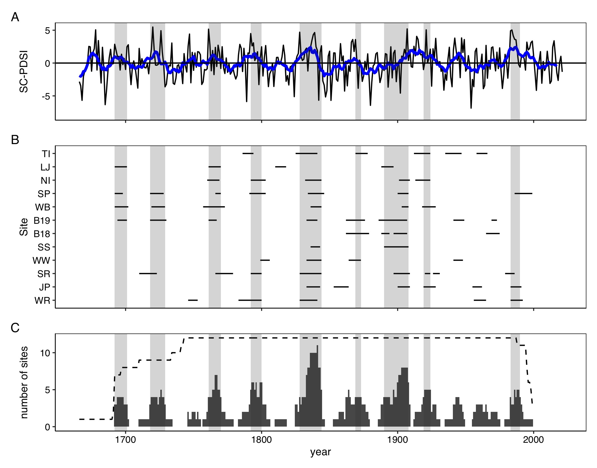

Figure 2: Variability of the self-calibrated Palmer Drought Severity Index (SC-PDSI) (A) and WSB outbreaks by site (B) and across the region (C). In panel (A) the thin black line shows a tree-ring based reconstruction of SC-PDSI, while the thick blue line shows a 10-year rolling mean of that time series. In C, the bars show the number of sites recording an outbreak and the dashed line shows the the number of potential tree-ring recording sites. In all panels, periods of regional outbreak are highlighted by light gray shading.

## Synchrony of outbreaks

We found that sites across the study area exhibited similar temporal patterns of WSB outbreak (Fig. 2 and Fig. 9). Over the 1730-1998 period, time series of the percent of trees defoliated at a site were significantly correlated (W = 0.28; p <0.001; mean inter-site rs = 0.25; mean inter-site C= 27%). However, relationships between some pairs of sites were neutral or even negative (range of. inter-site rs: -0.14 - 0.65; range of inter-site C: 0.12 - 1), highlighting site-level variation in outbreak dynamics across the study area (Fig. 10). This site-level variation was in part explained by geography; we found that significant synchrony among time-series of the percent of trees defoliated existed at distances up to 50 km and that synchrony decreased with increasing distance (Fig. 3).

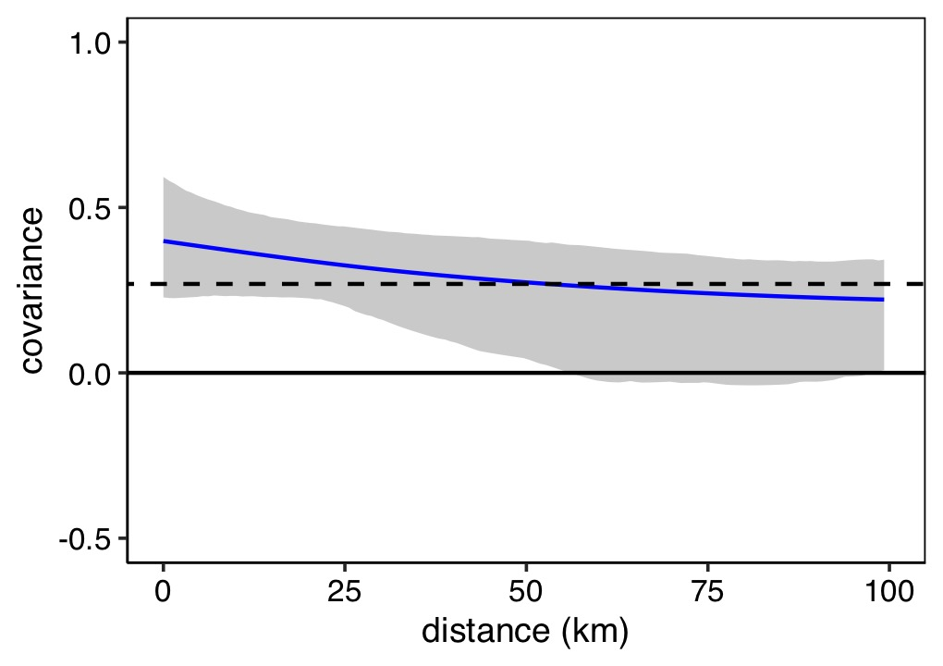

Figure 3: Nonparametric spatial covariance function describing the covarinace among records of the percent of trees defoliated at all 12 sites across study area over the 1730-1998 period. Gray shading indicates the 95% confidence interval based on 1,000 bootstrap replications. The dashed horizontal line indicates the average correlation across the study area (regional synchrony).

Multivariate event analysis indicated that both years of initiation and cessation were significantly clustered in time, with a higher degree of synchrony for cessation dates (Fig. 4). Years of outbreak initiation were more likely than not to occur within six years of another year of outbreak initiation, while years of outbreak cessation were more likely than not to occur within eight years of another year of outbreak cessation. At lags greater than 14 years, years of outbreak cessation were significantly asynchronous.

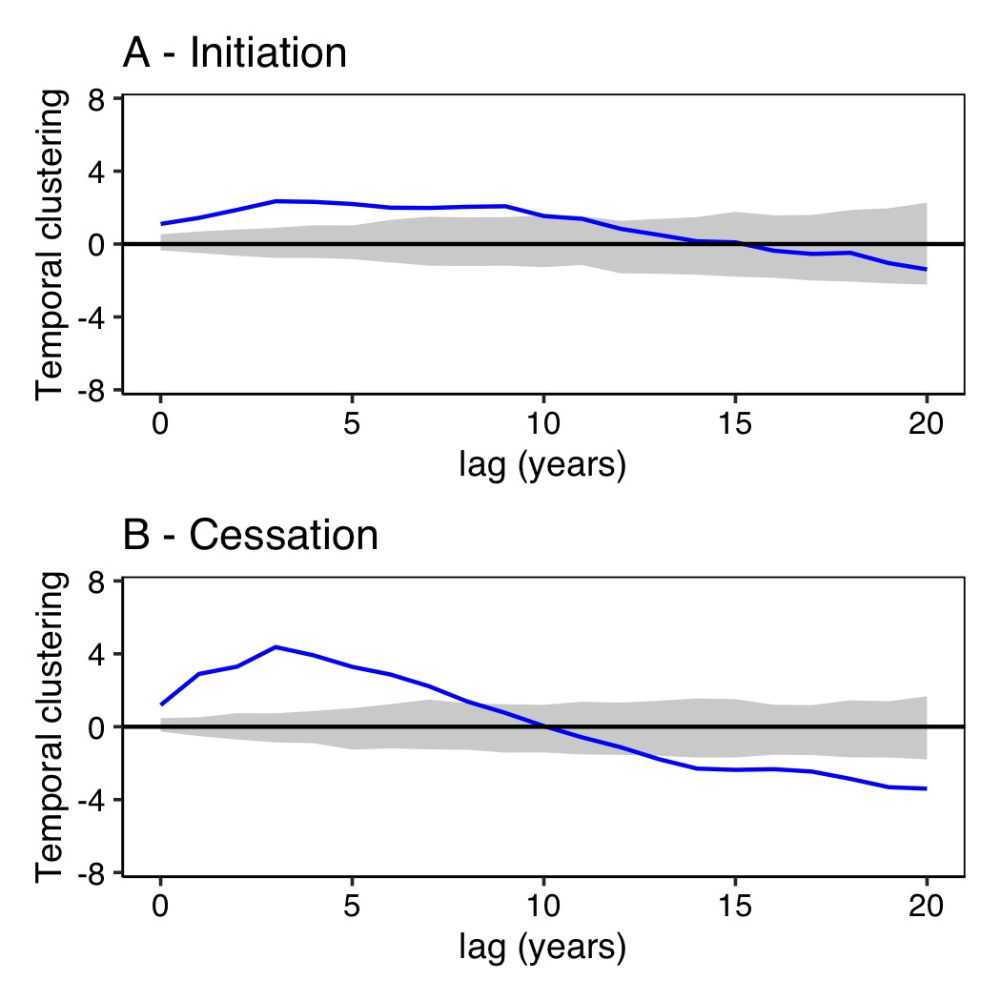

Figure 4: Bidirectional multivariate event analysis of temporal synchrony between dates of WSB outbreak initation (A) and cessation (B) at 12 sites over the 1730-2020 period. The solid black line is the L(t) function, a transformation of Ripley’s K such that the mean and variance are stabilized through time t, where values >0 indicate synchrony and values <0 indicate asynchrony. The dashed lines indicate 95% confidence interval.

## Effects of Euro-American settlement on outbreak dynamics or effects

We found that Euro-American settlement had little effect on outbreak dynamics or severity at the site-level, but reduced synchrony among sites. In the century prior to extensive Euro-American settlement, outbreaks occurred about as frequently but were slightly longer and more severe relative to the century following extensive Euro-American settlement (Fig. 5). However, these differences were not significantly different (Table 4).

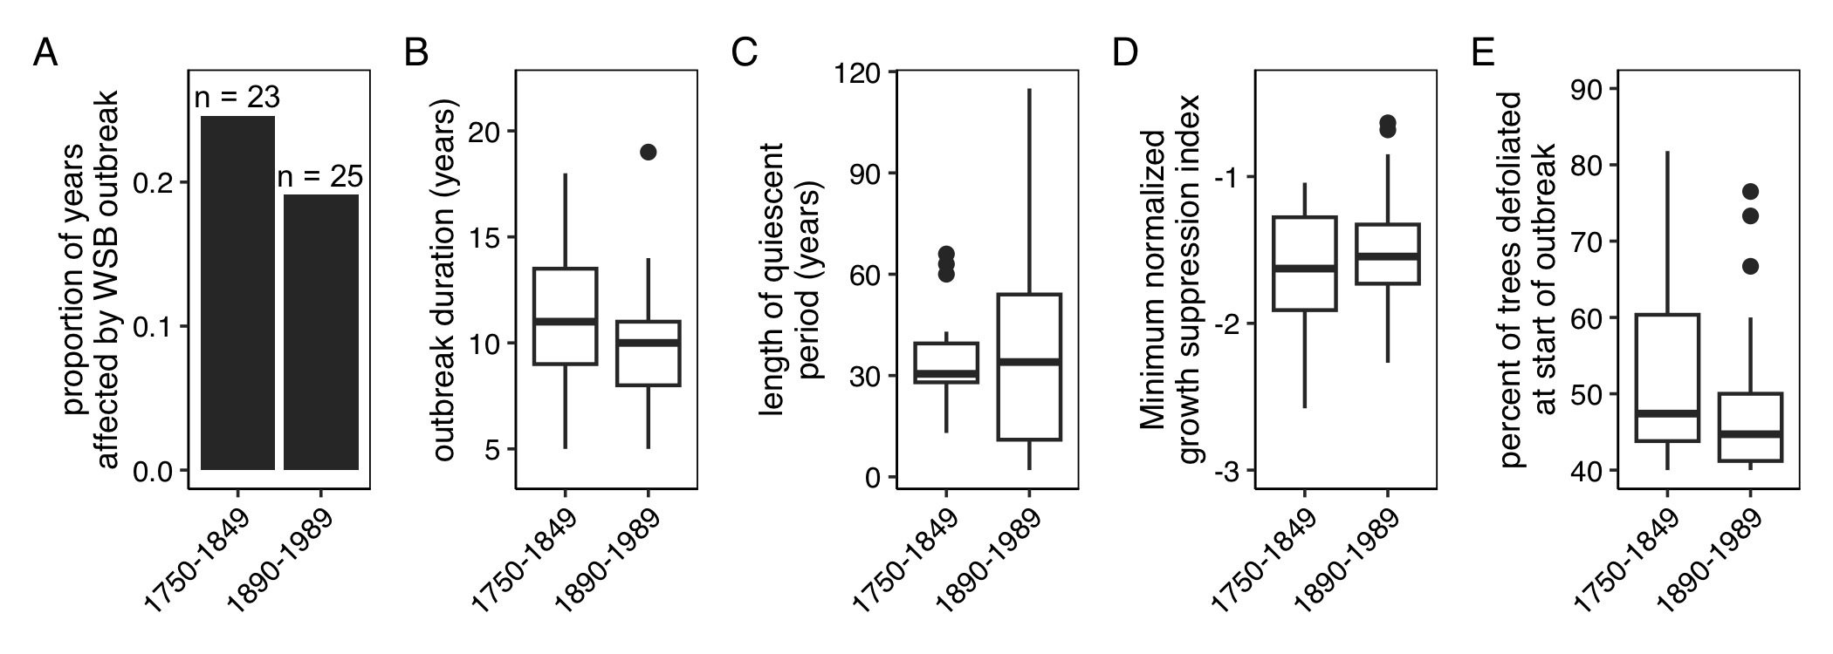

Figure 5: The proportion of years affected by WSB outbreak (A), the duration of outbreak (B), the length of the quiescent period (C), the minimum normalized growth suppression index (D), and the duration of outbreak (E) for the century prior to and proceeding extensive Euro-American colonization (1750-1849 and 1890-1989, respectively). In A, the sample sizes printed above bars show the number of total outbreaks recorded at any site during that period. For boxplots, the bottom and top limits of each box are the lower and upper quartiles, respectively; the thick black line within the box is the median; error bars equal ±1.5 times the interquartile range; and points denote outliers, values outside ±1.5 times the interquartile range.

While outbreak dynamics and effects were similar in the two time periods, regional synchrony was lower in the 1890-1989 period than the 1750-1849 period. The mean inter-site correlation was 50% lower in the century following century following extensive Euro-American settlement (mean rs for 1750-1859: 0.34 and mean rs for 1890-1989: 0.17; t=-3.8, p=0) and the mean inter-site concurrency was 40% lower (mean C for 1750-1859: 0.239 and mean C for 1890-1989: 0.14; t=-3.3, p<0.001). While regional synchrony was lower in the 1890-1989 period, spline correlograms calculated for the 1750-1849 and 1890-1989 time periods showed similar decreases in sychrony with increasing distances as the the 1750-1998 period (Fig. 13).

## Association between interannual climate variability and outbreaks

Over the 1730-2020, we found periods of outbreak were associated with interannual variability in drought severity (Figure 2). During periods of regional outbreak the mean SC-PDSI was greater (i.e., wetter) than during quiescent periods (mean SC-PDSIoutbreak:0.71; mean SC-PDSIquiescent:-0.2; t = 2.92; p = 0.004). These results were supported by superposed epoch analyses conducted using the regional record (Fig. 15. Here we found that outbreaks were generally more likely to initiate during periods of above-average moisture availability. The cessation of regional outbreak generally coincided with a switch from above average moisture availability to average or below average moisture availability (Fig. 15).

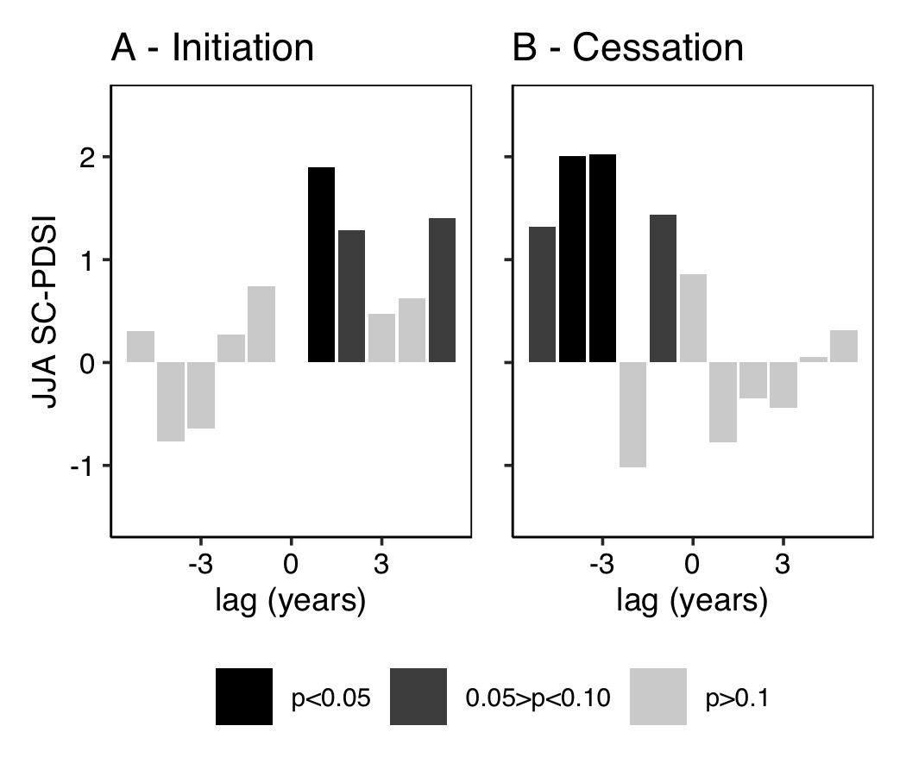

Figure 6: Superposed epoch analysis results illustrating the departure from the mean SC-PDSI for the years prior, during, and following regional outbreak years over the 1730-2020 period. Descending bars illustrate a negative association with summer SC-PDSI (i.e., drier conditions), ascending bars show a positive association with summer SC-PDSI (i.e., wetter conditions).

At the site-level, superposed epoch analyses confirmed that outbreaks were generally more likely to initiate during periods of positive SC-PDSI and end when moisture became more limiting (7). Additionally, site-level analyses suggested that initiation was often proceeded by periods of drought (7A).

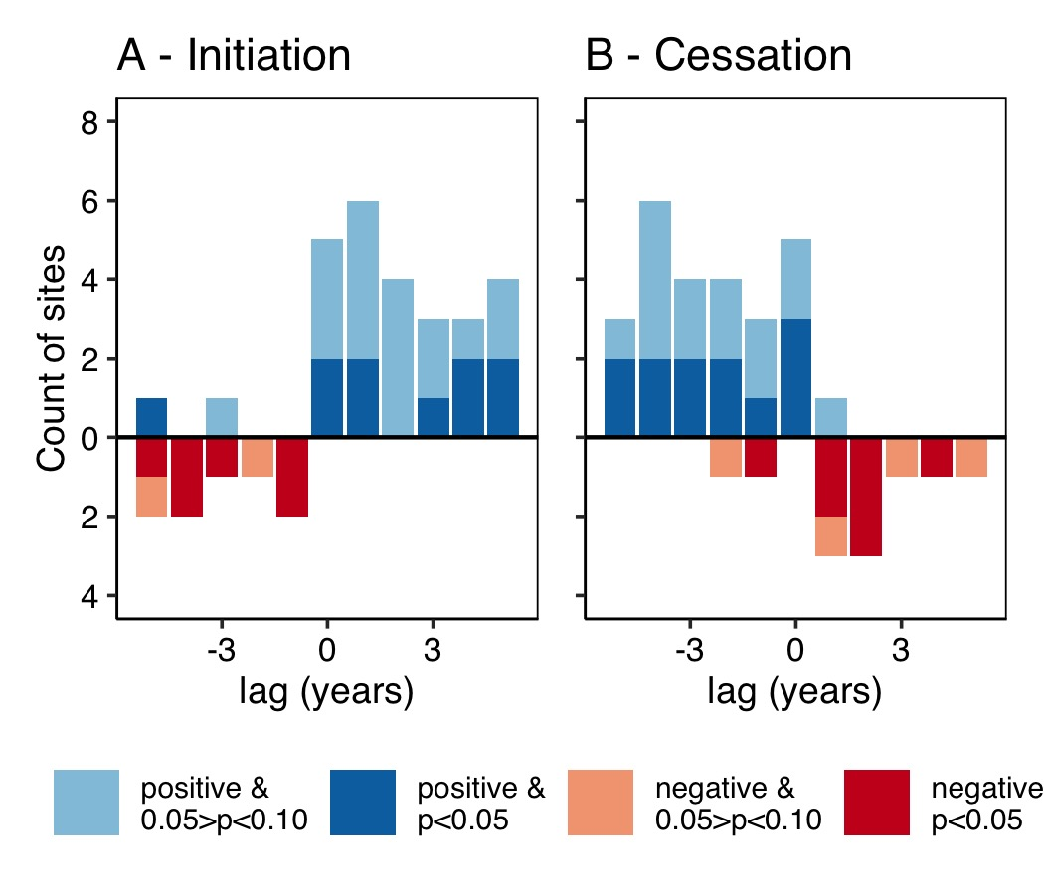

Figure 7: Summary of site-level superposed epoch analyses summarzing the association between summer SC-PDSI and outbreak initation (A) and cessation (B) over the 1730-2020 period. Red descending bars illustrate the number of sites with a statitcally significant negative association with summer SC-PDSI (i.e., drier conditions), blue ascending bars show the number of sites with a statistically significant positive association with summer SC-PDSI (i.e., wetter conditions).

Finally, we found that the initiation of regional outbreak generally coincided with periods of above average moisture availability that were longer and more extreme (Fig. 8; Table 5). Specifically we found that regional outbreak initiation coincided with periods of above average moisture availability that were on average 3 years longer than the average period (p = 0.03; t= 2.77). The maximum SC-PDSI during periods of above average moisture availability that coincided with outbreak initiation was on average 1.7x greater than the average period (p = 0.01; t = 3.28). Outbreak initiation was also generally proceeded by drought events that were longer and more severe, however these differences were not significant (Fig. 8; Table 5). Similarly, we found no significant relationships between outbreak cessation and attributes of concurrent wet periods or subsequent dry periods.

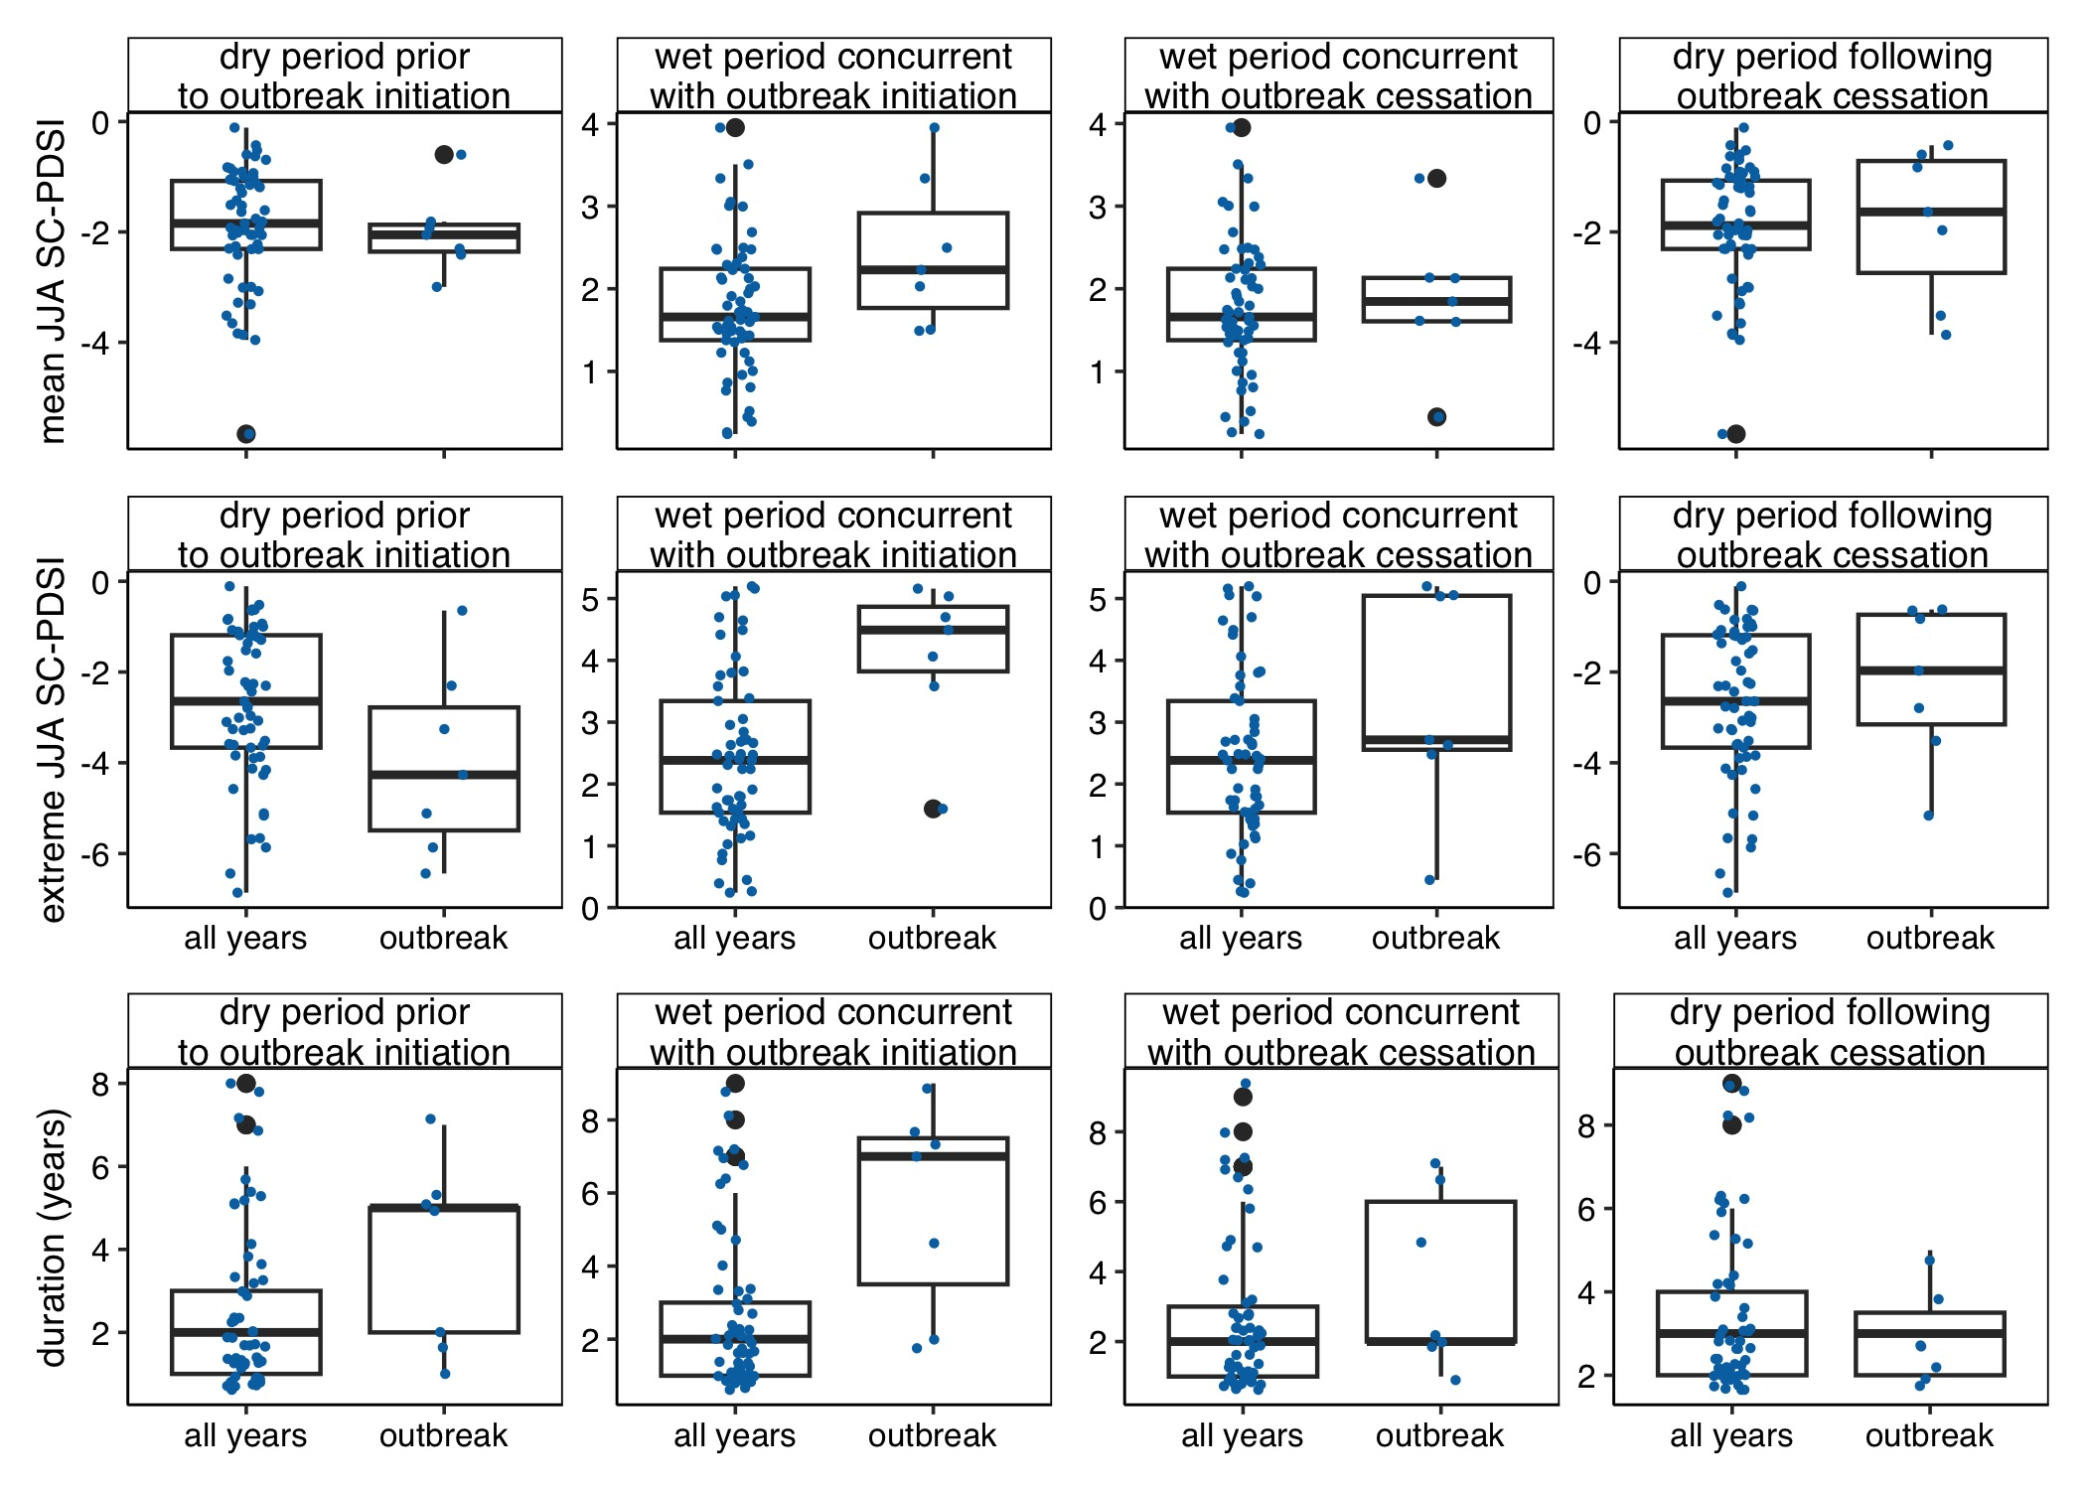

Figure 8: Climate conditions in the dry period prior and wet period coincident with periods of regional outbreak relative to all periods of above average moisture availability.

# Discussion

Here we combined tree-ring and geospatial data to reconstruct periods of WSB outbreak at 12 sites across northern to central Colorado. We used this data to test the overarching hypothesis that the effects of land use and climate variability on trees are important drivers of WSB outbreaks dynamics. Our results support this hypothesis, adding to a growing number of empirical studies that demonstrate the potential for human actions to alter the dynamics of insect outbreaks (Ciesla, 2015). In particular we show: (1) WSB outbreaks occur synchronously across sites, suggestive of the combined effects of density-dependent processes and Moran effects; (2) changes in forest communities driven by Euro-American settlement altered synchronicity of outbreaks; (3) outbreaks were often initiated by long periods of increased moisture availability that were often proceeded by periods of drought.

## Outbreak histories

We found that periods of regional outbreak occurred from 1761 to 1770, 1792 to 1800, 1833 to 1844, 1890 to 1894, 1897 to 1908, 1920 to 1924, and 1986 to 1990. Notably, all of these periods correspond with periods of outbreak identified in dendroecological studies from Colorado (Table 6). Further the 1980s outbreak is well documented in observational records from Colorado (Hadley and Veblen, 1993; Weber and Schweingruber, 1995) and the 1920s outbreak and is supported by reports from forest entomologists working in northern Idaho and Yellowstone National Park, where observational records of WSB outbreaks began much earlier than in Colorado (Johnson, 1975). This agreement between existing tree-ring and observational records confirms that tree-ring data can provide insights into periods of past WSB outbreak, as has been previously reported (Swetnam and Lynch, 1989).

Across all our sites the mean outbreak duration (10.8 years) and mean length of the quiescent period (33.1 years) were similar to those previously reported in dendroecological studies conducted in interior Pacific Northwest [mean duration: 12 years; mean quiescent interval: 15 years; Flower et al. (2014)], the Colorado Front Range [mean duration: 6.9 years; Weber and Schweingruber (1995)], and southern British Columbia [mean duration: 12 years; mean quiescent interval: 29 years; Campbell et al. (2006)]. However, outbreaks in our record were notably shorter and quiescent periods were longer than in dendroecological records from northern New Mexico [mean duration: 22 years; mean quiescent interval: 11 years; Swetnam and Lynch (1993)] and central British Columbia [mean: 18 years; Harvey et al. (2018)]. These differences likely reflect variation in tree-ring data collection and processing methods, but also highlight the need for more research that addresses the drivers of outbreak dynamics in space and time, as well as the need for infrastructure for sharing dendroecological data and research that integrates multiple studies.

## Inter-site synchrony

We found that WSB outbreaks occur synchronously across northern to central Colorado, consistent with previous dendroecological research that has identified synchrony across sites in the Interior Pacific Northwest (Ellis and Flower, 2017b; Flower et al., 2014). For population of irruptive insects, temporal synchrony may arise from density-dependent processes (e.g., dispersal, predation) and/or Moran effects (Moran, 1953), where spatial autocorrelation in exogenous drivers, such as climate, leads to synchronicity (Liebhold et al., 2004). Here we found that both regional synchrony (0.27) and the spatial scale at which synchrony was statistically significant (≤50 km) were lower than we would expect if climate was the only driver. For instance, across the 12 drought-sensitive ponderosa pine chronologies used to remove climate-trends in host ring-width series, we calculated greater regional synchrony (0.47) and significant correlations at larger distances (i.e, up to 100 km; Fig. 12). This supports previous research on spatiotemporal patterns of contemporary WSB outbreak in British Columbia that has suggested that dispersal is key in driving the synchronization of WBS population dynamics (Senf et al., 2017b). Our records also show that outbreaks can develop concurrently in disjunct populations. For instance, evidence of the 1790s outbreak appears in the tree-ring record first in ca. 1784 at the TI site, the furthest north and west site in our dataset, and the WR site, which is east of the Continental Divide in the southern Front Range. While budworms are strong fliers that can dispersing hundreds of kilometers in the right weather conditions Sturtevant et al. (2013), most dispersal occurs at much shorter distances [i.e, <15 km; Senf et al. (2017b)]. Thus both dispersal and Moran effects are likely important in driving the synchrony of local populations of WSBs (Flower et al., 2014; Senf et al., 2017b).

## Effects of Euro-American colonization on outbreak dynamics

We found that outbreak duration, frequency, and severity were comparable during the century prior to and following Euro-American colonization, but inter-site synchrony was lower in the 20th century. The lower inter-site synchrony in part reflects the 1925-1980 quiescent period present in the regional record. These findings suggest that Euro-American colonization may have initially caused a period of decreased synchrony that followed by a period of increased or similar synchrony at the end of the 20th century, as has previously been reported for the Southwest (Swetnam and Lynch, 1993). This pattern is hypothesized to occur due to changes in landscape-level availability of host trees, which may influence WSB outbreak dispersal and thus spatiotemporal patterns of outbreak (Senf et al., 2017b). Across our study area, initial logging and burning reduced host availability in the early 20th century (Veblen and Lorenz, 1991), but subsequent forest regeneration and fire suppression may have promoted increased host abundance by the end of the 20th century (Veblen et al., 2000). Collectively, these findings show that human land-use practices may influence WSB outbreak dynamics and that understanding landscape history is critical to predicting these effects.

## Climate effects on outbreak dynamics

Our 300 year record shows that WSB outbreaks were more likely to occur during periods of above average moisture availability, consistent with the expectation that greater moisture availability increases forage palatability and availability thereby increasing insect population growth rates (Price, 1991). Here we document higher PDSI values during years of outbreak, consistent with previous dendroecological research from the Southwest (Ryerson et al., 2003b; Swetnam and Lynch, 1993). We also show that outbreak initiation tended to co-occur with the start of periods of above average moisture availability, as has been reported in the Pacific Northwest (Ellis and Flower, 2017b; Flower et al., 2014). Additionally, we show that across our study area regionally synchronous outbreaks were more likely to occur when periods of increased moisture availability were longer and more extreme. These findings highlight the importance of considering cumulative effects of climate variability on ecological systems (Hartmann et al., 2018).

Our analyses provide mixed support for the idea that drought proceeds WSB outbreaks. Collectively site-level analyses suggested a significant relationship existed between outbreak initiation and drought at in the proceeding one to five years, as has been previously reported in the Pacific Northwest (Ellis and Flower, 2017b; Flower et al., 2014). The variation in the timing of the inciting drought may emerge due to density-dependent processes and/or a lagged effect of defoliation on radial growth, which may occur because trees can use previously stored carbon for growth (Richardson et al., 2015). Indeed, dendroecological studies of ongoing outbreaks show that the effect of defoliation on radial growth often lag defoliation by one to three years (Alfaro et al., 1982; Swetnam, 1985).

While site-level analyses suggested that drought may play a role in outbreak initiation, drought was not significantly associated with outbreak initiation at the regional-scale. Here we found that at 95% confidence level, outbreak initiation was favored by drought at four sites, whereas increased moisture availability was associated with outbreak initiation at eight sites. This variable effect of drought on outbreak initiation may exist because the drought sensitivity of the WSB-Douglas fir system varies (Harvey et al., 2018; Xu et al., 2019). Such variation has been hypothesized to occur for two alternative reasons. First, populations of Douglas fir from drier locations may be better adapted to dealing with drought (Bansal et al., 2015). So at arid locations, droughts may need to be more extreme in order to drive increases in nutritional quality, as has been suggested in dendroecological analyses comparing WSB outbreak histories at sites adjacent to grasslands and more mesic sites in interior British Columbia (Harvey et al., 2018). Alternatively, the chronic moisture stress experienced by populations of Douglas fir from drier locations may constrain any potential positive effects of drought on nutritionally quality (Xu et al., 2019). Future research is necessary to understand how drought may influence WBS-outbreaks across gradients of aridity.

Finally, here we assessed the effect of climate variability on WSB outbreak dynamics using summer SC-PDSI, which is highly correlated with other climate variables (Fig. 16, many of which may also influence WSB outbreak dynamics (Nealis and Régnière, 2021). For instance, in the WSB-Douglas fir system, drought commonly co-occurs with warm spring temperatures, which may positively affect WSB population growth rates by limiting mortality due to freezing of destruction of food supplies (Fellin and Dewey, 1982; Régnière and Nealis, 2019). Thus the positive effect of drought on outbreak initiation identified here may in part reflect the positive effects of warm spring temperatures. Further, exceptionally warm spring temperatures may actually negatively affect WSB populations by altering the synchrony of WSB larval emergence and the timing of host tree bud burst (Chen et al., 2001; Nealis, 2012; Régnière and Nealis, 2019).

# Implications

This study highlights the role of broad-scale driversin WSB outbreak dynamics, which has several important implications for understanding the ecology and management of WSB outbreak dynamics. First, forest management practices aimed at mitigating the effects of WSB, must consider landscape and regional processes. Here we attribute the early to mid 1900s quiescent period in our regional WSB record to a regional reduction in host availability due to Euro-American settlement practices. From this we suggest that efforts aimed at increasing stand resistance to outbreak should consider reducing WSB hosts in the surrounding landscape by emulating natural disturbance processes that promote heterogeneity at multiple scales (DeRose and Long, 2014; Windmuller-Campione et al., 2021). Second, we find that outbreaks were strongly linked to regional climate variability. Consequently future changes in climate, which are forecasted to increases in the intensity and frequency of drought across the Southwest (USGCRP, 2023), are likely to alter spatial and temporal patterns of WSB outbreak. Further, the effects of climate change on WSB outbreak dynamics are likely to vary across Douglas-fir’s distribution. Collectively this highlights the need for forest managers to plan for uncertainty by adopting adaptive management practices (Millar et al., 2016).

# Acknowledgements

This research was supported the USDA National Institute of Food and Agriculture, McIntire-Stennis project COL00520, accession number 7002894. Additionally, we would like to the thank Colorado State University and the Colorado Mountain Club for supporting O. Santiago.

# References

Abatzoglou, J.T., McEvoy, D.J., Redmond, K.T., 2017. The west wide drought tracker: Drought monitoring at fine spatial scales. Bulletin of the American Meteorological Society 98, 1815–1820. <https://doi.org/10.1175/BAMS-D-16-0193.1>

Akaike, H., 1973. Information theory and an extension of the maximum likelihood principle, in: Petrov, B.N., Csáki, F. (Eds.),. Academiai Kiado, Budapest, Hungary, pp. 267–281.

Alfaro, RenéI., Maclauchlan, L.E., 1992. A method to calculate the losses caused by western spruce budworm in uneven-aged douglas fir forests of british columbia. Forest Ecology and Management 55, 295–313. <https://doi.org/10.1016/0378-1127(92)90107-K>

Alfaro, R.I., Berg, J., Axelson, J., 2014. Periodicity of western spruce budworm in southern british columbia, canada. Forest Ecology and Management 315, 72–79. <https://doi.org/10.1016/j.foreco.2013.12.026>

Alfaro, R.I., Sickle, G.A.V., Thomson, A.J., Wegwitz, E., 1982. Tree mortality and radial growth losses caused by the western spruce budworm in a douglas-fir stand in british columbia. Canadian Journal of Forest Research 12, 780–787. <https://doi.org/10.1139/x82-117>

Bale, J.S., Masters, G.J., Hodkinson, I.D., Awmack, C., Bezemer, T.M., Brown, V.K., Butterfield, J., Buse, A., Coulson, J.C., Farrar, J., Good, J.E.G., Harrington, R., Hartley, S., Jones, T.H., Lindroth, R.L., Press, M.C., Symrnioudis, I., Watt, A.D., Whittaker, J.B., 2002. Herbivory in global climate change research: direct effects of rising temperature on insect herbivores. Global Change Biology 8, 1–16. <https://doi.org/10.1046/j.1365-2486.2002.00451.x>

Bansal, S., Harrington, C.A., Gould, P.J., St.Clair, J.B., 2015. Climate-related genetic variation in drought-resistance of Douglas-fir (Pseudotsuga menziesii). Global Change Biology 21, 947–958. <https://doi.org/10.1111/gcb.12719>

Bjørnstad, O.N., 2020. [Ncf: Spatial nonparametric covariance functions](http://CRAN.R-project.org/package=ncf).

Bjørnstad, O.N., Falck, W., 2001. [Nonparametric spatial covariance functions: Estimation and testing](http://link.springer.com/article/10.1023/A:1009601932481). Environmental and Ecological Statistics 8, 5370.

Brookes, M.H., Campbell, R.W., Colbert, J.J., Mitchell, R. G., Stark, R.W., 1987. [Western spruce budworm](https://naldc.nal.usda.gov/download/CAT89231792/PDF). Washington, D.C.

Bunn, A.G., 2008. A dendrochronology program library in R (dplR). Dendrochronologia 26, 115–124. <https://doi.org/10.1016/j.dendro.2008.01.002>

Bunn, A.G., Korpela, M., Campelo, F., Mérian, P., Qeadan, F., Zang, C., 2019. [dplR: Dendrochronology program library in r](https://CRAN.R-project.org/package=dplR).

Campbell, R., Smith, D.J., Arsenault, A., 2006. Multicentury history of western spruce budworm outbreaks in interior douglas-fir forests near kamloops, british columbia. Canadian Journal of Forest Research 36, 17581769.

Chen, Z., Kolb, T.E., Clancy, K.M., 2001. Mechanisms of Douglas-fir resistance to western spruce budworm defoliation: Bud burst phenology, photosynthetic compensation and growth rate. Tree Physiology 21, 1159–1169. <https://doi.org/10.1093/treephys/21.16.1159>

Ciesla, W.M., 2015. [The role of human activities on forest insect outbreaks worldwide](https://www.jstor.org/stable/43739853). The International Forestry Review 17, 269–281.

Cole, H.M., Andrus, R.A., Butkiewicz, C., Rodman, K.C., Santiago, O., Tutland, N.J., Waupochick, A., Hart, S.J., 2022. Outbreaks of Douglas-fir beetle follow western spruce budworm defoliation in the Southern Rocky Mountains, USA. Forests 13, 371. <https://doi.org/10.3390/f13030371>

Cook, E.R., Seager, R., Heim, R.R., Vose, R.S., Herweijer, C., Woodhouse, C., 2010. Megadroughts in North America: Placing IPCC projections of hydroclimatic change in a long-term palaeoclimate context. Journal of Quaternary Science 25, 48–61. <https://doi.org/10.1002/jqs.1303>

Covington, W.W., Everett, L.R., Steele, R., Irwin, L.L., Daer, T.A., Auclair, A.N., 2018. [Historical and anticipated changes in forest ecosystems of the inland west of the united states](https://www.taylorfrancis.com/chapters/edit/10.1201/9781315137797-4/historical-anticipated-changes-forest-ecosystems-inland-west-united-states-wallace-covington-richard-everett-robert-steele-larry-irwin-tom-daer-allan-auclair). Routledge, p. 1363.

Covington, W.W., Moore, M.M., 1994. Southwestern ponderosa forest structure: Changes since euro-american settlement. Journal of Forestry 92, 3947.

Daly, C., Gibson, W.P., Taylor, G.H., Johnson, G.L., Pasteris, P., 2002. A knowledge-based approach to the statistical mapping of climate. Climate research 22, 99113.

DeRose, R.J., Long, J.N., 2014. Resistance and Resilience: A Conceptual Framework for Silviculture. Forest Science 60, 1205–1212. <https://doi.org/10.5849/forsci.13-507>

Dymond, C.C., Neilson, E.T., Stinson, G., Porter, K., MacLean, D.A., Gray, D.R., Campagna, M., Kurz, W.A., 2010. Future Spruce Budworm Outbreak May Create a Carbon Source in Eastern Canadian Forests. Ecosystems 13, 917–931. <https://doi.org/10.1007/s10021-010-9364-z>

Ellis, T.M., Flower, A., 2017a. A multicentury dendrochronological reconstruction of western spruce budworm outbreaks in the okanogan highlands, northeastern washington. Canadian Journal of Forest Research 47, 12661277.

Ellis, T.M., Flower, A., 2017b. A multicentury dendrochronological reconstruction of western spruce budworm outbreaks in the okanogan highlands, northeastern washington. Canadian Journal of Forest Research 47, 12661277.

Fellin, D.G., Dewey, J.E., 1982. Western spruce budworm. Washington, D.C.

Flower, A., 2016. Three centuries of synchronous forest defoliator outbreaks in Western North America. PLOS ONE 11, e0164737. <https://doi.org/10.1371/journal.pone.0164737>

Flower, A., Gavin, D.G., Heyerdahl, E.K., Parsons, R.A., Cohn, G.M., 2014. Drought-triggered western spruce budworm outbreaks in the interior pacific northwest: A multi-century dendrochronological record. Forest Ecology and Management 324, 1627. <https://doi.org/10.1016/j.foreco.2014.03.042>

Gao, S., Liu, R., Zhou, T., Fang, W., Yi, C., Lu, R., Zhao, X., Luo, H., 2018. Dynamic responses of tree-ring growth to multiple dimensions of drought. Global Change Biology 24, 5380–5390. <https://doi.org/10.1111/gcb.14367>

Gavin, D.G., 2010. [K1D: Analysis of synchrony of events at one or multiple sites using the ripley k function](https://pages.uoregon.edu/dgavin/software.html).

Gavin, D.G., Hu, F.S., Lertzman, K., Corbett, P., 2006. Weak climatic control of stand-scale fire history during the late holocene. Ecology 87, 1722–1732. <https://doi.org/10.1890/0012-9658(2006)87[1722:WCCOSF]2.0.CO;2>

Gely, C., Laurance, S.G.W., Stork, N.E., 2020. How do herbivorous insects respond to drought stress in trees? Biological Reviews 95, 434–448. <https://doi.org/10.1111/brv.12571>

Gouhier, T.C., Guichard, F., 2014. Synchrony: quantifying variability in space and time. Methods in Ecology and Evolution 5, 524–533. <https://doi.org/10.1111/2041-210X.12188>

Greenbank, D.O., Schaefer, G.W., Rainey, R.C., 1980. SPRUCE BUDWORM (LEPIDOPTERA: TORTRICIDAE) MOTH FLIGHT AND DISPERSAL: NEW UNDERSTANDING FROM CANOPY OBSERVATIONS, RADAR, AND AIRCRAFT. The Memoirs of the Entomological Society of Canada 112, 1–49. <https://doi.org/10.4039/entm112110fv>

Guiterman, C.H., Lynch, A.M., Axelson, J.N., 2020. dfoliatR: An R package for detection and analysis of insect defoliation signals in tree rings. Dendrochronologia 63, 125750. <https://doi.org/10.1016/j.dendro.2020.125750>

Hadley, K.S., Veblen, T.T., 1993. Stand response to western spruce budworm and douglas-fir bark beetle outbreaks, colorado front range. Canadian Journal of Forest Research 23, 479–491. <https://doi.org/10.1139/x93-066>

Hamann, E., Blevins, C., Franks, S.J., Jameel, M.I., Anderson, J.T., 2021. Climate change alters plantherbivore interactions. New Phytologist 229, 1894–1910. <https://doi.org/10.1111/nph.17036>

Hartmann, H., Moura, C.F., Anderegg, W.R.L., Ruehr, N.K., Salmon, Y., Allen, C.D., Arndt, S.K., Breshears, D.D., Davi, H., Galbraith, D., Ruthrof, K.X., Wunder, J., Adams, H.D., Bloemen, J., Cailleret, M., Cobb, R., Gessler, A., Grams, T.E.E., Jansen, S., Kautz, M., Lloret, F., O’Brien, M., 2018. Research frontiers for improving our understanding of drought-induced tree and forest mortality. New Phytologist 218, 15–28. <https://doi.org/10.1111/nph.15048>

Harvey, J.E., Axelson, J.N., Smith, D.J., 2018. Disturbanceclimate relationships between wildfire and western spruce budworm in interior British Columbia. Ecosphere 9, e02126. <https://doi.org/10.1002/ecs2.2126>

Herms, D.A., Mattson, W.J., 1992. [The dilemma of plants: To grow or defend](https://www.jstor.org/stable/2830650). The Quarterly Review of Biology 67, 283–335.

Hessburg, P.F., Agee, J.K., 2003. An environmental narrative of Inland Northwest United States forests, 18002000. Forest Ecology and Management, The Effect of Wildland Fire on Aquatic Ecosystems in the Western USA. 178, 23–59. <https://doi.org/10.1016/S0378-1127(03)00052-5>

Huberty, A.F., Denno, R.F., 2004. Plant water stress and its consequences for herbivorous insects: A new synthesis. Ecology 85, 1383–1398. <https://doi.org/10.1890/03-0352>

Johnson, P.C., 1975. Outbreaks of the Western Spruce Budworm in the American Northern Rocky Mountain Area from 1922 Through 1971. Ogden, UT.

Kannenberg, S.A., Maxwell, J.T., Pederson, N., D’Orangeville, L., Ficklin, D.L., Phillips, R.P., 2019. Drought legacies are dependent on water table depth, wood anatomy and drought timing across the eastern US. Ecology Letters 22, 119–127. <https://doi.org/10.1111/ele.13173>

Kendall, M.G., 1970. Rank correlation methods, 4th edition. ed. Griffin, London, UK.

Liebhold, A.M., 2012. Forest pest management in a changing world. International Journal of Pest Management 58, 289–295. <https://doi.org/10.1080/09670874.2012.678405>

Liebhold, A., Sork, V., Peltonen, M., Koenig, W., Bjørnstad, O.N., Westfall, R., Elkinton, J., Knops, J.M.H., 2004. Within-population spatial synchrony in mast seeding of North American oaks. Oikos 104, 156–164. <https://doi.org/10.1111/j.0030-1299.2004.12722.x>

Loreau, M., Mazancourt, C. de, 2008. Species synchrony and its drivers: neutral and nonneutral community dynamics in fluctuating environments. The American naturalist 172. <https://doi.org/10.1086/589746>

Lough, J.M., Fritts, H.C., 1987. An assessment of the possible effects of volcanic eruptions on North American climate using tree-ring data, 1602 to 1900 A.D. Climatic Change 10, 219–239. <https://doi.org/10.1007/BF00143903>

Lukas, J., Barsugli, J., Doesken, N., Rangwala, I., Wolter, K., 2014. Climate change in colorado: A synthesis to support water resources management and adaptation. University of Colorado, Boulder, Colorado.

Lv, P., Rademacher, T., Huang, X., Zhang, B., Zhang, X., 2022. Prolonged drought duration, not intensity, reduces growth recovery and prevents compensatory growth of oak trees. Agricultural and Forest Meteorology 326, 109183. <https://doi.org/10.1016/j.agrformet.2022.109183>

Maclauchlan, L., Brooks, J.E., 2009. [Influence of past forestry practices on western spruce budworm defoliation and associated impacts in southern british columbia](http://www.jem-online.org/forrex/index.php/jem/article/view/418). Journal of Ecosystems and Management 10.

Meigs, G.W., Kennedy, R.E., Gray, A.N., Gregory, M.J., 2015. Spatiotemporal dynamics of recent mountain pine beetle and western spruce budworm outbreaks across the pacific northwest region, USA. Forest Ecology and Management 339, 71–86. <https://doi.org/10.1016/j.foreco.2014.11.030>

Millar, C.I., Stephenson, N.L., Stephens, S.L., 2016. Climate Change and Forests of the Future: Managing in the Face of Uncertainty. Ecological Applications 2145–2151. <https://doi.org/10.1890/06-1715.1@10.1002/(ISSN)1939-5582(CAT)SpecialCollection(VI)VirtualIssue>

Moran, P.a.P., 1953. The Statistical Analsis of the Canadian Lynx cycle. 1. Structure and Prediction. Australian Journal of Zoology 1, 163–173. <https://doi.org/10.1071/zo9530163>

MTBS Project, 2022. [MTBS data access: Burned area boundaries dataset](https://mtbs.gov/direct-download).

Nealis, V.G., 2012. The phenological window for western spruce budworm: Seasonal decline in resource quality. Agricultural and Forest Entomology 14, 340–347. <https://doi.org/10.1111/j.1461-9563.2012.00574.x>

Nealis, V., Régnière, J., 2021. Ecology of outbreak populations of the western spruce budworm. Ecosphere 12. <https://doi.org/10.1002/ecs2.3667>

Palmer, W.C., 1965. [Meteorologic drought](https://www.ncdc.noaa.gov/temp-and-precip/drought/docs/palmer.pdf).

Patrick, C.J., McCluney, K.E., Ruhi, A., Gregory, A., Sabo, J., Thorp, J.H., 2021. Multi-scale biodiversity drives temporal variability in macrosystems. Frontiers in Ecology and the Environment 19, 47–56. <https://doi.org/10.1002/fee.2297>

Pinheiro, J., Bates, D., R Core Team, 2022. [Nlme: Linear and nonlinear mixed effects models](https://CRAN.R-project.org/package=nlme).

Price, P.W., 1991. The plant vigor hypothesis and herbivore attack. Oikos 62, 244–251. <https://doi.org/10.2307/3545270>

PRISM Climate Group, 2021. [Monthly 30-year climate normals (1981-2010)](https://prism.oregonstate.edu/normals/).

Purves, D.W., Law, R., 2002. Fine-scale spatial structure in a grassland community: quantifying the plant’s-eye view. Journal of Ecology 90, 121–129. <https://doi.org/10.1046/j.0022-0477.2001.00652.x>

R Core Team, 2022. [R: A language and environment for statistical computing](http://www.R-project.org). R Foundation for Statistical Computing, Vienna, Austria.

Régnière, J., Nealis, V.G., 2019. Influence of temperature on historic and future population fitness of the western spruce budworm, Choristoneura occidentalis. International Journal of Pest Management 65, 228–243. <https://doi.org/10.1080/09670874.2018.1541113>

Richardson, A.D., Carbone, M.S., Huggett, B.A., Furze, M.E., Czimczik, C.I., Walker, J.C., Xu, X., Schaberg, P.G., Murakami, P., 2015. Distribution and mixing of old and new nonstructural carbon in two temperate trees. New Phytologist 206, 590–597. <https://doi.org/10.1111/nph.13273>

Ryerson, D.E., Swetnam, T.W., Lynch, A.M., 2003a. A tree-ring reconstruction of western spruce budworm outbreaks in the san juan mountains, colorado, USA. Canadian Journal of Forest Research 33, 10101028.

Ryerson, D.E., Swetnam, T.W., Lynch, A.M., 2003b. A tree-ring reconstruction of western spruce budworm outbreaks in the san juan mountains, colorado, USA. Canadian Journal of Forest Research 33, 10101028.

Schoennagel, T., Veblen, T.T., Kulakowski, D., Holz, A., 2007. Multidecadal Climate Variability and Climate Interactions Affect Subalpine Fire Occurrence, Western Colorado (usa). Ecology 88, 2891–2902. <https://doi.org/10.1890/06-1860.1>

Senf, C., Campbell, E.M., Pflugmacher, D., Wulder, M.A., Hostert, P., 2017b. A multi-scale analysis of western spruce budworm outbreak dynamics. Landscape ecology 32, 501514.

Senf, C., Campbell, E.M., Pflugmacher, D., Wulder, M.A., Hostert, P., 2017a. A multi-scale analysis of western spruce budworm outbreak dynamics. Landscape ecology 32, 501514.

Sherriff, R.L., Veblen, T.T., 2007. A Spatially-Explicit Reconstruction of Historical Fire Occurrence in the Ponderosa Pine Zone of the Colorado Front Range. Ecosystems 10, 311–323. <https://doi.org/10.1007/s10021-007-9022-2>

Speer, J.H., 2010. Fundamentals of Tree-ring Research. University of Arizona Press, Tucson, AZ.

Stokes, M.A., Smiley, T.L., 1996. [An introduction to tree-ring dating](https://books.google.com/books?hl=en&lr=&id=SvBF2Ora-eUC&oi=fnd&pg=PR9&dq=stokes+smiley+tree-ring+dating&ots=vtRk62nFYe&sig=fHWRt55K8aynahcTm07ZD8_pIok). University of Arizona Press.

Sturtevant, B.R., Achtemeier, G.L., Charney, J.J., Anderson, D.P., Cooke, B.J., Townsend, P.A., 2013. Long-distance dispersal of spruce budworm (Choristoneura fumiferana Clemens) in Minnesota (USA) and Ontario (Canada) via the atmospheric pathway. Agricultural and Forest Meteorology 168, 186–200. <https://doi.org/10.1016/j.agrformet.2012.09.008>

Swetnam, T.W., 1985. [Radial growth losses in Douglas-fir and white fir caused by western spruce budworm in northern New Mexico: 1700-1983](https://repository.arizona.edu/handle/10150/302602). Tucson, AZ.

Swetnam, T.W., Lynch, A.M., 1993. Multicentury, regional-scale patterns of western spruce budworm outbreaks. Ecological monographs 63, 399424.

Swetnam, T.W., Lynch, A.M., 1989. A tree-ring reconstruction of western spruce budworm history in the southern rocky mountains. Forest Science 35, 962986.

USFS, partners, its, 2020. [USDA forest service - aerial survey data download](https://www.fs.fed.us/foresthealth/applied-sciences/mapping-reporting/detection-surveys.shtml).

USGCRP, 2023. Fifth national climate assessment. <https://doi.org/10.7930/NCA5.2023>

Veblen, T.T., Donnegan, J.A., 2005. Historical Range of Variability for Forest Vegetation of the National Forests of the Colorado Front Range. Boulder, Colorado.

Veblen, T.T., Kitzberger, T., Donnegan, J., 2000. Climatic and Human Influences on Fire Regimes in Ponderosa Pine Forests in the Colorado Front Range. Ecological Applications 10, 1178–1195. https://doi.org/<https://doi.org/10.1890/1051-0761(2000)010[1178:CAHIOF]2.0.CO;2>

Veblen, T.T., Lorenz, D.C., 1991. The Colorado Front Range: A Century of Ecological Change. University of Utah Press.

Venables, W.N., Ripley, B.D., 2002. [Modern applied statistics with s](https://www.stats.ox.ac.uk/pub/MASS4/).

Weber, UrsM., Schweingruber, FritzH., 1995. A dendroecological reconstruction of western spruce budworm outbreaks (Choristoneura occidentalis) in the Front Range, Colorado, from 1720 to 1986. Trees 9. <https://doi.org/10.1007/BF00195274>

Weiskopf, S.R., Rubenstein, M.A., Crozier, L.G., Gaichas, S., Griffis, R., Halofsky, J.E., Hyde, K.J.W., Morelli, T.L., Morisette, J.T., Muñoz, R.C., Pershing, A.J., Peterson, D.L., Poudel, R., Staudinger, M.D., Sutton-Grier, A.E., Thompson, L., Vose, J., Weltzin, J.F., Whyte, K.P., 2020. Climate change effects on biodiversity, ecosystems, ecosystem services, and natural resource management in the united states. Science of The Total Environment 733, 137782. <https://doi.org/10.1016/j.scitotenv.2020.137782>

Wells, N., Goddard, S., Hayes, M.J., 2004. A Self-Calibrating Palmer Drought Severity Index. Journal of Climate 17, 2335–2351. <https://doi.org/10.1175/1520-0442(2004)017<2335:ASPDSI>2.0.CO;2>

White, T.C.R., 1984. The abundance of invertebrate herbivores in relation to the availability of nitrogen in stressed food plants. Oecologia 63, 90–105. <https://doi.org/10.1007/BF00379790>

Wilcox, K.R., Tredennick, A.T., Koerner, S.E., Grman, E., Hallett, L.M., Avolio, M.L., La Pierre, K.J., Houseman, G.R., Isbell, F., Johnson, D.S., Alatalo, J.M., Baldwin, A.H., Bork, E.W., Boughton, E.H., Bowman, W.D., Britton, A.J., Cahill Jr., J.F., Collins, S.L., Du, G., Eskelinen, A., Gough, L., Jentsch, A., Kern, C., Klanderud, K., Knapp, A.K., Kreyling, J., Luo, Y., McLaren, J.R., Megonigal, P., Onipchenko, V., Prevéy, J., Price, J.N., Robinson, C.H., Sala, O.E., Smith, M.D., Soudzilovskaia, N.A., Souza, L., Tilman, D., White, S.R., Xu, Z., Yahdjian, L., Yu, Q., Zhang, P., Zhang, Y., 2017. Asynchrony among local communities stabilises ecosystem function of metacommunities. Ecology Letters 20, 1534–1545. <https://doi.org/10.1111/ele.12861>

Willhite, E.A., Stock, M.W., 1983. Genetic variation among western spruce budworm (Choristoneura occidentalis) (Lepidoptera: Tortricidae) outbreaks in Idaho and Montana. The Canadian Entomologist 115, 41–54. <https://doi.org/10.4039/Ent11541-1>

Windmuller-Campione, M.A., DeRose, J., Long, J.N., 2021. Landscape-Scale Drivers of Resistance and Resilience to Bark Beetles: A Conceptual Susceptibility Model. Forests 12, 798. <https://doi.org/10.3390/f12060798>

Woodhouse, C.A., Gray, S.T., Meko, D.M., 2006. Updated streamflow reconstructions for the Upper Colorado River Basin. Water Resources Research 42. <https://doi.org/10.1029/2005WR004455>

Xu, B., Hicke, J.A., Abatzoglou, J.T., 2019. Drought and moisture availability and recent western spruce budworm outbreaks in the Western United States. Forests 10, 354. <https://doi.org/10.3390/f10040354>

Yamaguchi, D.K., 1991. A simple method for cross-dating increment cores from living trees. Canadian Journal of Forest Research 21, 414–416. <https://doi.org/10.1139/x91-053>

# Appendices

## Appendix A

Table 2: Chronology statistics for host sites.

| Site ID | Site Name | No. Series | Interseries correlation | Autocorrelation | Citation |
| --- | --- | --- | --- | --- | --- |
| B18 | Boulder County 18 | 16 | 0.65 (sd=0.09) | 0.64 (sd=0.14) |  |
| B19 | Boulder County 19 | 22 | 0.54 (sd=0.13) | 0.79 (sd=0.09) |  |
| LJ | Lost Junction | 46 | 0.63 (sd=0.09) | 0.64 (sd=0.13) |  |
| SS | Sugarloaf Saddle | 40 | 0.66 (sd=0.1) | 0.6 (sd=0.15) |  |
| WR | W. Rd 211 | 17 | 0.67 (sd=0.1) | 0.57 (sd=0.17) |  |
| JP | Lost Jeep | 17 | 0.66 (sd=0.1) | 0.68 (sd=0.11) |  |
| WW | Wigwam I | 21 | 0.52 (sd=0.11) | 0.7 (sd=0.12) |  |
| SR | South Rd. 30 | 21 | 0.55 (sd=0.11) | 0.72 (sd=0.09) |  |
| NI | North Inlet | 26 | 0.47 (sd=0.12) | 0.8 (sd=0.1) |  |
| SP | Summerland Park | 31 | 0.58 (sd=0.14) | 0.76 (sd=0.13) |  |
| WB | Wild Basin | 28 | 0.51 (sd=0.11) | 0.78 (sd=0.1) |  |
| TI | Three Island Lake Trail | 22 | 0.59 (sd=0.08) | 0.77 (sd=0.09) |  |

Table 3: Site and chronology statistics for nonhost sites.

| Site ID | Site Name | Latitude (degrees) | Longitude (degrees) | Chronology length (years) | No. Series | Interseries correlation | Autocorrelation | Citation |
| --- | --- | --- | --- | --- | --- | --- | --- | --- |
| CO565 | Ridge Road | 39.380 | -104.200 | 1779-1998 | 16 | 0.6 (sd=0.07) | 0.75 (sd=0.08) |  |
| CO591 | Boulder Ridge Road | 40.980 | -105.670 | 1423-2001 | 36 | 0.64 (sd=0.06) | 0.71 (sd=0.12) |  |
| CO607 | Jamestown | 40.130 | -105.420 | 1364-2000 | 24 | 0.73 (sd=0.05) | 0.66 (sd=0.13) |  |
| CO611 | Meyer Ranch | 39.550 | -105.270 | 1553-2002 | 34 | 0.63 (sd=0.06) | 0.68 (sd=0.17) |  |
| CO622 | Rustic | 40.720 | -105.580 | 1436-2002 | 37 | 0.73 (sd=0.06) | 0.71 (sd=0.14) |  |
| CO639 | Happy Meadows | 39.017 | -105.367 | 1620-2003 | 29 | 0.75 (sd=0.06) | 0.56 (sd=0.19) |  |
| CO666 | Johnny Park | 40.250 | -105.433 | 1615-2001 | 29 | 0.69 (sd=0.06) | 0.7 (sd=0.13) |  |
| DMC | Deer Mountain | 40.370 | -105.580 | 1547-2000 | 52 | 0.74 (sd=0.07) | 0.74 (sd=0.15) |  |
| DRC | Deer Ridge | 40.367 | -105.567 | 1690-2007 | 45 | 0.71 (sd=0.09) | 0.63 (sd=0.16) |  |
| ECC | Eldorado Canyon | 39.930 | -105.270 | 1678-2007 | 38 | 0.63 (sd=0.09) | 0.71 (sd=0.16) |  |
| TCC | Turkey Creek Bluff | 38.600 | -104.870 | 1634-2003 | 46 | 0.78 (sd=0.05) | 0.62 (sd=0.15) |  |
| VBC | Van Bibber Creek | 40.370 | -105.250 | 1566-2007 | 62 | 0.69 (sd=0.08) | 0.67 (sd=0.14) |  |

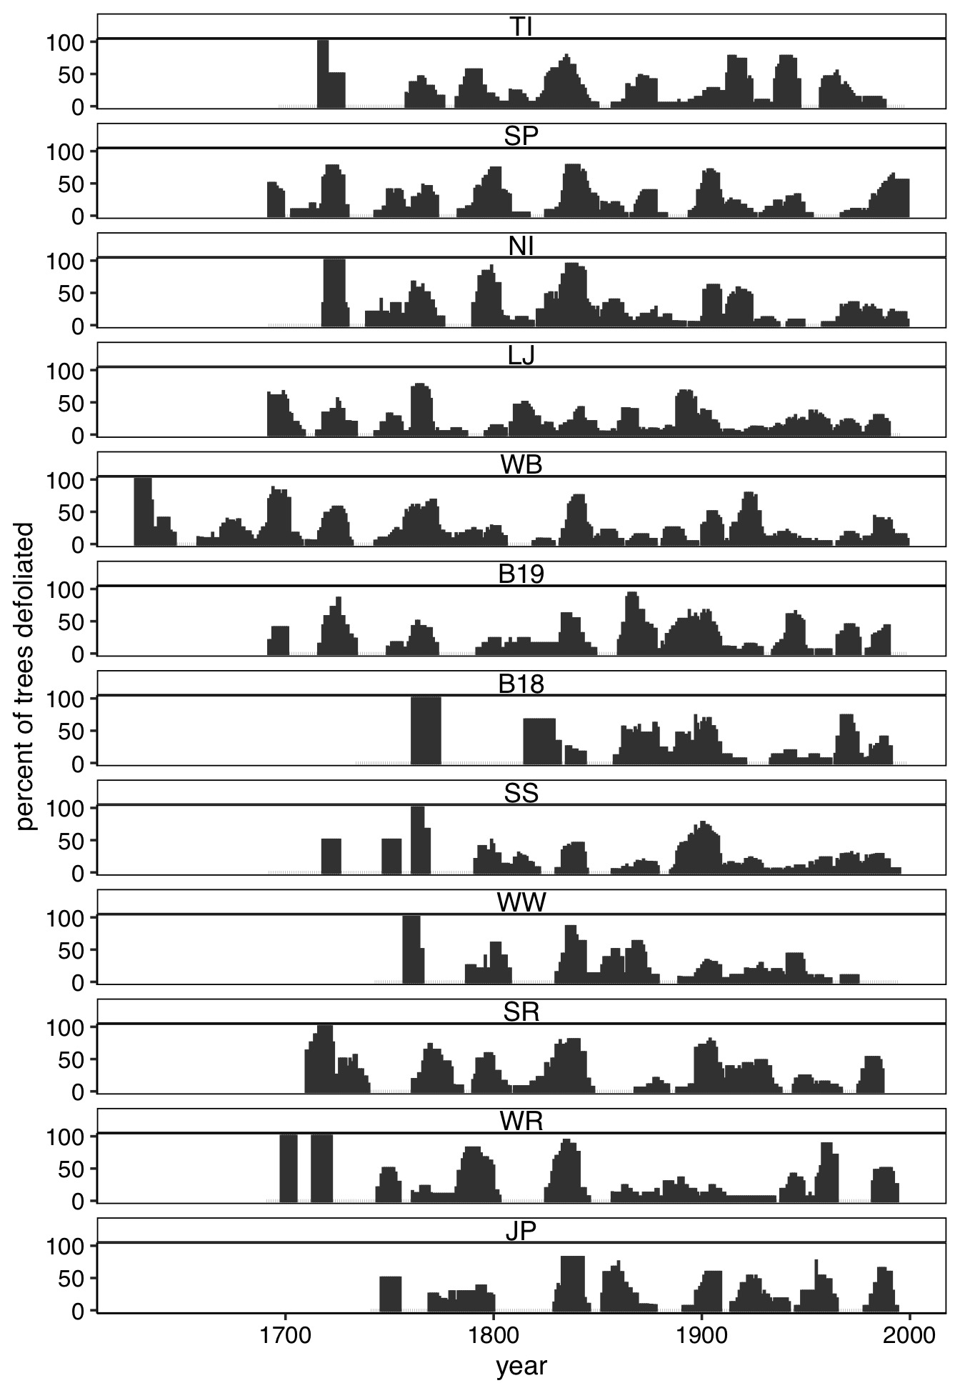

Figure 9: Site-level outbreak records expressed as the percent of trees recording an infestation.

Table 4: Summary of modelling results testing the effect of Euro-Americans on WSB outbreak dynamics and ecological effects .

| Response | Coefficient | p value |
| --- | --- | --- |
| occurence of years of outbreak | -0.180 | 0.324 |
| duration of outbreak | -0.146 | 0.112 |
| length of quiescent period | 0.016 | 0.939 |
| minimum normalized GSI during outbreak events | 0.132 | 0.271 |
| percent of trees defoliated at start of outbreak | -0.067 | 0.244 |

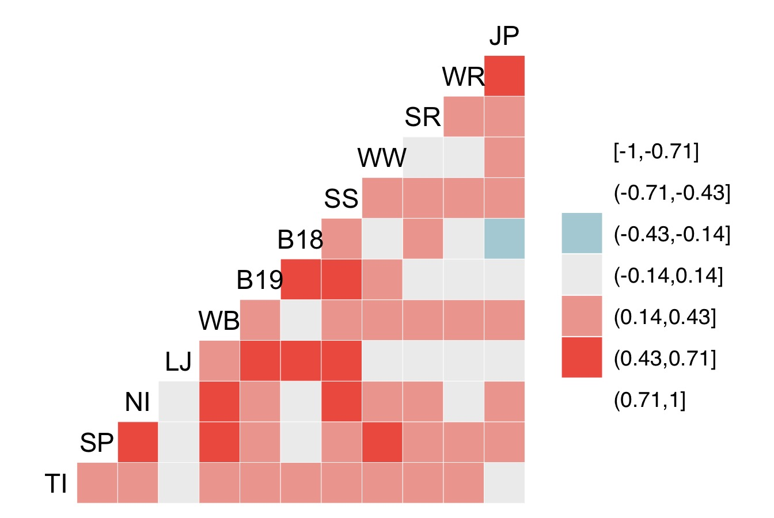

Figure 10: Pairwise Spearman’s correlation between time series of the percent of trees defoliated at each site.

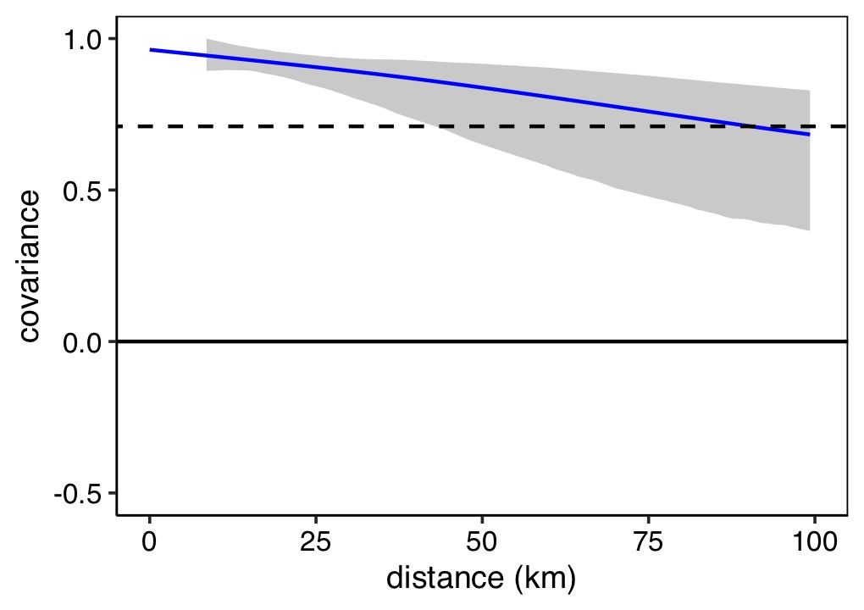

Figure 11: Nonparametric spatial covariance function describing the covarinace among times series SC-PDSI at all 12 sites across study area. SC-PDSI time series are derived from 4 x 4 km PRISM data for the period 1895-2022. Gray shading indicates the 95% confidence interval based on 1,000 bootstrap replications. The dashed horizontal line indicates the average correlation across the study area (regional synchrony)

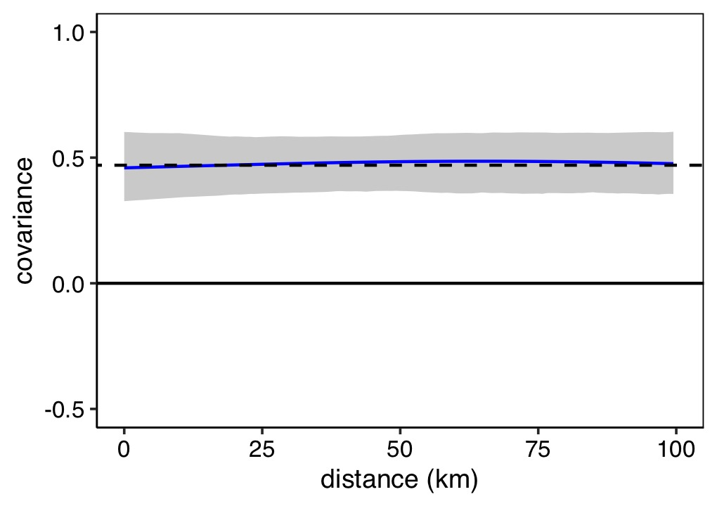

Figure 12: Nonparametric spatial covariance function describing the covarinace among the 12 drought-sensitive ponderosa pine chronologies used to reconstruct WSB histories. Gray shading indicates the 95% confidence interval based on 1,000 bootstrap replications. The dashed horizontal line indicates the average correlation across the study area (regional synchrony)

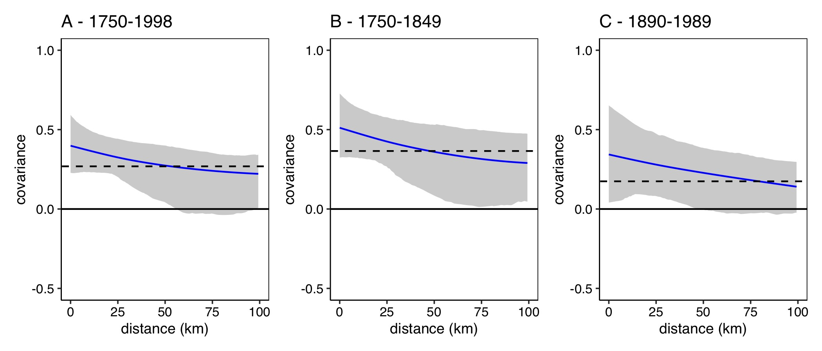

Figure 13: Nonparametric spatial covariance function describing the covarinace among time series of the percent of trees defoliated at site for the 1730-1998 and the centuries prior to and following extensive Euro-American settlement (1750-1848 and 1890-1989, respectively). Gray shading indicates the 95% confidence interval based on 1,000 bootstrap replications. The dashed horizontal line indicates the average correlation across the study area (regional synchrony)

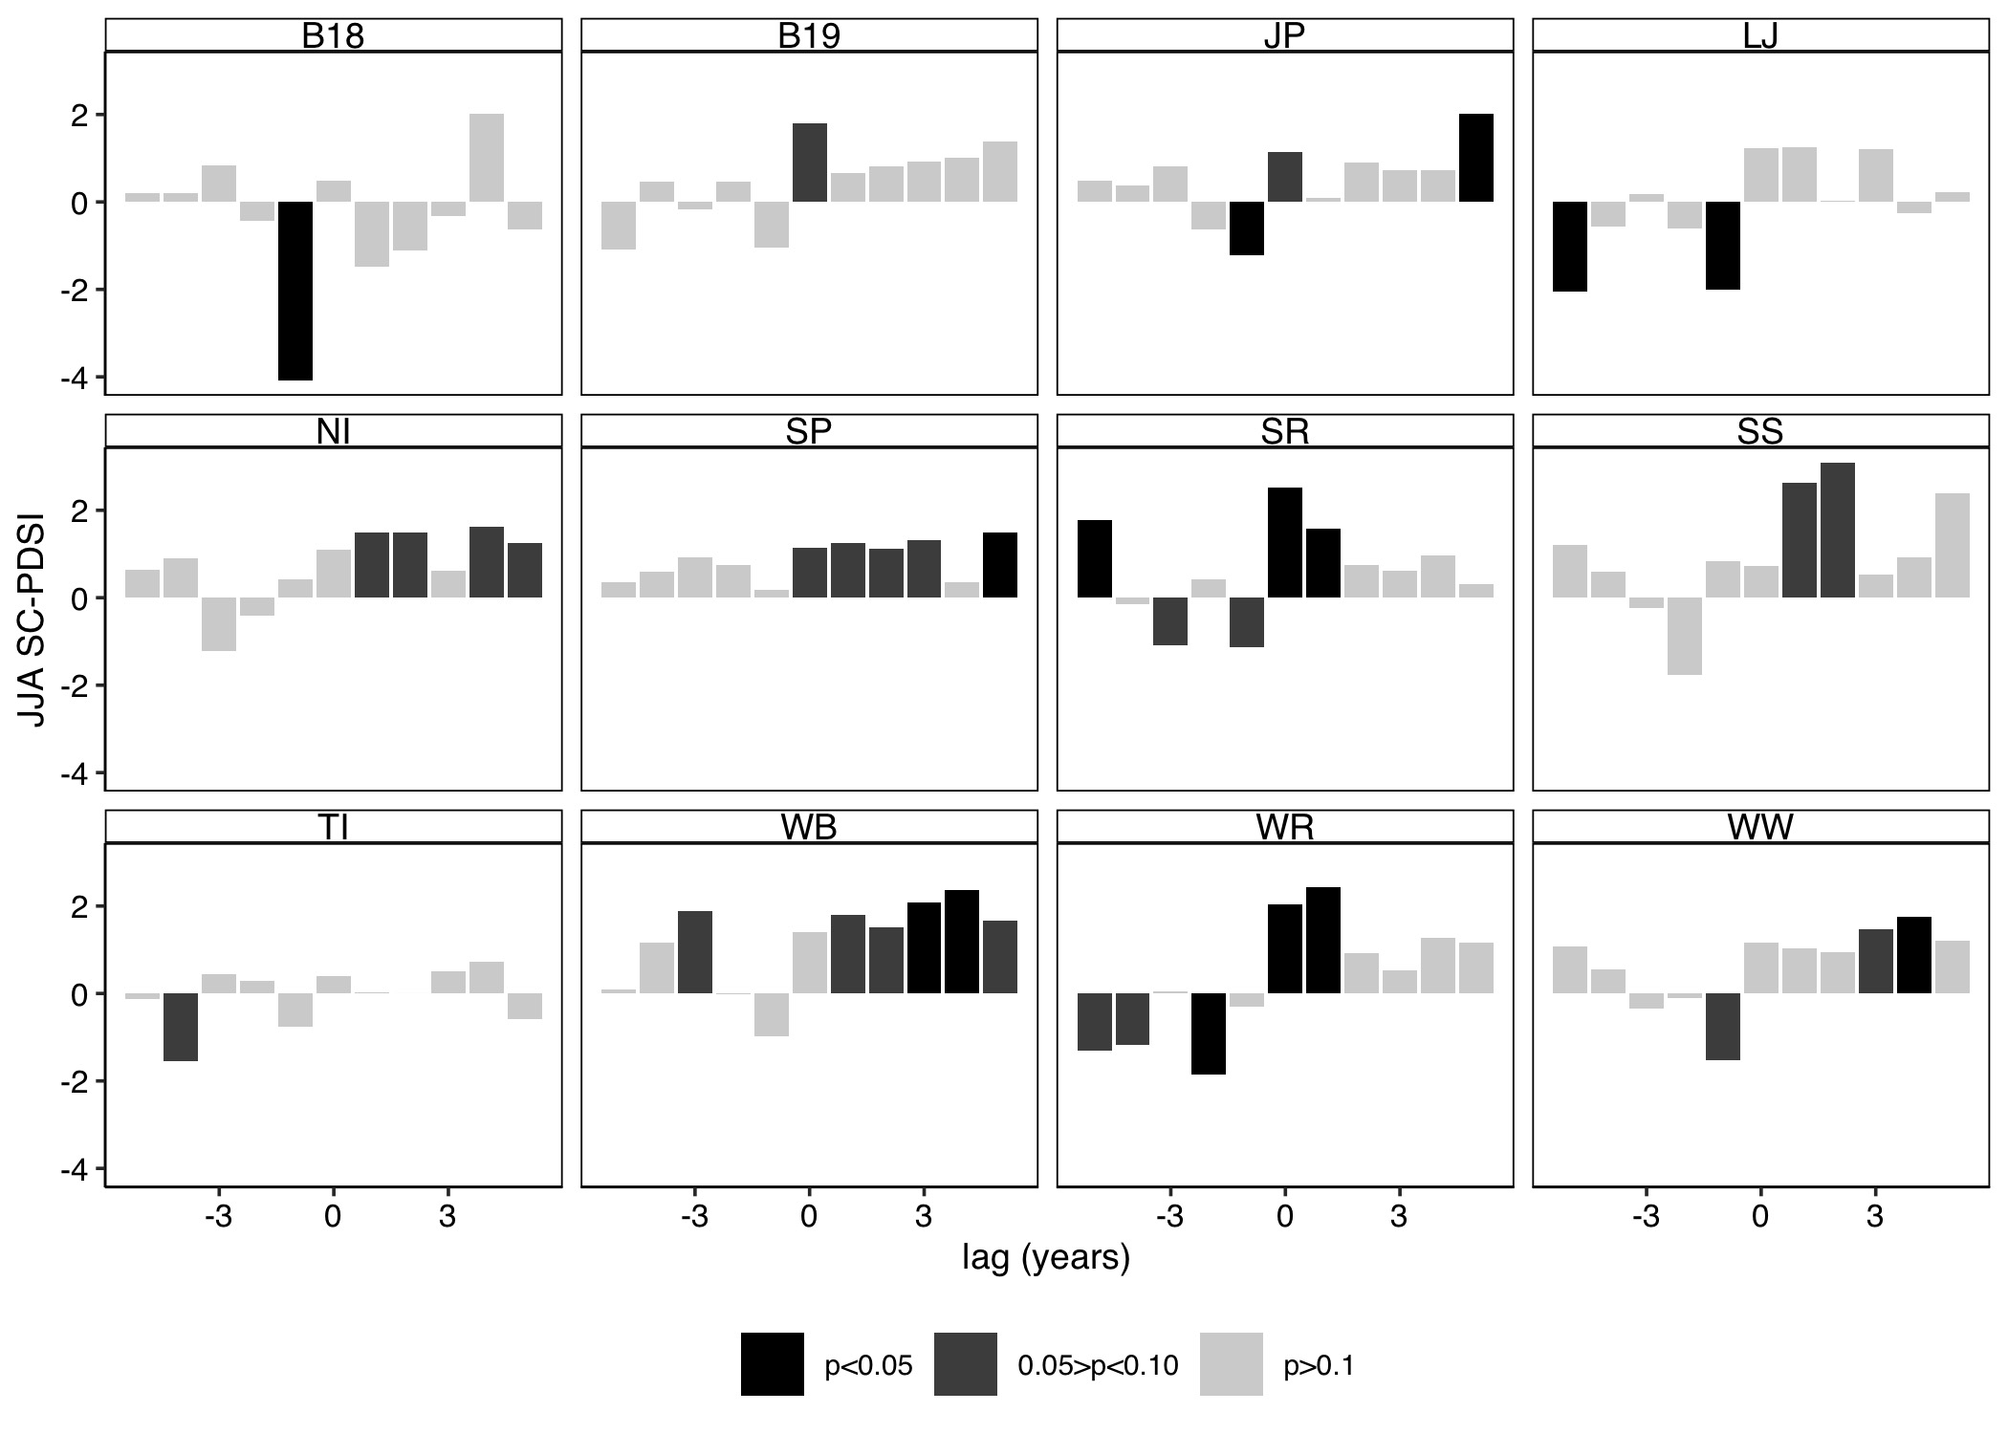

Figure 14: Superposed epoch analyses results illustrating the departure from the mean SC-PDSI for the years prior, during, and following outbreak initiation by site for the 1730-1998 period. Descending bars illustrate a negative association with SC-PDSI (i.e., drier conditions), ascending bars show a positive association with SC-PDSI (i.e., wetter conditions). Black bars indicate statistically significance at the 95% confidence interval.

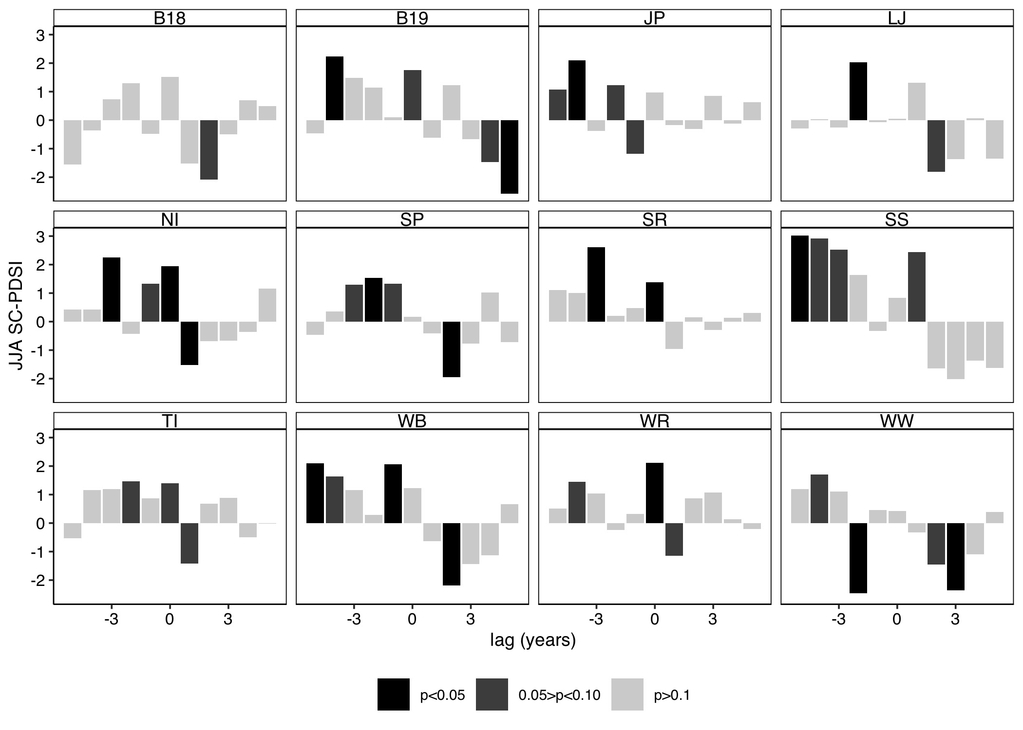

Figure 15: Superposed epoch analysis results illustrating the departure from the mean SC-PDSI for the years prior, during, and following outbreak cessation by site for the 1730-1998 period. Descending bars illustrate a negative association with SC-PDSI (i.e., drier conditions), ascending bars show a positive association with SC-PDSI (i.e., wetter conditions). Black bars indicate statistically significance at the 95% confidence interval.

Table 5: Results of t-tests comparing the climate conditions in the dry period prior and wet period coincident outbreak initaiton with all periods of above average moisture availability.

| Period | Metric | t-statistic | p-value |
| --- | --- | --- | --- |
| wet period concurrent with outbreak initiation | mean JJA SC-PDSI | 1.83 | 0.11 |
| wet period concurrent with outbreak initiation | extreme JJA SC-PDSI | 3.28 | 0.01 |
| wet period concurrent with outbreak initiation | duration (years) | 2.77 | 0.03 |
| dry period prior to outbreak initiation | mean JJA SC-PDSI | -0.33 | 0.75 |
| dry period prior to outbreak initiation | extreme JJA SC-PDSI | -1.59 | 0.16 |
| dry period prior to outbreak initiation | duration (years) | 1.59 | 0.15 |
| wet period concurrent with outbreak cessation | mean JJA SC-PDSI | 0.30 | 0.77 |
| wet period concurrent with outbreak cessation | extreme JJA SC-PDSI | 1.29 | 0.24 |
| wet period concurrent with outbreak cessation | duration (years) | 1.04 | 0.33 |
| dry period following outbreak cessation | mean JJA SC-PDSI | 0.15 | 0.88 |
| dry period following outbreak cessation | extreme JJA SC-PDSI | 0.68 | 0.52 |
| dry period following outbreak cessation | duration (years) | -0.81 | 0.43 |

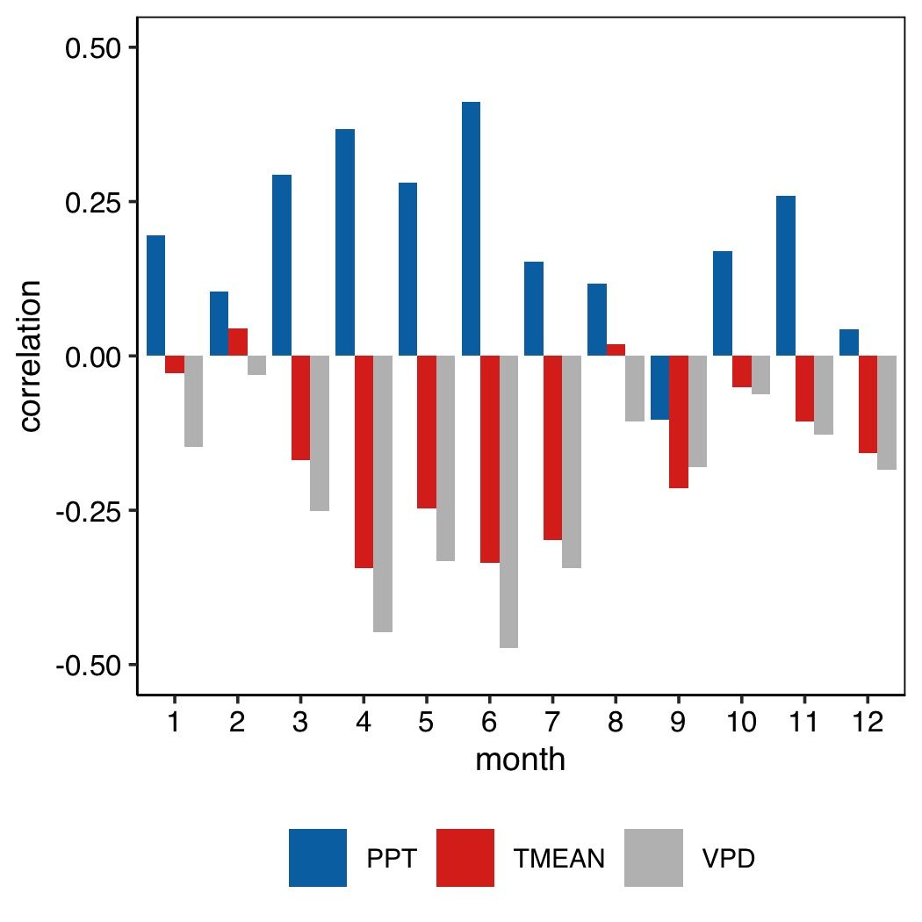

Figure 16: The correlation between regional time series of summer SC-PDSI and monthly total precipitation (PPT), mean daily temperature (TMEAN), and maximum daily vapour presssure deficit (VPD) (1895-2022).

## Appendix B

To determine if the effect of climate on WSB outbreak dynamics differed in the century prior to and following extensive Euro-American colonization, we first used a t-test to compare SC-PDSI values during the two periods. To account for serial autocorrelation, we performed the t-test on the residuals of an autoregressive model fit to the regional SC-PDSI time series. After confirming that SC-PDSI values were similar during the 1750-1959 and 1890-1989 periods [17], we performed separate superposed epoch analyses for each time period. These analyses in general suggested negligible effects of Euro-American settlement on climate-outbreak relationships (Fig. 18). However, during the 1890-1989 period outbreak initiation events were significantly associated with SC-PDSI at fewer sites than during the 1750-1848 period.

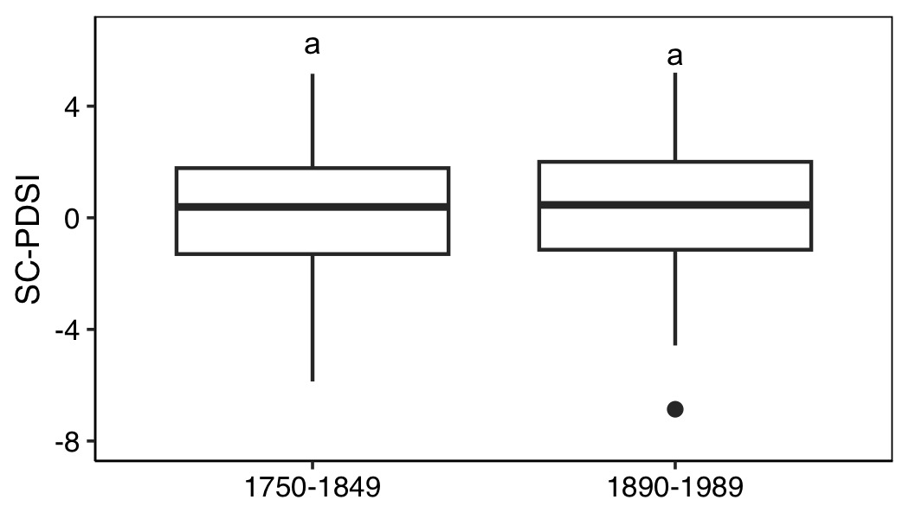

Figure 17: SC-PDSI values during the centuries prior to and following extensive Euro-American settlement (1750-1848 and 1890-1989, respectively). Letters above boxes indicate statistically significant differences. The bottom and top limits of each box are the lower and upper quartiles, respectively; the thick black line within the box is the median; error bars equal ±1.5 times the interquartile range; and points denote outliers, values outside ±1.5 times the interquartile range.

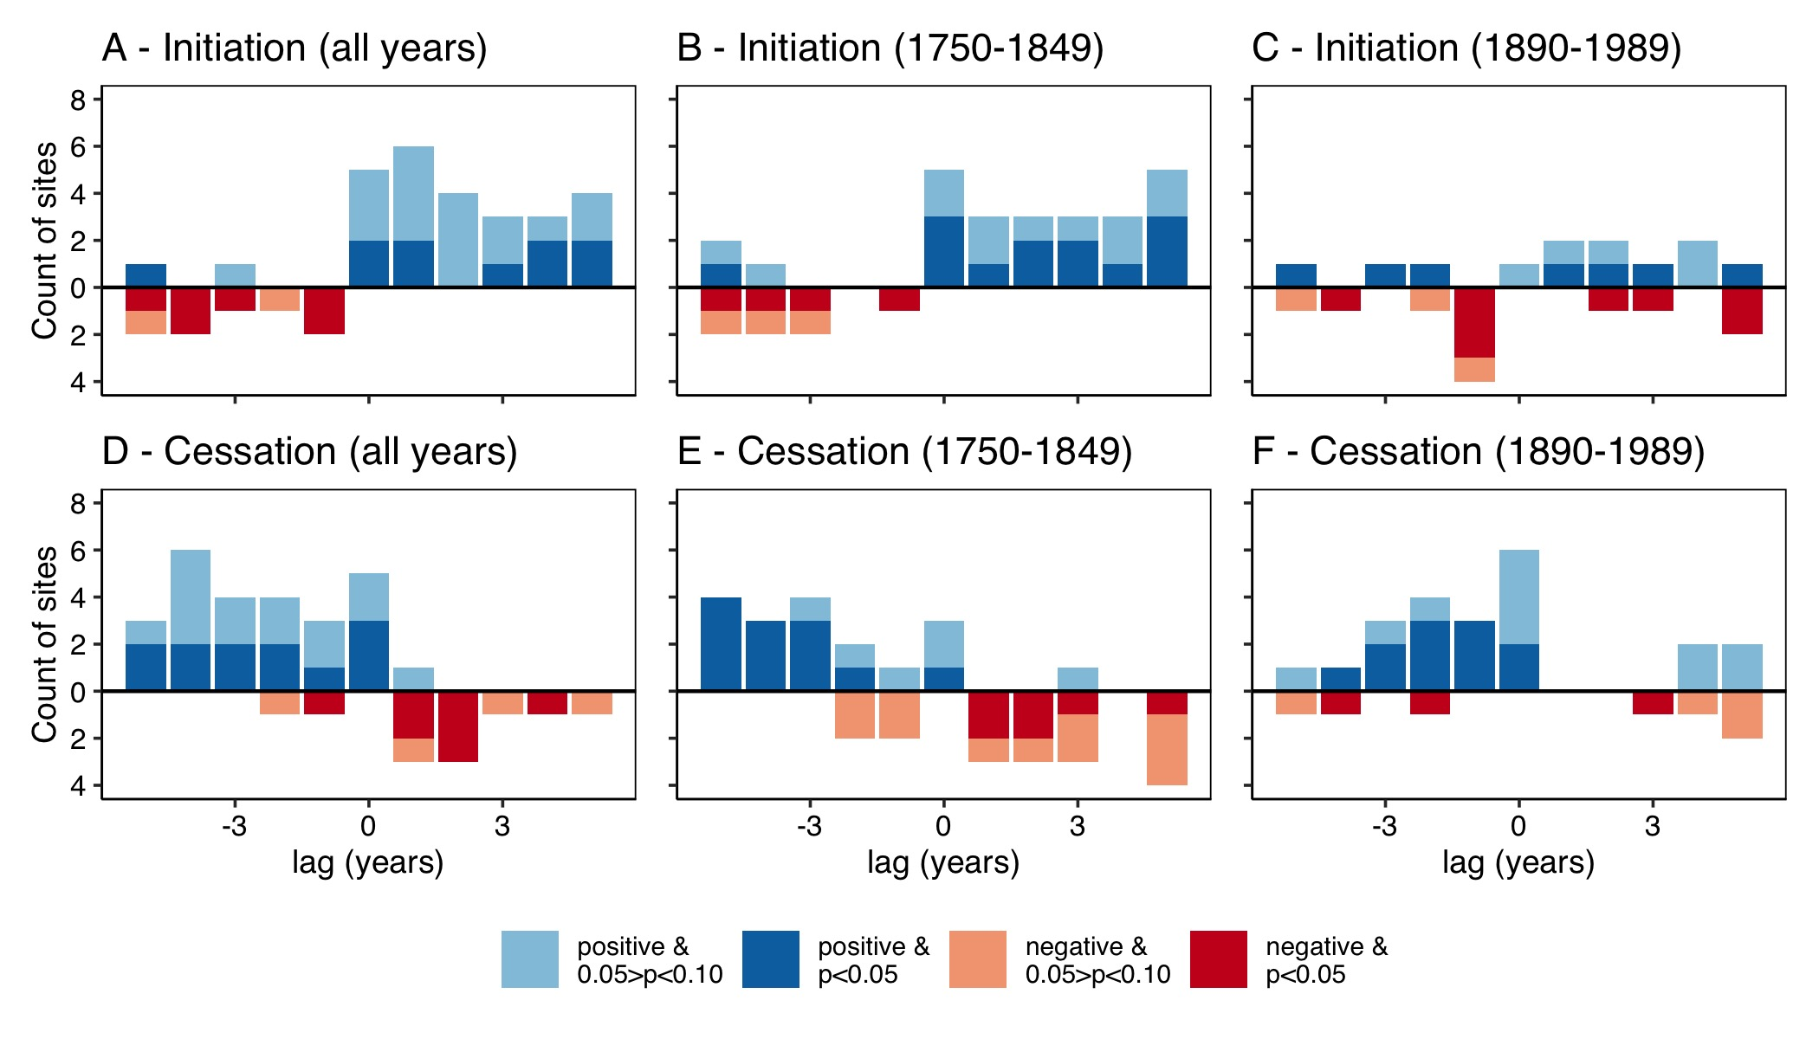

Figure 18: Summary of site-level superposed epoch analyses illustrating the association between SC-PDSI and outbreak initation (A-C) and cessation (D-E) for the 1730-1998 period and the centuries prior to and following extensive Euro-American settlement (1750-1848 and 1890-1989, respectively). Red descending bars illustrate the number of sites with a statitcally significant negative association with SC-PDSI (i.e., drier conditions), blue ascending bars show the number of sites with a statistically significant positive association with SC-PDSI (i.e., wetter conditions).

## Appendix C

Table 6: Published periods of WSB outbreak in Colorado.

| Start | End | Duration (years) | Study area | Source |
| --- | --- | --- | --- | --- |
| 1,938 | 1,945 | 7 | Colorado Front Range | Hadley and Veblen 1992 |
| 1,974 | 1,985 | 11 | Colorado Front Range | Hadley and Veblen 1992 |
| 1,720 | 1,730 | 10 | Pike NF, Colorado | Swetnam and Lynch 1989 |
| 1,748 | 1,765 | 17 | Pike NF, Colorado | Swetnam and Lynch 1989 |
| 1,760 | 1,770 | 10 | Roosevelt NF, Colorado | Swetnam and Lynch 1989 |
| 1,792 | 1,802 | 10 | San Isabel NF, Colorado | Swetnam and Lynch 1989 |
| 1,795 | 1,819 | 24 | Roosevelt NF, Colorado | Swetnam and Lynch 1989 |
| 1,796 | 1,803 | 7 | Pike NF, Colorado | Swetnam and Lynch 1989 |
| 1,821 | 1,823 | 2 | Roosevelt NF, Colorado | Swetnam and Lynch 1989 |
| 1,821 | 1,830 | 9 | San Isabel NF, Colorado | Swetnam and Lynch 1989 |
| 1,830 | 1,838 | 8 | Pike NF, Colorado | Swetnam and Lynch 1989 |
| 1,834 | 1,839 | 5 | Roosevelt NF, Colorado | Swetnam and Lynch 1989 |
| 1,848 | 1,868 | 20 | Pike NF, Colorado | Swetnam and Lynch 1989 |
| 1,865 | 1,872 | 7 | Roosevelt NF, Colorado | Swetnam and Lynch 1989 |
| 1,873 | 1,881 | 8 | Roosevelt NF, Colorado | Swetnam and Lynch 1989 |
| 1,881 | 1,885 | 4 | Pike NF, Colorado | Swetnam and Lynch 1989 |
| 1,886 | 1,893 | 7 | Roosevelt NF, Colorado | Swetnam and Lynch 1989 |
| 1,890 | 1,910 | 20 | Pike NF, Colorado | Swetnam and Lynch 1989 |
| 1,890 | 1,911 | 21 | San Isabel NF, Colorado | Swetnam and Lynch 1989 |
| 1,935 | 1,949 | 14 | San Isabel NF, Colorado | Swetnam and Lynch 1989 |
| 1,942 | 1,969 | 27 | Roosevelt NF, Colorado | Swetnam and Lynch 1989 |
| 1,942 | 1,956 | 14 | Pike NF, Colorado | Swetnam and Lynch 1989 |
| 1,972 | 1,985 | 13 | San Isabel NF, Colorado | Swetnam and Lynch 1989 |
| 1,977 | 1,985 | 8 | Roosevelt NF, Colorado | Swetnam and Lynch 1989 |
| 1,977 | 1,985 | 8 | Pike NF, Colorado | Swetnam and Lynch 1989 |
| 1,739 | 1,745 | 6 | Front Range, Colorado | Weber and Schweingruber 1995 |
| 1,794 | 1,801 | 7 | Front Range, Colorado | Weber and Schweingruber 1995 |
| 1,830 | 1,839 | 9 | Front Range, Colorado | Weber and Schweingruber 1995 |
| 1,845 | 1,851 | 6 | Front Range, Colorado | Weber and Schweingruber 1995 |
| 1,861 | 1,865 | 4 | Front Range, Colorado | Weber and Schweingruber 1995 |
| 1,870 | 1,875 | 5 | Front Range, Colorado | Weber and Schweingruber 1995 |
| 1,885 | 1,893 | 8 | Front Range, Colorado | Weber and Schweingruber 1995 |
| 1,944 | 1,946 | 2 | Front Range, Colorado | Weber and Schweingruber 1995 |
| 1,600 | 1,623 | 23 | Rio Grande NF, Colorado | Ryerson et al. 2003 |
| 1,650 | 1,671 | 21 | Rio Grande NF, Colorado | Ryerson et al. 2003 |
| 1,671 | 1,685 | 14 | Rio Grande NF, Colorado | Ryerson et al. 2003 |
| 1,689 | 1,703 | 14 | Rio Grande NF, Colorado | Ryerson et al. 2003 |
| 1,715 | 1,735 | 20 | Rio Grande NF, Colorado | Ryerson et al. 2003 |
| 1,753 | 1,778 | 25 | Rio Grande NF, Colorado | Ryerson et al. 2003 |
| 1,785 | 1,805 | 20 | Rio Grande NF, Colorado | Ryerson et al. 2003 |
| 1,810 | 1,824 | 14 | Rio Grande NF, Colorado | Ryerson et al. 2003 |
| 1,825 | 1,846 | 21 | Rio Grande NF, Colorado | Ryerson et al. 2003 |
| 1,849 | 1,876 | 27 | Rio Grande NF, Colorado | Ryerson et al. 2003 |
| 1,881 | 1,898 | 17 | Rio Grande NF, Colorado | Ryerson et al. 2003 |
| 1,903 | 1,932 | 29 | Rio Grande NF, Colorado | Ryerson et al. 2003 |
| 1,936 | 1,952 | 16 | Rio Grande NF, Colorado | Ryerson et al. 2003 |
| 1,960 | 1,977 | 17 | Rio Grande NF, Colorado | Ryerson et al. 2003 |
| 1,984 | 1,997 | 13 | Rio Grande NF, Colorado | Ryerson et al. 2003 |