Title

Sarah J. Hart, Olivia Santiago, Josh Carrell, and Thomas T. Veblen

January 03, 2024

# Abstract

# Introduction

Global change, including changes in climate, population density, and land-use, is altering ecosystems around the world (Weiskopf et al. 2020). In forested ecosystems of western North America, global change is altering plant-insect interactions, leading to changes in in ecosystem structure, composition, and function (Bale et al. 2002). Such changes may be particularly dramatic when insect herbivores increase consumption in response to elevated temperatures, CO2 concentrations, drought stress, and/or nutrient conditions (Hamann et al. 2021). Predicting the effects of global change on the structure, composition, and function of forest ecosystems requires a better understanding of the effects of global change on interactions between plants and insects.

The western spruce budworm (WSB; *Choristoneura occidentalis*) is one of the most widely distributed native defoliators of coniferous forests in North America, where it plays an important role in shaping ecosystem function (Johnson 1975, Brookes et al. 1987). WSBs are specialist herbivores that preferentially feed upon young buds and new foliage of their host tree, which include Douglas-fir (*Pseudotsuga menziesii*), true firs (*Abies* spp.) and spruce (*Picea spp.*). Typically, WSBs exist at low population levels and defoliation is minimal (Brookes et al. 1987). However, periodically WBS populations may experience irruptions leading to severe defoliation. These outbreaks occur when several thresholds are crossed and negative feedbacks among the WSB populations, host trees, and natural enemies no longer constrain WSB population dynamics. During outbreaks, affected trees may experience severe reductions in growth and seed production or even death (Alfaro et al. 1982), leading to changes in carbon cycling (Dymond et al. 2010), reductions in timber volume (Alfaro and Maclauchlan 1992), and changes to subsequent disturbance dynamics (Cole et al. 2022). Importantly, outbreaks often occur synchronously across broad spatial extents [i.e, 1000s of kilometers; Flower (2016)], leading to considerable fluctuation in the provisioning of ecosystem services at a subcontinental scale (Wilcox et al. 2017, Patrick et al. 2021).

Disjunct populations may fluctuate synchronously due to density-dependent processes, including dispersal, parasitoidism, disease, and predation. For example, analyses of the spatial patterning of a recent (ca. 1996-2011) WSB outbreak in interior southern British Columbia revealed that 90% of patches newly infested by WSB were within 5 km of an existing patch, consistent with the expectation that adult moth dispersal drives spatiotemporal patterns of outbreak (Senf et al. 2017). While dispersal may explain spatiotemporal synchrony at fine scales, WSB populations fluctuate synchronously across western North America (Flower 2016). At least part of this pattern has been attributed to Moran effects, where spatial autocorrelation in exogenous drivers leads to synchronicity (Moran 1953). For the WSB, Moran effects may occur if climate affects WSB population rates by altering insect survival or fecundity (Brookes et al. 1987, Swetnam and Lynch 1993) and/or if regionally-synchronized stand development affects forage quantity and quality (Brookes et al. 1987, Swetnam and Lynch 1993, Hadley and Veblen 1993).

Outbreaks of WSB are most likely to occur in multistoried stands with abundant hosts, particularly when the surrounding landscape is also characterized by abundant hosts (Brookes et al. 1987, Senf et al. 2017). At the stand and landscape scale, patterns of host abundance and size reflect past disturbances and land-use history (Hadley and Veblen 1993, Maclauchlan and Brooks 2009). Notably, the forcible displacement of native peoples by Euro-American settlers and the ensuing changes in land management practices altered forest composition, structure, and disturbance regimes across much of the Western US (Covington et al. 2018). Early Euro-American settlers often heavily logged forests near settlements and ignited fires, which often burned extensive areas (Veblen and Lorenz 1991). Both logging practices that emphasize the selective harvesting of large trees and severe wildfires can result reduce host abundance and quality, thereby limiting the susceptibility of stands to outbreaks in the near-term (Swetnam and Lynch 1993, Hadley and Veblen 1993). While initially logged and burned stands may be less susceptible to WSB outbreaks, after several decades stands may again become susceptible to WSB outbreaks as trees regenerate and grow (Swetnam and Lynch 1993, Hadley and Veblen 1993). Additionally in many forests characterized by a low-severity, frequent fire regime prior to Euro-American settlement, Euro-American fire suppression policies initiated in the early 1900s and livestock grazing resulted in denser stands composed of more shade-tolerant species, including Douglas-fir, (Covington and Moore 1994, Veblen et al. 2000, Hessburg and Agee 2003). Collectively these changes have been hypothesized to make stands more susceptible to WSB outbreaks and lead to increases in the severity and synchronicity of WSB outbreaks (Swetnam and Lynch 1989). However evidence for this effect appears to vary regionally, with some studies finding changes in outbreak characteristics following Euro-American settlement in the late 1800s (Swetnam and Lynch 1993, Hadley and Veblen 1993, Flower et al. 2014, Ellis and Flower 2017a), while others have not (Ryerson et al. 2003, Alfaro et al. 2014).

Given susceptible stand conditions, interannual variability in drought severity may synchronize the dynamics of disjunct populations of folivorous insects in several ways (Gely et al. 2020). First, droughts may negatively affect population growth rates by decreasing digestibility and forage availability [i.e., *plant vigor hypothesis*; Price (1991)]. For instance, droughts often cause decreases in leaf water content and increases leaf toughness and concentrations of defense compounds [REF], thereby decreasing digestibility. In addition, droughts may decrease forage availability by reducing conifer needle production and elongation (e.g., Adams et al. 2015). While droughts may decrease forage digestibility and availability, they may also lead to higher leaf nitrogen content, which may increase the growth rates [i.e., *plant stress hypothesis*; White (1984)]. Additionally, droughts commonly co-occur with warm temperatures, which may decrease insect mortality that occurs due to freezing or destruction of food supplies (Fellin and Dewey 1982, Régnière and Nealis 2019).

For the WSB-Douglas fir system, outbreak occurrence has been linked with both periods of drought and periods of above average moisture availability (Swetnam and Lynch 1993, Flower et al. 2014). This apparent contradiction may arise for several reasons. First, trees may respond nonlinearly to drought. For instance, carbon allocation to defenses is expected to be greatest at moderate levels of drought when fewer carbohydrates are used for growth and thus more resources available for the production of defense compounds [REF]. Second, temporal attributes of drought may be important. Recent research suggests that drought-driven increases in forage quality may be important in triggering outbreak initiation, but above average moisture availability is necessary for sustaining high population levels (Flower et al. 2014). Third, the effects of drought may vary with site aridity (Harvey et al. 2018, Xu et al. 2019), if populations of Douglas fir from drier locations are better adapted to dealing with drought (Bansal et al. 2015).

The aim of this paper is to use tree-ring methods to determine the history of WSB outbreaks from ca. 1700 to 2020 across central to northern Colorado. We use this data to quantify: (1) temporal synchrony in outbreak history, (2) the effects of Euro-American settlement on the dynamics of WSB outbreaks, and (3) the association between climate and outbreak initiation and cessation. Additionally we assess the stability of climate-outbreak relationships in the century prior to and following extensive Euro-American settlement and across a gradient of site aridity.

# Materials and Methods

## Study area

The study area is the montane zone (ca. 1500-3300 m) of central to northern Colorado (ca. 38.3° N to 40.8° latitude), where Douglas fir is commonly found (Fig. 1). Across the study area, we reconstructed periods of WSB outbreak from 12 sites that span a climatic water deficit gradient (ca. 270 - 660 mm/year; Fig. 9).

The study area typically experiences warm summers (1991-2020 mean July daily maximum temperature: 25.2 °C), cold winters (1991-2020 mean January daily minimum temperature: -10.3 °C), and moderate amounts of precipitation (1991-2020 mean total annual precipitation: 527 mm) (PRISM Climate Group 2021). At local scales, the climate is driven by elevation gradients, the prevailing westerly winds, and the north-south orientation of the mountains. Temperatures are warmer at lower elevations, while more precipitation falls at higher elevations, particularly on the windward side of the Rockies (Lukas et al. 2014). Summer precipitation patterns exhibit a distinct latitudinal gradient, where more southern locations often receive more precipitation due to the North American Monsoon system (Lukas et al. 2014).

Montane forests across the region are dominated by ponderosa pine (*Pinus ponderosa*) and Douglas fir (*Pseudotsuga menziesii)*, with lesser components of aspen (*Populus tremuloides*), lodgepole pine (*Pinus contorta*), and limber pine (*Pinus flexilis*) (Veblen and Donnegan 2005). Prior to Euro-American colonization, lower montane forests across the study area were characterized by frequent, low-severity fire, while higher elevation montane forests were characterized by a more variable fire regime (Sherriff and Veblen 2007).

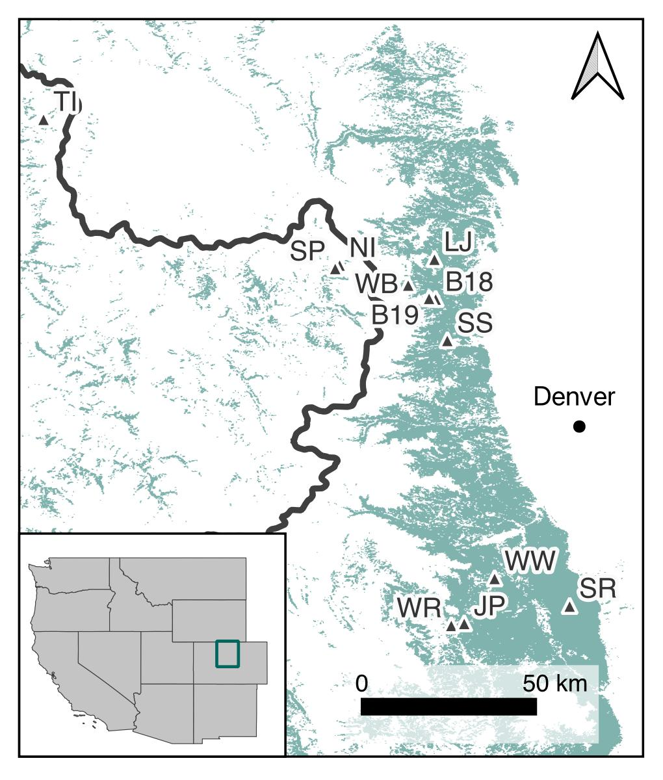

Figure 1: The study area and WSB reconstruction sample sites. The green polygon illustrates the distribution of Douglas fir and the thick black line shows the position of the Continental Divide. The study area’s location relative to the contiguous western United States is shown in the inset map.

## Data

### Dendroecological data

Ring-width data for reconstructing periods of WSB outbreak were collected from Douglas fir in the 1990s, but unpublished (Table 2). Sample sites were selected based on the availability large, old Douglas fir and the absence of evidence of recent fire or logging to minimize the potential effects of other disturbances on radial growth. At each site, tree-ring data were collected by preferentially sampling at least 20 large Douglas fir using an increment borer. Cores were transferred back to the University of Colorado Biogeography Lab, where they were dried, mounted, and sanded to a fine polish, following standard dendrochronological methods (Stokes and Smiley 1996). Ring-widths were then measured to a 0.01 mm precision using a Velmex unSlide digital encoded traversing table paired with a standard light microscope. To ensure accurate dating, ring-width series were visually cross-dated using the maker year approach (Yamaguchi 1991). Cross-dating was then verified statistically using the *dplR* package (Bunn et al. 2019) in R (R Core Team 2022).

### Geospatial disturbance data

To characterize recent history of WSB outbreaks across the study area, we acquired ADS data from the USFS (USFS and partners 2020). ADS data are collected annually via aerial sketch mapping by trained experts who record the disturbance agent, host species, and estimated outbreak severity across broad landscapes. Additionally, given young post-fire stands are not expected to be susceptible to WSB, we acquired data describing wildfire extent for the 1984-2022 period from the Monitoring Trends in Burn Severity Project (2022).

### Climate data

To characterize site aridity, we obtained a 250 x 250 m grid of the 1981-2010 normals of the annual climatic water deficit (CWD) for the study area from Rodman et al. (n.d.). CWD quantifies the evaporative demand that exceeds available soil moisture and indicates the extent of moisture limitation experienced by plants (Stephenson 1990). We overlaid the site locations with this dataset to assign CWD normals to each site.

To characterize temporal variation in drought severity, we obtained multi-century records of the self-calibrating Palmer Drought Severity Index (SC-PDSI; Wells et al. (2004), Palmer (1965)) from the North American Drought Atlas (NADA), which provides tree-ring based reconstructions of June-August SC-PDSI on a 0.5° resolution grid (Cook et al. 2010). Because the NADA reconstruction extends only to 2005, we also obtained gridded June-August SC-PDSI data from the West Wide Drought Tracker (Abatzoglou et al. 2017). This dataset is based on PRISM climate data (PRISM Climate Group 2021), which characterizes monthly precipitation and temperature, among other variables, at a 4 km resolution for the time period 1895-present. PRISM datasets are constructed using data from weather stations and a digital elevation model to adjust for the complex effects of topography on weather and climate (Daly et al. 2002).

For each site, we created time series of 1650-2005 SC-PDSI using the Northern American Drought Atlas product and 1981-2022 SC-PDSI values using the PRISM-based product by extracting the values for the cell the site fell within. We extended the SC-PDSI time series from the PRISM-based dataset back to 1700 using the following procedure. First, we scaled the mean and standard deviation of the NADA reconstruction to the mean of the detrended PRISM-based dataset, where the detrended values are the residuals from a linear regression of SC-PDSI vs. time during the common period between the two datasets (i.e, 1981-2005). We then spliced the two datasets, using the PRISM-based dataset to represent PDSI values from 1981-2022 and the adjusted NADA dataset to represent values from 1650-1980 (Schoennagel et al. 2007).

## Reconstructing periods of past outbreak

### Dendroecological approach

A common strategy for detecting periods of WSB outbreak from tree-ring data is to compare the radial growth of the host species, here Douglas-fir, with the radial growth of a non-host species (Swetnam and Lynch 1989). When the non-host species responds similarly to climate, host ring-width series can then be ‘corrected’ to remove the effects of interannual climate variability on the radial growth. This allows for the detection of periods of reduced radial growth that may attributed to non-climate factors, such as defoliation by WSB. Across our study area, both ponderosa pine and Douglas-fir have been known to respond negatively to periods of drought (Woodhouse et al. 2006), allowing for this method to be applied here.

To follow this general approach, we first obtained all available ponderosa pine chronologies collected in the state of Colorado from the International Tree Ring Databank (ITRDB), as well as previously published chronologies from Veblen et al. (2000) (Table 3). We then matched each Douglas-fir site with three non-host chronologies by identifying all non-host chronologies that were within 150 km of the sample site. We further limited this subset to the pine chronologies that were collected in the mid-1990s or later, to ensure our records could be linked with geospatial data (see 3.3.2). Of this subset, we then selected the three chronologies that showed the greatest similarity in radial growth patterns. This was achieved by first detrending host and non-host ring width series with a negative exponential curve that was fit to the ring-width data using non-linear least squares. The raw ring widths were then divided by the best fitting curve to produce a time series of dimensionless ring-width index (RWI) values. RWI values were further detrended using a 30-year 50% frequency response cubic smoothing spline. This double detrending approach was selected to first remove long-term age-growth related trends and second remove interdecadal patterns that may occur due to disturbance, while preserving high-frequency interannual variation due to climate. Next, we built mean value chronologies from the detrended ring-width series by first pre-whitening each series using an autoregressive time series model. Mean values were then calculated from the residuals of the autoregressive model using a robust mean approach that minimizes the effect of extreme outliers (Speer 2010). We then identified the three non-host chronologies that best correlated with each host chronology using pairwise pearson correlation coefficients. All detrending and chronology building was performed using the *dplR* package (Bunn 2008) in R (R Core Team 2022).

After identifying the three non-host sites that best represented interannual climate variability at each host site, we reprocessed the tree-ring data to better isolate the effects of WSB defoliation on radial growth. Because WSB outbreaks may persists for a decade or more Flower (2016), we detrended both the host and non-host tree-ring data using a 100-year cubic smoothing spline to preserve variability at the interdecadal scale (Swetnam 1985, Flower et al. 2014). We then constructed mean value chronologies for the non-host sites by first removing serial autocorrelation and then calculating a robust estimate of the mean, as above. To create a single climate-sensitive record for each host site, we performed principal components analysis on the three non-host chronologies and extracted the first principal component to serve as the control series (Flower et al. 2014).

To determine if individual trees experienced reductions in growth consistent with defoliation by WSB, we compared the detrended Douglas fir RWI with the control time series (Swetnam 1985). Specifically, we calculate the growth suppression index (GSI) using the following equation:

where is the host RWI value for host tree at year , is the standard deviation of the RWI series for host tree , is the standard deviation of nonhost control series, is the nonhost control series value for year , and is mean value of the nonhost control series. GSI values less than one indicate periods of reduced radial growth relative to potential growth. For each tree, we then defined defoliation events when: (1) at least eight consecutive years of negative GSI and (2) at least one year exhibited a GSI value that was at least 1.28 standard deviations below the mean (Swetnam 1985, Harvey et al. 2018). We then defined stand-level periods of outbreak as periods where: (1) at least 40% of the host trees recorded a defoliation event for 4 or more years and (2) the sample depth was greater than 4 trees (Flower et al. 2014). We performed the correction of host tree-ring series and determination of potential WSB defoliation events and outbreak events in R (R Core Team 2022) using the dfoliatR package (Guiterman et al. 2020).

### Combining tree-ring and geospatial data

We extended tree-ring records of WSB outbreak by spatially joining point data describing the location of sample sites with ADS data describing the annual extent of WSB outbreak for the 1996-2021 period. Additionally, we joined sample site location with data describing wildfire extent (MTBS Project 2022) and the extent of Douglas-fir beetle (*Dendroctonus psuedotsugae*) outbreak, which both lead to mortality of Douglas fir and thereby may be limit the potential for outbreaks to occur. When sites were affected by either Douglas-fir beetle or fire, we truncated the record in the year prior to the disturbance.

### Defining periods of regional outbreak

Finally, we used the composite record to define periods of regional outbreak, defined here as two or more consecutive years where at least one third of the sites simultaneously recorded a WSB outbreak. Given not all records extend as far back in time, we limited the regional record to time period where at least 50% of the sites were recording.

## Quantifying inter-site synchrony

We tested for synchrony in site-level outbreak histories using several approaches. First, to quantify the level of agreement among records of the percent of trees defoliated at each site we calculated Kendall’s coefficient of concordance (W), a non-parametric statistic that quantifies the multivariate agreement in terms of rank (Kendall 1970). Because Kendall’s W does not distinguish between asynchrony and synchrony, we also calculated the mean intersite Spearman’s correlation (rs ), which indicates correlation direction but the magnitude is sensitive to sample size (Loreau and Mazancourt 2008, Gouhier and Guichard 2014). Additionally we calculated concurrency (C), a measure of the proportion of peaks and troughs in agreement between two variables, which is useful for quantifying synchrony when the amplitude of two time series are uncorrelated but local maxima and minima co-occur (Gouhier and Guichard 2014). For all approaches, we determined statistical significance using a bootstrap resampling approach with 1000 replications, where each column in the dataset was shifted a random amount thereby preserving the serial autocorrelation present but not the cross-correlation (Purves and Law 2002). We performed all correlation analyses using the *synchrony* package (Gouhier and Guichard 2014) in R (R Core Team 2022).

Second, we quantified the spatial scale at which WSB outbreak occurs synchronously using a spline correlogram (Bjørnstad and Falck 2001). Here, time series of the percent of trees defoliated at each site were used to calculate cross correlations. Confidence intervals around the correlation function were calculated using a bootstrap resampling approach with 1000 replications. Calculations were performed using the *ncf* package (Bjørnstad 2020) in R (R Core Team 2022).

Third, we used Multivariate Event Analysis to test for clustering among years of outbreak initiation and cessation. Multivariate Event Analysis is a modification of Ripley’s K that identifies the synchrony of events in one dimension (time) within a defined window by comparing the timing of events within multiple records (Gavin et al. 2006). MEA was performed using the R implementation of the K1D software (Gavin 2010).

## Understanding the influence of Euro-American settlement on outbreak dynamics and effects

To determine if Euro-American settlement influenced the dynamics of WSB outbreaks, we split our dataset into two 100-yr periods: (1) 1750-1849, or approximately the century before intensive colonization occurred in the mid to late 1800s (Veblen et al. 2000), and (2) 1890-1989, or approximately the century after intensive colonization. We then compared site-level outbreak characteristics during these two period. Specifically we compared: (1) the probability of an outbreak occurring in an individual year, (2) outbreak duration, (3) the length the period of quiescence between outbreaks, (4) the minimum normalized GSI, and (5) the percent of trees defoliated. We modeled the response variable as a function of a categorically variable describing the time period as either 1750-1849 or 1890-1989 and tested the statistical hypothesis that the intercept differed from zero using a Wald test. In all models we included a random effect of site identity to account for multiple outbreak events within each site. In the model of outbreak occurrence in a given year, we additionally included a first order autocorrelation structure to account for temporal autocorrelation. Models were fit using Penalized Quasi-Likelihood using the packages MASS (Venables and Ripley 2002) and nlme (Pinheiro et al. 2022) in R (R Core Team 2022). Additionally, we used spline correlograms to determine if the Euro-American colonization affected the spatial scale at which WSB outbreak occurs synchronously. We performed separate analyses for the 1750-1959 and 1890-1989 periods and visually compared the results.

## Quantifying the relationship between climate and outbreaks of the WSB

To quantify the association between climate variability and WSB outbreak, we used several approaches. First, we used a t-test to determine if SC-PDSI differed during periods of regional outbreak and non-outbreak periods. To quantify SC-PDSI across the region, we averaged SC-PDSI across all sites. Given the assumption of independence of observations and strong serial autocorrelation in the regional SC-PDSI time series, we first fit an autoregressive model to the regional SC-PDSI time series. We used AIC (Akaike 1973) to select the level of complexity. We fit the autoregressive model using the R package *stats* (R Core Team 2022) and then performed the t-test on the residuals.

We then used superposed epoch analysis (Lough and Fritts 1987) to compare SC-PDSI values in years with and without outbreak initiations and cessations (Flower et al. 2014, Harvey et al. 2018). Specifically, we used superposed epoch analysis to calculate the departure from the mean SC-PDSI for the years prior to a year of outbreak initiation (cessation), during the year of outbreak initiation (cessation), and following the year of outbreak initiation initiation (cessation) using an 11-year window centered on the event year (Flower et al. 2014, Ellis and Flower 2017a). To determine if departures from the mean value were significant, we used 1000 bootstrap samples with a block resampling design that preserved autocorrelation in a 5-year window. While block resampling estimates null distributions for serially autocorrelated data, p-values generated in this way may be still be too small if autocorrelation is strong (i.e., > 60%) over lags greater than the analysis interval. Thus prior to running our superposed epoch analyses, we confirmed that minimal (r<0.05) serial correlation existed at lags greater than 5 years. We performed separate superposed epoch analysis for each site and then summarized these results by counting the number of sites with a positive or negative association that was statistically significant (Flower et al. 2014). We also performed a superposed epoch analysis using the dates of outbreak initiation and cessation using the regional outbreak record and the regional SC-PDSI time series. Superposed epoch analysis was performed in R (R Core Team 2022) using the *dplR* package (Bunn 2008).

To determine if the effect of climate on WSB outbreak dynamics differed in the century prior to and following extensive Euro-American colonization, we first used a t-test to compare SC-PDSI values during the two periods. To account for serial autocorrelation, we performed the t-test on the residuals of an autoregressive model fit to the regional SC-PDSI time series. After confirming that SC-PDSI values were similar during the 1750-1959 and 1890-1989 periods [15], we performed separate superposed epoch analyses for each time period.

To determine if the effect of climate on WSB outbreak dynamics depended upon site aridity, we used similar linear regression to to model the departure from the SC-PDSI value as a function of site CWD normals. We constructed separate models for years of outbreak initiation and cessation and for each lag (i.e., -5 to 5 years) for a total of 22 models.

To determine if the duration or severity of multi-year drought (i.e., negative SC-PDSI) or wet periods (i.e., positive SC-PDSI) were important in WSB outbreak dynamics, we first determined periods of drought and wet periods for each site-level SC-PDSI record. For each site-level outbreak event, we then determined the period of drought prior to outbreak initiation, the wet period concurrent with initiation, wet period concurrent with outbreak cessation, and dry period following outbreak cessation. For each of these periods, we then calculated the duration and mean and extreme SC-PDSI value (i.e., greatest PDSI value for wet periods and lowest SC-PDSI value for droughts). We then used a t-test to compare these values with expected values, which were generated from the periods of drought and wet periods present in the entire time series.

# Results

## Outbreak reconstruction summary

Using the combined tree-ring and geospatial datasets, we were able to reconstruct a total of 66 WSB outbreaks at 12 sites (Table 1; Figure 2). The 12 outbreak reconstructions have starting dates between 1637 and 1743 and ending dates between 2001 and 2020, with at least 50% of the sites records extending to 1730. All outbreak events occurred prior to 1996 and thus appear only in the dendrochronological record. Most sites experienced about five outbreaks, however one site experienced only two outbreaks and two sites experienced eight outbreak events. Outbreak duration at a site ranged from 5 to 22 years, with an average outbreak at a given site lasting for 9.5 to 13.5 years. At the site-level the average quiescent period ranged from 20.8 to 56.7 years.

Table 1: Summary of outbreak characteristics. The quiescent period length was calculated as the number of years between outbreak cessation and the initiation of a subsequent oubtkreak.

| Site | Lat.  (degrees) | Lon.  (degrees) | Combined record length (years) | Tree-ring record length (years) | Geospatial record length (years) | No. of outbreaks | Avg. outbreak duration (years) | Avg. quiescent period (years) |
| --- | --- | --- | --- | --- | --- | --- | --- | --- |
| TI | 40.756 | -106.754 | 1733-2020 | 1733-1997 | 1996-2020 | 6 | 11.8 (sd=3.13) | 23 (sd=11.16) |
| SP | 40.264 | -105.791 | 1692-2019 | 1692-2000 | 1996-2019 | 7 | 10.3 (sd=3.4) | 40.3 (sd=22.29) |
| NI | 40.275 | -105.776 | 1730-2019 | 1730-2000 | 1996-2019 | 5 | 11.2 (sd=1.64) | 28.2 (sd=21.93) |
| LJ | 40.295 | -105.464 | 1692-2020 | 1692-1995 | 1996-2020 | 4 | 9.8 (sd=0.5) | 56.7 (sd=15.28) |
| WB | 40.209 | -105.550 | 1637-2020 | 1637-2000 | 1996-2020 | 7 | 10.1 (sd=3.76) | 37.5 (sd=22.31) |
| B19 | 40.166 | -105.481 | 1692-2020 | 1692-1998 | 1996-2020 | 8 | 11 (sd=5.48) | 28.4 (sd=18.46) |
| B18 | 40.163 | -105.460 | 1835-2020 | 1835-1998 | 1996-2020 | 4 | 11.8 (sd=4.57) | 23.3 (sd=30.17) |
| SS | 40.027 | -105.421 | 1775-2020 | 1775-1995 | 1996-2020 | 2 | 13.5 (sd=7.78) | 47 (sd=NA) |
| WW | 39.241 | -105.265 | 1783-2001 | 1783-1994 | 1996-2001 | 4 | 9.5 (sd=1.91) | 38.3 (sd=25.93) |
| SR | 39.150 | -105.017 | 1710-2020 | 1710-1994 | 1996-2020 | 8 | 10.8 (sd=4.33) | 28.3 (sd=20.16) |
| WR | 39.086 | -105.408 | 1742-2001 | 1742-1994 | 1996-2001 | 5 | 12 (sd=4) | 47.8 (sd=45.14) |
| JP | 39.093 | -105.365 | 1767-2001 | 1767-1994 | 1996-2001 | 6 | 10 (sd=1.41) | 20.8 (sd=11.21) |

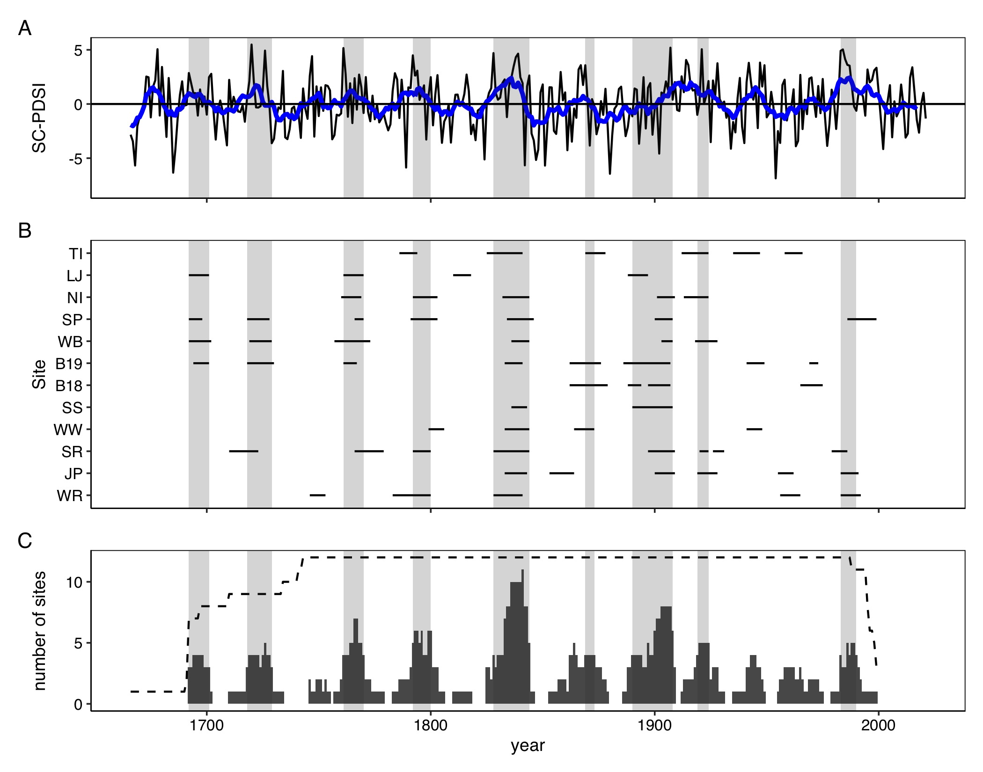

Figure 2: Variability of the self-calibrated Palmer Drought Severity Index (SC-PDSI) (A) and WSB outbreaks by site (B) and across the region (C). In panel (A) the thin black line shows a tree-ring based reconstruction of SC-PDSI, while the thick blue line shows a 10-year rolling mean of that time series. In C, the bars show the number of sites recording an outbreak and the dashed line shows the the number of potential tree-ring recording sites. In all panels, periods of regional outbreak are highlighted by light gray shading.

## Synchrony of outbreaks

We found that sites across the study area exhibited similar temporal patterns of WSB outbreak (Fig. 2 and Fig. 10). Over the 1730-1998 period, time series of the percent of trees defoliated at a site were significantly correlated (W = 0.28; p <0.001; mean inter-site rs = 0.25; mean inter-site C= 27%). However, relationships between some pairs of sites were neutral or even negative (range of. inter-site rs: -0.14 - 0.65; range of inter-site C: 0.12 - 1), highlighting site-level variation in outbreak dynamics across the study area (Fig. 11). The spatial dependence of time-series covariance among records of the percent of trees defoliated indicated that significant sychrony existed at distances up to 50 km and that synchrony decreased with increasing distance (Fig. 3).

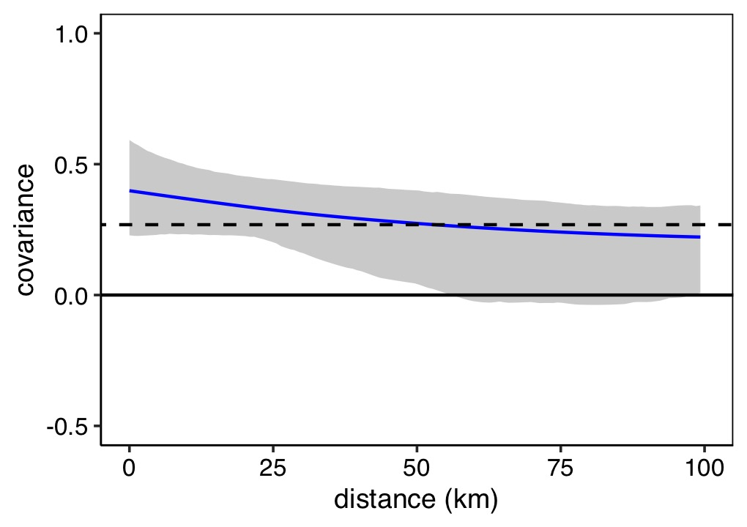

Figure 3: Nonparametric spatial covariance function describing the covarinace among records of the percent of trees defoliated at all 12 sites across study area over the 1730-1998 period. Gray shading indicates the 95% confidence interval based on 1,000 bootstrap replications. The dashed horizontal line indicates the average correlation across the study area (regional synchrony).

Multivariate event analysis indicated that both years of initiation and cessation were significantly clustered in time, with a higher degree of synchrony for cessation dates (Fig. 4). Years of outbreak initiation were more likely than not to occur within six years of another year of outbreak initiation, while years of outbreak cessation were more likely than not to occur within eight years of another year of outbreak cessation. At lags greater than 14 years, years of outbreak cessation were significantly asynchronous.

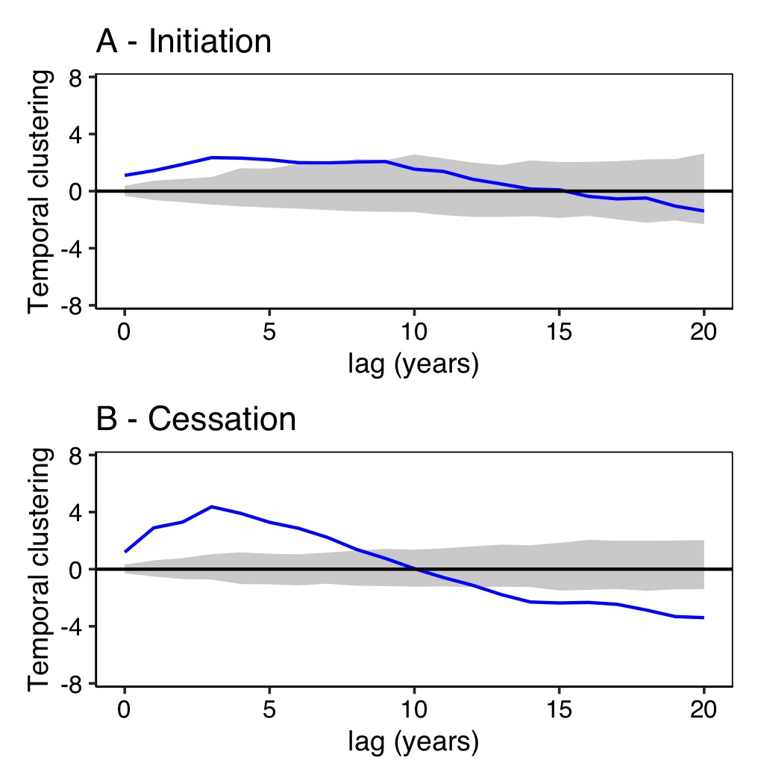

Figure 4: Bidirectional multivariate event analysis of temporal synchrony between dates of WSB outbreak initation (A) and cessation (B) at 12 sites over the 1730-2020 period. The solid black line is the L(t) function, a transformation of Ripley’s K such that the mean and variance are stabilized through time t, where values >0 indicate synchrony and values <0 indicate asynchrony. The dashed lines indicate 95% confidence interval.

## Effects of Euro-American settlement on outbreak dynamics or effects

We found that Euro-American settlement had little effect on outbreak dynamics or severity at the site-level, but reduced regional synchrony. In the century prior to extensive Euro-American settlement, outbreaks occurred about as frequently but were slightly longer and more severe relative to the century following extensive Euro-American settlement (Fig. 5). However, these differences were not significantly different (Table 4).

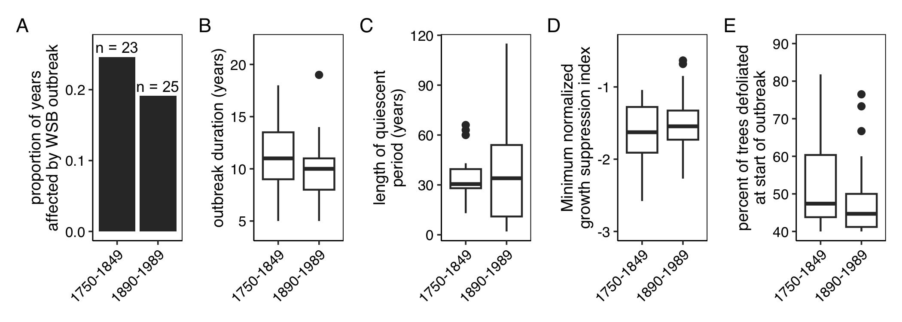

Figure 5: The proportion of years affected by WSB outbreak (A), the duration of outbreak (B), the length of the quiescent period (C), the minimum normalized growth suppression index (D), and the duration of outbreak (E) for the century prior to and proceeding extensive Euro-American colonization (1750-1849 and 1890-1989, respectively). In A, the sample sizes printed above bars show the number of total outbreaks recorded at any site during that period. For boxplots, the bottom and top limits of each box are the lower and upper quartiles, respectively; the thick black line within the box is the median; error bars equal ±1.5 times the interquartile range; and points denote outliers, values outside ±1.5 times the interquartile range.

While outbreak dynamics and effects were similar in the two time periods, regional synchrony was lower in the 1890-1989 period than the 1750-1849 period. The mean inter-site correlation was 50% lower in the century following century following extensive Euro-American settlement (mean rs for 1750-1859: 0.34 and mean rs for 1890-1989: 0.17; t=-3.8, p=0) and the mean inter-site concurrency was 40% lower (mean C for 1750-1859: 0.239 and mean C for 1890-1989: 0.14; t=-3.3, p<0.001). While regional synchrony was lower in the 1890-1989 period, spline correlograms calculated for the 1750-1849 and 1890-1989 time periods showed similar decreases in sychrony with increasing distances as the the 1750-1998 period (Fig. 14).

## Association between interannual climate variability and outbreaks

Over the 1730-2020, we found periods of regional outbreak were associated with interannual variability in moisture availability, as quantified using the SC-PDSI (Figure 2). During periods of outbreak the mean SC-PDSI was greater in quiescent periods than during periods of outbreak (mean SC-PDSIoutbreak:0.71; mean SC-PDSIno outbreak:-0.2; t = 2.92; p = 0.004). This pattern of greater SC-PDSI in periods of outbreak was apparent in both the century prior to and following extensive Euro-American settlement, although the effect was not significant during the 1890-1989 period (Figure 15).

At the site-level, superposed epoch analyses showed outbreaks were generally more likely to initiate during periods of above-average moisture availability (i.e., positive SC-PDSI), particularly when proceeded by periods of average or below-average moisture availability (Fig. 6A and Fig. 16). Outbreaks cessation generally coincided with a switch from above average moisture availability to average or below average moisture availability (Fig. 6B and Fig. 17). Superposed epoch analyses conducted using the regional record confirmed that periods of outbreak coincided with periods of elevated moisture availability (Fig. 7). However, there was less evidence for drought proceeding and following outbreaks. Analyses conducted using data from the century prior to and following Euro-American colonization also showed similar results, however during the 1890-1989 period outbreak initiation events were significantly associated with SC-PDSI at fewer sites (Fig. 18).

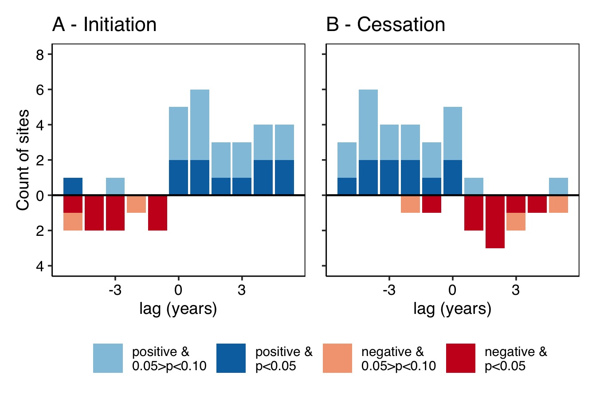

Figure 6: Summary of site-level superposed epoch analyses summarzing the association between summer SC-PDSI and outbreak initation (A) and cessation (B) over the 1730-2020 period. Red descending bars illustrate the number of sites with a statitcally significant negative association with summer SC-PDSI (i.e., drier conditions), blue ascending bars show the number of sites with a statistically significant positive association with summer SC-PDSI (i.e., wetter conditions).

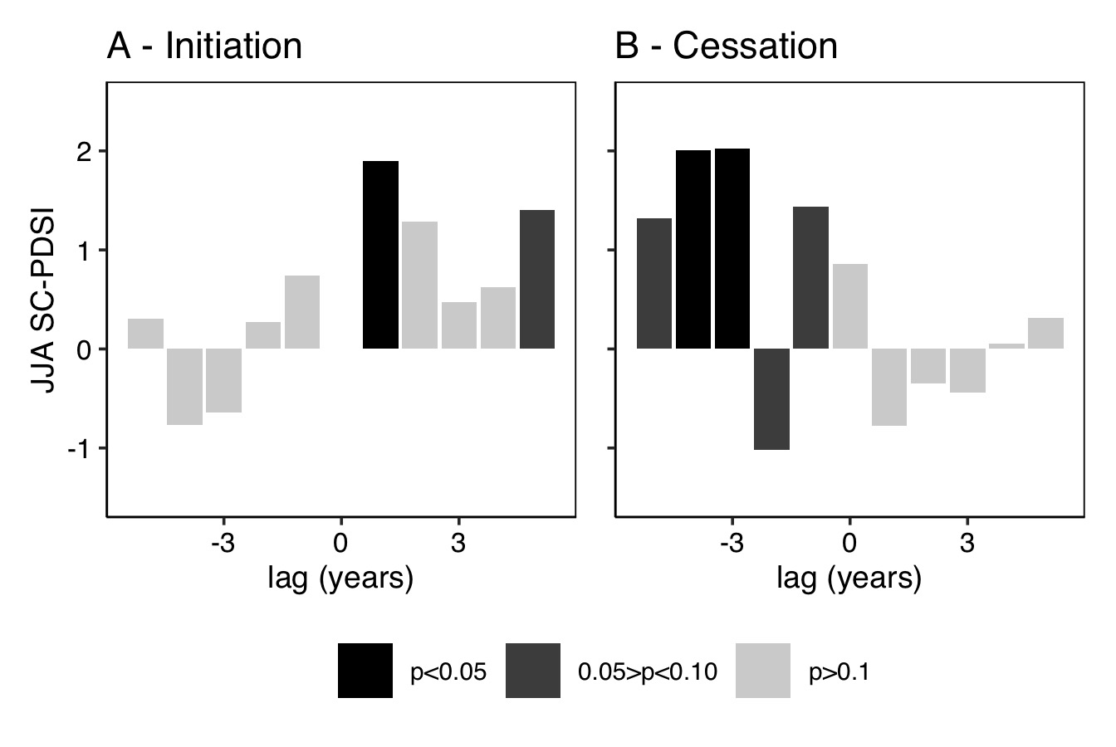

Figure 7: Superposed epoch analysis results illustrating the departure from the mean SC-PDSI for the years prior, during, and following regional outbreak years over the 1730-2020 period. Descending bars illustrate a negative association with summer SC-PDSI (i.e., drier conditions), ascending bars show a positive association with summer SC-PDSI (i.e., wetter conditions).

We found no significant effect of site aridity (i.e., mean annual CWD) on the association between SC-PDSI and outbreak initiation or cessation (Fig. 8; Table 5 - 6). However, there was a weak (r=-0.002 ; p=0.068) negative association between site aridity and the mean SC-PDSI in the year proceeding outbreak cessation.

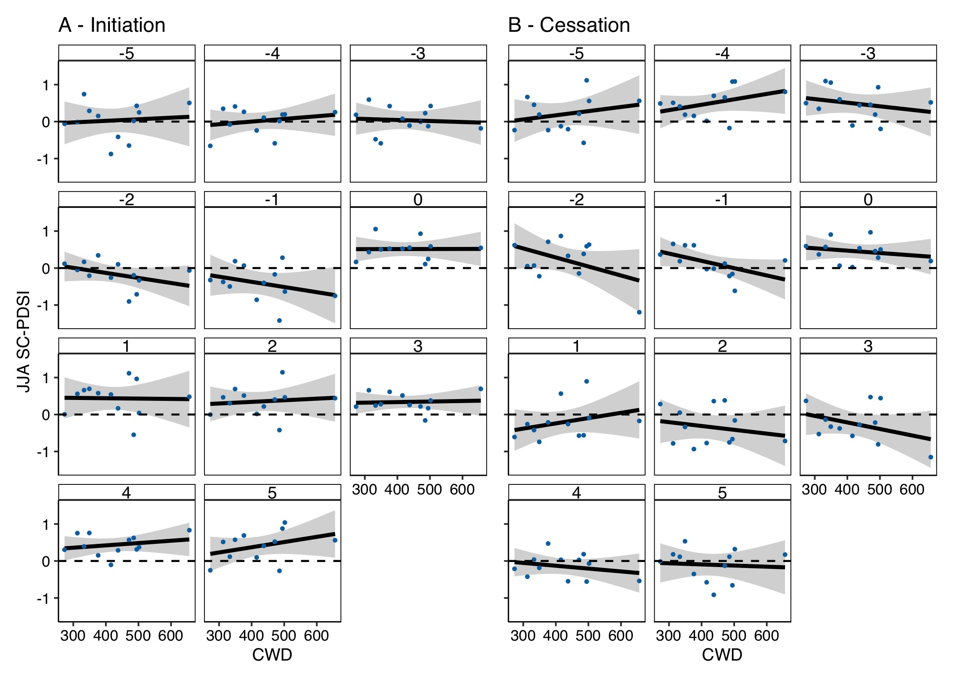

Figure 8: Linear regressions between site climatic water deficit (CWD) and mean summer SC-PDSI for the years prior, during, and following outbreak initiation (A) and cessation (B) for the 1730-2020 period. Shading illustrates the 95% confidence interval around the regression.

Finally, we found that periods of regional outbreak coincided with longer periods of above average moisture availability (mean duration for periods of regional outbreak = 5.7 years; mean for all periods of above average moisture availability = 1.8 years; Fig. 19). In general these periods were characterized by higher mean JJA SC-PDSI and higher maximum values of JJA SC-PDSI than the average periods of above average JJA SC-PDSI (Fig. 19).

# Discussion

Here we combined tree-ring and geospatial data to reconstruct periods of WSB outbreak at 12 sites across northern to central Colorado. Notably our results show that (1) WSB outbreaks occur synchronously across sites, suggestive of a regional driver and (2) outbreaks were often initiated by a period of above-average moisture availability that was proceeded by periods of drought.

## Outbreak histories

We found that periods of regional outbreak occurred from 1761 to 1770, 1792 to 1800, 1833 to 1844, 1890 to 1894, 1897 to 1908, 1920 to 1924, and 1986 to 1990. Notably, all of these periods correspond with periods of outbreak identified in dendroecological studies from Colorado (Table 8). Further the 1980s outbreak is well documented in observational records from Colorado (Hadley and Veblen 1993, Weber and Schweingruber 1995) and the 1920s outbreak and is supported by reports from forest entomologists working in northern Idaho and Yellowstone National Park, where observational records of WSB outbreaks began much earlier than in Colorado (Johnson 1975). This agreement between existing tree-ring and observational records confirms that tree-ring data can provide insights into periods of past WSB outbreak.

Across all our sites the mean outbreak duration (10.8 years) and mean length of the quiescent period (33.1 years) were similar to those previously reported in dendroecological studies conducted in interior Pacific Northwest [mean duration: 12 years; mean quiescent interval: 15 years; Flower et al. (2014)], the Colorado Front Range [mean duration: 6.9 years; Weber and Schweingruber (1995)], and southern British Columbia [mean duration: 12 years; mean quiescent interval: 29 years; Campbell et al. (2006)]. However, outbreaks in our record were notably shorter and quiescent periods were longer than in dendroecological records from northern New Mexico [mean duration: 22 years; mean quiescent interval: 11 years; Swetnam and Lynch (1993)] and central British Columbia [mean: 18 years; Harvey et al. (2018)]. These differences likely reflect variation in tree-ring data collection and processing methods, but also highlight the need for more research that addresses the drivers of outbreak dynamics in space and time, as well as the need for infrastructure for sharing dendroecological data and research that integrates multiple studies.

## Inter-site synchrony

We found that WSB outbreaks occur synchronously across northern to central Colorado, consistent with previous dendroecological research that has identified synchrony across sites in the Interior Pacific Northwest (Flower et al. 2014, Ellis and Flower 2017b). For population of irruptive insects, temporal synchrony may arise from density-dependent processes (e.g., dispersal, predation) and/or Moran effects (Moran 1953), where spatial autocorrelation in exogenous drivers, such as climate, leads to synchronicity of density-independent processes (Liebhold et al. 2004). Here we found that both regional synchrony (0.27) and the spatial scale at which synchrony was statistically significant (≤50 km) were lower than we would expect if climate was the only driver. For instance, across the 12 drought-sensitive ponderosa pine chronologies used to remove climate-trends in host ring-width series, we calculated greater regional synchrony (0.47) and significant correlations at larger distances (i.e, up to 100 km; Fig. 13). This supports previous research on spatiotemporal patterns of contemporary WSB outbreak in British Columbia that has suggested that dispersal is key in driving the synchronization of WBS population dynamics (Senf et al. 2017). Our records also show that outbreaks can develop concurrently in disjunct populations. For instance, evidence of the 1790s outbreak appears in the tree-ring record first in ca. 1784 at the TI site, the furthest north and west site in our dataset, and the WR site, which is east of the Continental Divide in the southern Front Range. While budworms are strong fliers that can dispersing hundreds of kilometers in the right weather conditions Sturtevant et al. (2013), the correspondence between periods of above-average moisture availability and periods of outbreak that we identified here suggests broad-scale climate variability is important in driving synchronicity in WSB population dynamics. Collectively, these findings confirm previous research that has argued that both dispersal and Moran effects are important in driving the synchrony of local populations of WSBs (Flower et al. 2014, Senf et al. 2017).

## Effects of Euro-American colonization on outbreak dynamics

Our results indicate that outbreak duration, frequency, and severity were comparable during the century prior to and following Euro-American colonization, but inter-site synchrony was lower in the 20th century. Additionally, our regional record shows a long quiescent period from 1925 to 1980. While none of the site examined here experienced severe disturbance in the past century, local WSB population dynamics are sensitive to landscape-level availability of host trees (Senf et al. 2017). Thus the decrease in regional synchrony may reflect lower availability of hosts at the landscape scale and a reduction in the potential for dispersal to synchronize population development (Swetnam and Lynch 1989, Veblen and Lorenz 1991, Hadley and Veblen 1993, Weber and Schweingruber 1995).

## Climate effects on outbreak dynamics

Our 300 year record of WSB outbreaks provides support for the idea that above average moisture availability increases forage digestibility and availability and thus higher population growth rates (**Price1991?**). SEA analyses showed that WSB outbreaks were more likely to initiate during periods of above average moisture availability and end when moisture became more limiting. These findings are consistent with previously dendroecological research from the American Southwest, which has shown that years of outbreak co-occur with years of above average moisture availability (Swetnam and Lynch 1993).

that were typically proceeded by drought, consistent with the hypothesis that drought events may synchronize the irruption of disjunct populations of WSBs by increasing forage quality . Here we identified significant relationships between outbreak initiation and drought in the proceeding one to five years, as has been previously reported (Flower et al. 2014). This apparent variation in the timing of the inciting drought may emerge for several reasons. First, dispersal between stands may result in a lag, consistent with bidirectional multivariate event analyses that showed that years of outbreak initiation were significantly clustered in a six year period. Second, the effect of defoliation on radial growth may be delayed because trees may use previously stored carbon for growth (Richardson et al. 2015). Indeed, dendrochronological studies of ongoing outbreaks show that the effect of defoliation on radial growth often lag defoliation by one to three years (Alfaro et al. 1982, Swetnam 1985). Third, the cumulative

Contrary to expectations, our results do not support the idea that site aridity drives the

However, we were only able to test this effect using a relative small number of sites. While not statistically significant, we found drought was more likely to proceed outbreak cessation at relatively arid sites.

While our study provides support for the hypothesis that drought followed by average moisture availability supports the development of WSB outbreaks, here we assessed the effect of climate variability on WSB outbreak dynamics using summer SC-PDSI, which is highly correlated with other climate variables (Fig. 20, many of which may also influence WSB outbreak dynamics (Nealis and Régnière 2021). For instance, summer SC-PDSI is positively correlated with spring (March-May) temperatures, which may affect WSB mortality due to freezing or destruction of food supplies (Fellin and Dewey 1982, Régnière and Nealis 2019). Thus the positive association between periods of above average moisture availability periods of WSB outbreak may in part reflect the effects of warmer temperatures on reduced WSB mortality. Untangling the direct effects versus of climate variation on insect populations versuses the indirect effects of climate variability on plants is critical to forecasting future outbreak dynamics (REF). For instance, in the WSB-Douglas fir system, exceptionally warm spring temperatures may alter the synchrony of WSB larval emergence and the timing of host tree bud burst, negatively impacting WSB population development rates (Chen et al. 2001, Nealis 2012, Régnière and Nealis 2019). Future projections of climate across the region suggest that temperatures may become warmer, thereby

We also highlight the need for more research that examines the effects of temp. Understanding these impacts is challenging given most dendrochonological reconstructions of climate focus on variables o

## Implications

# Acknowledgements

This research was supported the USDA National Institute of Food and Agriculture, McIntire-Stennis project COL00520, accession number 7002894. Additionally, we would like to the thank Colorado State University and the Colorado Mountain Club for supporting O. Santiago.

# References

Abatzoglou, J. T., D. J. McEvoy, and K. T. Redmond. 2017. [The west wide drought tracker: Drought monitoring at fine spatial scales](https://doi.org/10.1175/BAMS-D-16-0193.1). Bulletin of the American Meteorological Society 98:1815–1820.

Adams, H. D., A. D. Collins, S. P. Briggs, M. Vennetier, L. T. Dickman, S. A. Sevanto, N. Garcia-Forner, H. H. Powers, and N. G. McDowell. 2015. [Experimental drought and heat can delay phenological development and reduce foliar and shoot growth in semiarid trees](https://doi.org/10.1111/gcb.13030). Global Change Biology 21:4210–4220.

Akaike, H. 1973. Information theory and an extension of the maximum likelihood principle. Pages 267–281 *in* B. N. Petrov and F. Csáki, editors. Academiai Kiado, Budapest, Hungary.

Alfaro, R. I., J. Berg, and J. Axelson. 2014. [Periodicity of western spruce budworm in southern british columbia, canada](https://doi.org/10.1016/j.foreco.2013.12.026). Forest Ecology and Management 315:72–79.

Alfaro, R. I., G. A. V. Sickle, A. J. Thomson, and E. Wegwitz. 1982. [Tree mortality and radial growth losses caused by the western spruce budworm in a douglas-fir stand in british columbia](https://doi.org/10.1139/x82-117). Canadian Journal of Forest Research 12:780–787.

Alfaro, RenéI., and L. E. Maclauchlan. 1992. [A method to calculate the losses caused by western spruce budworm in uneven-aged douglas fir forests of british columbia](https://doi.org/10.1016/0378-1127(92)90107-K). Forest Ecology and Management 55:295–313.

Bale, J. S., G. J. Masters, I. D. Hodkinson, C. Awmack, T. M. Bezemer, V. K. Brown, J. Butterfield, A. Buse, J. C. Coulson, J. Farrar, J. E. G. Good, R. Harrington, S. Hartley, T. H. Jones, R. L. Lindroth, M. C. Press, I. Symrnioudis, A. D. Watt, and J. B. Whittaker. 2002. [Herbivory in global climate change research: direct effects of rising temperature on insect herbivores](https://doi.org/10.1046/j.1365-2486.2002.00451.x). Global Change Biology 8:1–16.

Bansal, S., C. A. Harrington, P. J. Gould, and J. B. St.Clair. 2015. [Climate-related genetic variation in drought-resistance of Douglas-fir (Pseudotsuga menziesii)](https://doi.org/10.1111/gcb.12719). Global Change Biology 21:947–958.

Bjørnstad, O. N. 2020. [Ncf: Spatial nonparametric covariance functions](http://CRAN.R-project.org/package=ncf).

Bjørnstad, O. N., and W. Falck. 2001. [Nonparametric spatial covariance functions: Estimation and testing](http://link.springer.com/article/10.1023/A:1009601932481). Environmental and Ecological Statistics 8:5370.

Brookes, M. H., R. W. Campbell, J. J. Colbert, Mitchell, R. G., and R. W. Stark. 1987. [Western spruce budworm](https://naldc.nal.usda.gov/download/CAT89231792/PDF). Washington, D.C.

Bunn, A. G. 2008. [A dendrochronology program library in R (dplR)](https://doi.org/10.1016/j.dendro.2008.01.002). Dendrochronologia 26:115–124.

Bunn, A. G., M. Korpela, F. Campelo, P. Mérian, F. Qeadan, and C. Zang. 2019. [dplR: Dendrochronology program library in r](https://CRAN.R-project.org/package=dplR).

Campbell, R., D. J. Smith, and A. Arsenault. 2006. Multicentury history of western spruce budworm outbreaks in interior douglas-fir forests near kamloops, british columbia. Canadian Journal of Forest Research 36:17581769.

Chen, Z., T. E. Kolb, and K. M. Clancy. 2001. [Mechanisms of Douglas-fir resistance to western spruce budworm defoliation: Bud burst phenology, photosynthetic compensation and growth rate](https://doi.org/10.1093/treephys/21.16.1159). Tree Physiology 21:1159–1169.

Cole, H. M., R. A. Andrus, C. Butkiewicz, K. C. Rodman, O. Santiago, N. J. Tutland, A. Waupochick, and S. J. Hart. 2022. [Outbreaks of Douglas-fir beetle follow western spruce budworm defoliation in the Southern Rocky Mountains, USA](https://doi.org/10.3390/f13030371). Forests 13:371.

Cook, E. R., R. Seager, R. R. Heim, R. S. Vose, C. Herweijer, and C. Woodhouse. 2010. [Megadroughts in North America: Placing IPCC projections of hydroclimatic change in a long-term palaeoclimate context](https://doi.org/10.1002/jqs.1303). Journal of Quaternary Science 25:48–61.

Covington, W. W., L. R. Everett, R. Steele, L. L. Irwin, T. A. Daer, and A. N. Auclair. 2018. [Historical and anticipated changes in forest ecosystems of the inland west of the united states](https://www.taylorfrancis.com/chapters/edit/10.1201/9781315137797-4/historical-anticipated-changes-forest-ecosystems-inland-west-united-states-wallace-covington-richard-everett-robert-steele-larry-irwin-tom-daer-allan-auclair). Page 1363. Routledge.

Covington, W. W., and M. M. Moore. 1994. Southwestern ponderosa forest structure: Changes since euro-american settlement. Journal of Forestry 92:3947.

Daly, C., W. P. Gibson, G. H. Taylor, G. L. Johnson, and P. Pasteris. 2002. A knowledge-based approach to the statistical mapping of climate. Climate research 22:99113.

Dymond, C. C., E. T. Neilson, G. Stinson, K. Porter, D. A. MacLean, D. R. Gray, M. Campagna, and W. A. Kurz. 2010. [Future Spruce Budworm Outbreak May Create a Carbon Source in Eastern Canadian Forests](https://doi.org/10.1007/s10021-010-9364-z). Ecosystems 13:917–931.

Ellis, T. M., and A. Flower. 2017a. A multicentury dendrochronological reconstruction of western spruce budworm outbreaks in the okanogan highlands, northeastern washington. Canadian Journal of Forest Research 47:12661277.

Ellis, T. M., and A. Flower. 2017b. A multicentury dendrochronological reconstruction of western spruce budworm outbreaks in the okanogan highlands, northeastern washington. Canadian Journal of Forest Research 47:12661277.

Fellin, D. G., and J. E. Dewey. 1982. Western spruce budworm. Washington, D.C.

Flower, A. 2016. [Three centuries of synchronous forest defoliator outbreaks in Western North America](https://doi.org/10.1371/journal.pone.0164737). PLOS ONE 11:e0164737.

Flower, A., D. G. Gavin, E. K. Heyerdahl, R. A. Parsons, and G. M. Cohn. 2014. [Drought-triggered western spruce budworm outbreaks in the interior pacific northwest: A multi-century dendrochronological record](https://doi.org/10.1016/j.foreco.2014.03.042). Forest Ecology and Management 324:1627.

Gavin, D. G. 2010. [K1D: Analysis of synchrony of events at one or multiple sites using the ripley k function](https://pages.uoregon.edu/dgavin/software.html).

Gavin, D. G., F. S. Hu, K. Lertzman, and P. Corbett. 2006. [Weak climatic control of stand-scale fire history during the late holocene](https://doi.org/10.1890/0012-9658(2006)87[1722:WCCOSF]2.0.CO;2). Ecology 87:1722–1732.

Gely, C., S. G. W. Laurance, and N. E. Stork. 2020. [How do herbivorous insects respond to drought stress in trees?](https://doi.org/10.1111/brv.12571) Biological Reviews 95:434–448.

Gouhier, T. C., and F. Guichard. 2014. [Synchrony: quantifying variability in space and time](https://doi.org/10.1111/2041-210X.12188). Methods in Ecology and Evolution 5:524–533.

Greenbank, D. O., G. W. Schaefer, and R. C. Rainey. 1980. [SPRUCE BUDWORM (LEPIDOPTERA: TORTRICIDAE) MOTH FLIGHT AND DISPERSAL: NEW UNDERSTANDING FROM CANOPY OBSERVATIONS, RADAR, AND AIRCRAFT](https://doi.org/10.4039/entm112110fv). The Memoirs of the Entomological Society of Canada 112:1–49.

Guiterman, C. H., A. M. Lynch, and J. N. Axelson. 2020. [dfoliatR: An R package for detection and analysis of insect defoliation signals in tree rings](https://doi.org/10.1016/j.dendro.2020.125750). Dendrochronologia 63:125750.

Hadley, K. S., and T. T. Veblen. 1993. [Stand response to western spruce budworm and douglas-fir bark beetle outbreaks, colorado front range](https://doi.org/10.1139/x93-066). Canadian Journal of Forest Research 23:479–491.

Hamann, E., C. Blevins, S. J. Franks, M. I. Jameel, and J. T. Anderson. 2021. [Climate change alters plantherbivore interactions](https://doi.org/10.1111/nph.17036). New Phytologist 229:1894–1910.

Harvey, J. E., J. N. Axelson, and D. J. Smith. 2018. [Disturbanceclimate relationships between wildfire and western spruce budworm in interior British Columbia](https://doi.org/10.1002/ecs2.2126). Ecosphere 9:e02126.

Hessburg, P. F., and J. K. Agee. 2003. [An environmental narrative of Inland Northwest United States forests, 18002000](https://doi.org/10.1016/S0378-1127(03)00052-5). Forest Ecology and Management 178:23–59.

Johnson, P. C. 1975. Outbreaks of the Western Spruce Budworm in the American Northern Rocky Mountain Area from 1922 Through 1971. Page 144. Ogden, UT.

Kendall, M. G. 1970. Rank correlation methods. 4th edition. Griffin, London, UK.

Liebhold, A., V. Sork, M. Peltonen, W. Koenig, O. N. Bjørnstad, R. Westfall, J. Elkinton, and J. M. H. Knops. 2004. [Within-population spatial synchrony in mast seeding of North American oaks](https://doi.org/10.1111/j.0030-1299.2004.12722.x). Oikos 104:156–164.

Loreau, M., and C. de Mazancourt. 2008. [Species synchrony and its drivers: neutral and nonneutral community dynamics in fluctuating environments](https://doi.org/10.1086/589746). The American naturalist 172.

Lough, J. M., and H. C. Fritts. 1987. [An assessment of the possible effects of volcanic eruptions on North American climate using tree-ring data, 1602 to 1900 A.D.](https://doi.org/10.1007/BF00143903) Climatic Change 10:219–239.

Lukas, J., J. Barsugli, N. Doesken, I. Rangwala, and K. Wolter. 2014. Climate change in colorado: A synthesis to support water resources management and adaptation. University of Colorado, Boulder, Colorado.

Maclauchlan, L., and J. E. Brooks. 2009. [Influence of past forestry practices on western spruce budworm defoliation and associated impacts in southern british columbia](http://www.jem-online.org/forrex/index.php/jem/article/view/418). Journal of Ecosystems and Management 10.

Moran, P. a. P. 1953. [The Statistical Analsis of the Canadian Lynx cycle. 1. Structure and Prediction.](https://doi.org/10.1071/zo9530163) Australian Journal of Zoology 1:163–173.

MTBS Project. 2022. [MTBS data access: Burned area boundaries dataset](https://mtbs.gov/direct-download).

Nealis, V. G. 2012. [The phenological window for western spruce budworm: Seasonal decline in resource quality](https://doi.org/10.1111/j.1461-9563.2012.00574.x). Agricultural and Forest Entomology 14:340–347.

Nealis, V., and J. Régnière. 2021. [Ecology of outbreak populations of the western spruce budworm](https://doi.org/10.1002/ecs2.3667). Ecosphere 12.

Palmer, W. C. 1965. [Meteorologic drought](https://www.ncdc.noaa.gov/temp-and-precip/drought/docs/palmer.pdf). Page 58.

Patrick, C. J., K. E. McCluney, A. Ruhi, A. Gregory, J. Sabo, and J. H. Thorp. 2021. [Multi-scale biodiversity drives temporal variability in macrosystems](https://doi.org/10.1002/fee.2297). Frontiers in Ecology and the Environment 19:47–56.

Pinheiro, J., D. Bates, and R Core Team. 2022. [Nlme: Linear and nonlinear mixed effects models](https://CRAN.R-project.org/package=nlme).

Price, P. W. 1991. [The plant vigor hypothesis and herbivore attack](https://doi.org/10.2307/3545270). Oikos 62:244–251.

PRISM Climate Group. 2021. [Monthly 30-year climate normals (1981-2010)](https://prism.oregonstate.edu/normals/).

Purves, D. W., and R. Law. 2002. [Fine-scale spatial structure in a grassland community: quantifying the plant’s-eye view](https://doi.org/10.1046/j.0022-0477.2001.00652.x). Journal of Ecology 90:121–129.

R Core Team. 2022. [R: A language and environment for statistical computing](http://www.R-project.org). R Foundation for Statistical Computing, Vienna, Austria.

Régnière, J., and V. G. Nealis. 2019. [Influence of temperature on historic and future population fitness of the western spruce budworm, Choristoneura occidentalis](https://doi.org/10.1080/09670874.2018.1541113). International Journal of Pest Management 65:228–243.

Richardson, A. D., M. S. Carbone, B. A. Huggett, M. E. Furze, C. I. Czimczik, J. C. Walker, X. Xu, P. G. Schaberg, and P. Murakami. 2015. [Distribution and mixing of old and new nonstructural carbon in two temperate trees](https://doi.org/10.1111/nph.13273). New Phytologist 206:590–597.

Rodman, K., T. Veblen, M. Battaglia, M. Chambers, P. Fornwalt, Z. Holden, T. Kolb, J. Ouzts, and M. Rother. (n.d.). [Data from: A changing climate is snuffing out post-fire recovery in montane forests](https://doi.org/10.5061/DRYAD.QZ612JMB7).

Ryerson, D. E., T. W. Swetnam, and A. M. Lynch. 2003. A tree-ring reconstruction of western spruce budworm outbreaks in the san juan mountains, colorado, USA. Canadian Journal of Forest Research 33:10101028.

Schoennagel, T., T. T. Veblen, D. Kulakowski, and A. Holz. 2007. [Multidecadal Climate Variability and Climate Interactions Affect Subalpine Fire Occurrence, Western Colorado (usa)](https://doi.org/10.1890/06-1860.1). Ecology 88:2891–2902.

Senf, C., E. M. Campbell, D. Pflugmacher, M. A. Wulder, and P. Hostert. 2017. A multi-scale analysis of western spruce budworm outbreak dynamics. Landscape ecology 32:501514.

Sherriff, R. L., and T. T. Veblen. 2007. [A Spatially-Explicit Reconstruction of Historical Fire Occurrence in the Ponderosa Pine Zone of the Colorado Front Range](https://doi.org/10.1007/s10021-007-9022-2). Ecosystems 10:311–323.

Speer, J. H. 2010. Fundamentals of Tree-ring Research. University of Arizona Press, Tucson, AZ.

Stephenson, N. L. 1990. [Climatic control of vegetation distribution: The role of the water balance](https://www.jstor.org/stable/2462028). The American Naturalist 135:649–670.

Stokes, M. A., and T. L. Smiley. 1996. [An introduction to tree-ring dating](https://books.google.com/books?hl=en&lr=&id=SvBF2Ora-eUC&oi=fnd&pg=PR9&dq=stokes+smiley+tree-ring+dating&ots=vtRk62nFYe&sig=fHWRt55K8aynahcTm07ZD8_pIok). University of Arizona Press.

Sturtevant, B. R., G. L. Achtemeier, J. J. Charney, D. P. Anderson, B. J. Cooke, and P. A. Townsend. 2013. [Long-distance dispersal of spruce budworm (Choristoneura fumiferana Clemens) in Minnesota (USA) and Ontario (Canada) via the atmospheric pathway](https://doi.org/10.1016/j.agrformet.2012.09.008). Agricultural and Forest Meteorology 168:186–200.

Swetnam, T. W. 1985. [Radial growth losses in Douglas-fir and white fir caused by western spruce budworm in northern New Mexico: 1700-1983](https://repository.arizona.edu/handle/10150/302602). Pages 1–44. Tucson, AZ.

Swetnam, T. W., and A. M. Lynch. 1989. A tree-ring reconstruction of western spruce budworm history in the southern rocky mountains. Forest Science 35:962986.

Swetnam, T. W., and A. M. Lynch. 1993. Multicentury, regional-scale patterns of western spruce budworm outbreaks. Ecological monographs 63:399424.

USFS, and its partners. 2020. [USDA forest service - aerial survey data download](https://www.fs.fed.us/foresthealth/applied-sciences/mapping-reporting/detection-surveys.shtml).

Veblen, T. T., and J. A. Donnegan. 2005. Historical Range of Variability for Forest Vegetation of the National Forests of the Colorado Front Range. Page 153. Boulder, Colorado.

Veblen, T. T., T. Kitzberger, and J. Donnegan. 2000. [Climatic and Human Influences on Fire Regimes in Ponderosa Pine Forests in the Colorado Front Range](https://doi.org/10.1890/1051-0761(2000)010[1178:CAHIOF]2.0.CO;2). Ecological Applications 10:1178–1195.

Veblen, T. T., and D. C. Lorenz. 1991. The Colorado Front Range: A Century of Ecological Change. University of Utah Press.

Venables, W. N., and B. D. Ripley. 2002. [Modern applied statistics with s](https://www.stats.ox.ac.uk/pub/MASS4/).

Weber, UrsM., and FritzH. Schweingruber. 1995. [A dendroecological reconstruction of western spruce budworm outbreaks (Choristoneura occidentalis) in the Front Range, Colorado, from 1720 to 1986](https://doi.org/10.1007/BF00195274). Trees 9.

Weiskopf, S. R., M. A. Rubenstein, L. G. Crozier, S. Gaichas, R. Griffis, J. E. Halofsky, K. J. W. Hyde, T. L. Morelli, J. T. Morisette, R. C. Muñoz, A. J. Pershing, D. L. Peterson, R. Poudel, M. D. Staudinger, A. E. Sutton-Grier, L. Thompson, J. Vose, J. F. Weltzin, and K. P. Whyte. 2020. [Climate change effects on biodiversity, ecosystems, ecosystem services, and natural resource management in the united states](https://doi.org/10.1016/j.scitotenv.2020.137782). Science of The Total Environment 733:137782.

Wells, N., S. Goddard, and M. J. Hayes. 2004. [A Self-Calibrating Palmer Drought Severity Index](https://doi.org/10.1175/1520-0442(2004)017<2335:ASPDSI>2.0.CO;2). Journal of Climate 17:2335–2351.

White, T. C. R. 1984. [The abundance of invertebrate herbivores in relation to the availability of nitrogen in stressed food plants](https://doi.org/10.1007/BF00379790). Oecologia 63:90–105.

Wilcox, K. R., A. T. Tredennick, S. E. Koerner, E. Grman, L. M. Hallett, M. L. Avolio, K. J. La Pierre, G. R. Houseman, F. Isbell, D. S. Johnson, J. M. Alatalo, A. H. Baldwin, E. W. Bork, E. H. Boughton, W. D. Bowman, A. J. Britton, J. F. Cahill Jr., S. L. Collins, G. Du, A. Eskelinen, L. Gough, A. Jentsch, C. Kern, K. Klanderud, A. K. Knapp, J. Kreyling, Y. Luo, J. R. McLaren, P. Megonigal, V. Onipchenko, J. Prevéy, J. N. Price, C. H. Robinson, O. E. Sala, M. D. Smith, N. A. Soudzilovskaia, L. Souza, D. Tilman, S. R. White, Z. Xu, L. Yahdjian, Q. Yu, P. Zhang, and Y. Zhang. 2017. [Asynchrony among local communities stabilises ecosystem function of metacommunities](https://doi.org/10.1111/ele.12861). Ecology Letters 20:1534–1545.

Willhite, E. A., and M. W. Stock. 1983. [Genetic variation among western spruce budworm (Choristoneura occidentalis) (Lepidoptera: Tortricidae) outbreaks in Idaho and Montana](https://doi.org/10.4039/Ent11541-1). The Canadian Entomologist 115:41–54.

Woodhouse, C. A., S. T. Gray, and D. M. Meko. 2006. [Updated streamflow reconstructions for the Upper Colorado River Basin](https://doi.org/10.1029/2005WR004455). Water Resources Research 42.

Xu, B., J. A. Hicke, and J. T. Abatzoglou. 2019. [Drought and moisture availability and recent western spruce budworm outbreaks in the Western United States](https://doi.org/10.3390/f10040354). Forests 10:354.

Yamaguchi, D. K. 1991. [A simple method for cross-dating increment cores from living trees](https://doi.org/10.1139/x91-053). Canadian Journal of Forest Research 21:414–416.

# Appendix A

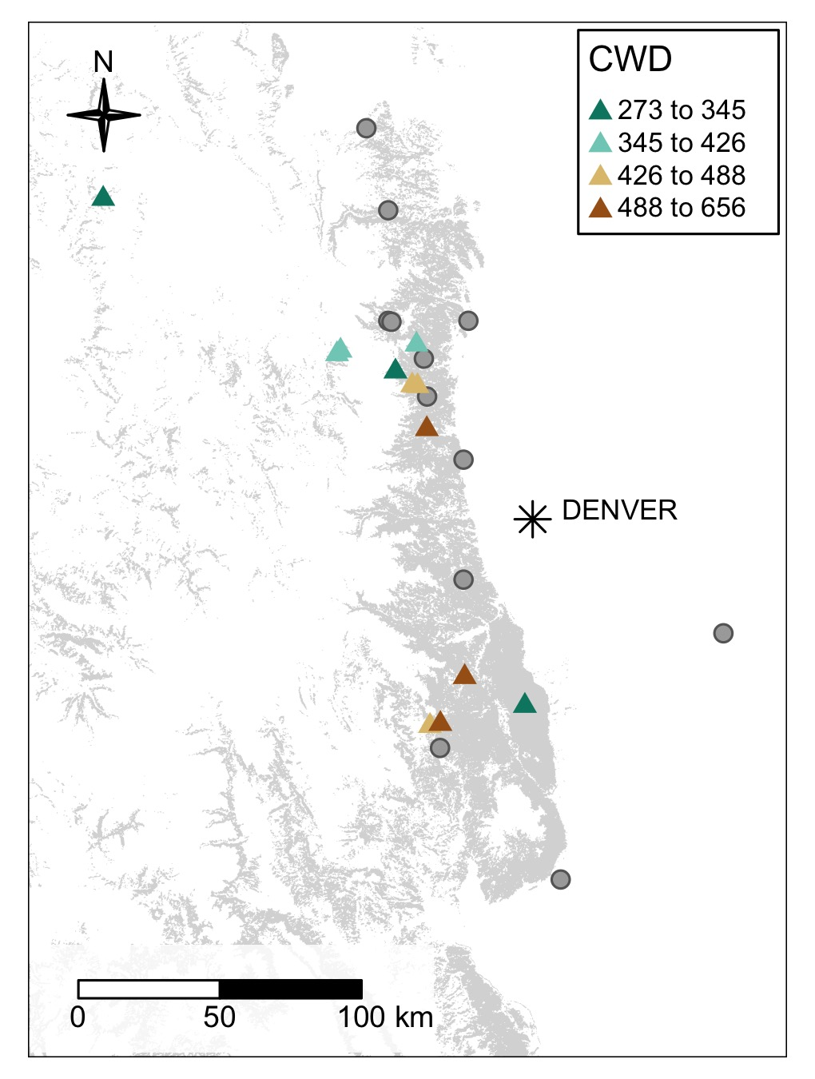

Figure 9: The study area and WSB reconstruction sample sites. The gray polygon illustrates the distribution of Douglas fir. Climatic water deficit (CWD) is average annual value in millimeters per year for the 1981-2010 period. The study area’s location relative to the contiguous western United States is shown in the inset map.

Table 2: Chronology statistics for host sites.

| Site ID | Site Name | No. Series | Interseries correlation | Autocorrelation | Citation |
| --- | --- | --- | --- | --- | --- |
| B18 | Boulder County 18 | 16 | 0.65 (sd=0.09) | 0.64 (sd=0.14) |  |
| B19 | Boulder County 19 | 22 | 0.54 (sd=0.13) | 0.79 (sd=0.09) |  |
| LJ | Lost Junction | 46 | 0.63 (sd=0.09) | 0.64 (sd=0.13) |  |
| SS | Sugarloaf Saddle | 40 | 0.66 (sd=0.1) | 0.6 (sd=0.15) |  |
| WR | W. Rd 211 | 17 | 0.67 (sd=0.1) | 0.57 (sd=0.17) |  |
| JP | Lost Jeep | 17 | 0.66 (sd=0.1) | 0.68 (sd=0.11) |  |
| WW | Wigwam I | 21 | 0.52 (sd=0.11) | 0.7 (sd=0.12) |  |
| SR | South Rd. 30 | 21 | 0.55 (sd=0.11) | 0.72 (sd=0.09) |  |
| NI | North Inlet | 26 | 0.47 (sd=0.12) | 0.8 (sd=0.1) |  |
| SP | Summerland Park | 31 | 0.58 (sd=0.14) | 0.76 (sd=0.13) |  |
| WB | Wild Basin | 28 | 0.51 (sd=0.11) | 0.78 (sd=0.1) |  |
| TI | Three Island Lake Trail | 22 | 0.59 (sd=0.08) | 0.77 (sd=0.09) |  |

Table 3: Site and chronology statistics for nonhost sites.

| Site ID | Site Name | Latitude (degrees) | Longitude (degrees) | Chronology length (years) | No. Series | Interseries correlation | Autocorrelation | Citation |
| --- | --- | --- | --- | --- | --- | --- | --- | --- |
| CO565 | Ridge Road | 39.380 | -104.200 | 1779-1998 | 16 | 0.6 (sd=0.07) | 0.75 (sd=0.08) |  |
| CO591 | Boulder Ridge Road | 40.980 | -105.670 | 1423-2001 | 36 | 0.64 (sd=0.06) | 0.71 (sd=0.12) |  |
| CO607 | Jamestown | 40.130 | -105.420 | 1364-2000 | 24 | 0.73 (sd=0.05) | 0.66 (sd=0.13) |  |
| CO611 | Meyer Ranch | 39.550 | -105.270 | 1553-2002 | 34 | 0.63 (sd=0.06) | 0.68 (sd=0.17) |  |
| CO622 | Rustic | 40.720 | -105.580 | 1436-2002 | 37 | 0.73 (sd=0.06) | 0.71 (sd=0.14) |  |
| CO639 | Happy Meadows | 39.017 | -105.367 | 1620-2003 | 29 | 0.75 (sd=0.06) | 0.56 (sd=0.19) |  |
| CO666 | Johnny Park | 40.250 | -105.433 | 1615-2001 | 29 | 0.69 (sd=0.06) | 0.7 (sd=0.13) |  |
| DMC | Deer Mountain | 40.370 | -105.580 | 1547-2000 | 52 | 0.74 (sd=0.07) | 0.74 (sd=0.15) |  |
| DRC | Deer Ridge | 40.367 | -105.567 | 1690-2007 | 45 | 0.71 (sd=0.09) | 0.63 (sd=0.16) |  |
| ECC | Eldorado Canyon | 39.930 | -105.270 | 1678-2007 | 38 | 0.63 (sd=0.09) | 0.71 (sd=0.16) |  |
| TCC | Turkey Creek Bluff | 38.600 | -104.870 | 1634-2003 | 46 | 0.78 (sd=0.05) | 0.62 (sd=0.15) |  |
| VBC | Van Bibber Creek | 40.370 | -105.250 | 1566-2007 | 62 | 0.69 (sd=0.08) | 0.67 (sd=0.14) |  |

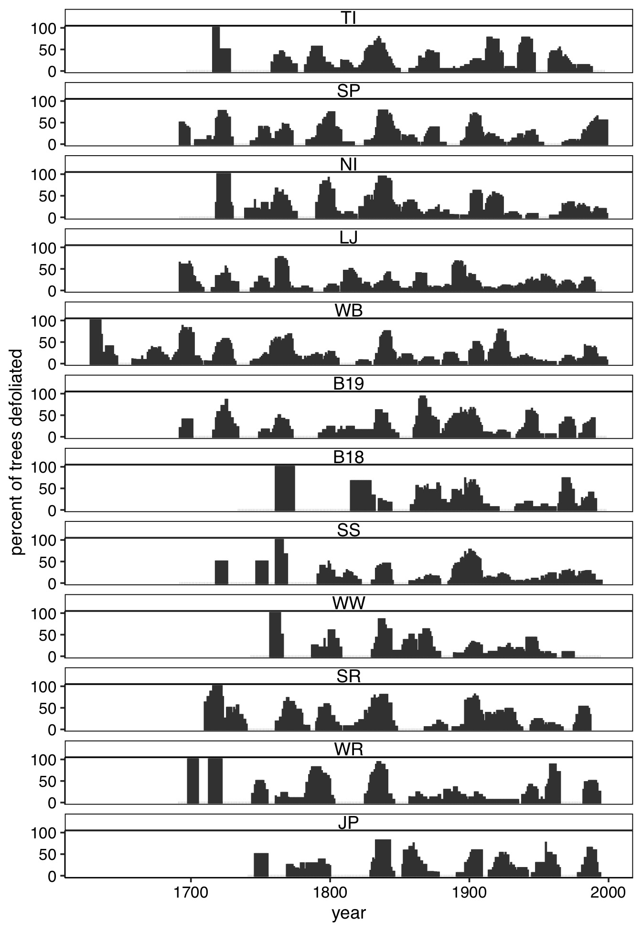

Figure 10: Site-level outbreak records expressed as the percent of trees recording an infestation.

Table 4: Summary of modelling results testing the effect of Euro-Americans on WSB outbreak dynamics and ecological effects .

| Response | Coefficient | p value |
| --- | --- | --- |
| occurence of years of outbreak | -0.180 | 0.324 |
| duration of outbreak | -0.146 | 0.112 |
| length of quiescent period | 0.016 | 0.939 |
| minimum normalized GSI during outbreak events | 0.132 | 0.271 |
| percent of trees defoliated at start of outbreak | -0.067 | 0.244 |

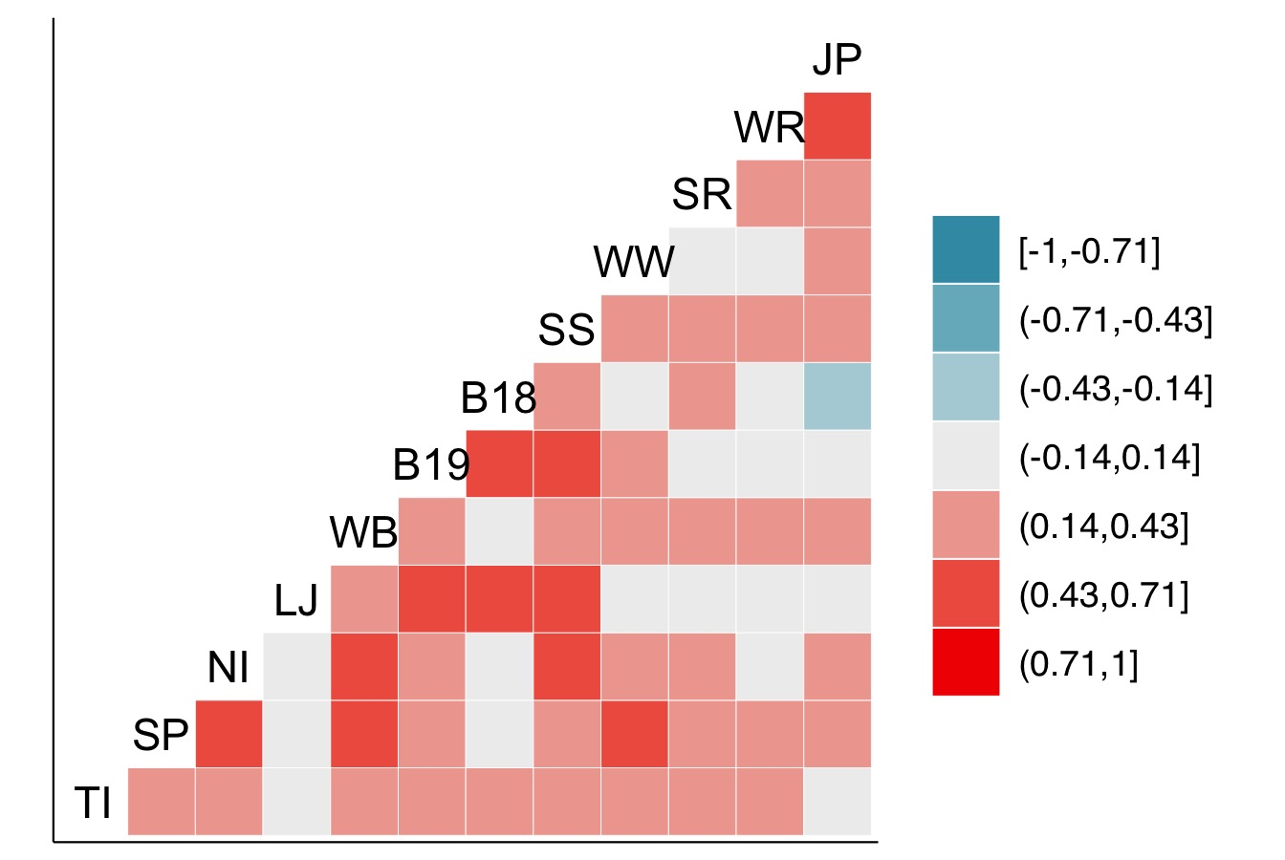

Figure 11: Pairwise Spearman’s correlation between time series of the percent of trees defoliated at each site.

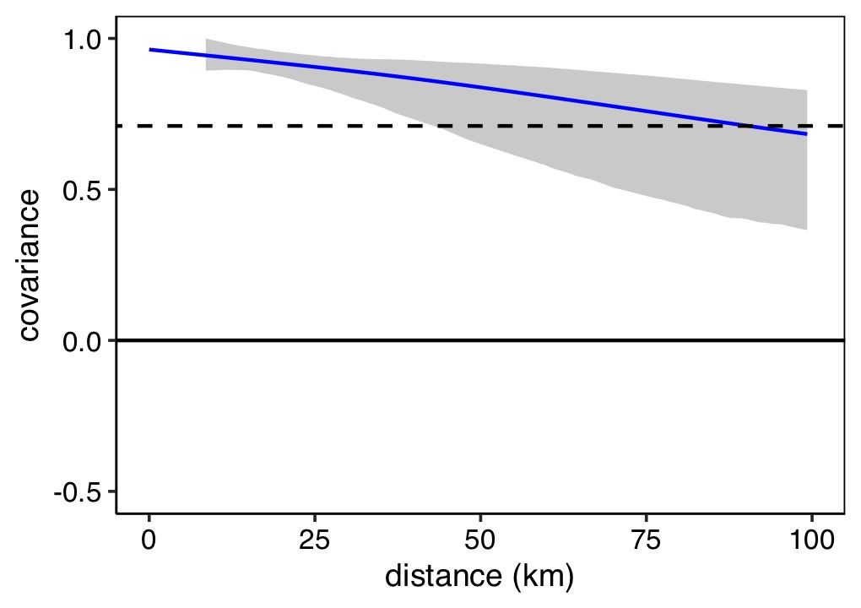

Figure 12: Nonparametric spatial covariance function describing the covarinace among times series SC-PDSI at all 12 sites across study area. SC-PDSI time series are derived from 4 x 4 km PRISM data for the period 1895-2022. Gray shading indicates the 95% confidence interval based on 1,000 bootstrap replications. The dashed horizontal line indicates the average correlation across the study area (regional synchrony)

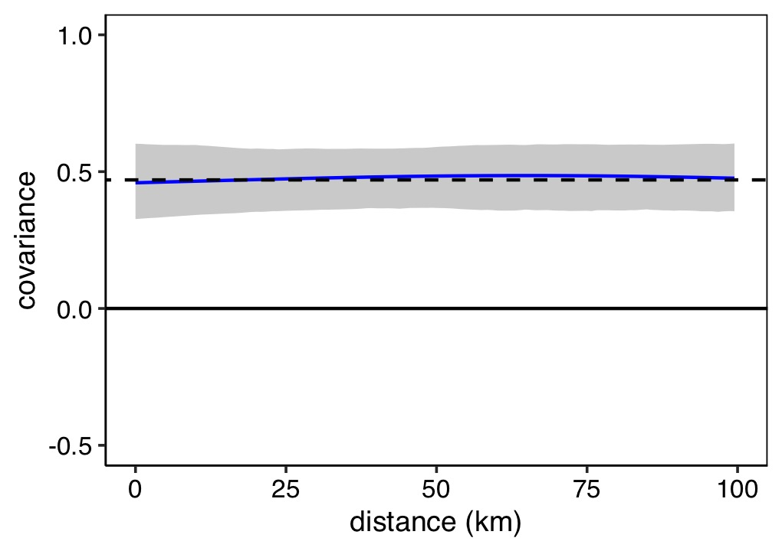

Figure 13: Nonparametric spatial covariance function describing the covarinace among the 12 drought-sensitive ponderosa pine chronologies used to reconstruct WSB histories. Gray shading indicates the 95% confidence interval based on 1,000 bootstrap replications. The dashed horizontal line indicates the average correlation across the study area (regional synchrony)

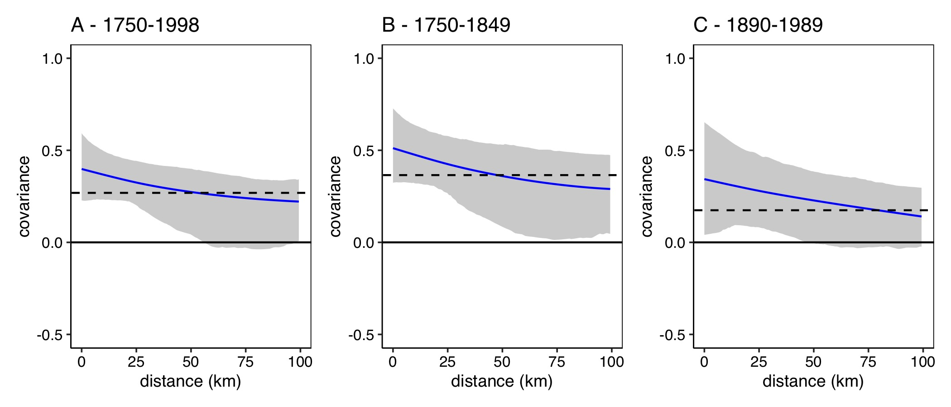

Figure 14: Nonparametric spatial covariance function describing the covarinace among time series of the percent of trees defoliated at site for the 1730-1998 and the centuries prior to and following extensive Euro-American settlement (1750-1848 and 1890-1989, respectively). Gray shading indicates the 95% confidence interval based on 1,000 bootstrap replications. The dashed horizontal line indicates the average correlation across the study area (regional synchrony)

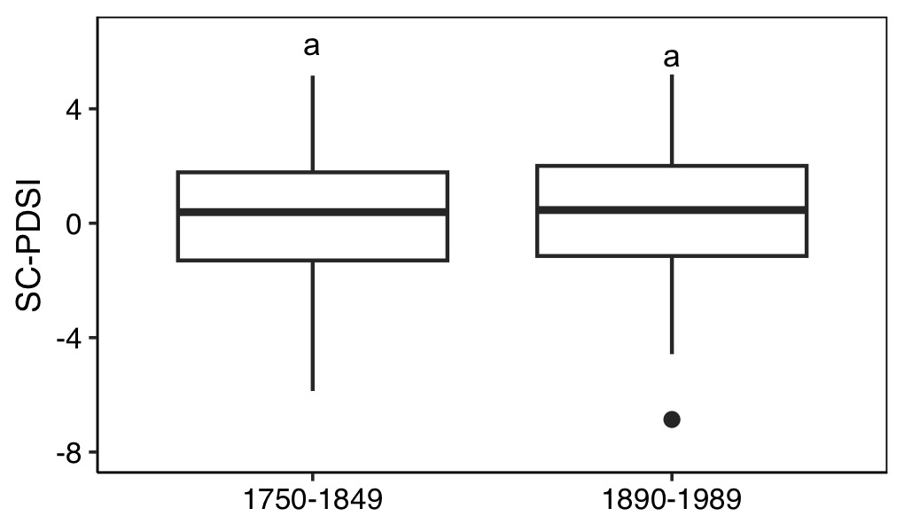

Figure 15: SC-PDSI values during the centuries prior to and following extensive Euro-American settlement (1750-1848 and 1890-1989, respectively). Letters above boxes indicate statistically significant differences. The bottom and top limits of each box are the lower and upper quartiles, respectively; the thick black line within the box is the median; error bars equal ±1.5 times the interquartile range; and points denote outliers, values outside ±1.5 times the interquartile range.

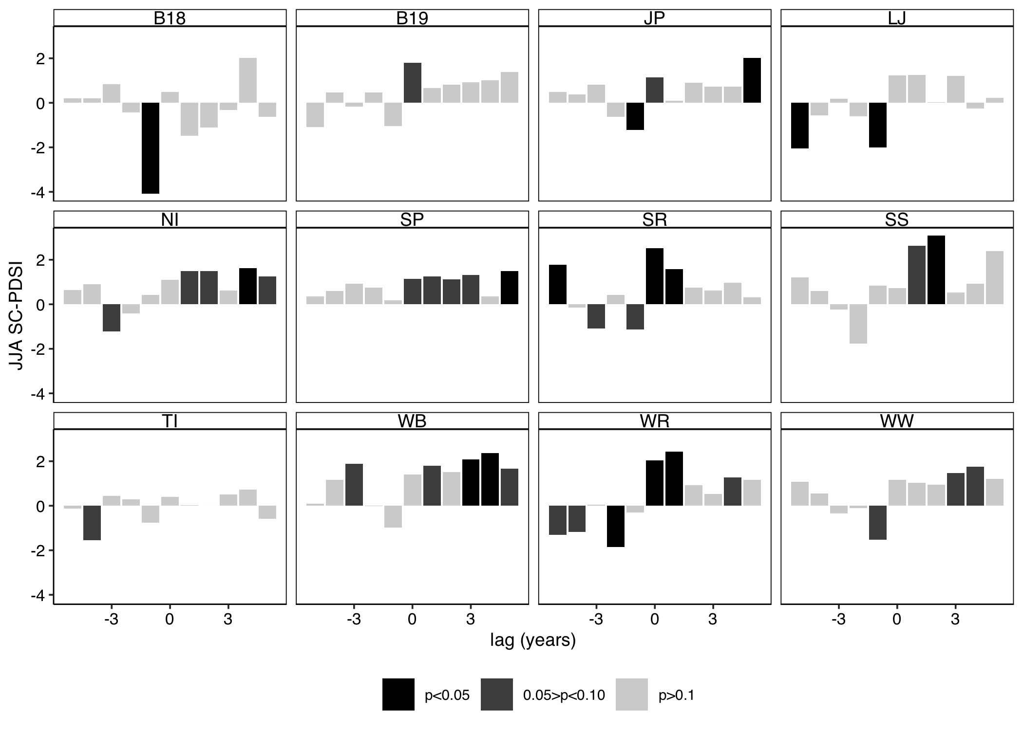

Figure 16: Superposed epoch analyses results illustrating the departure from the mean SC-PDSI for the years prior, during, and following outbreak initiation by site for the 1730-1998 period. Descending bars illustrate a negative association with SC-PDSI (i.e., drier conditions), ascending bars show a positive association with SC-PDSI (i.e., wetter conditions). Black bars indicate statistically significance at the 95% confidence interval.

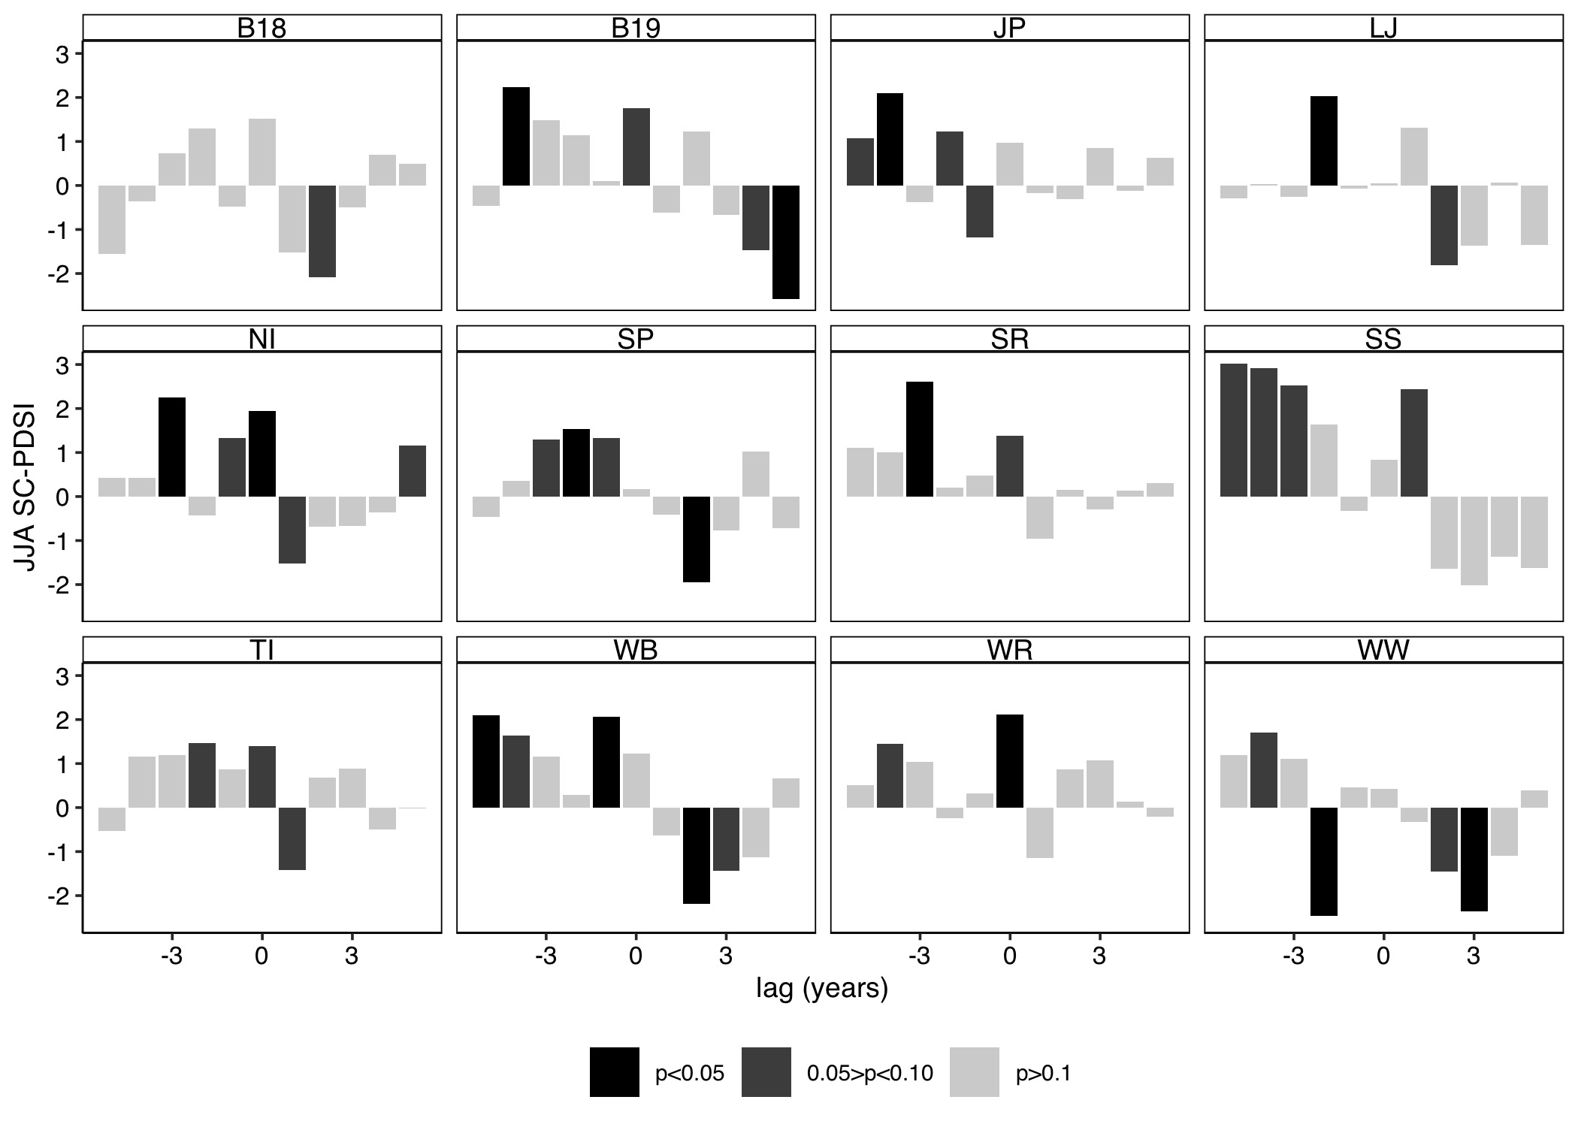

Figure 17: Superposed epoch analysis results illustrating the departure from the mean SC-PDSI for the years prior, during, and following outbreak cessation by site for the 1730-1998 period. Descending bars illustrate a negative association with SC-PDSI (i.e., drier conditions), ascending bars show a positive association with SC-PDSI (i.e., wetter conditions). Black bars indicate statistically significance at the 95% confidence interval.

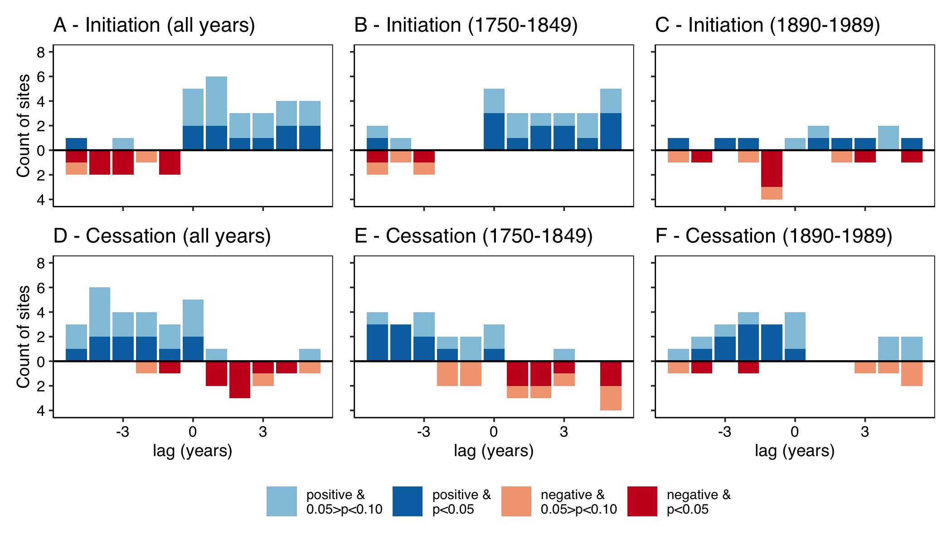

Figure 18: Summary of site-level superposed epoch analyses illustrating the association between SC-PDSI and outbreak initation (A-C) and cessation (D-E) for the 1730-1998 period and the centuries prior to and following extensive Euro-American settlement (1750-1848 and 1890-1989, respectively). Red descending bars illustrate the number of sites with a statitcally significant negative association with SC-PDSI (i.e., drier conditions), blue ascending bars show the number of sites with a statistically significant positive association with SC-PDSI (i.e., wetter conditions).

Table 5: Summary of linear models that tested if site climatic water deficit (CWD) was related to the departure from the mean SC-PDSI for the years prior, during, and following outbreak initiation.

| lag (years) | coefficient | standard error | p value |
| --- | --- | --- | --- |
| -5 | 0.000 | 0.001 | 0.771 |
| -4 | 0.001 | 0.001 | 0.497 |
| -3 | 0.000 | 0.001 | 0.803 |
| -2 | -0.001 | 0.001 | 0.197 |
| -1 | -0.001 | 0.001 | 0.329 |
| 0 | 0.000 | 0.001 | 0.984 |
| 1 | 0.000 | 0.001 | 0.947 |
| 2 | 0.000 | 0.001 | 0.714 |
| 3 | 0.000 | 0.001 | 0.842 |
| 4 | 0.001 | 0.001 | 0.455 |
| 5 | 0.001 | 0.001 | 0.246 |

Table 6: Summary of linear models that tested if site climatic water deficit (CWD) was related to the departure from the mean SC-PDSI for the years prior, during, and following outbreak cessation.

| lag (years) | coefficient | standard error | p value |
| --- | --- | --- | --- |
| -5 | 0.001 | 0.001 | 0.446 |
| -4 | 0.001 | 0.001 | 0.214 |
| -3 | -0.001 | 0.001 | 0.428 |
| -2 | -0.002 | 0.002 | 0.138 |
| -1 | -0.002 | 0.001 | 0.068 |
| 0 | -0.001 | 0.001 | 0.474 |
| 1 | 0.001 | 0.001 | 0.327 |
| 2 | -0.001 | 0.001 | 0.494 |
| 3 | -0.002 | 0.001 | 0.229 |
| 4 | -0.001 | 0.001 | 0.433 |
| 5 | 0.000 | 0.001 | 0.819 |

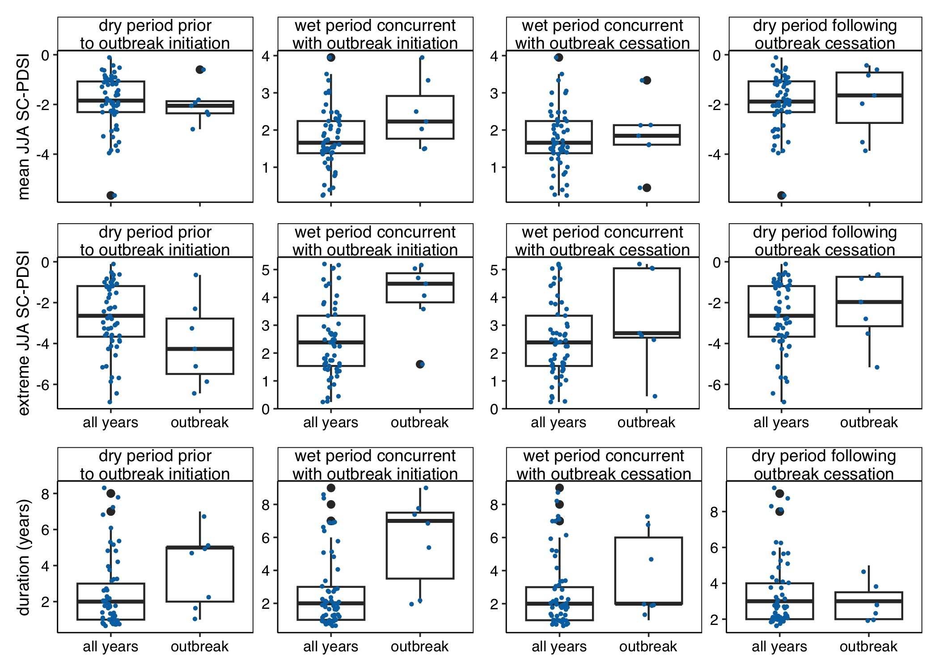

Figure 19: Climate conditions in the dry period prior and wet period coincident with periods of regional outbreak relative to all periods of above average moisture availability.

Table 7: Results of t-tests comparing the climate conditions in the dry period prior and wet period coincident outbreak initaiton with all periods of above average moisture availability.

| Period | Metric | t-statistic | p-value |
| --- | --- | --- | --- |
| wet period concurrent with outbreak initiation | mean JJA SC-PDSI | 1.83 | 0.11 |
| wet period concurrent with outbreak initiation | extreme JJA SC-PDSI | 3.28 | 0.01 |
| wet period concurrent with outbreak initiation | duration (years) | 2.77 | 0.03 |
| dry period prior to outbreak initiation | mean JJA SC-PDSI | -0.33 | 0.75 |
| dry period prior to outbreak initiation | extreme JJA SC-PDSI | -1.59 | 0.16 |
| dry period prior to outbreak initiation | duration (years) | 1.59 | 0.15 |
| wet period concurrent with outbreak cessation | mean JJA SC-PDSI | 0.30 | 0.77 |
| wet period concurrent with outbreak cessation | extreme JJA SC-PDSI | 1.29 | 0.24 |
| wet period concurrent with outbreak cessation | duration (years) | 1.04 | 0.33 |
| dry period following outbreak cessation | mean JJA SC-PDSI | 0.15 | 0.88 |
| dry period following outbreak cessation | extreme JJA SC-PDSI | 0.68 | 0.52 |
| dry period following outbreak cessation | duration (years) | -0.81 | 0.43 |

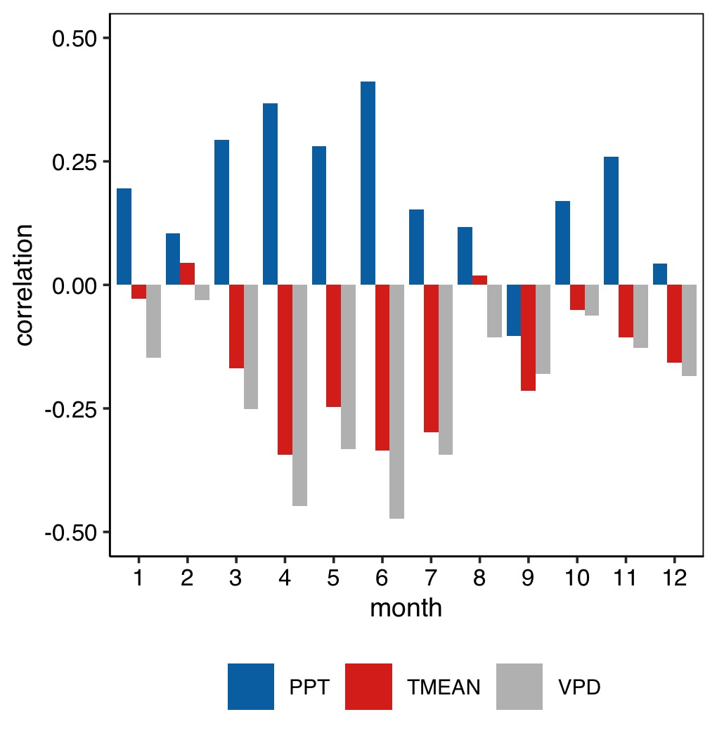

Figure 20: The correlation between regional time series of summer SC-PDSI and monthly total precipitation (PPT), mean daily temperature (TMEAN), and maximum daily vapour presssure deficit (VPD) (1895-2022).

# Appendix B

Table 8: Published periods of WSB outbreak in Colorado.

| Start | End | Duration (years) | Study area | Source |
| --- | --- | --- | --- | --- |
| 1,938 | 1,945 | 7 | Colorado Front Range | Hadley and Veblen 1992 |
| 1,974 | 1,985 | 11 | Colorado Front Range | Hadley and Veblen 1992 |
| 1,720 | 1,730 | 10 | Pike NF, Colorado | Swetnam and Lynch 1989 |
| 1,748 | 1,765 | 17 | Pike NF, Colorado | Swetnam and Lynch 1989 |
| 1,760 | 1,770 | 10 | Roosevelt NF, Colorado | Swetnam and Lynch 1989 |
| 1,792 | 1,802 | 10 | San Isabel NF, Colorado | Swetnam and Lynch 1989 |
| 1,795 | 1,819 | 24 | Roosevelt NF, Colorado | Swetnam and Lynch 1989 |
| 1,796 | 1,803 | 7 | Pike NF, Colorado | Swetnam and Lynch 1989 |
| 1,821 | 1,823 | 2 | Roosevelt NF, Colorado | Swetnam and Lynch 1989 |
| 1,821 | 1,830 | 9 | San Isabel NF, Colorado | Swetnam and Lynch 1989 |
| 1,830 | 1,838 | 8 | Pike NF, Colorado | Swetnam and Lynch 1989 |
| 1,834 | 1,839 | 5 | Roosevelt NF, Colorado | Swetnam and Lynch 1989 |
| 1,848 | 1,868 | 20 | Pike NF, Colorado | Swetnam and Lynch 1989 |
| 1,865 | 1,872 | 7 | Roosevelt NF, Colorado | Swetnam and Lynch 1989 |
| 1,873 | 1,881 | 8 | Roosevelt NF, Colorado | Swetnam and Lynch 1989 |
| 1,881 | 1,885 | 4 | Pike NF, Colorado | Swetnam and Lynch 1989 |
| 1,886 | 1,893 | 7 | Roosevelt NF, Colorado | Swetnam and Lynch 1989 |
| 1,890 | 1,910 | 20 | Pike NF, Colorado | Swetnam and Lynch 1989 |
| 1,890 | 1,911 | 21 | San Isabel NF, Colorado | Swetnam and Lynch 1989 |
| 1,935 | 1,949 | 14 | San Isabel NF, Colorado | Swetnam and Lynch 1989 |
| 1,942 | 1,969 | 27 | Roosevelt NF, Colorado | Swetnam and Lynch 1989 |
| 1,942 | 1,956 | 14 | Pike NF, Colorado | Swetnam and Lynch 1989 |
| 1,972 | 1,985 | 13 | San Isabel NF, Colorado | Swetnam and Lynch 1989 |
| 1,977 | 1,985 | 8 | Roosevelt NF, Colorado | Swetnam and Lynch 1989 |
| 1,977 | 1,985 | 8 | Pike NF, Colorado | Swetnam and Lynch 1989 |
| 1,739 | 1,745 | 6 | Front Range, Colorado | Weber and Schweingruber 1995 |
| 1,794 | 1,801 | 7 | Front Range, Colorado | Weber and Schweingruber 1995 |
| 1,830 | 1,839 | 9 | Front Range, Colorado | Weber and Schweingruber 1995 |
| 1,845 | 1,851 | 6 | Front Range, Colorado | Weber and Schweingruber 1995 |
| 1,861 | 1,865 | 4 | Front Range, Colorado | Weber and Schweingruber 1995 |
| 1,870 | 1,875 | 5 | Front Range, Colorado | Weber and Schweingruber 1995 |
| 1,885 | 1,893 | 8 | Front Range, Colorado | Weber and Schweingruber 1995 |
| 1,944 | 1,946 | 2 | Front Range, Colorado | Weber and Schweingruber 1995 |
| 1,600 | 1,623 | 23 | Rio Grande NF, Colorado | Ryerson et al. 2003 |
| 1,650 | 1,671 | 21 | Rio Grande NF, Colorado | Ryerson et al. 2003 |
| 1,671 | 1,685 | 14 | Rio Grande NF, Colorado | Ryerson et al. 2003 |
| 1,689 | 1,703 | 14 | Rio Grande NF, Colorado | Ryerson et al. 2003 |
| 1,715 | 1,735 | 20 | Rio Grande NF, Colorado | Ryerson et al. 2003 |
| 1,753 | 1,778 | 25 | Rio Grande NF, Colorado | Ryerson et al. 2003 |
| 1,785 | 1,805 | 20 | Rio Grande NF, Colorado | Ryerson et al. 2003 |
| 1,810 | 1,824 | 14 | Rio Grande NF, Colorado | Ryerson et al. 2003 |
| 1,825 | 1,846 | 21 | Rio Grande NF, Colorado | Ryerson et al. 2003 |
| 1,849 | 1,876 | 27 | Rio Grande NF, Colorado | Ryerson et al. 2003 |
| 1,881 | 1,898 | 17 | Rio Grande NF, Colorado | Ryerson et al. 2003 |
| 1,903 | 1,932 | 29 | Rio Grande NF, Colorado | Ryerson et al. 2003 |
| 1,936 | 1,952 | 16 | Rio Grande NF, Colorado | Ryerson et al. 2003 |
| 1,960 | 1,977 | 17 | Rio Grande NF, Colorado | Ryerson et al. 2003 |
| 1,984 | 1,997 | 13 | Rio Grande NF, Colorado | Ryerson et al. 2003 |