**GOOD AND BAD DATA VISUALIZATION**

**(Anik Das)**

**Bad Data:**

Figure Source: https://towardsdatascience.com/why-is-this-chart-bad-5f16da298afa

**Problems**: 1. Too many data variables 2. Colors not distinguishable

**Good Data:** Easier to understand, enough space

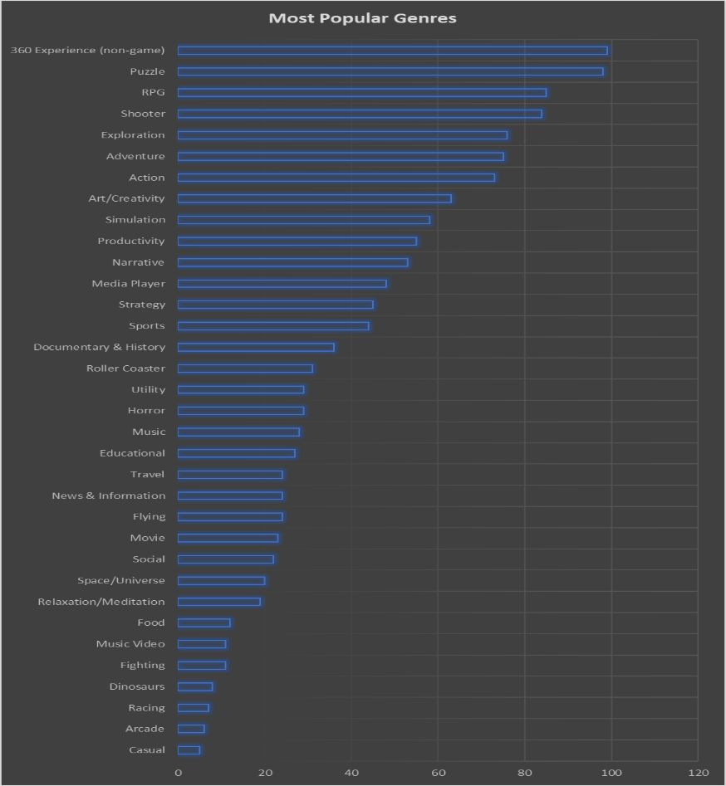

Figure Source: https://www.polymersearch.com/blog/10-good-and-bad-examples-of-data-visualization