Best Neighborhood for Starting Restaurant in Tokyo

Hasan uz zaman

May 17, 2020

# **Introduction**

Japan is one of the leading technologically advanced and civilized countries of the world. And Tokyo is the heart of Japan. Tokyo is a diverse city with a blend of different cultures, history and races. Beside japanese , many people from outside japan are living and working and leading a healthy life. Tokyo is the largest metropolitan area in the world. Around 35 million people live here. Tokyo is famous for many things such as anime, electronics, video games, food items etc. In this report , we will talk about food. Food is an essential part for the residents of Tokyo. Famous food items that Tokyo is known for are Edomae-zushi, Monjayaki, Ramen, Tempura, Tendon, Soba etc . There are also food items like indian, chinese, steak, fries, kababs, fried chicken, burgers etc can be found in Tokyo. All these food items are made and presented by different japanese restaurants, indian restaurants, global food chain shops like starbucks, mcdonalds.

**Problem:** There are many neighborhoods in Tokyo. Different types of restaurants and food shops number varys Neighborhood to Neighborhood. In some neighborhoods, there are many japanese restaurants compared to other types of cuisine restaurants and there also exist other neighborhoods where the picture is the exact opposite. So it's not easy to determine where to start a new restaurant in the right neighborhood where the restaurant will make good business and make good profit. This problem is for businessmen or shop owners or new startup platforms who want to find a suitable neighborhood to start their restaurant business.

**Solution To Problem:** So to start a new restaurant in a particular neighborhood or to start a specific type of restaurant, we have to analyze the neighborhoods data related to its restaurants and food shops with machine learning and data science to determine best possible suited neighborhoods to start a restaurant.

# **Data Collection and analyze**

To solve our given problem, the 2nd step is to collect data or data acquisition. For this step, we need to collect data about different neighborhoods of Tokyo. Tokyo is a big city with over 50 plus neighborhoods, So first thing we have to do is to collect the names of neighborhoods in Tokyo city. As there is no prepared list or table containing the names of Tokyo’s neighborhoods on the internet or any website, we have to make a table containing neighborhoods of Tokyo city. We create a google sheet and on that sheet we will list the neighborhoods as a table under label Neighborhood. The names of the neighborhoods are taken from the link : [https://en.wikipedia.org/wiki/Category:Neighborhoods_of_Tokyo](https://en.wikipedia.org/wiki/Category:Neighborhoods_of_Tokyo%E2%80%9D.It%E2%80%99s). It’s a wikipedia page containing all the neighborhood's names. After putting neighborhoods names on the table, we need two more columns to add. The columns will contain each neighborhood’s corresponding latitude and longitude. We can obtain the coordinates of neighborhoods using Google or Foursquare location service. We have to put the right coordinates to the right neighborhood. After finishing the task , finally our neighborhood table is ready. Since we can not use excel sheets directly on our machine learning process, we first need to convert the excel file into a csv file. We will use google’s colaboratory for machine learning or data analysis environment to solve our given problem. In colaboratory, we will first import our essential libraries like pandas, numpy, matplotlib, sklearn, etc to make our environment ready for work. Then we will create a dataframe and in that dataframe, we will load our csv file that we made on Tokyo’s neighborhoods data. Now our data frame is ready for further work.

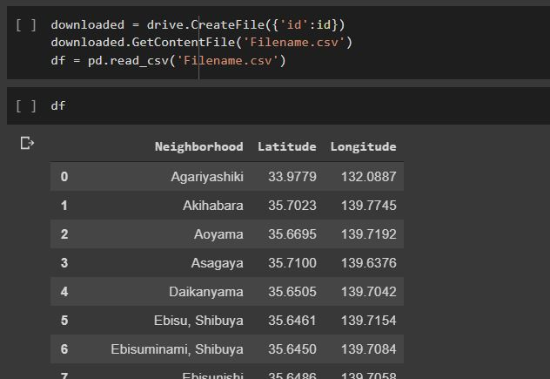

We will use location service Foursquare to extract data about the venues of all the neighborhoods using latitude and longitude of Neighborhoods and using those data, we will find our solution to the given problem. We will discuss the later process in the next section.