***حسن عبد الهادي   
حسنين صاحب   
نور ستار***

*Cosmetic store website*

**1.0-INTRODUCTION:**

Nowadays the internet became one of the most important sector in the world, the internet has changed the way that the people look at life and business, shopping throw the internet became common thing and a lot of people prefer to buy throw the internet due to the easy way fined what u looking for with the ability to do it at any time and from anywhere.

**2.0-PROBLEM STATEMENT:**

We wish to make shopping as far as one click from our hand, so anyone who wants to buy from the store can access it throw the internet at any time and wherever having access to the world web.

This system will have a large impact on the shopping process by give the ability for reliably update data and the possibility to take action on trigger events and Enhance the time that was take to manage the data as well as the time that was need to retrieve the data, and making the shopping more arrange between the branches and more easy to update.

**What is online shopping?**

If the customer need to buy a piece of jewelry, the customer should go to the shop by him/her self and buy the jewelry.

The project helps the shop to do the purchase process in easier and faster way and also can save the time and money. This system will allow the customers to do all the operation such as search and buying, and finally know about the special offers.

**3.0-OBJECTIVES:**

The aim of this project is to prepare the best way to purchase for customers with the easiest way and the pest price can offer. The system will allow the customers to search for the most possible prices anywhere and anytime. This is one of the biggest advantages of online shopping because the customer will have the peace of mind if they know that their received the best price by buying from online system.

By butting the system online, shopping will be available 24 hour 7 days a week and dealing with it anywhere and the customers can do directly anywhere and there is no need to go to the shop.

The system will provide great benefit for the shop by decrease the member of employees which the shop needed and as consequence well need to less physical space less bills and less rent for office which is the company needed.

less bills and less rent for office which is the shop needed. They processes of information will be more quickly than use manually system. However, The systems can do the same task repeatedly without getting bored, without break time or mistakes. The system can generated a lot of kind of helpful reports for help the company to make its decisions.

**4.0-SCOPE OF STUDY:**

The scope of this study will cover customer services to how to shop by using online shopping system. The system is online website which allows the customer to buy Cosmetics, after entering the system the customer can search items; customer can select the item and order it.

The system also decrease the company work ,which allow the staff to control the day by day operation with easy way , manager can manage the system such as add new item ,delete an item, edit it ,make the price for each one.

**5.0-LIST OF REQUIREMENTS**:

|  |
| --- |
| Listed below are the functional requirements and non-functional requirement of the system. In the priority column, the following short hands are used: ▪ M – mandatory requirements (something the system must do) ▪ D – desirable requirements (something the system preferably should do) ▪ O – optional requirements (something the system may do) **5.1. FUNCTIONAL REQUIREMENTS** |

|  |  |  |  |
| --- | --- | --- | --- |
| **No.** | **Requirement ID** | **Requirement Description** | **Priority** |
| 1 | **CSW _01** | **Search** |  |
|  | **CSW** _01_01 | Site must have a search engine to navigate through the items | M |
| 2 | **CSW** _01_02 | Customer must type the name of the item that he/she is looking for | M |
|  | | | |
| 3 | **CSW _02** | **Order** |  |
| 4 | **CSW** _02_01 | Customer can order any item if the item available | M |
| 5 | **CSW** _02_02 | Customer must enter his/her information (name, address and phone number) | M |
|  | | | |
| 6 | **CSW _03** | **Cancel Order** |  |
| 7 | **CSW** _03_01 | Customer can cancel an order | O |
|  | | | |
| 8 | **CSW _04** | **Login (**Administrator**)** |  |
| 9 | **CSW** _04_01 | Administrators have accounts and can login | M |
|  | | | |
| 10 | **CSW _05** | **Add item** |  |
| 11 | **CSW** _05_01 | Administrators can add items to the site | M |
|  | | | |
| 12 | **CSW _06** | **Edit Item** |  |
| 13 | **CSW** _06_01 | Administrators canedit an existing item | M |
|  | | | |
| 14 | **CSW _07** | **Delete Item** | M |
| 15 | **CSW** _06_02 | Administrators candelete an item | D |

**5.2.NON- FUNCTIONAL REQUIREMENTS**:

|  |  |  |  |
| --- | --- | --- | --- |
| **Priority** | **Requirement Description** | **Requirement ID** | **No.** |
|  | **Reliability issues** | **CSW _08** | **13** |
| **M** | If the system should crash no more than once per 24 hours. | **CSW _08­_1** | **14** |
| **M** | If the system has been crashed, it should not be more than 20 Minutes | **CSW _08­_2** | **15** |
|  | If the systems has been crashed, it should behave perfectly normal when reloaded again | **CSW _08­_3** | **16** |
|  | | | |
|  | **Usability issues** | **CSW _09** | **17** |
| **M** | That means we should make sure that the system stay working smoothly without any interruption. | **CSW _09_1** | **18** |
|  | | | |
|  | **Security issues** | **CSW _10** | **19** |
| **M** | Only Administrator will be able to enter the system to make maintenance. | **CSW _10_1** | **20** |
|  | | | |
|  | **Performance** | **CSW _11** | **21** |
| **M** | The system must have a high speed of manipulation data and reply to the user request. | **CSW _11_1** | **22** |

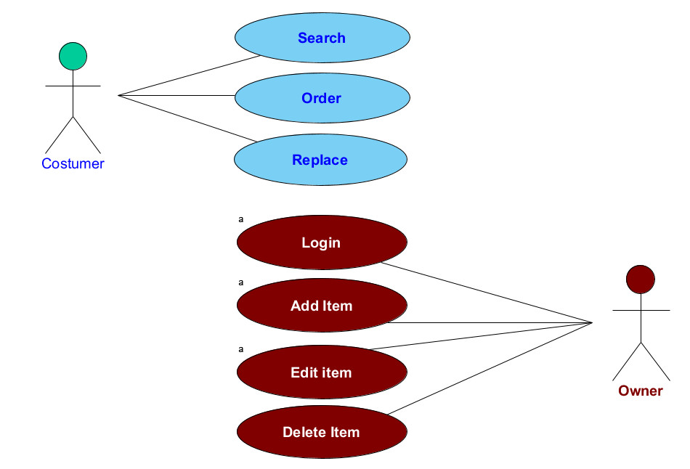**6.0-USE CASE DIAGRAM FOR CSW:**

**Cancel Order**

**7.0-USE CASE: SEARCH (CSW_01):**



**Search**

**Customer**

**7.1 BREIF DESCRIPTION (CSW_01_01)**:

User initiates this use case. This use case will enable the user to search through the database of items by entering the name of the item.

**7.2 PRE-CONDITIONS (CSW_01_02)**

Not applicable.

**7.3 CHARACTERISTIC OF ACTIVATION (CSW_01_03)**

Event-driven (on user’s choice).

**7.4 FLOW OF EVENTS (CSW_01_04)**

**7.4.1 BASIC FLOW (CSW_01_04_01)**:

* + The use case begins when the user enters the main page.
  + The user types an item name and hit search button.
  + The system will show the result of that search.

**7.4.2 ALTERNATIVE FLOW (CSW_01_04_02)**

Not applicable.

**7.4.3 EXCEPTIONAL FLOW (CSW_01_04_03)**

**[E-1: Item does not exist]**

* The system will show (Item does not exist) message if the item does not exist in the database.
* The system will return to main page.

**7.5 POST-CONDITIONS (CSW_01_05)**

Not applicable

**7.6 RULE(S) (CSW_01_06)**

Not applicable.

**7.7 CONSTRAINT(S) (CSW_01_07)**

Not applicable

**8.0-USE CASE: ORDER (CSW_02):**



**Order**

**Customer**

**8.1 BREIF DESCRIPTION (CSW_02_01)**:

The user initiates this use case. This use case enables the costumer to order an item.

**8.2 PRE-CONDITIONS (CSW_02_02)**

* The costumer selects an Item first.
* The item must exist and be available.

**8.3 CHARACTERISTIC OF ACTIVATION (CSW_02_03)**

Event-driven (on user’s choice).

**8.4 FLOW OF EVENTS (CSW_02_04)**

**8.4.1 BASIC FLOW (CSW_02_04_01)**:

* + The use case begins when the user selects an item.
  + The user hits order button.
  + The system will show a dialog.
  + The user will enter his/her information and address.
  + The user will press (order now) button.

**8.4.2 ALTERNATIVE FLOW (CSW_02_04_02)**

Not applicable.

**8.4.3 EXCEPTIONAL FLOW (CSW_02_04_03)**

**[E-1: Item is not available]**

* The system will show (Item is not available) message if the item is not available.
* The system will return to main page.

**8.5 POST-CONDITIONS (CSW_02_05)**

Not applicable

**8.6 RULE(S) (CSW_02_06)**

Not applicable.

**8.7 CONSTRAINT(S) (CSW_02_07)**

Not applicable

**9.0-USE CASE: CANCEL ORDER (CSW_03):**



**Customer**

**Cancel order**

**9.1 BREIF DESCRIPTION (CSW_03_01)**:

The user initiates this use case. This use case enables the costumer to cancel a previous order.

**9.2 PRE-CONDITIONS (CSW_03_02)**

The costumer must have ordered an Item before.

**9.3 CHARACTERISTIC OF ACTIVATION (CSW_03_03)**

Event-driven (on user’s choice).

**9.4 FLOW OF EVENTS (CSW_03_04)**

**9.4.1 BASIC FLOW (CSW_03_04_01)**:

* + The use case begins when the user press (cancel an order) button.
  + The system will show an order cancellation window.
  + The user will type the number of the order.
  + The user will press (cancel order now) button.

**9.4.2 ALTERNATIVE FLOW (CSW_03_04_02)**

Not applicable.

**9.4.3 EXCEPTIONAL FLOW (CSW_03_04_03)**

**[E-1: Order cannot be canceled]**

* The system will show (**Order cannot be canceled**) cannot be canceled.
* The system will return to main page.

**9.5 POST-CONDITIONS (CSW_03_05)**

Not applicable

**9.6 RULE(S) (CSW_03_06)**

Not applicable.

**9.7 CONSTRAINT(S) (CSW_03_07)**

The order can be canceled within 6 hours from the time of order.

**10.0-USE CASE: LOGIN (ADMIN) (CSW_04):**



**Admin**

**Login**

**10.1 BREIF DESCRIPTION (CSW_04_01)**:

The admin initiates this use case. This use case will enable the admin to login into the system

**10.2 PRE-CONDITIONS (CSW_04_02)**

The person must be a registered admin in order for him/her to login to the system.

**10.3 CHARACTERISTIC OF ACTIVATION (CSW_04_03)**

Event-driven (on admin’s choice).

**10.4 FLOW OF EVENTS (CSW_04_04)**

**10.4.1 BASIC FLOW (CSW_04_04_01)**:

• This use case begin when the admin enter the main page and press (login here) button.  
• The system will display login form.  
• The user enters the ID and Password and press “login” button. [A-1: Forget ID Password ]  
• The system will retrieve the ID & Password from database.  
• The system will verify ID & Password [E-1: wrong ID & Password].  
• System will display main page.

**10.4.2 ALTERNATIVE FLOW (CSW_04_04_02)**

**[A-1: Forget Id & Password]**• Press “forget password “ button.  
• The system show password recovery page.  
• The admin should enter his /her e-mail.  
• The admin will press “retrieve password “button.  
• The system retrieve admin E-mail from database.  
• The system will verify user E-mail(E-1 :A-1 :E-mail not exist ).  
• The system will send ID & Password by e-mail and display retrieve successful page.

**10.4.3 EXCEPTIONAL FLOW (CSW_04_04_03)**

**[E-1:A-1:E-Mail Not Exist]**

The system will show error message “E-mail not exist “and display the main page.

**10.5 POST-CONDITIONS (CSW_04_05)**

The user Login to the system.

**10.6 RULE(S) (CSW_04_06)**

Not applicable.

**10.7 CONSTRAINT(S) (CSW_04_07)**

The user must enter the correct user name and password.

**11.0-USE CASE: ADD ITEM (ADMIN) (CSW_05):**



**Add item**

**Admin**

**11.1 BREIF DESCRIPTION (CSW_05_01)**:

The admin initiates this use case. This use case will enable the admin to add an item to the database.

**11.2 PRE-CONDITIONS (CSW_05_02)**

The person must be a registered admin in order for him/her to add an item to the system.

**11.3 CHARACTERISTIC OF ACTIVATION (CSW_05_03)**

Event-driven (on admin’s choice).

**11.4 FLOW OF EVENTS (CSW_05_04)**

**11.4.1 BASIC FLOW (CSW_05_04_01)**:

* + The use case begins when the admin press (Add Item) button.
  + The system will show an add item window.
  + The admin will enter the new item information along with its picture.
  + The admin will press (add now) button.

**11.4.2 ALTERNATIVE FLOW (CSW_05_04_02)**

Not applicable.

**11.4.3 EXCEPTIONAL FLOW (CSW_05_04_03)**

Not applicable

**11.5 POST-CONDITIONS (CSW_05_05)**

The Item is added to the database.

**11.6 RULE(S) (CSW_05_06)**

Not applicable.

**11.7 CONSTRAINT(S) (CSW_05_07)**

Not applicable.

**12.0-USE CASE: EDIT ITEM (ADMIN) (CSW_06):**



**Admin**

**Edit Item**

**12.1 BREIF DESCRIPTION (CSW_06_01)**:

The admin initiates this use case. This use case will enable the admin to edit an existing item.

**12.2 PRE-CONDITIONS (CSW_06_02)**

The person must be a registered admin in order for him/her to edit an item to the system.

**12.3 CHARACTERISTIC OF ACTIVATION (CSW_06_03)**

Event-driven (on admin’s choice).

**12.4 FLOW OF EVENTS (CSW_06_04)**

**12.4.1 BASIC FLOW (CSW_06_04_01)**:

* + The use case begins when the admin press (Edit Item) button.
  + The system will ask for item id.
  + The system will show edit window.
  + The admin will enter the new information.
  + The admin will press (Done) button.

**12.4.2 ALTERNATIVE FLOW (CSW_06_04_02)**

Not applicable.

**12.4.3 EXCEPTIONAL FLOW (CSW_06_04_03)**

Not applicable

**12.5 POST-CONDITIONS (CSW_06_05)**

The Item is edited.

**12.6 RULE(S) (CSW_06_06)**

Not applicable.

**12.7 CONSTRAINT(S) (CSW_06_07)**

Not applicable.

**13.0-USE CASE: DELETE ITEM (ADMIN) (CSW_07):**



**Delete Item**

**Admin**

**13.1 BREIF DESCRIPTION (CSW_07_01)**:

The admin initiates this use case. This use case will enable the admin to delete an existing item.

**13.2 PRE-CONDITIONS (CSW_07_02)**

The person must be a registered admin in order for him/her to edit an existing item.

**13.3 CHARACTERISTIC OF ACTIVATION (CSW_07_03)**

Event-driven (on admin’s choice).

**13.4 FLOW OF EVENTS (CSW_07_04)**

**13.4.1 BASIC FLOW (CSW_07_04_01)**:

* + The use case begins when the admin press (delete Item) button.
  + The system will ask for item id.
  + The system will show a confirm window.
  + The admin will press (Yes) button.

**13.4.2 ALTERNATIVE FLOW (CSW_07_04_02)**

Not applicable.

**13.4.3 EXCEPTIONAL FLOW (CSW_07_04_03)**

Not applicable

**13.5 POST-CONDITIONS (CSW_07_05)**

The Item is deleted.

**13.6 RULE(S) (CSW_07_06)**

Not applicable.

**13.7 CONSTRAINT(S) (CSW_07_07)**

Not applicable.

**14.0- ACTIVITY DIAGRAM FOR CSW**

The activity diagram for CSW will present each use case by the following**:**

**14.1-Order an Item:**

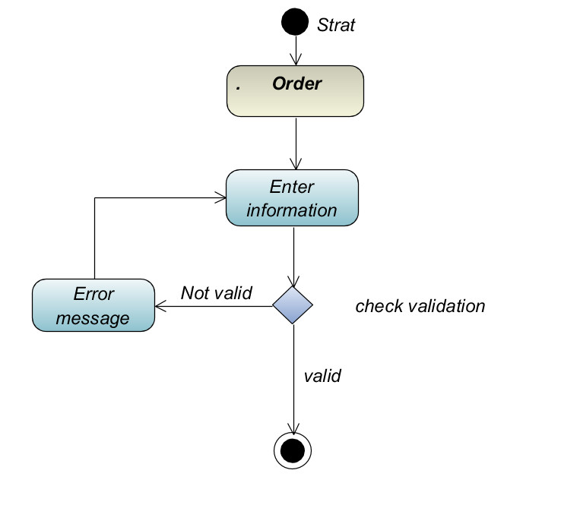

**14.2- Search:**

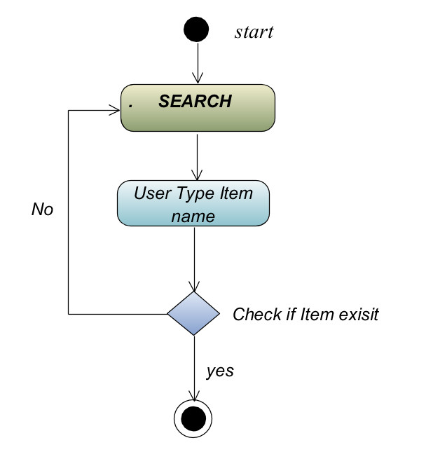

**14.3-Cancel an Order:**

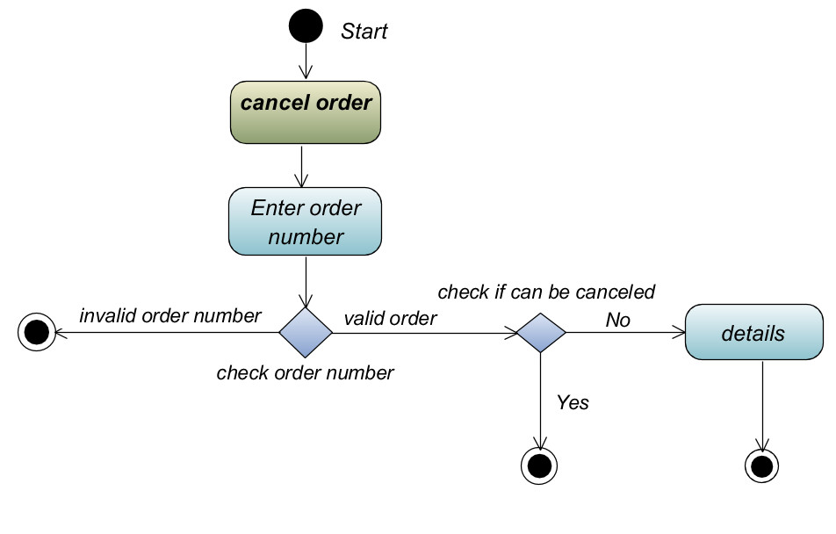

**14.4-Login (Admin):**

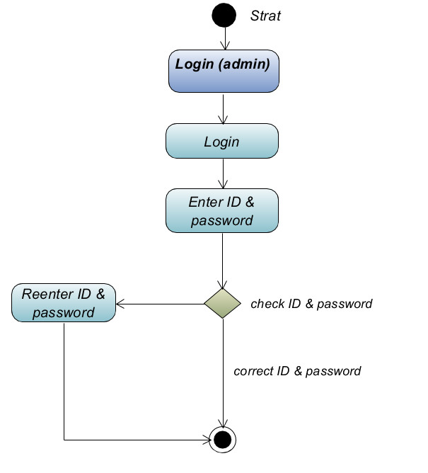

**14.5-Add an Item (Admin):**

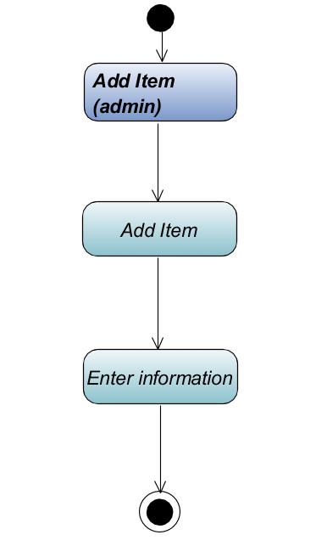

**14.6-Edit an Item (Admin):**

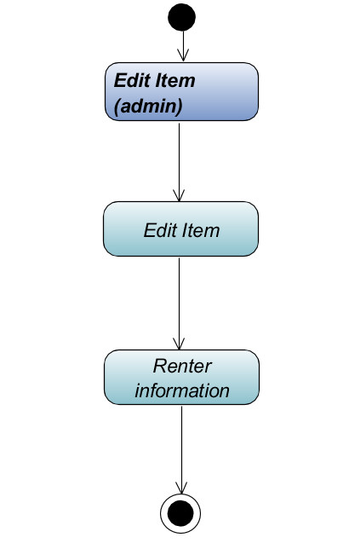

**14.7-Delete an Item (Admin):**

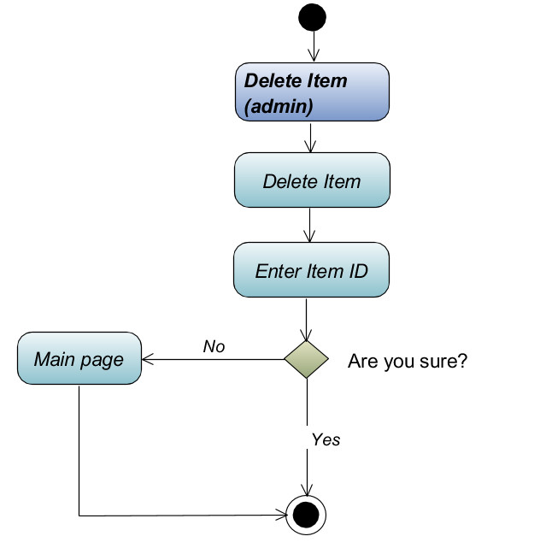

**15.0- ANALYSIS SEQUENCE DIAGRAM:**

# NOTE: We will use Combined Fragment method to handle exceptions and conditions.

# **Combined fragment** is an [interaction fragment](https://www.uml-diagrams.org/sequence-diagrams.html#interaction-fragment) which defines a combination (expression) of interaction fragments. A combined fragment is defined by an **interaction operator** and corresponding **interaction operands**. Through the use of combined fragments the user will be able to describe a number of **traces** in a compact and concise manner.

**15.1 SEQUENCE DIAGRAM FOR USE CASE search:**

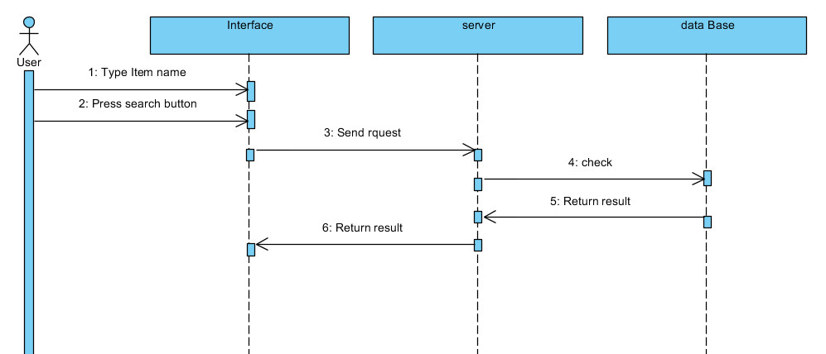

**15.2 SEQUENCE DIAGRAM FOR USE CASE Order:**

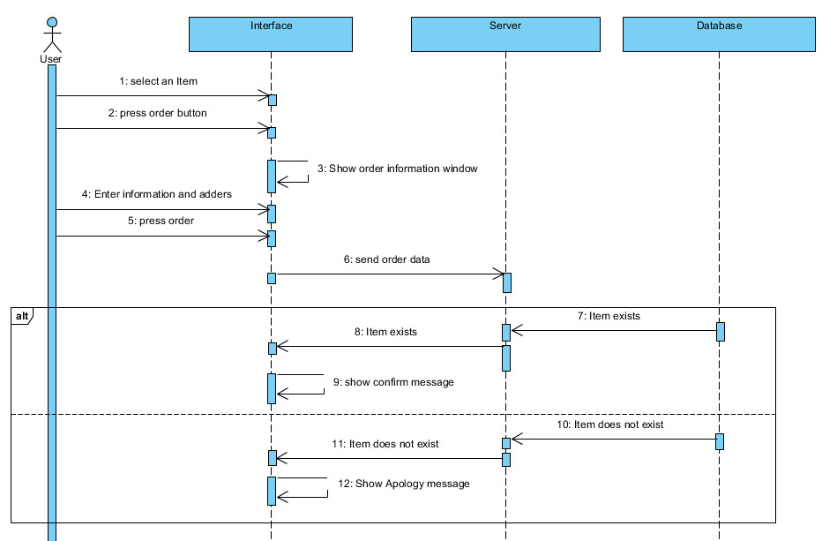

[Item exists]

[Item does not exist]

**15.3 SEQUENCE DIAGRAM FOR USE CASE Cancel Order:**

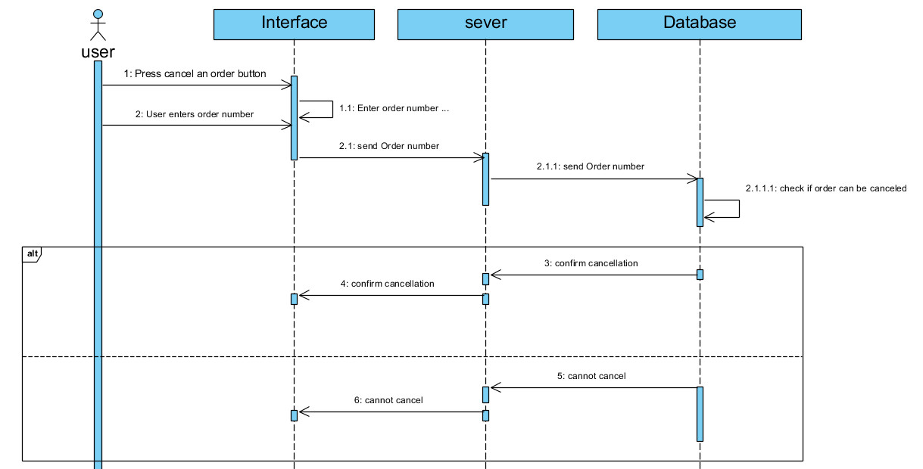

[Can cancel]

[Cannot cancel]

**15.4 SEQUENCE DIAGRAM FOR USE CASE Login (Admin):**

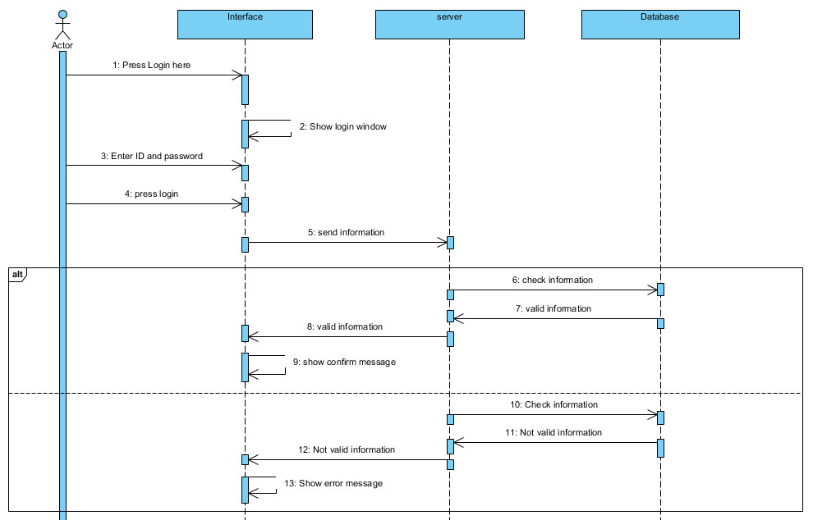

[Valid information]

[Invalid information]

**15.5 SEQUENCE DIAGRAM FOR USE CASE Add an Item (Admin):**

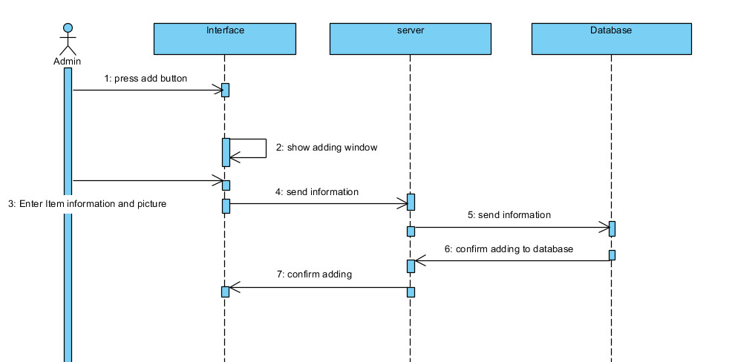

**15.6 SEQUENCE DIAGRAM FOR USE CASE Edit an Item (Admin):**

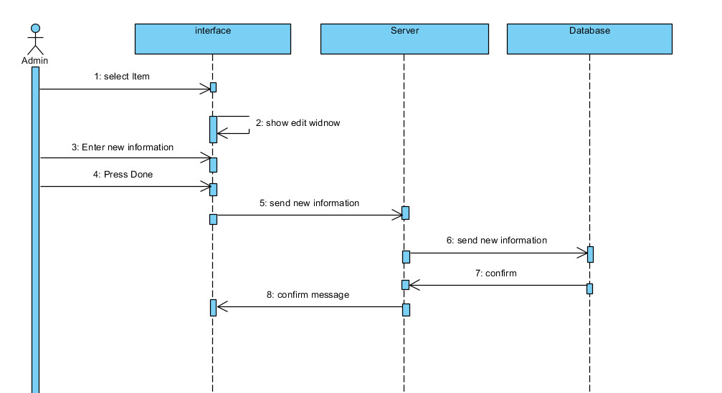

**15.7 SEQUENCE DIAGRAM FOR USE CASE Delete an Item (Admin):**

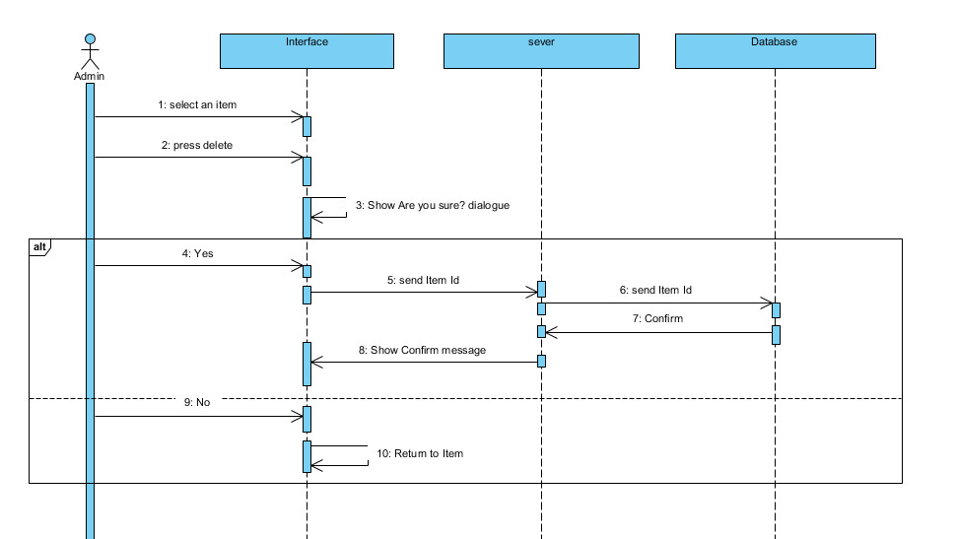

[No]

[Yes]