RAPTOR EXPERIMENTS
EX:1-----GREATEST NUMBER
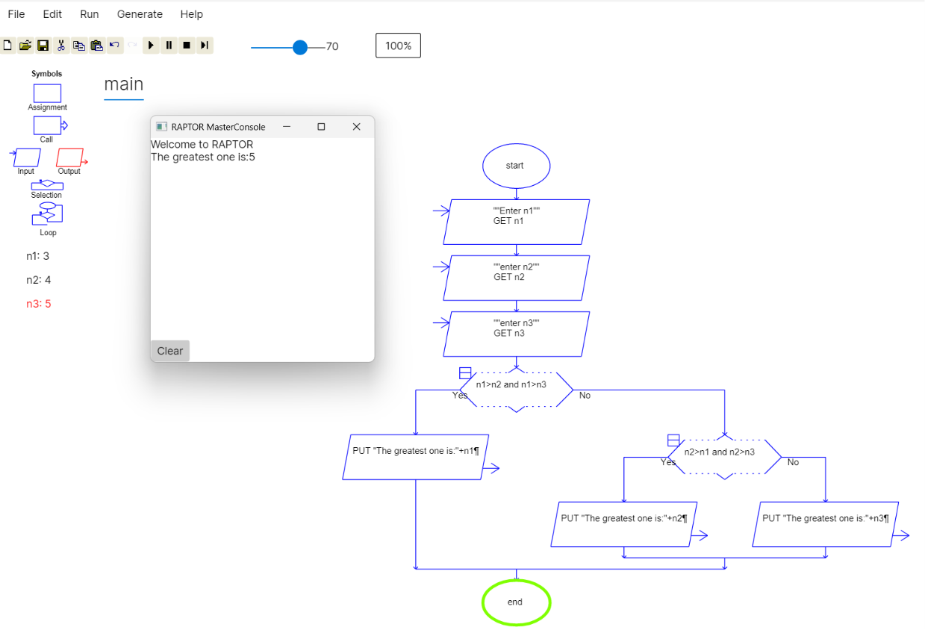 EX:2-----ARMSTRONG NUMBER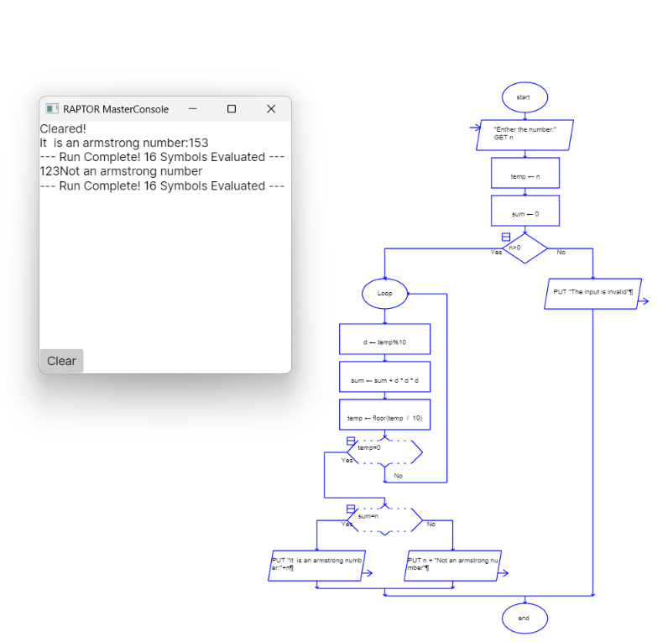

EX:3-----FACTORIAL
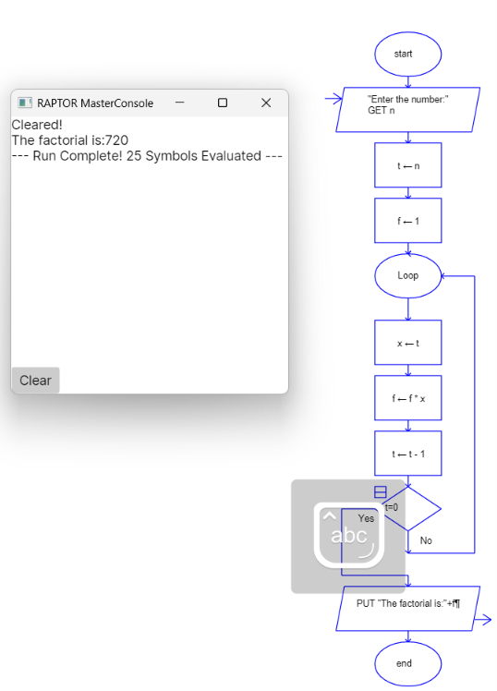
EX:4----STRING LENGTH
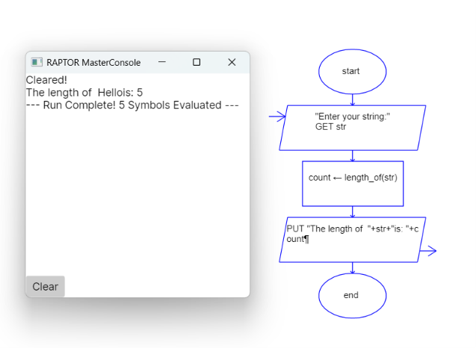

EX:5:STRING REPLACEMENT
