SPI_Slave_24bit_Verilog
SPI slave protocol verilog.
- Clock:
- Sử dụng clock 10mhz.
- Timing Diagram:
- Register Write Timing Diagram.
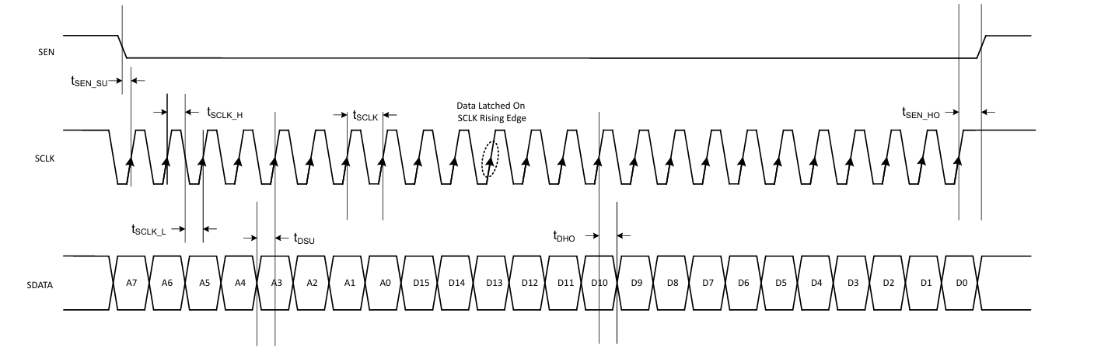
- Register Read Timing Diagram.
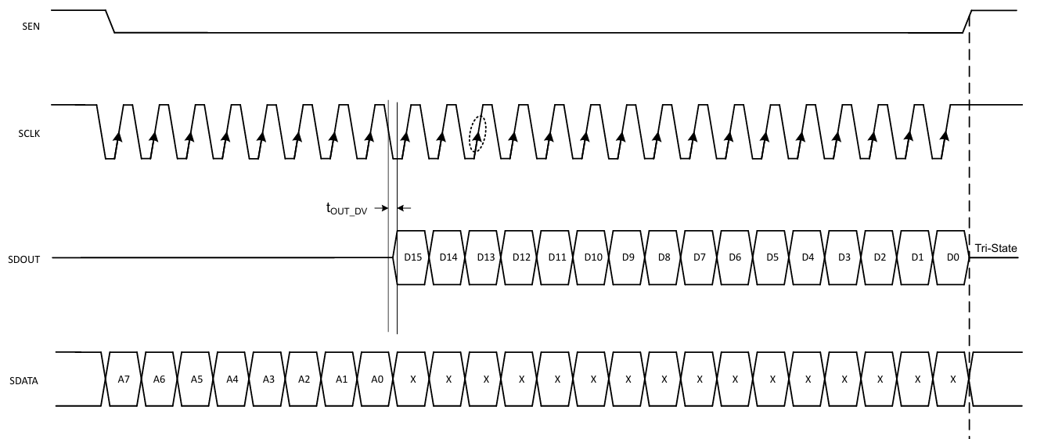
- Signal Run on kit
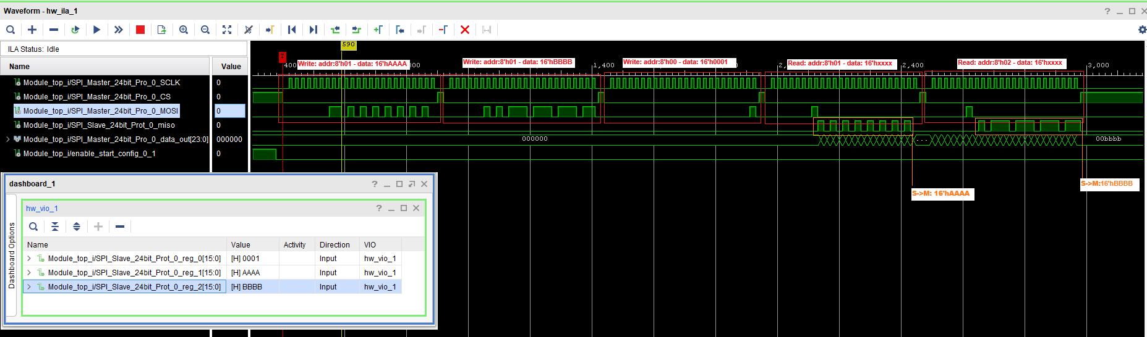
- Mode: CPOL=1 CPHA = 1

