User Flow
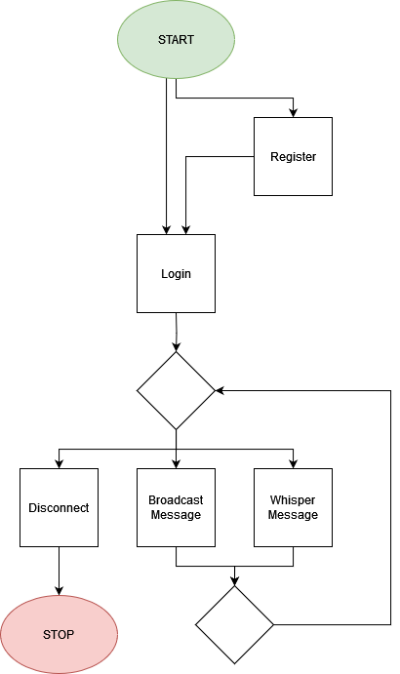

Commands

REGISTER
Command: REGISTER|<username>|<password>
Registers on a chat server.

LOGIN
Command: LOGIN|<username>|<password>
Logs in to a chat server.

BROADCAST
Command: BROADCAST|<message>
Broadcasts a message to all user logged into a chat.

WHISPER
Command: WHISPER|<user>|<message>
Sends messages to a specific user.

DISCONNECT
Command: DISCONNECT
Disconnects from the chat server.

