

|  |
| --- |
| HATtrick Games |
| Goldcrest Game Design Document |

|  |
| --- |
| Hamish Carrier, Arran Ford, Timothy Veletta  Version 1.0 |

Table of Contents

1 Concept Document 3

1.1 Credit Page 3

1.2 Sign-Off 3

1.3 Introduction 3

1.4 Game Analysis 3

1.5 Game Atmosphere 4

1.6 Game Play 4

1.7 Key Features 5

1.8 Selling Features 5

2 Design Document 6

2.1 Design Version 6

2.2 Design Guidelines 6

2.3 Game Design Definitions 6

2.4 Game Matrix 6

2.5 Game Flow Chart 7

2.6 Player Elements 7

2.6.1 Player Definition 7

2.6.2 Player Properties 8

2.6.3 Player Rewards (Power-ups & Pick-ups) 8

2.6.4 User Interface (UI) 8

2.6.5 Player View 9

2.7 Antagonistic Elements 9

2.7.1 Antagonistic Definitions 9

2.7.2 Antagonistic Properties 9

2.7.3 Antagonistic List 9

2.7.4 Artificial Intelligence (AI) 10

2.8 The Story 10

2.8.1 The Story Copy 10

2.9 Level Design 11

2.10 Audio & Sound F/X 11

2.11 Game Architecture 12

2.11.1 Game Architecture Overview 13

2.11.2 How to play Copy 13

3 Technical Document 14

3.1 System Requirements 14

3.2 Visual Content 14

3.3 Audio Content 14

3.4 Programming Content 15

3.5 Code Structure 16

3.6 Concerns and Alternatives 16

3.7 Resources 16

3.8 Technical Matrix 16

# Concept Document

## Credit Page

|  |  |
| --- | --- |
| Document Purpose: | To detail, plan and describe the game and design of the 3D XNA game project for ICT309 |
| Document Version: | V1.0 |
| Working Title: | Goldcrest |
| Game Concept: | V1.0 |
| Game Document Author: | Hamish Carrier, Arran Ford, Timothy Veletta |

## Sign-Off

This section is here to confirm that each team leader has read through the design and agrees with the current game design.

|  |  |
| --- | --- |
| Game Design Sign-off | |
| Hamish Carrier: |  |
| Arran Ford: |  |
| Timothy Veletta: |  |

## Introduction

(Game Title) is a tactical turn-based arena combat game where the player controls a team of adventurers through a series story-driven encounters. It is being built for the Windows platform using the XNA framework and the (Game Engine). The game has been inspired by turn-based games such as Banner Saga, Heroes and Might and Magic and Kings Bounty and is set in a medieval fantasy world.

## Game Analysis

This is a general overview of the game.

|  |  |
| --- | --- |
| Game Description |  |
| Genre: | * Turn-Based * Strategy * Role-Playing |
| Game Elements: | * Combat * Targeting * Positioning * Reacting * Resource Management * Character Progression |
| Game Content: | * Action * Adventure |
| Theme: | * Fantasy * Medieval |
| Style: | * Realistic |
| Game Sequence: | * Linear Storyline |
| Player: | * Single Player |
| Game Reference |  |
| Game Taxonomy: | * Fictional Game/Narrative |
| Player Immersion: | * Tactical * Strategy * Narrative |
| Reference: | * The game is based in fantasy world with a classic good versus evil story, the player will begin in an arena for an evil characters amusement and will have to fight his way out with the help of other prisoners, similar to the start of the Lionheart role playing game. The combat will be turn based strategy similar to Banner Saga and Kings Bounty. The enemies will be classic monsters referencing Dungeons and Dragons and Lord of the Rings. |
| Game Technical |  |
| Technical From: | * 3D Graphics |
| View: | * Perspective * High Angle * Rotatable * Movable |
| Platform: | * C# * XNA |
| Device: | * Windows PC |
| Game Sales |  |
| Consumer Group: | * PC Gamers * Strategy Enthusiasts |
| Payment: | * Digital Download |
| Estimated Price: | * $2.49 on Steam |
| Device Support List | * Windows PC |

## Game Atmosphere

* Generally, most of the levels will have an engaging atmosphere with short periods of intense action.
* One of the levels will have an urgent atmosphere where the player will have to race against time to defeat the enemies before more enemies join the battle.
* The background music will vary based upon the pace of the level ranging from neutral, fantasy themed music at the introduction to more fast paced music through the multiple boss battles.

## Game Play

* Strategically positioning the player’s characters around the arena while attempting to defeat the enemy characters.
* The player will be able to manage character attributes and feats.
* The player will primarily use the mouse to select and move characters.
* The game will have a basic menu including options for, new game, load game, save game and mute.
* The overall game is won by completing all of the levels and then defeating the final boss.
* Completing a level could involve a range of tasks from defeating all other enemies or moving all of your characters to a certain position.
* The player loses a stage if the player’s main character is killed or if all of the player’s characters are downed at the same time.

## Key Features

* The game will consist of 7 stages in 2 different environments.
* There will be multiple normal enemies and 2 boss fights.
* About an hour of game time.
* Can replay with different customizations.
* Engaging fantasy soundtrack, fully voice acted with combat sound effects.
* Realistic 3D graphics with animations.
* Windows PC only.
* Single player story driven game.
* Avoidable traps.
* Challenging AI opponent.

## Selling Features

* No DRM.
* Very cheap price.
* Customize to match your play style.
* Engaging story.
* Amateur voice acting.
* 5 unique characters.

# Design Document

## Design Version

D1.0 Main Design Document Completed

## Design Guidelines

Creative design needs to be adjusted to fit within the 10 week deadline, while still creating an engaging and enjoyable experience for the end user.

## Game Design Definitions

The player moves through a series of encounters controlling a team of characters, in which the immediate goal is to clear the field of enemy characters. To complete the game the player must beat all seven battles while keeping their main character alive.

The menu system is created to allow the user to resume play from a save point.

## Game Matrix

|  |  |  |  |  |  |  |
| --- | --- | --- | --- | --- | --- | --- |
| Object | Properties | |  |  |  |  |
| Unit type | Hit Points | Damage | Armour Damage | Armour Class | Passive Ability | Movement |
| Player Characters |  |  |  |  |  |  |
| Main Character | 350 | 100 | 3% | 70-30 |  | 3 |
| Ranged | 200 | 70 | 8% | 45-15 | 5 range | 5 |
| Melee Healer | 280 | 80 | 4% | 60-50 | AoE Heal/Res | 4 |
| Melee Fighter | 310 | 150 | 5% | 35-15 |  | 5 |
| Mage | 200 | 75 | 0% | 30-5 | 4 range, pure damage | 4 |
| Enemy Characters |  |  |  |  |  |  |
| Final Boss | 1000 | 180 | 10% | Dynamic 60% min |  | 4 |
| Mini Boss | 650 | 60 | 5% | 45-10 | 6 range | 3 |
| Weak | 100 | 30 | 2% | 0 |  | Slow |
| Ranged | 160 | 200 | 3% | 35-10 | 4 range | 4 |
| Tank | 300 | 35 | 8% | 60-45 | Reduce movement by 1 | 2 |
|  |  |  |  |  |  |  |

## Game Flow Chart

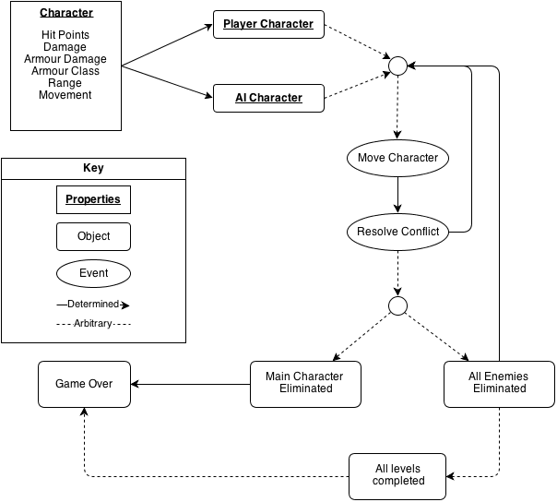

## Player Elements

### Player Definition

The player will make use of the following elements to defeat the enemies:

* Buttons
* Controllers
* Helpers
* Resource Generators
* Save Points – at the end of each level
* Spawn Points – the player gets to select where each of their characters spawns in at the beginning of the level, within a certain boundary.

Each turn the player characters have the opportunity to:

1. Move
2. And either of:
   1. Attack an enemy
   2. Heal an ally (if applicable)
   3. Revive an ally (if applicable)

The player wins the game by defeating all enemies in every level. They lose if the main character dies without being revived.

### Player Properties

Each of the player characters have the following properties:

* Hit Points – the amount of health they have
* Damage – the amount of damage they do with their attacks
* Armor Damage – the amount of damage they do to armor with each of their attacks
* Armor Class – the amount of armor they have which reduces damage from enemy attacks
* Passive Ability – additional range, area of effect damage or healing
* Movement – the distance a character can move in a single turn

### Player Rewards (Power-ups & Pick-ups)

* The melee healer character can heal and resurrect friendly characters when he is within 1 range of them.
* At the end of each level the player gets the opportunity to upgrade their characters stats making them stronger.

### User Interface (UI)

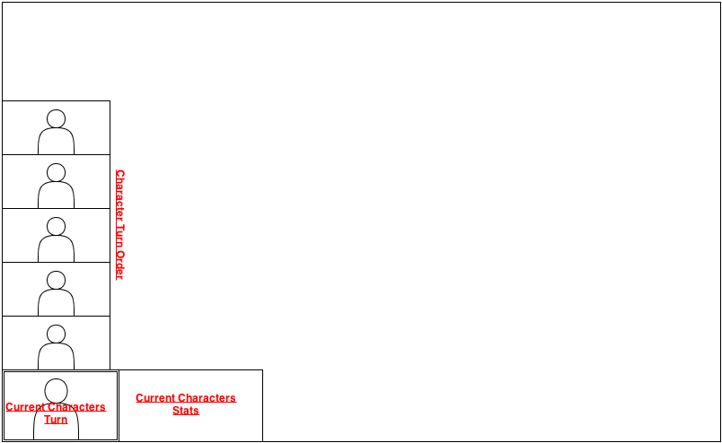

The mouse will be used to control the game, with keyboard shortcuts allowing the player to complete some of the more common functions using a single key. The Xbox 360 controller will not be supported.

### Player View

The player view will initially be from a high angle looking down on the action as shown below.

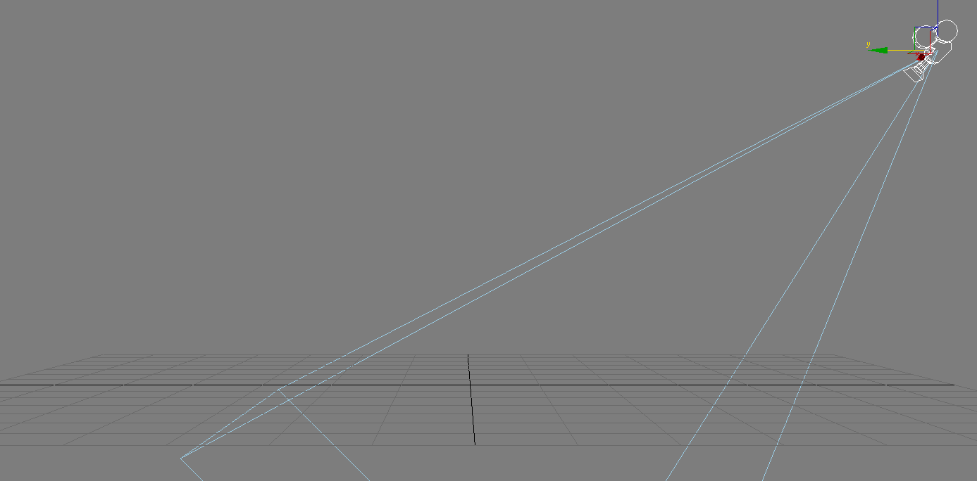

The player will be able to translate the camera forwards, backwards, left and right using the ASDW keys and zoom in and out using the mouse scroll.

## Antagonistic Elements

### Antagonistic Definitions

* Alarms
* Boss Monsters
* Deadly Traps

### Antagonistic Properties

Each of the AI characters have the following properties:

* Hit Points – the amount of health they have
* Damage – the amount of damage they do with their attacks
* Armor Damage – the amount of damage they do to armor with each of their attacks
* Armor Class – the amount of armor they have which reduces damage from enemy attacks
* Passive Ability – additional range, area of effect damage or healing
* Movement – the distance a character can move in a single turn

### Antagonistic List

* Final Boss
* Mini Boss
* Weakling
* Ranged
* Tank

### Artificial Intelligence (AI)

The factors that affect AI decision making include:

* Importance of target
* Distance to target
* Movement amount
* Targets remaining health
* Targets remaining armor
* Own damage

All these factors are combined to give a score for each of the player’s characters which is given by:

$Total Damage=Attackers Damage-\frac{Attackers Damage × Defenders Armor}{100}$

|  |  |
| --- | --- |
| **Unit** | **Unit Importance** |
| Main Character | 10 |
| Ranged | 7 |
| Melee Healer | 3 |
| Melee Fighter | 4 |
| Mage | 5 |

$Movement Difference=Movement Amount-Distance to Target$

$Decision Score=\frac{Total Damage}{10}+Unit Importance+Movement Difference$

The decision score for each of the player characters is worked out every time it is an AI characters turn and the highest scoring target is moved towards and attacked if possible.

## The Story

“The once peaceful village of Goldcrest has been rocked by an evil unheard of in these parts.”

“The nearby castle known as Hordrigg Citadel has once again opened its doors and all the evil that had remained shut off from the world for so long, poured out, led by the evil demon Zayn.”

“Zayn and his minions wreaked havoc and destruction all over Goldcrest causing many to lose hope.”

“Only one option remains, they fight back.”

“Led by the legendary Strom Ironclaw, the strongest combatants of Goldcrest must come together and storm the Citadel.”

### The Story Copy

* The story begins with the invasion of the village of Goldcrest by the evil demon Zayn and his minions before he retreats to the Hordrigg Citadel.
* Now it is the chance for the villagers of Goldcrest, led by their hero Strom Ironclaw, to get their revenge by storming the Citadel in an attempt to slay the evil Zayn.
* The first level begins with the players in the forest between the village of Goldcrest and the Hordrigg Citadel where the player has been ambushed by some minions of Zayn.
* After defeating the minions the player progresses to the front gate of the Hordrigg Citadel where they come across the guardsmen of Hordrigg and must fight them.
* Once in side the castles walls, the player confronts the first boss, the sorcerer Morren.
* After defeating Morren, Strom and his party proceed to enter the castle in search of the demon Zayn.
* After encountering further enemies, Strom enters Zayn’s lair, to fight the evil demon and (hopefully) defeat him.

## Level Design

There are 6 levels planned, these are:

1. Goldcrest Forest
2. Hordrigg Citadel Gates
3. Citadel Courtyard
4. The Crimson Hall
5. Into the Depths
6. Zayn’s Lair

## Audio & Sound F/X

* Music
  + Menu Music
  + Goldcrest Forest Music
  + Hordrigg Citadel Gates Music
  + Citadel Courtyard Music
  + Into the Depths Music
  + Zayn’s Lair Music
* Sound Effects
  + Each of the characters have the following sound effects (some will be reused)
    - Attacking
    - Taking Damage
    - Dying
    - Moving
  + Pressing a button
  + Using a controller
  + Deadly trap door

## Game Architecture

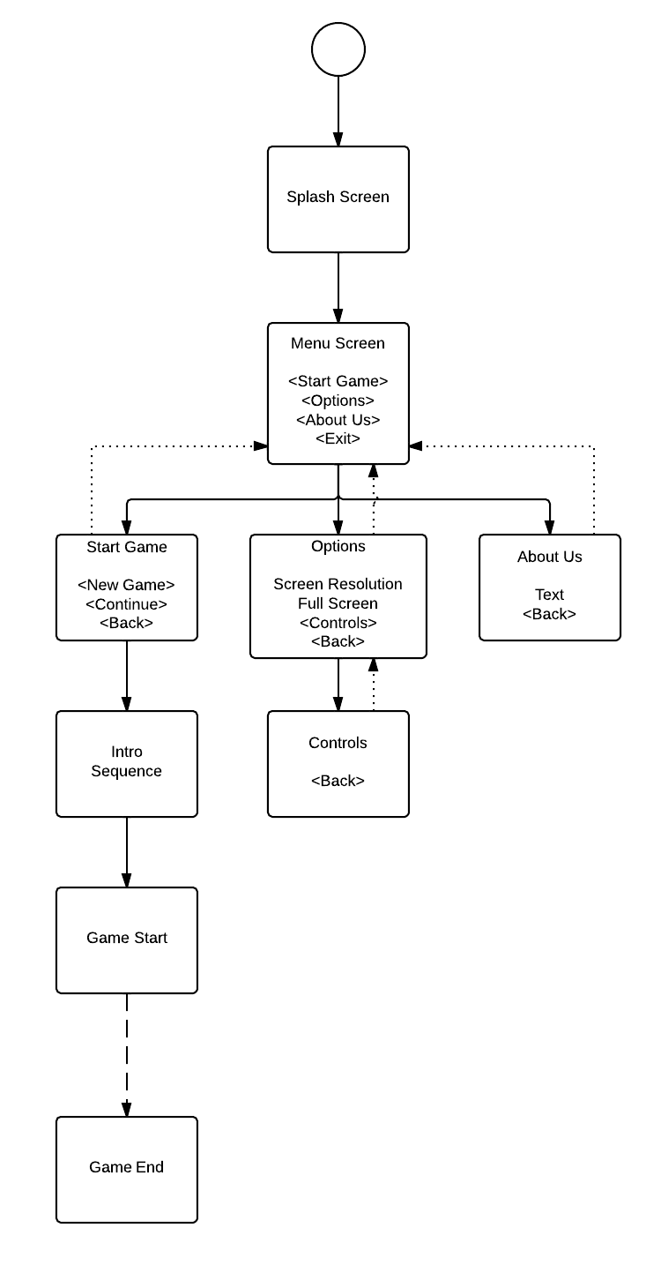

### Game Architecture Overview

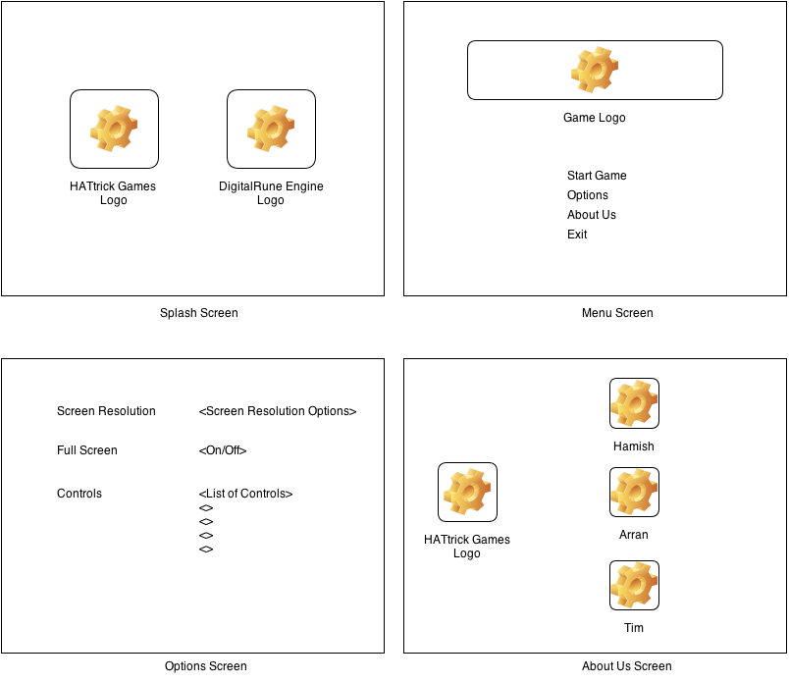

### How to play Copy

**Controls**

1. Left click a unit to select it.
2. Right click a highlighted square to move to it.
3. Right click an enemy unit to attack it.
4. Use the ASDW keys to move the camera.
5. Use the mouse scroll to zoom in and out.

**Combat**

1. Your goal is to reduce your enemies’ health points to 0, killing them.
2. Each of your characters has an amount of damage used when attacking which is reduced by the targets armor.
3. Each of your attacks also reduce your opponent’s armor by a small amount. This causes attacks later on to do more damage.

**End Game**

1. You win when you eliminate all the enemy minions and monsters.
2. You lose if Strom Ironclaw dies without being revived. Strom can only be revived by the melee healer and this can only occur once in the entire game.

# Technical Document

## System Requirements

Minimum

* OS: Windows XP or later
* Processor: 1.2GHz processor
* Graphics: Graphics Card that supports Pixel Shader 2.0 and Vertex Shader 2.0
* DirectX: 9.0
* Hard Drive: 100 MB HD space

## Visual Content

* General
  + File Size Restrictions
    - Less than 3 MB per asset file.
  + File Format Type
    - 3D Models - .x .fbx
    - Images - .bmp .dds .dib .jpg .pfm .png .ppm .tga
    - Fonts - .spritefont
    - Effects - .fx
* Player Elements
  + Type of States
    - Attack
    - Taking damage
    - Idle
    - Moving
    - Death
* Heads Up Display (HUD)
  + Type Icons
    - Each of the characters
    - Character properties icons
  + States
    - Dead
  + Font Type
* Antagonistic Elements
  + Type of States
    - Attack
    - Taking Damage
    - Idle
    - Moving
    - Death
* Global Elements
  + Background/Texture/Tiles
  + Font Type

## Audio Content

* General
  + File Size Restrictions
    - Less than 5 MB per file
  + File Format Type
    - Audio - .xap .wma .mp3 .wav
  + File Quality Type
* Player Elements
  + Type of Sound f/x
    - Attacking
    - Taking Damage
    - Dying
    - Moving
  + Device Vibration
    - None
* Antagonistic Elements
  + Type of Sound f/x
    - Attacking
    - Taking Damage
    - Dying
    - Moving
  + Device Vibration
    - None
* Global Elements
  + Ambient Music
    - Level background music
* Splash Screens
  + Ambient Music
    - Menu background music
* Menus
  + Type of Sound f/x
    - Changing menu selection
    - Confirmation of selection

## Programming Content

* General
  + Requirements
    - C# and XNA
  + File Size Restrictions
    - None
  + File Format Type
    - .cs
  + Specify Coding Conventions
    - See Team Charter
  + Language/Device Restrictions
    - C#
  + Screen Type (Small, Medium, Large)
    - 1920px by 1080px
    - 1366px by 768px
* Player Elements
  + Type of Event
* Antagonistic Elements
  + Type Event
* Global Elements
  + Type of Event
* Splash Screens
  + Type of Event
* Menus
  + Type of Event
  + Type of Options

## Code Structure

## Concerns and Alternatives

* We may run out of time and hence may have to reduce the number of levels in the game.

## Resources

* Visual Studio 2010
* Photoshop/GIMP
* 3DS Max 2011 (minimum)
* Git with Github

## Technical Matrix

* Visual Content
  + Strom Ironclaw Model
  + Morren Model
  + Zayn Model
  + Goldcrest Forest Model
  + Citadel Gates Model
  + Citadel Courtyard Model
  + Crimson Hall Model
  + Into the Depths Model
  + Zayn’s Lair Model
* Audio Content
  + Ambient Music for each level
  + Menu music
  + Menu selection sounds
  + Sounds for each character
* Programming Content
  + See Code Structure