

Game Concept & Design Document Template

By
Micah Hrehovcsik

Document Contents

1 Project Specifications and requirements 1
1.1 Project Specifications 2
1.2 Requirements for the Project 2
2 Concept Document 2
2.1 Title Page 2
2.2 Credit Page 2
2.3 Sign-Off 3
2.4 Introduction 3
2.5 Game Analysis 3
2.6 Game Atmosphere 5
2.7 Game Play 5
2.8 Key Features 6
2.9 Selling Features 6
3 Design Document 7
3.1 Design Version 7
3.2 Design Guidelines 7
3.3 Game Design Definitions 7
3.4 Game Matrix 7
3.5 Game Flow Chart 8
3.6 Player Elements 8
3.6.1 Player Definition 8
3.6.2 Player Properties 8
3.6.3 Player Rewards (Power-ups & Pick-ups) 9
3.6.4 User Interface (UI) 9
3.6.5 Heads up Display (HUD) 9
3.6.6 Player View 9
3.7 Antagonistic Elements 9
3.7.1 Antagonistic Definitions 10
3.7.2 Antagonistic Properties 10
3.7.3 Antagonistic List 10
3.7.4 Artificial Intelligence (AI) 10
3.8 Global Game Elements 10
3.9 The Story 10
3.9.1 The Story Copy 10
3.10 Concept Art 11
3.11 Level Design 11
3.12 Audio & Sound F/X 11
3.13 Game Architecture 11
3.13.1 Game Architecture Overview 12
3.13.2 How to play 12
4 Technical Document 13
4.1 System Requirements 13
4.2 Visual Content 13
4.3 Audio Content 14
4.4 Programming Content 14
4.5 Code Structure 14
4.6 Concerns and Alternatives 15
4.7 Resources 15
4.8 Technical Matrix 15
5 Appendix A 16
5.1 Taxonomy 16
5.2 Genre 16
5.3 Game Elements 17
5.4 Content 17
5.5 Theme 17
5.6 Style 17
6 Appendix B 18
7 Appendix C 1
8 Appendix D 1

Credit Page

Document Purpose: | To detail, plan and describe the game and design of the 3D XNA game project for ICT309
Document Version: | 1
Working Title: | TBD
Game Concept: | TBD
Game Document Author: | Hamish Carrier, Arran Ford, Timothy Veletta

Sign-Off

This section is here to confirm that each team leader has read through the design and agrees with the current game design.

Game Design Sign-off

Hamish Carrier:
Arran Ford:
Timothy Veletta:

Introduction

(Game Title) is a tactical turn-based arena combat game where the player controls a team of adventurers through a series story-driven encounters. It is being built for the Windows platform using the XNA framework and the (Game Engine). The game has been inspired by turn-based games such as Banner Saga, Heroes and Might and Magic and Kings Bounty and is set in a medieval fantasy world.

Game Analysis

This is a general overview of the game.

Game Description
Genre: | - Turn-Based  - Strategy  - Role-Playing
Game Elements: | - Combat  - Targeting  - Positioning  - Reacting  - Resource Management  - Character Progression

Game Content: | - Action  - Adventure
Theme: | - Fantasy  - Medieval
Style: | - Realistic
Game Sequence: | - Linear Storyline
Player: | - Single Player
Game Reference
Game Taxonomy: | - Fictional Game/Narrative
Player Immersion: | - Tactical  - Strategy  - Narrative
Reference: | - The game is based in fantasy world with a classic good versus evil story, the player will begin in an arena for an evil characters amusement and will have to fight his way out with the help of other prisoners, similar to the start of the Lionheart role playing game. The combat will be turn based strategy similar to Banner Saga and Kings Bounty. The enemies will be classic monsters referencing Dungeons and Dragons and Lord of the Rings.

Game Technical
Technical From: | - 3D Graphics
View: | - Perspective  - High Angle  - Rotatable  - Movable
Platform: | - C#  - XNA
Device: | - Windows PC
Game Sales
Consumer Group: | - PC Gamers  - Strategy Enthusiasts
Payment: | - Digital Download
Estimated Price: | - $2.49 on Steam
Device Support List | - Windows PC

Game Atmosphere

- Generally, most of the levels will have an engaging atmosphere with short periods of intense action.
- One of the levels will have an urgent atmosphere where the player will have to race against time to defeat the enemies before more enemies join the battle.
- The background music will vary based upon the pace of the level ranging from neutral, fantasy themed music at the introduction to more fast paced music through the multiple boss battles.

Game Play

- Strategically positioning the player’s characters around the arena while attempting to defeat the enemy characters.
- The player will be able to manage character attributes and feats.
- The player will primarily use the mouse to select and move characters.
- The game will have a basic menu including options for, new game, load game, save game and mute.
- The overall game is won by completing all of the levels and then defeating the final boss.
- Completing a level could involve a range of tasks from defeating all other enemies or moving all of your characters to a certain position.
- The player loses a stage if the player’s main character is killed or if all of the player’s characters are downed at the same time.

Key Features

- The game will consist of 7 stages in 2 different environments.
- There will be multiple normal enemies and 2 boss fights.
- About an hour of game time.
- Can replay with different customizations.
- Engaging fantasy soundtrack, fully voice acted with combat sound effects.
- Realistic 3D graphics with animations.
- Windows PC only.
- Single player story driven game.
- Avoidable traps.
- Challenging AI opponent.

Selling Features

- No DRM.
- Very cheap price.
- Customize to match your play style.
- Engaging story.
- Amateur voice acting.
- 5 unique characters.

Design Document

Design Version

D1.0 Main Design Document Completed

Design Guidelines
Creative design needs to be adjusted to fit within the 10 week deadline, while still creating an engaging and enjoyable experience for the end user.

Game Design Definitions

The player moves through a series of encounters controlling a team of characters, in which the immediate goal is to clear the field of enemy characters. To complete the game the player must beat all seven battles while keeping their main character alive.

The menu system is created to allow the user to resume play from a save point.

Game Matrix

Object | Properties
Unit type | Hit Points | Damage | Armour Damage | Armour Class | Passive Ability | Movement
Player Characters
Main Character | 350 | 100 | 3% | 70-30 |  | 3
Ranged | 200 | 70 | 8% | 45-15 | 5 range | 5
Melee Healer | 280 | 80 | 4% | 60-50 | AoE Heal/Res | 4
Melee Fighter | 310 | 150 | 5% | 35-15 |  | 5
Mage | 200 | 75 | 0% | 30-5 | 4 range, pure damage | 4
Enemy Characters
Final Boss | 1000 | 180 | 10% | Dynamic 60% min |  | 4
Mini Boss | 650 | 60 | 5% | 45-10 | 6 range | 3
Weak | 100 | 30 | 2% | 0 |  | Slow
Ranged | 160 | 200 | 3% | 35-10 | 4 range | 4
Tank | 300 | 35 | 8% | 60-45 | Reduce movement by 1 | 2

Game Flow Chart

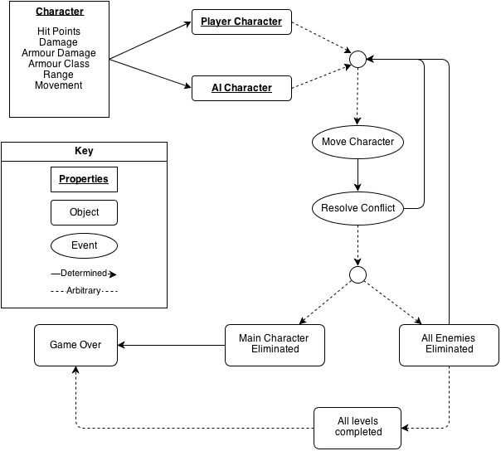

Player Elements

Player Definition

The player will make use of the following elements to defeat the enemies:
- Buttons
- Controllers
- Helpers
- Resource Generators
- Save Points – at the end of each level
- Spawn Points – the player gets to select where each of their characters spawns in at the beginning of the level, within a certain boundary.

Each turn the player characters have the opportunity to:
- Move
- And either of:
  - Attack an enemy
  - Heal an ally (if applicable)
  - Revive an ally (if applicable)

The player wins the game by defeating all enemies in every level. They lose if the main character dies without being revived.

Player Properties

Each of the player characters have the following properties:
- Hit Points – the amount of health they have
- Damage – the amount of damage they do with their attacks
- Armor Damage – the amount of damage they do to armor with each of their attacks
- Armor Class – the amount of armor they have which reduces damage from enemy attacks
- Passive Ability – additional range, area of effect damage or healing
- Movement – the distance a character can move in a single turn

Player Rewards (Power-ups & Pick-ups)

- The melee healer character can heal and resurrect friendly characters when he is within 1 range of them.
- At the end of each level the player gets the opportunity to upgrade their characters stats making them stronger.

User Interface (UI)

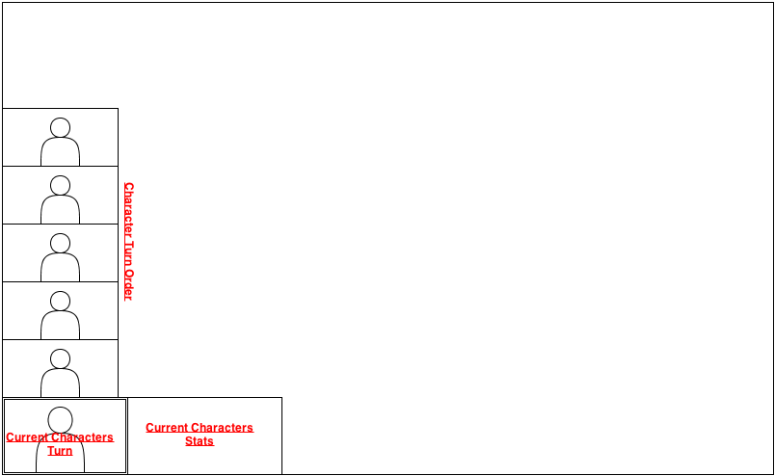
The mouse will be used to control the game, with keyboard shortcuts allowing the player to complete some of the more common functions using a single key. The Xbox 360 controller will not be supported.

Player View

The player view will initially be from a high angle looking down on the action as shown below.

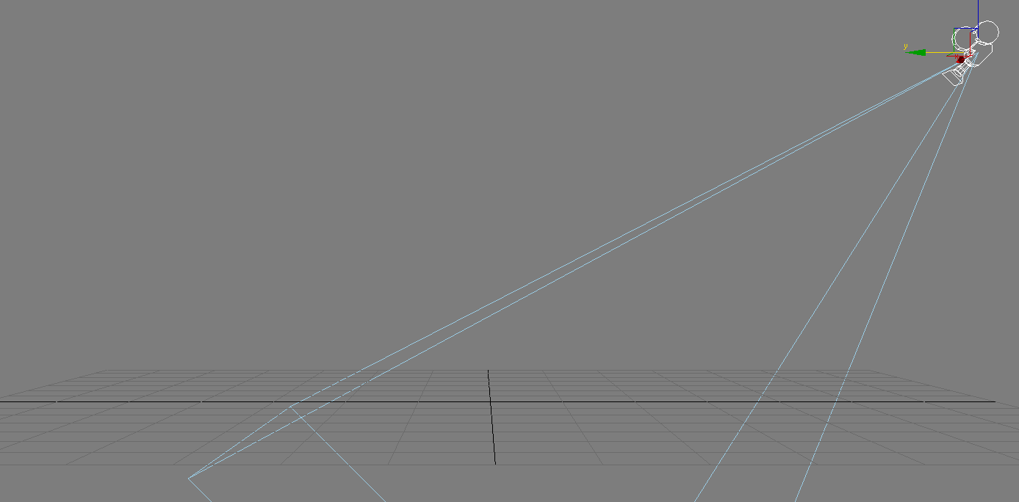

The player will be able to translate the camera forwards, backwards, left and right using the ASDW keys and zoom in and out using the mouse scroll.

Antagonistic Elements

Antagonistic Definitions

- Alarms
- Boss Monsters
- Deadly Traps

Antagonistic Properties

Each of the AI characters have the following properties:
- Hit Points – the amount of health they have
- Damage – the amount of damage they do with their attacks
- Armor Damage – the amount of damage they do to armor with each of their attacks
- Armor Class – the amount of armor they have which reduces damage from enemy attacks
- Passive Ability – additional range, area of effect damage or healing
- Movement – the distance a character can move in a single turn

Antagonistic List

- Final Boss
- Mini Boss
- Weakling
- Ranged
- Tank

Artificial Intelligence (AI)

This is where visuals and written description(s) of the antagonistic element’s behaviors.

These should be labeled in such a way that they can be used in level design with out having to describe them again.

Devise generic names for repetitive behaviors.

This is how an AI action could be broken down:
- Normal State: What is the object doing if it has not come in contact with the player?
- Detection State: What does it take for this object to detect the player?
- Reaction State: What does the object do as an action after passing the reaction state?
- End State: What happens to the object after player has reacted correctly or incorrectly to object?

Global Game Elements

In this section it is important to describe the boundaries, neutral objects, camera views and scale of the world.

Neutral game world objects can be things like a static background, objects that do not interact with the player or antagonistic elements.

The Story

This is where the story can be described in detail.

A story board can be used to tie in graphics to the text.

This can later be used for splash screen concepts.

The Story Copy
A shorter version of the story (The in game version) should also be written here.

This is where the script for in game characters or story information during the cut scenes would be placed.

This category does not always pertain to the current Game Design.

Concept Art

Sketches that are used for the concept can go into this section as visual reference.

In the case of a brand, certain creative restrictions should be noted here.

This is a good place to interact with a graphic designer to get graphics to match to game names.

Level Design

This is where information pertaining to level design and visuals of the level design goes.

Level design can best be shown as a flow chart.

Use generic names to create level design.

Level Copy
This is where the script for in game characters or story information during the cut scenes would be placed.

Audio & Sound F/X

This is where game ambient and Sound F/X should be listed with generic names then described.

This section also includes deciding if you will use a device’s vibration ring mode.

Game Architecture

This is best done by a flow chart to represent the overall game.

Number each screen.

- Title Screen
- Option Screens
- Game Modes
- End Screens

See Appendix D

Game Architecture Overview

The splash screens or video clip need to be in accordance to game story and style.

If cut scenes use video then story boards should be created.

This will need to be created with the graphic designer.

Menu should be designed with the most important options easily accessible.

Be aware how many clicks it takes to accomplish a task.

It would be wise to get together with someone from quality control and a programmer.

The Game Instructions should be written so that the player understands how to play the game.

Mock-ups should be made so that the programmers get the correct layout of the menu.

Mention and describe high score screen here as well.

Architecture Copy

All text fro the game can be complied here.

Review Game Architecture Overview

How to play Copy

This will be game copy.

Information for the player, clearly describing how to play the game.

Technical Document

The information concerning the technical aspects of the game should be placed here.

The technical document is best achieved with consensus from the people responsible for the Visual, Programming and Audio aspects.

This part of the document is meant to be modular. Meaning you could have several Game Technical documents attached to the Concept Document and Game Mechanic Document.

System Requirements

This is a list of system requirements that a device will have to meet to run the game.

This also represents the restrictions that may apply to the end product.

Visual Content

A list of technical requirements from those in concerned with the visual aspects of the game.

This is a section that will require extensive meetings with a graphic designer.

All objects should be listed with their generic names.

- General
  - File Size Restrictions
  - File Format Type
  - File Quality Type
  - Visual Scale
- Player Elements
  - Type of States (Default, Damage, Destroyed, ect.)
    - Amount Animation Frames
- Heads Up Display (HUD)
  - Type Icons
  - States
  - Font Type
- Antagonistic Elements
  - Type of States (Default, Damage, Destroyed, ect.)
  - Amount Animation Frames
- Global Elements
  - Background/Texture/Tiles
  - Font Type

Audio Content

It is very important to communicate with the audio designer before and while the audio content is being developed.

- General
  - File Size Restrictions
  - File Format Type
  - File Quality Type
- Player Elements
  - Type of Sound f/x
  - Device Vibration
- Antagonistic Elements
  - Type of Sound f/x
  - Device Vibration
- Global Elements
  - Ambient Music
- Splash Screens
  - Ambient Music
- Menus
  - Type of Sound f/x

Programming Content

Contents should be collaboration with the programmer.

The object here is to try to organize and modulate as much as possible.

- General
  - Requirements
  - File Size Restrictions
  - File Format Type
  - Specify Coding Conventions
  - Language/Device Restrictions
  - Screen Type (Small, Medium, Large)
- Player Elements
  - Type of Event
- Antagonistic Elements
  - Type Event
- Global Elements
  - Type of Event
- Splash Screens
  - Type of Event
- Menus
  - Type of Event
  - Type of Options

Code Structure
This is where an overview of how objects/functions/data interact, a list of what specified functions/routines do and a list of what order modules will be written.

Concerns and Alternatives

If there are concerns about something technical they should be stated here and what will be alternatives to the concern.

Resources

A list of applications and equipment, that is acceptable for use on development of this game.

This is mostly a legal issue that development members must be aware of.

Technical Matrix

The Matrix will be split into the different device series for each content category.

Technical Matrix includes the content lists of Audio, Visual and Programming.

Appendix A

In this appendix there are lists for a games Taxonomy, Genre, Elements, Contents, Theme and Style. These lists are far from complete but are useful for further examples.

Taxonomy
- Simulation
  - Story
  - Play
  - Chance
    - Fiction
    - Non Fiction
- Story
  - Simulation
  - Play
  - Chance
    - Fiction
    - Non Fiction
- Play
  - Story
  - Chance
  - Simulation
    - Fiction
    - Non Fiction

Genre
- Basic
  - Adventure
  - Arcade (any "twitch" element)
  - Construction & Management
  - Puzzle
  - Role-play
  - Simulator
  - Strategy
- More Specific
  - Abstract (i.e., Arkanoid)
  - Adventure
  - Arcade (very generalised category)
  - Beat-em-up
  - Flight Sim/Space Sim
  - FPS (first-person shooter)
  - MMOG(Massive Multi-player Online)
    - MMORPG (role playing game)
    - MMORTS (real time strategy)
    - MMOTBS (turn base strategy)
  - Platform
  - Puzzle
  - Racing
  - RPG (role-playing game)
  - RTS (real-time strategy)
  - Shoot-em-up (scrolling shooter)
  - TBS (turn based strategy)
  - Trading

Game Elements
- Alignment
- Catch
- Chase
- Collecting
- Combat
- Cooperation
- Dodging
- Escape
- Fighting
- Forbidden Act
- Hiding
- Jump
- Luck
- Maze
- Nursing
- Obstacles
- Puzzle
- React
- Resource Management
- Seeking
- Shooting
- Story Comprehension
- Target
- Trading
- Trivia
- Timing

Content
- Action
- Drama
- Erotic
- Horror
- Humor
- Pure Play
- Realism
- Thriller

Theme
- Abstract
- Crime
- Fantasy
- Noir
- Porn
- Sci-Fi
- Spy
- War
- Western

Style
- Abstract
- Cartoon
- Manga
- Old School
- Realism

Appendix B
Object | Properties
Unit type | Hit Points | Damage | Bullet speed | Movement
Basic Enemies
Cannon -01 | 30 | 100 | Medium | NA
Cannon -02 | 60 | 150 | Slow | NA
Static rocket launcher | 70 | 700 | Medium | NA
Flock 1 | 15 | 500 | NA | Medium
Flock 2 | 15 | 35 | Slow | Medium
Medium 1 | 80 | 350 | Fast | Slow
Medium 2 | 90 | 400 | Medium | Slow
Rail | 120 | 600 | NA | Slow
Small 1 | 25 | 200 | Fast | Fast
Small 2 | 30 | 210 | Fast | Fast

Appendix C

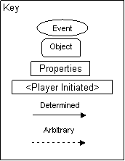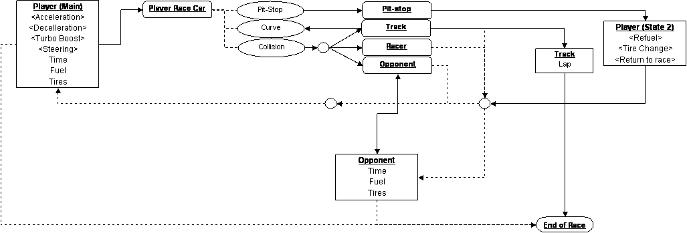

Appendix D
