
Design Document for:

Sanguine Wanderer

One Liner, i.e. The Ultimate Racing Game

“Something funny here!”™

All work Copyright ©2013 by HATtrick Games

Written by Hamish Carrier, Arran Ford, Timothy Veletta

Version 0.01

Sanguine Wanderer 1
Game Overview 3
Philosophy 3
Common Questions 3
What is the game? 3
Why create this game? 3
Where does the game take place? 3
What do I control? 3
How many characters do I control? 3
What is the main focus? 3
What’s different? 3
Feature Set 4
General Features 4
Editor 4
Gameplay 4
The Game World 5
Overview 5
World Feature #1 5
World Feature #2 5
The Physical World 5
Overview 5
Key Locations 5
Travel 5
Scale 5
Objects 5
Weather 5
Day and Night 5
Time 6
Rendering System 6
Overview 6
2D/3D Rendering 6
Camera 6
Overview 6
Camera Detail #1 6
Camera Detail #2 6
Game Engine 6
Overview 6
Game Engine Detail #1 6
Water 6
Collision Detection 6
Lighting Models 7
Overview 7
Lighting Model Detail #1 7
Lighting Model Detail #2 7
The World Layout 8
Overview 8
World Layout Detail #1 8
World Layout Detail #2 8
Game Characters 9
Overview 9
Creating a Character 9
Enemies and Monsters 9
User Interface 10
Overview 10
User Interface Detail #1 10
User Interface Detail #2 10
Weapons 11
Overview 11
Weapons Details #1 11
Weapons Details #2 11
Musical Scores and Sound Effects 12
Overview 12
Red Book Audio 12
3D Sound 12
Sound Design 12
Single-Player Game 13
Overview 13
Single Player Game Detail #1 13
Single Player Game Detail #2 13
Story 13
Hours of Gameplay 13
Victory Conditions 13
Character Rendering 14
Overview 14
Character Rendering Detail #1 14
Character Rendering Detail #2 14
World Editing 15
Overview 15
World Editing Detail #1 15
World Editing Detail #2 15
Extra Miscellaneous Stuff 16
Overview 16
Junk I am working on… 16
“XYZ Appendix” 17
“Objects Appendix” 17
“User Interface Appendix” 17
“Networking Appendix” 17
“Character Rendering and Animation Appendix” 17
“Story Appendix” 17

Game Overview

Philosophy

- To create an immersive fantasy world in which the player can explore, interact with other characters and fight for their survival.
- Our game only runs on the Windows Operating System, the reasoning for this is it is not economically feasible to build for other platforms.

Common Questions

What is the game?

The Sanguine Wanderer is a first person role playing game with an action-oriented real-time combat system. The player takes on the role of ‘The Wanderer’ who has come to save the village of … from the darkness that has entered the nearby mine.

Why create this game?

Because we each enjoy playing games of this genre and it offers creative flexibility when it comes to showing off the capabilities of our game engine.

Where does the game take place?

In a fictional fantasy village with a dark mine nearby.

What do I control?

The player takes on the role of ‘The Wanderer’, armed with his spear and shield.

How many characters do I control?

The player only ever controls ‘The Wanderer’.

What is the main focus?

The player has to save the village from the evil that inhabits the nearby dark mine.

What’s different?

The character will use a spear as his primary weapon.

Feature Set

General Features

- 1st person point of view
- 3D graphics
- Inventory system
- Levelling system
- Interactive NPCs
- Engaging fantasy setting
- Real-time combat

Editor

- Level editor

Gameplay

- Real time combat, the player will fight a variety of monsters using a small shield to block attacks and a short spear to damage the enemy.
- Leveling up, over time the players’ avatar will increase in strength and find new items to help him in his quest.
- Interaction, the player will talk to some NPC’s to learn about his mission and progress the story.

The Game World

Overview

The game will be based in a typical fantasy world, the time period is medieval, and the story takes place in a village surrounded by hills and forests, with a tall tower in the distance.

World Feature #1

The game will feature typical isolated village that will be populated with NPC’s that can be interacted with.

World Feature #2

The game will also feature a monster filled forest where the player can encounter a variety of monsters to combat and in doing so, increase his strength.

The Physical World

Overview

Physically the world will be mostly flat, with the occasional hill, it will be filled with NPC’s, buildings, plants and other scenery.

Key Locations

The key locations include:
- NPC populated village.
- Monster filled forest
- Mysterious end game tower

Travel

The player will travel on foot using the WASD keys.

Scale

The overall game world will be 1km² in area, the village will take up close to a quarter of this area, the rest will be hills and forest populated with monsters, the tower will be on top of a hill on the very edge of this area on the opposite side of the map to the village.

Objects

There will be environmental objects in the world, these will be rocks, trees, fences and buildings, the only interaction possible with these objects will be collision. The other objects will include items that can be picked up from enemies after killing them. These will be replacement weapons and armor for the main character, the player will also be able to pick up potions to heal himself with.

Day and Night

The game will have day and night in a basic form, upon reaching a certain plot point the game world will change from day to night time.

Time

Time will be irrelevant in the game.

Rendering System

Overview

Give an overview of how your game will be rendered and then go into detail in the following paragraphs.

2D/3D Rendering

Describe what sort of 2D/3D rendering engine will be used.

Camera

Overview

The camera will be a straight forward first person view. It will stay level with the player characters head, the mouse will be used to look around in any direction. The keyboard will be used to strafe and moved backwards and forwards along the cameras current axis.

Game Engine

Overview

Describe the game engine in general.

Game Engine Detail #1

The game engine will keep track of everything in the world like such and such.

Water

There will be water in the world that looks awesome and our game engine will handle it beautifully.

Collision Detection

Our game engine handles collision detection really well. It uses the such and such technique and will be quite excellent. Can you see I am having a hard time making up stupid placeholder text here?

Lighting Models

Overview

Describe the lighting model you are going to use and then go into the different aspects of it below.

Lighting Model Detail #1

We are using the xyz technique to light our world.

Lighting Model Detail #2

We won’t be lighting the eggplants in the game because they are purple.

The World Layout

Overview
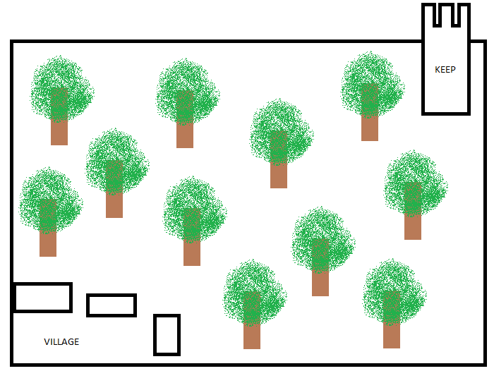

Provide an overview here.

World Layout Detail #1

World Layout Detail #2

Game Characters

Overview

Over of what your characters are.

Creating a Character

How you create or personalize your character.

Enemies and Monsters

Describe enemies or monsters in the world or whomever the player is trying to defeat. Naturally this depends heavily on your game idea but generally games are about trying to kill something.

User Interface

Overview

Provide some sort of an overview to your interface and same as all the previous sections, break down the components of the UI below.

User Interface Detail #1

User Interface Detail #2

Weapons

Overview

Overview of weapons used in game.

Weapons Details #1

Weapons Details #2

Musical Scores and Sound Effects

Overview

This should probably be broken down into two sections but I think you get the point.

Red Book Audio

If you are using Red Book then describe what your plan is here. If not, what are you using?

3D Sound

Talk about what sort of sound APIs you are going to use or not use as the case may be.

Sound Design

Take a shot at what you are going to do for sound design at this early stage. Hey, good to let your reader know what you are thinking.

Single-Player Game

Overview

Describe the single-player game experience in a few sentences.

Here is a breakdown of the key components of the single player game.

Single Player Game Detail #1

Single Player Game Detail #2

Story

Describe your story idea here and then refer them to an appendix or separate document which provides all the details on the story if it is really big.

Hours of Gameplay

Talk about how long the single-player game experience is supposed to last or what your thoughts are at this point.

Victory Conditions

How does the player win the single-player game?

Character Rendering

Overview

Provide an overview as to how your characters will be rendered. You may have decided to include this elsewhere or break it out to provide more detail to a specific reader.

Character Rendering Detail #1

Character Rendering Detail #2

World Editing

Overview

Provide an overview about the world editor.

World Editing Detail #1

World Editing Detail #2

Extra Miscellaneous Stuff

Overview

Drop anything you are working on and don’t have a good home for here.

Junk I am working on…

Crazy idea #1

Crazy idea #2

“XYZ Appendix”

Provide a brief description of what this appendix is for and then get down to business and provide data to the reader.

Here are a few examples of some of the appendices in my latest design…

“Objects Appendix”

“User Interface Appendix”

“Networking Appendix”

“Character Rendering and Animation Appendix”

“Story Appendix”

