ASSIGNMENT: REQUIREMENTS DOCUMENTATION AND DESIGN OF SOFTWARE/SYSTEM/APPLICATION

A Capstone Project
Presented to the Faculty of the
School of Computing
Holy Angel University



In Partial Fulfillment
of the Requirements for the Degree
Bachelor of Science in Information Technology with
Area of Specialization in Web Development

Kris Dane D. Madlambayan Oliver D. Sazon
Mikko E. Pangilinan Tsun Kit Wilson L. Yaochingco

July 2026

ConsultIO: Development of a Web-Based Faculty-Student Consultation and Appointment Scheduling System for the School of Computing of Holy Angel University

Kris Dane D. Madlambayan, Mikko E. Pangilinan, Oliver D. Sazon,
and Tsun Kit Wilson L. Yaochingco

Holy Angel University
Information Technology

Requirement Documentation
The Requirement Documentation section presents the requirements that will form the basis for the study’s design and development of the proposed ConsultIO: Development of a Web-Based Faculty-Student Consultation and Appointment Scheduling System for the School of Computing of Holy Angel University. The requirements specify the functions that the system should perform and the quality attributes that it should possess to ensure that it meets the needs of the stakeholders. The requirements were determined by carrying out a requirement analysis procedure with the targeted users and the host organization. The researchers conducted interviews, observations, and document reviews. The information gathered from the requirement analysis enabled the researchers to identify the functions that the system under study should perform as well as the quality attributes that must be met. This will facilitate designing, developing, implementing and evaluating the proposed ConsultIO web-based consultation and appointment scheduling system for the School of Computing of Holy Angel University, which will address the needs of the students, faculty, and administration in terms of consultation and appointment scheduling.

Functional Requirements
The functional requirements define the specific features and services that the proposed ConsultIO system must perform to meet the needs of its intended users. Table 1 presents the functional requirements of the proposed system, including the corresponding user roles, descriptions, and implementation priorities.
Functional Requirement | User / Role | Description | Priority
The system allows users to register using their official HAU email accounts. | Student, Faculty | Allows students and faculty members to create an account using their official @hau.edu.ph email addresses for identity verification. | High
The system allows users to securely log in to the system. | Student, Faculty, Administrator | Allows authorized users to access the system using their registered credentials after successful authentication. | High
The system allows students to view faculty consultation schedules. | Student | Allows students to view faculty consultation days, available time slots, and consultation availability. | High
The system allows students to request consultation appointments. | Student | Allows students to submit consultation requests by selecting a faculty member, consultation purpose, preferred date, and preferred time. | High
The system allows faculty members to manage consultation availability. | Faculty | Allows faculty members to create, update, or remove their available consultation schedules. | High
The system allows faculty members to approve, reject, or reschedule consultation requests. | Faculty | Allows faculty members to respond to consultation requests based on their availability. | High
The system allows students to upload supporting documents. | Student | Allows students to upload documents related to their consultation request before the scheduled consultation. | High
The system allows faculty members to view uploaded supporting documents. | Faculty | Allows faculty members to review the documents submitted by students before conducting the consultation. | High
The system allows users to receive appointment notifications and reminders. | Student, Faculty | Allows users to receive automated notifications regarding appointment requests, approvals, cancellations, schedule changes, and upcoming consultations. | High
The system allows students to view the status of consultation requests. | Student | Allows students to monitor whether their consultation requests are pending, approved, cancelled, completed, or rescheduled. | High
The system allows faculty members to record consultation notes and follow-up actions. | Faculty | Allows faculty members to document consultation discussions, recommendations, and post-consultation action items. | High
The system allows users to view consultation history. | Student, Faculty | Allows students and faculty members to access records of completed consultations for future reference. | High
The system allows administrators to monitor consultation activities. | Administrator | Allows administrators to monitor consultation appointments, consultation records, and consultation activities within the School of Computing. | High
The system allows administrators to view consultation statistics through a dashboard. | Administrator | Allows administrators to view consultation statistics and summary information through an administrative dashboard. | High
The system allows administrators to generate consultation reports. | Administrator | Allows administrators to generate reports containing consultation records and consultation activity summaries for monitoring purposes. | High
The system allows administrators to generate AI-assisted consultation report summaries. | Administrator | Allows administrators to generate AI-assisted summaries of consultation reports to support monitoring and decision-making within the School of Computing. | High
The system allows users to update their profile information. | Student, Faculty | Allows users to update their personal information such as profile picture and contact information, where applicable. | Medium
The system allows students to view assigned post-consultation action items. | Student | Allows students to monitor tasks, recommendations, and follow-up actions assigned by faculty members after consultations. | Medium
Table 1. Functional Requirements of the Proposed ConsultIO System

Non-Functional Requirements
The non-functional requirements define the quality attributes that the proposed ConsultIO: Development of a Web-Based Faculty-Student Consultation and Appointment Scheduling System for the School of Computing of Holy Angel University must possess to ensure that the system is secure, reliable, user-friendly, and efficient. These requirements establish the expected standards for system performance and overall quality, ensuring that the proposed system effectively supports the consultation and appointment scheduling process within the School of Computing. Table 2 presents the non-functional requirements of the proposed system.
Quality Attribute | Non-Functional Requirement | Description | Priority
Security | The system shall require users to authenticate using their official Holy Angel University email accounts before accessing protected features. | Ensures that only authorized students, faculty members, and administrators can access the system and its consultation records. | High
Usability | The system shall provide a user-friendly and intuitive web interface. | Enables users to easily navigate the system and perform consultation-related tasks with minimal learning effort. | High
Performance Efficiency | The system shall process user requests and display information within an acceptable response time under normal operating conditions. | Ensures efficient scheduling, record retrieval, and system navigation. | High
Reliability | The system shall accurately store, retrieve, and update consultation records and appointment information. | Ensures that consultation information remains complete, consistent, and available whenever needed. | High
Compatibility | The system shall be accessible using commonly used web browsers and devices with internet connectivity. | Allows users to access the system using different computers and supported web browsers. | Medium
Maintainability | The system shall be designed to support future updates, enhancements, and maintenance activities. | Enables developers to improve or modify the system without significantly affecting existing functionalities. | Medium
Confidentiality | The system shall restrict access to consultation records based on user roles and permissions. | Protects confidential consultation information from unauthorized access. | High
Availability | The system shall be available whenever users need to access consultation services through an internet connection. | Ensures continuous access to consultation scheduling and management services during normal operating periods. | High
Table 2. Non-Functional Requirements of the Proposed ConsultIO System
Design of Software/System/Application
The Design of Software/System/Application section highlights the initial technical design of the proposed ConsultIO: Development of a Web-Based Faculty-Student Consultation and Appointment Scheduling System for the School of Computing of Holy Angel University. It contains the information about how the proposed system will capture, process, and manage consultation data to facilitate student-faculty and administrator communication, consultation-related records, and appointment scheduling in a web-based environment to ensure confidentiality and convenience for the key stakeholders of the existing consultation process. Additionally, this section provides the system models, as one of the pivotal deliverables of the project, to demonstrate the information flow, key processes, database design and structure, and other relevant data organization concepts related to the designed ConsultIO system that will be developed to address the limitations of the current consultation process.

Appendix A. Use Case Diagram
Appendix A. Use Case Diagram
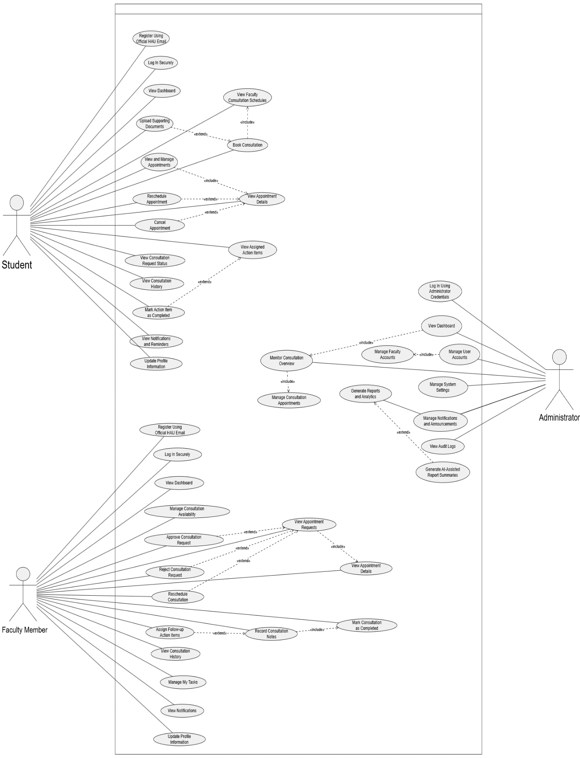

Appendix B. Context Diagram

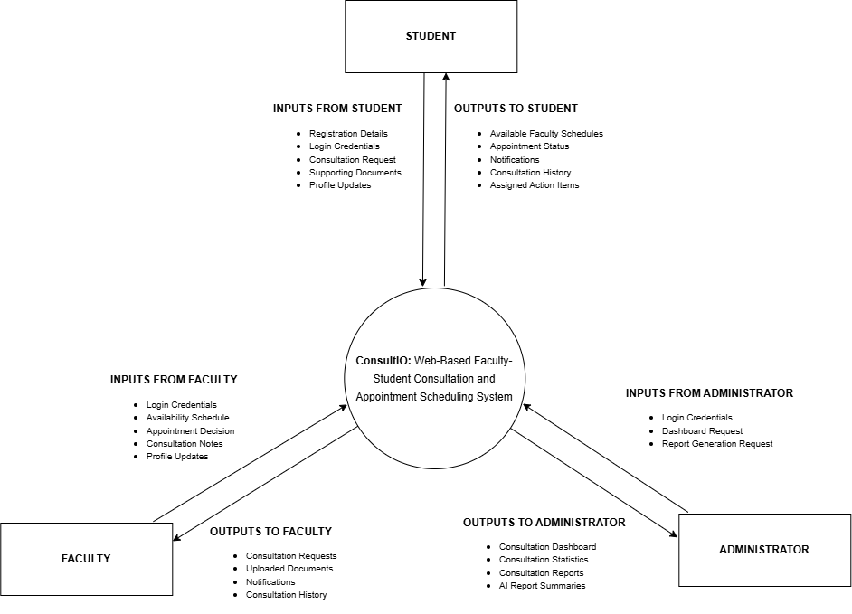
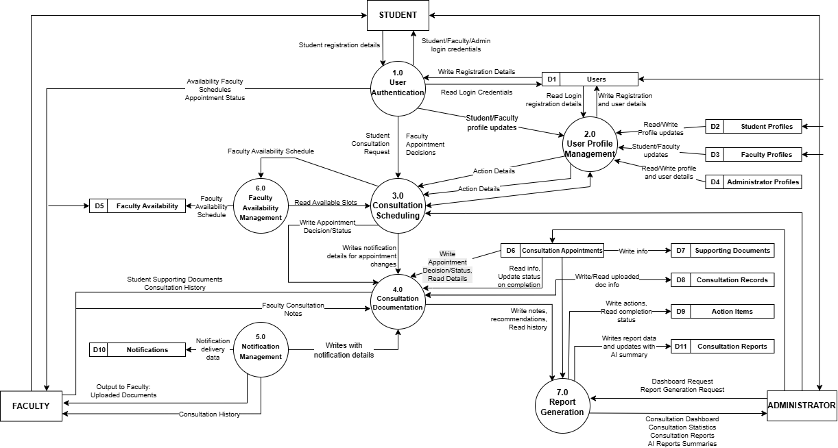
Appendix C. Level 0 Data Flow Diagram

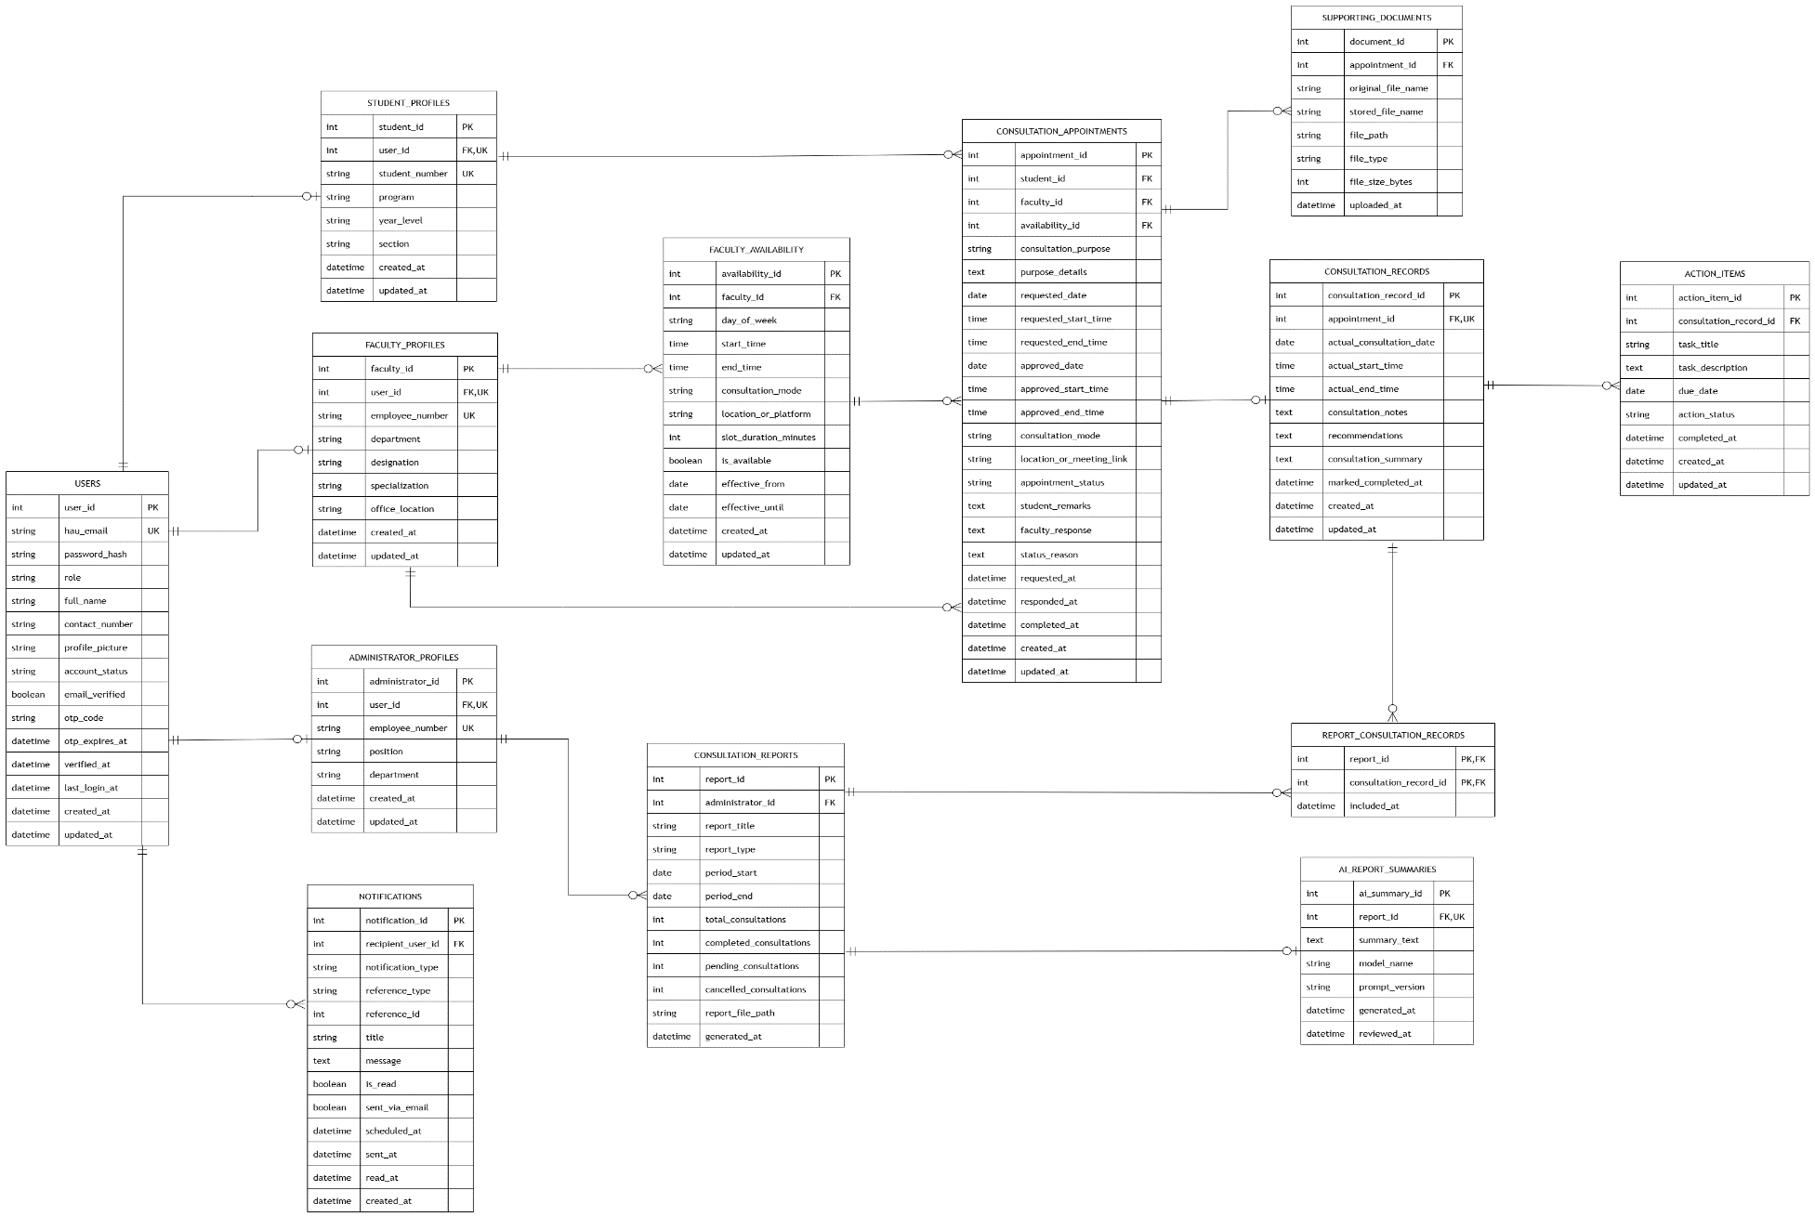
Appendix D. Entity Relationship Diagram (ERD)

Appendix E. Data Dictionary
Table/Entity | Field Name | Data Type | Size/Format | Key | Description
Users | user_id | Integer | Auto-increment | Primary Key | Unique identifier of each user account.
Users | hau_email | String | VARCHAR(150) | Unique Key | Official Holy Angel University email address used for registration, verification, and login.
Users | password_hash | String | VARCHAR(255) | — | Encrypted form of the user’s password.
Users | role | String | Student, Faculty, Administrator | — | Identifies the user’s role and system access privileges.
Users | full_name | String | VARCHAR(150) | — | Complete name of the user.
Users | contact_number | String | VARCHAR(30) | — | Contact number provided by the user.
Users | profile_picture | String | VARCHAR(255) | — | File path or location of the user’s profile image.
Users | account_status | String | Pending Verification, Active, Inactive | — | Indicates the current status of the user account.
Users | email_verified | Boolean | True/False | — | Indicates whether the official HAU email has been verified.
Users | otp_code | String | VARCHAR(10) | — | One-time password used for email verification.
Users | otp_expires_at | DateTime | YYYY-MM-DD HH:MM:SS | — | Date and time when the OTP expires.
Users | verified_at | DateTime | YYYY-MM-DD HH:MM:SS | — | Date and time when the email was successfully verified.
Users | last_login_at | DateTime | YYYY-MM-DD HH:MM:SS | — | Date and time of the user’s latest login.
Users | created_at | DateTime | YYYY-MM-DD HH:MM:SS | — | Date and time when the user account was created.
Users | updated_at | DateTime | YYYY-MM-DD HH:MM:SS | — | Date and time when the user account was last updated.
Student Profiles | student_id | Integer | Auto-increment | Primary Key | Unique identifier of each student profile.
Student Profiles | user_id | Integer | Whole number | Foreign Key, Unique Key | References the corresponding account in the Users entity.
Student Profiles | student_number | String | VARCHAR(50) | Unique Key | Official student identification number.
Student Profiles | program | String | VARCHAR(100) | — | Academic program of the student.
Student Profiles | year_level | String | VARCHAR(30) | — | Current academic year level of the student.
Student Profiles | section | String | VARCHAR(50) | — | Assigned class section of the student.
Student Profiles | created_at | DateTime | YYYY-MM-DD HH:MM:SS | — | Date and time when the student profile was created.
Student Profiles | updated_at | DateTime | YYYY-MM-DD HH:MM:SS | — | Date and time when the student profile was last updated.
Faculty Profiles | faculty_id | Integer | Auto-increment | Primary Key | Unique identifier of each faculty profile.
Faculty Profiles | user_id | Integer | Whole number | Foreign Key, Unique Key | References the corresponding account in the Users entity.
Faculty Profiles | employee_number | String | VARCHAR(50) | Unique Key | Official employee identification number of the faculty member.
Faculty Profiles | department | String | VARCHAR(100) | — | Department or academic unit of the faculty member.
Faculty Profiles | designation | String | VARCHAR(100) | — | Academic designation or position of the faculty member.
Faculty Profiles | specialization | String | VARCHAR(150) | — | Field or subject specialization of the faculty member.
Faculty Profiles | office_location | String | VARCHAR(100) | — | Assigned faculty office or consultation location.
Faculty Profiles | created_at | DateTime | YYYY-MM-DD HH:MM:SS | — | Date and time when the faculty profile was created.
Faculty Profiles | updated_at | DateTime | YYYY-MM-DD HH:MM:SS | — | Date and time when the faculty profile was last updated.
Administrator Profiles | administrator_id | Integer | Auto-increment | Primary Key | Unique identifier of each administrator profile.
Administrator Profiles | user_id | Integer | Whole number | Foreign Key, Unique Key | References the corresponding account in the Users entity.
Administrator Profiles | employee_number | String | VARCHAR(50) | Unique Key | Official employee identification number of the administrator.
Administrator Profiles | position | String | VARCHAR(100) | — | Administrative position, such as Chairperson or Dean.
Administrator Profiles | department | String | VARCHAR(100) | — | Department or academic unit overseen by the administrator.
Administrator Profiles | created_at | DateTime | YYYY-MM-DD HH:MM:SS | — | Date and time when the administrator profile was created.
Administrator Profiles | updated_at | DateTime | YYYY-MM-DD HH:MM:SS | — | Date and time when the administrator profile was last updated.
Faculty Availability | availability_id | Integer | Auto-increment | Primary Key | Unique identifier of each faculty availability schedule.
Faculty Availability | faculty_id | Integer | Whole number | Foreign Key | References the faculty member who created the schedule.
Faculty Availability | day_of_week | String | VARCHAR(15) | — | Day of the week when the faculty member is available.
Faculty Availability | start_time | Time | HH:MM:SS | — | Starting time of the available consultation period.
Faculty Availability | end_time | Time | HH:MM:SS | — | Ending time of the available consultation period.
Faculty Availability | consultation_mode | String | Face-to-Face or Online | — | Specifies the consultation mode supported by the schedule.
Faculty Availability | location_or_platform | String | VARCHAR(255) | — | Physical room or external online platform information.
Faculty Availability | slot_duration_minutes | Integer | Minutes | — | Duration of each consultation slot.
Faculty Availability | is_available | Boolean | True/False | — | Indicates whether the schedule is currently available for booking.
Faculty Availability | effective_from | Date | YYYY-MM-DD | — | Starting date when the availability schedule becomes effective.
Faculty Availability | effective_until | Date | YYYY-MM-DD | — | Ending date when the availability schedule remains valid.
Faculty Availability | created_at | DateTime | YYYY-MM-DD HH:MM:SS | — | Date and time when the availability schedule was created.
Faculty Availability | updated_at | DateTime | YYYY-MM-DD HH:MM:SS | — | Date and time when the availability schedule was last updated.
Consultation Appointments | appointment_id | Integer | Auto-increment | Primary Key | Unique identifier of each consultation appointment.
Consultation Appointments | student_id | Integer | Whole number | Foreign Key | References the student who submitted the request.
Consultation Appointments | faculty_id | Integer | Whole number | Foreign Key | References the faculty member requested for consultation.
Consultation Appointments | availability_id | Integer | Whole number | Foreign Key | References the selected faculty availability schedule.
Consultation Appointments | consultation_purpose | String | VARCHAR(255) | — | Main reason or subject of the consultation.
Consultation Appointments | purpose_details | Text | Variable length | — | Additional details regarding the consultation concern.
Consultation Appointments | requested_date | Date | YYYY-MM-DD | — | Consultation date initially requested by the student.
Consultation Appointments | requested_start_time | Time | HH:MM:SS | — | Starting time initially requested by the student.
Consultation Appointments | requested_end_time | Time | HH:MM:SS | — | Ending time initially requested by the student.
Consultation Appointments | approved_date | Date | YYYY-MM-DD | — | Final consultation date approved by the faculty member.
Consultation Appointments | approved_start_time | Time | HH:MM:SS | — | Final approved starting time.
Consultation Appointments | approved_end_time | Time | HH:MM:SS | — | Final approved ending time.
Consultation Appointments | consultation_mode | String | Face-to-Face or Online | — | Specifies how the consultation will be conducted.
Consultation Appointments | location_or_meeting_link | String | VARCHAR(255) | — | Physical room or external online meeting link.
Consultation Appointments | appointment_status | String | Pending, Approved, Rejected, Rescheduled, Cancelled, Completed | — | Current status of the appointment.
Consultation Appointments | student_remarks | Text | Variable length | — | Additional remarks submitted by the student.
Consultation Appointments | faculty_response | Text | Variable length | — | Response or instructions provided by the faculty member.
Consultation Appointments | status_reason | Text | Variable length | — | Reason for rejection, cancellation, or rescheduling.
Consultation Appointments | requested_at | DateTime | YYYY-MM-DD HH:MM:SS | — | Date and time when the request was submitted.
Consultation Appointments | responded_at | DateTime | YYYY-MM-DD HH:MM:SS | — | Date and time when the faculty member responded.
Consultation Appointments | completed_at | DateTime | YYYY-MM-DD HH:MM:SS | — | Date and time when the consultation was completed.
Consultation Appointments | created_at | DateTime | YYYY-MM-DD HH:MM:SS | — | Date and time when the appointment record was created.
Consultation Appointments | updated_at | DateTime | YYYY-MM-DD HH:MM:SS | — | Date and time when the appointment record was last updated.
Supporting Documents | document_id | Integer | Auto-increment | Primary Key | Unique identifier of each uploaded supporting document.
Supporting Documents | appointment_id | Integer | Whole number | Foreign Key | References the related consultation appointment.
Supporting Documents | original_file_name | String | VARCHAR(255) | — | Original name of the uploaded file.
Supporting Documents | stored_file_name | String | VARCHAR(255) | — | System-generated name used to store the file.
Supporting Documents | file_path | String | VARCHAR(500) | — | Server or storage location of the uploaded file.
Supporting Documents | file_type | String | VARCHAR(100) | — | File extension or MIME type.
Supporting Documents | file_size_bytes | Integer | Bytes | — | Size of the uploaded document in bytes.
Supporting Documents | uploaded_at | DateTime | YYYY-MM-DD HH:MM:SS | — | Date and time when the document was uploaded.
Consultation Records | consultation_record_id | Integer | Auto-increment | Primary Key | Unique identifier of each completed consultation record.
Consultation Records | appointment_id | Integer | Whole number | Foreign Key, Unique Key | References the related consultation appointment.
Consultation Records | actual_consultation_date | Date | YYYY-MM-DD | — | Actual date when the consultation was conducted.
Consultation Records | actual_start_time | Time | HH:MM:SS | — | Actual starting time of the consultation.
Consultation Records | actual_end_time | Time | HH:MM:SS | — | Actual ending time of the consultation.
Consultation Records | consultation_notes | Text | Variable length | — | Notes recorded by the faculty member.
Consultation Records | recommendations | Text | Variable length | — | Recommendations, instructions, or feedback provided during the consultation.
Consultation Records | consultation_summary | Text | Variable length | — | Brief summary of the completed consultation.
Consultation Records | marked_completed_at | DateTime | YYYY-MM-DD HH:MM:SS | — | Date and time when the consultation was marked as completed.
Consultation Records | created_at | DateTime | YYYY-MM-DD HH:MM:SS | — | Date and time when the consultation record was created.
Consultation Records | updated_at | DateTime | YYYY-MM-DD HH:MM:SS | — | Date and time when the consultation record was last updated.
Action Items | action_item_id | Integer | Auto-increment | Primary Key | Unique identifier of each post-consultation action item.
Action Items | consultation_record_id | Integer | Whole number | Foreign Key | References the related consultation record.
Action Items | task_title | String | VARCHAR(200) | — | Short title of the assigned task or follow-up activity.
Action Items | task_description | Text | Variable length | — | Detailed description of the post-consultation task.
Action Items | due_date | Date | YYYY-MM-DD | — | Deadline for completing the action item.
Action Items | action_status | String | Pending or Completed | — | Current completion status of the action item.
Action Items | completed_at | DateTime | YYYY-MM-DD HH:MM:SS | — | Date and time when the action item was completed.
Action Items | created_at | DateTime | YYYY-MM-DD HH:MM:SS | — | Date and time when the action item was created.
Action Items | updated_at | DateTime | YYYY-MM-DD HH:MM:SS | — | Date and time when the action item was last updated.
Notifications | notification_id | Integer | Auto-increment | Primary Key | Unique identifier of each notification.
Notifications | recipient_user_id | Integer | Whole number | Foreign Key | References the user who receives the notification.
Notifications | notification_type | String | VARCHAR(50) | — | Category of the notification, such as request, approval, reminder, or cancellation.
Notifications | reference_type | String | VARCHAR(50) | — | Identifies the type of related system record.
Notifications | reference_id | Integer | Whole number | — | Identifier of the related appointment, action item, or consultation record.
Notifications | title | String | VARCHAR(200) | — | Subject or short title of the notification.
Notifications | message | Text | Variable length | — | Complete notification message.
Notifications | is_read | Boolean | True/False | — | Indicates whether the notification has been viewed.
Notifications | sent_via_email | Boolean | True/False | — | Indicates whether the notification was also sent through email.
Notifications | scheduled_at | DateTime | YYYY-MM-DD HH:MM:SS | — | Date and time when the notification is scheduled for delivery.
Notifications | sent_at | DateTime | YYYY-MM-DD HH:MM:SS | — | Date and time when the notification was sent.
Notifications | read_at | DateTime | YYYY-MM-DD HH:MM:SS | — | Date and time when the notification was marked as read.
Notifications | created_at | DateTime | YYYY-MM-DD HH:MM:SS | — | Date and time when the notification record was created.
Consultation Reports | report_id | Integer | Auto-increment | Primary Key | Unique identifier of each consultation report.
Consultation Reports | administrator_id | Integer | Whole number | Foreign Key | References the administrator who generated the report.
Consultation Reports | report_title | String | VARCHAR(200) | — | Descriptive title of the consultation report.
Consultation Reports | report_type | String | VARCHAR(50) | — | Category of report, such as consultation summary, workload, or appointment statistics.
Consultation Reports | period_start | Date | YYYY-MM-DD | — | Starting date of the reporting period.
Consultation Reports | period_end | Date | YYYY-MM-DD | — | Ending date of the reporting period.
Consultation Reports | total_consultations | Integer | Whole number | — | Total number of consultations included in the report.
Consultation Reports | completed_consultations | Integer | Whole number | — | Number of completed consultations in the report.
Consultation Reports | pending_consultations | Integer | Whole number | — | Number of pending consultation requests in the report.
Consultation Reports | cancelled_consultations | Integer | Whole number | — | Number of cancelled consultations in the report.
Consultation Reports | report_file_path | String | VARCHAR(500) | — | Storage location of the generated report file.
Consultation Reports | generated_at | DateTime | YYYY-MM-DD HH:MM:SS | — | Date and time when the report was generated.
Report Consultation Records | report_id | Integer | Whole number | Composite Primary Key, Foreign Key | References the consultation report.
Report Consultation Records | consultation_record_id | Integer | Whole number | Composite Primary Key, Foreign Key | References a consultation record included in the report.
Report Consultation Records | included_at | DateTime | YYYY-MM-DD HH:MM:SS | — | Date and time when the consultation record was included in the report.
AI Report Summaries | ai_summary_id | Integer | Auto-increment | Primary Key | Unique identifier of each AI-assisted summary.
AI Report Summaries | report_id | Integer | Whole number | Foreign Key, Unique Key | References the consultation report summarized by the system.
AI Report Summaries | summary_text | Text | Variable length | — | AI-generated abridged summary of the consultation report.
AI Report Summaries | model_name | String | VARCHAR(100) | — | Name or identifier of the AI model used.
AI Report Summaries | prompt_version | String | VARCHAR(50) | — | Version of the summarization prompt used by the system.
AI Report Summaries | generated_at | DateTime | YYYY-MM-DD HH:MM:SS | — | Date and time when the AI-assisted summary was generated.
AI Report Summaries | reviewed_at | DateTime | YYYY-MM-DD HH:MM:SS | — | Date and time when the summary was reviewed by an authorized administrator.

