ASSIGNMENT: METHODOLOGY AND REQUIREMENTS ANALYSIS

A Capstone Project
Presented to the Faculty of the
School of Computing
Holy Angel University



In Partial Fulfillment
of the Requirements for the Degree
Bachelor of Science in Information Technology with
Area of Specialization in Web Development

Kris Dane D. Madlambayan Oliver D. Sazon
Mikko E. Pangilinan Tsun Kit Wilson L. Yaochingco

July 2026

ConsultIO: Development of a Web-Based Faculty-Student Consultation and Appointment Scheduling System for the School of Computing of Holy Angel University

Kris Dane D. Madlambayan, Mikko E. Pangilinan, Oliver D. Sazon,
and Tsun Kit Wilson L. Yaochingco

Holy Angel University
Information Technology

Methodology
The software development methodology that will be used in this capstone project is the Evolutionary Prototyping Model, one of the Prototyping Software Development Methodology. The evolutionary prototyping model emphasizes the need for creating an initial version of the proposed system which is then refined and developed according to the feedback received from the identified target users until the final version is accomplished. The abovementioned methodology was chosen by the researchers to develop, design, test and evaluate ConsultIO: Development of a Web-Based Faculty-Student Consultation and Appointment Scheduling System for the School of Computing of Holy Angel University to ensure that the product’s features, UI/UX design, and overall performance would successfully address the identified consultation and appointment scheduling needs of the faculty, students, and the school administrators.
The Evolutionary Prototyping model is a software development approach that requires building the initial prototype that satisfies the specified user requirements during the early stages of development. The created prototype is given to the users for evaluation and approval; this means that the prototype’s features and design are further improved based on the received feedback and approved. According to Pressman and Maxim (2020), prototyping is a technique that helps developers and users understand software requirements through an initial version of the system under development, which is further improved based on evaluation and iterative refinement. In other words, evolutionary prototyping requires constant development and improvement of the prototype until it takes its final form. I believe that evolutionary prototyping is beneficial because unclear or changing requirements can be identified at an early stage, some aspects of the system can be improved in accordance with some users’ problems or issues during development, and the final system will perfectly match the users’ needs.

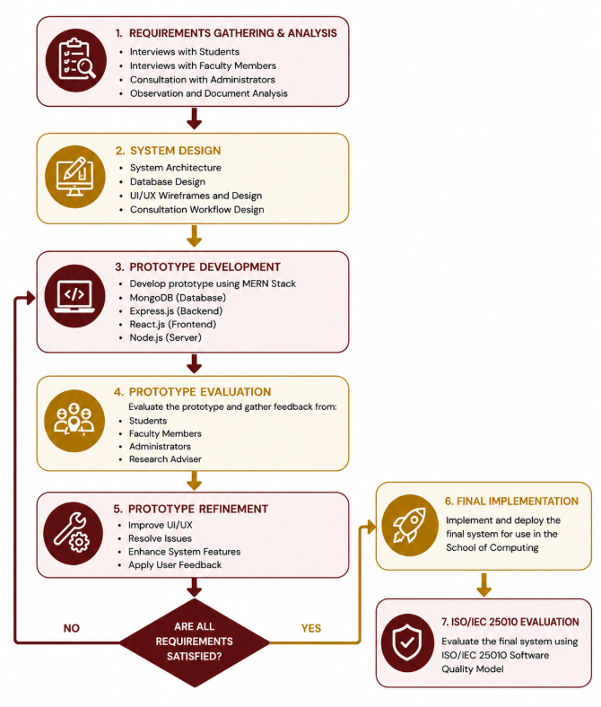
Figure 2. Evolutionary Prototyping Model Applied in the Development of ConsultIO: Development of a Web-Based Faculty-Student Consultation and Appointment Scheduling System for the School of Computing of Holy Angel University
As shown in Figure 2, the researchers utilized the Evolutionary Prototyping Model in developing ConsultIO. First, they engaged in a process of requirements gathering and analysis. In this phase, the information was gathered through interviews, observations, and document analysis in order to understand what the system should be able to do. The information was gathered from both students and faculty members. Secondly, the researchers moved on to the system design. In this phase, they had to conceptualize the system architecture, design the database, develop the user interface, and design the consultation process. Following the system design, the researchers built the first prototype of the system using the MERN Stack (MongoDB, Express.js, React.js, and Node.js). After developing the first prototype, it was presented to the target users and the research adviser for evaluation. During the evaluation, the target users and the adviser provided feedback on the system functions, features, and interface. The feedback was used during the prototype improvement phase, during which the prototype was modified several times until all requirements were met. Lastly, after the prototype was approved by the target users and the adviser, the researchers will develop the final system. The final system will then be evaluated against the ISO/IEC 25010 Software Quality Model in order to assess its overall software quality. Overall, it is expected that the final system will be able to address the issues of consultation and appointment scheduling within the School of Computing of Holy Angel University.
The researchers decided to use the Evolutionary Prototyping Model for the development of the ConsultIO project due to its appropriateness and effectiveness for the system and the research. According to Pressman and Maxim (2020), the Prototyping Model is a software development method best suited for systems in which customers are unclear about their requirements and/or they are expected to change throughout the development cycle. The researchers believe that this method is appropriate for ConsultIO: Development of a Web-Based Faculty-Student Consultation and Appointment Scheduling System for the School of Computing of Holy Angel University since the end-users of the system would have varying degrees of involvement in the development process. The system will serve the students, faculty members, and administrators of the School of Computing, and each of them has different expectations and requirements regarding the consultation process. The researchers also identified that ConsultIO, which is designed to feature user authentication, appointment and faculty availability management, student record submission, consultation records, notification system, consultation history, and administrative dashboard with AI consultation report summary features, requires extensive end-user involvement. Since these systems would be used by different categories of users, it is only reasonable that their requirements must be addressed to achieve a working concept that could meet the needs of the School of Computing. ConsultIO is primarily intended to address the challenges in the current consultation procedure in the school. Currently, consultation processes between faculty members and students are conducted via e-mail using the official HAU e-mail addresses as well as through different messengers. This method has resulted in manual, slow processing of requests, schedule clashes, and lack of uniformity and control in the management of consultation records. However, the researchers cannot be entirely certain that the requirements specified for ConsultIO are entirely suitable for addressing the problems or that they will not change as the users evaluate the prototypes (Pressman & Maxim, 2020). Due to the evolutionary nature of the prototyping model, the researchers can first develop an initial prototype, solicit feedback from the end-users, and continue modifying and testing the same prototype until it meets the requirements. ConsultIO will then be a fully-developed and functional software application fit for purpose and satisfying all the requirements for a consultation system for the School of Computing. In conclusion, the researchers chose the Evolutionary Prototyping Model for the development of ConsultIO due to its suitability for the scope and purpose of the system in question.
The researchers will adopt the Evolutionary Prototyping Model in developing ConsultIO: Development of a Web-Based Faculty-Student Consultation and Appointment Scheduling System for the School of Computing of Holy Angel University by considering the Evolutionary Prototyping Model’s phases. The researchers will first embark on a requirements gathering and analysis wherein they will solicit the input of respondents, including students, faculty members, and administrators, through interviews, observations, and document analysis necessary to understand the current consultation process, requirements, and features. After obtaining the requirements, the researchers will then formulate a rapid design based on the information gathered from the previous step, which will include developing the system’s overall architecture, databases, and interfaces. The researchers will develop a working prototype after rapid design using the MERN Stack (MongoDB, Express.js, React.js, and Node.js) to build and deploy the application. The proposed system will be designed around eight (8) critical features: HAU email authentication, consultation appointment scheduling, faculty availability management, document submission, consultation records, reminders, consultation history, and the administrative dashboard. The next step will involve the prototyping presentation wherein they will present the working prototype to students, faculty members, administrators, and the research adviser to obtain their feedback on the proposed system’s functionalities, interfaces, and performance. Lastly, the researchers will revise and enhance the initial prototype based on the comments and suggestions provided by the target users and the research adviser. They will continue iterating the prototype in subsequent cycles until it meets the required standard, specifications, and expectations. Once satisfied with the final version of the prototype, they will proceed to implement and evaluate the final product using the ISO/IEC 25010 Software Quality Model. Overall, using the Evolutionary Prototyping Model allows the researchers to continually refine the prototype until they achieve a system that perfectly addresses the needs of the target users.
Requirements Analysis
The target host organization of the proposed system is the School of Computing (SOC) of Holy Angel University (HAU), a private institution of higher learning located in Angeles City, Pampanga. This organization offers bachelor’s degree programs in Information Technology, Computer Science, and Information Systems, and is tasked to provide quality computing education and academic services to students through the faculty’s advisory, research and capstone guidance, consultancy and internship assistance, and consultation services. Such consultation services give opportunity for students to seek assistance from faculty advisors and members regarding their queries, concerns and inquiries on subjects, programming and research, thesis and capstone projects, internships, and other school-related requirements and issues. Currently, the coordination of consultation services within the said department is done through official Holy Angel University’s email account and messenger platforms, and requires students and faculty members to manually set appointments and correspondence pertaining to consultation. Due to the absence of centralized consultation management system specifically for the School of Computing, the abovementioned procedures pose several limitations and issues, which concern delay in response, overlapping consultation schedules, lack of consultation documentation accessibility, absence of record-keeping of prior consultation, and inadequate monitoring of consultation activities and records, which impede the faculty’s and students’ ability to communicate efficiently and effectively. Thus, the School of Computing was selected as the target host organization for this proposed system, ConsultIO: Faculty-Student Consultation and Appointment Scheduling System. ConsultIO is a web-based application designed to manage and monitor consultation services between students and faculty members, and provides features including but not limited to appointment setting through students’ official Holy Angel University’s email account, submission of documents prior to consultation, automated notification system, and consultation history monitoring for students; personal schedule management, appointment approval and rejection, consultation note-taking, post-consultation follow-up, and record keeping for faculty members; and consultation monitoring, statistical analysis, and artificial intelligence consultation report reviewing features for School Chairperson, Dean, and other authorized administrator. Therefore, by considering the relevance of the proposed system and its features to the target host organization’s needs and requirements, it can be concluded that the School of Computing serves as an ideal target host organization for ConsultIO, as its organizational structure, processes and procedures, consultation services, and user requirements are taken into account in developing this proposed system.
The proposed information system, ConsultIO, will be utilized among three categories of users: students, faculty members, and administrators. Ideally, students, who will be the primary users of the system, will apply to the account using their @hau.edu.ph email addresses. This is to ensure that only Holy Angel University students can use the system. Having successfully registered and logged in into the system, students will be able to view consultation schedules of faculty members, request consultation appointments based on the available slots, upload documents necessary for their requested consultation, receive email updates for their submitted requests, view the status of their pending consultation requests, check consultation history, and view post-consultation action items if applicable. Generally, students will use the system to view consultation-related information conveniently and be reminded of their consultation-related tasks without having to use email or messaging services. Faculty members will, on the other hand, constitute the second category of users within the new system. The users will apply the system to set consultation schedules, mark consultation slots as available, view and approve or reject consultation requests, view student-submitted documents for consultation meetings, record consultation details including any subsequent action items, and mark consultations as completed. These features will offer faculty members the ability to manage consultation requests while ensuring that there are no scheduling overlaps and ensuring total record of all consultations. The third category of users will comprise administrators, including potentially the School of Computing Chairperson or Dean. The administrators will be tasked with the role of overseeing all activities related to consultation within the School. As such, it is recommended that the administrators have a dashboard where they can view consultation statistics, view consultation records, and generate reports on consultation-related activities. Additionally, the administrators may use AI consultation report summaries to generate brief overviews of consultation activities within a specified period. These features will enhance the ability of administrators to oversee consultation activities while also enabling them to review the general consultation load of faculty members and make evidence-based decisions. Collectively, the three categories of users will benefit from the proposed information system to ensure effective communication and coordination of consultation activities within the School of Computing, Holy Angel University.
At present, the consultation process of SOC of Holy Angel University is done through e-mail addresses of the university and various communication platforms such as Microsoft teams, outlook, canvas and other messaging platforms. The current consultation process of SOC is considered semi automated since communication takes place electronically but consultation scheduling, coordination, confirmation and record keeping processes are done manually by the students and faculty members. There is no integrated consultation management system in SOC that manages consultation records, monitors the availability of consultation slots for the faculty members, facilitates the scheduling of consultation appointments and automates consultation appointment reminders. Students are required to request consultation on their own by identifying the faculty member they wish to consult and informing them via emails and other messaging platforms. Upon receiving a consultation request, the faculty member reviews the request, monitors their academic and personal schedule and informs the student regarding the availability of the requested consultation time slot. In case the requested time is not available, the faculty member proposes another available time for consultation. The student then confirms the consultation time and date in agreement with their faculty member. Students can also send additional documents regarding their consultation request via emails and other online communication platforms once the consultation time and date have been set up before conducting consultations physically or virtually via MS teams. Following the consultation, faculty members provide recommendations, instructions, feedback, or follow-up activities, while consultation information and related documents remain stored only within email conversations, Microsoft Teams messages, or other communication platform records. The current process primarily involves students, faculty members, and, indirectly, School of Computing administrators, who have limited visibility over consultation activities because consultation records are dispersed across multiple communication platforms. As illustrated in Appendix B (Current Process Flowchart), the consultation process follows several manual coordination steps from consultation request to consultation completion, resulting in a workflow that depends heavily on continuous communication between students and faculty members. Although existing communication platforms facilitate information exchange, they do not provide integrated features for centralized appointment scheduling, consultation record management, automated notifications, consultation history tracking, document management, or administrative monitoring, thereby creating the need for the proposed ConsultIO system.
The current state of consultation process in the School of Computing of Holy Angel University lacks efficiency in many aspects. Since consultation requests are being coordinated via emails using the university’s official HAU email address or other messengers such as Teams, Outlook, Canvas and other communication tools, the consultation process may lead to delays in response from faculty members, consultation scheduling conflicts or denied scheduled time if a faculty member is not available and requires to reschedule, and lack of a centralized database of consultation records, documents, and instructions. Additionally, there is a need to ensure that the faculty consultation load or records are monitored by the school administrator, which requires time and effort in managing communications between students and faculty using different mediums for consultation. Therefore, a centralized web-based consultation and appointment system must be utilized to centralize consultation, manage consultation appointments and records, notify students and faculty members, and monitor consultation activities within the School of Computing.
The proposed information system, ConsultIO, will require the collection, processing, storage, and generation of various data to support the consultation and appointment scheduling process of the School of Computing of Holy Angel University. ConsultIO will collect user data, including the user’s official @hau.edu.ph email, name, student or employee ID, user category (i.e., student, faculty member, and administrator), and account credentials for authentication and authorization purposes. To support the appointment scheduling process, the information system will process and store consultation request data such as the requested faculty member, consultation purpose, preferred consultation date and time, faculty availability, appointment status, and schedule confirmation or updates. In addition, the information system will collect, process, and store students’ uploaded documents before their consultation requests, consultation notes from faculty members, consultation history, follow-up tasks and actions, and automated appointment request and schedule notification records. ConsultIO will also generate consultation records, consultation reports (e.g., statistics), and administrative reports necessary for the monitoring and evaluation process of the School of Computing’s consultation service by the authorized administrators. The administrative module of the information system will generate AI-assisted consultation reports based on the records of consultation requests processed in the system to provide a brief summary of the consultation activity while supporting the evaluation and monitoring process of the School of Computing’s consultation service. Overall, the data collected, processed, stored, and generated by ConsultIO will support the information system’s intended purpose of providing secure access to the consultation service, organizing and managing consultation requests and records, and supporting the monitoring and evaluation of the School of Computing’s consultation and appointment scheduling process to address the identified inefficiencies in the current consultation process.
The researchers can gather the required information about the system requirements of ConsultIO by conducting interviews, observation, and document analysis from the target users of the proposed system and the host organization, especially the School of Computing of Holy Angel University. The researchers can conduct interviews with the selected faculty members, students, and administrators who can provide information and requirements for the proposed system. The researchers can perform observations to understand and document the current process of consultation appointments, including how the faculty members set up their consultation schedules, how students communicate with the faculty members in requesting consultation via their official hau email, teams, outlook, canvas, or other messenger apps, and how student requests for consultation are processed. The researchers can also perform document analysis from the available documents, forms, guidelines, emails, or data that give insights into information that needs to be included in the scope of the proposed system from the target organization. These research methods would be able to produce the required information needed by the researchers because they can directly contact and interact with the target participants to identify and gather the necessary information from them. Furthermore, using multiple data-gathering methods allows the researchers to validate the collected information, gain a better understanding of the operational requirements of the School of Computing, and ensure that the proposed system is designed according to the actual needs of its intended users while effectively addressing the limitations of the existing consultation process.
References
HOME. (2026). Retrieved July 27, 2026, from HAU website: https://www.hau.edu.ph/contacts
HOME. (2026). Retrieved July 27, 2026, from HAU website: https://www.hau.edu.ph/admissions/registrar-forms
HOME. (2026). Retrieved July 27, 2026, from HAU website: https://www.hau.edu.ph/services/academic-records
Peralta Community College District. (2021, January). Technology master plan 2021– 2026. https://www.peralta.edu/hubfs/PCCD-TMP-2021-2026-1.pdf
Botangen, K. A., & Khan, C. L. (2014). Class-Scheduling System for the Central Luzon State University(Abridged). ResearchGate. https://doi.org/10.13140/RG.2.2.12729.57445
Fatima, M., Arguelles, A., Zedrick Arsolon, K., Kylha, M., Daban, A., Lualhati, V., … Pineda. (2025). FGM Track: A Web-Based Appointment and Payment System for Faye Gumabay-Magalona Dental Clinic using Rule-Based Algorithms and Integrated Data Analytics. Retrieved from https://rsisinternational.org/journals/ijrias/uploads/vol10-iss10-pg931-941- 202511_pdf.pdf
nikhilsreejith7. (2026). Major Project Report. Retrieved July 27, 2026, from Scribd website: https://www.scribd.com/document/781819239/Major-Project-Report
Anchal Das, Sandhyarani Sahoo, & Smruti Smaraki Sarangi. (2026). Smart Doctor Appointment Booking and Patient Management System Using MERN Stack. American Journal of AI Cyber Computing Management, 6(2(2)), 112–119. https://doi.org/10.64751/ajaccm.2026.v6.n2(2).602
Sehgal, H., Jha, D., & Bhushan, S. (2024). Doctor Appointment Booking System using MERN stack. Zenodo. https://doi.org/10.5281/zenodo.12107644
Mark Angelo M. Dela Fuente, Joshua A. Facunla, Hannah Noreen F. De Guzman, Emille F. Jacinto, Justine B. Hilario, Cris Norman P. Olipas, & Angelito I. Cunanan. (2023). Project Clinik: A Cross-Platform Scheduling and Appointment Reservation System. Formosa Journal of Computer and Information Science, 2(1), 13–24. https://doi.org/10.55927/fjcis.v2i1.4077
Antipuesto, D.J. (2015) Manual Healthcare System and Computer Information System. - References - Scientific Research Publishing. (2023). Retrieved July 27, 2026, from Scirp.org website: https://www.scirp.org/reference/referencespapers?referenceid=3483292
Ramprasad, S. (2026). Bookmydoc: Online Doctor Booking and Patient Care Using Mern Stack. International Journal of Innovative Research in Technology, 12, 2349–6002. Retrieved from https://ijirt.org/publishedpaper/IJIRT199551_PAPER.pdf
Manarte, L. (2024). Technology and Access to Healthcare with Different Scheduling Systems: A Scoping Review. Healthcare Informatics Research, 30(3), 194– 205. https://doi.org/10.4258/hir.2024.30.3.194
Anam, K., Asyhar, B., Saddhono, K., & Setyawan, B. W. (2021). E-SIP: Website- Based Scheduling Information System to Increase the Effectivity of Lecturer's Performance and Learning Process. Ingénierie des Systèmes d’Information, 26(3), 265–273. https://doi.org/10.18280/isi.260303
Ampuan, A. D., & Delena, R. D. (2022). An Implementation and Evaluation of Web- Based Appointment System for the Mindanao State University – Main Campus. Journal of Information Systems and Informatics, 4(4), 922–937. https://doi.org/10.51519/journalisi.v4i4.379
Chio, M. E. B., Dal, P. M. M., Garrido, J. L., Baldelovar, A., & Saledaien, J. V. M. (2022). THESISIT: Web-Based University Thesis Management Portal with a Defense Scheduling System. Science International (Lahore), 34(6), 531–536. https://www.sci-int.com/pdf/638059414876779028.7%20531- 536%20Ma.%20Esther%20B.%20Chio%20Thesis-6.12-22..pdf

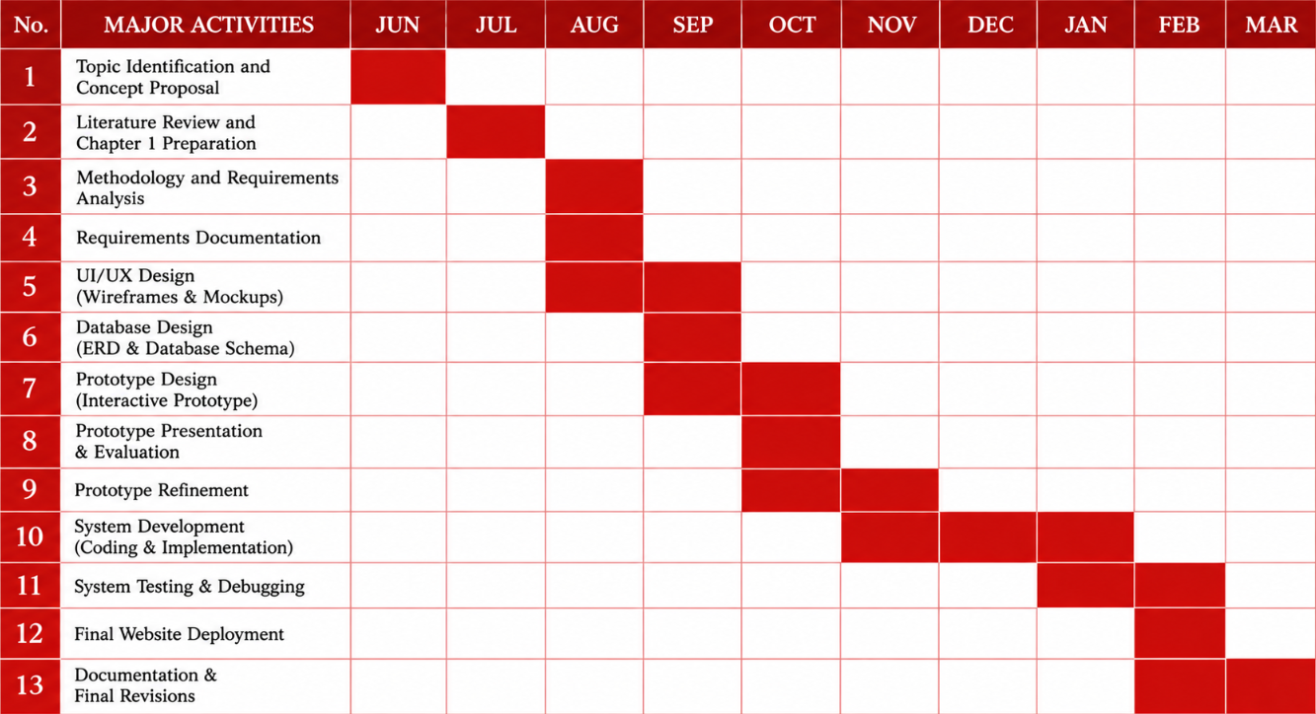

Appendix A. Gantt Chart

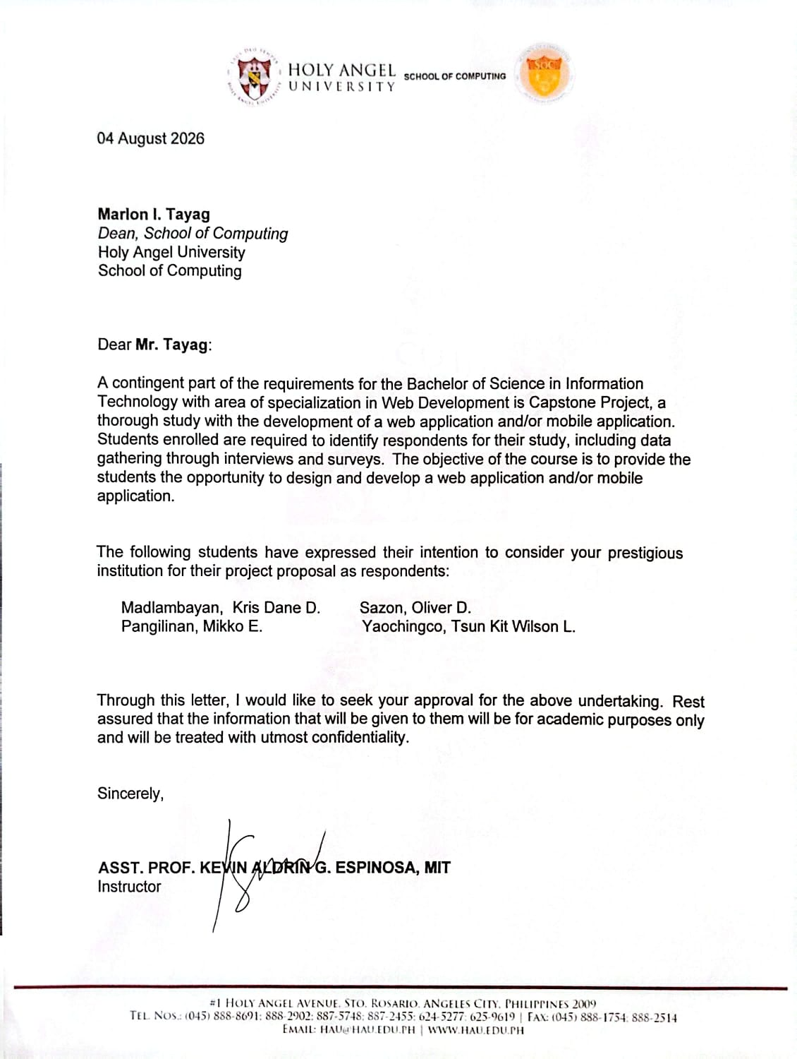
Appendix B. Cover Letter to Host/Locale

Appendix C. Current Process Flowchart
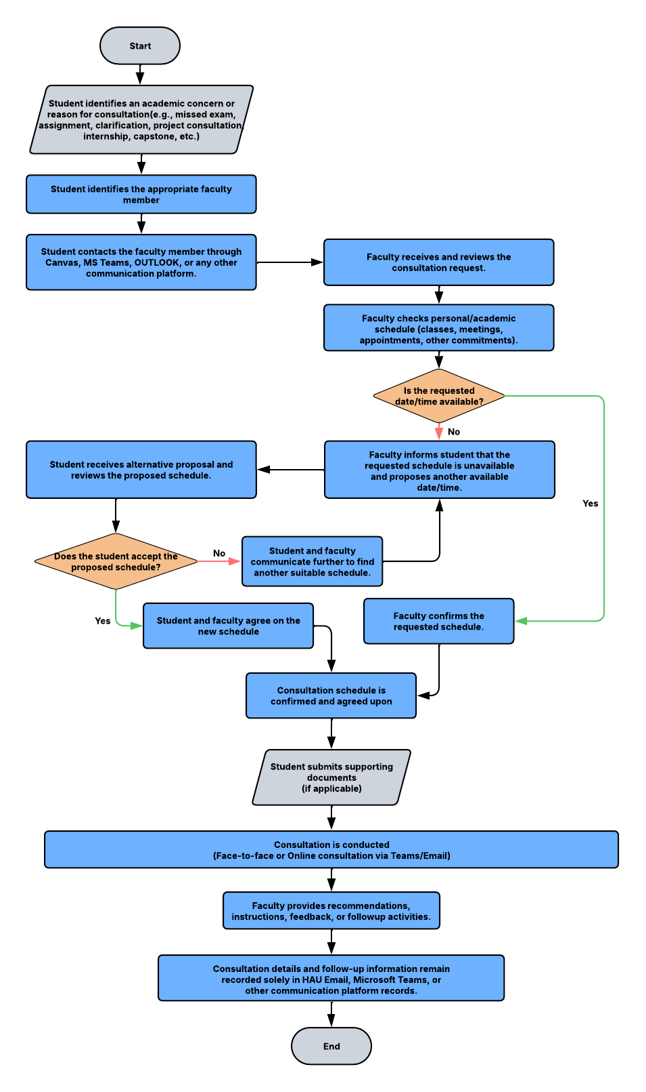

Appendix D. Existing Files, Forms, or Manuals
As of the moment of the preparation of this proposal, the proponents have yet to perform the requirement-gathering activities for the School of Computing of Holy Angel University. Consequently, no consultation forms or manuals have been acquired. From the perspective of the proponents, academic consulting is mostly performed via email or Microsoft Teams or other communication means. The presence of standard consultation documents will be checked during the requirement-gathering stage. Should they not be present, the system requirements will be determined through interviews, observations, and document analyses with the future users of the suggested system.

