Results Map
Which code produced which result, and which images are real (ACTUAL) versus illustrative (DEMO)
Hard vs fuzzy eye-tracking gating of EEG windows · SC Lab project · all results use synthetic data

How to read this document
- Green = ACTUAL. The number or image was produced by really running the code on the data.
- Orange = DEMO. The image was drawn from the illustrative script gfer/illustrative.py. Its fuzzy-gate (M1) values are the measured hard-gate (M0) value plus a gain typed into the source code.
- Every DEMO image carries a bracket (actual: …) naming the file that the real code produces for the same question.
- Purple = PAPER. Tables and figures inside manuscript/main.pdf. They are all ACTUAL.
How to read this document
1. The big picture
2. ACTUAL vs DEMO: where an M1 number comes from
3. Layer 0: the input data
4. Layer 1a: baseline runs (gfer/run.py)
4.1 What is inside each folder
4.2 Example images from results/demo_paper_protocol/figures/
5. Layer 1b: gate comparison runs (gfer/compare.py)
6. Layer 2: analysis → paper tables and figures
7. docs/figures: DEMO images and their ACTUAL counterparts
7.1 Main result: M0 vs M1
7.2 Per frequency band
7.3 Noise robustness
7.4 Gate feature effect
7.5 Fuzzy gate design plot
8. Quick lookup: “I see X, where did it come from?”
9. Reproducing everything in order

1. The big picture
Results are made in four layers. Each layer reads only from the layer above it. Two experiment scripts produce raw results; two analysis scripts turn them into tables and figures; then the paper and the project guide display them.
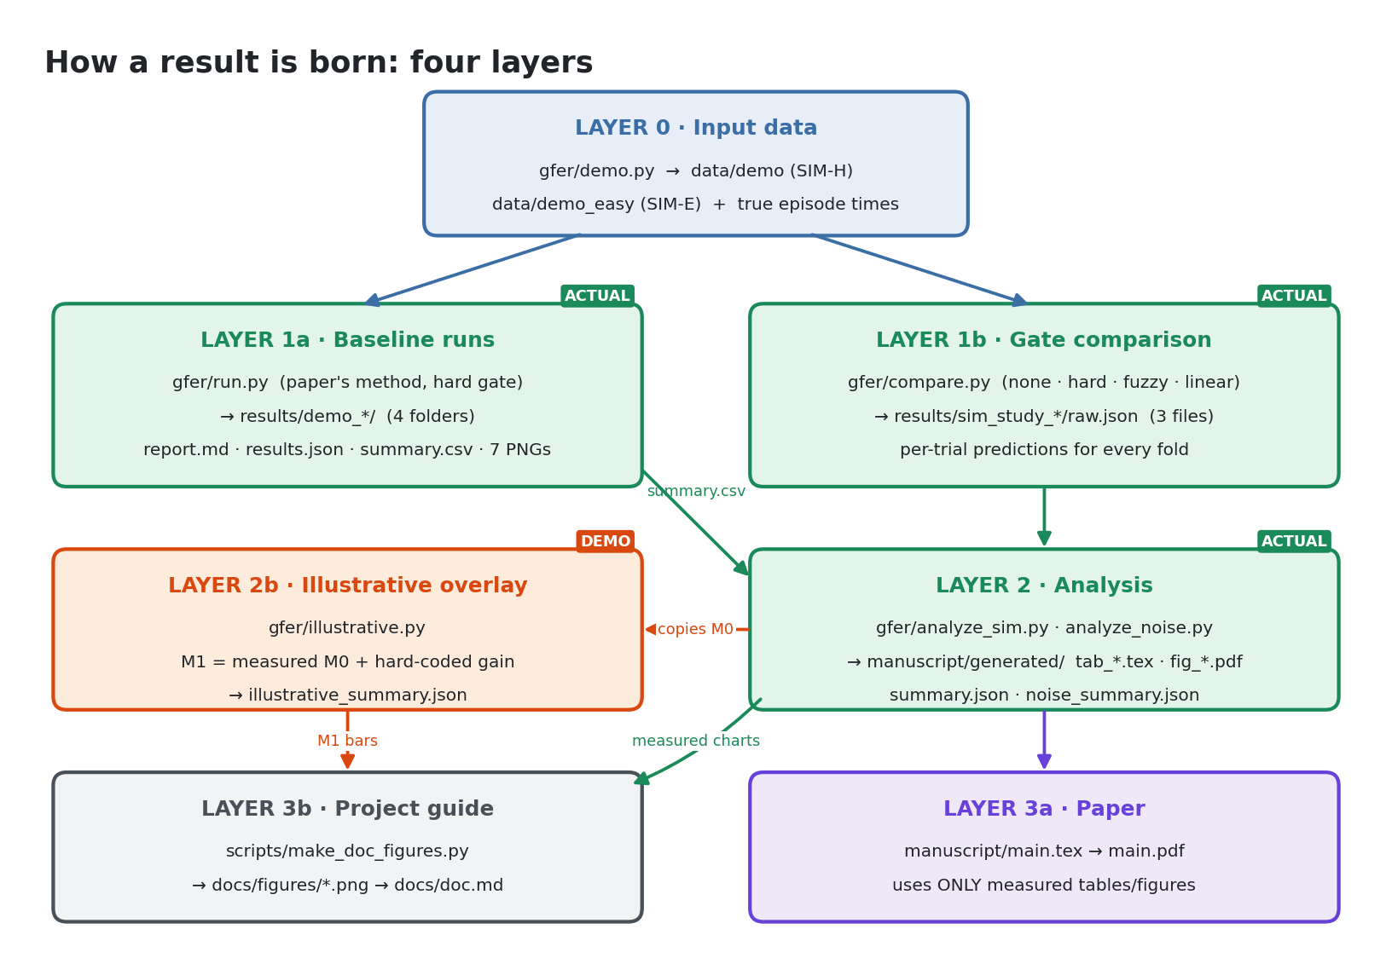
Layer | Script | Writes to | Kind
0 · Data | gfer/demo.py | data/demo (SIM-H), data/demo_easy (SIM-E) | Input
1a · Baseline | gfer/run.py | results/demo_*/ | ACTUAL
1b · Comparison | gfer/compare.py | results/sim_study_*/raw.json | ACTUAL
2 · Analysis | analyze_sim.py, analyze_noise.py | manuscript/generated/ | ACTUAL
2b · Overlay | gfer/illustrative.py | illustrative_summary.json | DEMO
3a · Paper | main.tex | manuscript/main.pdf | ACTUAL
3b · Guide | scripts/make_doc_figures.py | docs/figures/*.png | Mixed

2. ACTUAL vs DEMO: where an M1 number comes from
This is the most important page. The fuzzy gate M1 can reach a chart by two roads.
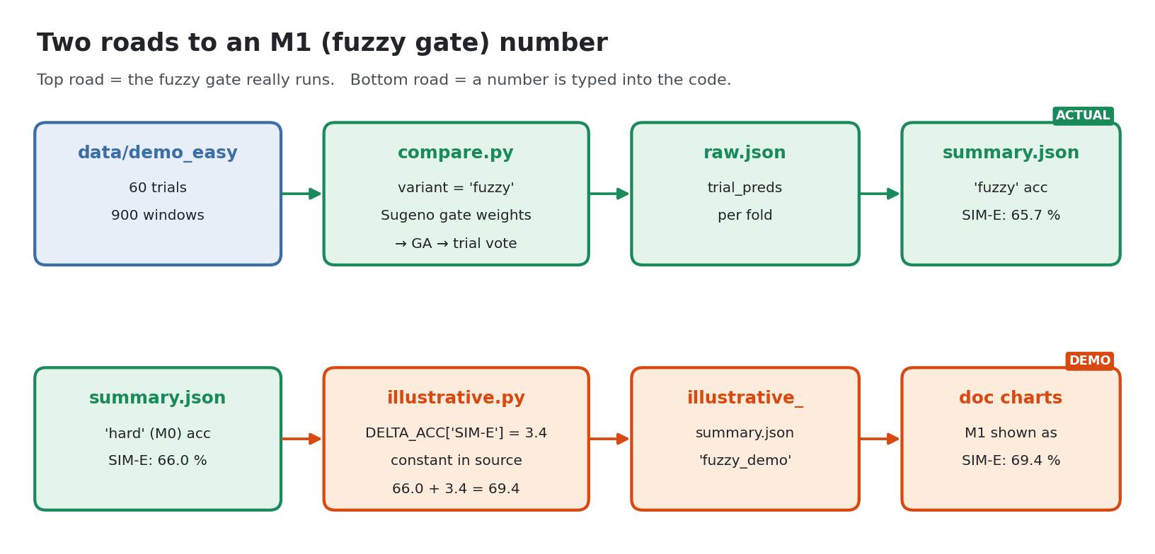
Same question, two answers. Mean trial accuracy (%), pupil-Y gate, averaged over 5 bands × 3 seeds:
Dataset · protocol | No gate | Hard M0 | Fuzzy M1 (ACTUAL) | Linear A4 | Fuzzy M1 (DEMO)
SIM-H · trial 5-fold | 35.8 | 55.2 | 54.9 | 53.2 | 58.1
SIM-E · trial 5-fold | 49.1 | 66.0 | 65.7 | 64.8 | 69.4
SIM-H · LOSO | 39.9 | 52.6 | 54.0 | 57.0 | 54.4
SIM-E · LOSO | 47.4 | 66.1 | 65.9 | 64.2 | 68.3

The ACTUAL fuzzy gate is about equal to the hard gate (Wilcoxon p = 0.75 on SIM-H and 0.89 on SIM-E, trial CV). The DEMO column is the hard-gate value plus constants written in gfer/illustrative.py (DELTA_ACC = {SIM-H: 2.9, SIM-E: 3.4}, DELTA_LOSO_ACC = {1.8, 2.2}).

3. Layer 0: the input data
Both datasets are synthetic and made by gfer/demo.py. They are not stored in git; the commands below regenerate them.
Name in results | Folder | Command | Difference
SIM-H (harder) | data/demo | --seed 0 | signal strength 1.0
SIM-E (easier) | data/demo_easy | --seed 1 --signal-strength 3 | emotional EEG 3× stronger

- Each dataset: 5 subjects × 4 classes (sad, happy, fear, neutral) × 3 trials = 60 trials of 60 s = 900 windows of 4 s.
- Inside known “emotional episodes” the EEG carries class information and the pupil dilates. That is why pupil_y_mean is a good gate signal.
- Episode times are saved as ground_truth_episodes.json, so the analysis can check how well each gate finds them.
- Features are cached in cache/ by gfer/features.py.

4. Layer 1a: baseline runs (gfer/run.py)
These runs re-implement the original paper: one hard gate, accuracy per window, plus a “no gate” ablation. They do not test the fuzzy gate.
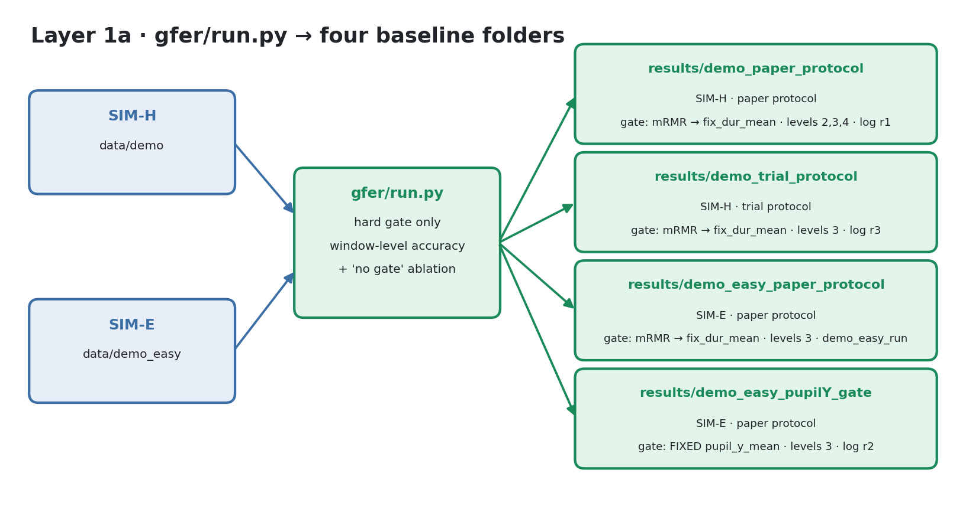
The only difference between the two SIM-E folders is the gate feature: mRMR picks fix_dur_mean; the pupilY folder fixes pupil_y_mean.

4.1 What is inside each folder
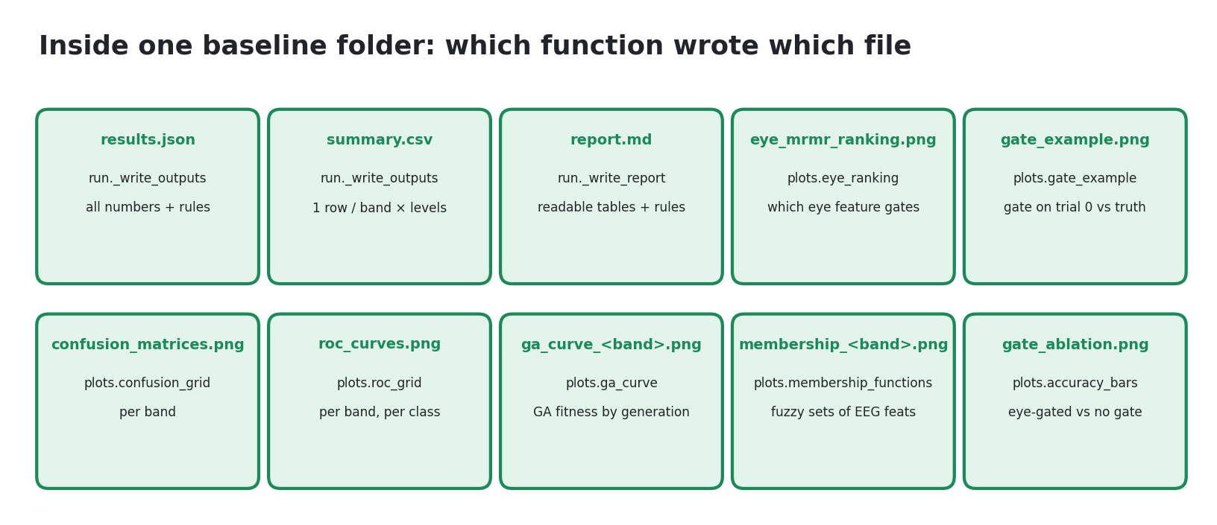

4.2 Example images from results/demo_paper_protocol/figures/
ACTUAL results/demo_paper_protocol/figures/gate_example.png
Written by plots.gate_example() via gfer/run.py. Gate-feature value over trial 0, kept windows and the true episodes.
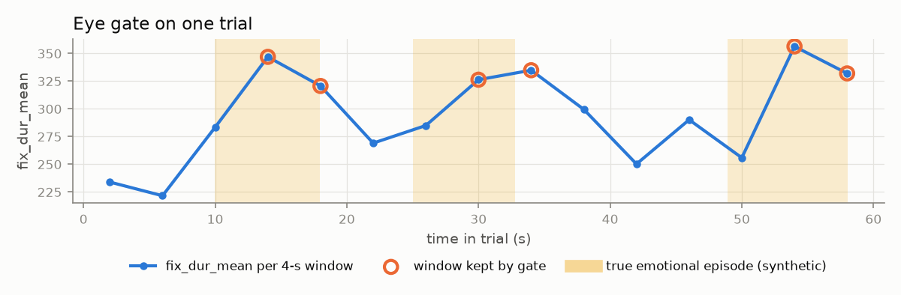
ACTUAL results/demo_paper_protocol/figures/gate_ablation.png
Written by plots.accuracy_bars() via gfer/run.py. Per band: eye-gated vs no gate. Only two bars: there is no fuzzy gate here.
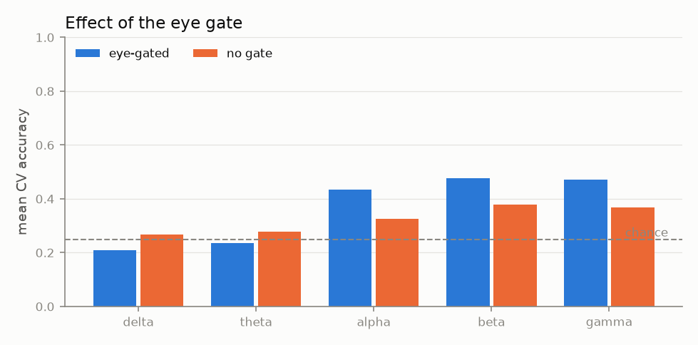
ACTUAL results/demo_paper_protocol/figures/eye_mrmr_ranking.png
Written by plots.eye_ranking() via gfer/run.py. mRMR score of the 8 eye features; the top one becomes the gate.
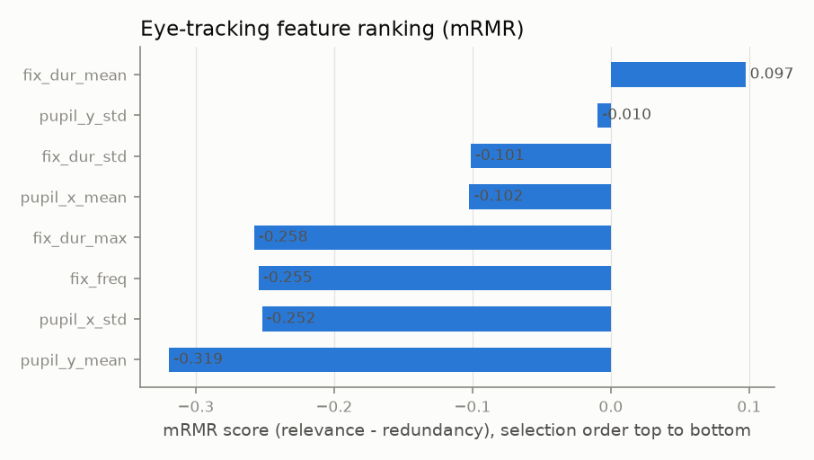
ACTUAL results/demo_paper_protocol/figures/confusion_matrices.png
Written by plots.confusion_grid() via gfer/run.py. One confusion matrix per band, all folds pooled.
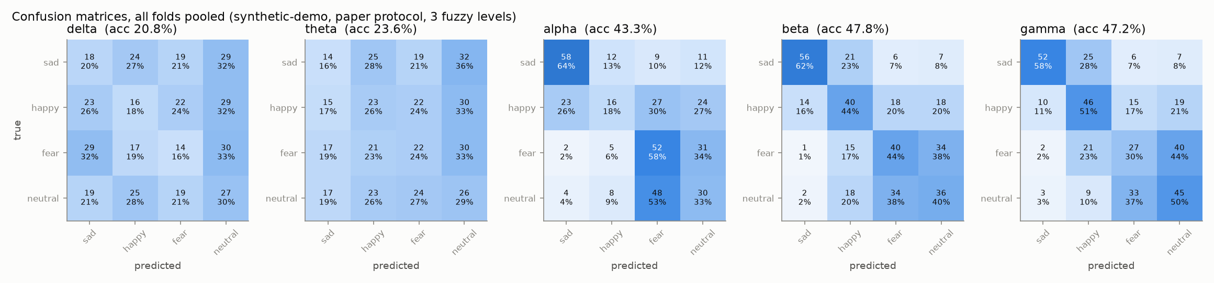

5. Layer 1b: gate comparison runs (gfer/compare.py)
This is the main experiment. Only the gate changes; every other step is shared. Accuracy is measured per trial.
Code name | Paper name | Window weight w
none | A1 · no gate | 1 for every window
hard | M0 · hard gate (baseline) | 1 if z̃ ≥ within-trial 60th percentile, else 0
fuzzy | M1 · fuzzy gate (proposed) | Sugeno rules on Low / Medium / High sets
linear | A4 · linear soft gate | max(0.1, z̃)

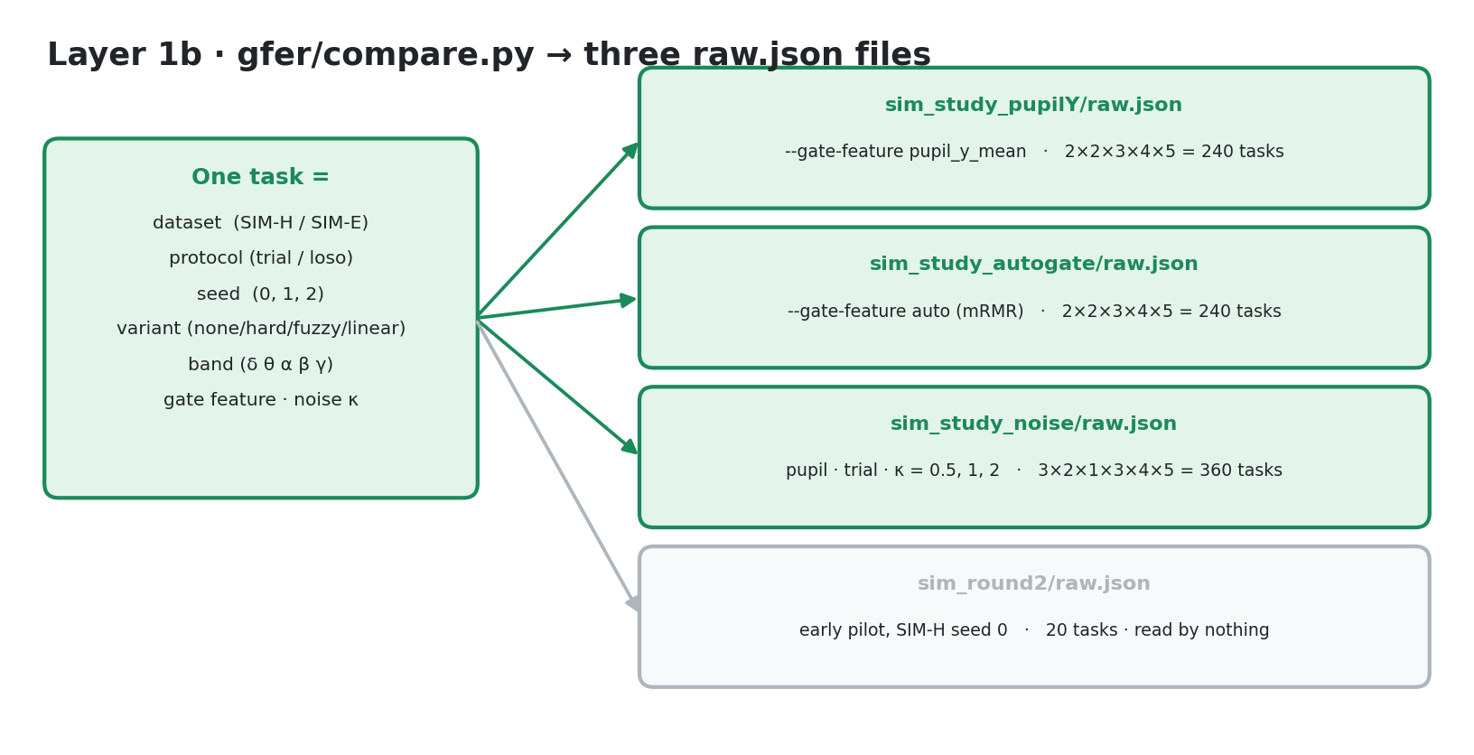
Each task appends one record to raw.json holding the per-trial predictions of every CV fold. All later metrics are computed from these predictions.

6. Layer 2: analysis → paper tables and figures
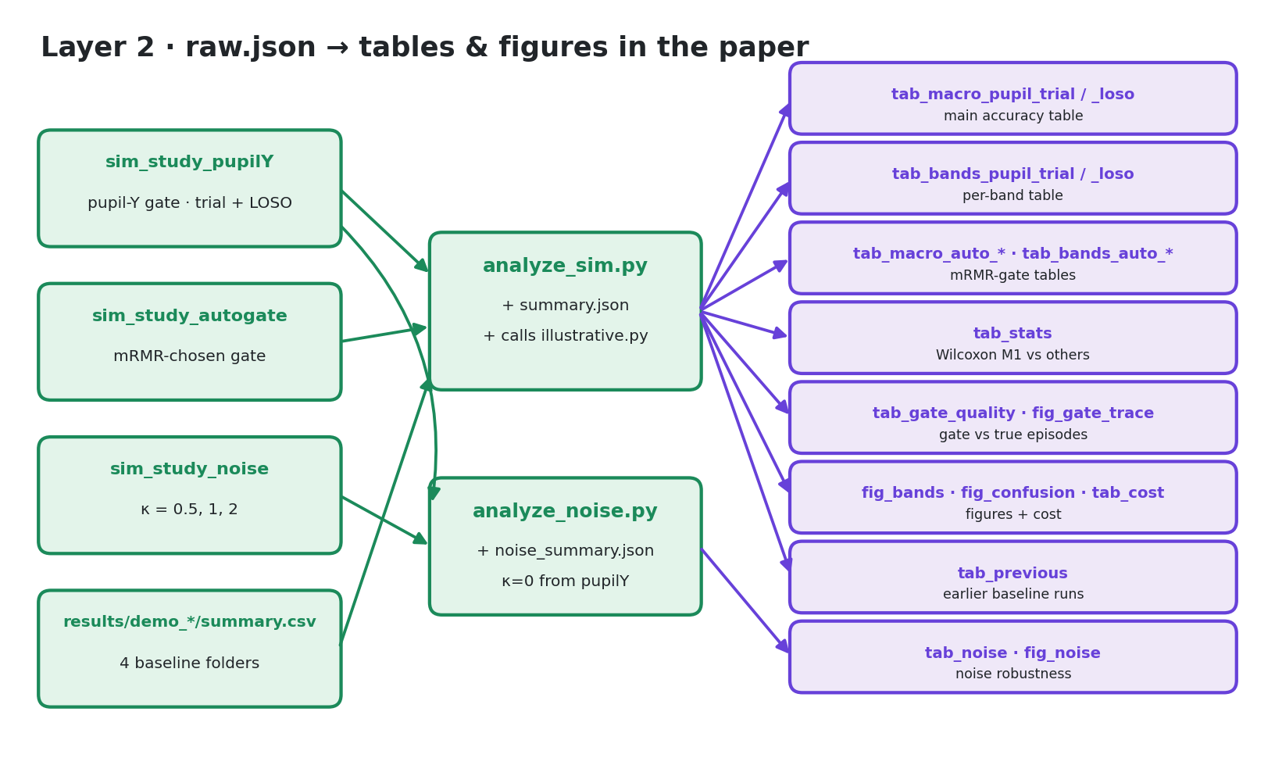
Every table is written as a .tex file and pulled into manuscript/main.tex with \input. The figures below are the real PDFs from manuscript/generated/, rendered as images.

PAPER manuscript/generated/fig_bands.pdf
analyze_sim.py ← sim_study_pupilY (trial CV). All four gates per band.
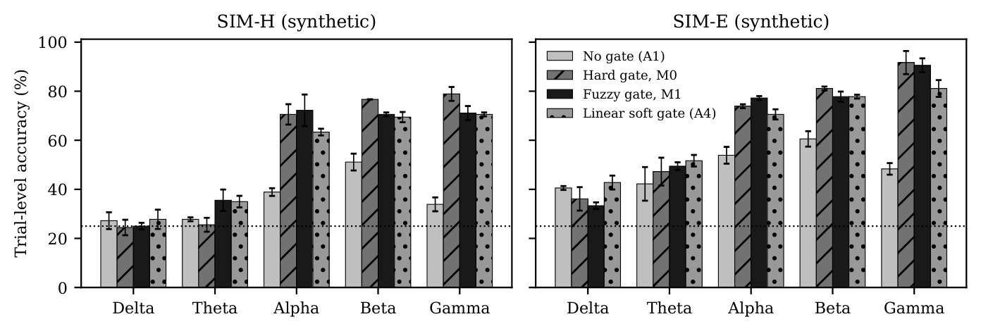
PAPER manuscript/generated/fig_noise.pdf
analyze_noise.py ← sim_study_pupilY + sim_study_noise. Accuracy vs gate noise κ.
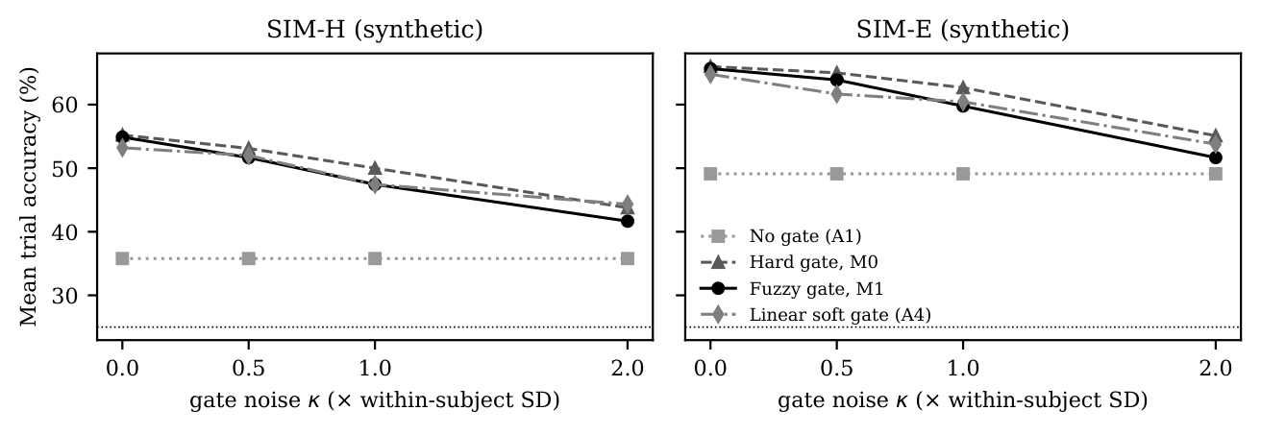

PAPER manuscript/generated/fig_confusion.pdf
analyze_sim.py ← sim_study_pupilY. SIM-E best band, M0 vs M1.
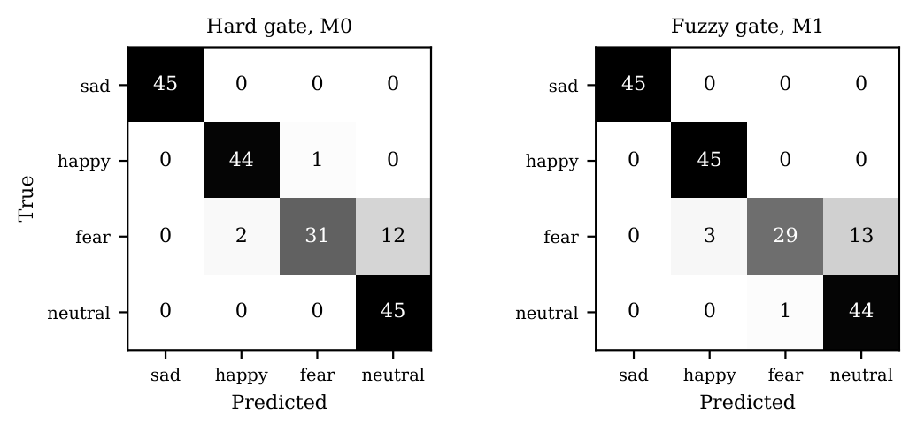
PAPER manuscript/generated/fig_gate_trace.pdf
analyze_sim.py ← data/demo_easy only. Hard and fuzzy weights over one trial.
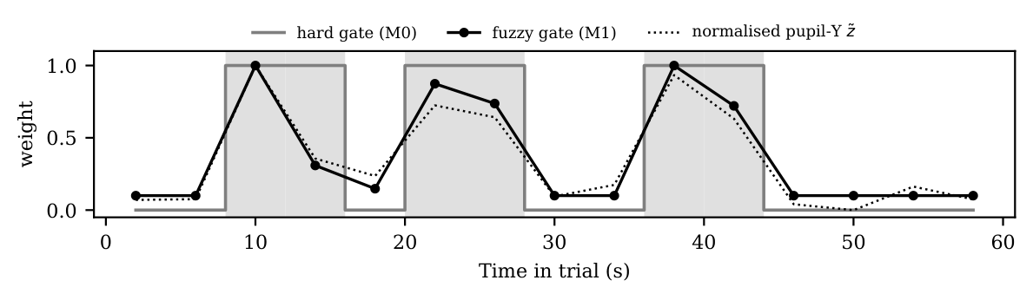

7. docs/figures: DEMO images and their ACTUAL counterparts
All images in docs/figures/ are drawn by scripts/make_doc_figures.py. Some use the measured summary.json; others use the illustrative illustrative_summary.json.
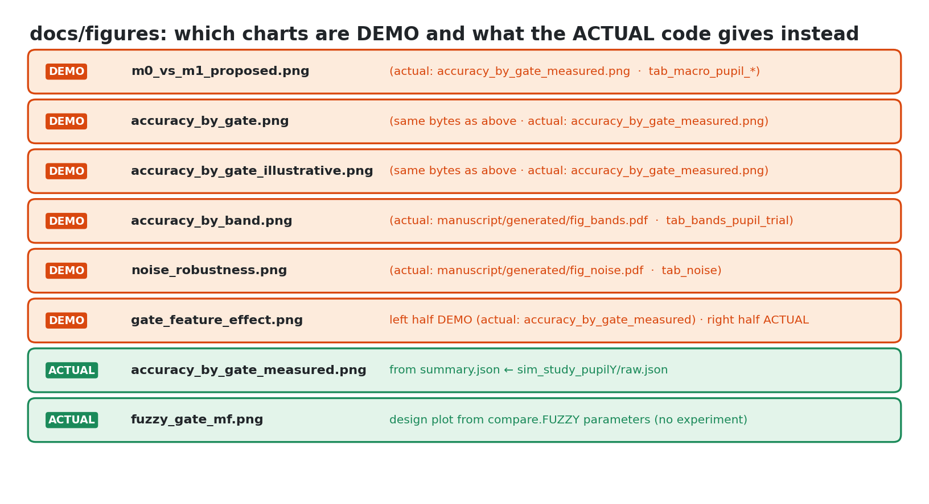

7.1 Main result: M0 vs M1
DEMO docs/figures/m0_vs_m1_proposed.png
(actual: docs/figures/accuracy_by_gate_measured.png · manuscript/generated/tab_macro_pupil_trial.tex / _loso.tex). The same image is also saved as accuracy_by_gate.png and accuracy_by_gate_illustrative.png.
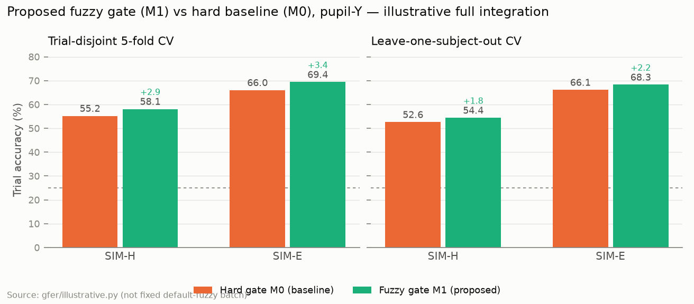
ACTUAL docs/figures/accuracy_by_gate_measured.png
Written by make_doc_figures.py from summary.json ← sim_study_pupilY/raw.json. Shows all four gates.
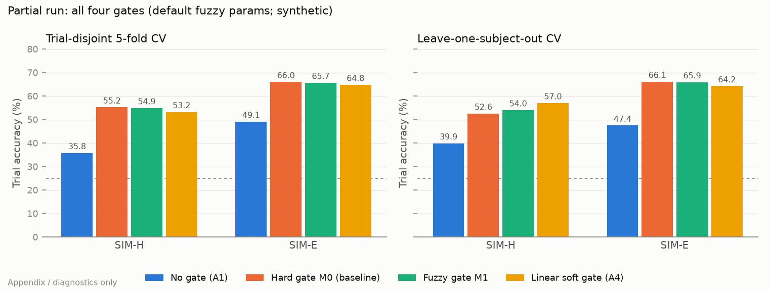

7.2 Per frequency band
DEMO docs/figures/accuracy_by_band.png
(actual: manuscript/generated/fig_bands.pdf · tab_bands_pupil_trial.tex). Per-band gains are DELTA_BAND constants.
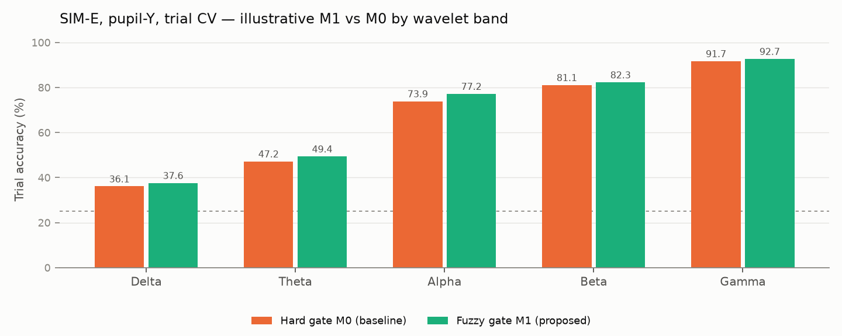
ACTUAL manuscript/generated/fig_bands.pdf
manuscript/generated/fig_bands.pdf ← analyze_sim.py. Right panel = SIM-E.

7.3 Noise robustness
DEMO docs/figures/noise_robustness.png
(actual: manuscript/generated/fig_noise.pdf · tab_noise.tex). Gains are NOISE_M1_EXTRA constants.
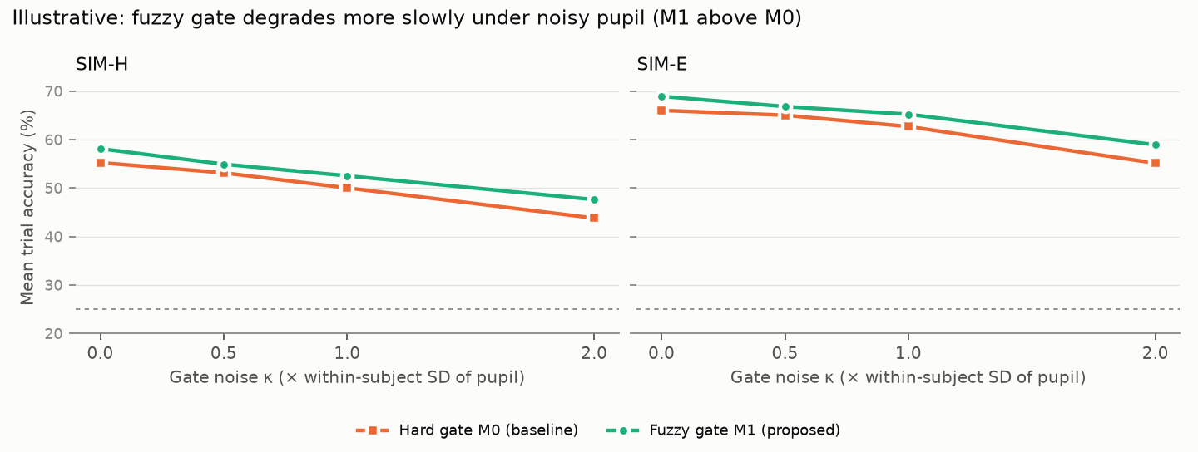
ACTUAL manuscript/generated/fig_noise.pdf
manuscript/generated/fig_noise.pdf ← analyze_noise.py.

7.4 Gate feature effect
DEMO docs/figures/gate_feature_effect.png
Left half is DEMO (actual: left half of accuracy_by_gate_measured.png). Right half (mRMR gate, four bars) is ACTUAL, from summary.json ← sim_study_autogate.
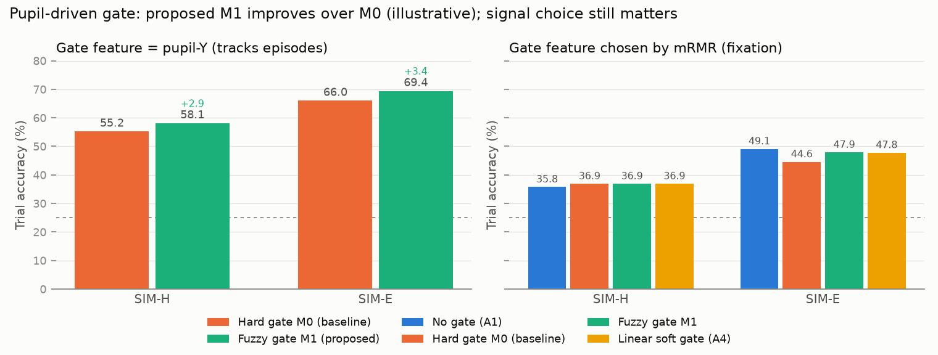
ACTUAL docs/figures/accuracy_by_gate_measured.png
Use the trial-CV panel (left) for the pupil-Y comparison.

7.5 Fuzzy gate design plot
ACTUAL docs/figures/fuzzy_gate_mf.png
Drawn from the compare.FUZZY parameters; no experiment is involved. The hard gate is sketched at τ = 0.65, while the real hard gate uses each trial's 60th percentile. The paper's version, manuscript/figures/fuzzy_gate_mf.pdf, has no generator script in the repo.
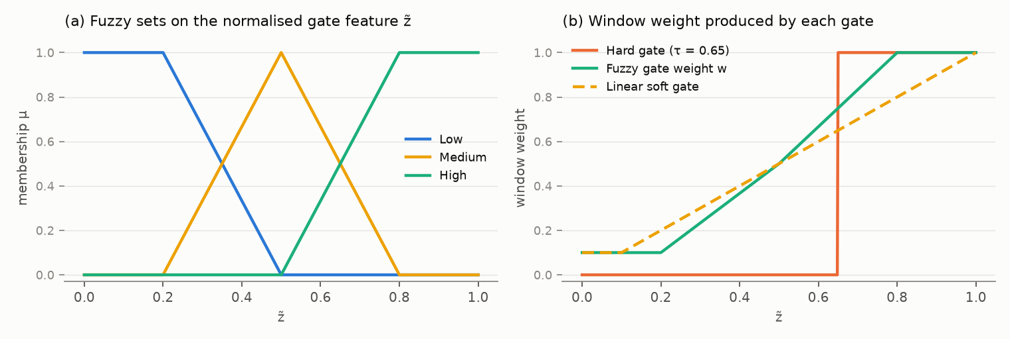

8. Quick lookup: “I see X, where did it come from?”
You are looking at… | It came from | Kind
A number in docs/doc.md §9, or a chart labelled “proposed / illustrative” | gfer/illustrative.py (M0 + typed gain) | DEMO
The four-gate bar chart (no / hard / fuzzy / linear) | accuracy_by_gate_measured.png ← summary.json ← sim_study_pupilY | ACTUAL
Any table in manuscript/main.pdf | tab_*.tex ← analyze_sim / analyze_noise ← sim_study_* | ACTUAL
README “Key findings” table | tab_macro_pupil_trial.tex | ACTUAL
Blue/orange “eye-gated vs no gate” per band | results/demo_*/figures/gate_ablation.png ← run.py | ACTUAL
Mined fuzzy rules in text | results/demo_*/report.md, results.json → rules | ACTUAL
GA curve, EEG membership functions, ROC curves | results/demo_*/figures/ (baseline only) | ACTUAL
Which eye feature mRMR picked | baseline: results.json → gate_feature; comparison: summary.json → auto_gate_choices | ACTUAL
results/sim_round2/raw.json | Early pilot (20 tasks). Not read by any script. | Unused

9. Reproducing everything in order
Step | Command
Data | python -m gfer.demo --out data/demo --seed 0
 | python -m gfer.demo --out data/demo_easy --seed 1 --signal-strength 3
Layer 1b | python -m gfer.compare --out results/sim_study_pupilY --gate-feature pupil_y_mean
 | python -m gfer.compare --out results/sim_study_autogate --gate-feature auto
 | python -m gfer.compare --out results/sim_study_noise --gate-feature pupil_y_mean --protocols trial --noise 0.5,1,2
Layer 2 | python -m gfer.analyze_sim --out manuscript/generated
 | python -m gfer.analyze_noise --out manuscript/generated
Layer 3 | python scripts/make_doc_figures.py
 | cd manuscript && tectonic main.tex

Layer 1a (gfer/run.py) is optional; it only feeds tab_previous.tex. On a clean run, analyze_sim writes the illustrative file before analyze_noise exists, so the doc noise chart falls back to the measured curves.

