AI AGENT
WORKSPACE MANAGER
Product and System Design Specification
A cross-platform local control plane for terminal-based AI coding agents
Document status  Design baseline  Version  0.2  Date  10 July 2026  Primary target  Windows, macOS and Linux desktop | CORE PROMISE  Find every agent session.  Start a native CLI session from scratch.  Open it in the right workspace.  Launch it with the right shell.  Explain every effective setting.

Prepared as a build-ready design file. Provider capabilities and external APIs are time-sensitive; verify adapters against current vendor documentation during implementation.

Document guide
This specification defines the product, user experience, architecture, data model, terminal subsystem, provider-integration contract, security boundary, delivery plan and acceptance criteria for a desktop application that manages local AI coding-agent sessions. It is written so that a product designer, desktop engineer and provider-adapter engineer can work from one shared baseline. Version 0.2 makes creation of brand-new native CLI sessions a first-class requirement and defines the terminal-parity contract.
RECOMMENDED PRODUCT NAME Use “Agent Workspace Manager” as the descriptive name during development. A branded name can be chosen after user testing. Avoid calling it only an “AI project manager,” because its core value is session, process and workspace orchestration rather than task planning.

How to read this document
Audience | Read first | Then
Product owner | Sections 1-6 | Roadmap, metrics and risks
UX designer | Sections 5-8 | Terminal settings, trust and error states
Desktop engineer | Sections 9-18 | IPC, PTY, storage and lifecycle
Provider-adapter engineer | Sections 12-15 | Appendix A interfaces and capability matrix
Security reviewer | Sections 19-21 | Trust zones, secret handling and plugin model
QA engineer | Sections 23-26 | Acceptance criteria and test matrix

Contents
Sections 1-16 | Sections 17-Appendices
1. Executive summary | 2. Product definition
3. Goals and non-goals | 4. Users and jobs to be done
5. Product principles | 6. Scope and release strategy
7. Information architecture | 8. UX flows and wireframes
9. Logical architecture | 10. Desktop process architecture
11. Domain model and terminology | 12. Provider adapter system
13. Session discovery and reconciliation | 14. Workspace detection and Git context
15. Terminal and shell subsystem | 16. Configuration inheritance and command construction
17. Session lifecycle and process management | 18. Data storage, indexing and search
19. Security, privacy and workspace trust | 20. IPC and internal API contracts
21. Plugin and extension model | 22. Observability and diagnostics
23. Reliability and recovery | 24. Performance targets
25. Testing strategy | 26. Accessibility and localization
27. Packaging and updates | 28. Delivery roadmap
29. Risk register | 30. Product metrics
31. Open decisions | 32. Definition of done
Appendices A-F

1. Executive summary
The proposed application is feasible and useful. It should be built as a local control plane for terminal-based AI coding agents: it discovers saved sessions, maps them to workspaces and providers, starts brand-new sessions or resumes existing sessions in managed terminal tabs, applies predictable configuration inheritance, and exposes operational state such as running, waiting, completed or failed. A new session must run the provider's real CLI with native interactive behavior; the application surrounds the CLI but does not recreate it.
The design deliberately separates four things that are often blended together: provider session metadata, workspace context, shell and terminal behavior, and the runtime process. This separation is the difference between a durable platform and a clever launcher that cracks when one provider changes a file path.
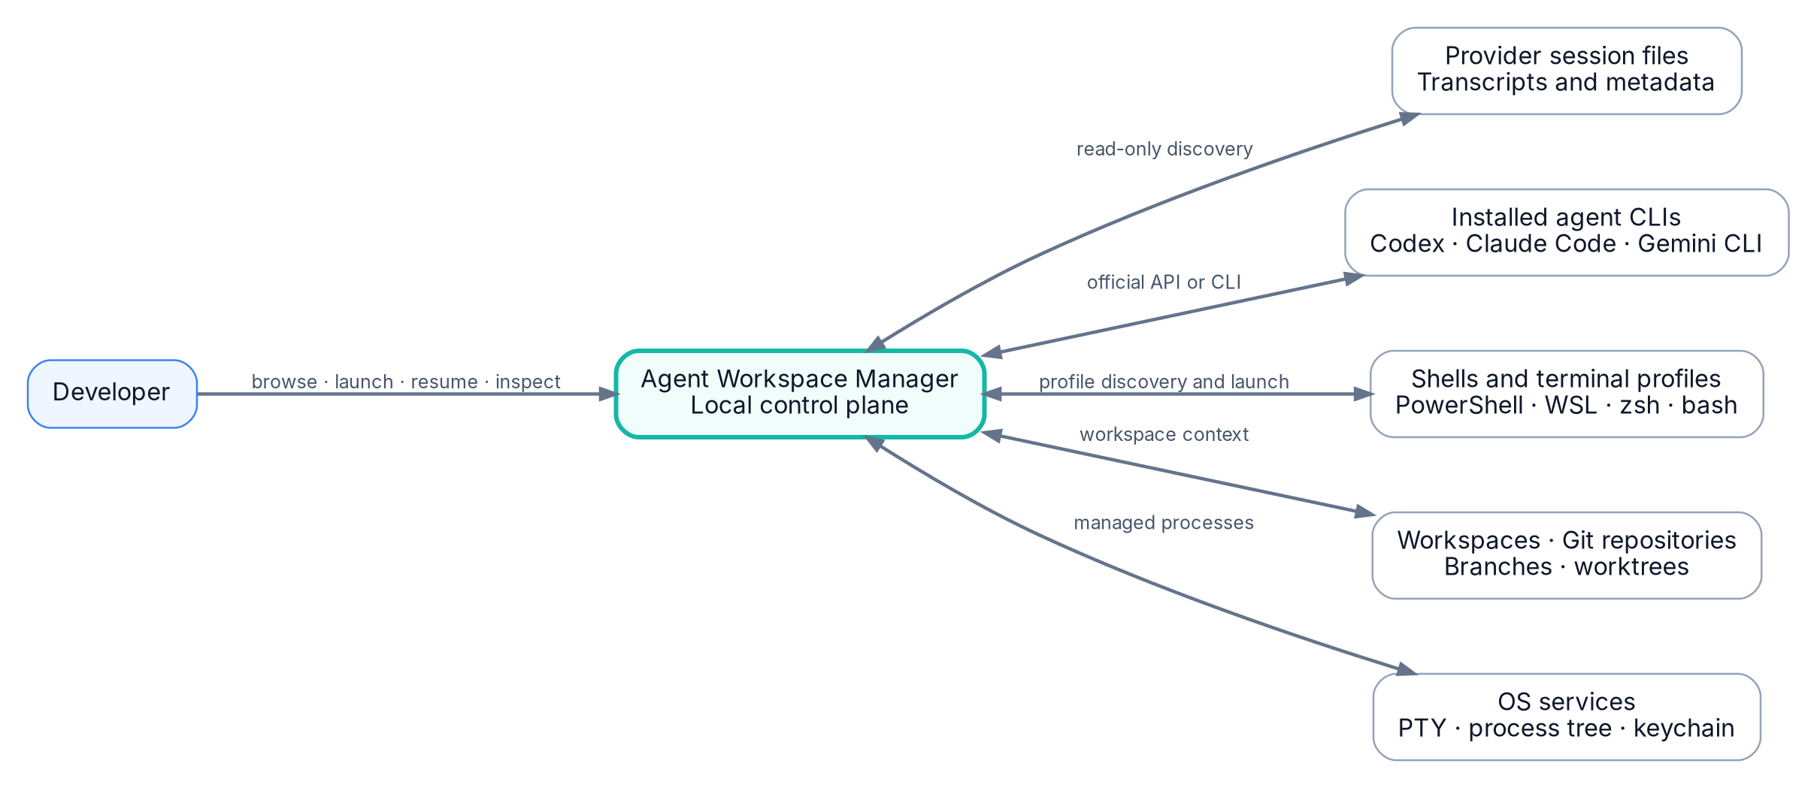
Figure 1. Product context and external systems
PRIMARY ARCHITECTURE DECISION Use a provider-adapter layer and a normalized local index. Provider files are inputs, not the application database. Prefer supported provider APIs or CLIs; use transcript parsing only as a read-only fallback.

1.1 Recommended implementation stack
Layer | Recommendation | Reason
Desktop shell | Electron + TypeScript | Fastest path to a mature cross-platform terminal stack and one language across UI, core and adapters.
UI | React or equivalent component framework | Strong ecosystem for tabbed desktop interfaces and settings forms.
Terminal renderer | xterm.js | Mature browser terminal emulator with configurable terminal options and VT support.
PTY backend | node-pty | Cross-platform pseudoterminal bridge using ConPTY on Windows and POSIX PTYs on Unix-like systems.
Database | SQLite + FTS5 | Single-file local index, transactions, simple migration story and full-text search.
Secrets | OS-native credential store | Keeps tokens and sensitive environment values outside ordinary JSON configuration.
Provider integration | In-process typed adapters plus isolated workers for untrusted parsing | Simple for first-party adapters, with a path to stronger isolation.

1.2 MVP boundary
- Discover and normalize saved sessions from two providers, initially Codex and Claude Code.
- Group sessions by canonical workspace, provider and lifecycle state.
- Start brand-new provider sessions and resume saved sessions in embedded terminal tabs using user-selected terminal profiles, while preserving native CLI behavior and avoiding unrequested launch flags.
- Support global, provider, workspace and session configuration with visible provenance.
- Only promise reliable reattachment for processes launched and managed by the application, or for providers offering a supported structured control protocol.
- Keep provider source files read-only and keep all normalized metadata in the application database.

2. Product definition

2.1 Product statement
PRODUCT STATEMENT Agent Workspace Manager is a local desktop application that discovers, organizes, launches and monitors AI coding-agent sessions across providers and workspaces while preserving the developer’s selected shell and terminal behavior.

2.2 Problem statement
Developers increasingly run several coding agents across many repositories, shells and terminal windows. Session histories are provider-specific, difficult to search and often disconnected from the workspace, branch or environment in which the work happened. A developer can know that an important session exists while still losing several minutes to locate its provider, find its native identifier, reconstruct the correct shell environment and remember which flags were used.
The application reduces this context-reconstruction tax. It does not replace the agents. It makes their local sessions understandable and operable from one place.

2.3 Product value
User pain | Product response | Outcome
Sessions scattered by provider | Unified normalized catalog | One place to find and resume work
Wrong shell or environment | Terminal profiles and inherited launch configuration | The resumed session behaves like the user expects
Unknown effective flags | Typed configuration resolver with provenance | Settings stop being invisible folklore
Many active agents | Lifecycle dashboard and attention inbox | Waiting and failed sessions become visible
Provider formats change | Versioned adapters and source fingerprints | Core data remains stable
Terminal closed accidentally | Managed runtime metadata and restart recovery | The app can explain what can and cannot be recovered

2.4 Market position
The product sits between terminal emulators, IDE agent panels and task managers. It should not compete by becoming a complete IDE. Its wedge is cross-provider session continuity and operational visibility. Over time it can become an orchestration layer for local agents, worktrees, approvals and hooks.

3. Goals and non-goals

3.1 Goals
- Accurately discover saved AI-agent sessions without modifying provider-owned files.
- Classify sessions by provider, installation, workspace and lifecycle state.
- Launch or resume sessions in embedded terminal tabs on Windows, macOS and Linux.
- Follow the user’s shell startup behavior, including PowerShell profiles, shell startup files and version-manager-initialized environments.
- Provide deterministic configuration inheritance: Global < Provider < Workspace < Session.
- Present the final executable, arguments, working directory and environment before launch.
- Use official structured provider integrations where available and degrade gracefully to CLI or file-derived discovery.
- Keep transcript indexing and telemetry local and privacy-conscious by default.

3.2 Non-goals for the first release
- Stealing or moving an arbitrary process from another terminal’s PTY into this application.
- Migrating conversation history between unrelated providers.
- Editing provider transcript files or native session databases.
- Building a full source-code editor, debugger or Git client.
- Cloud synchronization of transcripts, tokens or secrets.
- Automatically executing repository-provided startup commands before trust is granted.
- Perfectly cloning every visual and keyboard behavior of Windows Terminal, iTerm2 or another terminal application.
HARD BOUNDARY An externally running CLI already belongs to another terminal or provider runtime. Detection is possible; reliable generic reattachment is not. The UI must say “external process detected” rather than imply that the process can be teleported into a tab.

4. Users and jobs to be done

4.1 Primary persona: multi-agent developer
A developer works across several repositories and uses more than one AI coding agent. They frequently resume old work, compare approaches across providers and need the correct shell environment, proxy settings, model options and working directory. Their biggest problem is not starting an agent. It is reconstructing context and knowing which session needs attention.

4.2 Secondary personas
Persona | Need | Design implication
Single-provider power user | Better organization and fast resume | The app must still add value with only one provider.
Team lead or reviewer | Understand what local agents are doing without reading every transcript | Status and summaries should be available without taking control of the session.
Tool integrator | Add support for an internal agent | Adapter SDK and diagnostics must be documented.
Security-conscious enterprise developer | Know what executes and where data is stored | Trust prompts, launch previews and local-only indexing must be explicit.

4.3 Core jobs to be done
- When I return to a repository, show me all relevant agent sessions regardless of provider.
- When I open a session, resume it with the correct workspace, shell, agent executable and inherited options.
- When several agents are running, tell me which one is active, waiting, complete or broken.
- When a launch behaves unexpectedly, show exactly where every effective setting came from.
- When a provider changes its storage format, preserve my local organization and explain which sessions need re-indexing.

5. Product principles
Principle | Meaning in practice
Local first | Session discovery, indexing and search stay on the device unless the user explicitly enables a remote feature.
Read provider data, do not own it | Provider files are never silently rewritten or deleted. Archive and rename are local metadata unless the provider has an official operation.
Specific settings win | Session overrides workspace, workspace overrides provider, provider overrides global. Every winner is visible.
Structured before textual | Prefer provider APIs and argument arrays. Avoid scraping terminal pixels or concatenating shell strings.
Truthful process semantics | Distinguish saved, app-managed running, externally running and remote sessions.
Inspectable automation | Show launch previews, trust decisions, parser errors and adapter capabilities.
Graceful degradation | A provider with only basic discovery can still appear in the catalog without pretending to support live status.

6. Scope and release strategy

6.1 Capability layers
Layer | Capability | Release target
Catalog | Discover, normalize, group, search and locally rename sessions | MVP
Managed terminal | Start and resume sessions in tabs with PTY lifecycle management | MVP
Configuration | Four-level inheritance, validation and effective-config inspector | MVP
Awareness | Structured status, approval attention and tool progress | Release 2
Orchestration | Worktrees, session forks, bulk actions and policies | Release 3
Ecosystem | Third-party adapters, shared templates and enterprise policy | Later

6.2 Provider rollout
Begin with Codex and Claude Code because both expose explicit session-resume workflows, and Codex offers a structured app-server path that can stream thread and item events. Add Gemini CLI after the adapter contract is stable; its current command documentation includes automatic session saving and an interactive resume browser. These capabilities should be verified during implementation because provider interfaces evolve quickly. [R1-R4]

6.3 Feature flags
- Keep transcript-content indexing behind an explicit privacy toggle.
- Gate structured provider protocols separately from basic CLI launch.
- Gate third-party adapter loading until adapter isolation and signing policy are complete.
- Keep external-process detection experimental until false-positive rates are measured.

7. Information architecture

7.1 Primary navigation
The left navigation should be workspace-first because workspace is the developer’s durable mental model. Provider remains visible within each workspace. A second view can invert the hierarchy for users who think provider-first.
Navigation area | Contents
Home | Attention inbox, recently active sessions, running agents and failures
Workspaces | Workspace > provider > session hierarchy
Providers | Provider > installation > workspace > session hierarchy
All sessions | Flat searchable catalog with filters
Terminal profiles | Detected shells, imported terminal profiles and custom profiles
Settings | Global configuration, security, storage, adapter diagnostics and updates

7.2 Session list item anatomy
- Title, with local rename clearly distinguished from provider-native title.
- Provider icon and installation badge if multiple versions exist.
- Lifecycle glyph and concise status text.
- Workspace, branch or worktree context.
- Last activity timestamp and source confidence.
- Badges for managed runtime, external runtime, structured integration or file-derived metadata.

7.3 Filters
Filters should be combinable and represented in the URL-like internal navigation state so tabs can preserve them. Required filters: provider, workspace, state, managed/external, branch, updated date, trust state and capability level.

8. UX flows and wireframes

8.1 Main workspace and terminal view
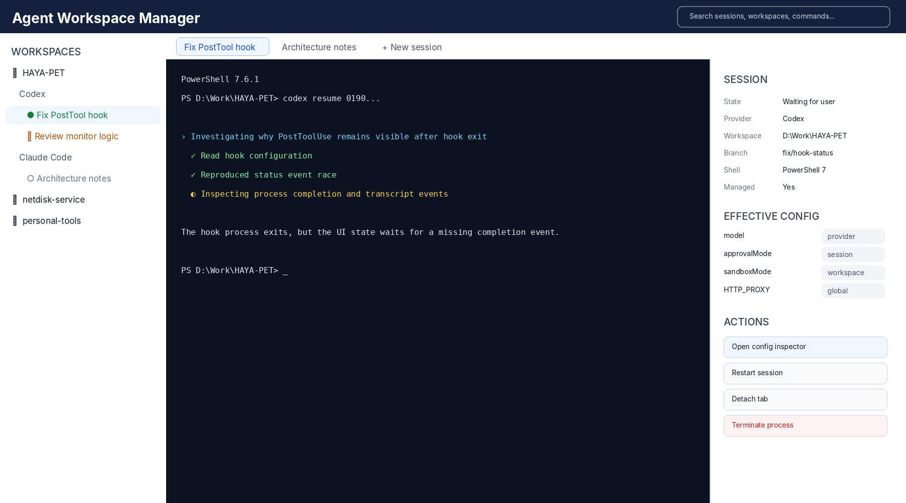
Figure 2. Main workspace navigator, managed terminal tab and session inspector
Opening a session creates or focuses a tab. The terminal owns the interactive experience while the inspector exposes metadata and effective configuration. A status chip must never be inferred only from terminal text when a structured provider event is available.

8.2 Terminal profile settings
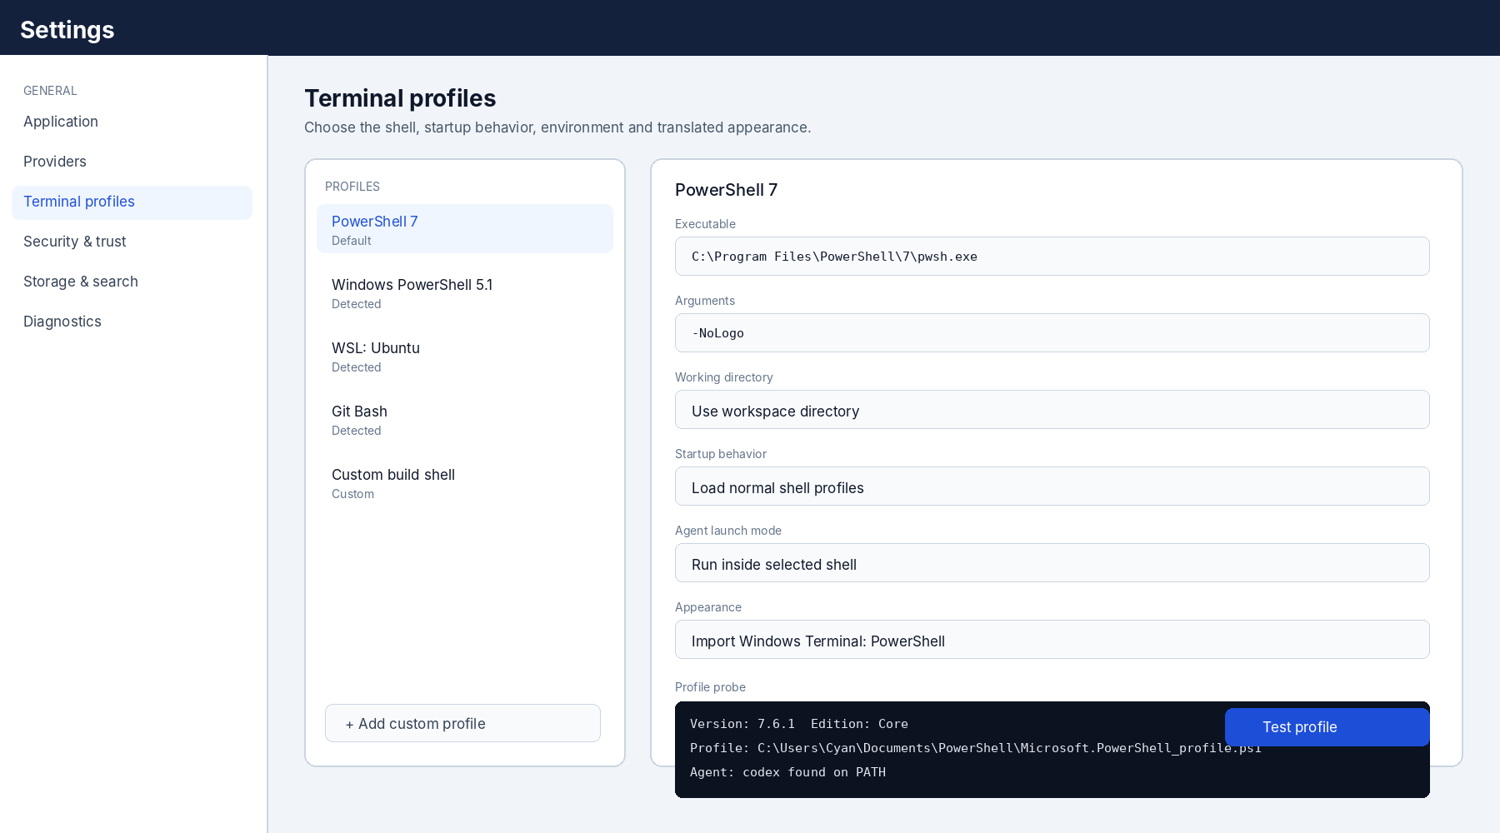
Figure 3. Terminal profile discovery, editing and probe diagnostics
The profile editor separates executable, arguments, shell startup behavior, environment and appearance. The “Test profile” action starts an isolated diagnostic terminal and reports the actual executable, version, profile path, PATH visibility and agent command discovery.

8.3 Effective configuration inspector
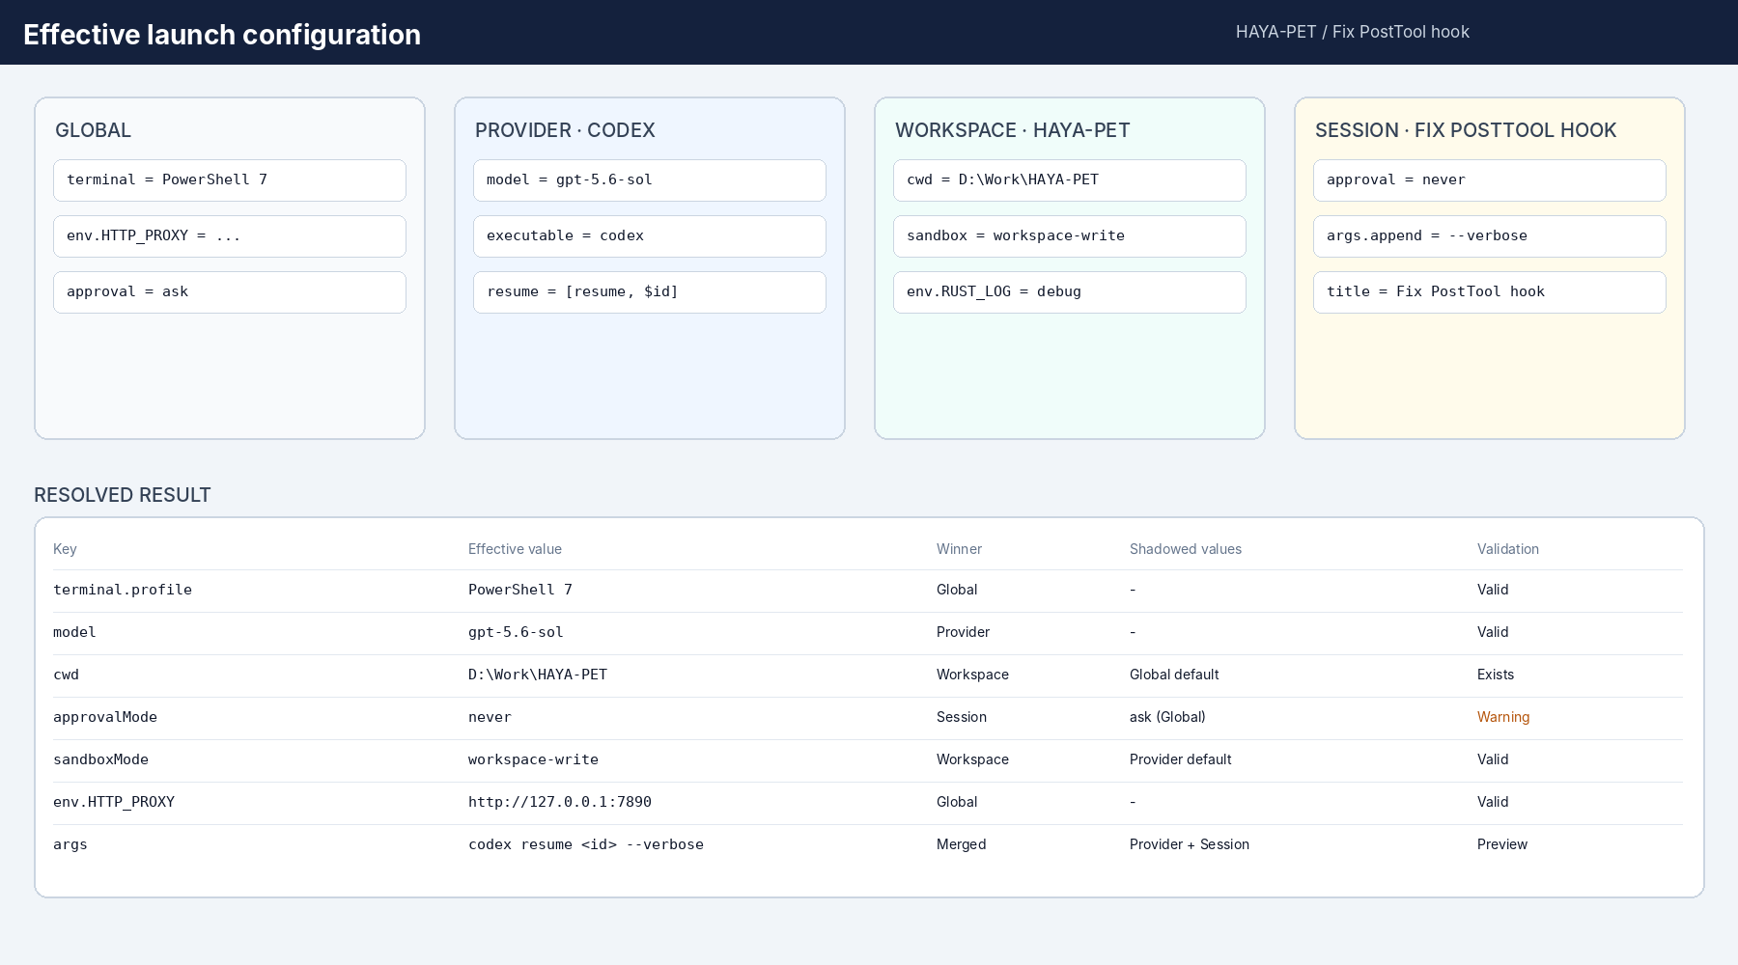
Figure 4. Configuration layers, resolved values and provenance
The inspector is a core debugging surface, not an advanced afterthought. It should show winners, shadowed values, merge behavior, warnings and the exact final launch preview. Sensitive values are masked by default and revealed only through an intentional action.

8.4 New session flow
- User chooses a workspace or opens “New session.”
- Application suggests providers installed and valid for that workspace.
- User selects a provider and optional saved terminal profile.
- Application resolves configuration and shows a compact launch preview.
- If the workspace is untrusted or a repository config contributes executable behavior, request trust before spawn.
- Create a runtime record, PTY and tab; start the provider and stream output.

8.4.1 Native CLI parity contract
“New session” means starting the provider's official terminal CLI without requiring a pre-existing transcript or session file. The embedded terminal is a host for that real program. Provider prompts, menus, slash commands, approvals, authentication, tools, hooks, MCP integrations, child processes and future CLI features remain owned by the provider executable.
Area | Required behavior | Product rule
Provider implementation | Execute the installed official CLI binary or its documented launcher. | Never clone or reinterpret the provider UI in the terminal surface.
Terminal contract | Give the child a real PTY or ConPTY with stdin, stdout, stderr, resize and signal handling. | Do not substitute a line-oriented subprocess pipe for interactive sessions.
Shell environment | Load the user-selected terminal profile and normal shell startup files in native CLI mode. | Do not add -NoProfile, clean-shell flags or a replacement PATH unless explicitly configured.
Interactive controls | Pass arrows, Tab, Enter, Escape, Ctrl+C, Ctrl+D/Z, bracketed paste and IME input to the CLI. | Application shortcuts must yield while the terminal is focused, except for an explicit escape chord.
Native capabilities | Support login flows, model selection, slash commands, approval prompts, hooks, MCP, plugins and shell tools. | The app observes these capabilities where possible but must not block unknown provider features.
Rendering | Render ANSI/VT sequences, Unicode, wide glyphs, alternate screen buffers, cursor changes and OSC 8 links. | Translate only terminal-emulator behavior; do not rewrite provider output.
Process behavior | Allow the CLI to spawn tools, compilers, shells, pagers and editors inside the same managed process tree. | Track and terminate the complete tree safely; do not assume the provider is the only process.
Provider upgrades | New CLI versions should normally work without an app release when they stay within terminal standards. | Adapters may lose rich status parsing, but basic native terminal operation must continue.
Application chrome | Add tabs, workspace context, session metadata, launch previews and lifecycle controls outside the terminal. | Management UI may surround the CLI but must not consume or mutate its protocol.

8.4.2 New-session launch sequence
- User invokes “New AI session” from the global action, a provider node or a workspace node.
- Application preselects the workspace and provider from invocation context, while keeping both editable.
- User selects a terminal profile and optional launch preset. The default preset is “Native CLI - no extra provider flags.”
- Adapter resolves the installed executable and validates that the selected shell can locate or invoke it.
- Configuration resolver merges global, provider, workspace and session-template layers and displays the exact executable, arguments, working directory and masked environment changes.
- Trust manager blocks untrusted workspace commands, executable overrides and environment mutations until approved.
- Runtime manager creates a provisional runtime record, PTY, terminal tab and output stream before starting the child.
- Shell adapter starts the official CLI using the selected native launch mode. The application does not type commands into an already-running prompt.
- After the provider creates a native session identity or source file, the adapter links it to the provisional runtime and inserts the new session into the catalog.
DEFAULT NEW-SESSION MODE
Native CLI mode: selected shell profile + selected workspace + official provider executable + no unrequested provider flags.

8.4.3 Session registration after launch
A new process may begin before the provider exposes a durable session ID. The application therefore creates a provisional runtime identity first and reconciles it later. Rich integrations should consume a documented session-start event. File-based adapters may correlate newly created source files using provider installation, process start time, workspace, process ID where available and a narrow observation window.
- Do not assign the newest file blindly when multiple sessions start at nearly the same time.
- Keep the tab usable even if native-session identification fails; show “Running - not yet catalogued” with diagnostics.
- If the CLI exits before it persists a session, retain only bounded runtime history and do not fabricate a resumable session.
- When identity becomes available, update the tab title, catalog entry and runtime relationship atomically.

8.4.4 New-session edge cases
- First-run authentication may open a browser or display a device-code flow. The terminal remains interactive and the application opens only validated external URLs.
- A shell profile may print banners, prompt for input or fail. Surface the shell output unchanged and attach a diagnostic rather than silently switching shells.
- If a provider command is an alias or shell function, native shell-hosted mode can use it; direct mode requires a real executable and must explain the difference.
- Multiple brand-new sessions in one workspace are allowed. Each receives an independent runtime and provisional identity.
- A provider update may introduce an unknown full-screen UI. Standards-compliant terminal rendering must continue even when rich status parsing is temporarily unavailable.

8.5 Resume flow
- User selects a saved session.
- Adapter validates that the native session is still present and resumable.
- Application resolves workspace and path translation for the selected shell.
- Application chooses structured API, direct CLI or shell-hosted launch according to provider and profile policy.
- After spawn, lifecycle moves from saved to launching to running or failed.

8.6 Attention inbox
The home screen should aggregate sessions that require action: approval requested, input requested, failed launch, provider authentication required, source file missing, parser upgrade required and workspace trust blocked. This is the product’s operational heartbeat.

8.7 Destructive actions
Action | Default behavior | Native provider effect
Archive | Hide from normal views using local metadata | Only call provider archive API when explicitly supported and selected
Delete local index entry | Remove normalized record; rediscovery can recreate it | None
Delete native session | Unavailable unless provider offers a clear supported operation | Provider-owned and separately confirmed
Terminate runtime | Stop the app-managed process tree | Does not delete session history
Forget workspace trust | Revoke local trust and block automatic startup behavior | None

9. Logical architecture
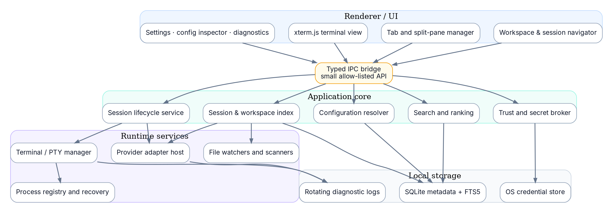
Figure 5. Logical component architecture

9.1 Component responsibilities
Component | Responsibility
Session and workspace index | Normalized metadata, source fingerprints, relationships and local annotations
Provider adapter host | Installation detection, discovery, parsing, resume/new launch specs, capability reporting and structured events
Terminal manager | PTY allocation, input/output streaming, resize, process termination, scrollback and terminal snapshots
Process registry | Runtime identity, PIDs, exit state, app restart reconciliation and managed-process ownership
Configuration resolver | Typed merge, provenance, validation, secret references and launch preview
Trust manager | Workspace trust, adapter trust, executable allow lists and risky-config prompts
Search service | Metadata search by default; optional transcript FTS index
Diagnostics service | Rotating logs, parser reports, environment probes and support bundle export

9.2 Dependency rule
DEPENDENCY RULE UI components depend on typed application services. Core services depend on adapter contracts, storage interfaces and runtime interfaces. Provider-specific code must never leak directly into UI components or database table semantics.

9.3 Event model
Use an internal event bus with typed domain events. Persist only events required for history, diagnostics or recovery. Terminal byte streams are high-volume transport and should not be copied into the domain event log by default.
Example domain events
type DomainEvent =
| { type: "session.discovered"; sessionId: string }
| { type: "session.updated"; sessionId: string; fields: string[] }
| { type: "runtime.started"; runtimeId: string; sessionId?: string }
| { type: "runtime.stateChanged"; runtimeId: string; state: RuntimeState }
| { type: "provider.attentionRequired"; sessionId: string; reason: AttentionReason }
| { type: "adapter.diagnostic"; providerId: string; severity: Severity; code: string };

10. Desktop process architecture
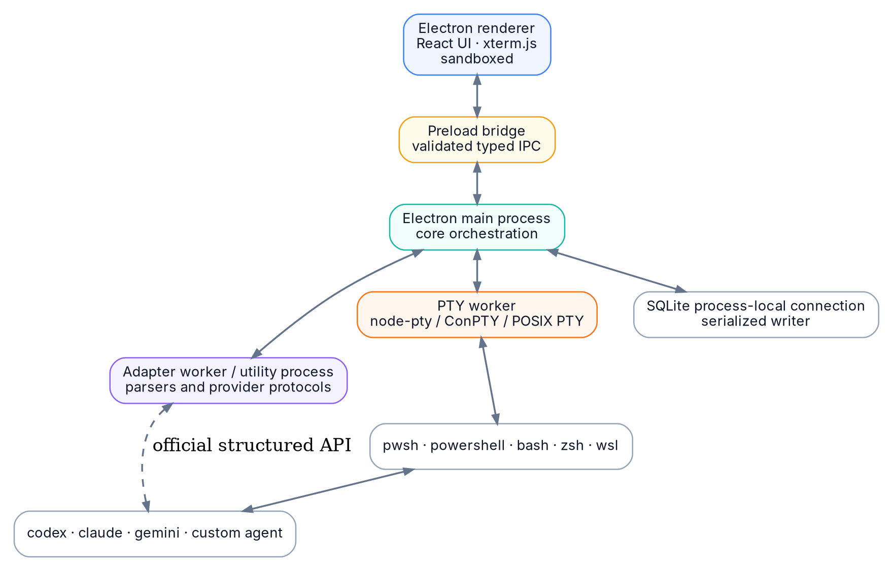
Figure 6. Recommended Electron process deployment

10.1 Renderer boundary
The renderer should be sandboxed and must not receive general filesystem, process or shell access. It communicates through a narrow preload bridge with schema-validated requests and responses. Electron’s current security guidance recommends context isolation, process sandboxing, restrictive content policy and IPC sender validation. [R12]

10.2 Main process
The main process owns lifecycle orchestration, configuration, database writes, trust decisions and API authorization. Long-running parsers and high-volume PTY I/O should be moved into workers or utility processes when profiling shows pressure on the main event loop.

10.3 Adapter workers
First-party adapters may begin in-process for simplicity. Parsers for large or untrusted files should run with strict size, time and memory limits in a worker. A future third-party adapter system must run out of process with a capability-limited RPC contract.

10.4 PTY worker
A separate PTY worker reduces the blast radius of native module faults and prevents terminal output bursts from starving the desktop main process. On Windows, ConPTY requires bidirectional communication channels and careful servicing to avoid deadlocks; keeping the PTY loop isolated fits that operational requirement. [R8]

11. Domain model and terminology
Term | Definition
Provider | An AI agent product family, such as Codex or Claude Code.
Provider installation | A discovered executable or service endpoint with a concrete path, version and environment.
Native session | A provider-owned conversation or thread identifier and its source data.
Normalized session | The application’s stable record that references one native session.
Workspace | A canonical local directory, usually a repository or project root.
Terminal profile | Shell executable, shell arguments, startup mode, environment and translated appearance settings.
Launch profile | Resolved provider, terminal, workspace and session configuration converted into an executable LaunchSpec.
Runtime instance | One running or completed process/API execution associated with a session.
Managed runtime | A runtime launched and owned by this application.
External runtime | A detected process not launched by this application.
Source confidence | Evidence score describing how reliably a discovered file maps to a session.
Attention item | A state requiring user action or investigation.

11.1 Identity rules
- Application IDs are generated and stable even if the provider moves its files.
- Native session IDs are namespaced by provider and installation.
- Workspace identity uses canonical path plus platform/host identity; WSL and Windows representations may refer to the same logical workspace through an explicit mapping.
- Source file paths are evidence, not primary keys.
- Runtime identity is unique per launch, even when the same session is resumed repeatedly.

12. Provider adapter system

12.1 Adapter contract
Core provider adapter interface
interface AgentProviderAdapter {
readonly manifest: ProviderManifest;
detectInstallations(ctx: DetectionContext): Promise<AgentInstallation[]>;
discoverSessions(ctx: DiscoveryContext): AsyncIterable<DiscoveredSession>;
inspectSession(ref: NativeSessionRef, ctx: InspectContext): Promise<SessionInspection>;
buildNewLaunch(input: NewSessionInput): Promise<LaunchPlan>;
buildResumeLaunch(input: ResumeSessionInput): Promise<LaunchPlan>;
connectStructuredRuntime?(input: StructuredConnectInput): Promise<StructuredRuntime>;
watchProviderChanges?(ctx: WatchContext): AsyncIterable<ProviderChange>;
performNativeAction?(action: ProviderAction): Promise<ProviderActionResult>;
}

12.2 Capability declaration
Provider capability matrix
interface ProviderCapabilities {
discovery: "official-api" | "documented-files" | "heuristic-files";
resume: "structured" | "cli" | "interactive-only" | "unsupported";
newSession: "structured" | "cli" | "unsupported";
liveStatus: "structured" | "hooks" | "process-only" | "unsupported";
fork: boolean;
archive: boolean;
deleteNative: boolean;
transcriptPreview: boolean;
externalRuntimeDetection: boolean;
}

12.3 Integration preference order
- Supported structured local protocol or SDK.
- Documented CLI with explicit session identifier and deterministic arguments.
- Documented session files for read-only discovery plus documented CLI resume.
- Heuristic read-only file parsing, marked with reduced confidence.
- Terminal-text inference only for cosmetic hints, never as the sole source for destructive decisions.

12.4 Initial provider notes
Provider | Discovery approach | Resume approach | Live-state path
Codex | Prefer app-server thread listing or documented local sources; maintain file fallback only if needed | App-server thread/resume or documented CLI resume | Structured thread, turn and item events through app server [R1-R2]
Claude Code | Documented session metadata or provider-supported listing where available | claude --resume / --continue | Hooks and supported session behavior; do not parse prompt rendering when hooks or process state suffice [R3-R5]
Gemini CLI | Documented automatic session data and resume browser behavior | Provider-supported resume command/workflow | Start with process state; add structured integration only when officially documented [R6-R7]
Custom CLI | User-defined roots and launch templates | User-supplied argument template | Process-only unless plugin supplies events

12.5 Adapter manifest
Illustrative adapter manifest
{
"id": "example-agent",
"displayName": "Example Agent",
"adapterApi": 1,
"execution": "isolated-worker",
"permissions": ["read:session-roots", "spawn:declared-executables"],
"supportedPlatforms": ["win32", "darwin", "linux"],
"capabilities": {
"discovery": "documented-files",
"resume": "cli",
"newSession": "cli",
"liveStatus": "process-only"
}
}

12.6 Versioning
- Version the adapter API independently from the application version.
- Adapters declare supported provider-version ranges and parser schemas.
- Each source record stores parser version and content fingerprint.
- A parser upgrade reprocesses affected sources transactionally and preserves local annotations.
- Unknown provider versions produce a warning and conservative capabilities rather than a crash.

13. Session discovery and reconciliation
Figure 7. Session discovery and reconciliation pipeline

13.1 Discovery triggers
- Application startup after the database opens.
- Manual refresh at provider, workspace or global scope.
- File-system watcher events, debounced and coalesced.
- Provider installation change, version change or adapter update.
- Periodic low-frequency integrity scan to recover from missed watcher events.

13.2 Fast-path scanning
The first pass reads only directory entries and lightweight metadata. Parse content only when the path is new, the fingerprint changed, the parser version changed or the previous parse failed with a retryable error. This keeps startup responsive even with thousands of sessions.

13.3 Parsing rules
- Apply strict file-size and nesting-depth limits.
- Never execute content found in transcripts or configuration during discovery.
- Parse using streaming readers where formats can grow without bound.
- Treat malformed records as partial evidence and attach a diagnostic to the source.
- Preserve unknown fields in a bounded raw-metadata bag when useful for forward compatibility.

13.4 Confidence scoring
Confidence | Evidence | UI treatment
Verified | Official API result or native ID validated by provider | Normal session
High | Known provider root, schema and valid native ID | Normal session with source badge
Medium | Recognized transcript and workspace metadata but missing native validation | “Likely session” badge
Low | Filename or partial shape only | Hidden by default under diagnostics
Invalid | Corrupted, unsupported or unsafe source | Diagnostic only

13.5 Reconciliation
Reconciliation must be idempotent. A scan produces candidate identities; the service matches them to existing normalized sessions using provider ID, installation, native ID and source relationships. Missing source files create tombstones rather than immediate deletion. A session disappears from normal views only after all sources are missing and any provider validation fails.

13.6 Duplicate sessions
Two files can describe the same native session, and one session can move between files. Merge automatically only when native identity is conclusive. Otherwise present a “possible duplicate” diagnostic and preserve both records until the user or a stronger parser resolves the ambiguity.

14. Workspace detection and Git context

14.1 Workspace root selection
Workspace resolution should use provider metadata first, then explicit user mapping, then repository detection, then current working directory. Repository detection walks upward for VCS markers with a bounded depth. Monorepos may optionally define named sub-workspaces without changing the canonical repository root.

14.2 Canonicalization
- Resolve symlinks where safe, while preserving the user-facing path spelling.
- Normalize case according to platform filesystem semantics.
- Handle network shares and removable volumes without blocking startup.
- Store host identity so the same path string on two machines is not treated as the same workspace.
- Model Windows and WSL path mappings explicitly rather than by string replacement alone.

14.3 Git enrichment
Field | Source | Fallback
Repository root | git rev-parse --show-toplevel or library equivalent | Workspace root
Branch | Git HEAD | Detached commit label
Worktree | git worktree metadata | Primary checkout
Remote | Configured remote URL, normalized | None
Dirty state | Optional bounded status probe | Unknown

14.4 Workspace identity across WSL
A session launched from Windows PowerShell may use D:\Work\Project while a WSL profile uses /mnt/d/Work/Project. Maintain a path-mapping record per WSL distribution. Probe with wsl.exe and the distribution’s path-conversion utilities where available. Never assume every mounted drive follows /mnt/<letter>.

15. Terminal and shell subsystem

15.1 Conceptual split
Concept | Owns | Examples
Terminal renderer | Visual cells, cursor, scrollback, selection, links and keyboard input | xterm.js
PTY backend | Bidirectional terminal channel and resize semantics | ConPTY, POSIX PTY
Shell | Interactive environment and startup files | pwsh, powershell.exe, zsh, bash, fish
Terminal profile | User-selected combination of shell, args, environment and translated appearance | PowerShell 7 with imported Windows Terminal colors
Agent process | The coding agent CLI or structured runtime | codex, claude, gemini

15.2 Terminal architecture
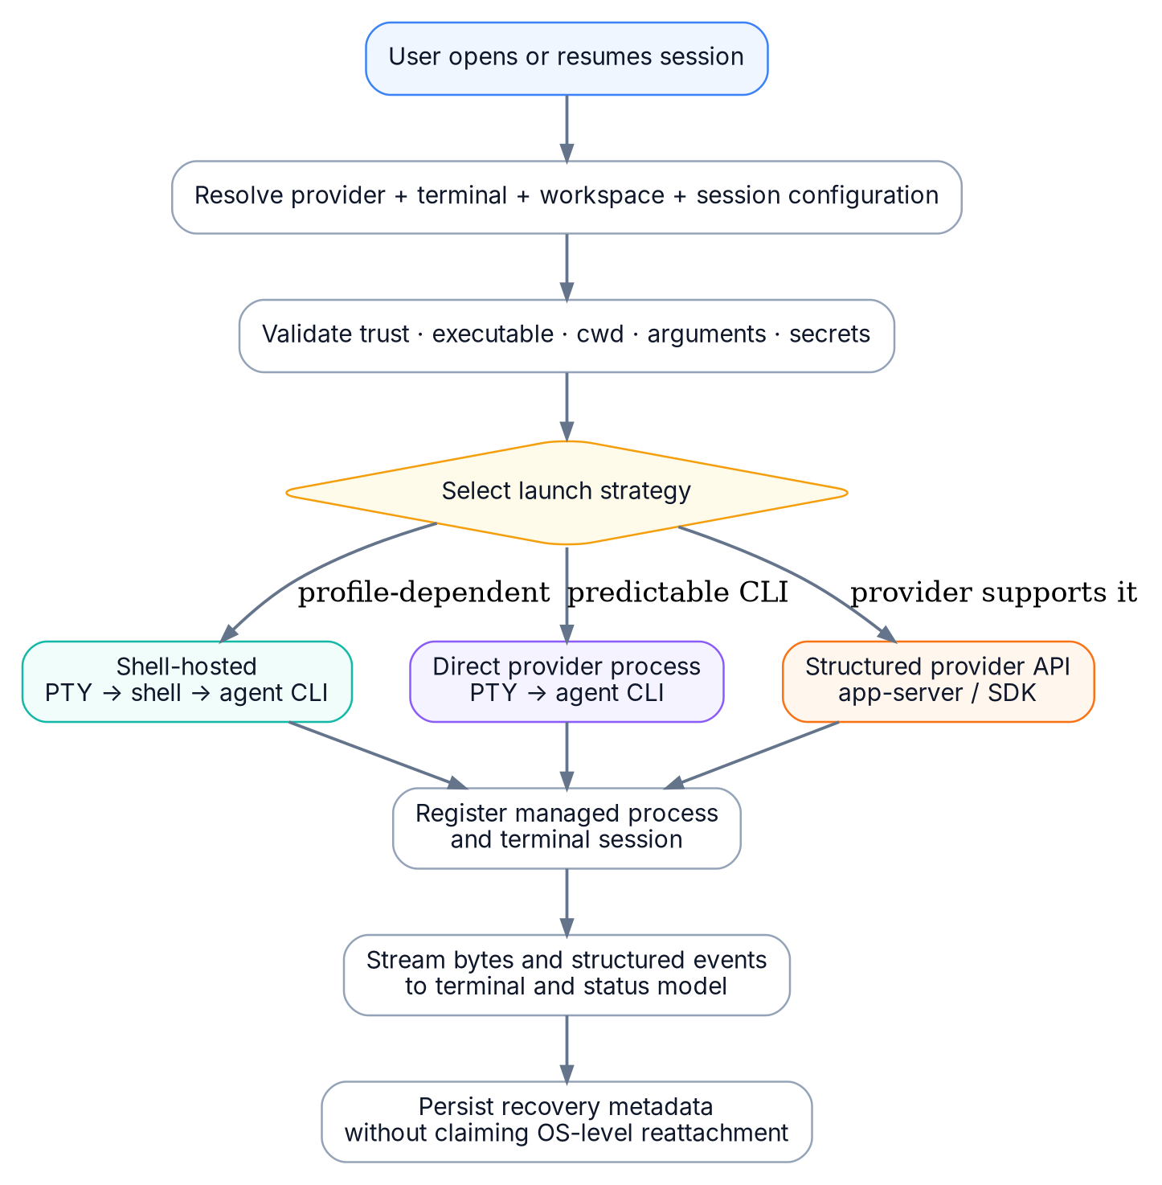
Figure 8. Launch strategy selection and managed runtime creation
On Windows, ConPTY is the operating-system mechanism for hosting character-mode applications. The host creates the pseudoconsole and bidirectional channels before the child process, services input and output, and handles resize and termination. [R8] On macOS and Linux, node-pty uses native pseudoterminal facilities. [R9]

15.3 Terminal profile model
Terminal profile data contract
interface TerminalProfile {
id: string;
name: string;
source: "detected" | "windows-terminal" | "system-default" | "custom";
shell: {
kind: "pwsh" | "windows-powershell" | "cmd" | "wsl" | "bash" | "zsh" | "fish" | "custom";
executable: string;
args: string[];
startupMode: "normal" | "interactive-login" | "interactive-nonlogin" | "clean" | "custom";
loadUserProfile: boolean;
};
environment: { inheritParent: boolean; variables: Record<string, SecretOrValue | null> };
appearance: TranslatedTerminalAppearance;
pathMapping?: PathMappingStrategy;
}

15.4 Shell discovery
Platform | Discovery
Windows | Known system paths, PATH search, App Execution Aliases where resolvable, Windows Terminal profiles, WSL distribution list and user-added executables
macOS | User login shell, /etc/shells, PATH search, common Homebrew locations and user-added executables
Linux | User login shell, /etc/shells, PATH search, distribution-specific common paths and user-added executables

Deduplicate shells by canonical executable path plus stable base arguments. Probe each candidate using a clean noninteractive command to obtain version and identity. A probe failure should not delete the profile; it marks it unavailable with diagnostic output.

15.5 PowerShell 5.1 and PowerShell 7
Treat Windows PowerShell 5.1 and PowerShell 7 as separate shells. PowerShell 7 installs side by side rather than replacing Windows PowerShell 5.1. [R10] Do not infer profile paths from hard-coded Documents folders. Run the selected executable and inspect $PROFILE because profile paths vary by user and host application. Microsoft documents CurrentUserCurrentHost, CurrentUserAllHosts, AllUsersCurrentHost and AllUsersAllHosts profile locations through the $PROFILE object. [R11]
POWERSHELL LAUNCH RULE For a normal interactive terminal, omit -NoProfile so the selected shell loads its own normal profile chain. Use -NoProfile only for detection probes, safe diagnostics or an explicit “clean shell” profile.

PowerShell profile probe concept
pwsh -NoLogo -NoProfile -NonInteractive -Command '$p = $PROFILE | Select-Object *; [pscustomobject]@{ version=$PSVersionTable.PSVersion.ToString(); edition=$PSVersionTable.PSEdition; profiles=$p } | ConvertTo-Json -Depth 4 -Compress'

15.6 Windows Terminal settings import
Windows Terminal can supply useful profile metadata and appearance defaults, but the embedded terminal is not Windows Terminal. Import and translate a controlled subset: command line, starting directory, font face, font size, color scheme, cursor shape, opacity, padding and icon. Windows Terminal stores profile defaults and per-profile settings in its configuration, and Microsoft documents standard settings.json locations for stable, preview and unpackaged installations. [R13-R14]
- Do not import key bindings in the MVP. Application tab shortcuts and terminal shortcuts would conflict.
- Do not promise pixel-identical rendering. Mark imported appearance as “translated.”
- Do not execute profile command lines until they pass executable and argument validation.
- Detect settings fragments and dynamic profiles where practical, but allow the user to select a simple detected shell if import is incomplete.

15.7 macOS and Linux shell startup
Startup behavior differs by shell. Bash distinguishes login from interactive non-login startup files; zsh reads .zshrc for interactive shells and additional profile/login files for login shells. [R16-R17] The terminal profile must therefore expose startup mode rather than hiding it behind a generic “load settings” checkbox.
Shell / platform | Default profile behavior | User override
PowerShell on Windows | Normal profile loading | Clean or custom arguments
zsh on macOS | Interactive login by default to match common terminal behavior | Interactive non-login or clean
bash/zsh on Linux | Interactive non-login by default | Login or clean
fish | Interactive | Custom arguments
WSL distribution | Launch distribution, then its selected shell behavior | Distribution and shell override

15.8 Agent launch modes
Mode | Process tree | Use when | Trade-off
Shell-hosted | PTY → selected shell → agent | User environment depends on shell profile, aliases or version manager | Harder quoting and noisier startup
Direct CLI | PTY → agent executable | Executable and environment are already known | Does not receive environment created only inside startup scripts
Structured runtime | Provider protocol or SDK, optionally with terminal UI | Provider exposes official control and events | Provider-specific implementation

15.8.1 Native CLI mode is the product default
The default path for “New AI session” is native CLI mode. It launches the same provider program the user would launch in an external terminal, under the selected shell profile and working directory. The application may add environment values or provider flags only when they are present in resolved configuration, and every addition must appear in the launch preview with provenance.
PARITY BOUNDARY
Behavioral parity is required for the CLI process. Pixel parity with Windows Terminal, iTerm2 or another terminal emulator is not required.

15.8.2 Terminal and keyboard ownership
- When the terminal viewport has focus, keystrokes belong to the PTY by default. Application commands use configurable chords that do not shadow common CLI controls.
- Ctrl+C must reach the foreground process. Closing a tab uses an application action, not interception of the CLI interrupt sequence.
- The renderer must support alternate-screen applications and restore scrollback correctly when the provider leaves that mode.
- Clipboard paste may be guarded for multiline content, but the resulting bytes must be delivered exactly after user confirmation.
- Mouse reporting is passed through when requested by a terminal application; application selection behavior must adapt to that mode.

15.8.3 Native mode versus integrated mode
Mode | Purpose | Behavioral contract
Native CLI | Exact terminal workflow for new and resumed sessions. | Runs the official CLI in a PTY. Provider UI and interaction remain native. This is the default.
Integrated protocol | Richer structured state, approvals or custom application UI when a provider offers a documented protocol. | May not look or behave exactly like the CLI. Present it as a separate mode, never as hidden substitution.
Blank shell | General terminal tab without automatically starting an agent. | Loads the selected shell profile and leaves the prompt under user control.

15.8.4 Environment equivalence strategy
Native shell-hosted mode provides the strongest equivalence because shell startup scripts can modify PATH, environment variables, version managers, aliases and functions before the agent starts. Direct mode is more deterministic but inherits only the environment provided by the application. The profile test screen should display an environment comparison between a clean process, the selected interactive shell and the final agent launch.

15.9 Command injection strategy
Do not spawn a shell and then type the agent command into the terminal. That races profile loading, pollutes history and can land input inside an interactive startup prompt. Build the process invocation before spawn. For shell-hosted mode, use a shell adapter that produces an argument array or temporary script with explicit lifecycle ownership.

15.10 Input and display requirements
- Resize PTY on terminal container resize, debounced to avoid storms.
- Preserve UTF-8 byte boundaries and wide-character cell width.
- Support IME composition without sending partial composition text to the PTY.
- Require Ctrl-click or Cmd-click for links and validate schemes before opening.
- Support bracketed paste and a configurable paste warning for multiline commands.
- Keep terminal scrollback bounded per tab and optionally persist only a limited encrypted snapshot.
- Expose accessibility labels and a screen-reader mode supported by the terminal renderer.
xterm.js exposes configurable terminal options and documents its supported VT sequences. Imported appearance and interaction options should map only to stable public APIs. [R15]

15.11 Process termination
A tab close offers three actions when a runtime is active: keep running in background, terminate gracefully, or force terminate. The application first sends provider-specific or shell-appropriate graceful input, waits a bounded interval, then terminates the managed process tree. On Windows, closing the pseudoconsole terminates attached client applications, so graceful shutdown must happen before PTY teardown. [R8]

16. Configuration inheritance and command construction
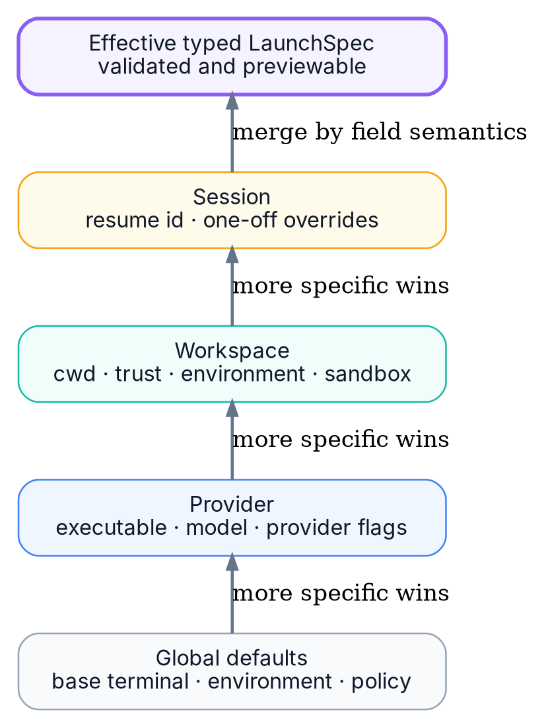
Figure 9. Configuration precedence and typed launch-spec resolution

16.1 Precedence
The required order is Global < Provider < Workspace < Session. “Higher” in the UI means more specific, not more important. A session value overrides the same semantic key from all less-specific layers.

16.2 Merge semantics by type
Field type | Merge rule | Example
Scalar | Most specific non-null value wins | model, shell profile, approval mode
Map | Merge by key; null explicitly removes inherited key | environment variables
Typed option set | Merge by semantic option key | sandbox mode, model, profile
Argument list | Explicit append, prepend, replace and remove operations | extra provider flags
Command hook list | Concatenate only when hook type declares composability | pre-launch checks
Secret reference | Most specific reference wins; value never copied into config history | API token

16.3 Raw startup commands
AVOID A STRING-ONLY DESIGN A single startupCommand string cannot be safely merged across shells or configuration levels. Store executable, argument operations, environment, working directory and optional shell expression separately. Raw shell expressions belong in an advanced field with a visible warning.

16.4 LaunchSpec
Resolved launch specification
interface LaunchSpec {
intent: "new-session" | "resume-session" | "blank-shell";
parityMode: "native-cli" | "integrated";
strategy: "shell-hosted" | "direct" | "structured";
executable: string;
args: string[];
cwd: string;
env: Record<string, string>;
terminalProfileId?: string;
providerId?: string;
nativeSessionId?: string;
provisionalSessionKey?: string;
gracefulStop?: StopStrategy;
provenance: Record<string, ConfigProvenance>;
maskedPreview: string;
validation: ValidationIssue[];
}

16.5 Conflict handling
- Two values for the same scalar key: the most specific wins and the inspector shows the shadowed values.
- Duplicate raw CLI flags: adapters normalize recognized flags into typed options before resolution.
- Unknown flags: preserve order in the explicit argument operation list and warn if a known exclusive option may conflict.
- Executable conflict: session wins, but switching executable invalidates installation-specific native IDs until adapter validation succeeds.
- Working-directory conflict: session wins only if it exists and satisfies workspace trust policy.
- Environment deletion: a null value removes an inherited variable from the child environment.

16.6 Resolution algorithm
Resolution pseudocode
function resolveLaunchConfig(layers: ConfigLayer[]): ResolvedConfig {
const ordered = layers.sort(bySpecificityAscending);
const result = emptyResolvedConfig();
for (const layer of ordered) {
mergeScalars(result, layer);
mergeEnvironmentByKey(result, layer);
mergeTypedProviderOptions(result, layer);
applyArgumentOperations(result, layer.arguments);
recordProvenance(result, layer);
}
normalizeProviderOptions(result);
validatePathsAndTrust(result);
return result;
}

16.7 Configuration storage
Store configuration as versioned typed JSON in the database with revision history. Export and import should use a documented schema. Secrets are represented by stable secret IDs, not embedded values. Workspace-local configuration files may be supported later, but they are untrusted inputs and cannot silently enable command execution.

17. Session lifecycle and process management
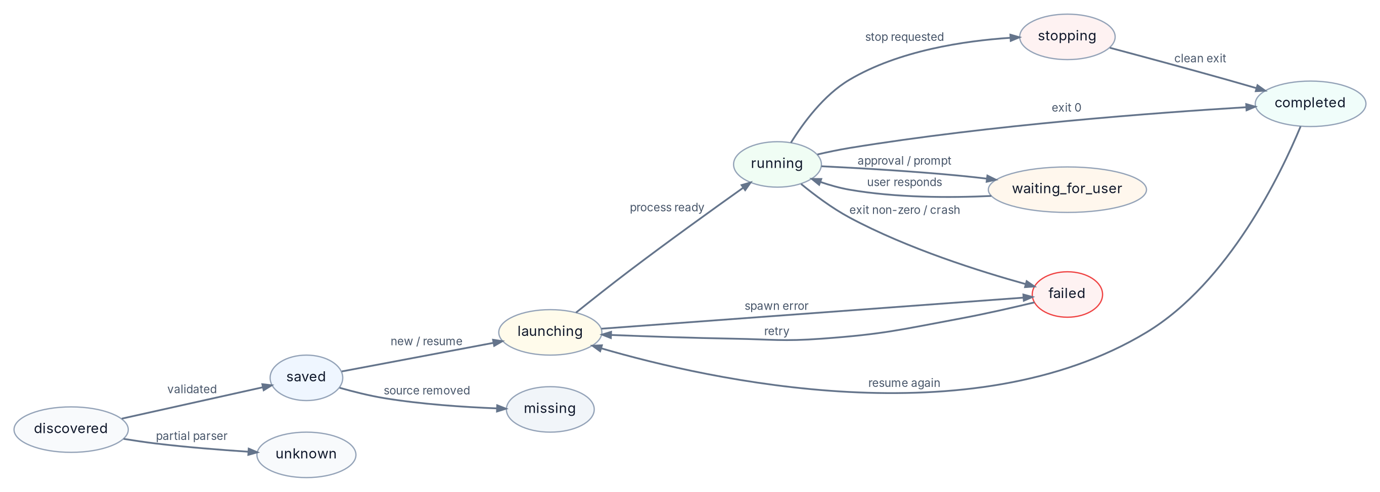
Figure 10. Normalized session lifecycle state machine

17.1 Separate persisted session from runtime
A session can exist with zero, one or many runtime instances over time. The session lifecycle presented in the catalog is derived from the active runtime, provider state and saved-session availability. Runtime history is never overwritten when a session is resumed again. A brand-new launch begins as a runtime with a provisional session key and may have no SessionRecord relationship until the provider exposes durable identity.

17.2 Managed versus external
Runtime class | What the app knows | What the app may do
Managed PTY runtime | PID tree, PTY handle, launch spec, output stream and exit code | Input, resize, graceful stop, force stop, background tab recovery
Managed structured runtime | Provider connection, thread/turn IDs and event stream | Provider-supported control, resume/fork/stop as documented
External detected runtime | Possible PID, executable and workspace correlation | Show detection with uncertainty; focus external app only when supported
Saved only | Native session metadata and resume capability | Launch a new runtime

17.3 App restart recovery
A desktop restart cannot generically recreate a destroyed PTY connection. Recovery should be honest: persist tabs, terminal dimensions, LaunchSpec, runtime metadata and bounded scrollback snapshot; on restart, mark old runtimes as “ownership lost” unless a provider protocol or persistent broker supports reconnection. Offer “resume session in new runtime” rather than claiming attachment.

17.4 Optional persistent broker
A later release can introduce a small local broker process that survives UI restarts and owns PTYs. The desktop reconnects to the broker using a local authenticated channel. This improves app-restart resilience but increases installer, security and process-lifecycle complexity. It should not block the MVP.

17.5 Attention derivation
- Provider structured event explicitly requests approval or input.
- Provider hook reports a waiting state.
- Process is alive but no output and provider-specific prompt detection is high-confidence.
- Launch fails, authentication expires or executable disappears.
- Adapter parser fails on a previously valid source.
- Workspace trust blocks a requested startup behavior.

17.6 Concurrency
Multiple runtimes may point to the same native session. Default behavior should warn before launching a second writable runtime because concurrent continuation may produce confusing provider state. Allow the user to proceed for providers that explicitly support parallel branches or thread forks.

18. Data storage, indexing and search
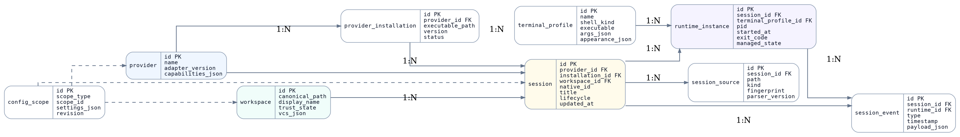
Figure 11. Core relational data model

18.1 SQLite ownership
Use one SQLite database per user profile. Prefer a single serialized writer with short transactions and concurrent read connections as supported by the selected binding. Enable WAL after verifying packaging and backup behavior. All schema changes run through ordered migrations with backups before destructive operations.

18.2 Core tables
Table | Purpose | Retention
provider | Adapter identity and capabilities | Permanent
provider_installation | Detected executable or endpoint | Until unavailable and unreferenced
workspace | Canonical workspace and trust state | User-controlled
session | Normalized session metadata | Until explicitly forgotten
session_source | Provider file/API evidence and fingerprints | While source or tombstone matters
runtime_instance | Launch and exit history | Configurable retention
session_event | Low-volume lifecycle and diagnostic events | Bounded retention
config_scope | Versioned settings by scope | Revision retention
terminal_profile | Detected/imported/custom terminal profile | User-controlled
local_annotation | Pins, tags, local title and archive state | Permanent

18.3 Search modes
Mode | Indexed data | Default
Metadata search | Title, workspace, provider, branch, tags, timestamps and status | On
Transcript preview search | Selected message excerpts | Off until user enables content indexing
Full transcript search | Provider transcript content in FTS5 | Opt-in per provider or workspace
Terminal scrollback search | In-memory current tab buffer | On for active tab; not global by default

SQLite FTS5 provides a full-text virtual table suitable for local transcript search. [R18] Use an external-content design or a separate sanitized content table so metadata remains usable even when the content index is disabled or rebuilt.

18.4 Privacy-preserving indexing
- Do not index environment variables, secret values or obvious token patterns.
- Allow per-workspace exclusion and immediate index purge.
- Store only content needed for the selected search mode.
- Expose database and index locations in settings.
- Provide a “rebuild index” and “delete transcript index” action.

18.5 Backup and export
Export should separate settings, local annotations and optional session metadata. Never include provider transcript contents or secrets unless the user explicitly selects them. Use a manifest with schema version and platform information. Database backup uses SQLite’s safe backup mechanism or a closed-database copy, not a blind copy during writes.

19. Security, privacy and workspace trust
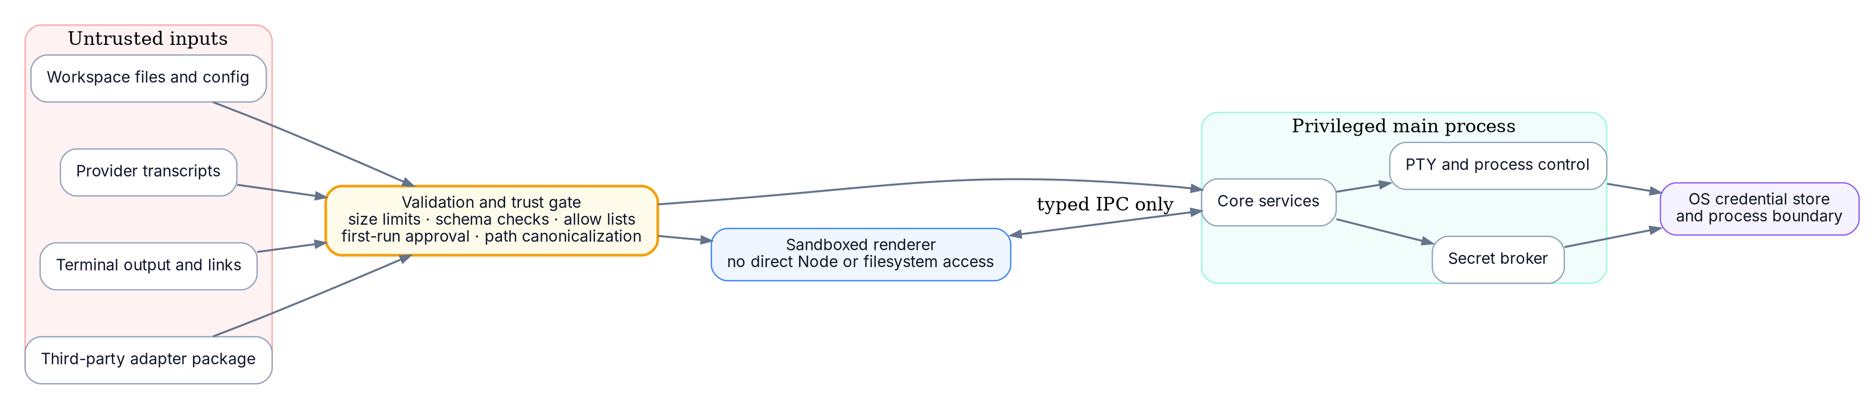
Figure 12. Security trust zones and validation gate

19.1 Threat model
Threat | Example | Control
Malicious repository config | A cloned project defines a destructive startup expression | Workspace trust, no automatic execution, launch preview
Malicious transcript content | Terminal escape sequences or links attempt unsafe actions | Terminal sequence policy, link validation, no execution during parsing
Renderer compromise | UI code attempts filesystem or process access | Sandbox, context isolation, narrow IPC and CSP
Adapter compromise | Third-party adapter reads unrelated files or spawns arbitrary commands | Out-of-process capability model and signed distribution policy
Secret leakage | Effective config or logs print tokens | Secret references, masking and log redaction
Path confusion | Symlink or WSL mapping points outside trusted workspace | Canonicalization and trust check after resolution

19.2 Workspace trust states
State | Behavior
Unknown | Read metadata only. Block repository-provided executable actions and prompt before first launch if config contributes behavior.
Trusted | Allow saved workspace launch configuration subject to global policy.
Restricted | Allow sessions and terminal launch but ignore workspace startup hooks and raw expressions.
Blocked | Do not launch processes in the workspace; catalog remains visible.

19.3 Secret handling
- Store tokens in Windows Credential Manager, macOS Keychain or a Linux secret service where available.
- Configuration contains secret references such as secret://provider/codex-token.
- Resolve secrets only in the privileged process immediately before launch.
- Mask secret-derived environment values and command arguments in UI previews and logs.
- Never pass secrets to adapter workers that do not declare and receive a required capability.

19.4 Terminal security
- Allow only safe URL schemes for clickable links and require a modifier key.
- Prompt before large or multiline paste by default.
- Ignore or constrain terminal escape sequences that request unsupported host behavior.
- Do not let OSC sequences directly open files or URLs without validation.
- Rate-limit title changes and other UI-affecting sequences.

19.5 Electron hardening
Use contextIsolation, renderer sandboxing, no general Node integration, a restrictive Content Security Policy, validated IPC senders and limited navigation. These controls align with Electron’s published security checklist. [R12]

20. IPC and internal API contracts

20.1 Principles
- Every IPC route has a request and response schema.
- Renderer requests are capability-scoped and validated in the main process.
- No route accepts arbitrary executable plus arbitrary arguments unless the user is in a dedicated advanced custom-profile flow.
- Long-running operations return operation IDs and publish progress events.
- Terminal byte transport uses a dedicated channel with backpressure and bounded buffering.

20.2 Example renderer API
Renderer-facing bridge
interface DesktopBridge {
sessions: {
query(filter: SessionFilter): Promise<Page<SessionListItem>>;
inspect(sessionId: string): Promise<SessionDetail>;
refresh(scope: RefreshScope): Promise<OperationRef>;
startNew(request: NewSessionRequest): Promise<RuntimeHandle>;
resume(request: ResumeSessionRequest): Promise<RuntimeHandle>;
};
runtimes: {
launch(request: LaunchRequest): Promise<RuntimeHandle>;
write(runtimeId: string, data: Uint8Array): Promise<void>;
resize(runtimeId: string, cols: number, rows: number): Promise<void>;
stop(runtimeId: string, mode: "graceful" | "force"): Promise<void>;
};
configuration: {
resolve(target: ConfigTarget): Promise<ResolvedConfigView>;
update(scope: ConfigScopeRef, patch: ConfigPatch, revision: number): Promise<ConfigScope>;
};
diagnostics: {
runTerminalProbe(profileId: string): Promise<OperationRef>;
compareNativeEnvironment(profileId: string): Promise<EnvironmentComparison>;
exportSupportBundle(options: SupportBundleOptions): Promise<SaveResult>;
};
}

20.3 Terminal stream protocol
Use binary frames for PTY output, separate control messages for state and resize acknowledgements, and a per-runtime sequence number for detecting dropped frames. The UI should acknowledge consumed bytes so the PTY worker can apply backpressure rather than retaining unbounded memory.

20.4 Error model
Error envelope
interface AppError {
code: string; // stable machine-readable code
message: string; // user-safe summary
operationId?: string;
retryable: boolean;
details?: Record<string, unknown>; // redacted
diagnosticRef?: string; // opens local diagnostic detail
}

21. Plugin and extension model

21.1 First-party adapters first
Ship first-party adapters inside the application until the adapter API, diagnostics and security model are proven. A premature plugin marketplace would turn every session transcript into an attractive treasure chest for untrusted code.

21.2 Future third-party model
- Out-of-process adapter executable with a versioned JSON-RPC or message protocol.
- Declarative permissions for session roots, executable paths, network access and secrets.
- No direct database access.
- No arbitrary renderer code.
- Signed package verification and explicit user installation.
- Per-adapter disable, update and diagnostic controls.

21.3 Custom provider without code
Provide a limited declarative custom-CLI profile for users who need basic launch and discovery. It may define known executable names, bounded session roots, filename patterns and new/resume argument templates. It cannot parse arbitrary formats or execute code during discovery.
Declarative custom provider example
{
"id": "internal-agent",
"displayName": "Internal Agent",
"detect": { "executables": ["internal-agent"] },
"sessionRoots": ["${HOME}/.internal-agent/sessions"],
"launch": {
"new": ["${executable}"],
"resume": ["${executable}", "--resume", "${nativeSessionId}"]
}
}

22. Observability and diagnostics

22.1 Local diagnostic logs
Category | Examples | Default retention
Application | Startup, migrations, update and window lifecycle | 14 days
Adapter | Detection, parser versions, source errors and capability negotiation | 14 days
Terminal | Spawn, resize, exit and PTY errors; no raw output by default | 7 days
Configuration | Resolution warnings and validation codes; masked values | 14 days
Security | Trust decisions and blocked actions | 30 days

22.2 Support bundle
The support bundle is user-generated and previewable. It includes app version, platform, adapter manifests, redacted logs, configuration schemas, provider installation diagnostics and database integrity status. It excludes transcripts, terminal output, workspace file contents and secret values unless explicitly added.

22.3 Diagnostics UI
- Provider installation list with executable, version, health and source.
- Session parser report with source path, fingerprint, parser version and last error.
- Terminal profile probe with shell version, profile paths, PATH and agent discovery.
- Database migration and integrity status.
- Workspace trust decisions and contributing configuration scopes.

23. Reliability and recovery

23.1 Failure domains
Failure | Expected behavior
One malformed transcript | Quarantine that source; continue indexing other sessions
Provider executable missing | Keep saved sessions; mark installation unavailable and offer rediscovery
PTY native module crash | Mark affected runtimes failed; preserve UI and restart worker
Database write failure | Rollback transaction and keep prior index
App crash | Recover tabs and saved launch metadata; do not claim lost PTYs are attached
Adapter update incompatible | Disable adapter, retain normalized data and surface diagnostic
Workspace volume offline | Keep session metadata with workspace unavailable badge

23.2 Database safety
- Wrap each discovery reconciliation batch in a transaction.
- Create migration backup before schema changes that rewrite tables.
- Run integrity checks after abnormal shutdown when appropriate.
- Keep source fingerprints so a rebuild does not require reparsing unchanged content.

23.3 Terminal backpressure
PTY output can arrive faster than a renderer can paint. Use bounded queues, binary transport and renderer acknowledgements. When a tab is backgrounded, reduce paint frequency while continuing to drain the PTY. If the UI falls far behind, retain a tail buffer and insert a visible truncation marker rather than exhausting memory.

23.4 File watcher resilience
Watchers are advisory, not authoritative. Coalesce bursts, detect renames as delete-plus-create where needed, and run periodic reconciliation. Network volumes and provider atomic-write patterns can produce unusual event sequences; correctness comes from fingerprints and scans, not from believing every watcher event literally.

24. Performance targets
Metric | Target for MVP | Measurement
Cold start to usable UI | < 2.5 s with existing index | Desktop performance trace
Background discovery start | After UI becomes interactive | Startup trace
Metadata search | < 100 ms p95 for 25,000 sessions | Synthetic database benchmark
Open terminal tab | < 500 ms to PTY spawn p95, excluding slow shell profiles | Launch telemetry
Terminal input echo | < 50 ms local p95 | PTY loop benchmark
Memory at idle | < 300 MB target for Electron build | Cross-platform soak test
Incremental source parse | Only changed fingerprints | Discovery counters
UI list scrolling | 60 fps target on modern hardware | Renderer profiling

Slow user shell profiles are not counted as application spawn overhead, but the diagnostics screen should report profile startup duration and identify it as external startup cost.

25. Testing strategy

25.1 Test pyramid
Layer | Coverage
Unit | Config merge, path canonicalization, identity matching, parser fixtures, command construction and redaction
Contract | Provider adapters against recorded official responses and versioned file fixtures
Integration | SQLite migrations, file watchers, PTY spawn, IPC validation and secret store adapters
End-to-end | Discover → select → resolve → trust → launch → interact → stop → reopen
Manual compatibility | Real shells, prompt frameworks, IME, WSL distributions, network paths and high-output commands

25.2 Terminal test matrix
OS | Shell/profile cases | Required scenarios
Windows 10/11 | PowerShell 5.1, PowerShell 7 stable, cmd, WSL Ubuntu, Git Bash | Profile loading, Unicode, resize, Ctrl+C, process tree stop, path mapping
macOS | zsh login/non-login, bash, PowerShell | Profile startup, command key handling, IME, Keychain
Linux | bash, zsh, fish, PowerShell, Wayland/X11 desktop variants | PTY behavior, secret service fallback, packaging

25.3 Provider fixture strategy
- Keep anonymized fixtures for every supported provider schema version.
- Include partial writes, corrupt JSON/JSONL, moved roots, duplicate sources and very large transcripts.
- Run adapter contract tests against the newest provider version before release.
- Never include real user secrets or proprietary code in fixtures.

25.4 Security tests
- IPC fuzzing and schema rejection.
- Workspace config path traversal and symlink escape tests.
- Terminal OSC/link injection tests.
- Secret masking snapshot tests.
- Untrusted adapter permission denial tests.
- Launch preview versus actual process argument verification.

25.5 Native CLI parity suite
For every supported provider and release channel, run the same smoke scenario once in a reference external terminal and once in the embedded terminal using the same shell profile, workspace and provider configuration. Differences are classified as expected terminal-emulator differences, application defects or provider-specific limitations.
- Start a session without any pre-existing native session file.
- Complete first-run authentication or a mocked equivalent.
- Exercise provider help, model/profile selection, slash commands, approval prompts and cancellation.
- Run a child shell command, a long-running tool and a full-screen or alternate-buffer interaction when supported.
- Verify resize, Unicode, wide glyphs, IME, bracketed paste, OSC 8 links, Ctrl+C and clean exit.
- Confirm executable path, provider version, current directory, profile loading and a safe allowlist of environment variables match the reference terminal.
- Verify the application contributes no provider argument unless it appears in the resolved configuration preview.
- Verify the newly persisted native session is linked to the provisional runtime without confusing it with another simultaneous launch.

26. Accessibility and localization

26.1 Accessibility
- All non-terminal controls must meet keyboard navigation and visible-focus requirements.
- Lifecycle state uses text plus icon, never color alone.
- Provide accessible names for terminal tabs, sessions and attention badges.
- Expose terminal renderer screen-reader mode and document its performance trade-offs.
- Support font scaling without clipping the sidebar and inspector.
- Respect reduced-motion settings for status animations.

26.2 Localization
Store UI strings separately from provider-native output. Do not translate terminal output or provider session content. Dates and paths follow platform conventions, while stable internal error codes remain language-neutral. Design layouts for 30-40 percent text expansion.

27. Packaging and updates

27.1 Packages
Platform | Package strategy
Windows | Signed installer, x64 and arm64 as supported; bundle native node-pty binaries; register no shell extensions in MVP
macOS | Notarized universal or separate architecture builds; Keychain integration
Linux | AppImage plus one package format after user validation; document secret-service dependencies

27.2 Native module compatibility
Electron upgrades can require rebuilding native modules such as node-pty. Pin Electron and native-module versions in a compatibility matrix and run packaging smoke tests for every target architecture before release.

27.3 Update policy
- Signed updates only.
- Stage provider-adapter updates separately when possible.
- Back up configuration and database before migrations.
- Allow update deferral, but warn when an adapter cannot support a newly detected provider version.

28. Delivery roadmap

28.1 Phase 0 - technical spikes
Spike | Exit criterion
Windows/macOS/Linux PTY prototype | Interactive shell, resize, Unicode, Ctrl+C and clean process-tree termination
PowerShell profile discovery | Correctly distinguishes 5.1 and 7, reports $PROFILE paths and loads normal profiles
Codex adapter proof | List/resume one session through preferred official path and receive structured lifecycle events where supported
Claude Code adapter proof | Discover and resume a named/native session through documented CLI behavior
SQLite index proof | Index 25,000 synthetic sessions and meet search target

28.2 Phase 1 - catalog MVP
- Application shell, navigation and settings.
- Provider installation discovery.
- Codex and Claude Code read-only session discovery.
- Workspace mapping, search, local rename, pin and archive.
- Adapter diagnostics and database migrations.

28.3 Phase 2 - managed terminal MVP
- Reference-terminal parity harness for each supported provider and shell profile.
- xterm.js and node-pty integration.
- Terminal profile discovery and custom profile editor.
- Native new-session and resume flows, provisional session reconciliation, and process registry.
- Global/provider/workspace/session configuration resolver.
- Effective configuration inspector and trust prompts.

28.4 Phase 3 - operational awareness
- Structured provider events and hooks.
- Attention inbox and notifications.
- Runtime history and basic usage statistics.
- Gemini CLI adapter.

28.5 Phase 4 - resilience and ecosystem
- Optional persistent PTY broker.
- Worktree and fork orchestration.
- Isolated third-party adapter SDK.
- Enterprise policy and managed configuration.

28.6 Suggested team
Role | Initial allocation
Desktop/full-stack engineer | Application shell, IPC, storage and packaging
Systems/terminal engineer | PTY, process lifecycle, shell adapters and WSL
Provider integration engineer | Codex, Claude Code and adapter SDK
Product designer | Navigation, terminal profiles, config inspector and attention model
QA/security contributor | Cross-platform matrix, fixtures and threat testing

29. Risk register
Risk | Likelihood | Impact | Mitigation
Provider session formats change | High | High | Adapter versioning, source fingerprints, official APIs first and fixture tests
Embedded terminal edge cases consume schedule | High | High | Early PTY spike, narrow MVP profile set and platform test matrix
Users expect arbitrary process attachment | High | Medium | Clear managed/external vocabulary and honest UX
Shell profiles make launches nondeterministic | High | Medium | Profile probes, clean mode and direct launch option
Repository config becomes code-execution vector | Medium | High | Workspace trust and no automatic raw command execution
Electron native module packaging issues | Medium | High | Pinned matrix, CI packaging and smoke tests
Transcript indexing creates privacy concern | Medium | High | Metadata-only default and opt-in content indexing
Cross-provider normalization hides useful details | Medium | Medium | Common core plus provider-specific metadata panel
Performance degrades with large histories | Medium | Medium | Fingerprint scans, lazy parsing, pagination and FTS5
Embedded terminal diverges from the provider CLI | Medium | High | Run the official binary in a real PTY, keep native mode free of hidden flags, and gate releases with the reference-terminal parity suite.

30. Product metrics
Metric | Why it matters
Time to resume a known session | Measures the central context-reconstruction benefit
Successful launch rate | Captures shell, path, provider and config correctness
Sessions discovered per provider versus provider-native list | Measures adapter recall and precision
Config-inspector opens after failed launch | Shows whether provenance is solving real problems
Attention item resolution time | Measures operational dashboard value
Percentage of launches using workspace/session overrides | Validates inheritance demand
Terminal profile probe failure rate | Identifies ecosystem compatibility gaps
Opt-in rate for transcript search | Tests whether search value justifies privacy cost
Native new-session success rate | Shows whether users can start the real provider CLI from the app without terminal-specific failures.

Telemetry should be opt-in or privacy-preserving and must never include transcript text, terminal output, paths, command arguments or environment values. Local metrics can be displayed without leaving the device.

31. Open decisions
Decision | Recommended default | Revisit when
Electron versus Tauri/native | Electron | A PTY prototype shows unacceptable footprint or packaging constraints
Persistent PTY broker | Not in MVP | Users strongly value UI-restart reattachment
Transcript content index | Off by default | Privacy UX and performance are validated
Workspace-local config file | Defer | Trust model and schema are stable
Third-party adapters | Defer | First-party adapter API has survived at least two provider changes
Cloud sync | No | A clear encrypted, user-controlled use case exists
Provider-native archive/delete | Read-only by default | Each provider exposes stable supported operations
Default launch experience | Native CLI mode with no extra provider flags | A documented provider protocol offers materially better UX and users explicitly select integrated mode

32. Definition of done

32.1 MVP acceptance criteria
- On Windows, macOS and Linux, the application discovers supported provider installations and at least two providers’ saved sessions.
- Sessions are grouped by canonical workspace and provider with stable IDs across rescans.
- A user can create and test terminal profiles, including PowerShell 5.1 and PowerShell 7 on Windows when installed.
- A user can resume a supported session in an embedded terminal tab using normal shell startup behavior.
- Global, provider, workspace and session settings resolve deterministically and display provenance.
- No provider-owned session file is modified during discovery or ordinary local archive/rename actions.
- Untrusted workspace configuration cannot execute without an explicit trust decision.
- Terminal tabs support resize, Unicode, paste, Ctrl+C, background operation and graceful/force termination.
- Failed scans and launches produce actionable diagnostics without crashing the application.
- Database migration, backup and support-bundle export pass cross-platform tests.
- A user can start a brand-new AI CLI session in an embedded terminal without an existing session record, and the resulting native session appears in the catalog after the provider persists it.
- In native CLI mode, the application runs the official provider command in a real PTY/ConPTY, passes normal interactive input and signals, and adds no provider option that is absent from resolved configuration.
- Authentication prompts, slash commands, approvals, hooks, MCP integrations, child tools, alternate-screen behavior and provider-defined terminal interactions work to the same behavioral standard as the reference external terminal.
- Simultaneous new sessions are reconciled to their own native identities or remain explicitly provisional; the application never silently links a runtime to an uncertain session file.

32.2 Product quality bar
QUALITY BAR
The MVP is ready when a developer can discover, start and resume the provider's real CLI faster and more safely than managing separate terminal windows, without losing native CLI behavior.

Appendix A. TypeScript domain interfaces
Core domain interfaces
type SessionLifecycle =
| "discovered"
| "saved"
| "launching"
| "running"
| "waiting_for_user"
| "stopping"
| "completed"
| "failed"
| "missing"
| "unknown";
type ResumeSupport =
| "structured"
| "cli"
| "interactive-only"
| "file-derived"
| "unsupported";
type LaunchIntent = "new-session" | "resume-session" | "blank-shell";
type ParityMode = "native-cli" | "integrated";
interface NewSessionRequest {
providerId: string;
workspaceId?: string;
terminalProfileId: string;
presetId?: string;
parityMode?: ParityMode; // defaults to native-cli
}
interface SessionRecord {
id: string;
providerId: string;
installationId?: string;
nativeSessionId?: string;
workspaceId?: string;
origin: "discovered" | "app-created";
title?: string;
lifecycle: SessionLifecycle;
sourceConfidence: number;
resumeSupport: ResumeSupport;
createdAt?: string;
updatedAt?: string;
local: { pinned: boolean; archived: boolean; titleOverride?: string; tags: string[] };
}
interface RuntimeInstance {
id: string;
sessionId?: string;
provisionalSessionKey?: string;
intent: LaunchIntent;
parityMode: ParityMode;
kind: "managed-pty" | "managed-structured" | "external";
state: "starting" | "running" | "waiting" | "stopping" | "exited" | "lost";
pid?: number;
terminalProfileId?: string;
launchSpecHash?: string;
startedAt: string;
endedAt?: string;
exitCode?: number;
}

Native-session reconciliation invariant
INVARIANT
A running terminal may exist without a durable session ID. A durable session must never be linked to a runtime unless the adapter has conclusive provider identity or high-confidence correlation that the user can inspect.

Appendix B. Example configuration document
Workspace configuration example
{
"schemaVersion": 1,
"scope": { "type": "workspace", "id": "ws_01J..." },
"terminalProfileId": "term_pwsh7",
"providerOptions": {
"sandboxMode": "workspace-write"
},
"environment": {
"RUST_LOG": { "value": "debug" },
"HTTP_PROXY": { "inherit": true },
"OLD_TOKEN": null
},
"arguments": {
"append": ["--verbose"],
"removeSemantic": ["approval-mode"]
},
"rawShellExpression": null
}

Appendix C. Example resolved configuration
Resolved LaunchSpec example
{
"strategy": "shell-hosted",
"executable": "C:\Program Files\PowerShell\7\pwsh.exe",
"args": [
"-NoLogo",
"-NoExit",
"-File",
"C:\Users\Cyan\AppData\Local\AgentManager\launch\run-01J.ps1"
],
"cwd": "D:\Work\HAYA-PET",
"providerId": "codex",
"nativeSessionId": "0190...",
"provenance": {
"terminalProfileId": "global",
"model": "provider:codex",
"sandboxMode": "workspace:ws_01J",
"approvalMode": "session:sess_01J"
},
"validation": []
}

Appendix D. Reference SQL schema sketch
Schema sketch, not a final migration
CREATE TABLE session (
id TEXT PRIMARY KEY,
provider_id TEXT NOT NULL,
installation_id TEXT,
workspace_id TEXT,
native_id TEXT,
title TEXT,
lifecycle TEXT NOT NULL,
source_confidence REAL NOT NULL,
created_at TEXT,
updated_at TEXT,
UNIQUE(provider_id, installation_id, native_id)
);
CREATE TABLE session_source (
id TEXT PRIMARY KEY,
session_id TEXT NOT NULL REFERENCES session(id) ON DELETE CASCADE,
path TEXT NOT NULL,
kind TEXT NOT NULL,
fingerprint TEXT NOT NULL,
parser_version TEXT NOT NULL,
last_error_code TEXT,
UNIQUE(path, kind)
);
CREATE VIRTUAL TABLE session_content_fts USING fts5(
session_id UNINDEXED,
title,
body,
tokenize = 'unicode61'
);

Appendix E. Provider capability checklist
Capability question | Required adapter answer
How is the installation found? | Executable candidates, version probe and confidence
Where are sessions discovered? | Official API or bounded source roots
What is the stable native identity? | Native ID fields and fallback identity strategy
How is workspace inferred? | Native metadata, cwd, repository evidence and confidence
How is a new session launched? | Structured call or executable plus argument array
How is a session resumed? | Structured call, explicit CLI args or unsupported
How is live state obtained? | Structured events, hooks, process-only or unsupported
Which native actions are safe? | Fork, archive, delete and rename support
What changes across versions? | Supported version range and parser migrations
What secrets are required? | Secret capability declaration and injection point

Appendix F. Source references
The product design is original. The following official documentation was used to validate current external capabilities and platform behavior as of 10 July 2026. Provider and platform documentation can change; adapters should be revalidated before implementation and release.
R1 OpenAI Codex App Server - thread start, resume, fork and streamed events
R2 OpenAI Codex CLI reference - resume and related command-line behavior
R3 Anthropic Claude Code common workflows - continue and resume sessions
R4 Anthropic Claude Code CLI reference - named session resume behavior
R5 Anthropic Claude Code hooks reference - session lifecycle hook points
R6 Google Gemini CLI repository - official open-source CLI and capabilities
R7 Google Gemini CLI command reference - automatic sessions and resume browser
R8 Microsoft Windows Console - creating a Pseudoconsole session (ConPTY)
R9 Microsoft node-pty - cross-platform pseudoterminal library
R10 Microsoft PowerShell - install PowerShell 7 side by side with Windows PowerShell 5.1
R11 Microsoft PowerShell about_Profiles - $PROFILE and host-specific profile paths
R12 Electron security checklist
R13 Microsoft Windows Terminal installation and settings.json locations
R14 Microsoft Windows Terminal general profile settings and defaults
R15 xterm.js terminal options and supported terminal behavior
R16 GNU Bash manual - Bash startup files
R17 Zsh manual - startup and shutdown files
R18 SQLite FTS5 extension
NEXT IMPLEMENTATION ARTIFACT After approval, split this specification into an architecture decision record set, a prioritized product backlog and a provider-adapter test fixture repository.

