SPEED-CLUSTERING

Haykel OUHICHI
1st author's affiliation
25, rue Robert Latouche
Résidence Jean Médecin
+33 (0)6 19 38 35 70
Haykel.ouhichi@esprit.tn

Dalel GHARSALLI
3rd author's affiliation
25, rue Robert Latouche
Résidence Jean Médecin
+33 (0)6 62 73 99 10
Dalel.gharsalli@esprit.tn

ABSTRACT
Born from the idea of creating an application which makes a classification of persons per profile whether on foot, by bike or by car. Speed application provides users with their current location, speed and other informations and allows them a grouping of their visited places.
Keywords
Clustering, GPS, Speed, Position, Maps, Latitude, Longitude, K-Means.
- Data Collection
The GPS Sensor used in our project allows the users to determine their position, their speed and the hour of day in earth, at sea and in the air 24/ 24 hour, in all weathers and to any place in the world.
In the launch of the application, there will be a restoration and a recovery of all these data then posting them on the first interface «transportation mode”.

- Data Storage
Once Data are collected it will be stored in a local data base which uses LINQ to SQL to allow an object-oriented approach in order to work with data and comprises an object model and a runtime.
The local DB will be useful on one hand to apply various processing like classification and on the other hand to
Keep a journalisation of the activities of the users and the possibility of displaying them at the needs.

- Profiles classification
After collecting Data we apply a classification by speed on users in order to obtain finally 3 profiles whether on foot, by bike or by car.
And this classification will be marked on our page with small images which signify each case.

- Clustering
The algorithm of the k-averages (or K-means ) is an algorithm of partitioning of data raising statistics and machine learning. This method divide observations K cluster in which every observation belongs to the partition with the closest average.

In our application once profiles are classified we ally K-means algorithm to have a clear distribution in form of group of the places the most visited and seen frequently by the users.
These cluster will be shown on the maps and marked with circles.
- Application fonctionnalities:

Deployment of the application to the phone  Our application SPEED as its logo indicates it, contains 8 page each presents a precise feature. | Application Welcome Page  It is the welcome page ,where we find the main menu which allows us to reach 7 interface.
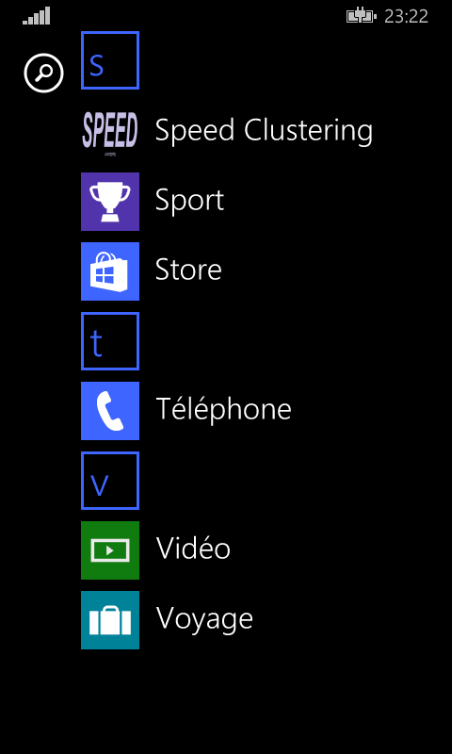 | 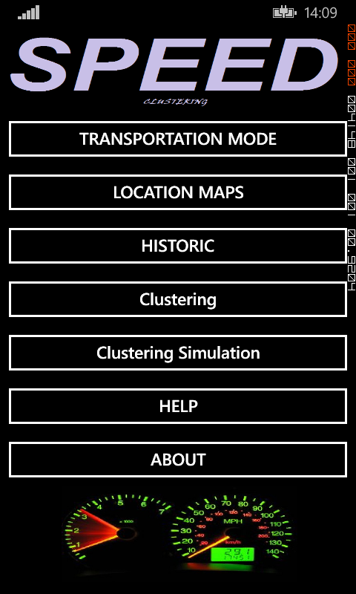
Transportation Mode Page  In this interface we get back the longitude and the latitude as well as the speed of the user which allows us to classify him per profiles whether on foot, by bicycle or by car. | Location in Maps Page  This interface posts the current location of the user according to its coordinates. His displacement will be marked with circles one the maps to visualize his trajectory and touring on Maps in real time.
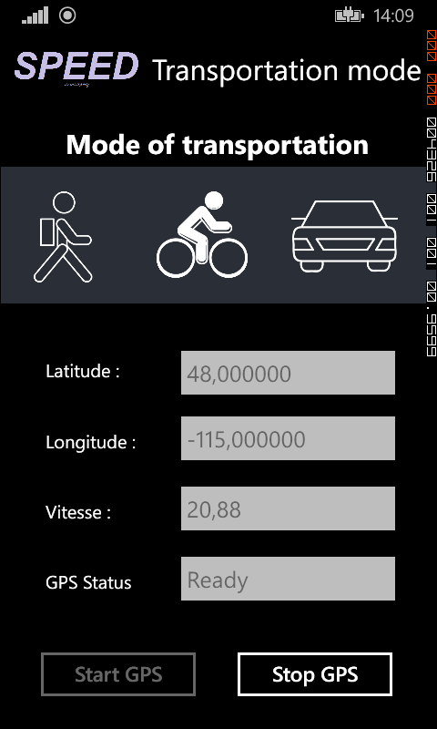 | 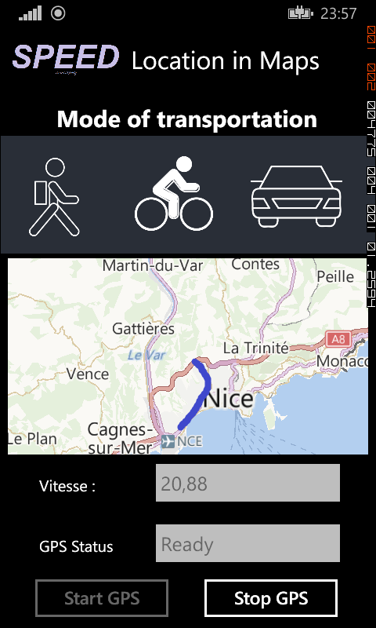
Historic Page  Keep tracking about user activities in term of time ,position, date and time. All of these informations are stocked in a local DataBase | Clustering Page  On this page we apply the algorithm of clustering to the data stored in our base. Every cluster will be posted on the map with a different color and the user will have the possibility of choosing the number of group from the beginning.
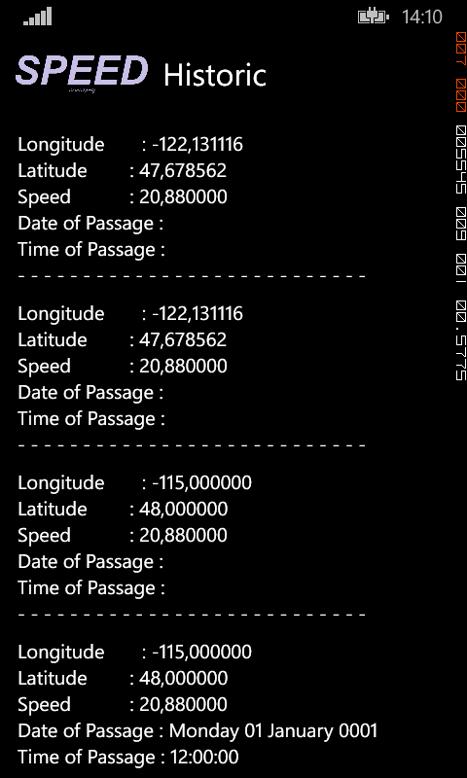 | 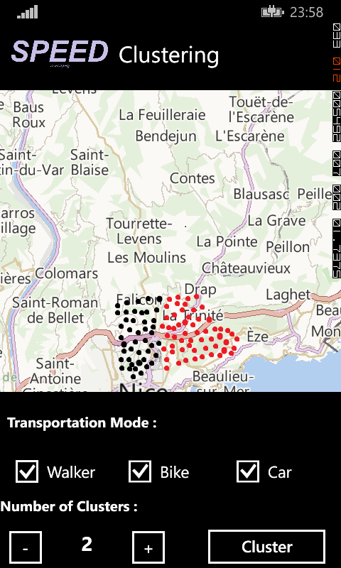
Clustering Simulation Page  For the clustering simulation we chose Paris as zone to apply the k-means. It‘s a direct simulation at the level of the RAM, no stored data. | Help Page  It explains in detail the role of each part in our application.
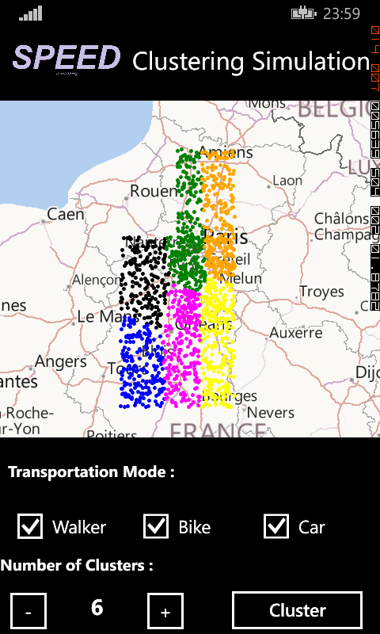 | 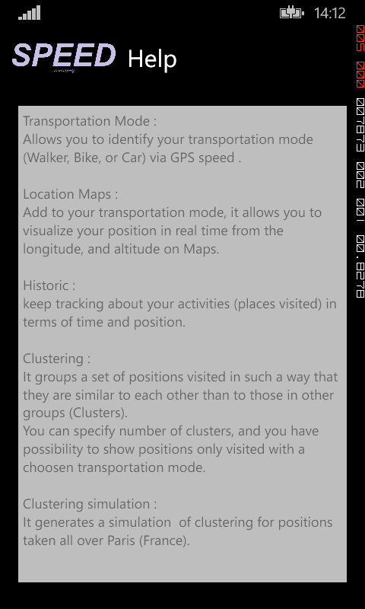

About Page  Gives an overview about the application and every person who participates in its development. | Application Tile  A Tile that represents our app on the Start screen
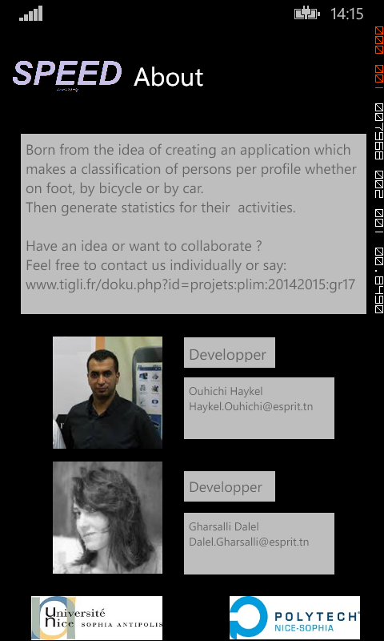 | 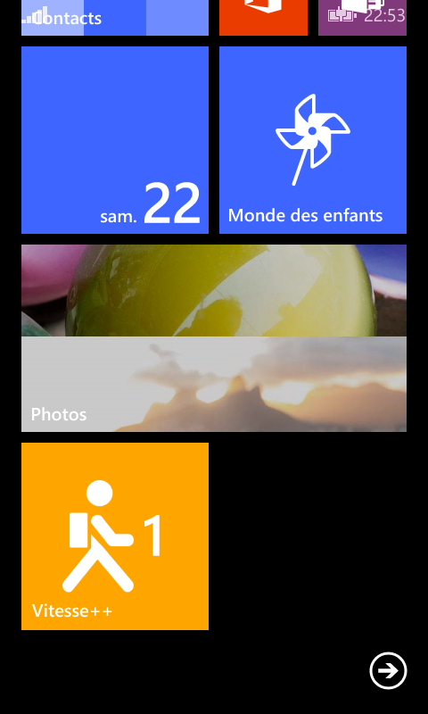

Results
The final result of our project is to have a clear classification of users according to their profiles as well as a classification by cluster of their busiest and most visited place.
Our application emphasizes the importance of the non-supervised classification and presents a direct resolution of the recognition of the modality of the transport problem of our everyday life.

