SPEED-CLUSTERING

Haykel OUHICHI
1st author's affiliation
25, rue Robert Latouche
Résidence Jean Médecin
+33 (0)6 19 38 35 70
Haykel.ouhichi@esprit.tn

Dalel GHARSALLI
3rd author's affiliation
25, rue Robert Latouche
Résidence Jean Médecin
+33 (0)6 62 73 99 10
Dalel.gharsalli@esprit.tn

ABSTRACT
Born from the idea of creating an application which makes a classification of persons per profile whether on foot, by bicycle or by car. Speed application provides users with their current location, speed and other informations and allows them a grouping of their visited places.

Keywords
Clustering, GPS, Speed, Position, Maps, Latitude, Longitude, K-Means.

Technologies and Tools

GPS (GLOBAL POSITIONING SYSTEM)

2.2.1 What is a GPS Sensor?

In our application and in order to response to all our needs we used the GPS Sensor The GPS is a system of radio navigation by satellite developed and exploited by the Ministry of Defence in the United States. it allows the users to determine their position, their speed and the hour of day in earth, atsea and in the air 24 hour / 24, in all weathers and to any place in the world. The GPS signals are accessible by an unlimited number of users simultaneously and it’ s given free of charge to all the users. Due to GPS sensor, you can get current information about users such as:
• Latitude
• Longitude
• Altitude
• Time of fix (the time the reading is taken)
• Status (when currently receiving data)
• NumSats (the number of satellite links)
• Bearing (the current direction or heading)
• Speed
We can say also that GPS Sensor have some options like displaying it automatciclly when it s closed by selecting “Show GPS Sensor” when GPS pane isclosed check box or to close it and showing the GPS pane.
2.2.2 How does it works ?

Every GPS satellite transmits signals in equipments on the ground. The GPS receivers receive passively the signals of satellites, without broadcast. They require a view released of the sky and are thus used only outside. Their performances can be allocated in the woody zones or near big buildings. The functioning of the GPS receivers depends on an extremely precise hourly reference which is supplied to them by the clocks of the U.S. Naval Observatory. Every GPS satellite contains atomic clocks.
The system of GPS global positioning ( Global Positioning System) uses a network of satellites which allows the users having a GPS receiver to determine their position to any place in the world.

K-means clustering

The objective of the method

Clustering is the process of partitioning a group of data points into a small number of clusters and it is one of the simplest unsupervised learning algorithms that solve the well known clustering problem The algorithm of the k-averages (or K-means ) is an algorithm of partitionnement of data raising statistics and machine learning. It is a method which divide observations K partitions(clusters ) in which every observation belongs to the partition with the closest average. The dynamic thick clouds are a generalization of this base, for which every partition is represented by a core which can be more complex than an average. We add also that the classic algorithm of K-means is the same that the algorithm of quantification of Lloyd-Max.

2.2.2 Algorithm method

In the method of “k-means”, the choice of the initial centers is made on the basis of a random edition without put back of k individuals from the population to be classified.

2.2.3 Stop condition of the algorithm
• When two successive iterations lead to the same partition
• When we reach the max number of iterations

Local data base

To store and retrieve data in we made appeal to a local database. This local DB uses uses LINQ to SQL which provides an object-oriented approach in order to work with data and comprises an object model and a runtime.

Application functionalities

Deployment of the application to the phone  Our application SPEED as its logo indicates it, contains 8 page each presents a precise feature. | Application Welcome Page  It is the welcome page ,where we find the main menu which allows us to reach 7 interface.
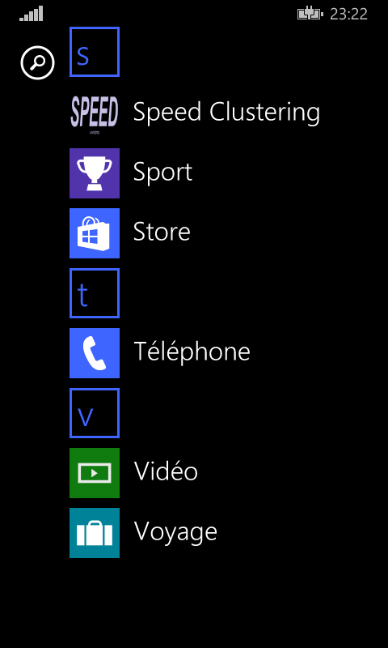 | 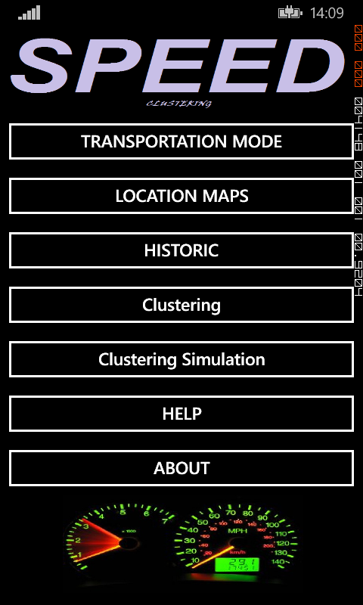
Transportation Mode Page  In this interface we get back the longitude and the latitude as well as the speed of the user which allows us to classify him per profiles whether on foot, by bicycle or by car. | Location in Maps Page  This interface posts the current location of the user according to its coordinates. His displacement will be marked with circles one the maps to visualize his trajectory and touring on Maps in real time.
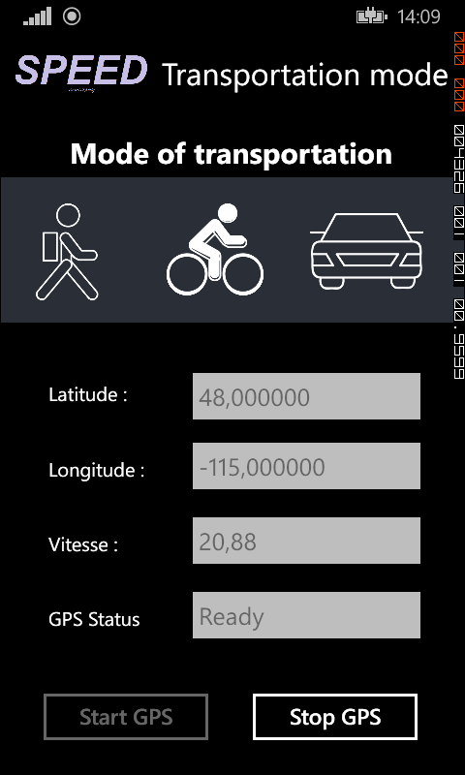 | 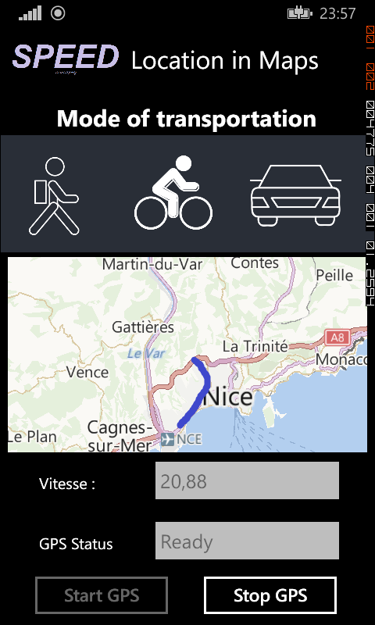
Historic Page  Keep tracking about user activities in term of time ,position, date and time. All of these informations are stocked in a local DataBase | Clustering Page  On this page we apply the algorithm of clustering to the data stored in our base. Every cluster will be posted on the map with a different color and the user will have the possibility of choosing the number of group from the beginning.
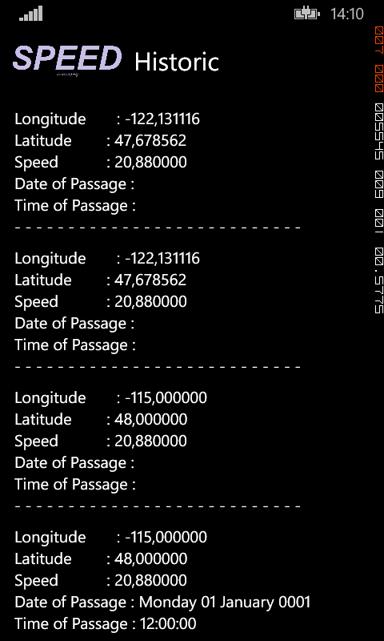 | 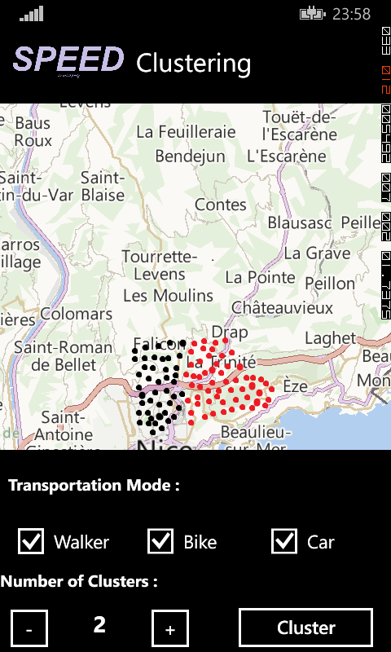
Clustering Simulation Page  For the clustering simulation we chose Paris as zone to apply the k-means. It‘s a direct simulation at the level of the RAM, no stored data. | Help Page  It explains in detail the role of each part in our application.
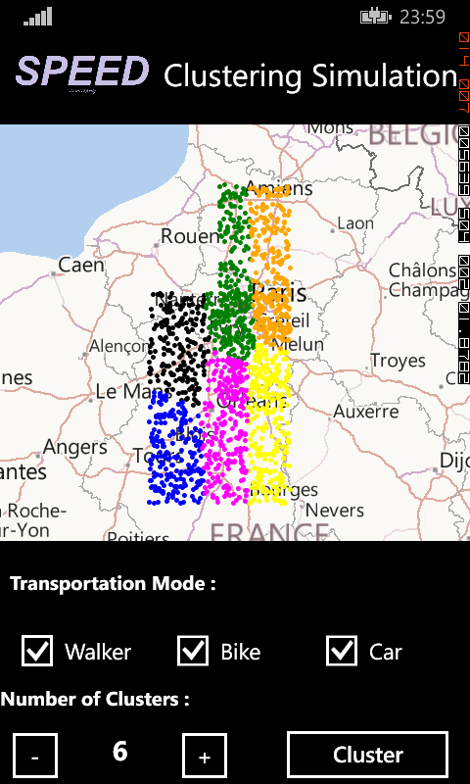 | 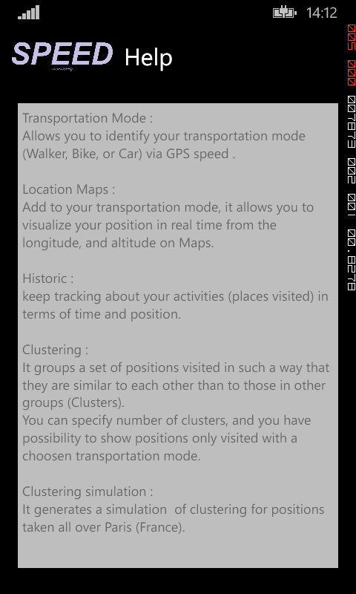
About Page  Gives an overview about the application and every person who participates in its development. | Application Tile  A Tile that represents our app on the Start screen
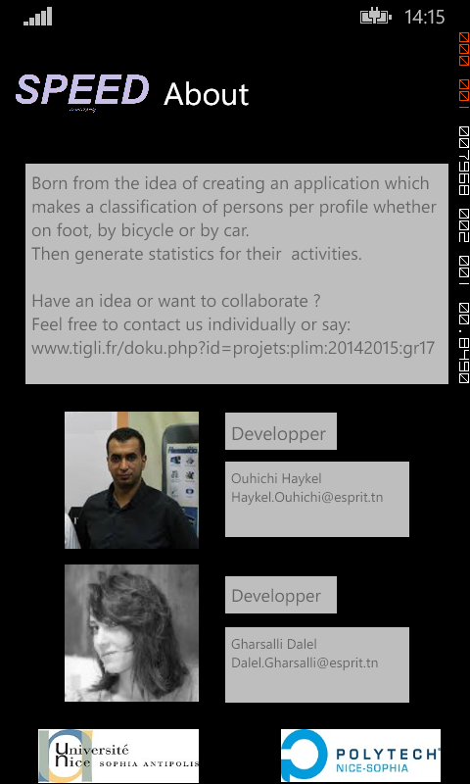 | 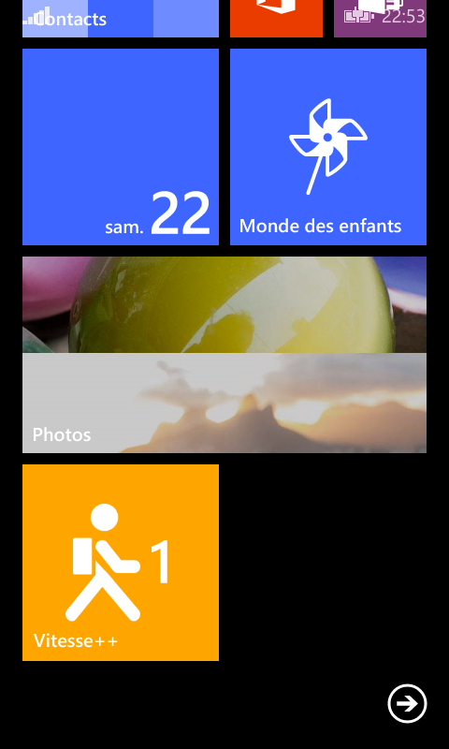

Results
The final result of our project is to have a clear classification of users according to their profiles as well as a classification by cluster of their busiest and most visited place.

