Database Systems Assignment 1
10 questions | 100 marks
Topics: ER diagrams, relational schema, relational algebra, SQL, functional dependencies, and normalization.
Write clear expressions and SQL. For Questions 3–8, also show the result using the supplied data. Equivalent correct answers are accepted, except where a particular operator or method is requested.

Question 1 ER diagram with three relationship types (12 marks)
A museum records volunteers, training modules, trainers, and access cards. The entity attributes and keys are listed below.
Entity | Attributes | Key
Volunteer | vid, vname, team | vid
Module | mid, title, hours | mid
Trainer | tid, tname | tid
AccessCard | card_id, issue_date | card_id
Completes: A volunteer may complete zero or more modules, and a module may be completed by zero or more volunteers. Store one score per completed volunteer-module pair. Repeat attempts are not recorded.
Teaches: Each module must have exactly one trainer. Every trainer must teach at least one module and may teach several modules.
AssignedTo: A volunteer may have zero or one access card. Every access card must be assigned to exactly one volunteer.
Draw one ER diagram showing all four entities, their attributes and underlined primary keys, all three relationships. Show all participation constraints using the notation reference below.

*ER notation reference
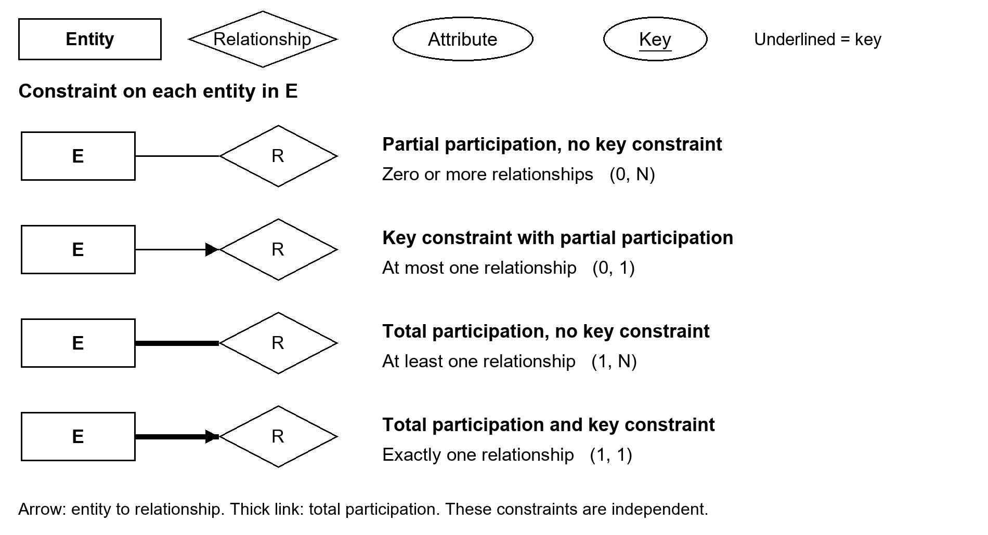

Question 2 Convert the ER diagram to tables (8 marks)
Convert your ER diagram from Question 1 into relational schemas. List each relation’s attributes, primary key and foreign keys. State the uniqueness condition needed to preserve the 1:1 relationship. You do not need to write CREATE TABLE statements.

*Schema example
Relation | Primary key | Foreign keys
Department(did, dname) | did | None
Staff(sid, sname, did) | sid | did references Department(did)

Reference Data for Questions 3 to 8
Each Completion row records one completed module and its score. All scores are known; there are no NULL values.
Notes: Relational algebra uses set semantics, so projection removes duplicates. Names need not be unique for volunteers; keep IDs when requested. For Questions 3–8, only the columns needed by those queries are shown. Module.tid and the Trainer and AccessCard tables are omitted from the data.

Volunteer
vid | vname | team
V1 | Amy | Outreach
V2 | Ben | Exhibits
V3 | Chloe | Outreach
V4 | Dan | Services
V5 | Eva | Exhibits

Module
mid | title | hours
M1 | Safety | 2
M2 | Visitor Care | 3
M3 | Robotics | 4
M4 | Night Tour | 2

Completion
vid | mid | score
V1 | M1 | 80
V1 | M2 | 75
V1 | M3 | 90
V2 | M1 | 70
V2 | M3 | 60
V3 | M1 | 90
V3 | M2 | 85
V4 | M3 | 88

Relational algebra notation reference
Operation | Symbol | Meaning
Selection (filter) | σ | Keep rows satisfying a condition.
Projection | π | Keep named columns and remove duplicates.
Natural join | ⋈ | Match rows on all shared attribute names.
Set difference | − | Rows in R that are absent from S.
Union | ∪ | Rows occurring in R or S.
Intersection | ∩ | Rows occurring in both R and S.
Cartesian product | × | All pairs of rows from R and S.
Rename | ρ | Rename a relation or its attributes.
Division | / | Values paired with every row of the divisor.
For union, intersection and difference, both inputs must have compatible schemas. Division checks every divisor row and allows additional related rows.

Question 3 Selection and projection (10 marks)
Use the reference data. For each part, write a relational algebra expression and give the result.
(a) Return vid and vname for volunteers in the Outreach team. [5 marks]
(b) Return the distinct team names from Volunteer. [5 marks]

Question 4 Join and set difference (10 marks)
Write relational algebra expressions and give the results.
(a) Return vid and vname for volunteers who completed Robotics (M3). Hint: select the M3 completion rows, then join with Volunteer. [5 marks]
(b) Return vid for volunteers who have not completed any module. Hint: subtract completed volunteer IDs from all volunteer IDs. [5 marks]

Question 5 Division and exact module matching (8 marks)
Required(mid) contains exactly M1 and M2. The final goal is to identify volunteers who completed only these two modules and no others.
(a) As an intermediate step, use division, written /, to return the volunteer IDs that completed both M1 and M2. Additional modules are allowed in this intermediate result. Give the expression and result. [4 marks]
(b) From the intermediate result in part (a), return the volunteer IDs that completed M1 and M2 and no other modules. Give a relational algebra expression and the final result. [4 marks]
Hint for (a): first project Completion onto (vid, mid), then divide by Required.
Hint for (b): identify volunteers with a completed module other than M1 or M2, then subtract their IDs from the result of part (a).

Question 6 SQL filtering and sorting (10 marks)
Write SQL and give the result for each part.
(a) Return vid and vname for volunteers in Exhibits, ordered by vid. [5 marks]
(b) Return mid, title, and hours for modules lasting at least 3 hours. Sort by hours descending, then mid ascending. [5 marks]

Question 7 SQL joins and grouping (12 marks)
Write SQL and give the result for each part.
(a) Return mid, title, and score for modules completed by V1. Join Completion with Module and sort by mid. [6 marks]
(b) For each module completed by at least three volunteers, return mid, the number of volunteers, and the average score. Use GROUP BY and HAVING; sort by mid. Display averages to two decimal places in the written result. SQL rounding is optional. [6 marks]

Question 8 Simple SQL subqueries (10 marks)
Write SQL and give the result for each part.
(a) Use IN with a subquery to return vid and vname for volunteers who completed M2. Sort by vid. [5 marks]
(b) Use a subquery containing MAX to return vid and score for the highest score in M1. Sort by vid. [5 marks]

Question 9 Attribute closure and a candidate key (10 marks)
Consider table R(A, B, C, D) with functional dependency F = { A → B, A → C, C → D }. These are the given dependencies and all other dependencies must be derived from them.
(a) Compute attributed closure A⁺ and C⁺. Show the attributes added at each step. [6 marks]
(b) Identify the candidate key and briefly explain why it determines the whole relation. [4 marks]

Question 10 Basic normalization (10 marks)
A shop stores table OrderLine(OrderID, ProductID, ProductName, UnitPrice, Qty). All values are atomic. The primary key is (OrderID, ProductID). A product has one fixed name and unit price across the orders. The given functional dependencies are:
ProductID → ProductName, UnitPrice
(OrderID, ProductID) → Qty
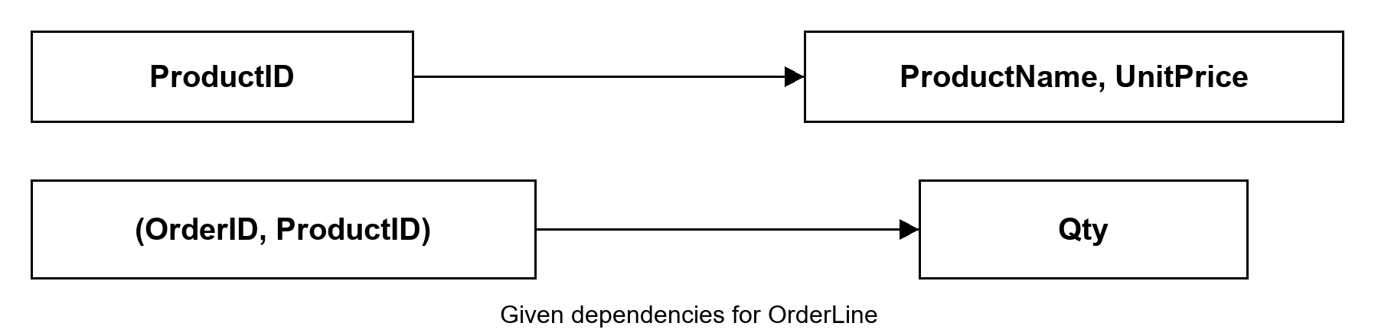
(a) Identify the partial dependency. Is OrderLine in 2NF? Give a short reason. Hint: partial dependency means a dependency X → A, where X is part of some candidate key. [4 marks]
(b) Decompose OrderLine into two relations in 3NF. List their attributes and primary keys, and identify the foreign key linking them. Hint: keep product information in its own relation. [6 marks]

