PURBANCHAL UNIVERSITY

ACME ENGINEERING COLLEGE

SITAPAILA, KATHMANDU

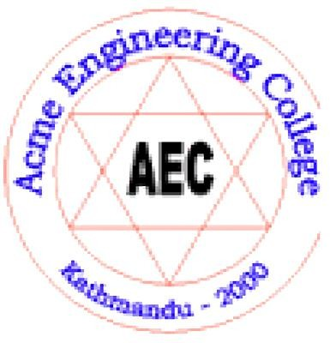

FINAL PROJECT REPORT ON

**STUDENT RECORD MANAGEMENT SYSTEM**

**…………………………………………………………………………………**

*In the partial fulfillment of the requirement for the award of the Degree of Bachelor of Computer Engineering*

**SUBMITTED BY:**

|  |  |
| --- | --- |
| Ashish Adhikari | (03) |
| Hilen Adhikari | (09) |
| Kapil Ojha | (11) |
| Nishan Sherestha | (12) |

Under the support and guidance of Er. Roshani Ghimire

**DEPARTMENT OF COMPUTER, ELECTRONICS & COMMUNICATION ENGINEERING**

**January, 2022**

**ABSTRACT**

This project is a discussion on the management of records in general, be it at a school or college

.Records management involves the storage, retrieval and use of information. More precisely, it is “the application of systematic and scientific control to all the recorded information that an organisation needs to do business.”

Poor records management results in difficulties in administering, planning and monitoring an education system. In fact, poor records management and the lack of staff development along the entire information cycle are responsible for problems with management and policy implementation in schools.

Although different methods or systems can be used to bring about efficient records management, there are some basic rules that must be respected. So as to manage any information well, it is vital initially to determine its characteristics and functions. This is important, because the way in which records (which contain the information) are arranged depends on the type of information they contain. So we made digital record management system for the schools which makes record easy and efficient.

**ACKNOWLEDGEMENT**

We are grateful to our Project Coordinator, who have contributed in inspiring and clarifying our thought over the years Er. Roshani Ghimire (senior lecture of Computer, Electronics & Communication department). We wish to acknowledge Er. Sarad Poudel (Head of Department at Department of Computer , Electronic and Communication Engineering , Acme Engineering College) who was instrumental in bringing this Project to light. We are also thankful for the tireless generosity to well-wishers and our family for spiritual, moral and even financial support. Thanks also to the entire family of Acme Engineering College, for making us feel so welcome at Acme Engineering College from day one. Your hospitality is very much appreciated. Finally, honour and glory to the highest God for having enabled us successfully accomplishes.

* **Ashish Adhikari**
* **Hilen Adhikari**
* **Kapil Ojha**
* **Nishan Shrestha**

**LIST OF FIGURES**

# FIGURE 1 : SDLC 11

# FIGURE 2 : WATERFALL MODEL 13

# FIGURE 3 : SPIRAL MODEL 14

# FIGURE 4 : PROTOTYPE MODEL 15

# FIGURE 5 : FLOWCHART 20

# FIGURE 6 : CONCEPT FLOW DIAGRAM / DFD LEVEL 0 22

# FIGURE 7 : DFD LEVEL 1 24

# FIGURE 8: DFD LEVEL 2 OF GENERAL DETAILS 25

# FIGURE 9 : DFD LEVEL 2 OF ACADEMIC DETAILS 26

# FIGURE 10: ER DIAGRAM 27

# FIGURE 11: USECASE DIAGRAM 28

**TABLE OF CONTENTS**

**LIST OF FIGURES 4**

**CHAPTER 1: INTRODUCTION 7**

* 1. **ABOUT THE PROJECT: 7**
  2. **PROJECT SCOPE 7**
  3. **OBJECTIVES 8**

**CHAPTER 2: LITREATURE REVIEW 9**

* 1. **STUDY OF PREVIOUS SYSTEM 9**
  2. **WHY WE SELECT THIS PROJECT ? 9**

**CHAPTER 3: SYSTEM ANALYSIS AND DESIGN 10**

* 1. **SYSTEM ANALYSIS 10**
     1. **REQUIREMENT: 10**
     2. **SYSTEM USED: 10**

**3.2 SYSTEM DEVELOPMENT LIFE CYCLE 11**

* 1. **FEASIBILITY ANALYSIS 16**
     1. **SCHEDULE GANTT CHART 17**
  2. **ANALYSIS 18**

1. ALGORITHM 18
2. FLOWCHART 19
3. CONCEPT FLOW DIAGRAM (CFD) 22
4. DATA FLOW DIAGRAM (DFD) 23
5. ER-DIAGRAM 26
6. USECASE DIAGRAM 28

**CHAPTER 4: IMPLEMENTATION AND TESTING 29**

# IMPLEMENTATION 29

# TESTING 29

# RESULT 30

**CHAPTER 5: DISCUSION AND CONCLUSION 31**

**CHAPTER 6: REFERENCES 32**

**CHAPTER 1 : INTRODUCTION**

* 1. **ABOUT THE PROJECT:**

Student record Management System is based on the concept of managing student information. This is a offline system used by the teachers to record the progress report of the student and the student to view their personal progress record. This project is a conceptual system that can be implemented in any student record management system. Generally, in this project we have made a simple idea of whose data should be stored and who can store as well as view the record. This mini project contains limited features, but the essential one.

Talking about the features of Student management system, the user can add various information of the students. For that, the user has to full name, class, faculty, email, roll number, and contact details as require. The user can also modify all the available records easily. Before modifying the student’s record the user has to enter the respective roll number which shows the old available record. After that, the user can modify each and every field. Deleting a record is too simple here, the user just has to enter roll number of the student. In order to view student record, the user has to search for it. It is done by entering roll number of the student. Then the system displays each and every available detail .

As the number of students has increased in the colleges drastically, storing records in the paper has become very inefficient. So by using student record management system the records become virtual and finding as well as recording the data becomes easier and saves valuable time.

* 1. **PROJECT SCOPE:**

Student record management system helps student as well as teachers record and retrieve student’s academic data. It helps storing the data of the student much efficient. The data of the student can be found much efficiently. Students and teachers don’t have to shuffle through the papers to find the academic of the students. Student can give feedback regarding their result and Personal information. It allows us to retrieve data much quicker.

* 1. **OBJECTIVES:**

The objective of this project is to build a student record management system are as follows:

* To view the academic record of the student.
* To make progress record of student by teachers, much easily.
* To store Academic record of the student, much easily.
* To view which student is weak in certain subject by teachers as well as students.
* To save the valuable time of teachers while creating report card.
* To take feedback from student.

**CHAPTER 2: LITREATURE REVIEW**

* 1. **STUDY OF PREVIOUS SYSTEM**:

While studying the previous system of student record management system, we found many errors and drawbacks that must be corrected in the upgraded system. We found some drawbacks from the previous system that are listed below:

* + - Data management of student were not correct i.e. all data were stored in the files and copies which is harder to stored data correctly.
    - As we are in the modern era, all services have gone systematically. But due to increasing number of student records daily it’s harder to manage using previous system.
    - In the previous system the budget has to be slightly higher because a greater number of student.
    - Record management was also a bit harder because the student record could not give accurate notice to the student.[1]
  1. **WHY WE SELECT THIS PROJECT?**

After seeing the present student record management system of our country. We have selected this project so that we can eradicate such problem and manage it systematically. Due to inefficiency in student record management.

So, find such solution we decided to work in this project so that there will be more efficient as well as it would be systematically in the factor of development. We manage to find out the advantage of proper student record management which are listed below:

* + - Easier access to student’s academic record.
    - There is high efficiency in record keeping and accessing data.
    - There is no need for shuffling through the papers.
    - Price of record keeping is reduced.

So, there are also other reason to choose these projects beside the above ones. If we systematically implement this system.

**CHAPTER 3: SYSTEM ANALYSIS AND DESIGN**

* 1. **SYSTEM ANALYSIS**

It is a process of planning a new business system or replacing an existing system by defining its components or modules to satisfy the specific requirements. Before planning, you need to understand the old system thoroughly and determine how computers can best be used in order to operate efficiently.

System Design focuses on how to accomplish the objective of the system. System Analysis and Design (SAD) mainly focuses on −

* + - Systems
    - Processes
    - Technology

1. REQUIREMENT:

Operating System : Windows xp\vista\7\8\10 Ram : 256 MB or more

HardDisk : 40 GB or more

Processor : P3 or more

Compiler : Standard C++ Compiler [2]

1. SYSTEM USED:

Operating System : Windows 10 Ram : 4 GB

HardDisk : 500GB

Processor : Intel I5

Compiler : Standard C++ Compiler (Code Block with MinGW)

**3.2 SYSTEM DEVELOPMENT LIFE CYCLE**

An effective System Development Life Cycle (SDLC) should result in a high quality system that meets customer expectations, reaches completion within time and cost evaluations, and works effectively and efficiently in the current and planned Information Technology infrastructure.

System Development Life Cycle (SDLC) is a conceptual model which includes policies and procedures for developing or altering systems throughout their life cycles.

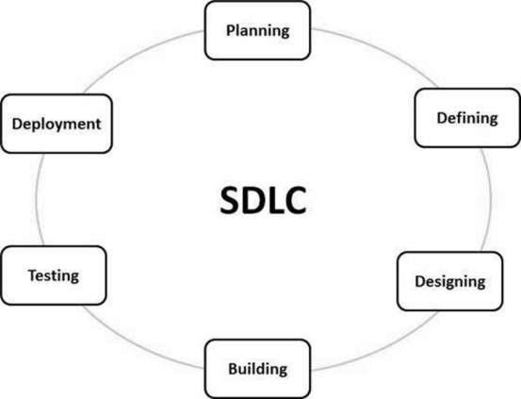

*FIGURE 1 : SDLC*

(Source: https:/[/www.tutorialspoint.com/sdlc/sdl](http://www.tutorialspoint.com/sdlc/sdlc_overview.htm))c[_overview.htm)](http://www.tutorialspoint.com/sdlc/sdlc_overview.htm))

SDLC is used by analysts to develop an information system. SDLC includes the following activities −

1. Requirement Gathering and Analysis

During this phase, all the relevant information is collected from the customer to develop a product as per their expectation. Any ambiguities must be resolved in this phase only.

Business analyst and Project Manager set up a meeting with the customer to gather all the information like what the customer wants to build, who will be the end-user, what is the purpose of the product. Before building a product a core understanding or knowledge of the product is very important.

1. Design

In this phase, the requirement gathered in the SRS document is used as an input and software architecture that is used for implementing system development is derived.

1. Implementation or Coding

Implementation/Coding starts once the developer gets the Design document. The Software design is translated into source code. All the components of the software are implemented in this phase.

1. Testing

Testing starts once the coding is complete and the modules are released for testing. In this phase, the developed software is tested thoroughly and any defects found are assigned to developers to get them fixed.

1. Deployment

Once the product is tested, it is deployed in the production environment or first [UAT (User](https://www.softwaretestinghelp.com/what-is-user-acceptance-testing-uat/) [Acceptance testing)](https://www.softwaretestinghelp.com/what-is-user-acceptance-testing-uat/) is done depending on the customer expectation.

1. Maintenance

After the deployment of a product on the production environment, maintenance of the product

i.e. if any issue comes up and needs to be fixed or any enhancement is to be done is taken care by the developers.

**Software Development Life Cycle Models**

A software life cycle model is a descriptive representation of the software development cycle. SDLC models might have a different approach but the basic phases and activity remain the same for all the models.

1. **Waterfall Model-:**

It is the very first model that is used in SDLC. It is also known as the linear sequential model.

In this model, the outcome of one phase is the input for the next phase. Development of the next phase starts only when the previous phase is complete.

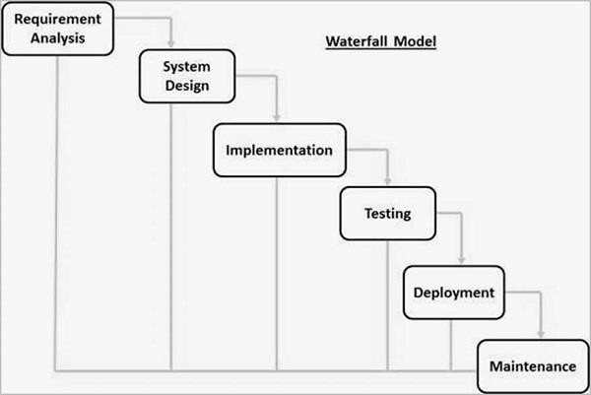

*FIGURE 2 : WATERFALL MODEL*

(Source : https://[www.tutorialspoint.com/sdlc/sdlc_waterfall_model.htm)](http://www.tutorialspoint.com/sdlc/sdlc_waterfall_model.htm))

1. **Spiral SDLC Model**-: Spiral model is a combination of the Iterative and Waterfall SDLC models with a significant accent on the risk analysis. The main issue of the spiral model is defining the right moment to take a step into the next stage.

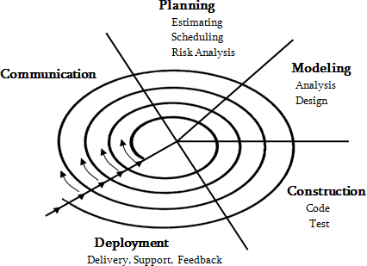

*FIGURE 3 : SPIRAL MODEL*

(Source : https://[www.tutorialspoint.com/sdlc/sdlc_spiral_model.htm)](http://www.tutorialspoint.com/sdlc/sdlc_spiral_model.htm))

1. **Prototyping Model-:** is a software development model in which prototype is built, tested, and reworked until an acceptable prototype is achieved. It also creates base to produce the final system or software. It works best in scenarios where the project’s requirements are not known in detail. It is an iterative, trial and error method which takes place between developer and client.

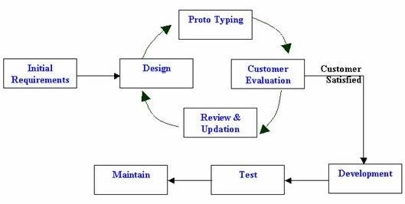

*FIGURE 4 : PROTOTYPE MODEL*

(Source : https://learnwithkamal.files.wordpress.com/2014/09/prototype1.jpg)

**Which model We select And Why?**

We preferred waterfall model because of following reason;

* + Simple and easy to understand and use.
  + Easy to manage due to the rigidity of the model. Each phase has specific deliverables and a review process.
  + Phases are processed and completed one at a time.
  + Works well for smaller projects where requirements are very well understood.
  + Clearly defined stages.
  1. **FEASIBILITY ANALYSIS**

As the name implies, a feasibility analysis is used to determine the viability of an idea, such as ensuring a project is legally and technically feasible as well as economically justifiable. It tells us whether a project is worth the investment—in some cases, a project may not be doable.

**Types of Feasibility Study**

Technical Feasibility-:

This assessment focuses on the technical resources available to the organization. It helps organizations determine whether the technical resources meet capacity and whether the technical team is capable of converting the ideas into working systems.

Economic Feasibility-:

This assessment typically involves a cost/ benefits analysis of the project, helping organizations determine the viability, cost, and benefits associated with a project before financial resources are allocated.

1. Legal Feasibility-:This assessment investigates whether any aspect of the proposed project conflicts with legal requirements like zoning laws, data protection acts or social media laws. Let’s say an organization wants to construct a new office building in a specific location.
2. Operational Feasibility-:This assessment involves undertaking a study to analyze and determine whether—and how well—the organization’s needs can be met by completing the project. Operational feasibility studies also examine how a project plan satisfies the requirements identified in the requirements analysis phase of system development.
3. Scheduling Feasibility-:This assessment is the most important for project success; after all, a project will fail if not completed on time. In scheduling feasibility, an organization estimates how much time the project will take to complete.[3]
   * 1. **SCHEDULE GANTT CHART**

Start Date: 25th May 2021

End Date: 10th Jan 2022 (This given date exclude holidays )

|  |  |
| --- | --- |
| **SCHEDULE GANTT CHART** | |
|  | **W1 W2 W3 W4 W5 W6 W7 W8 W9 W10 W11 W12** |
| **Preparation**  **and Planning** | |
| **Team formation** |  |
| **Develop Project Proposal** |  |
| **Approve project proposal** |  |
| **Project Defence** |  |
| **Development**  **and Test** | |
| **Specify detail requirement** |  |
| **Develop prototype** |  |
| **Approve**  **prototype** |  |
| **Develop beta version** |  |
| **Test beta version** |  |
| **Apply final Correction** |  |
| **Approve Final**  **version** |  |
| **Implementation** | |
| **Train user** |  |
| **Roll out final**  **version** |  |
| **Final Report** |  |

W=Week

* 1. **ANALYSIS:**

# ALGORITHM

In [mathematics](https://en.wikipedia.org/wiki/Mathematics) and [computer science,](https://en.wikipedia.org/wiki/Computer_science) an **algorithm** is a finite sequence of [well-](https://en.wikipedia.org/wiki/Well-defined) [defined](https://en.wikipedia.org/wiki/Well-defined) instructions, typically used to solve a class of specific problems or to perform a computation Algorithms are used as specifications for performing [calculations](https://en.wikipedia.org/wiki/Calculation), [data](https://en.wikipedia.org/wiki/Data_processing) [processing,](https://en.wikipedia.org/wiki/Data_processing) [automated reasoning,](https://en.wikipedia.org/wiki/Automated_reasoning) [automated decision-making](https://en.wikipedia.org/wiki/Automated_decision-making) and other tasks. In contrast, a [heuristic](https://en.wikipedia.org/wiki/Heuristic_(computer_science)) is an approach to problem solving that may not be fully specified or may not guarantee correct or optimal results, especially in problem domains where there is no well-defined correct or optimal result.

Step1: Start

Step 2: Display Entry Page

Step 3: Ask for user’s choice weather to

* 1. Admin Page *( If 1 go to step 05)*
  2. Student Page *( If 2 go to step 15)*
  3. See Feedback *(If 3 go to step 16)*
  4. Exit *(If 4 go to step 18)*

Step 4: Display Admin id and password (if correct go to step 6 else go to step2) Step 5: Ask for user’s choice weather to

1. General Record Page *( If 1 go to step 06)*
2. Academic Record Page *(If 2 go to step 14 )*
3. Exit *(If 3 go to step 18)*

Step 6: Ask for user’s choice weather to

1. Add new student
2. Display student info *( If 2 go to step 09 )*
3. Modify student info *( If 3 go to step 10 )*
4. Search student *(If 4 go to step 12)*
5. Delete student info *(If 5 go to step 13)*
6. Exit *( If 6 go to step 18)*

Step 7: Input student information and store it in student data file Step8: Ask whether to add more or not

Step 9: Display all student data

Step `10: Ask for student roll number *(to modify) If roll number match go to step 11*

*If roll number don’t match display roll not exist and move back to step 10*

Step 11: Input modified details and store student data file. Step 12: Ask for roll number if matches display student details.

Else display roll not exist.

Step 13: ask for roll number if match delete student Else display roll number not exist

Step 14: Same as *(Step06 to Step13 but for academic Record )*

Step 15: Display Student Roll and password *( If correct go to step 17 else go to step15 )*

Step 16: Display all the feedback enter by student Step 17: Ask for user’s choice weather to

1. Record *( If 1 then ask for choice*
   1. *View all general Record*
   2. *View your academic* record )
2. Feedback
3. Exit *( If 3 go to step 18)*

Step 18: End

# FLOWCHART

Flowcharts are a methodology used to analyse, improve, document and manage a process or program. Flowcharts are helpful for:

* Aiding understanding of relationships among different process steps
* Collecting data about a particular process
* Helping with decision making
* Measuring the performance of a process
* Depicting the structure of a process
* Tracking the process flow

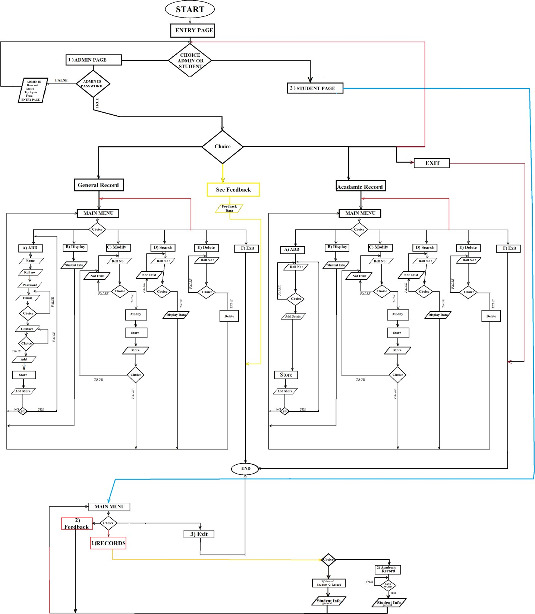

*FIGURE 5 : FLOWCHART*

Flowchart shows first the program is been Start. Then display Entry Page. There ask for user’s choice weather to

* 1. **Admin Page** ( If this then Display Admin id and password Then if correct thrn Ask for user’s choice weather to
     1. General Record Page ( If this then Ask for user’s choice weather to
        1. Add new student
        2. Display student info ( If this then Display all student data )
        3. Modify student info ( If this then Ask for student roll number (to modify)

If roll number match then: Input modified details and store student data file. If roll number don’t match display roll not exist and move back to modify )

* + - 1. Search student (If this then Ask for roll number if matches display student details.Else

display roll not exist.)

* + - 1. Delete student info (If this then : ask for roll number if match delete student

Else display roll number not exist )

* + - 1. Exit ( If this then end the system)
    1. Academic Record Page *(Same process is been follows as above but*

*for academic records)*

* + 1. See Feedback *(Viewed all feedback enter by student)*
  1. **Student Page** ( If this then Display Student Roll and password ( If correct then give choice to
* Records

-View all general Records

-View your Academic records

* Feedback
* Exit )

# CONCEPT FLOW DIAGRAM (CFD)

This template shows the Context Diagram. It was created in Concept Draw DIAGRAM diagramming and paints drawing software using the Block Diagrams Solution from the “Diagrams”.

The context diagram graphically identifies the system. external factors, and relations between them. It’s a high level view of the system. The context diagrams are widely used in software engineering and systems engineering for designing the systems that process the information.

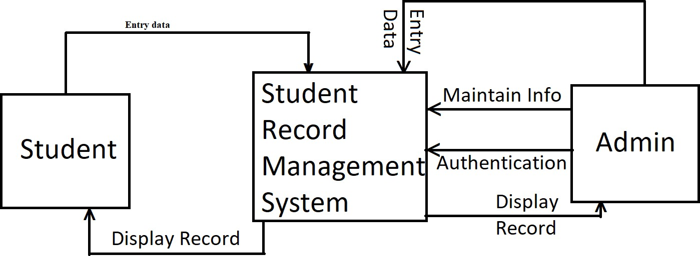

*FIGURE 6 : CONCEPT FLOW DIAGRAM / DFD LEVEL 0*

# DATA FLOW DIAGRAM (DFD)

A Data Flow Diagram (DFD) is a traditional visual representation of the information flows within a system. A neat and clear DFD can depict the right amount of the system requirement graphically. It can be manual, automated, or a combination of both.

It shows how data enters and leaves the system, what changes the information, and where data is stored.

The objective of a DFD is to show the scope and boundaries of a system as a whole. It may be used as a communication tool between a system analyst and any person who plays a part in the order that acts as a starting point for redesigning a system. The DFD is also called as a data flow graph or bubble chart.

* DFD is the abbreviation for **Data Flow Diagram**.
* The flow of data of a system or a process is represented by DFD.
* It also gives insight into the inputs and outputs of each entity and the process itself.
* DFD does not have control flow and no loops or decision rules are present.

Level 1 DFD

In level 1 DFD, a context diagram is decomposed into multiple processes. In this level, we highlight the main objectives of the system and breakdown the high-level process of 0-level DFD into subprocesses.

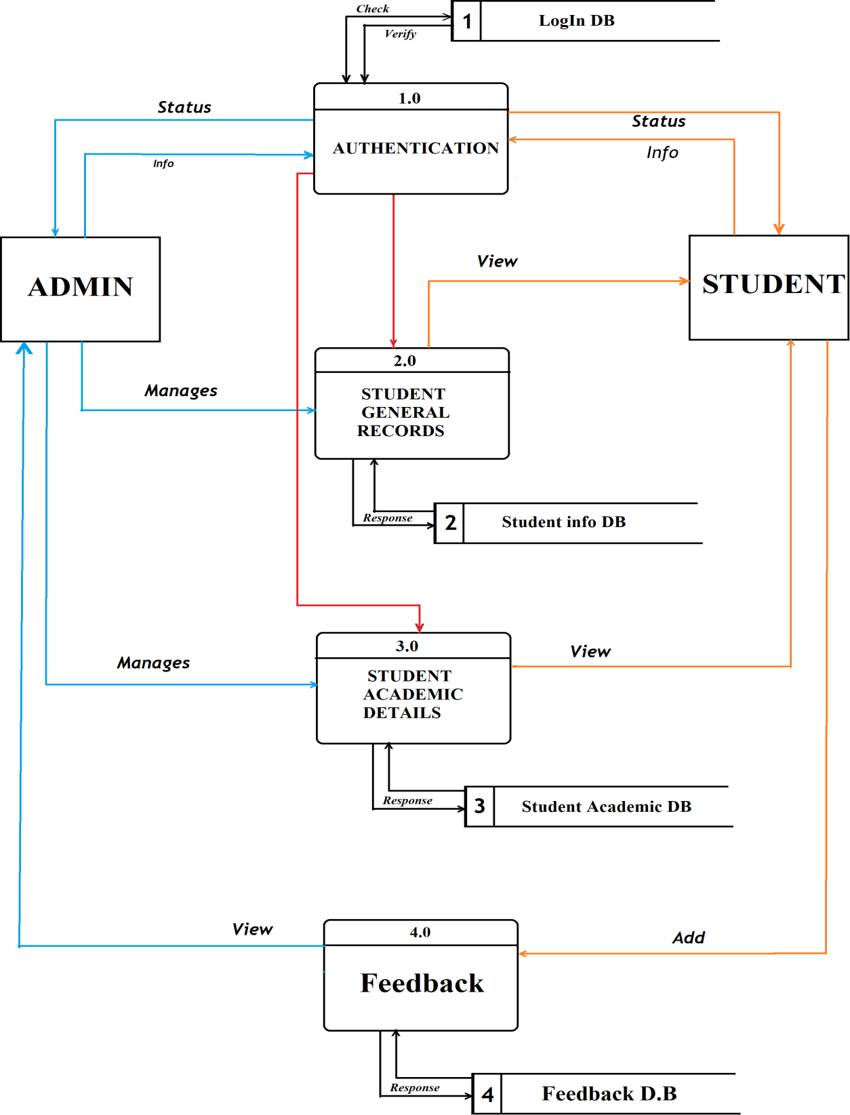

*FIGURE 7 : DFD LEVEL 1*

Level 2 DFD

level 2 DFD goes one process deeper into parts of 1-level DFD. It can be used to project or record the specific/necessary detail about the system's functioning.

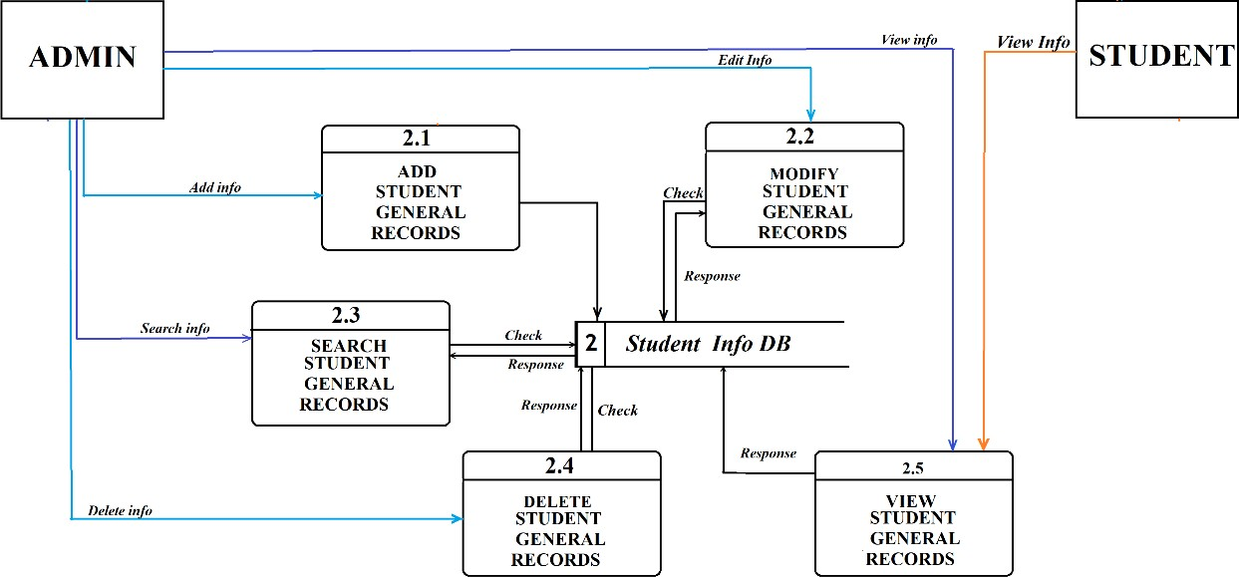

*FIGURE 8: DFD LEVEL 2 OF GENERAL DETAILS*

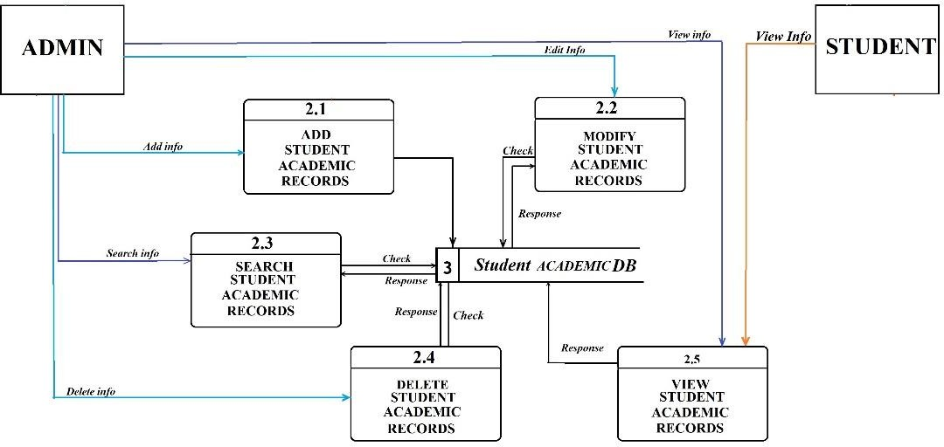

*FIGURE 9 : DFD LEVEL 2 OF ACADEMIC DETAILS*

# ER-DIAGRAM

The entity-relationship diagram of School Records Management System shows all the visual instrument of database tables and the relations between Students, Teachers, Schools, records etc. It used structure data and to define the relationships between structured data groups of School Management System functionalities.

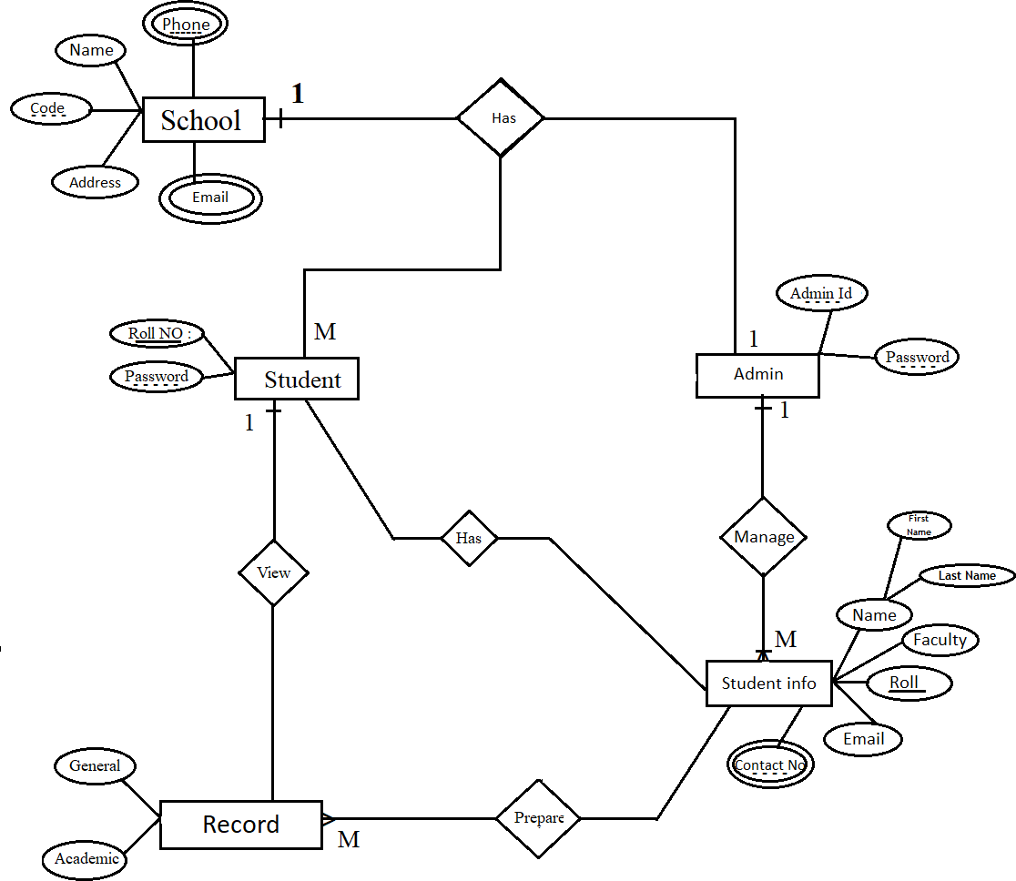

*FIGURE 10: ER DIAGRAM*

# USECASE DIAGRAM

A [use case diagram](https://www.google.com/url?sa=t&rct=j&q&esrc=s&source=web&cd&cad=rja&uact=8&ved=2ahUKEwiYy4finOnwAhUbPXAKHeqxDyAQFjACegQICxAD&url=https%3A%2F%2Fwww.smartdraw.com%2Fuse-case-diagram%2F&usg=AOvVaw1paPH3m325jLG07S4AOK-M) is a visual representation of how a user might interact with a program. A use case diagram depicts the system’s numerous use cases and different sorts of users. The circles or ellipses are used to depict the use cases.

By creating the use case of the Student records Management System, we must determine first the possible features to identify the flow of the system. After that, you can now create the blueprint or core of the system function. The **objective** of a use case diagram is to show the interactions of numerous items called actors with the use case and to capture fundamental functionalities of a system. As you see through the diagrams, there are the use cases involved to define the core functions of a system. These processes were expected by the users to be connected to produce a certain output. Being a programmer, this could be an important role that the **Student Record Management System** should have.

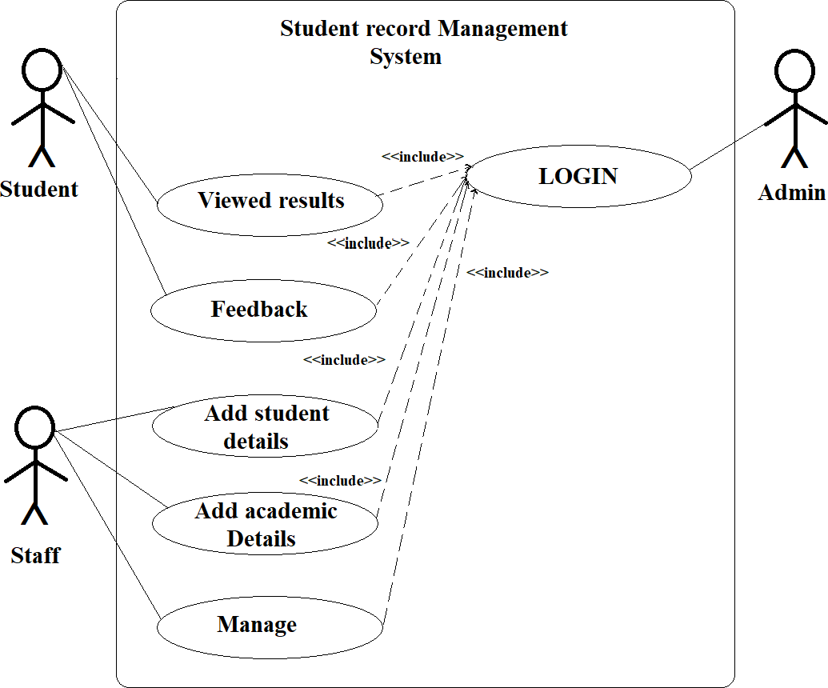

*Figure 11 : USECASE DIAGRAM*

**CHAPTER 4: IMPLEMENTATION AND TESTING**

* 1. **IMPLEMENTATION**

The system will be implemented by using the following programming languages and software’s ;

**1) C++**

C++ is a general-purpose programming language created by Bjarne Stroustrup as an extension of the C programming language, or "C with Classes". The language has expanded significantly over time, and modern C++ now has object-oriented, generic, and functional features in addition to facilities for low-level memory manipulation. It is almost always implemented as a compiled language, and many vendors provide C++ compilers.[4]

**2) Notepad**

Windows Notepad is a simple text editor for Microsoft Windows that enables computer users to create plain text documents.

* 1. **TESTING :**

Software testing is performed in parallel with coding for testing process, a master test plan is developed during the analysis phase.During the design phase, unit, system and integration test plans are developed. The actual testing is done during implementation

* + - Unit Testing-:Each module is tested alone in an attempt to discover any errors in its code
    - Integration Testing-:The process of bringing together all of the modules that a program comprises for testing purposes.Modules are typically integrated in a bottom-up, incremental fashion.
    - System Testing-:The bringing together of all of the programs that a system comprises for testing purposes.
    - Stub Testing-:Stubs are two or three lines of code written by a programmer to stand in for the missing modules.

**We select system testing because of following reason:**

* It covers a complete end to end software testing.
* The business requirements and system software architecture are both tested in system testing.
* Appropriate system testing help in relieving after production goes live issues and bugs.
* System testing is led in a situation like a production condition or some of the time it is finished with production parallel test condition where the same data input is feed to the exiting framework and new framework to look at the differences in functionalities removed and added. This causes the client to understand the new framework better and feel great with new functionalities included or existing functionalities revised or removed.
  1. **RESULT:**

In order to design a system that could facilitate the capture, storage and retrieval of students records, the data collected was analysed to determine the best way it could be stored and retrieved through using the ER Diagram and DFD and therefore the basic requirements for the design of the student records management system are :

* Every user should have their own identity.
* Login facility.
* User can take update of his/her Personal information and can view the results.
* Student can give feedback regarding their result and Personal information.

**CHAPTER 5: DISCUSION AND CONCLUSION**

Student management system is very useful in an institution or in school or in college or in universities. There is no paper work in this proposed system. Supervision can be done from anywhere. This project especially minimizes human effort necessary. This application is handled by the college so there is no information leak and data will be secured. Since it is a offline based application anyone can use the system anywhere at any time and it is very easy to get the necessary information without the latency. It is very useful to the students to get their records. Parents also get benefited more since the college is going to send a result of the students. Since this application will be handled by the college whenever they need any changes in an application they can make it without the upfront investment, and the system will be more secure when it is handled by the own college.

**CHAPTER 6: REFERENCES**

1. [16 Best Student Record Management System for Schools & Institutes](https://www.softwaresuggest.com/blog/best-student-record-management-system/) [(softwaresuggest.com)](https://www.softwaresuggest.com/blog/best-student-record-management-system/)

(accessed date :30th May 2021)

1. [https://forums.codeblocks.org/index.php?topic=16779.0&fbclid=IwAR1PbtkUYVv7](https://forums.codeblocks.org/index.php?topic=16779.0&fbclid=IwAR1PbtkUYVv7gM1qQ11a2irjrs-_KLZfhMMysPkKrpbbRzJrzvcAGw-leKs%23%3A~%3Atext%3DRe%3A%20What%20Is%20The%20Minimum%20PC%20Requirement%20for%20codeblocks%20to%20run%3F&text=A%20machine%20capable%20of%20running%2Cthe%20OS%20has%20been%20started) [gM1qQ11a2irjrs-_KLZfhMMysPkKrpbbRzJrzvcAGw-](https://forums.codeblocks.org/index.php?topic=16779.0&fbclid=IwAR1PbtkUYVv7gM1qQ11a2irjrs-_KLZfhMMysPkKrpbbRzJrzvcAGw-leKs%23%3A~%3Atext%3DRe%3A%20What%20Is%20The%20Minimum%20PC%20Requirement%20for%20codeblocks%20to%20run%3F&text=A%20machine%20capable%20of%20running%2Cthe%20OS%20has%20been%20started) [leKs#:~:text=Re%3A%20What%20Is%20The%20Minimum%20PC%20Requireme](https://forums.codeblocks.org/index.php?topic=16779.0&fbclid=IwAR1PbtkUYVv7gM1qQ11a2irjrs-_KLZfhMMysPkKrpbbRzJrzvcAGw-leKs%23%3A~%3Atext%3DRe%3A%20What%20Is%20The%20Minimum%20PC%20Requirement%20for%20codeblocks%20to%20run%3F&text=A%20machine%20capable%20of%20running%2Cthe%20OS%20has%20been%20started) [nt%20for%20codeblocks%20to%20run%3F&text=A%20machine%20capable%20of](https://forums.codeblocks.org/index.php?topic=16779.0&fbclid=IwAR1PbtkUYVv7gM1qQ11a2irjrs-_KLZfhMMysPkKrpbbRzJrzvcAGw-leKs%23%3A~%3Atext%3DRe%3A%20What%20Is%20The%20Minimum%20PC%20Requirement%20for%20codeblocks%20to%20run%3F&text=A%20machine%20capable%20of%20running%2Cthe%20OS%20has%20been%20started)

[%20running,the%20OS%20has%20been%20started](https://forums.codeblocks.org/index.php?topic=16779.0&fbclid=IwAR1PbtkUYVv7gM1qQ11a2irjrs-_KLZfhMMysPkKrpbbRzJrzvcAGw-leKs%23%3A~%3Atext%3DRe%3A%20What%20Is%20The%20Minimum%20PC%20Requirement%20for%20codeblocks%20to%20run%3F&text=A%20machine%20capable%20of%20running%2Cthe%20OS%20has%20been%20started) (accessed date : 30th May 2021)

1. [What Is a Feasibility Study? How to Conduct One for Your Project](https://www.projectmanager.com/training/how-to-conduct-a-feasibility-study) [(projectmanager.com)](https://www.projectmanager.com/training/how-to-conduct-a-feasibility-study)

(accessed date : 1st june 2021)

1. <https://en.wikipedia.org/wiki/C%2B%2B> (accessed date : 9th September 2021)