Tourism Experience Analytics
Classification, Prediction & Recommendation System
Project Report

1. Objective
The goal of this project is to help a tourism platform understand and anticipate visitor behavior using historical trip data. Three connected capabilities were built: (1) predicting the rating a visitor is likely to give an attraction, (2) predicting the likely visit mode (Business, Couples, Family, Friends, or Solo), and (3) recommending attractions a visitor is likely to enjoy. All three are deployed together in an interactive Streamlit application.

2. Data Overview
The dataset consists of eight linked tables covering transactions, attractions, attraction types, visit modes, and a geography hierarchy (city, country, region, continent) describing where each attraction is located.
Metric | Value
Unique users | 33,530
Unique attractions | 30
Attraction types | 17
Transactions (after cleaning) | 49,208
Visit year range | 2013 – 2022
Average rating | 4.16 / 5

Note on scope: the data provided did not include a user demographics table (home continent, region, country, or city for each visitor) — only each attraction's own location is known. As a result, all location-based features in this project describe where attractions are, not where visitors live. Models instead combine attraction location and type with each user's own visit history (their average rating given and number of past visits).

3. Data Cleaning
The following cleaning steps were applied to the raw transaction data:
- Removed 3,722 duplicate transaction rows
- Validated ratings fall within the expected 1–5 range
- Validated visit months fall within 1–12
- Joined all 8 tables into a single dataset via their foreign keys (Attraction → City → Country → Region → Continent, and Visit Mode)
- Standardized placeholder "unknown" categories (rows coded as "-") to a consistent "Unknown" label
The result is a single, model-ready dataset of 49,208 clean transaction records.

4. Exploratory Data Analysis

4.1 Attraction type: popularity vs. average rating
Nature & Wildlife Areas and Beaches are by far the most visited attraction types, together accounting for roughly 47% of all transactions. Interestingly, popularity and satisfaction don't move together — Speciality Museums and Ballets rate the highest on average despite very low visit counts, while Flea & Street Markets are among the lowest-rated categories.
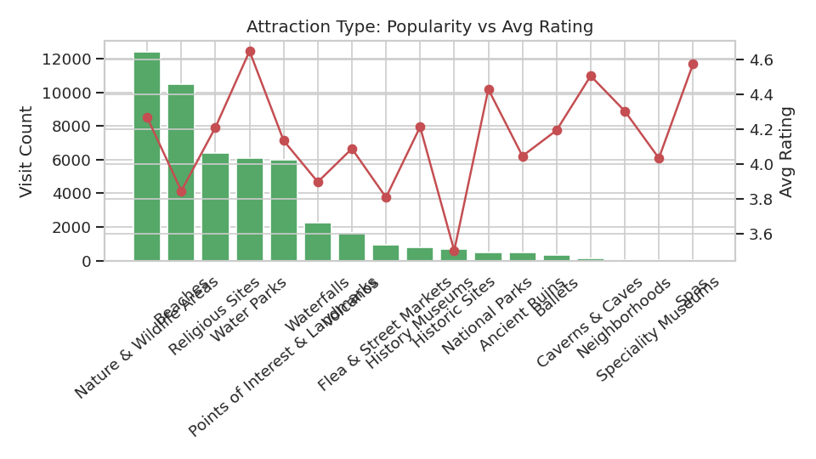

4.2 Visit mode distribution
Couples (41%) and Family (29%) trips dominate the dataset, while Business travel is a small minority (about 1%). This imbalance is the main challenge for the visit-mode classification task.
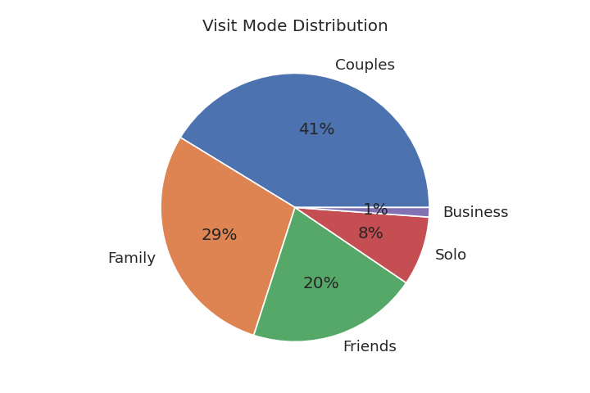

4.3 Rating distribution
Ratings skew strongly positive: most visitors rate their experience 4 or 5, with very few 1- or 2-star ratings. This ceiling effect limits how much variance a regression model can explain.
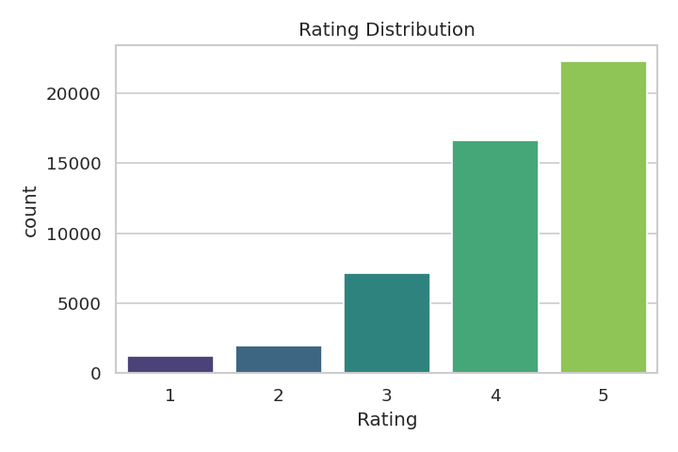

5. Regression: Predicting Rating
Three candidate models were trained to predict the 1–5 rating a visitor gives an attraction, using attraction location/type, visit timing, and historical popularity/rating as features.
Model | R² | RMSE | MAE
Linear Regression | 0.090 | 0.921 | 0.722
Random Forest | 0.099 | 0.917 | 0.720
Gradient Boosting (selected) | 0.110 | 0.912 | 0.714

Gradient Boosting performed best and was selected as the production model. The modest R² is consistent with the rating distribution shown in Section 4.3: since most ratings cluster at 4–5, there is limited variance left for any model to explain from the available features. Adding user demographic features (had they been available) would likely improve this further.

6. Classification: Predicting Visit Mode
Three candidate models were trained to predict which of five visit modes a transaction belongs to.
Model | Accuracy | Precision | Recall | F1 (weighted)
Logistic Regression | 0.441 | 0.307 | 0.441 | 0.344
Random Forest | 0.469 | 0.454 | 0.469 | 0.407
LightGBM (selected) | 0.473 | 0.466 | 0.473 | 0.409

LightGBM was selected as the production model, correctly classifying visit mode roughly 47% of the time — more than double the ~20% random baseline for five balanced classes. Performance is strongest on the majority classes (Couples: 85% recall) and weakest on minority classes like Business (4% recall) and Solo (3% recall), a direct consequence of the class imbalance shown in Section 4.2. Collecting more Business/Solo examples, or applying class-balancing techniques, would likely improve minority-class performance.

7. Recommendation System
Two complementary recommendation approaches were implemented:
- Collaborative filtering: a user–attraction rating matrix is factorized using Truncated SVD (30 latent components), producing personalized recommendations based on patterns across similar users.
- Content-based filtering: attractions are compared by type and location using cosine similarity, allowing recommendations even for a user with no rating history.
The Streamlit app automatically falls back to content-based / popularity recommendations when a requested User ID has no transaction history, avoiding a dead end for new or unknown users.

8. Application
All three models are deployed together in a single Streamlit application ("Waypoint") with four sections: an overview dashboard, a rating predictor, a visit-mode predictor, and a recommendation tool supporting both existing and new users.

9. Limitations & Future Work
- No user home-location data was available, limiting personalization to behavioral history rather than demographics.
- Only 30 unique attractions are represented, which caps the ceiling for both prediction accuracy and recommendation diversity.
- Visit mode classes are imbalanced (Business and Solo are rare), reducing recall for those categories.
- Future work: acquire user demographic data if available, apply class-balancing (e.g. SMOTE) for the classification task, and expand the attraction catalog.

10. Conclusion
This project delivers a complete, working pipeline — from raw transaction data to a deployed, interactive application — covering all three requested capabilities: rating prediction, visit mode classification, and attraction recommendation. Model performance is reasonable given the available features and data volume, and is clearly documented alongside its limitations so future iterations can build on a transparent baseline.

