**Bike Stores Sample Database**

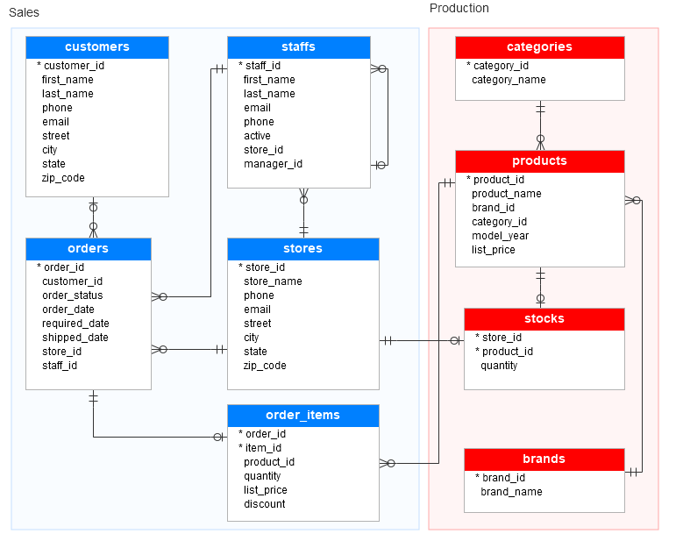



Write SQL for the below.

1. Get the list of Orders which are expected to be delivered late.

ans:

select * from sales_orders

where required_date>shipped_date

1. Get Sales of product which has maximum orders.

Ans:

select a.ProductName,a.Product_id,b.no_of_orders,a.sales from

(select

p.product_name as ProductName,p.product_id as Product_id,

sum((i.quantity*i.list_price) - discount) as sales

from

production_products p

join

sales_order_items i

on

p.product_id=i.product_id

group by

p.product_name,

p.product_id) a

inner join

(select top 1 product_id,count(order_id) no_of_orders from sales_order_items group by product_id order by no_of_orders desc ) b

on a.Product_id = b.Product_id

3. Get category wise which product has no orders.

Ans:

select pc.category_id,pc.category_name,pp.product_id,pp.product_name,soi.order_id from production_categories pc

left join

production_products pp

on pc.category_id=pp.category_id

left join

sales_order_items soi

on pp.product_id=soi.product_id

where

soi.order_id is null

4. Get the product list details which needs immediate replenishment.

Ans:

select pp.product_id,pp.product_name,ps.quantity from production_stocks ps

join

production_products pp

on ps.product_id=pp.product_id

where ps.quantity=0;

5. Get year wise which customer placed maximum order items in single order.

Ans: select * from (

select *, rank() over(partition by year order by no_of_items desc ) rank_1 from (

select count(soi.item_id) no_of_items,so.order_id order_id,sc.customer_id customer_id,year(so.order_date) year from

sales_order_items soi left join

sales_orders so on so.order_id = soi.order_id

inner join sales_customers sc on

sc.customer_id = so.customer_id

group by so.order_id,sc.customer_id,year(so.order_date)) a) b

where rank_1 =1