**BỘ GIÁO DỤC VÀ ĐÀO TẠO**

**TRƯỜNG ĐẠI HỌC CMC**



**DEVELOPMENT AND OPERATIONS (DEVOPS)**

**Topic: Software Deployment of a Web-Based Personal Budgeting System**

**Group of students:**

**Trần Quỳnh Anh - BIT230008**

**Nguyễn Hải Anh - BIT230500**

**Đoàn Anh Vũ - BIT230458**

**Hà Nội, tháng - 2025**

**Work Assignment**

|  |  |  |  |  |  |
| --- | --- | --- | --- | --- | --- |
| **TT** | **Student Code** | **Full Name** | **Work Content** | **Evaluate (base 10)** | **Note** |
| 1 | BIT230500 | Nguyễn Hải Anh | Docker Compose (Database + Grafana + promotheus Container) | 10 | Host computer + Help with every other content |
| 2 | BIT230008 | Trần Quỳnh Anh | Jenkins CI + Docker Containerize | 9,75 | Leader – in charge with report and slide |
| 3 | BIT230458 | Đoàn Anh Vũ | MinIO + Public container to Docker hub | 9,5 |  |

**TABLE OF CONTENTS**

LIST OF FIGURES 4

LIST OF ABBREVATIONS 5

INTRODUCTION 6

1.1. Background and Rationale for Choosing the Topic 6

1.2. Objectives 6

1.3. Scope of the Study 6

CHAPTER 1. PROBLEM INTRODUCTION 8

1.1. General Introduction 8

1.2. Proposed Problem 8

1.3. Implementation Plan 9

1.4. Technologies and Tools Used 9

CHAPTER 2. IMPLEMENTATION SOLUTION 11

2.1. Requirement Analysis 11

2.3. Deployment Process 11

2.3.1. CI/CD Deployment using Jenkins, Docker and GitHub 11

2.3.2. CI/CD Workflow using Jenkins, Docker and GitHub 12

CHAPTER 3. IMPLEMENTATION RESULTS 19

3.1. System Architecture Overview 19

3.2 Result Evaluation 19

3.3. Screenshots 19

CONCLUSION 22

# LIST OF FIGURES

Figure 1: Clone code from GitHub 13

Figure 2: Build with Maven 13

Figure 3: Deploy WAR to Local Tomcat 14

Figure 4: Build Docker Image 14

Figure 5: Dockerfile 15

Figure 6: Run Docker Compose 15

Figure 7: FIle docker-compose.yml 17

Figure 8: Run MinIO container 17

Figure 9: MinIO container running on Docker with ports 9000 and 9001 exposed 17

Figure 10: Run docker container 18

Figure 11: Spring Boot application container running with port mapping 8091:8080 18

Figure 12: Push Docker Image 18

Figure 13: Jenkins pipeline run triggered by GitHub push with successful build execution 20

Figure 14: All container is created and run sequentialy automatically  20

Figure 15: Project succesfully deployed at port 8091 (Image in profile is got from MinIO) 21

Figure 16: Promotheus graph in Grafana tracking http request and 4xx error 21

# LIST OF ABBREVATIONS

|  |  |
| --- | --- |
| **Symbol** | **Meaning** |
| CI | Continuous Integration |
| CD | Continuous Deployment / Delivery |
| SCM | Source Code Management |
| VCS | Version Control System |
| UI | User Interface |
| API | Application Programming Interface |
| OS | Operating System |
| IDE | Integrated Development Environment |
| YAML | Yet Another Markup Language |
| WAR | Web Application Archive |
| JDK | Java Development Kit |
| SDK | Software Development Kit |
| CLI | Command Line Interface |
| SQL | Structured Query Language |
| DBMS | Database Management System |
| DB | Database |
| HTTP | HyperText Transfer Protocol |
| HTTPS | HyperText Transfer Protocol Secure |
| IP | Internet Protocol |
| URL | Uniform Resource Locator |
| Git | A distributed version control system |
| GitHub | A web-based platform for version control using Git |
| Jenkins | An open-source automation server for CI/CD |
| Docker | A containerization platform |
| Docker Hub | A cloud-based repository for Docker images |
| Docker Compose | A tool for defining and running multi-container Docker applications |
| MinIO | A high-performance object storage system |
| Prometheus | An open-source monitoring and alerting toolkit |
| Grafana | An open-source platform for monitoring and observability |
| UI | User Interface |

# INTRODUCTION

## 1.1. Background and Rationale for Choosing the Topic

In today’s digital era, effective financial management is increasingly supported by personal budgeting applications. These systems help individuals track their income and expenses, set financial goals, and make informed decisions about their money. However, building such applications is only part of the challenge; deploying them reliably, securely, and efficiently is equally important. This is where DevOps practices come into play.

With the growing demand for continuous integration, continuous delivery (CI/CD), and automated deployment pipelines, DevOps has become an essential approach for modern software development and deployment. By choosing the topic "Software Deployment of a Web-Based Personal Budgeting System", this project aims to apply DevOps principles in a real-world scenario—deploying a financial web application that is both functional and maintainable. The topic was selected to gain hands-on experience with tools like Docker, Jenkins, GitHub Actions, and cloud services, ensuring that the application is always in a deployable state with minimal manual intervention.

## 1.2. Objectives

The main objectives of this report are:

* To design and implement a DevOps pipeline for the deployment of a personal budgeting web application.
* To automate the build, test, and deployment processes using modern DevOps tools and technologies.
* To ensure reliable and consistent software delivery using containerization (Docker) and orchestration tools if applicable.
* To explore best practices in DevOps for small-scale personal finance software systems.
* To demonstrate the benefits of continuous integration and continuous deployment (CI/CD) pipelines in maintaining application quality and uptime.

## 1.3. Scope of the Study

This study focuses primarily on the deployment aspects of the personal budgeting system using DevOps practices. The scope includes:

* Setting up the infrastructure needed for deployment (e.g., Docker, CI/CD pipelines).
* Automating the build and deployment process of the budgeting system.
* Using version control (Git) and integrating it with CI/CD tools.
* Testing the application deployment across different environments (development, staging, production).
* Monitoring and logging basic system metrics post-deployment.

# CHAPTER 1. PROBLEM INTRODUCTION

## 1.1. General Introduction

In the digital age, managing personal finances through traditional spreadsheets or manual methods is becoming increasingly inefficient. To address this, web-based personal budgeting systems are emerging as essential tools that allow users to track their income, expenses, and financial goals in an intuitive and accessible way.

However, developing a useful budgeting application is not enough. Ensuring that it is reliably deployed, frequently updated, and easily scalable is a critical part of delivering long-term value to users. This challenge lies in the **software deployment process**, which is often time-consuming, error-prone, and lacks consistency when performed manually.

With the rapid evolution of cloud infrastructure and DevOps methodologies, modern software deployment can now be streamlined and automated. By integrating tools like **Docker, CI/CD pipelines**, and **cloud hosting**, developers can ensure that applications are deployed faster, with fewer errors, and are easier to maintain.

This project aims to explore and implement the deployment of a **Web-Based Personal Budgeting System** using DevOps principles to demonstrate how such practices can enhance software delivery and lifecycle management.

## 1.2. Proposed Problem

The main problem addressed in this study is the **inefficiency and unreliability of traditional software deployment methods**, especially when applied to web-based applications like personal finance management systems. Without automation, deployment processes are prone to:

* Configuration mismatches between development and production environments.
* Long downtime during updates or releases.
* High manual effort in testing, building, and deploying applications.
* Difficulty in scaling or rolling back when failures occur.

To solve these issues, this project proposes designing and implementing a **DevOps-based deployment pipeline** for a personal budgeting web application. The solution involves:

* **Containerizing** the application using Docker to ensure consistency across environments.
* Setting up **CI/CD pipelines** (e.g., using Jenkins or GitHub Actions) to automate build, test, and deployment stages.
* Hosting the application on a server or cloud platform with version control integration for smooth release cycles.
* Monitoring deployment to track performance and failures.

By addressing the deployment process as the central challenge, this project highlights the importance of DevOps in reducing risks, improving software quality, and accelerating delivery in modern web development.

## 1.3. Implementation Plan

|  |  |  |  |  |
| --- | --- | --- | --- | --- |
| **No** | **Task** | **Deliverables** | **Person in charge** | **Duration (week)** |
| 1 | Docker Compose Setup | Docker Compose file integrating Database, Grafana, and Prometheus | Nguyễn Hải Anh | 2 |
| 2 | CI/CD with Jenkins and Docker | Jenkinsfile and Dockerfile for automating build and deployment | Trần Quỳnh Anh | 2 |
| 3 | MinIO Integration & Docker Hub | MinIO configuration and pushing container image to Docker Hub | Đoàn Anh Vũ | 2 |
| 4 | Documentation & Presentation | Final report and presentation slides | Trần Quỳnh Anh | 1 |

## 1.4. Technologies and Tools Used

|  |  |  |
| --- | --- | --- |
| **Tool/Technology** | **Purpose** | **Role in the Project** |
| Git & GitHub | Version control | Used to manage source code, track changes, and integrate with CI/CD pipeline for automated deployments. |
| Docker | Containerization | Used to package the application and its dependencies into a consistent and portable container image, ensuring it runs the same across environments. |
| Docker Compose | Multi-container setup | Used to define and manage multi-container applications (e.g., application + database) for local development and testing. |
| Jenkins / GitHub Actions | CI/CD automation | Used to automate the build, test, and deployment pipeline. (Choose one depending on what you used). |
| Ngrok | Create public URL | Used to expose the local Jenkins server via a secure tunnel for receiving GitHub webhooks. |
| Apache | Web server / reverse proxy | Serves the frontend and handles routing, reverse proxy, and load balancing (if applicable). |
| SQL Server | Database | Used as the backend database for storing transaction data, budgets, categories, etc. |
| Spring Boot | Backend Framework | The core backend logic of the application, handling APIs, user logic, and interaction with the database. |
| HTML/CSS/JavaScript | Frontend technologies | Technologies used to build the user interface of the personal budgeting system. |
| Visual Studio Code | Development environment | Code editor used for writing and debugging the application code. |
| Postman | API testing | Used to test backend APIs before and after deployment. |
| **Grafana** | System monitoring dashboard | Used to visualize system and application metrics collected by Prometheus in real time through customizable dashboards. |
| **Prometheus** | Metrics collection & monitoring | Collects time-series data and metrics from application and infrastructure components for system health monitoring. |
| **MinIO** | Object storage | Provides high-performance, S3-compatible object storage for storing application files, reports, or backups. |
| **Kubernetes (K8s)** | Container orchestration | Automates deployment, scaling, and management of Docker containers across a distributed cluster. |

# CHAPTER 2. IMPLEMENTATION SOLUTION

## 2.1. Requirement Analysis

The personal finance management system was designed and implemented based on the following functional and non-functional requirements:

* Functional Requirements:
  + Allow users to record, update, and delete personal income and expenses.
  + Display categorized financial summaries (e.g., by time period or expense type).
  + Provide reporting and statistical visualization (charts, tables).
  + Support user authentication and role-based access control
* Non-Functional Requirements:
  + The system must operate smoothly on modern web browsers.
  + Data must be securely stored and efficiently retrieved from a relational database (SQL Server).
  + The development workflow must support automated build, test, and deployment using CI/CD (Jenkins integrated with GitHub).
  + The application must be containerized using Docker to ensure consistency across environments, simplify deployment, and enable future scalability (e.g., deployment via Docker Compose or orchestration platforms).
  + System components (e.g., backend, frontend, database) must be defined as Docker services and run in isolated containers.

These requirements ensure that the system not only fulfills user needs but is also maintainable, portable, and ready for real-world deployment scenarios using modern DevOps practices.

## 2.3. Deployment Process

### 2.3.1. CI/CD Deployment using Jenkins, Docker and GitHub

The Continuous Integration and Continuous Deployment (CI/CD) process for this project is built using **Jenkins, Docker**, and **GitHub**. The goal of the pipeline is to automate the entire lifecycle from code integration to deployment using containerized infrastructure and Tomcat.

When code is pushed to the main branch of the GitHub repository, a **webhook** triggers Jenkins, which then executes a defined pipeline (in Jenkinsfile) to perform the following:

* Clone the updated source code
* Build the project using Maven
* Deploy the application to Apache Tomcat
* Build a Docker image of the application
* Push the Docker image to Docker Hub
* Run the application using Docker and Docker Compose

This automation improves reliability, consistency, and delivery speed.

### 2.3.2. CI/CD Workflow using Jenkins, Docker and GitHub

This section provides an in-depth explanation of the CI/CD workflow, illustrating how Jenkins, Docker, and GitHub are integrated to automate the entire process—from code integration to deployment and monitoring.

The Jenkins pipeline is defined in a Jenkinsfile, which orchestrates multiple stages including building, deploying, containerizing, and pushing the application image to Docker Hub. Below is the detailed step-by-step workflow:

**2.3.3.1. Source Code Management with GitHub**

* The entire application source code is hosted on GitHub at:  
  https://github.com/HAnh3112/JavaWebFinal.git
* Jenkins uses the Git plugin to automatically **clone** the latest code from the main branch whenever the pipeline is triggered.

**2.3.3.2 Webhook Integration using Ngrok**

Since Jenkins was hosted locally without a public IP address, we used **Ngrok** to expose Jenkins to the internet in order to receive webhook events from GitHub. This enabled true continuous integration, where each git push automatically triggered the Jenkins pipeline.

Steps:

* **Ngrok** was used to expose Jenkins on a temporary public URL.
* This URL was added to the GitHub repository as a **webhook endpoint** under Settings → Webhooks.
* GitHub then sent a POST request to Jenkins every time code was pushed to the main branch.
* Jenkins processed the webhook and started the pipeline automatically.

This integration simulates a real-world CI/CD environment, even when running Jenkins on a local machine.

**2.3.3.3 Jenkins Pipeline Overview**

The CI/CD pipeline is defined using Declarative Pipeline Syntax and contains multiple stages, each responsible for a specific task:

**Stage 1: Clone**

When code is pushed to the main branch of the GitHub repository, a webhook automatically triggers Jenkins to start the pipeline. The pipeline begins by cloning the repository: 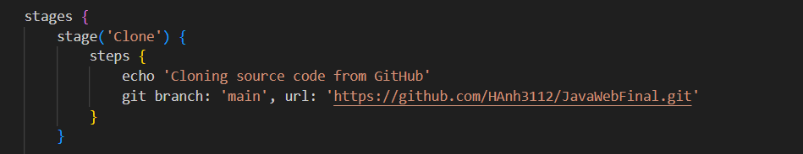

Figure 1: Clone code from GitHub

**Stage 2: Build with Maven**

Jenkins then uses Maven (configured as Maven 3.9.9 in Jenkins global settings) to compile the Java source code and package it into a .war file, skipping tests to speed up the process:

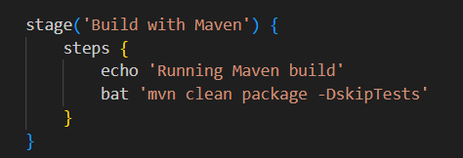

Figure 2: Build with Maven

**Stage 3: Deploy WAR to Local Tomcat**

After building, the .war file is copied to the local Apache Tomcat server (installed at D:\apache-tomcat-11.0.7). Tomcat is restarted to reflect the new deployment:

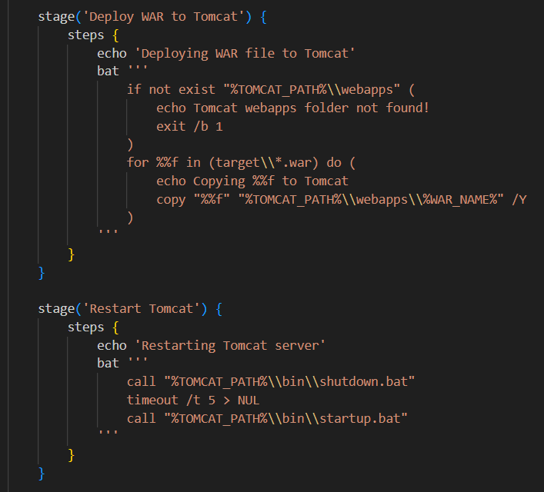

Figure 3: Deploy WAR to Local Tomcat

**Stage 4: Build Docker Image**

Using a multi-stage Dockerfile, Jenkins builds a Docker image of the application. The first stage compiles the app with Maven, and the second stage deploys it on a Tomcat base image:

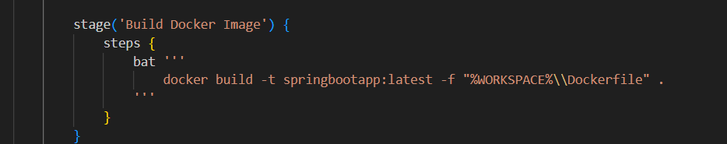

Figure 4: Build Docker Image

Relevant part of the Dockerfile:

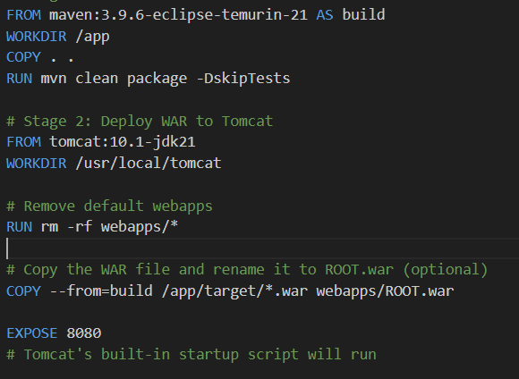

Figure 5: Dockerfile

**Stage 5: Launch Environment with Docker Compose**

To orchestrate services such as the app, SQL Server, Prometheus, and Grafana, Docker Compose is used. Jenkins executes the following commands to stop any existing setup and relaunch everything:

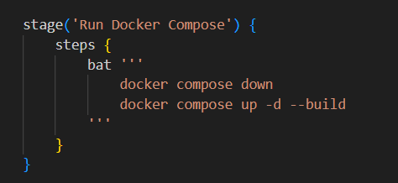

Figure 6: Run Docker Compose

Key services in docker-compose.yml:

* sql2022: Microsoft SQL Server 2022
* prometheus: Monitoring system
* grafana: Visualization dashboard

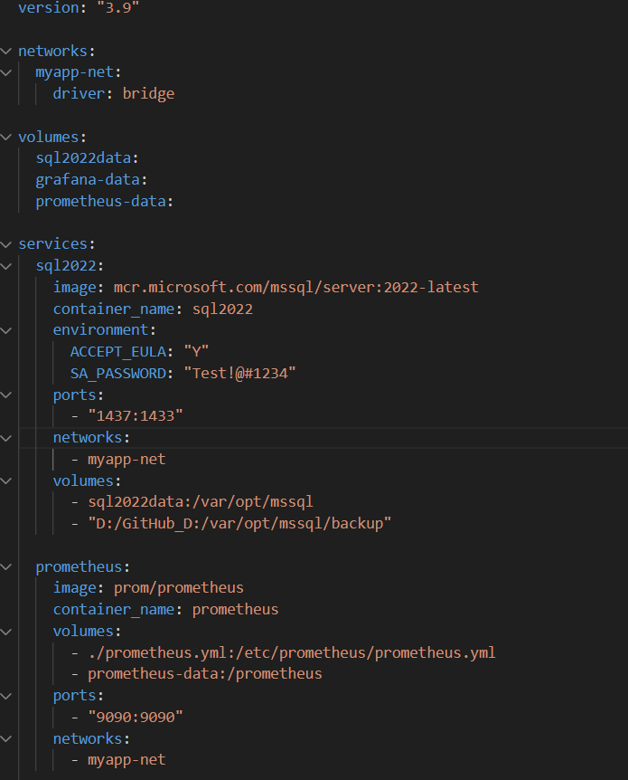

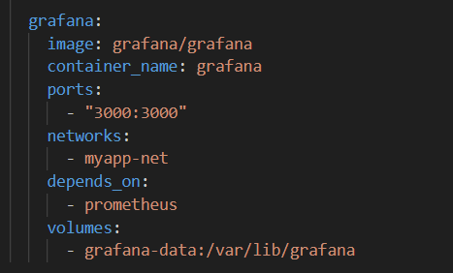

Figure 7: FIle docker-compose.yml

**Stage 6: Run MinIO container:**

Jenkins pipeline will startup MinIO container. If it already started, this stage will simply be skipped

Figure 8: Run MinIO container

MinIO will be run in 2 default ports: 9000 and 9001. Port 9000 is port for accessing data locally from other container, while port 9001 is admin panel, allow us to manage and monitor it.



Figure 9: MinIO container running on Docker with ports 9000 and 9001 exposed

**Stage 7: Run Docker container:**

Project’s container will now be created and run on port 8091 using the newest version of image we created. If the container already exists, it will remove the older container and create new one. The container is also placed in the same network “myapp-net” to be able to access to other services.

Figure 10: Run docker container



Figure 11: Spring Boot application container running with port mapping 8091:8080

**Stage 8: Push Docker image to Dockerhub:**

After passing all previous step, it implies that the image created work perfectly and ready to be pushed to public. Jenkins pipeline will then push it to public Dockerhub, allow another computer to pull back and run. Note that we are not using cloud for database, hence the pulling computer needs to have the database to be able to run.

Figure 12: Push Docker Image

# CHAPTER 3. IMPLEMENTATION RESULTS

## 3.1. System Architecture Overview

The system consists of the following main components, all running as isolated containers within a Docker Compose network:

* Spring Boot Application (Custom WAR deployed on Tomcat)
* Microsoft SQL Server 2022 (SQL Database)
* Prometheus (Monitoring and metrics collection)
* Grafana (Visualization and dashboard)
* Docker Compose (Service orchestration)
* MinIO (Only as a Local Files Storage)

All services are connected via a custom Docker network (myapp-net), allowing inter-service communication and network isolation.

## 3.2 Result Evaluation

* After successful deployment and integration of monitoring tools, the following results were observed:
* Fast Deployment: The application and supporting services were automatically deployed within minutes using Jenkins pipeline.
* System Observability: Prometheus successfully collected application metrics. Grafana visualized them using real-time dashboards.
* Maintainability: The environment can be replicated or scaled easily using container orchestration.
* Data Persistence: SQL Server data was preserved across container restarts using Docker volumes.

## 3.3. Screenshots

Figure 13: Jenkins pipeline run triggered by GitHub push with successful build execution

Figure 14: All container is created and run sequentialy automatically

Figure 15: Project succesfully deployed at port 8091 (Image in profile is got from MinIO)

Figure 16: Promotheus graph in Grafana tracking http request and 4xx error

# CONCLUSION

In this project, we have successfully implemented a CI/CD pipeline that automates the process of building, testing, and deploying applications using Jenkins, Docker, and GitHub. By applying containerization through Docker and orchestration via Docker Compose, we were able to deploy and manage multiple services including a SQL Server database, Jenkins, MinIO object storage, Prometheus for monitoring, and Grafana for visualization.

The integration of Jenkins with GitHub enabled continuous integration, ensuring that every code change pushed to the repository was automatically built and tested. This reduces manual intervention, minimizes errors, and accelerates the development workflow. The use of Docker and Docker Hub allowed for consistent and scalable deployment across environments.

Moreover, with the help of Prometheus and Grafana, the system's performance and health were effectively monitored, enabling proactive debugging and system optimization. The implementation of MinIO demonstrated our ability to work with object storage in a cloud-native manner.

Through this project, we not only gained practical experience with modern DevOps tools but also improved our collaboration and problem-solving skills. Each team member contributed significantly, and the project was completed successfully within the planned timeframe.

This CI/CD system provides a strong foundation for future projects, offering automation, reliability, and scalability in software development and deployment workflows.