**MINISTRY OF EDUCATION AND TRAINING**

**CMC UNIVERSITY**



**ASSIGNMENT REPORT**

**COURSE: Mobile Application Development**

**Project Title : FinGuard: A Personal Financial Management Tool**

**Group Member :**

**Trần Quỳnh Anh - BIT230008**

**Nguyễn Hải Anh - BIT230500**

**Đoàn Anh Vũ - BIT230458**

**Hoàng Nguyên Giáp - BIT230135**

**Hà Nội, tháng năm 2024**

# Contents

Contents 2

INTRODUCTION 2

LIST OF GROUP MEMBERS 3

CHAPTER I: SYSTEM INTRODUCTION 4

1. Introduction 4

2. System Survey and Research 4

2.1 System Objectives 4

2.2 Identifying Surveyed Subjects 4

3. Define System Requirements Specification 4

3.1 Similar application 4

3.2 Functional Requirements 4

3.3 Non-functional Requirements 4

CHAPTER II: TECHNOLOGY USED 5

1. Describe the technology used in the system 5

2. Describe the methodology used in the system 5

CHAPTER III: ANALYSIS OF THE SYSTEM 5

CHAPTER III: DATABASE DESIGN 5

CHAPTER V: INTERFACE DESIGN 5

PART VI: LIMITATIONS AND FUTURE IMPROVEMENTS 6

PART VII: CONCLUSION 6

# INTRODUCTION

Managing personal finances is a crucial skill in today’s fast-paced and unpredictable world. Effective financial management allows individuals to prepare for emergencies, save for future goals, and make informed spending decisions. However, many people still lack the habit of tracking their income and expenses, which often leads to overspending, inadequate savings, and poor financial planning.

In response to this problem, our team has developed a mobile application that helps users manage their personal finances in a simple and efficient way. The application is built using the Flutter framework, ensuring cross-platform compatibility and a smooth user experience.

The app provides key features such as daily income and expense tracking, budget management, and financial goal setting. Through an intuitive and user-friendly interface, users can easily monitor their spending habits, control their budgets, and improve their overall financial health.

This project aims not only to offer a practical solution for individual users but also to help raise awareness about the importance of financial discipline and planning in daily life.

# IMPLEMENTATION PLAN

|  |  |  |  |  |  |
| --- | --- | --- | --- | --- | --- |
| **No.** | **Task** | **Description** | **Main Responsible Member** | **Time (Week)** | **Deliverables** |
| 1 | Requirement Analysis | Identify core features and design user flow | Trần Quỳnh Anh | Week 1 | List of planned features, use-case diagram |
| 2 | Wireframe Design | Create low-fidelity screen sketches | Đoàn Anh Vũ | Complete wireframes for all main screens |
| 3 | Database Design | Define tables, data models, and relationships | Nguyễn Hải Anh | Week 2 | ERD diagram, SQL schema or model classes |
| 4 | Flutter Project Setup | Initialize project structure and dependencies | Nguyễn Hải Anh | Flutter project on Git, with folder structure and dependencies set |
| 5 | Navigation Setup | Configure screen navigation using Flutter routes | Nguyễn Hải Anh | Working route configuration for all screens |
| **Screens** | | | | | |
| 6 | Register/Login Screen | Design UI | Hoàng Nguyên Giáp | Week 3 | Register/Login Screen |
| 7 | Add Transaction (Income/Expense) Screen | Design UI | Trần Quỳnh Anh | Add Transaction Screen |
| 8 | Category Management Screen | Manage categories (add/edit/delete) | Hoàng Nguyên Giáp | Category management screen |
| 9 | Transaction History Screen | Display transactions by date/category | Đoàn Anh Vũ | Transaction History Screen |
| 10 | Budget Planning Overview Screen | All the current budget plans | Nguyễn Hải Anh | Budget planning overview screen |
| 11 | Set Budget Planning Screen | Add budget plans | Nguyễn Hải Anh | Set budget plans screen |
| 12 | Dashboard Screen | Show charts and summary (income, expenses) | Trần Quỳnh Anh | Dashboard screen with charts and totals |
| **API** | | | | | |
| 13 | Transaction API | Implement CRUD API for transactions | Trần Quỳnh Anh | Week 4 | TransactionController with endpoints tested |
| 14 | Categories API | Create API to manage categories (CRUD) | Hoàng Nguyên Giáp | CategoriesController with endpoints tested |
| 15 | Budget Planning API | API for setting and retrieving budget plans | Nguyễn Hải Anh | BudgetPlanningController with endpoints tested |
| 16 | Function Testing | Test features, find and fix bugs | Hoàng Nguyên Giáp | Week 6 | Test report with fixed bugs and screenshots |
| 17 | Report Writing | Document system overview, features, and development | Trần Quỳnh Anh | Week 7 | Draft of group report in Word/PDF |
| 18 | Final Report Compilation | Format and finalize the full group report | Trần Quỳnh Anh | Week 8 | Finalized PDF report ready for submission |

# CHAPTER I: PROJECT OVERVIEW

## Project Introduction

In the modern era, where economic instability and rapid lifestyle changes are common, managing personal finances has become a critical life skill. The ability to track income, monitor expenses, and set realistic financial goals plays a key role in achieving long-term financial stability. Despite the importance of these habits, many individuals still struggle to manage their finances effectively, often due to a lack of suitable tools or knowledge.

To address this issue, our team has developed a mobile application designed to support users in managing their personal finances more efficiently. Built using the Flutter framework, the application offers cross-platform compatibility and a smooth user experience across devices. The app integrates core functionalities such as transaction tracking, budget planning, and financial summary visualization through an intuitive interface. This project aims to contribute to the financial well-being of users by providing them with the tools and awareness necessary to take control of their personal finances.

## Problem Statement & Objectives

### 2.1 Objectives of the application

The main objectives of this application are:

* To provide a simple and user-friendly platform for tracking daily income and expenses.
* To enable users to create and manage budgets, helping them set spending limits and stay within them.
* To visualize financial data through charts and summaries, offering insights into spending habits.
* To raise users' awareness about the importance of personal financial discipline and long-term planning.
* To support financial goal-setting, encouraging users to save and spend more consciously.

### 2.2 Target Users

The application is designed for a broad range of users, including:

* Students learning to manage their personal finances independently.
* Young professionals seeking to monitor their income and spending habits.
* Individuals or families who want to plan budgets and save for future goals.
* Anyone looking for a simple and efficient tool to improve their financial awareness and discipline.

# CHAPTER II: REQUIREMENTS ANALYSIS

1. System Requirements

## Functional Requirements

The core functional requirements of the application include:

* **User Registration and Login:**
  + Users can securely create an account, log in, and log out.
* **Transaction Management:**
  + Add, edit, or delete income and expense transactions.
  + Assign categories to each transaction.
  + Include notes and select the transaction date.
* **Category Management:**
  + Create, update, and delete income or expense categories.
  + Clearly separate income and expense category types.
* **Budget Planning:**
  + Allow users to set monthly budget limits for each category.
  + Track expenses against the defined budget.
* **Transaction History:**
  + Display a list of transactions filtered by date, category, or type.
  + Support searching and filtering for easier tracking.
* **Dashboard Overview:**
  + Provide charts and summaries for income, expenses, and budget status.
  + Show real-time updates of financial activities.
* **Data Security and Storage:**
  + Ensure secure data storage via backend services.
  + Maintain personalized data per user account.

## Non-functional Requirements

* **Platform Support:** The application is developed specifically for Android devices using the Flutter framework. It is optimized for performance and usability on a wide range of Android smartphones and tablets.
* **Performance:** The app should respond to user interactions within 300 milliseconds to ensure a smooth and seamless experience.
* **Security:**
* User authentication must be implemented securely
* All communication between the client and the backend server should be protected (e.g., HTTPS).
* User data must be stored and handled in a way that ensures confidentiality and integrity.
* **Usability:** The user interface must be intuitive and user-friendly, allowing individuals with little or no technical background to use the app effectively.
* **Scalability:** While the app is initially intended for Android and personal use, the architecture should allow for future enhancements such as cloud data backup, multi-user support, push notifications, and expanded reporting features.

# CHAPTER III: TECHNOLOGY USED

1. Technologies Used
   1. Mobile Platform: **Flutter (Dart)**

## Backend / API / Database Services

* Spring Boot (Java): The backend RESTful API is developed using the Spring Boot framework. It provides a robust and scalable environment for handling user authentication, transaction processing, and data management.
* SQL Server: SQL Server is used as the relational database system to store persistent data such as:
* User accounts and login credentials
* Transactions (income/expense)
* Categories and budget plans
* Postman: Postman is used to test and document all API endpoints during development.

1. Development Tools & Frameworks

|  |  |
| --- | --- |
| **Tool/Framework** | **Purpose** |
| Android Studio | Main IDE for Flutter development on Android |
| Visual Studio Code | IDE for backend (Spring Boot) development |
| Git & GitHub | Version control and collaborative coding |
| Postman | API testing and documentation |

1. Development Methodology

The team followed an Agile development methodology, allowing for iterative and incremental development through clearly defined weekly tasks and deliverables. The development process involved:

* **Requirement Analysis (Week 1):**  
  Identifying key features, target users, and technical feasibility.
* **UI/UX Design (Weeks 1–2):**  
  Creating wireframes and interface prototypes based on user flows.
* **Backend & API Development (Weeks 2–5):**  
  Building a secure and well-structured API to support data flow.
* **Frontend Integration (Weeks 3–6):**  
  Connecting UI screens with API logic, ensuring smooth user experience.
* **Testing & Bug Fixing (Week 6):**  
  Comprehensive testing across functions to ensure reliability.
* **Documentation (Weeks 7–8):**  
  Preparing technical and user documentation, finalizing the group report.

This structured approach ensured that the team could efficiently handle tasks, respond to feedback, and produce a stable, feature-complete application within the scheduled timeline.

# CHAPTER IV: SYSTEM DESIGN

1. Use Case Diagrams

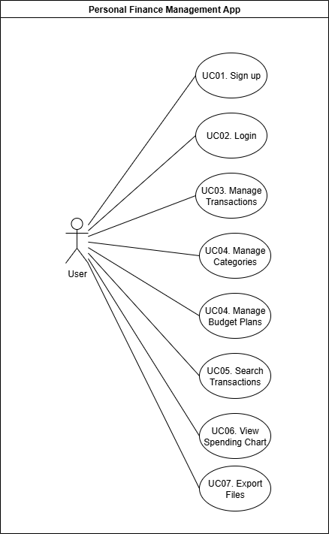

1. System Architecture

The system is designed using a client-server architecture with clear separation between the frontend and backend. It follows the MVC (Model–View–Controller) and RESTful service design principles.

**Architecture Overview:**

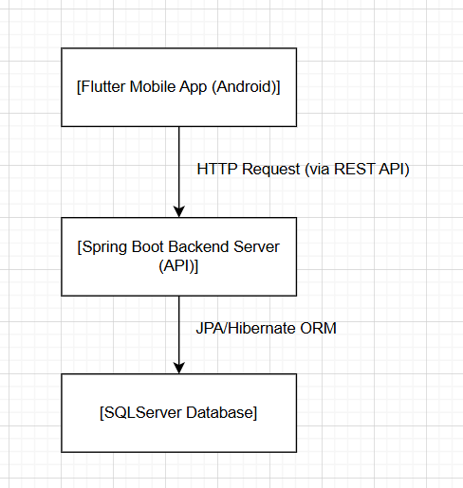

1. Database Design

|  |  |
| --- | --- |
| **Table Name** | **Description** |
|  |  |
|  |  |
|  |  |
|  |  |

**Entity Relationship Diagram (ERD):**

1. API Design

# CHAPTER V: USER INTERFACE DESIGN

1. Design Process Overview

The user interface of FinGuard was designed following a user-centered approach. The process began with identifying core user tasks and mapping out typical usage scenarios. Based on these, wireframes were developed to visualize screen layouts and user interactions before implementation.

The design focused on the following goals:

* Simplicity: ensuring an intuitive interface for all users
* Consistency: applying a uniform color palette and font system
* Responsiveness: optimizing for various screen sizes
* Visual clarity: presenting financial data in a clean and informative way
* Low-fidelity wireframes were first created using Draw.io, then converted into high-fidelity, interactive screens using Flutter.

1. Wireframe Design

The wireframe system includes all main screens and demonstrates a complete user journey from authentication to transaction management, budget planning, and data export. Key wireframe components include:

* **Login & Register Screens**
  + Contain input fields for email and password.
  + “Sign in” and “Sign up” buttons are clearly distinguished.
* **Dashboard Screen**
  + Displays core balances: total income, total expense, and net balance.
  + Provides visual pie charts of expenses by category.
  + Features recent transactions and navigation buttons for History, Budget, Categories, and Add Transaction.
  + Offers data export options (CSV, Excel) and optional integration with an AI agent.
* **Add Transaction Screen**
  + Allows users to input transaction type (Income or Expense), amount, category, and date.
  + Includes validation for required fields.
* **Transaction History Screen**
  + Lists transactions grouped by date.
  + Includes search and filter functionality by type, category, and amount/date range.
* **Category Management Screen**
  + Displays existing categories with corresponding icons.
  + Allows adding new categories, with icon selection functionality.
* **Budget Planning Screen**
  + Enables users to set monthly budgets for specific categories.
  + Shows total budget, total spent, and remaining budget.
  + Budget items can be edited individually.

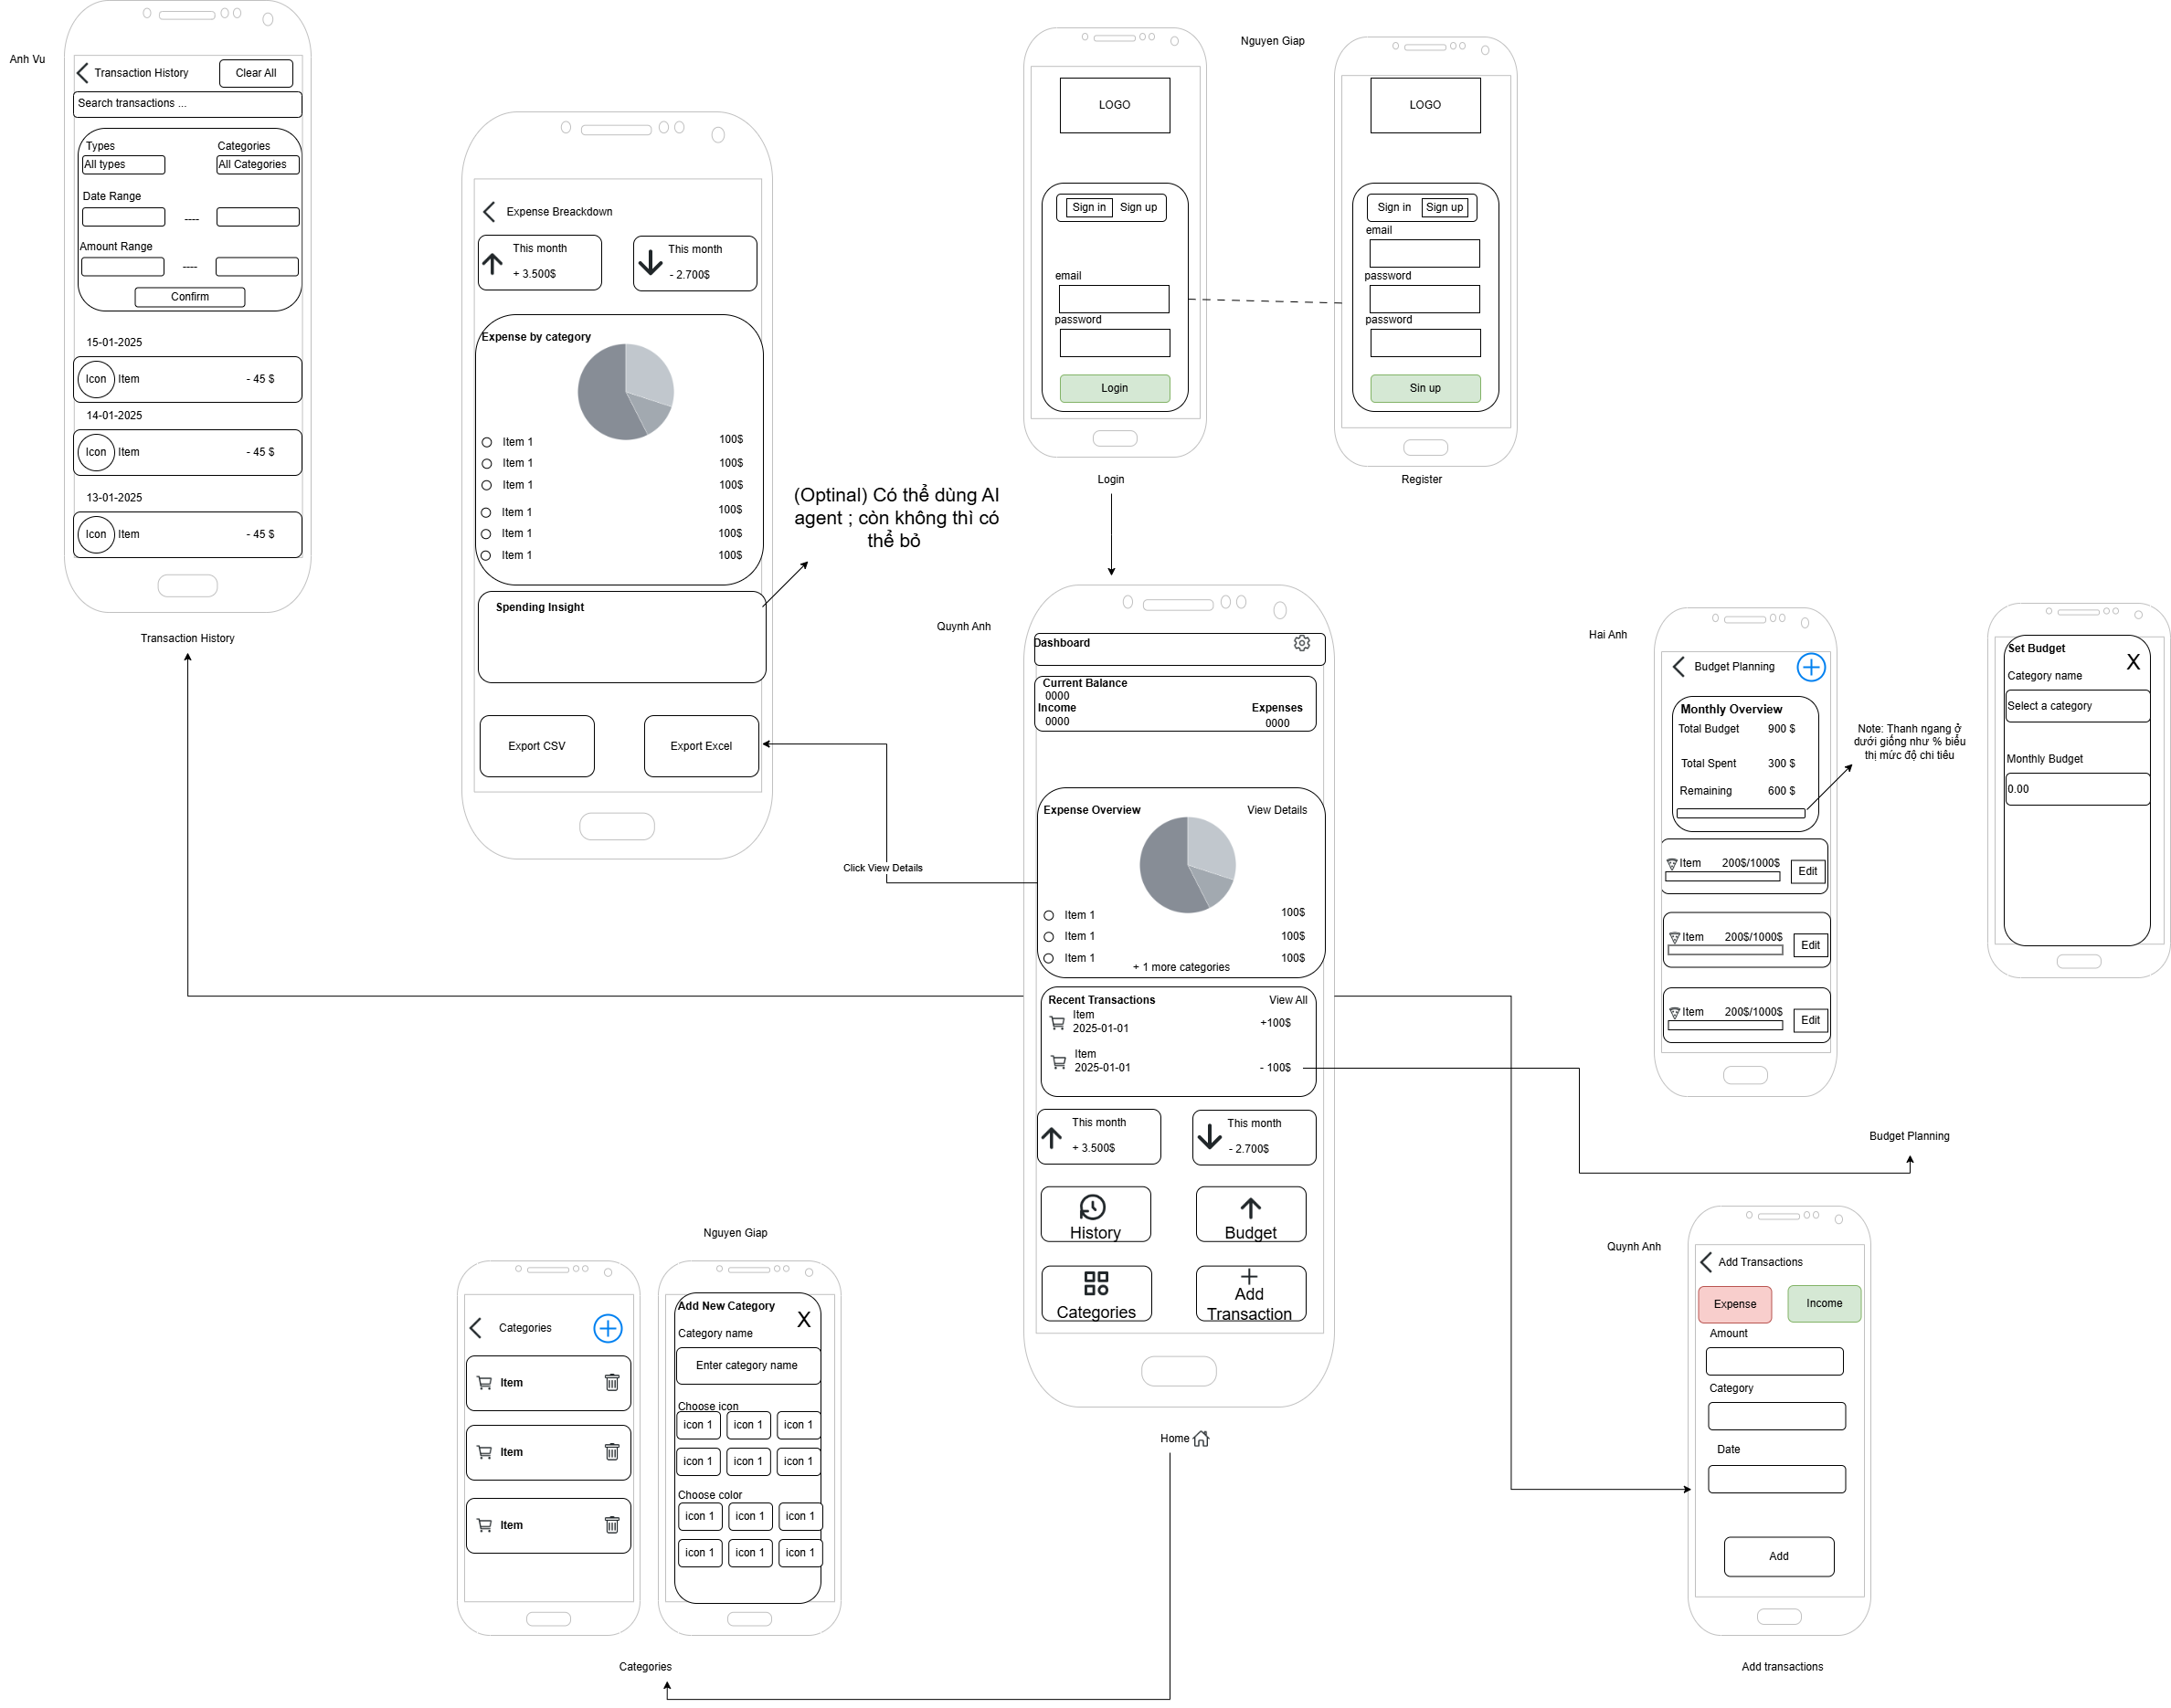

Figure 1: Wireframe System Overview

1. Sitemap

To visualize the navigation logic of FinGuard, a sitemap diagram has been created, illustrating the hierarchical structure of screens and actions. This sitemap replaces the traditional navigation flow diagram by presenting a clearer overview of how users traverse the application.

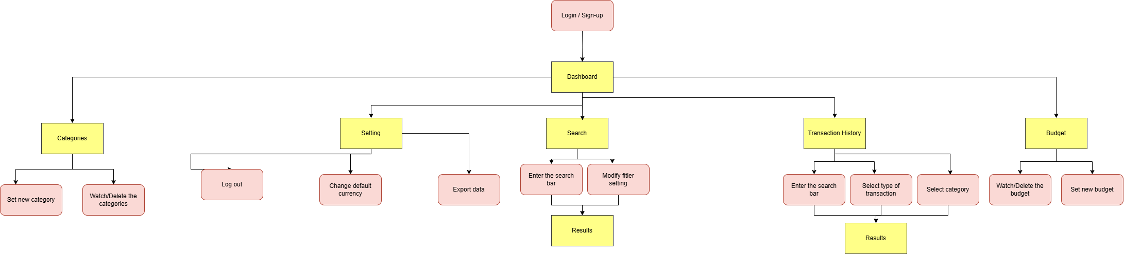

1. Final UI Design

**CHAPTER VI: IMPLEMENTATION**

# CHAPTER VII: LIMITATIONS AND FUTURE WORK

# PART VIII: CONCLUSION