

**Experiment1.2**

**Student Name:** FIDA KHAN **UID:**23BCS10345

**Branch:**BE- CSE **Section/Group:**811- B

**Semester:** Fourth **Date of Performance:**25/01/2025

**Subject Name:**DBMS **Subject Code:**23CSH-205

1. **Aim:**

Design Pharmacy management system Tables:

Medicine: medicine_id, name, category, price and stock. Supplier: suplier_id, name, and contact number.

Prescription: prescription_ id, patient_id, medicine_id, and quantity

1. **Objective:**

-Insert at least 15 record in each table

-Retrieve all medicines whose stock value is less then 5

-Find all prescriptions for a particular patient.

-Create A PL/SQL to display "Take your Medicines on Time".

1. **DBMS script and output:** CREATE TABLE Medicine ( medicine_id INT PRIMARY KEY, name VARCHAR(100),

category VARCHAR(50), price DECIMAL(10, 2),

stock INT);

CREATE TABLE Supplier (

supplier_id INT PRIMARY KEY, name VARCHAR(100),

contact_number VARCHAR(15)); CREATE TABLE Prescription ( prescription_id INT PRIMARY KEY, patient_id INT,

medicine_id INT, quantity INT,

FOREIGN KEY (medicine_id) REFERENCES Medicine(medicine_id)

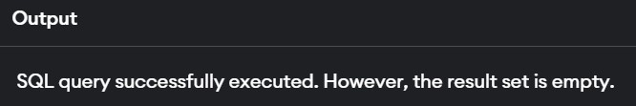

INSERT INTO Medicine (medicine_id, name, category, price, stock) VALUES (1, 'A', 'a', 5.99, 10),

(2, 'B', 'b', 7.49, 3),

(3, 'C', 'c', 12.99, 8),

(4, 'D', 'd', 15.99, 2),

(5, 'E', 'e', 10.99, 4),

(6, 'F', 'f', 14.99, 6),

(7, 'G', 'g', 9.99, 1),

(8, 'H', 'h', 19.99, 7),

(9, 'I', 'i', 25.99, 5),

(10, 'J', 'j', 8.99, 9),

(11, 'K', 'k', 11.99, 0),

(12, 'L', 'l', 13.99, 4),

(13, 'M', 'm', 18.99, 3),

(14, 'N', 'n', 10.49, 2),

(15, 'O', 'o', 16.99, 6);

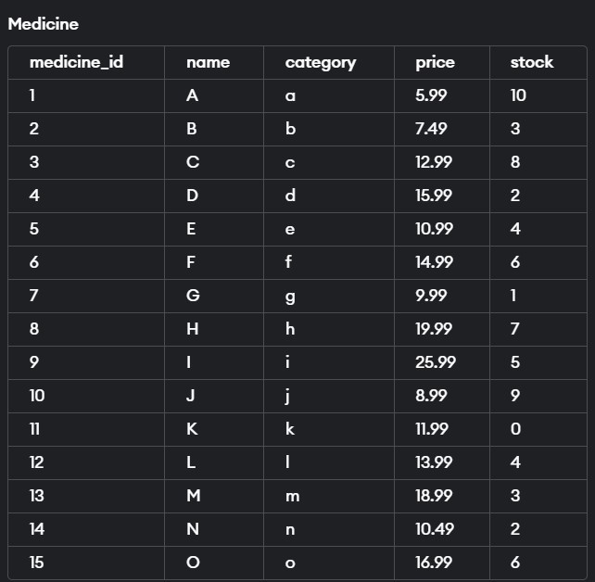

INSERT INTO Prescription (prescription_id, patient_id, medicine_id, quantity) VALUES (1, 101, 1, 2),

(2, 101, 3, 1),

(3, 102, 2, 3),

(4, 103, 4, 1),

(5, 104, 5, 2),

(6, 105, 6, 1),

(7, 106, 7, 4),

(8, 107, 8, 1),

(9, 108, 9, 2),

(10, 109, 10, 1),

(11, 110, 11, 1),

(12, 111, 12, 2),

(13, 112, 13, 1),

(14, 113, 14, 1),

(15, 114, 15, 1);

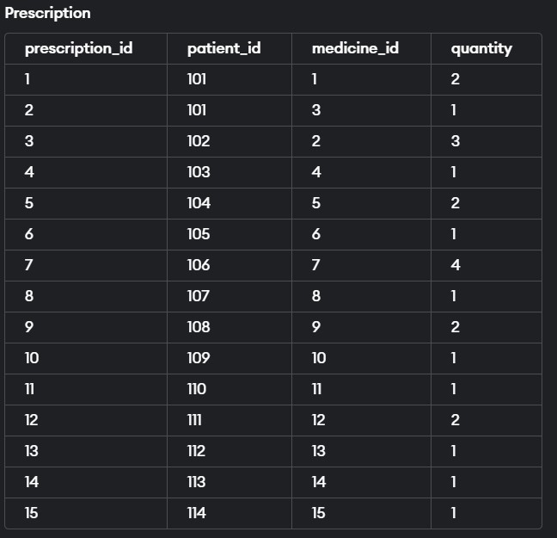

INSERT INTO Supplier (supplier_id, name, contact_number) VALUES (1, 'sup1', '123-456-7890'),

(2, 'sup2', '234-567-8901'),

(3, 'sup3', '345-678-9012'),

(4, 'sup4', '456-789-0123'),

(5, 'sup5', '567-890-1234'),

(6, 'sup6', '678-901-2345'),

(7, 'sup7', '789-012-3456'),

(8, 'sup8', '890-123-4567'),

(9, 'sup9', '901-234-5678'),

(10, 'sup10', '012-345-6789'),

(11, 'sup11', '123-456-7891'),

(12, 'sup12', '234-567-8902'),

(13, 'sup13', '345-678-9013'),

(14, 'sup14', '456-789-0124'),

(15, 'sup15', '567-890-1235');

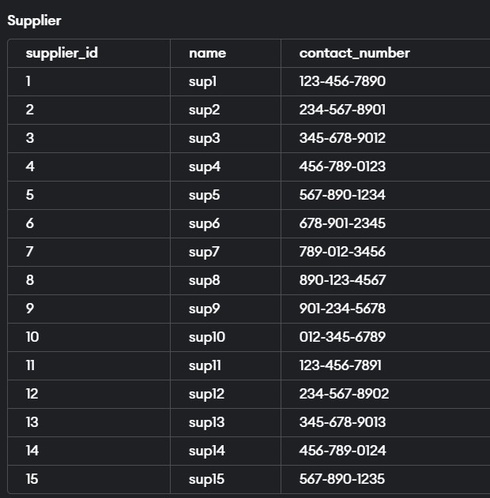

SELECT * FROM Medicine WHERE stock < 5;

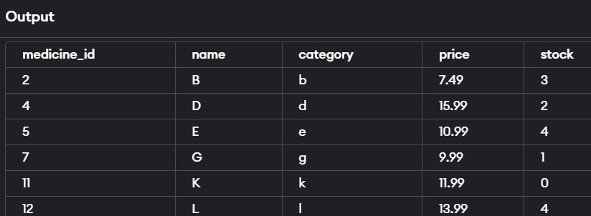

SELECT *

FROM Prescription WHERE patient_id = 101;

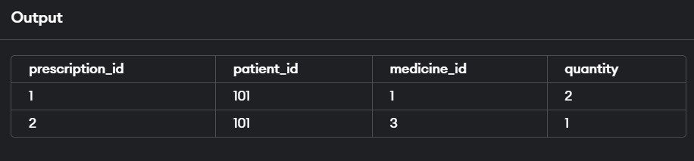

BEGIN DBMS_OUTPUT.PUT_LINE('Take your Medicines on Time');END;/