TO DETECT THE STRESS LEVEL OF STUDENTS USING NLP

Harshit Bisht

Department of Computer Science And Engineering

Graphic Era Deemed To Be University, Dehradun, Uttarakhand

harshitbisht02@gmail.com

**Abstract:**

|  |
| --- |
| XXX-X-XXXX-XXXX-X/XX/$XX.00 ©20XX IEEE |

Many mental health issues, such as mental stress, somatization, obsessiveness, interpersonal sensitivity, melancholy, anxiety, hostility, terror, paranoia, and psychosis, affect college students and can have a severe impact on their lives. Clearly, college students' mental health issues have an impact on the stability of the campus as well as their own development. The majority of colleges are also increasingly monitoring and preventing students' psychological crises. It is essential for students' general wellbeing and academic achievement to identify and treat their stress levels as they continue to face academic, social, and personal problems. Stress is something that concerns our lives. There are many variables in our day-to-day life that are tension. Human environments, like worksite, home, or society, may somehow inflict stress on a person. Stress is defined as a complex psychological and behavioural condition when the person's demands are imbalanced and the way demands are met. Also, the American Institute of Stress found that 80% of workers experience stress in their everyday work and need support in managing stress. Based on Ahuja and Banga , study recorded major suicide cases among students aged 15-29 due to stress. There are 8934 cases recorded in 2015, and study was inspired to identify stress in early stages. These figures and stress effects on people, which has been the leading cause of many diseases like hypertension, sleep deprivation, and others. Stress that cannot be adequately treated can lead to serious cases where one person committed suicide. This is vital to identify and control stress before it becomes severe. Many researchers investigate stress detection in many fields. This paper will elaborate on stress

identification based on the sentiment of the text used in the social media profiles . Early detection can help track tension, and different machine learning and deep learning approaches have been explored and compared.

**Keywords:**

Natural Language Processing, Deep learning, Stress level of students, NLTK, LSTM, Sentiment analysis.

**1.Introduction:**

Student stress is an increasing issue since it can negatively affect their academic performance, mental health, and general well-being. Promoting mental health and well-being in educational environments may depend on early detection and management for stress-related problems. Machine learning models and Natural Language Processing (NLP) methods have become powerful tools for identifying people's degrees of stress in recent years. Our study aimed to add to the body of knowledge on the application of NLP and machine learning strategies for enhancing mental health and wellbeing in educational settings. We soutline our study project's approach, findings, and ramifications in this report. We outline the data collecting and pre-processing procedures, as well as the NLP strategies and LSTM models applied in our study. We next go over our findings and their implications for boosting mental health and wellbeing in educational contexts, along with the model's accuracy rate.

In this study, we used NLP methods and Long Short-Term Memory (LSTM) models to identify students' degrees of stress. Our objective was to create a model that could properly identify children' levels of stress so that those who required early intervention might receive it.

Overall, our study makes a significant contribution to the expanding subject of NLP and mental health and has significant ramifications for fostering students' mental health and wellbeing. We have created a model that can identify students' levels of stress and offer early interventions and tailored help to those who require it by utilising NLP and machine learning approaches. Our findings, in our opinion, can be applied to better student lives and foster mental health and wellbeing in learning environments.

# 2. Literature Review

In the past few years, the field of  sentiment analysis has seen many incredible advancements. Initially, a simple binary classification that distributes evaluations to bipolar classes was proposed with sentiment analysis. A model developed by Pak and Paroubek [5] divides tweets into three categories. Positive, negative, and objective were the three categories. In their research model, they started by gathering tweets to create a database of data. They used the Twitter API to their advantage and frequently interpreted the tweets depending on the emoticons used. The twitter corpus they used allowed them to build a sentiment classifier. This classifier was created using the Naive Bayes technique, which made use of POS tags and N-grams. They faced their drawback when the dataset turned out to be less effective as it only contains emoticons.

Effective data pre-processing methods for social media information, particularly tweets, are covered in the works [6,7,8,9,10]. As the data includes items like stop words, symbols, and punctuation that are frequently used in sentences but do not add to the analysis. The first step is to eliminate them and change the word's various spellings to its base form.

Arya and Mishra discuss the limitations, problems, and need for more advanced research and technology in the application of machine learning in the health industry. The authors looked at articles on mental stress detection using ML that utilised suicidal propensity, clinical datasets, real-time data, Questioner approach, blogs, discussion forums, social networking sites, and bio-signal technologies (ECG, EEG). The work demonstrates the significant promise of ML algorithms for mental health [14]. SVM and Naive-Bayesian machine learning techniques were employed by Aldarwish et al. to predict stress from user-generated content on social media platforms (Facebook, Twitter, Live Journal) They employed BDI-questionnaire datasets for social interaction stress that included 6773 posts, 2073 depressive posts, and 4700 non-depressed posts (textual). SVM accuracy was 57% and Naive-Bayesian accuracy was 63%. They also stressed the use of big data approaches for stress detection [15].

ELMo [11], OpenAI GPT [12], and BERT [13] are a few examples of pre-trained language models that have shown to be quite useful. As a result, Natural Language Processing (NLP) has entered a new phase. Many researchers have benefited greatly from the transfer learning skills made possible by language models that have already been trained. Since it may be adjusted to adapt to the NLP job, the pre-trained model can now serve as the foundation. It is preferable to use this method rather than starting the model's training from scratch [16]. A method augmented by lexicons was introduced by Zubair et al. It was anticipated that the classification system would serve as its focal point. Emojis, modifiers, and domain-specific phrases had to be incorporated in order to analyse social media posts.

# 3.Proposed LSTM model for detecting levels of stress

## 3.1. LSTM

Long Short-Term Memory, often known as LSTM, is a sort of recurrent neural network (RNN) architecture that is frequently used for processing time series data, text, and other sequential data. The vanishing gradient problem in typical RNNs, which can happen when gradients propagate backwards through a lot of time steps, can prevent learning and lead to the introduction of LSTM networks as a solution.

The employment of a memory cell and a set of gates to regulate the flow of information distinguishes LSTMs from conventional RNNs. The gates control how much information is permitted to enter or exit the memory cell at each time step, while the memory cell is in charge of retaining data over an extended period of time. The model can selectively forget or remember information thanks to the gates, which are built using sigmoid and/or tanh activation functions.

The input gate, forget gate, and output gate are the three types of gates utilised in LSTMs. Although the forget gate determines how much information can be deleted from the memory cell, the input gate controls how much fresh information can enter the cell. The output gate regulates how much data can be output from the memory cell to the output layer or the subsequent time step.

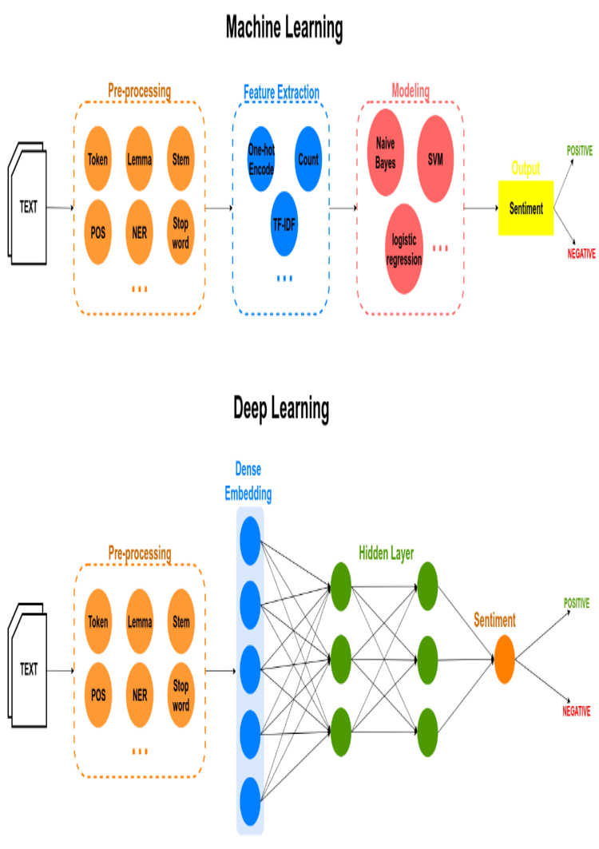

## 3.2. Dataset Specifications

For this work, I have used the Twitter Sentiment Dataset provided by HUSSEIN, SHERIF (2021). Dataset in Kaggle. The dataset contains three columns index, text and category of the text.

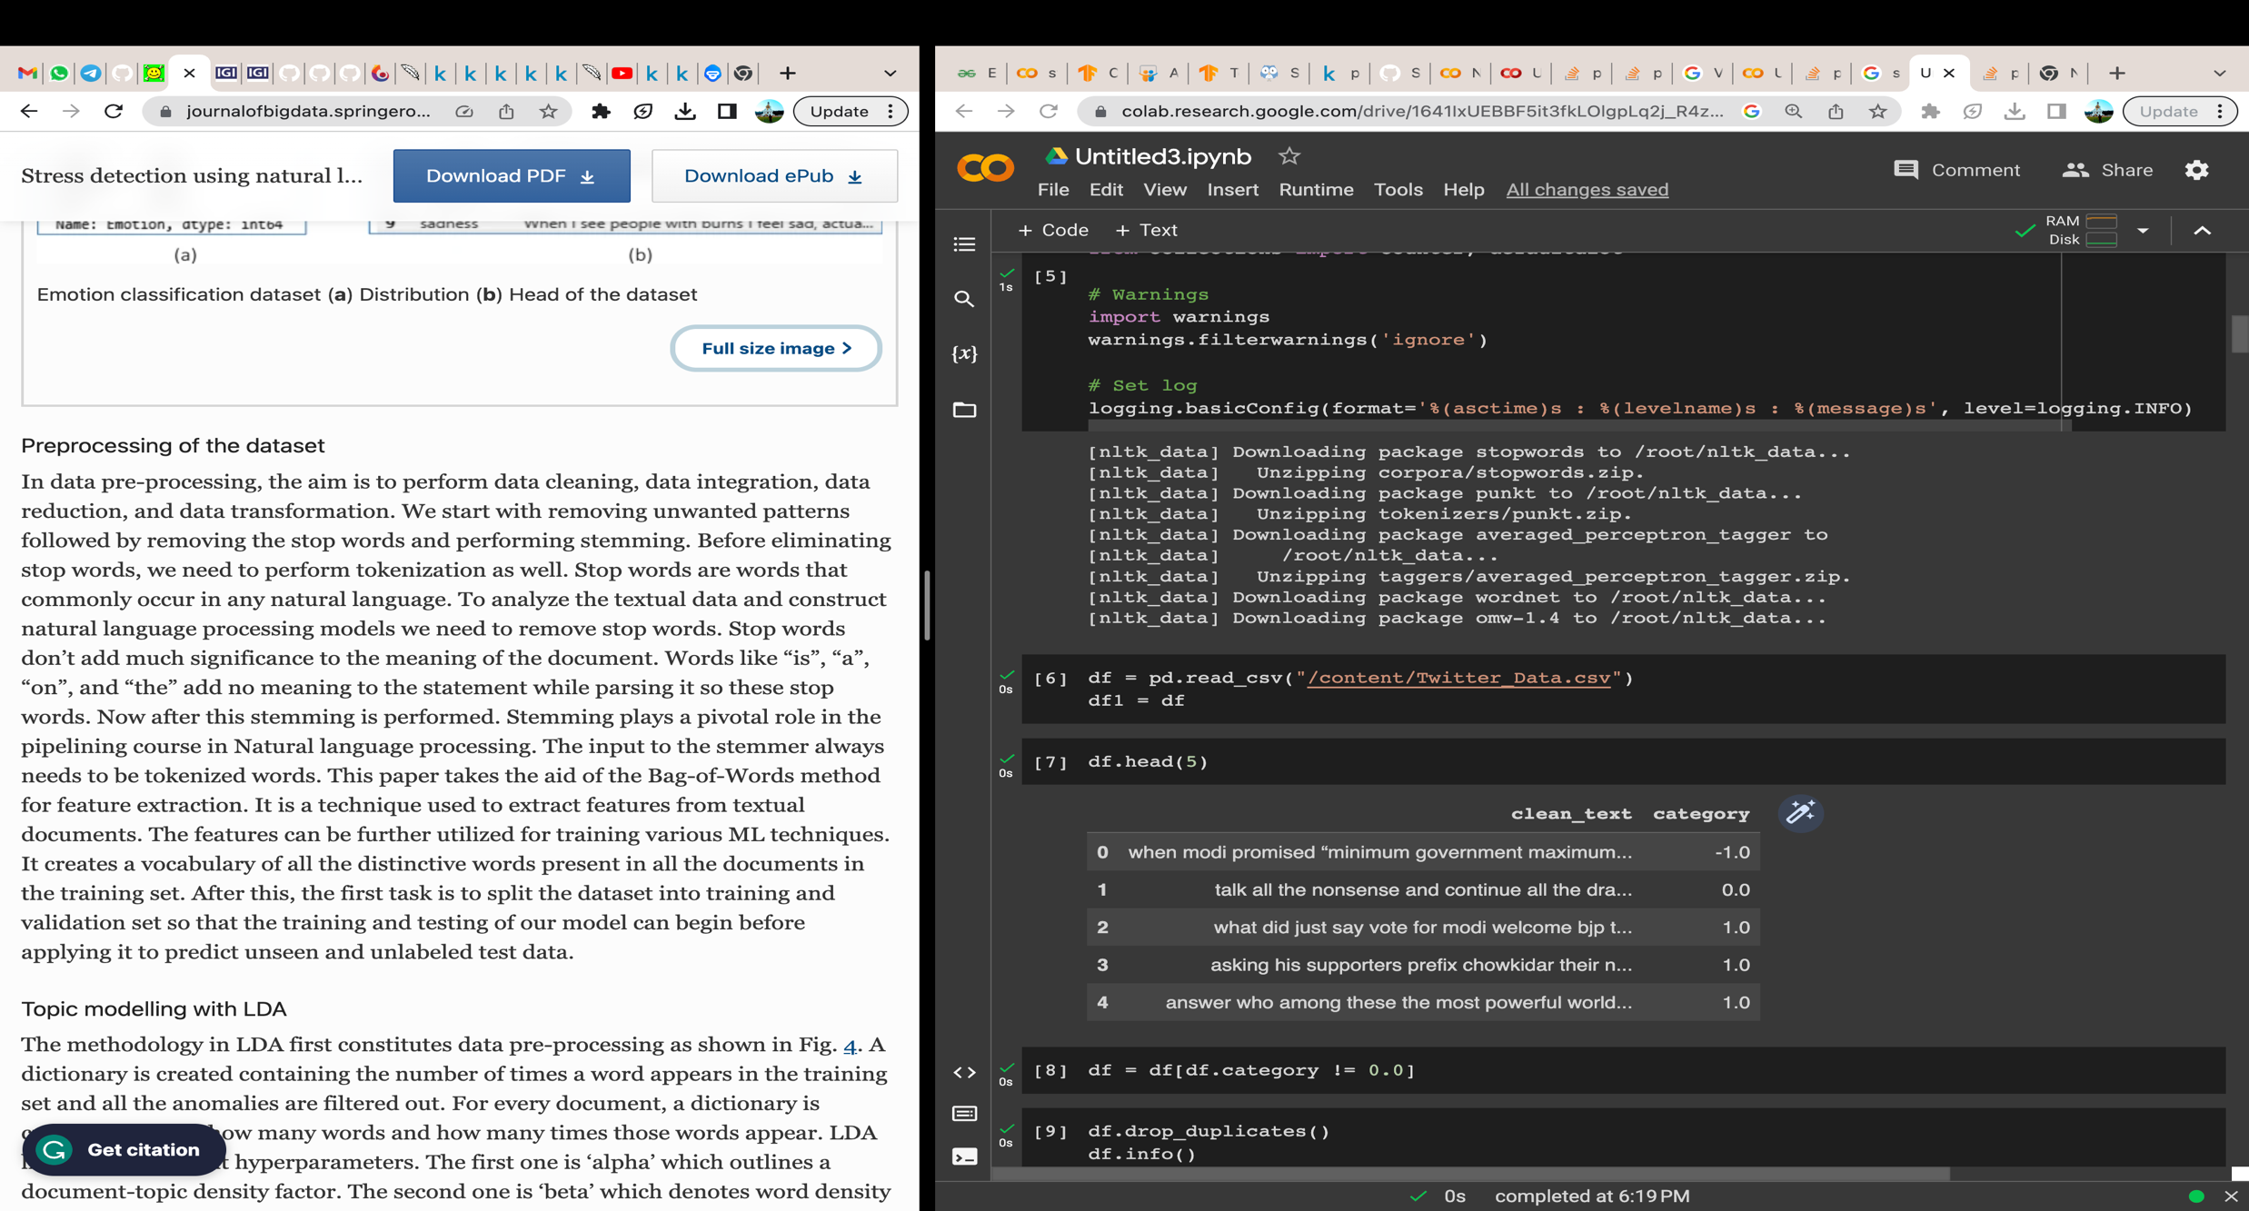.

|  |  |
| --- | --- |
| **Sentiment** | **Label** |
| **Negative** | **-1** |
| **Neutral** | **0** |
| **Positive** | **1** |

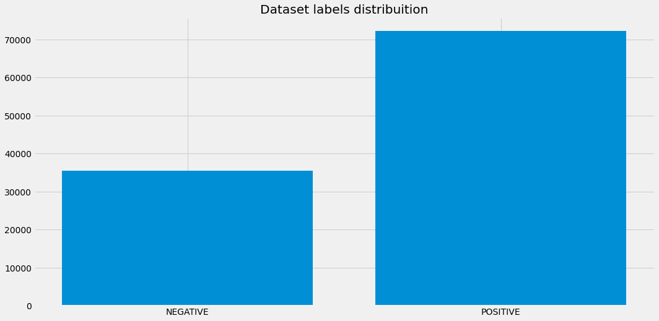

In this the dataset is split into train and test set.

Due to limiting computational power I have trained my model on a comparatively smaller dataset. After 8 epochs the accuracy was found to be 84.75% and loss was 35.89%.

**4.IMPLEMENTATION OF PROPOSED LSTM MODEL**

**Data Pre-processing**

Any machine learning project, even those based on natural language processing, must start with data preprocessing (NLP). It entails preparing raw data for analysis by a machine learning model by cleaning and converting it. Following are some typical methods for NLP data preprocessing:

Text Cleaning: Cleaning the raw text data is the initial step in data preprocessing. This can entail changing all text to lowercase, eliminating stop words, removing extraneous letters, punctuation, or digits (common words such as "the," "and," and "a" that do not provide much meaning to the text).

Tokenization: Tokenization is the division of a text file into smaller pieces known as tokens. Often, these "tokens" are words or phrases that can be entered into a machine learning model. Word-level, character-level, and subword-level tokenization are only a few of the tokenization approaches available.

Pad Sequencing: Text data with varying durations is frequently used in natural language processing. Yet, the majority of machine learning algorithms demand inputs that are a set length. Sequence padding is one technique to deal with this.

Sequences can be "padded" to make them all the same length by appending zeros (or other values) to the end.

Lemmatization and stemming: are two methods for getting words back to their original form. Stemming is the process of stripping words of their suffixes to reveal their stem form (e.g., "walking" becomes "walk"). Similar techniques like lemmatization utilise morphological and vocabulary analysis to strip words back to their dictionary or root forms (e.g., "better" becomes "good").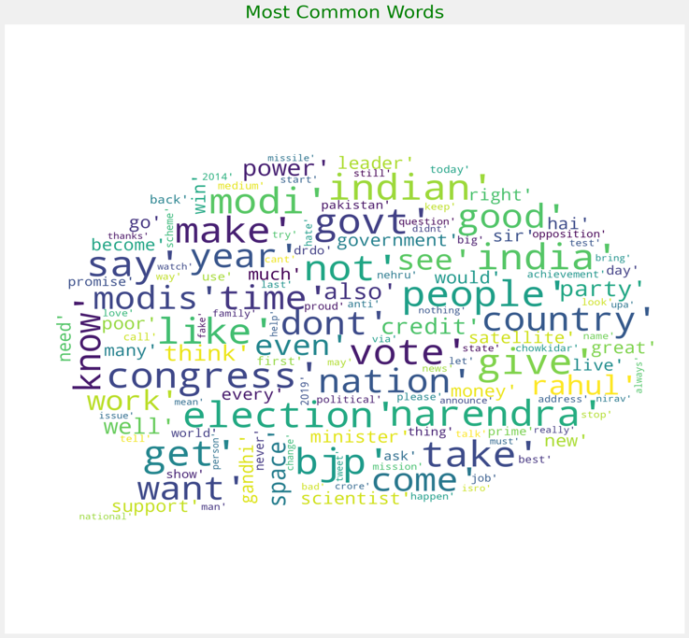

Vectorization: Text data must be translated to numerical data before being fed to a model since machine learning models often operate on numerical data. A text document is vectorized by giving each token a numerical representation. Bag-of-words, n-grams, and word embeddings are typical vectorization methods.

**Data Splitting**

The data are normally separated into training and test sets after pre-processing. The test set is used to assess the machine learning model's performance after it has been trained using the training set.

**Training**

Using the retrieved features and accompanying stress level labels to train a Sequential Model using LSTM.

## 5. Experimental Results

Below are the outcomes of our suggested model. The effectiveness of our model is tested using the following statistical metrics.

**Precision:** Precision tells us what percentage of affirmative identifications were actually accurate.

### Precision = TP / (TP+FP)

**Recall:** Recall gives us information on how many real positives were successfully detected.

### Recall= TP / (TP+FN)

**F1-Score:** The F1 score can be thought of as a weighted average of precision and recall, with the highest value being 1 and the worst being 0. The F1 score combines precision and memory relative to a certain positive class.

### F1= 2 * [ (Precision * Recall) / (Precision + Recall)]

**Accuracy:** One statistic for assessing classification models is accuracy. The percentage of predictions that our model correctly predicted is known as accuracy. In percentage:

### Accuracy = 100 * [(TP+TN) / (TP+TN+FP+FN)]

Here, TP, TN, FP, and FN stand for True Positive, False Positive, and True Negative, respectively.

|  |  |  |
| --- | --- | --- |
|  | Actual Negative (0) | Actual Positive (1) |
| Predicted Positive  (1) | True Negative (TN) | True Positive (TP) |
| Predicted Negative (0) | False Positive (FP) | False Negative (FN) |

**Table 3: Confusion Matrix**

# 6.Application Areas

The following are some possible uses for an stress level detection system:

Education: To track student stress levels in educational environments, stress level detection utilising NLP can be employed. This enables educators to recognise kids who could be experiencing stress-related problems and offer them the necessary support.

Mental health: To track patient stress levels in mental health settings, stress level detection utilising NLP might be employed. By identifying patients who may be at risk of developing mental health disorders, mental health providers can better support those people.

Workplace: To track employee stress levels, stress level detection utilising NLP can be utilised there. Employers can use this to recognise workers who could be under a lot of stress and offer them the right kind of support.

Research: To examine the connections between stress and various variables, such as age, gender, and socioeconomic position, stress level detection utilising NLP may be employed in research settings. This can aid in the better understanding of the causes and effects of stress by researchers.

Sports: To track the stress levels of athletes, stress level detection utilising NLP can be employed in sporting environments. This enables coaches to spot athletes who could be under a lot of stress and offer them the right kind of support.

Social media: NLP-based stress level detection can be used to track user stress levels on social media sites. Social media businesses can utilise this information to identify users who may be at risk of developing mental health disorders and offer them the necessary support.

## 7. Conclusion

With the aid of LSTM models and NLP approaches, our research effort sought to identify student stress levels. Our findings indicate that this strategy can be a useful tool for fostering mental health and wellbeing in learning environments. Our methodology has the potential to detect students who may be at risk of experiencing stress-related mental health disorders and offer them the proper support, with an accuracy rate of 84.75%.

Our study has significant ramifications for elevating students' mental health and wellbeing. We have developed a method to identify students' stress levels using NLP and machine learning approaches, which may be used to identify those kids who require early intervention and individualised support. This may have a substantial effect on pupils' academic achievement and mental health.

In general, our study effort offers a significant contribution to the NLP and mental health fields. Our research should help to improve students' lives by promoting mental health and well-being in learning environments.

# References

[1]. Liang Y, Zheng X, Zeng DD. A survey on big data-driven digital phenotyping of mental health. Inform Fusion. 2019;52(1):290–307.

[2]. Liu B, Zhang L. A survey of opinion mining and sentiment analysis. Boston: Springer US. 2012; p. 415–463.

[3]. Munikar M, Shakya S, Shrestha A. Fine-grained sentiment classification using BERT. Artif Intell Transform Business Society. 2019;2019:1–5.

[4]. Wang B, Liu Y, Liu Z, Li M, Qi M. Topic selection in latent Dirichlet allocation, 2014 11th International Conference on Fuzzy Systems and Knowledge Discovery (FSKD). 2014. p. 756–760.

[5]. Alexander P, Patrick P. Twitter as a corpus for sentiment analysis and opinion mining. Proceedings of LREC. 2010.

[6]. Jianqiang Z, Xiaolin G. Comparison research on text pre-processing methods on Twitter sentiment analysis. IEEE Access. 2017;5:2870–9.

[7]. Pradha S, Halgamuge MN, Vinh NQT. Effective text data preprocessing technique for sentiment analysis in social media data, 2019 11th International Conference on Knowledge and Systems Engineering (KSE). 2019. p. 1–8.

[8]. Deepa DR, Tamilarasi A. Sentiment analysis using feature extraction and dictionary-based approaches, 2019 Third International conference on I-SMAC (IoT in Social, Mobile, Analytics, and Cloud) (I-SMAC). 2019. p. 786–790.

[9]. Chaturvedi S, Mishra V, Mishra N. Sentiment analysis using machine learning for business intelligence, 2017 IEEE International Conference on power, control, signals, and instrumentation engineering (ICPCSI). 2017. p. 2162–2166.

[10]. Ho J, Ondusko D, Roy B, Hsu DF. Sentiment analysis on tweets using machine learning and combinatorial fusion, 2019 IEEE Intl Conf on Dependable, Autonomic and Secure Computing, Intl Conf on Pervasive Intelligence and Computing, Intl Conf on Cloud and Big Data Computing, Intl Conf on Cyber Science and Technology Congress (DASC/PiCom/CBDCom/CyberSciTech). 2019. p. 1066–1071.

[11]. Peters ME, Neumann M. Deep contextualized word representations. 2018.

[12]. Radford A, Narasimhan K. Improving language understanding by generative pre-training. 2018.

[13]. Devlin J, Chang M, Lee K, Toutanova K. BERT: pre-training of deep bidirectional transformers for language understanding, in Proceedings of the 2019 Conference of the North American Chapter of the Association for Computational Linguistics: Human Language Technologies, NAACL-HLT 2019, vol 1. Minneapolis; 2019. p. 4171–4186.

[14]. Arya V, Mishra AK. Machine learning approaches to mental stress detection: a review. Ann Optimization Theory Pract. 2021;31(4):55–67.

[15]. Aldarwish MM, Ahmad HF. Predicting Depression Levels Using Social Media Posts, 2017 IEEE 13th International Symposium on Autonomous Decentralized System (ISADS), Bangkok. 2017.

[16]. Jin Z, Lai X, Cao J. Multi-label sentiment analysis base on BERT with modified TF-IDF, 2020 IEEE International Symposium on Product Compliance Engineering-Asia (ISPCE-CN), 2020.