Major activities in service our major goals for the past funding year:

The primary goal for this funding year was to maintain our recruitment goals and implement our intervention with harmonized protocols for both intervention sites, including the University of Iowa and Northeastern University. For instance our major goals last year were to (1) Maintain our Manual of Procedures (MOP) following single IRB approval for both sites, (2) Pre-register study protocol in a peer-reviewed protocols journal, (3) Complete a site visit at Northeastern, (4) Continue enrollment at target levels and working effectively with our DSMC and Safety Officer, (5) Complete a robust and automated processing pipeline for actigraph accelerometer and Polar HR data, and (6) Finalize our data analytic plan for survey, cognitive, and actigraph data.

All goals except submission of our protocol and finalizing our data analytic plans in a peer-reviewed protocol journal have been completed. This decision was to prioritize time towards maintaining recruitment and retention goals. Across sites, we are now at 41% of our enrollment goal. We are still in a strong position to submit our planned protocol paper and complete pre-registration and peer-review of our data analytic plan before completion of enrollment. This timeline ensures our protocol paper is published before the first papers from our intervention are published. Below are our major activities completed, demonstrating we are on track to meet our enrollment goals with safe study procedures.

1. Completed two Data and Safety Monitoring Committee meetings with no concerns and approval to continue

Our first meeting was on August 4th, 2025. Following the meeting, the Chair Dr. McAuley sent a letter summarizing our meeting, stating approval for the form of our Open and Closed Reports, and suggested modifications to procedures. The primary modification was for our Safety Officer Dr. James Hopson to be the person evaluating relatedness of adverse events to our intervention. In response we implemented a standard email form for notifying him of adverse events, which he uses to send his written evaluation of relatedness.

Our second meeting was on February 19, 2026. We again reviewed recruitment, retention, and adverse events. From this meeting the main suggestion for protocol improvement was to ensure we are checking with participants weekly throughout the intervention about any changes in health that affect their ability to participate in the study. Any changes in health reported will be documented as adverse events. Weekly check-in’s were occurring for our exercise intervention, but not in regard to health for the cognitive training intervention. We are currently in the process of implementing this modification. We have had no adverse events related to the intervention, and participants have safely recovered from unrelated adverse events. Both the committee and our Safety Officer approved the continuation of our trial. Our next meeting will be in June/July 2026.

2. Maintained enrollment for our intervention study (R33) at Iowa and Northeastern sites
Recruitment has been steadily on track throughout this funding period at the Iowa site and is steadily increasing at the Northeastern site (Figure 1). The discrepancy in site enrollments was in part due to administrative delays in receiving this year’s funds that could be approved for spending through the sub-award. This delayed Northeastern from having funds to pay for advertisement placement in their community. Once we moved past this barrier, advertisements on public transportation apps for trains and buses has been effective in increasing enrollments.

Our goal for the coming year is for Iowa to stay on track or boost enrollments beyond initial projections if possible, and for Northeastern to increase their rate to 4 to 5 per month on a consistent basis. At Iowa we will accomplish this by moving efforts from the recently completed observational/cross-sectional study to fully dedicate all personnel time to the intervention study, while also increasing community engagement to rural areas. At Northeastern we will accomplish this through ensuring their staffing stays equipped to maintain capacity for higher enrollments, through continual communication in our bi-weekly full team meetings.
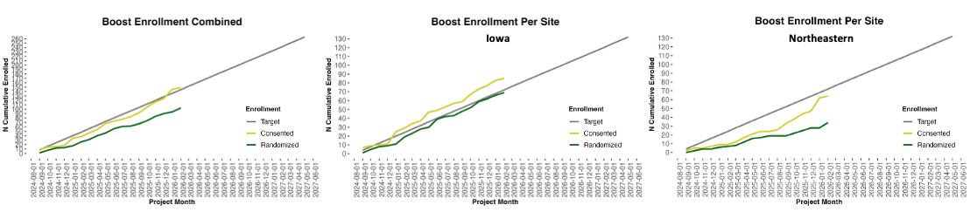
Figure 1. Trial enrollment through Feb 2026

Intervention adherence is excellent, demonstrating that our intervention is feasible, enjoyable, and safe. As of Feb 2026, we have had n=103 participants randomized to one of three cognitive training groups and 67 participants have complete cognitive training. A total of n=19 (18%) have dropped out during cognitive training, though of those that have completed all have finished the required training to move on to exercise training. Though drop-out is somewhat higher than expected, we are maintaining a strong level of continued participation in procedures for intent-to-treat analysis, and our DSMC approved additional recruitment to continue to enroll enough participants to reach our proposed number of completers.

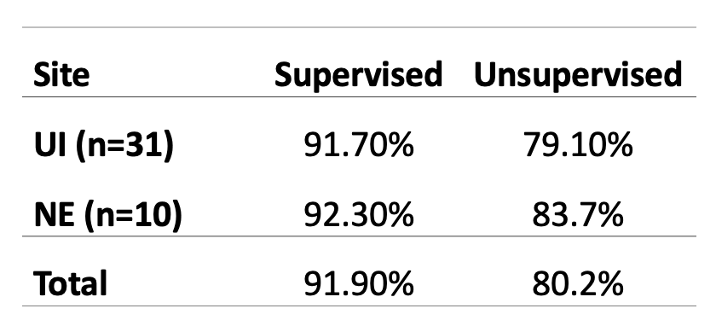
For exercise training, 48 participants have completed both the supervised (6-week) and unsupervised (6-week) training. Of the participants entering exercise training, our drop-out rate is low at 8%. Table 2 shows adherence broken down by site and for all participants, which is excellent. As expected adherence dips during the unsupervised phase of training, which supports our primary goal of testing whether and to what extent different types of cognitive training affect adherence during the unsupervised exercise training phase. Overall, these data continue to show our cognitive and exercise training interventions are both feasible and safe at both study sites.
Table 1. Adherence during exercise training.

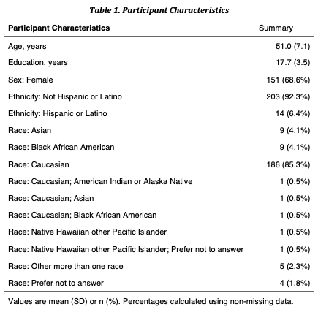
Table 2. Demographics for completed Observational study, n=220
3. Completed enrollment for our observational study (R61).

The R61 phase of our study included initial validation studies for our newly developed cognitive task battery and cognitive training portal. We initially proposed to collect an observational study sample using fully online task deployment, and were later cautioned against this as the data quality and breadth of demographic representation for online study participation was seen to decline during our first funding year. We therefore developed an alternative
approach for a broad and representative sample with performance on the same cognitive task battery that participants in our intervention study complete, which involved developing satellite research sites off campus from the University of Iowa. This past year we completed our target sample of N=220, with demographics as shown in Table 1. This sample provides a basis for establishing and finalizing our data analysis workflows for cognitive, survey, and health behavior data.

4. Developed robust and automated processing pipeline for actigraph accelerometer and Polar HR data.

A major goal for this reporting period was to develop our pipelines for organization, preprocessing, and analysis of our actigraph and Polar heart rate (HR) data. We utilize wrist-worn actigraphs to measure physical activity at four points throughout the study including baseline, post cognitive training, post exercise training, and 6 weeks following conclusion of exercise training. We utilize Polar HR monitors to program personalized heart rate zones for structured exercise sessions throughout exercise training. A research assistant in Computer Science, Zachary Gilliam, has led this software development. Below we show visualizations at the group-level for our observational (Figure X) and intervention (Figure X) studies, with only the baseline session represented for our intervention. Because these studies are still in progress, we report only descriptive visualizations to demonstrate data quality and feasibility for these workflows.

[Actigraph: can we make a group-level figure that mimics what we have in our individualized reports? We could put an example report in as an appendix]

[Polar HR: what does Zak currently have for this and what is useful to show?]

Approaches to ensure robust and unbiased results

Methods for computerized transfer task paradigms deployed through a web browser for standardized multi-site assessments. We continue to maintain all cognitive tasks on a server that deploys tasks through a browser with tight timing-control using the open-source JATOS software (Figure X). The JATOS software runs tasks from a server housed at our central study site (Iowa, UI). Once a task is completed, subject data is immediately transferred to the JATOS results database. Raw participant data and task meta-data are uploaded and stored on the UI server, enabling immediate access for preprocessing and quality control. An added benefit of this approach is the portability of the entire transfer task battery to the home-setting, in the case this is needed for our study or for scaling our study to a larger state-wide or national or international scale in the future.
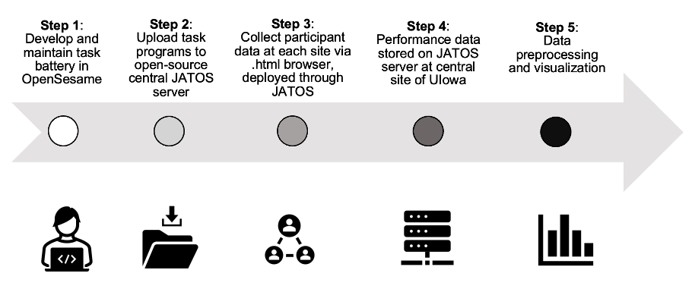

Figure X.
Data workflow for cognitive performance data. This funding year we developed software for Step 5 that completes quality assurance checks and visualization at individual and group level.
Centralized data management and administration with shared RedCap database. The University of Iowa site maintains a central RedCap Project database, and have a fully functional multi-site data management workflow for overseeing incoming electronic and phone screen data, electronic consent, randomization, enrollment, training progress, and survey data into a shared RedCap Project. We utilize data access groups to release randomization within RedCap and maintain blinding for blinded research staff. We have a fully functional system across sites for participants to both use their Polar HR monitor for exercise sessions, and send a weekly exercise log integrated into RedCap that includes ratings of perceived exertion, affect, and arousal for their exercise sessions.

Harmonized exercise testing, training, and physical activity assessment procedures.
In addition to our RedCap database, we have verified our harmonization for exercise testing and training. Our sub-maximal exercise test procedures and data are entered during the session on RedCap, allowing for full transparency of the ramp protocol and stopping criteria. In addition, the exercise logs for each week of training, are fully harmonized and completed in paper-form for participants and sent weekly to Exercise Specialists for entry into RedCap. The UI site Exercise Specialist sees entries in real-time, enabling harmonization through communication of procedures for monitoring and coaching participants. Finally, a central source of data for our trial is wrist-worn actigraph data to measure free-living physical activity. Both sites have collected data, which has been processed centrally by our data processing team at UI.

Specific objectives, results, and key outcomes

Because we are still in the early phases of enrollment, we do not have results from the study yet.

