**README**

**HBGDki-India Data Science Workshop**

**March 23rd, 2017**

This USB drive contains companion material for the HBGDki-India Data Science Workshop. During the training, we will provide these materials hosted in the cloud, including instances of the R statistical programming environment, such that attendees only need a web browser to be able to fully participate in the training. However, to allow attendees to further investigate the training material on their own time and on their own computers, we are making these materials available on this USB drive.

For any additional information about the material for this training, please visit <http://github.com/HBGDki/gc-india-training>. You can also file issues at this website if you have any additional questions after the training.

The drive contains the following:

* Data, code, and documentation for the training exercises, located in “**material/training**”
* A Windows-only portable installation of R and all associated packages located in “**windows**” (see “Using Portable R” below for instructions on how to start this environment up)
* Shiny applications “ggplotyourdata” and “FREM-explorer”, located in “**material/shinyapps**”
* An introduction to the Super Learner growth curve imputation method, located in “**material/superlearner**”

## **Using Portable R**

This USB drive contains a portable R installation for Windows machines. This is useful if you are not able to use the cloud resources we have provided during the training, and is also useful for having a self-contained environment for further exploration after the training.

To launch Portable R, navigate to the “windows” directory of the USB drive and open the “RStudioPortable” executable.

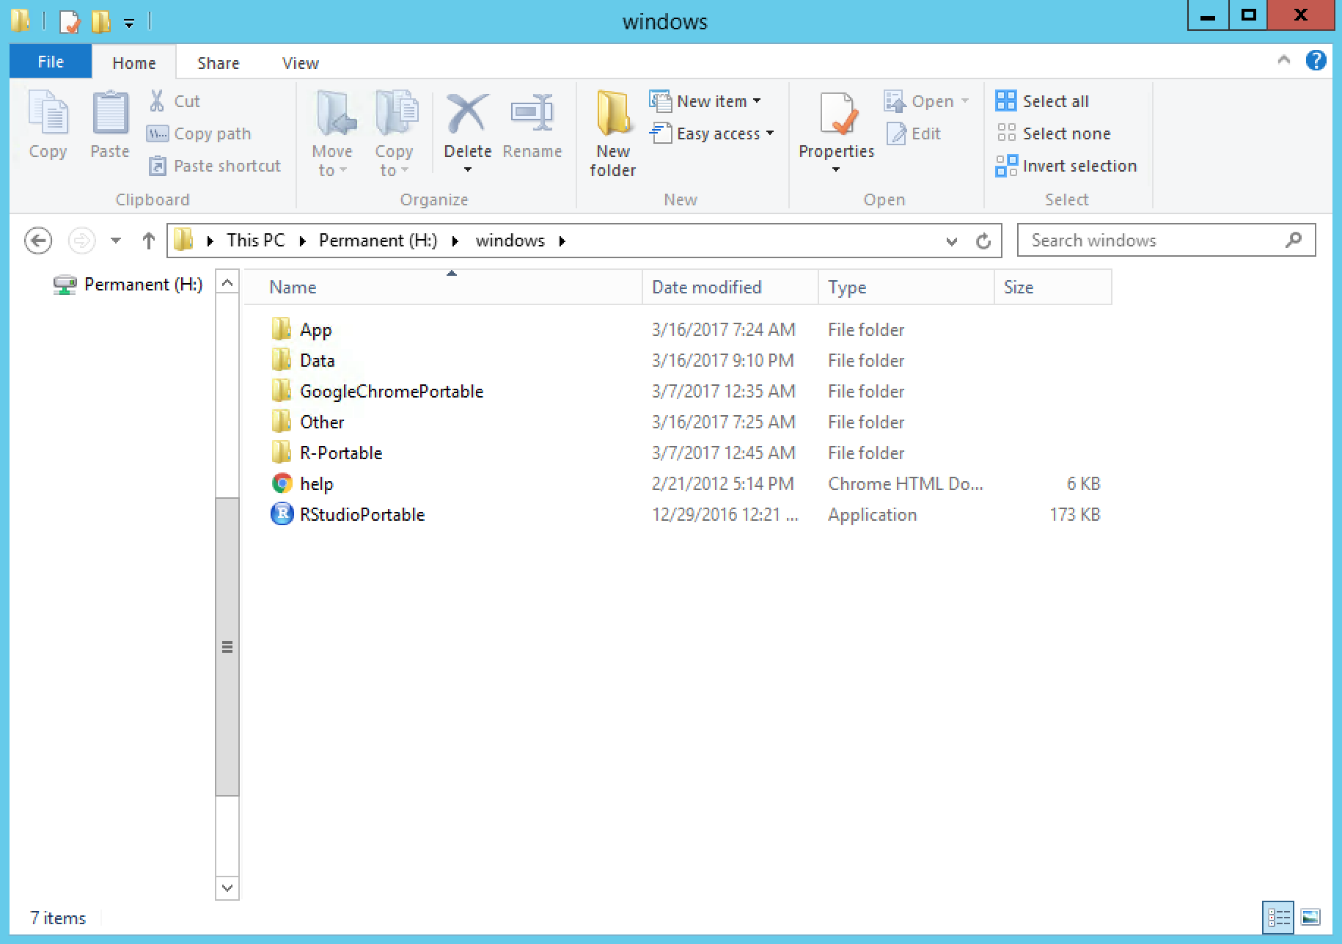

Once you open RStudioPortable, it should prompt you for the location of R. If you do not receive this prompt, open the “Tools” menu and navigate to “Tools -> Global Options…”

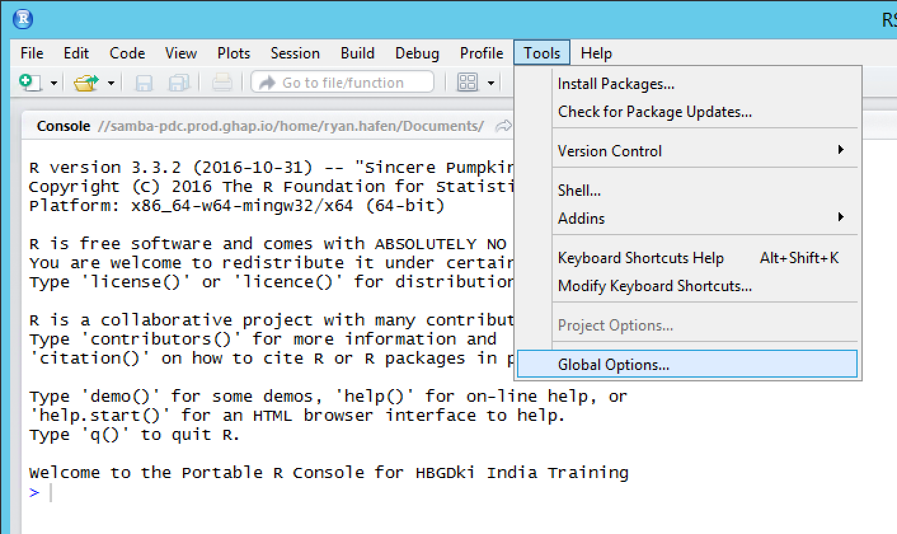

Then for the “R version:” entry, click “Change…”

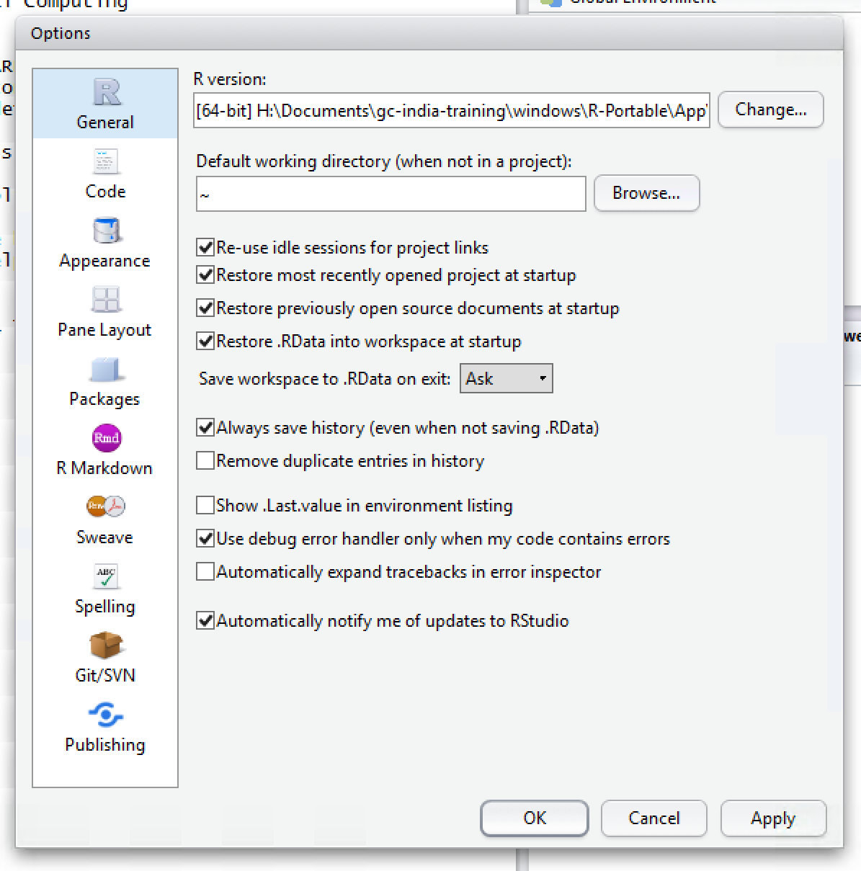

This will bring up a window for you to navigate to the R installation directory. Assuming your USB drive is H:\, navigate to H:\windows\R-Portable\App\R-Portable\bin and then click “Select Folder”.

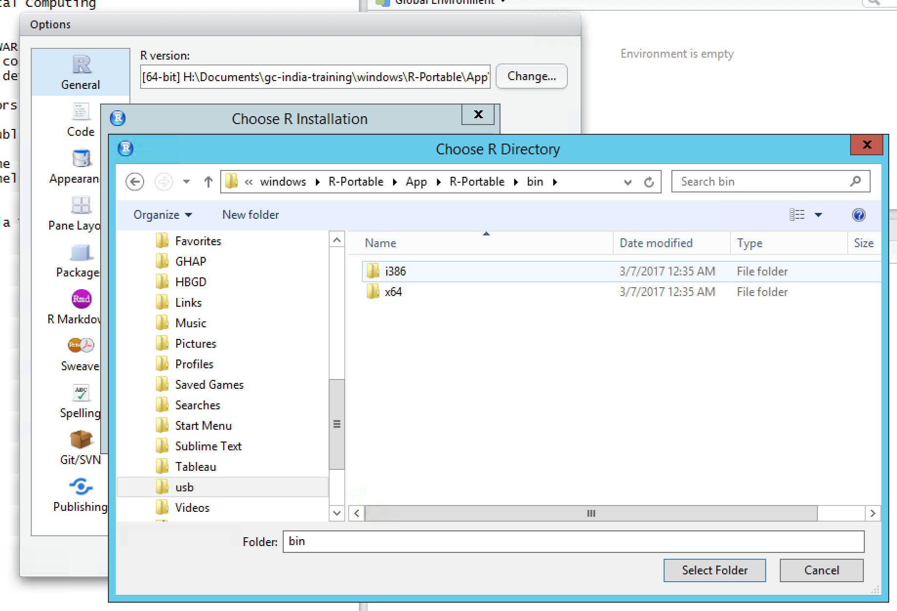

It will then ask you to choose 32-bit or 64-bit R. Make the selection appropriate for your computer and click “OK”.

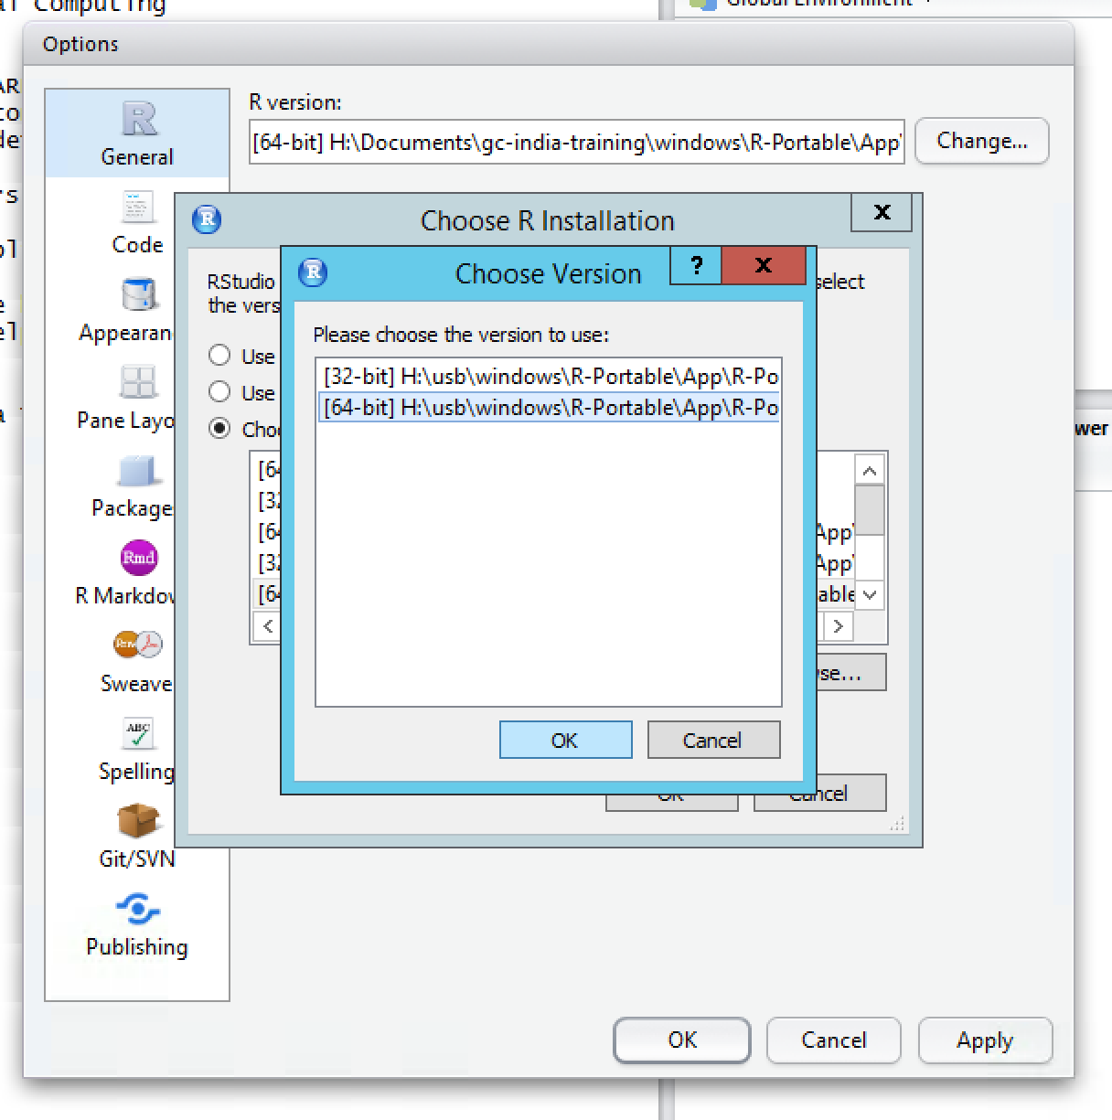

You will now be prompted to restart RStudio. The next time you enter RStudio, you should see a message in your R startup that says “Welcome to the Portable R Console for HBGDki India Training”.