1. first do git clone

2. cd <repo_name>

3. git status % this will whether you are updated or not

4. git pull % do git pull if the status show not fully updated

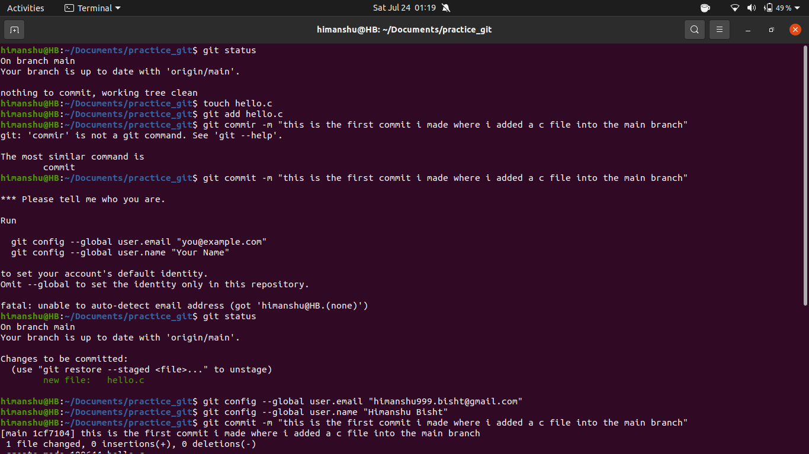

**Task 1**

- create a simple file in your directory by using the command

**touch hello.c**

- after creating the file you need to add that file into commit area(this area will tell which files will be commited in this commit)

**git add <file_name>**

-then you need to push those changes to your remote repo by using

**git push origin <branch_name>**

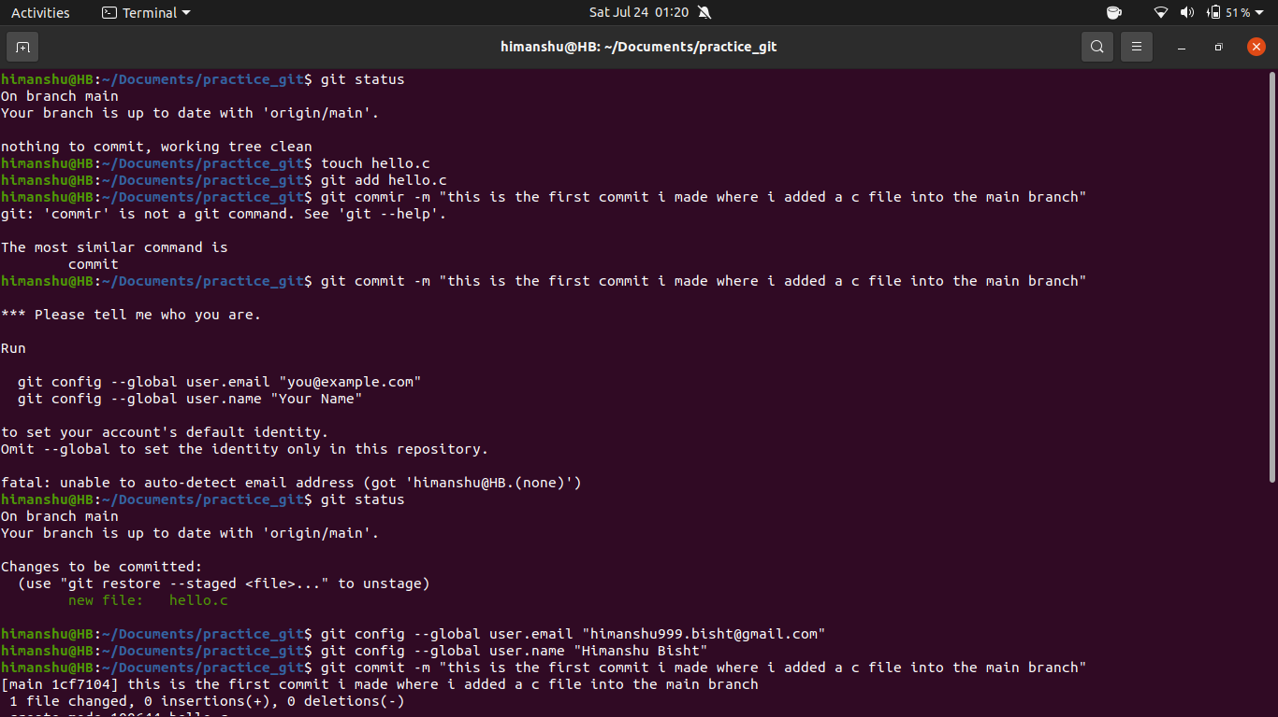

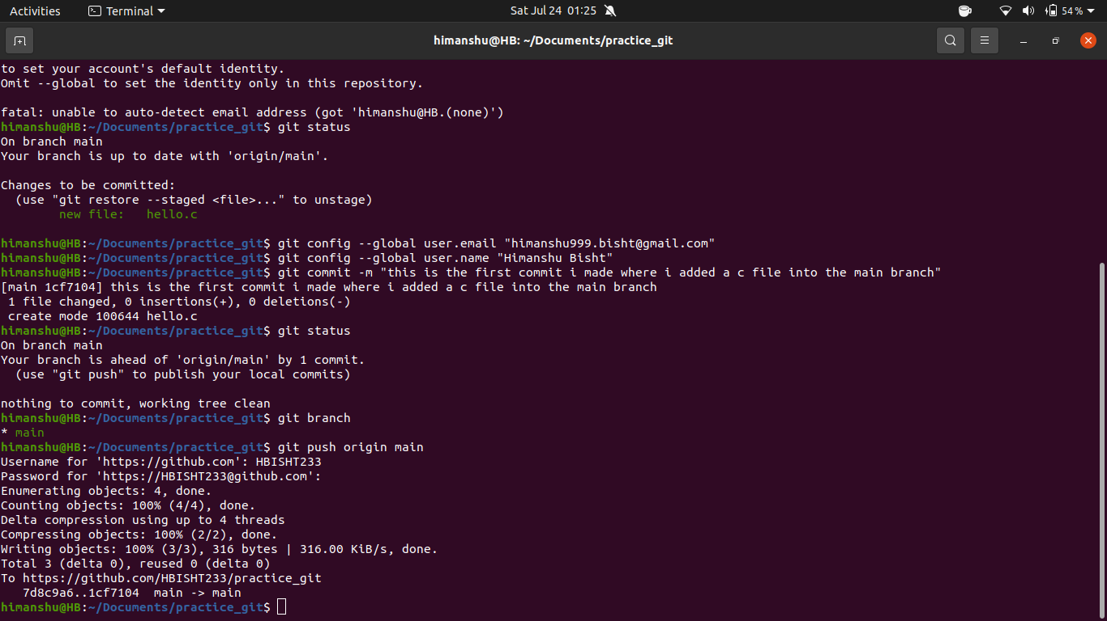

- you can see those changes are now also made in your remote git repo

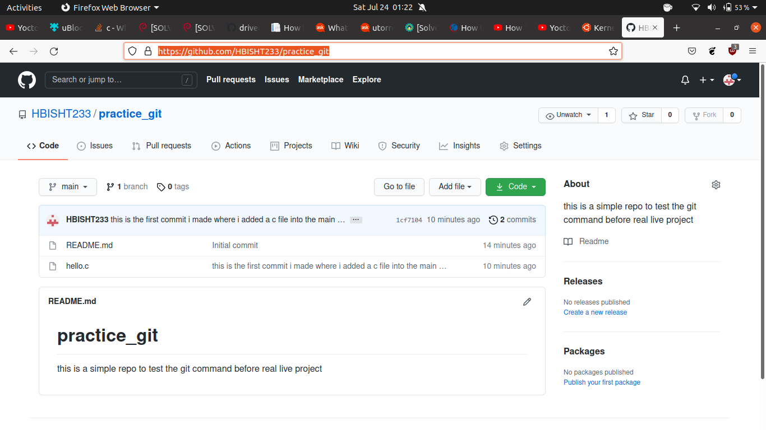

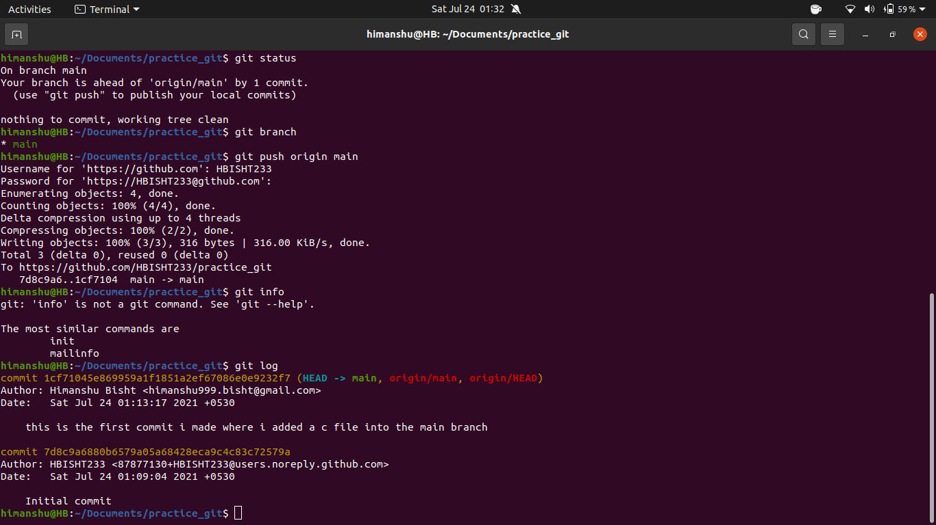

- compiled a kernel module and added that to my repo

