Yocto project

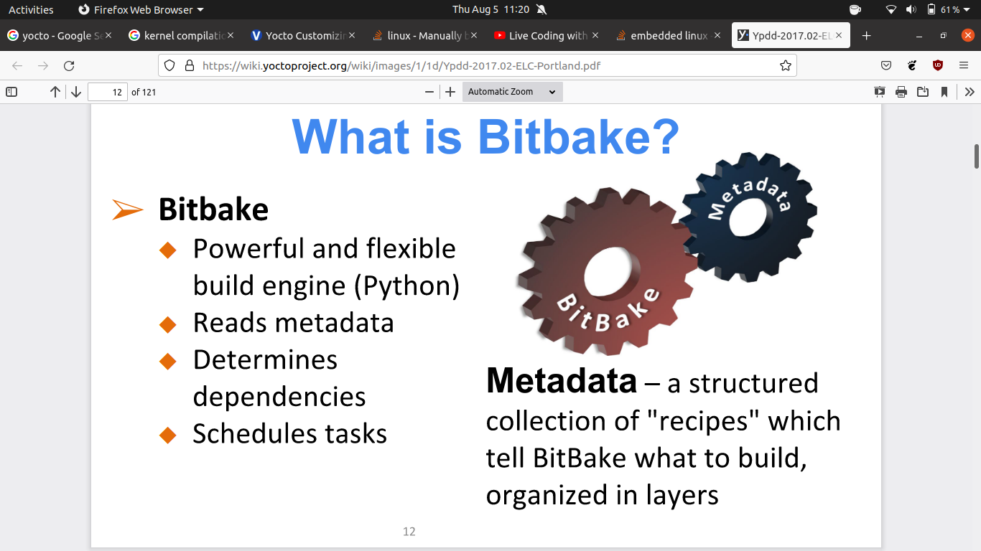

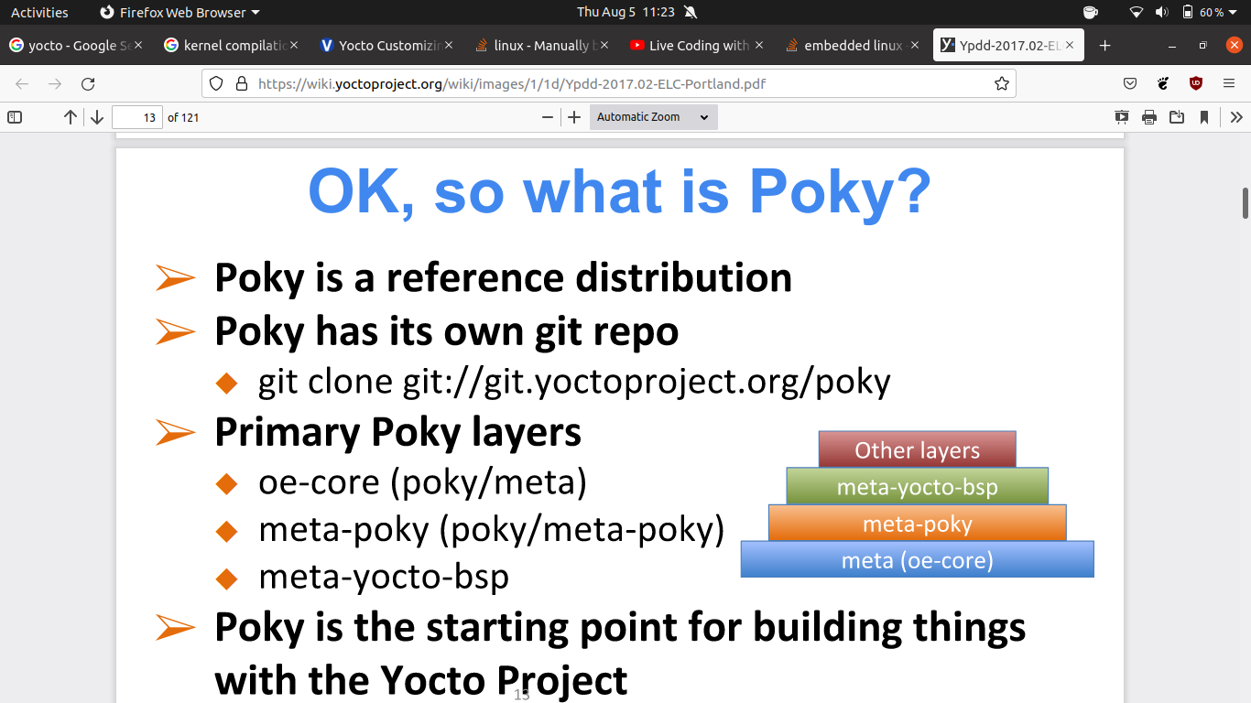

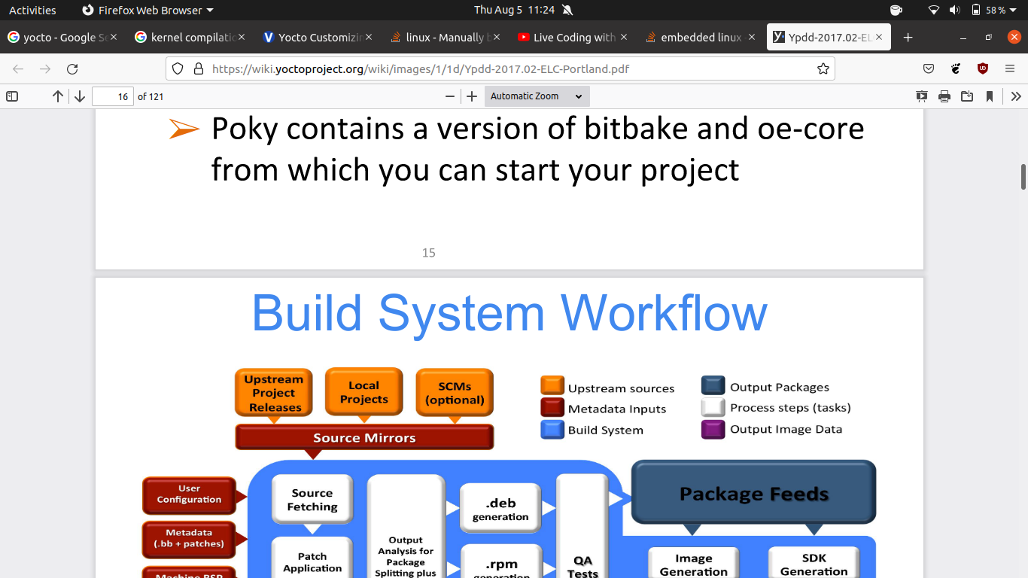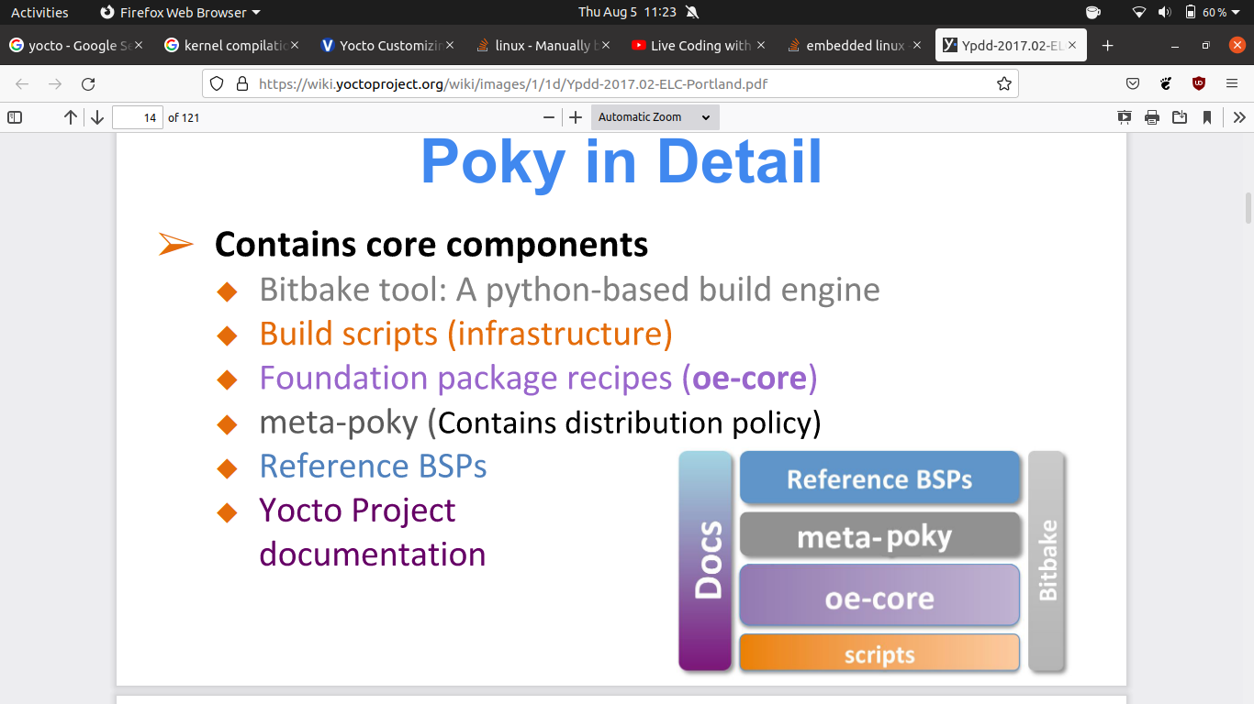

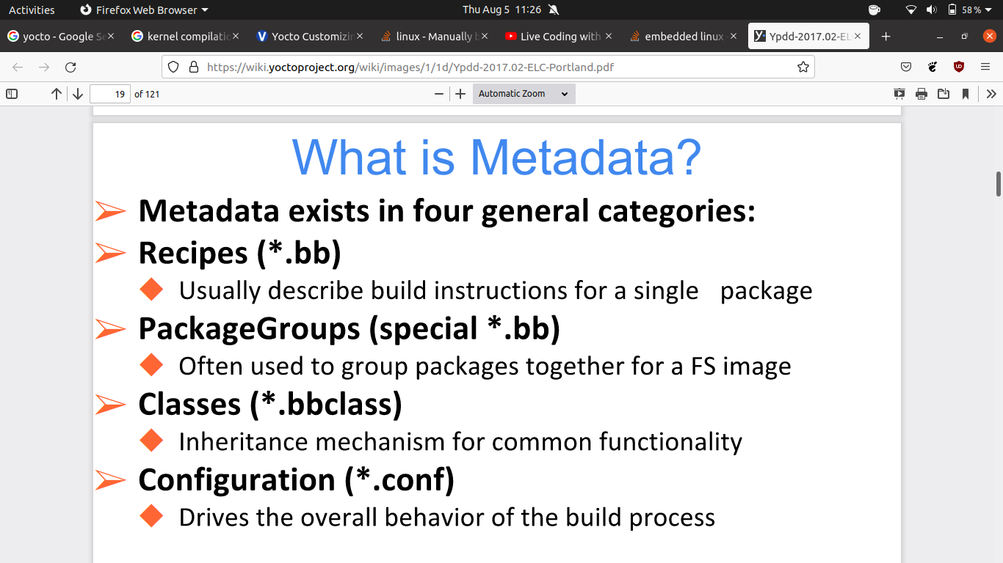

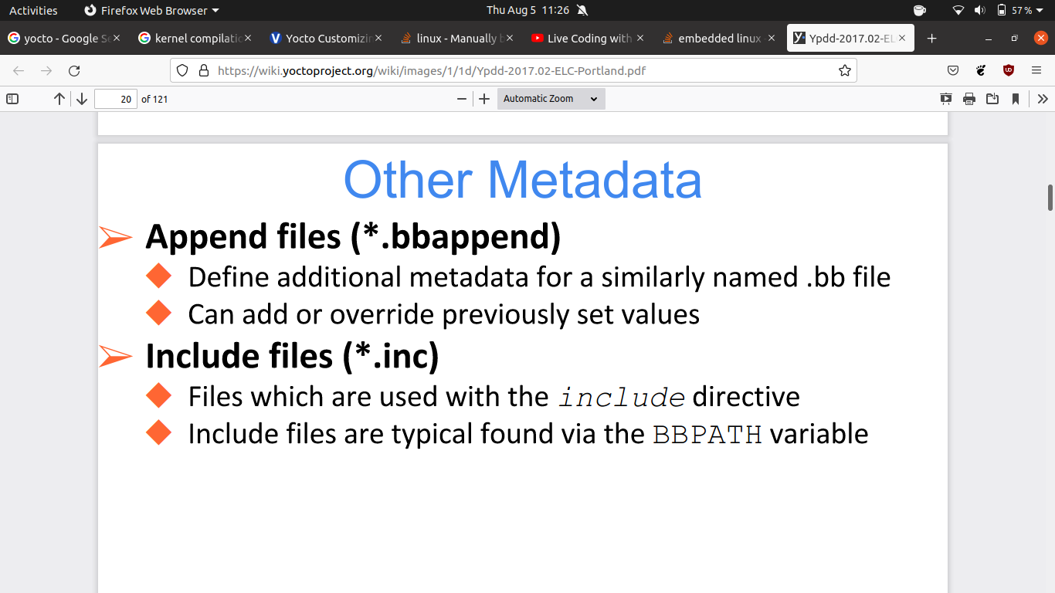

note: in order to start bitbake inside the poky you first need to first locate the source

**- source oe-init-build-env**

pre-requisite installation

- **sudo apt-get install gawk wget git-core diffstat unzip texinfo gcc-multilib \**

**build-essential chrpath socat libsdl1.2-dev xterm**

1. clone the yocto project and use these below commands

**git clone http://git.yoctoproject.org/git/poky**

**cd poky**

**git checkout -b fido origin/fido**

**source oe-init-build-env**

2. By default, the target architecture for the build is qemux86, which produces an image that can be used in the QEMU emulator and is targeted at an Intel® 32-bit based architecture. To change this default, edit the value of the [MACHINE](_top) variable in the configuration file before launching the build.

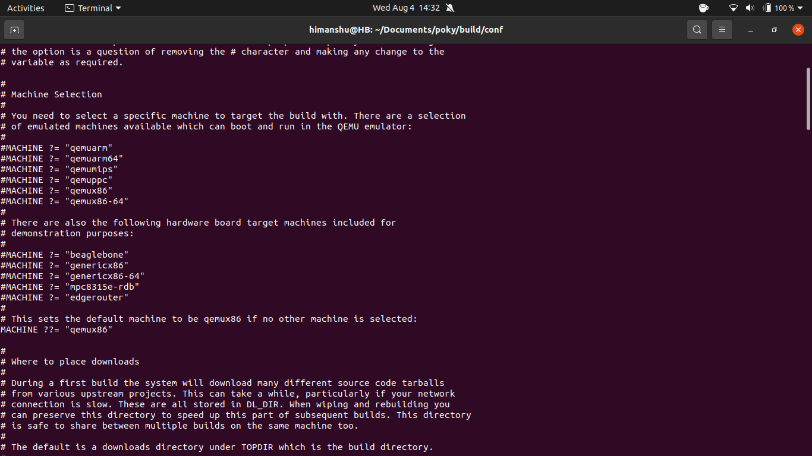

**3. bitbake -k core-image-sato**

**4. you may get some error**

**sudo apt-get build-dep m4**

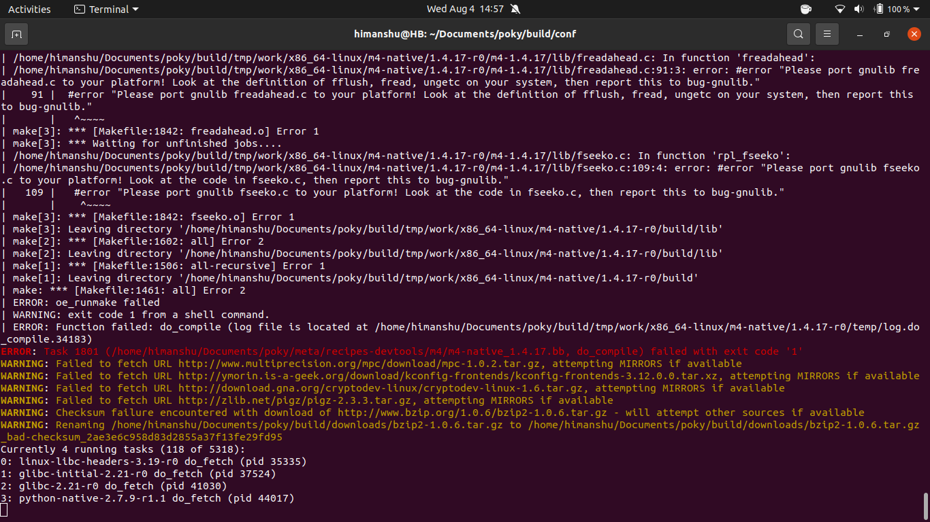

#1 download and first build

- **git clone http://git.yoctoproject.org/git/poky**

**- git checkout yocto-2.6.2**

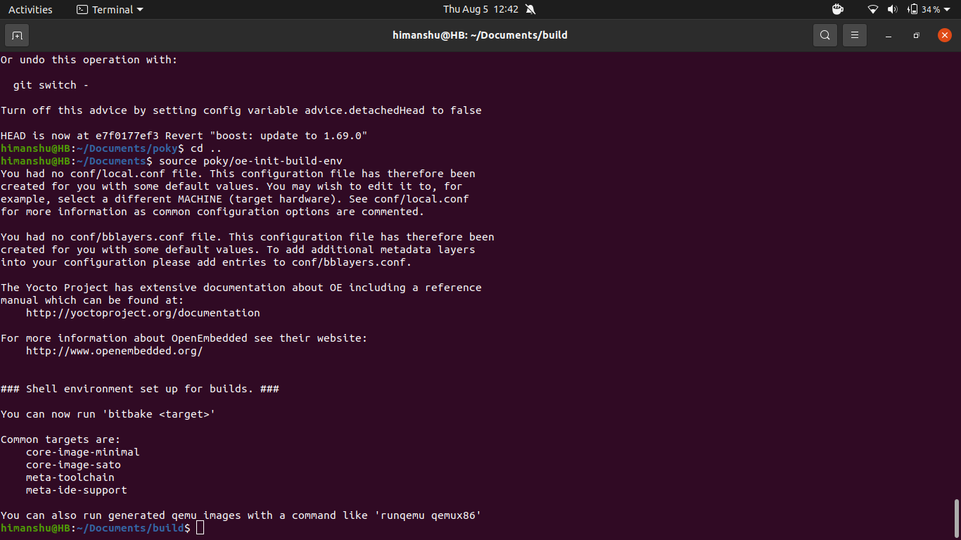

**this will create a local config**

**also there will a new folder build**

**-time bitbake core-image-minimal [use this command to make the image]**

**note: you will get some error so add this line DEPENDS=”libmnl-native” to the qemu_3.0.0.bb file**

