**Tutorial:**

This tutorial covers a simple example of performing transformations over variables in a dataset. All files used in this tutorial can be obtained at the GitHub repository.

**Step 1:**

Creating Var Definition file, created by the user contains 4 columns

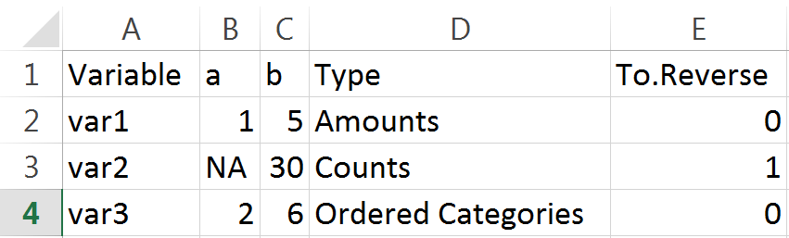

* **Names of the variables should correspond to the column names in the data file**
* **The minimum value that can be obtained by the variable**
* **The maximum value that can be obtained by the variable**
* **The type of the variable, allowed names are: ‘Amounts’, ‘Counts’, ‘Ratio’, ‘Proportion’, ‘Counted Fraction’, ‘Bounded Amounts’, ‘Bounded Counts’, ‘Ranks’, ‘Ordered Categories’, ‘Binary (categories)’, ‘Category’, ‘Difference’.**
* **If to reverse the variable (b – the variable)**

Notice that there are NA’s in the ‘a’ column, the program will estimate ‘a’ to be the minimum of the variable, if ‘b’ are absent then the program will estimate it using the maximum of the variable.

**Step 2:**

Loading the files.

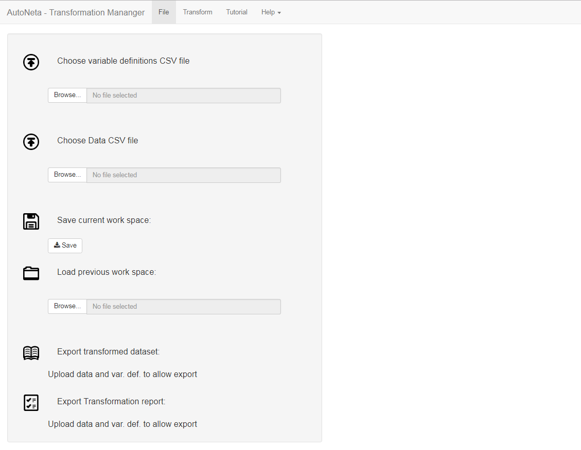

Load data

Load var def

After loaded, change tab to ‘Transform’ tab.

**Step 3:**

Applying the transformations

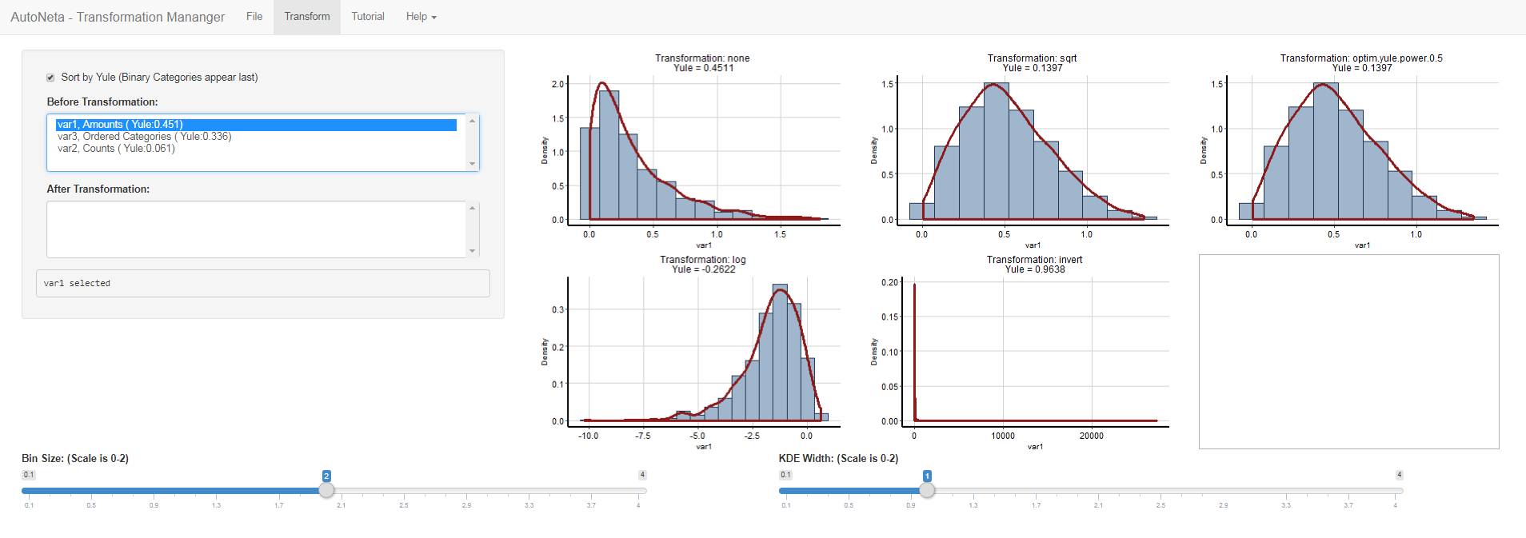

* Variable list before transformation with their Yule index (<https://nl.wikipedia.org/wiki/Yule%27s_Index>)
* Variable list after transformation with their before transformation Yule index and after transformation Yule index.
* The available transformations and plotting of the histogram/density of the variable. Choosing the desired transformation is done by clicking at the corresponding plot, after choosing the transformation a button of apply transformation will appear. Clicking it will result with the variable moving from the Variable list before transformation to the Variable list after transformation.

**Step 4:**

Export the resulting transformed variables and a summary of the transformations.

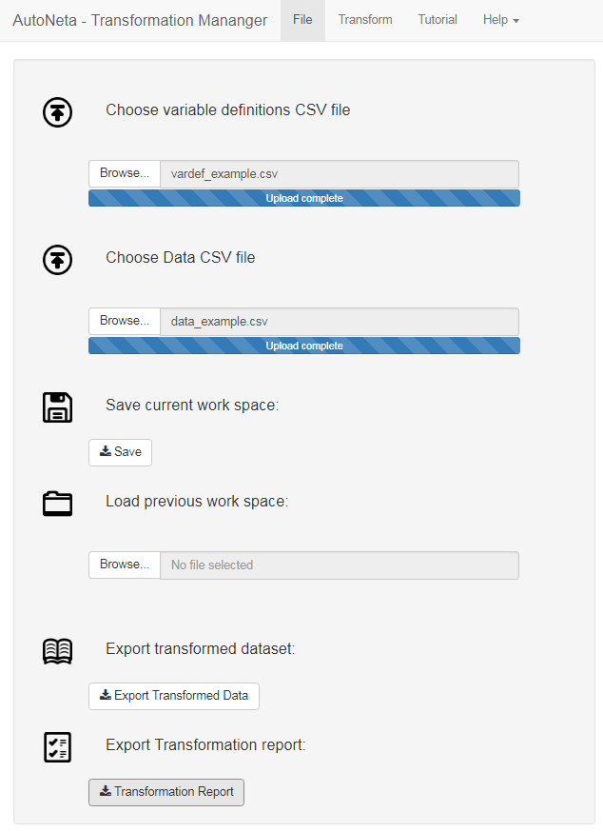

* **Exports the transformed data (same columns names as the inserted file)**
* **Transformation report, tells you the transformation used for each variable and more.**