28.01.2020

**HBP NRP Reporting -- DLR**

Motivation:

Whenever a runner strikes the ground, the muscles and tendons deflect like springs and reuse the stored energy to push the athlete off the ground, thereby saving up to 84 % of the muscular energy consumption. In bionic research, roboticists increasingly replicate the elastic properties underlying the human motor performance. But the control of efficient elastic movements in changing environments is largely unknown in both robotics and neuroscience.

PROJECT 1: Energy efficient motion in robots

In order to make sufficient use of compliant elements in robots, we developed a simple, yet energy efficient controller. The controller is able to drive multiple actuated joints with one control signal, while automatically adapting the weights to the relative forces of each actuator to match the ever-changing mechanical conditions of the robot and its environment. The controller is able to extract the eigenfrequencies of the mechanical system and drives the motion along this frequencies. In this way, the intrinsic motions of the system are excited leading to a close to optimal energy efficiency. Within this project, the controller was implemented in the Neurorobotics Platform in such a way, so that it is easily applicable to different robots to find the corresponding eigenmodes.

The controller is exemplary delivered as implementation on the Myoarm. The settings can be chosen, such that the controller automatically adapts the scaling weights using Gradient Descent (gd) or the Oja Rule (oja) or the weights can be manually fixed to generate a certain motion. In the attached Video the experiment simulation can be seen. The motion of the myoarm is initialized and converges to a swinging motion along its nonlinear normal mode. Below the adjustment of the scaled weights during this adjustment is shown.

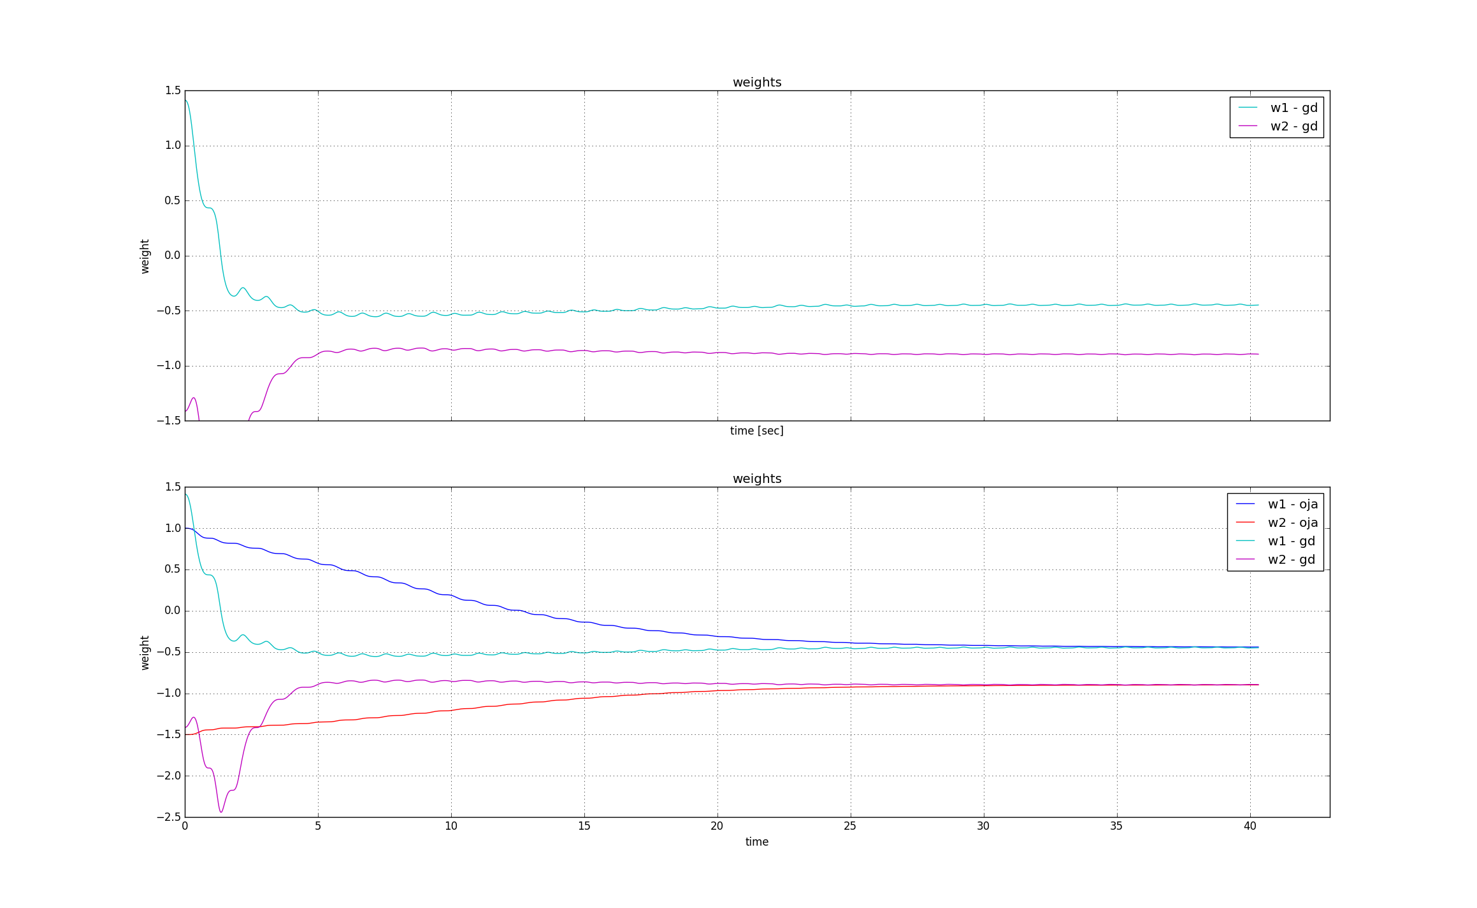

**Why we needed the NRP**

The NRP enabled us to easily implement the novel controller on different systems to test it on different mechanical systems. Through the modular design of the platform it was easily possible to run the controller on different systems. Due to the variability of the interfaces, the control can be applied to different kinds of actuation, be it directly applied forces to joints, OpenSim muscles or motor models.

**Why this is important to you**

The controller allows you to easily find the intrinsic eigenmodes of a mechanical system during fast periodic motions. Instead of forcefully driving a motion, the controller drives the intrinsic motions of the system and can thus generate energy efficient and natural motions. This helps to design energy efficient systems by investigating the “natural” motions of the system beforehand and set the parameters in such a way that the dedicated task supports the intrinsic motions. Therefore robots can be designed in an energy efficient manner.

PROJECT 2: Understanding how motions are generated in the CNS

Analogue to the energy-efficient robot controller (see Project 1), our research suggests that the human brain transforms sensory input from the multi-dimensional joint space into a 1D synergy space along multiplicative weights. Based on the robotic control approaches and on previously known electrophysiological evidence, a plausible CNS model was found to scale the forces for different muscles during a periodic dynamic motion. It was implemented as a Neuro-Controller in the NRP to test its performance. The structure of the controller is seen below.

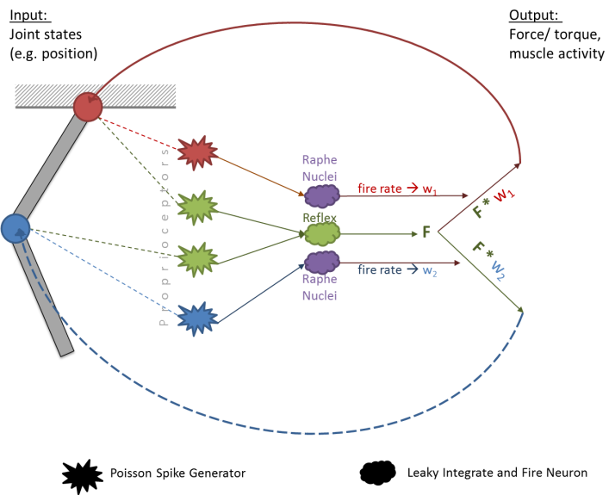In the Neuro-Controller, the weights to scale the control signal are encoded through a spinal chord model that is implemented in the NRP using PyNN. The motion of each joint triggers the activity of different proprioceptive neuron pools. The proprioceptors trigger the release of serotonin in the raphe nuclei. In turn, the serotonin increases the excitability of the motoneurons of the moving joint and thus, leads to a scaling of the control signal. The attached video shows the simulation of a simple mechanical system in the NRP with the Neuro-Controller implemented. It can be seen how the system automatically adjusts to a stable motion.

The average firing rates (w-neuro) that scale the signal are shown below in comparison with the weights that are simultaneously adapted through the Oja Rule. It can be seen that both methods leas to the same results.

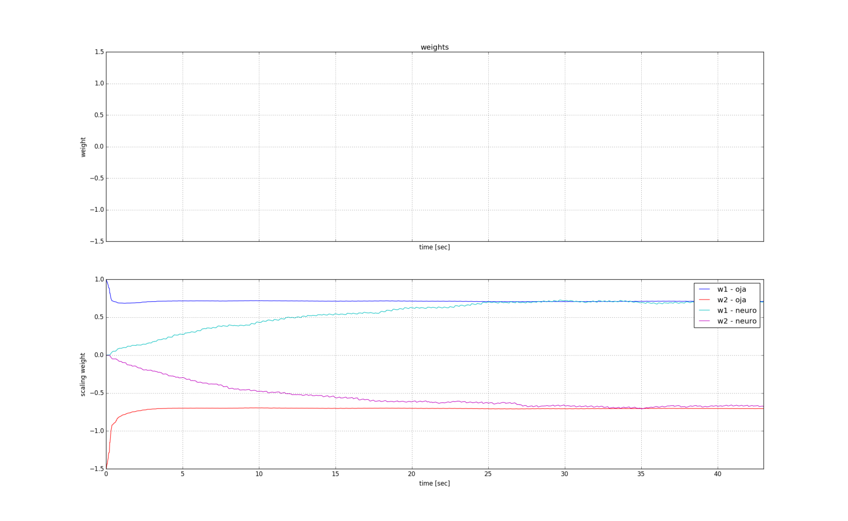

**Why we needed the NRP**

The use of the NRP enabled us to implement the Neuro-Controller in PyNN/Nest and easily link the signals to different mechanical system. The many features like the BrainVisualizer and the SpikeTrains helped to check the implementation for its correctness and verify the realistic efficacy.

**Why this is important to you**

Within the NRP, the developed Neuro-Controller can be easily interface to different brain model. This can help to test novel hypotheses about the working principle of the brain and the CNS. While the robotic implementation cannot replace those user studies, together with brain simulations it can help pre-test ideas for its plausibility and possibly adjust errors in the theory without time- and money consuming studies.