Clungene® COVID-19 Antigen and IgG/IgM Rapid Tests – Welcome to our Homepage

COVID-19 caused by the novel coronavirus (SARS-CoV-2) became a pandemic in the first half of 2020. In the fall the second wave broke up, causing an even more desperate situation in many countries.

To slow the pandemic down and to minimize the economic loss caused by the COVID-19, **it is essential to test people regularly and in a systematic way.** Our company, **Happy Business Services Ltd. has been distributing both antibody and antigen rapid test cassettes**. Both of them can be performed quickly and can be applied by healthcare professionals at point of care (POC) sites.

**Antigen tests** are capable of identifying COVID-19 at the **early phase** of the infection, whereas **antibody tests** can detect it in the **late phase and past infections**, too. In this way, the two tests **complement each other perfectly**.

**Clungene® COVID-19 IgG/IgM Rapid Test Cassette**

It detects the antibodies produced by the human immune system against the SARS-CoV-2 virus (IgG and (IgM). This test is for detecting the late phase of the infection, just as well as an infection happened in the past. Sensitivity: 86.6%. Specificity: 98.33% (IgG+IgM combined). 8 days after the appearance of the symptoms, specificity is over 90%.

**Clungene® COVID-19 Antigen Rapid Test Cassette**

It detects the nucleocapsid protein of SARS-CoV-2 (which is detected by the human immune system, too). This test is for detecting the early phase of the infection. Sensitivity: 91.4%. Specificity: 100.0%.

Our company, **Happy Business Services Ltd.** is one of the major importers of rapid tests. Our supplier, Hangzhou Clongene Biotech Co. Ltd. has been manufacturing more than 1,000 types of microbiological test materials and products. We have sold hundreds of thousands of tests in Hungary, supplied state institutions, healthcare institutions, municipalities and companies, too.

Happy Business Services Ltd. has obtained [**Bisnode A**](https://www.bisnode.hu/cegkereses/0/Happy%20Business%20Services) certificate. This testifies that the financial risk of co-operating with our company is low. Only the 7.44% of the Hungarian companies have obtained this certificate.

The following figure shows in what time period the antigen test and the antibody test is able to detect COVID-19.

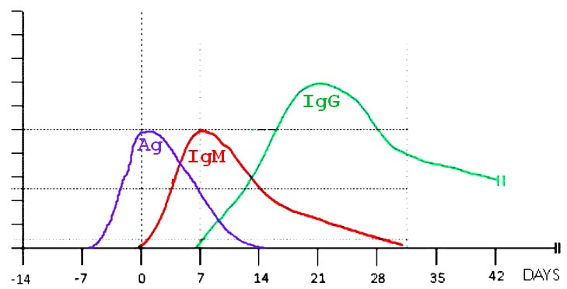

This figure serves as a reference; it shows when the COVID-19 antigen (Ag) and the two immunoglobulins (IgM and IgG) can be detected. “0” represents the day when the symptoms first occur (onset day). The virus protein – the antigen – appears first; this can be detected by the antigen test. This is followed by the two antibodies, IgM and IgG, which are detected by the antibody test. The presence of IgM usually refers to the early-to-mid phase of the infection. In most cases, IgG appears later, in the second half of the infection, but it is present in the body in a detectable amount for months.

The typical symptoms of COVID-19 appear 2–14 days after becoming infected; typically, 5–6 days after. In the period of incubation (shown by negative numbers) no test can detect the infection consistently. However, it is assumed that during the major part of this period people might not spread the infection because there is not enough virus in their body yet.

**Using COVID-19 rapid tests is a quick and cost-effective way of screening the employees of a company, an office or any other institution. Identifying and isolating those who are affected is an effective way of slowing the spread of the virus down, which may prevent the shut-down of the workplace and the financial loss associated with that.**

A comparison on the most frequently applied testing methods.

|  |  |  |  |
| --- | --- | --- | --- |
|  | **RT-PCR** | **Antigen rapid test**  (Ag test) | **Antibody rapid test** (serological test, IgG/IgM test) |
| **What is being detected?** | The genetic material (RNA) of SARS-CoV-2 (the novel coronavirus) | A specific protein present in SARS-CoV-2 (and recognized by the human immune system) | The antibodies produced by the human immune system against SARS-CoV-2 |
| **What specimen is used?** | Naso-, or oropharyngeal swab | Naso-, or oropharyngeal swab | Blood (finger-prick or venous blood, or plasma) |
| **How long does it take?** | More than 2 hours | 15–30 minutes | 15 minutes |
| **Are there any further tools, materials, devices needed?** | Yes | No | No |
| **Can it detect the infection after the time described below elapsed after the onset day?** | | | |
| **First week?** | Yes | Yes | Unlikely |
| **Second week?** | Yes | Sometimes | Yes, in most cases |
| **Third and fourth week?** | Sometimes | No | Yes |
| **Can it detect a past infection?** | No | No | Yes (provided the antibody is still present) |

**The information provided by COVID-19 rapid tests is for reference whether people are or have been infected or not. The tests are for professional use only.**

**REQUEST FOR QUOTATION**

FAQ

**Segítse Ön is a COVID-19 elleni védekezést!**

**Kérjen ajánlatot!**

[Minden mező marad, DE szükség lesz egy plusz, „kétállású” mezőre is, mely szerint Termék: IgG/IgM gyorsteszt / Antigén gyorsteszt]

**References**

## **Clungene® COVID-19 IgG/IgM Rapid Test – References**

There are hundreds of medical institutions, doctors, health centres, nursing homes, private clinics, companies and other institutions who have been using **Clungene® COVID-19 Rapid Test Cassettes**, which are distributed by us. Here you can find the webpage of some of them.

#### **Affidea Magyarország Kft.**

[https://www.affidea.hu/covid-19-szures/](https://www.affidea.hu/covid-19-szures)

#### **Kelen Kórház (Kelen Hospital)**

<https://kelen.hu/szolgaltatasaink/koronavirus-gyorsteszt-ellenanyag-vizsgalat/>

#### **Medical Service Budapest Mamut Egészségközpont (Mammut Health Centre)**

<http://mammutegeszsegkozpont.hu/allasfoglalas/>

#### **Medical Service Budapest Árkád Egészségközpont (Árkád Health Centre)**

<http://arkadegeszsegkozpont.hu/covid-19-szures/>

#### **Róbert Magánkórház (Róbert Private Hospital)**

<https://robertkorhaz.hu/leiras/koronavirus-gyorstesz>t

**Moreover, our partners, Phoenix Pharma and Hungaropharma distributes our rapid tests for all pharmacies in Hungary.**

**Prevent the spread of the virus by using rapid tests!**

Request for Quotation

Contact Name



Company Name



E-mail



Telephone



Amount of Antigen Rapid Tests



Minimum order quantity: 2 boxes (1 box contains 25 tests)

Amount of Antibody Rapid Tests



Minimum order quantity: 8 boxes (1 box contains 25 tests)

Comments



Send quotation

Az űrlap alja

**COMPOSITION**

(1) COVID-19 IgG/IgM Rapid Test

- 25 Test Cassettes (each packed individually)

- 25 Droppers (single use)

- 25 Lancets (single use, for finger-prick blood specimen collection)

- 25 Alcohol pads (single use, for disinfection)

- 1 Bottle of Buffer (contains solution for 25 tests)

- 1 Package Insert

(2) COVID-19 Antigen Rapid Test

- 25 Test Cassettes (each packed individually)

- 25 Extraction Reagent (in separate ampoules, 1 ampoule contains 0.3ml reagent)

- 25 Sterilized Swabs (single use for specimen collection)

- 25 Extraction Tubes

- 25 Dropper Tips

- 1 Work Station

- 1 Package Insert